**CSC4840/6840 Computer Graphics Imaging**

Spring 2017

Homework 4

Due date: April 12, 2017 at 11:59 pm

In this homework, you will learn how to use fluid simulation and particles to create photorealistic pictures.

Requirements:

* Choose ONE picture from the three pictures attached below and use 3D graphics to recreate the scene. Try to reproduce the liquid material and lighting effect in this picture as much as possible. Your grade is largely based on how closely you can reproduce the visual effects in this picture.
* Cycles rending engine may give better lighting effect but the rendering process are usually quite long, especially on laptops. For most people, I recommend that you use Blender’s default rendering engine.

Submit the following to the “homework 4” assignment drop box on iCollege.

* Your Blender file.
* All the texture image files.
* At least one rendered image, preferably multiple pictures from different camera positions.

Do not submit by email.

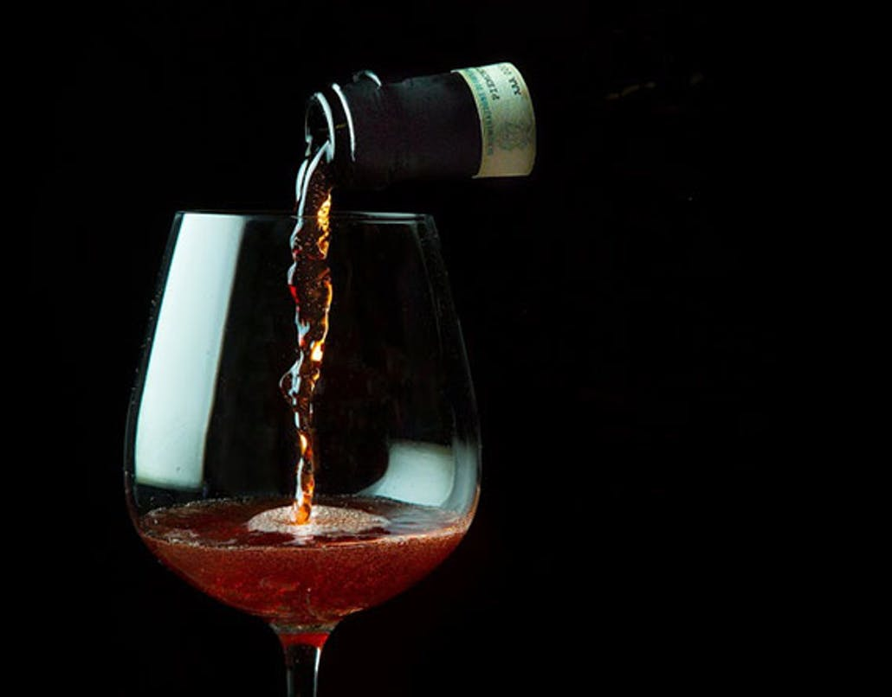

<https://www.tastingtable.com/drinks/national/how-to-pour-wine-how-to-open-a-bottle-of-wine>



<https://www.shutterstock.com/video/clip-3790958-stock-footage-bottle-pouring-white-wine-on-a-white-background.html>

