MANUSCRIPT TITLE

by

FIRST NAME LAST NAME

Under the Direction of Committee Chair’s Name, MA/PhD

ABSTRACT

The abstract paragraph is mandatory. Start the abstract paragraph here. Double-space this paragraph. Limit the abstract of a thesis to 150 words. Limit the abstract of a dissertation to 350 words.

INDEX WORDS: Sample keyword, Sample keyword, Sample keyword

MANUSCRIPT TITLE

by

FIRST NAME LAST NAME

A Thesis/Dissertation Submitted in Partial Fulfillment of the Requirements for the Degree of

Level and Degree Title

in the College of Arts and Sciences

Georgia State University

2017

Copyright by

Full Legal Name

2017

MANUSCRIPT TITLE

by

FIRST NAME LAST NAME

Committee Chair: First Name Last Name

Committee: First Name Last Name

First Name Last Name

First Name Last Name

Electronic Version Approved:

Office of Graduate Studies

College of Arts and Sciences

Georgia State University

May 2017

**DEDICATION**

This page is optional but highly recommended. The dedication is usually for acknowledging family or friends and is typically a matter of politeness.

# ACKNOWLEDGEMENTS

Again, this page is optional but also highly recommended. You may use this section to express acknowledgement of those who have helped you with this document (your committee members and instructors) and your academic career. This section should be double spaced.

**TABLE OF CONTENTS**

ACKNOWLEDGEMENTS v

LIST OF TABLES viii

LIST OF FIGURES ix

LIST OF ABBREVIATIONS x

1 INTRODUCTION 1

1.1 Purpose of the Study 1

1.1.1 Subsection heading 1

1.2 Expected Results 1

2 EXPERIMENT 2

2.1 Section heading 2

2.1.1 Subsection heading 2

2.2 Section heading 2

3 RESULTS 3

3.1 Section heading 3

3.1.1 Subsection heading 3

3.2 Section heading 3

4 CONCLUSIONS 4

REFERENCES 5

APPENDICES 6

Appendix A 6

Appendix A.1 6

Appendix A.2 6

Appendix B 6

Appendix C 6

# LIST OF TABLES

Table 1.1 The Greek Alphabet 1

# LIST OF FIGURES

Figure 3.1 You're Almost Ready to Graduate! 3

# LIST OF ABBREVIATIONS

# INTRODUCTION

Insert body text here…

## Purpose of the Study

Insert text here…

Table 1.1 The Greek Alphabet

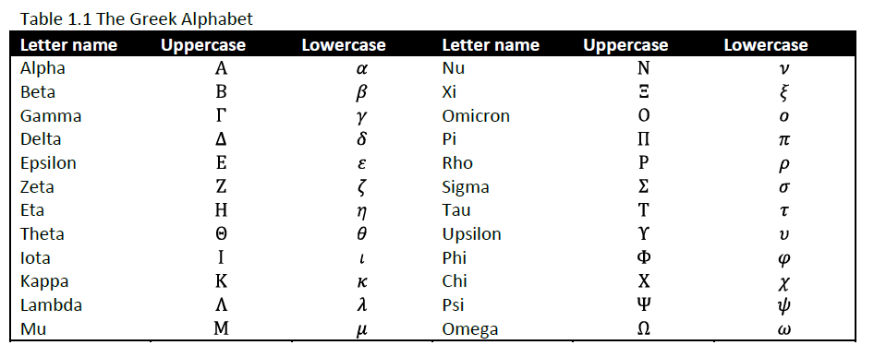

### Subsection heading

## Expected Results

Insert text here…

# EXPERIMENT

Insert body text here…

## Section heading

### Subsection heading

## Section heading

# RESULTS

Insert body text here…

## Section heading

### Subsection heading

## Section heading

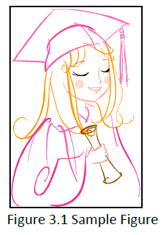

Figure 3.1 You're Almost Ready to Graduate!

# CONCLUSIONS

Insert body text here…

# REFERENCES

# APPENDICES

## Appendix A

### Appendix A.1

### Appendix A.2

## Appendix B

## Appendix C