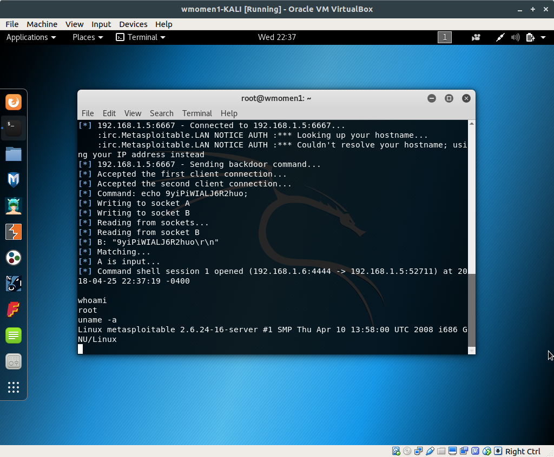
Using mfsconsole and unreal backdoor

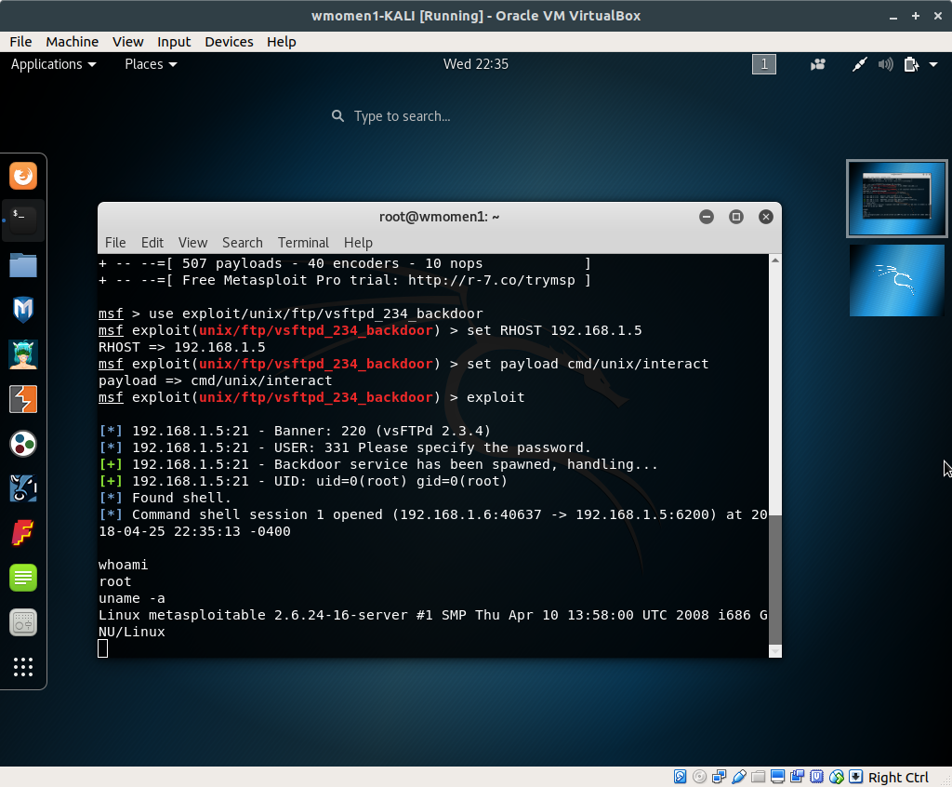
Using mfsconsole and vsftpd backdoor

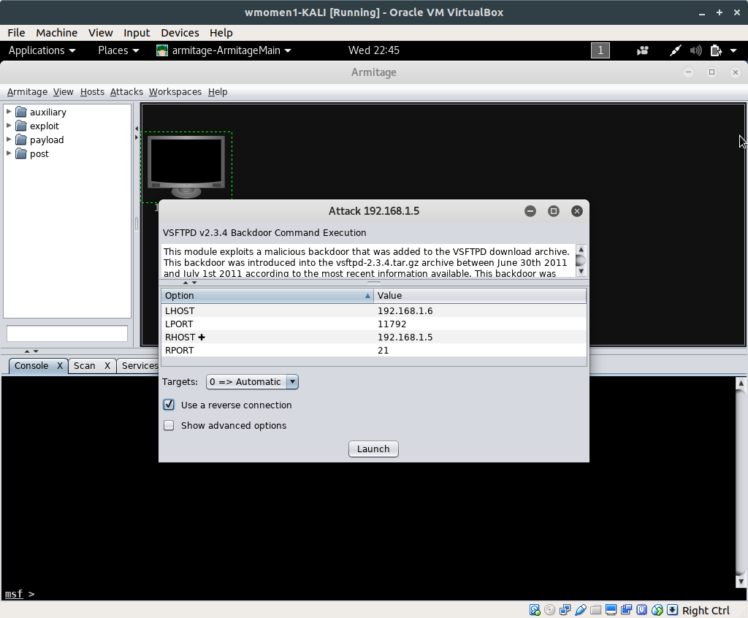
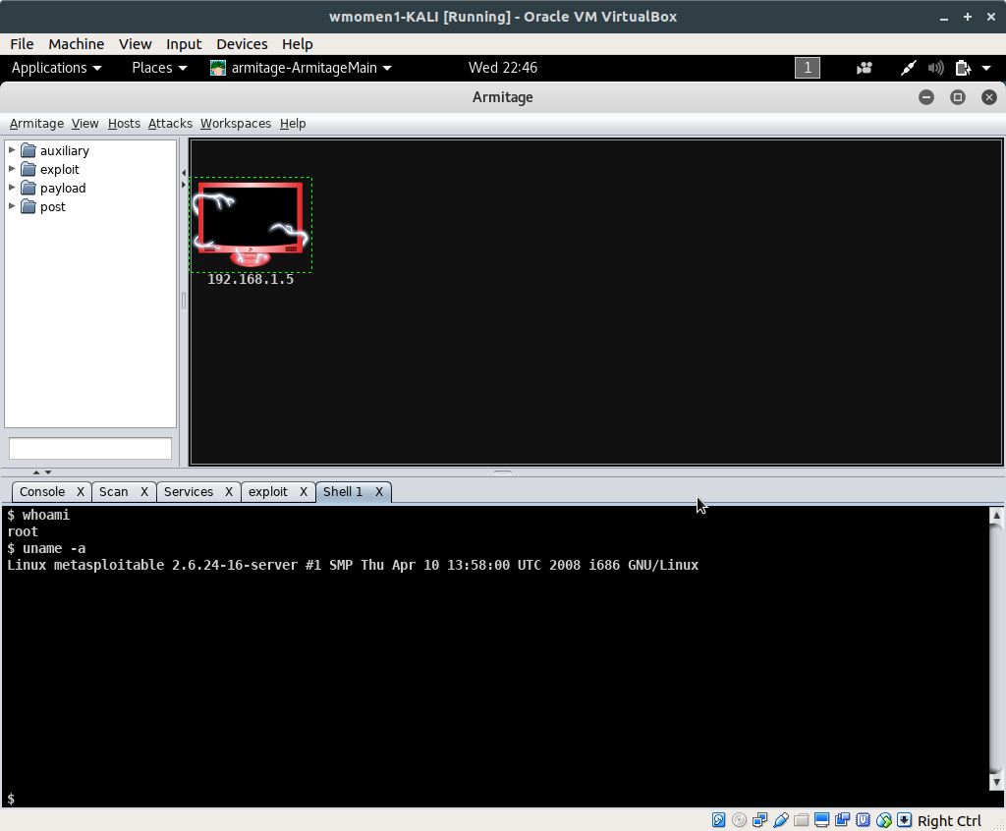

Using armitage and vsftpd backdoor

Using armitage and vsftpd backdoor

