CSC3320 System Level Programming

Program Challenge 7

Due at 11:59 pm on Wednesday, Oct. 19, 2016

In this assignment, you need to try some simple C programs and understand some basic differences between C and Java through practices.

Part 1:
Create and run Kernighan and Ritchie’s famous “hello,world” program.

Step 1: Go to your home directory (cd ~) and create a new file named as hello.c (vi hello.c or nano hello.c), then include following lines in your hello.c .

#include <stdio.h>

int main(void)
{
printf("Hello,world\n");
return 0;
}

Step 2: Save your file and exit editor.

Step 3: Compile and link the hello.c program by following command.
$cc hello.c

Note: after this command, a default executable program named as “a.out” will be generated in current directory if there are no errors with your C program. You can use ls to check the existence of a.out .

Step 4: Run the executable program a.out
$./a.out

Questions:
1) Attach a screenshot of the output in step 4.
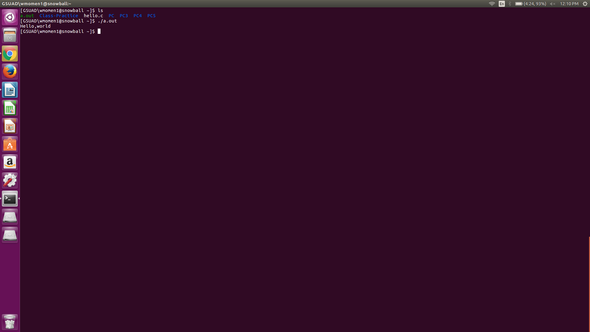

2) Try following command to compile and link hello.c again. And tell what new file is generated after this command?
$cc -o hello hello.c

a hello file is created. It is the executable for the hello.c program.

3) Try command below and attach a screenshot of the output.
$./hello

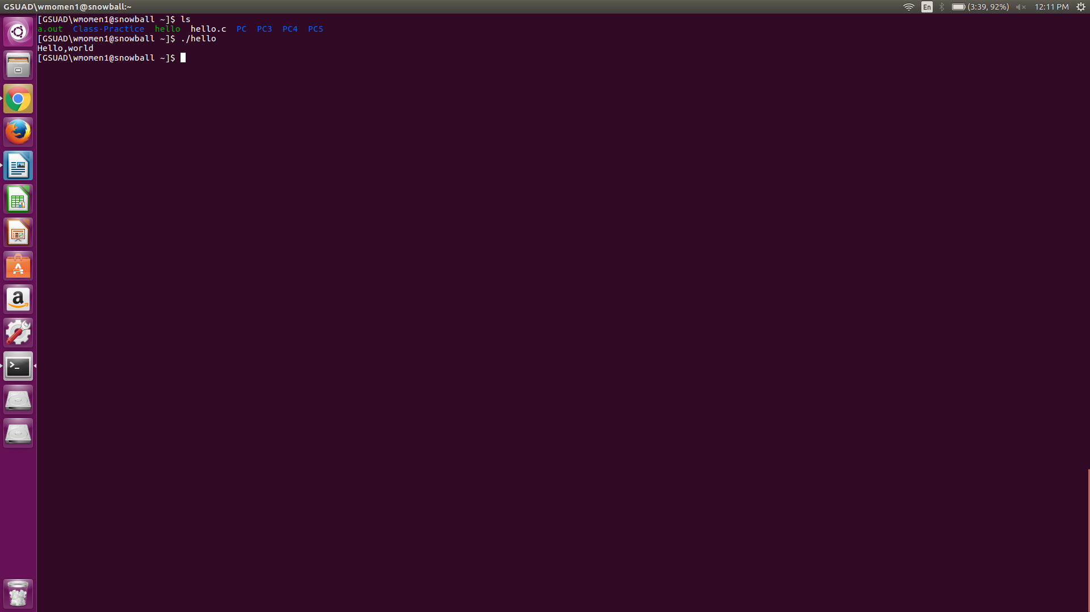

4) Now write a new C program named as myName.c based on hello.c. In this program, print out your first name and last name instead of “Hello,world”. For example, the output could be “My name is Yuan Long”.
Execute your myName.c and attach a screenshot of the output. Then write the source code of myName.c in your answer sheet and upload your file myName.c to iCollege.

# include <stdio.h>

int main(void)
{
printf("My name is Wasfi Momen.\n");
return 0;

}
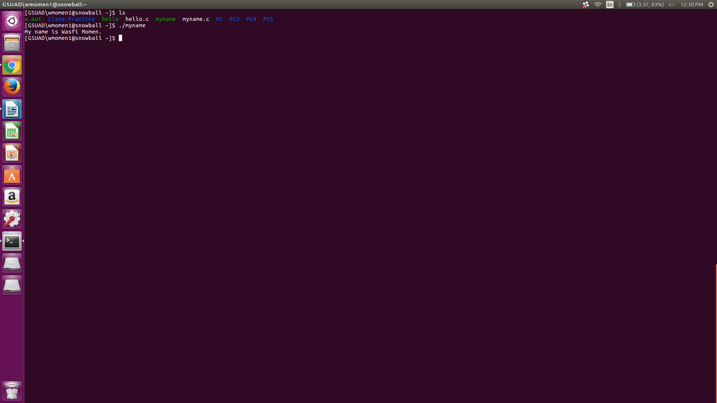

Part 2:
In program challenge 5 you have created a shell script to calculate factorial of a given integer number. Now it is your turn to write a C program for it.

Questions:
1) The function of C is similar to the method of Java. If you know how to write Java program, it will be much easier for you to write a C program for the same task. So please write a Java program first in this part and name your Java program as factorial.java.
In your Java program, define a variable named as num to store the value of the given integer number, e.g. int num=5. And define another variable named as res to store the final result (i.e. the factorial of a given integer number). Please use while loop instead of for loop. Besides, you do not need to write other methods, just add some statements in the main method.
Then put the source code of factorial.java in your answer sheet.

Note: If you want to run your Java program in terminal,
- to compile factorial.java, please try
$javac factorial.java
- To execute it, please try
$java factorial

public class factorial {

public static void main (String [] args) {
int num = 5;
int res = 1;

while(num > 0 ){
res=res*num;
num--;
}

System.out.println("Factorial of 5 is: " + res);
}
}

2) Now convert your Java program to C program by following steps.

Step 1: create a new file named as factorial.c (vi factorial.c or nano factorial.c), then include following lines in your factorial.c.

#include <stdio.h>

int main(void)
{
/* Replace this comment with the statements
from main method of factorial.java */
return 0;
}

Step 2: Replace the comments in factorial.c with the statements from main method of factorial.java

Step 2: You may have used System.out.println(….) in your Java code. Please remove this statement in factorial.c and replace it by the statement below:
printf("The factorial of %d is %d\n",num,res);

Step 3: Compile and link the factorial.c program
$cc -o factorial factorial.c

Step 4: Run the executable program
$./factorial

Then put the source code of factorial.c in your answer sheet. Attach a screenshot of the output (note: the given number should be 5 ) and upload your file factorial.c to iCollege.

#include <stdio.h>

int main(void)
{

int num = 5;
int num2 = num;
int res = 1;

while(num2 > 0 ){
res=res*num2;
num2--;
}

printf("The factorial of %d is %d\n",num, res);
return 0;
}

Part 3:
Modify factorial.c in part 2 and read user’s input as the given integer number. Name your new C program as factorial_read.c . Sample outputs are as below:

$ ./factorial
Please input a number:2
The factorial of 2 is 2
$ ./ factorial
Please input a number:4
The factorial of 4 is 24
$ ./ factorial
Please input a number:5
The factorial of 5 is 120

Then put the source code of factorial_read.c in your answer sheet. Attach a screenshot of the output (given interger number 10 ) and upload your file factorial_read.c to iCollege.

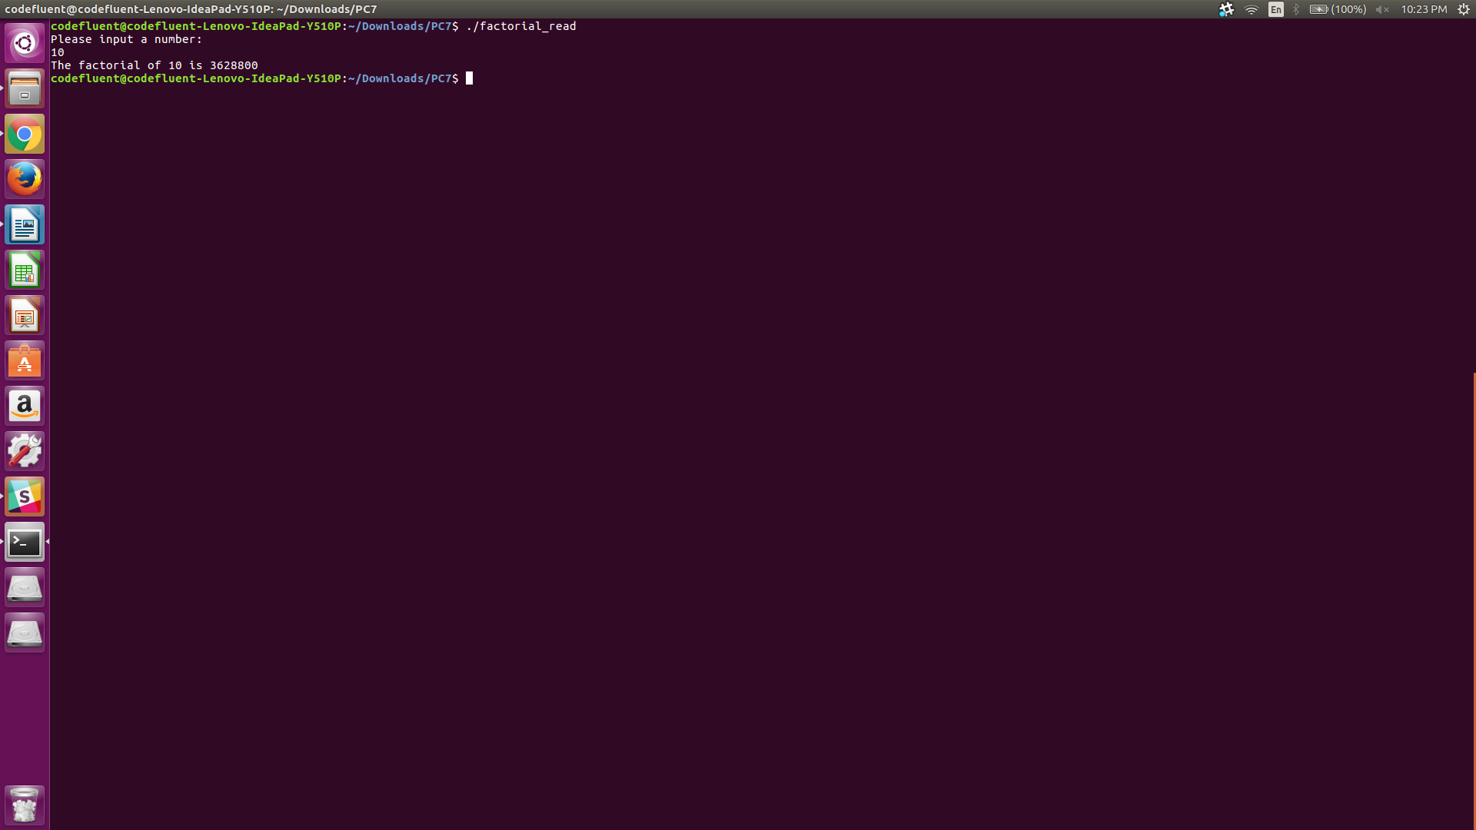

Submssion:

- Upload an electronic copy (MS word or pdf) of your answer sheet to the folder named “PC7” of the dropbox in the iCollege system

- Upload files myName.c, factorial.c, factorial_read.c to the folder named “PC7” of the dropbox in the iCollege system. Note: if you do not upload these three C files, you would get zero for this assignment.

- Please add the program challenge number and your name at the top of your answer sheet.

- Name your file in the format of PC7_FirstnameLastname (eg. PC7_YuanLong.docx, PC7_YuanLong.pdf)

