CSC3320 System Level Programming

Program Challenge 6

Due at 11:59 pm on Wednesday, Oct. 12, 2016

Part 1:
Please complete the tasks in following table step by step and finish the questions below the table.

Step 1: Go to your home directory (cd ~) and create a new file named as exp1.sh (vi exp1.sh or nano exp1.sh), then include following lines in your exp1.sh.

#!/bin/bash
#
#exp1.sh in Part 1 of PC6
#

x=0 # initialize x = 0
i=1
while [ $i -le 5 ] # while i<=5
do
x=`expr $x + $i`
i=`expr $i + 1` # i=i+1
done

echo x=$x

Step 2: Save your file and exit editor.

Step 3: Try following command to make simple.sh executable.
$chmod a+x exp1.sh

Step 4: Execute this file by invoking its name.
$./ exp1.sh

Note: when type the shell script in your terminal, please be very careful about spaces.
Questions:
1) Attach a screenshot of the output in step 4.

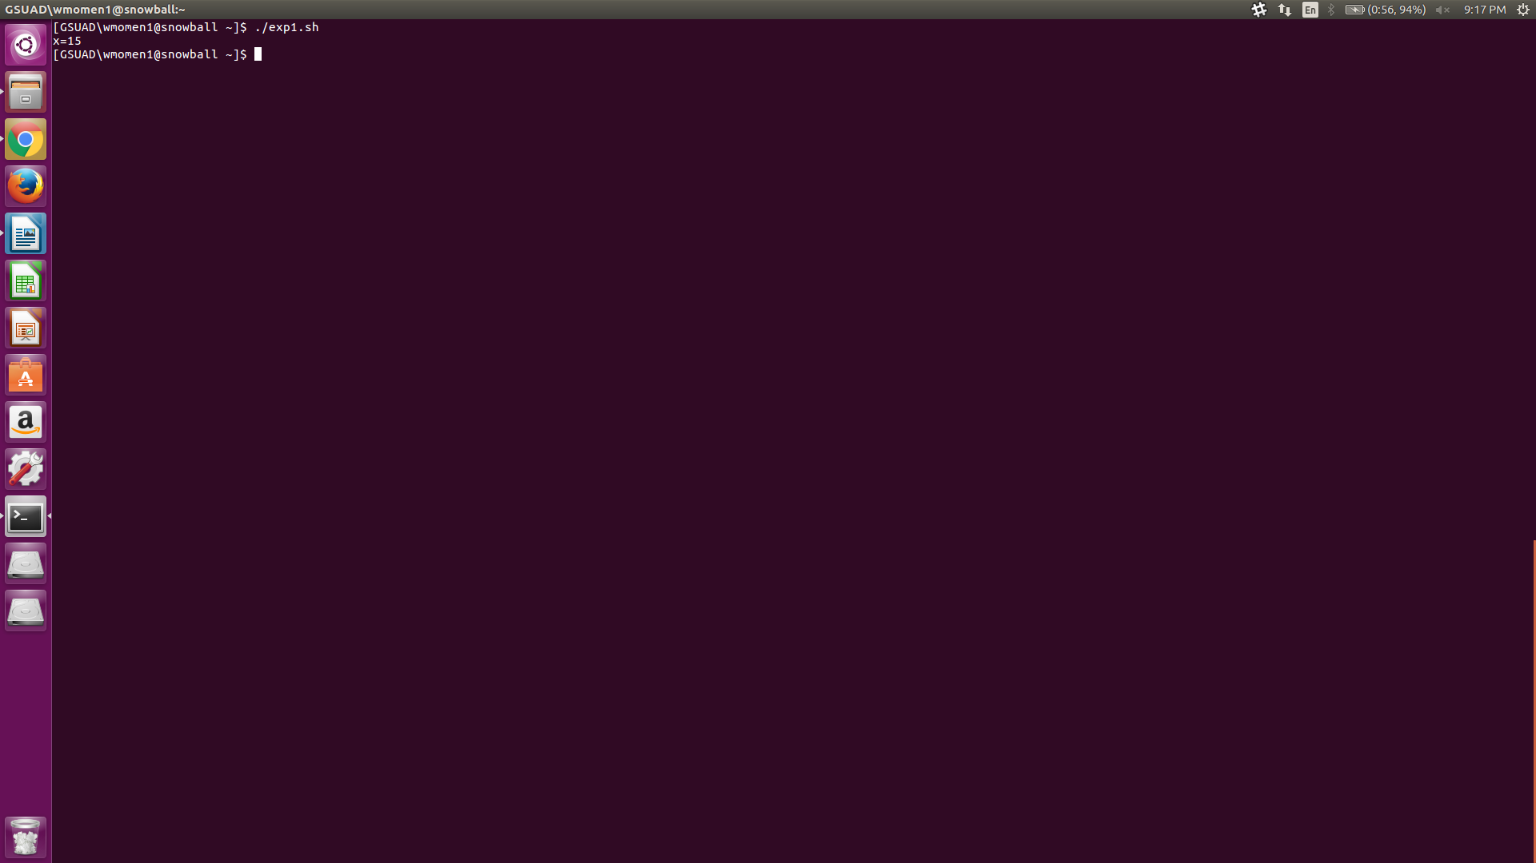

2) Describe what does the shell script exp1.sh do?

exp1.sh executes a while do loop with a variable x and i. i is added to x and i is incremented by 1 each time the loop executes until x equals 5.

Part 2:
Step 1: Edit your exp1.sh and change “ -le 5 ” to “ -le $1 ” .

Step 2: When finished, save the exp1.sh and exit editor. Then try executing it again by typing following command.
$./ exp1.sh 10

Question:
Attach a screenshot of the output.

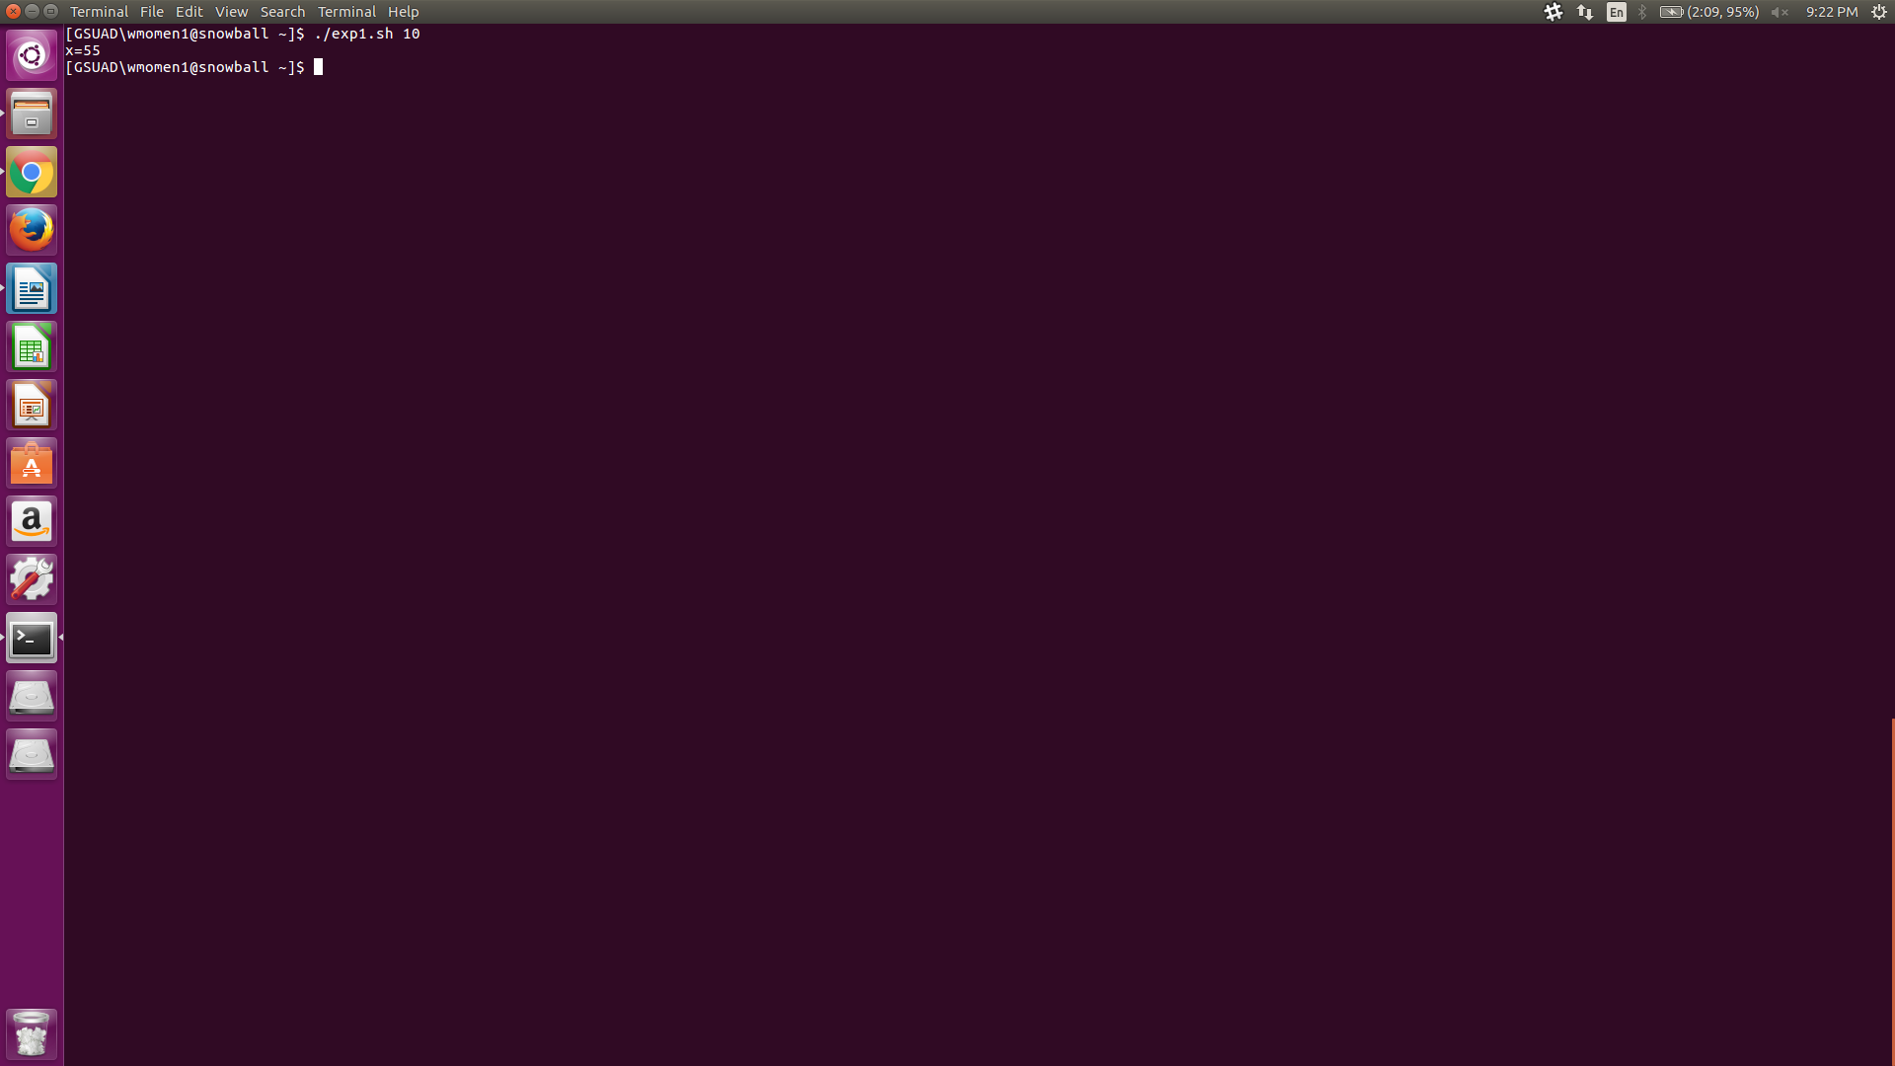

Part 3:
Step 1: Edit your exp1.sh in part2 by making following modifications:
- Add two new lines below between line “i=1” and line “while [ $i -le $1 ]”
echo please input the max number
read max
- Change “ -le $1 ” to “ -le $max ” .

Step 2: When finished, save the exp1.sh and exit editor. Then try executing it again by typing following command and type 10 as input of the max number.
$./ exp1.sh

Question:
Attach a screenshot of the output.
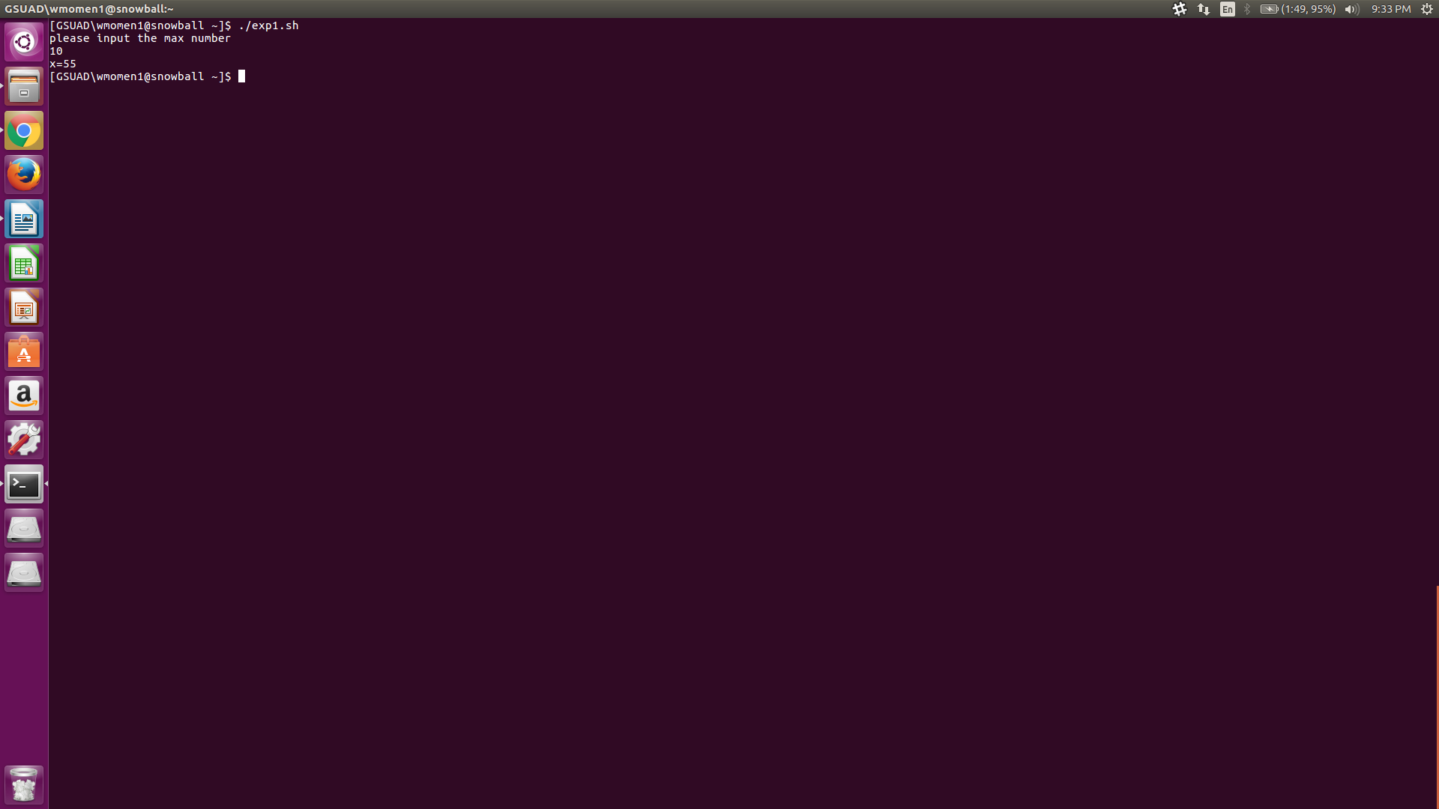

Part 4:
Write a shell script to calculate factorial of a given integer number. Please name your shell script as factorial.sh. The integer number should be given on command line. The sample outputs are as below:

$ ./factorial.sh 2
the factorial of 2 is 2
$ ./factorial.sh 4
the factorial of 4 is 24
$ ./factorial.sh 5
the factorial of 4 is 120

Question:
Execute your factorial.sh and attach a screenshot of the output when the given number is 10. Then write the source code of factorial.sh in your answer sheet and also upload your file factorial.sh to iCollege.
Note: if you do not upload factorial.sh, you would get zero for this assignment.

Submssion:

- Upload an electronic copy (MS word or pdf) of your answer sheet to the folder named “PC6” of the dropbox in the iCollege system

- Upload file factorial.sh to the folder named “PC6” of the dropbox in the iCollege system. Note: if you do not upload factorial.sh, you would get zero for this assignment.

- Please add the program challenge number and your name at the top of your answer sheet.

- Name your file in the format of PC6_FirstnameLastname (eg. PC6_YuanLong.docx, PC6_YuanLong.pdf)

