**Product Requirements Document**

**Code for Boulder**

**Planning Permit Project**

**General Requirements and Objectives**

Develop mutually complementary smart phone app and Web site to track development projects in planning in City of Boulder.

City must open up data files and APIs for access.

City must provide timely updates of information generated in course of development; staff responses, developer updates, scheduled meetings, etc.

Application and site should attract users, foster civic engagement and lead to a more inclusive city planning process.

**User Experience and Design Requirements**

Smart Phone platform shall be iOS

Logical balance between phone app features and pointers and Web site more detailed information.

Web site features should be flexible, elements loosely coupled, allow for extensibility and modernization.

Application features/options should present themselves as function of where the user is geographically.

**Technical Requirements - Front End**

Module 1 - Front Page with List of Projects

Application shall contain locative functionality – what development projects are planned or in process connected to the spot where the user is standing and accessing the app. (See Screen Shots below.)

Upon user click, list of candidate projects shall appear; list should be clickable.

For Phase 1, pick first 10 or so projects listed on city web site:

<https://bouldercolorado.gov/plan-develop/development-review-projects>

Plus Armory Site at 4750 Broadway: <https://www-webapps.bouldercolorado.gov/pds/publicnotice/index.php?caseNumber=LUR2015-00012>

Candidate projects could be presented as list or map (see Yelp approach.)

Click on project will deliver thumbnail description and outline of available information, documents and contacts.

Further explore what user should see before they register.  For example, can explore all the data, see what projects are close to you, read comments and such without registering.

Application shall contain link to comments on particular development projects.

Module 2 – Create User Profile

If you click the favorites button or keep me informed button, or click to make a comment, you would be prompted to create a user profile.

Enter your user info:  address (for updates on projects near you), mobile number for text notifications; Twitter, Facebook IDs to enable easy sharing of the sites info or comments; also maybe for following updates via tweets or fb posts.

Application shall allow user to set a favorites list of projects in development.

Module 3 - Notifications Module

Application shall contain alerts functions for changes/updates to project documentation pertaining to favorites list.

Would be cool to get the Twitter or FB handle and automatically like our page or handle for them.

As a community member, I can like a Facebook page to get updates on development projects in boulder. Use Ron Rovtar’s Dakota Ridge page as first implementation. Add NextDoor app link in Phase 2.

Module 4 – Participation Module

Application shall contain a feature to save/send screen shots, links or documents brought up in the course of a user session.

As a community member, I can follow tweets on development projects in boulder

As an engagement system, app can allow posting new development projects to Facebook and Twitter to inform the community of changes, hot topics, and opportunities to comment to decision makers.

* Utilize Citygram code which is open source

Consider more of a push model versus only trying to get people to come to the site and query for info...  And the social media connections seem like a leverage point.  If you Favorite, then you’ll get a newsfeed.

Long term, application should enable user to overlay project on larger subcommunity, on trail and transit systems, and other community-wide elements that often constrain particular planning projects.

App should provide access to schedules, and dynamically inform the user where in the process a particular project is, and at which points public input is possible. Sample steps:

* Concept Plan
* Site Plan Review
  + Site Plan Published
  + First Citizen Comments
  + Staff Response 1, 2, etc.
* Presentation to Planning Board
* Hearing at City Council 1, 2, etc

**Screen Shots – From Current City Web site**

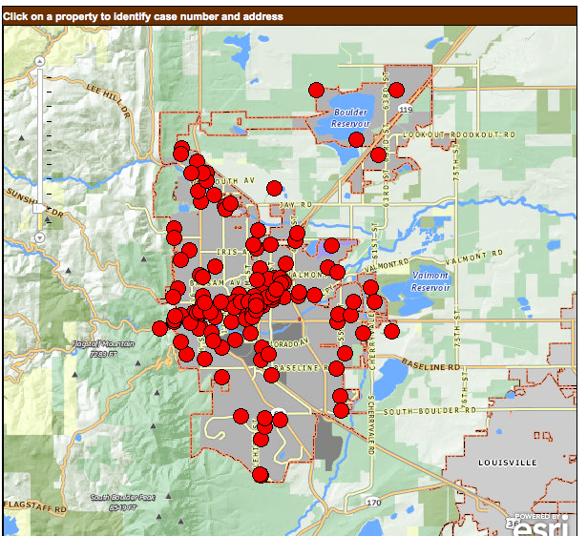

Click on dot on map – currently brings you to page below:

|  |
| --- |
|  |

**Appendix**

**Data Requirements Module**

App should access (and City must commit to) dynamic provision of data as soon as accessible; e.g. not just developer’s original Site Plan, but also updates, staff reviews, Planning Board and City Council comments, public comments, developer town meeting presentations, etc.

The app will interface City data, documents through RESTful web services.

App should provide links to related documentation, for example each project falls with a Subcommunity Plan which contains guidelines and restrictions that govern projects in that Subcommunity (e.g. Armory part of North Boulder Subcommunity.) All are subject to Boulder Comprehensive Plan.