What is OWIN?

OWIN defines a standard interface between .NET web servers and web applications. The goal of the OWIN interface is to decouple server and application, encourage the development of simple modules for .NET web development, and, by being an open standard, stimulate the open source ecosystem of .NET web development tools.

Owin Firewall:

Owin provides a very simple IP blocking mechanism for ASP.NET Core applications.

public void Configure(IApplicationBuilder app, IHostingEnvironment env, ILoggerFactory loggerFactory)

{

loggerFactory.AddConsole(Configuration.GetSection("Logging"));

loggerFactory.AddDebug();

app.UseOwinFirewall(new Daenet.Owin.OwinFirewallOptions(new List<string>()

{ "81.207.142.79", "::1", "localhost", "222.111.228.225/27" }));

app.UseMvc();

}

About the Application:

These are the test applications for .net4 and .net5 with the help of Owin Webapp you can able to use this firewall.

To run this application just press start and and to unblock the particular Ip-addresses go into to the startup of the application

With the ever growing use of mobile devices, social networks, cloud-based applications e.g. Azure and intrusions, securing your business’ vital assets is critical. Daenet provides you the Owin firewall that keep running your applications safely.

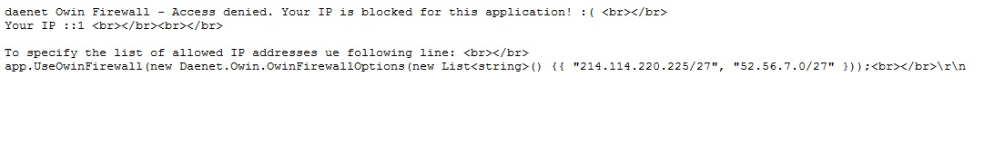

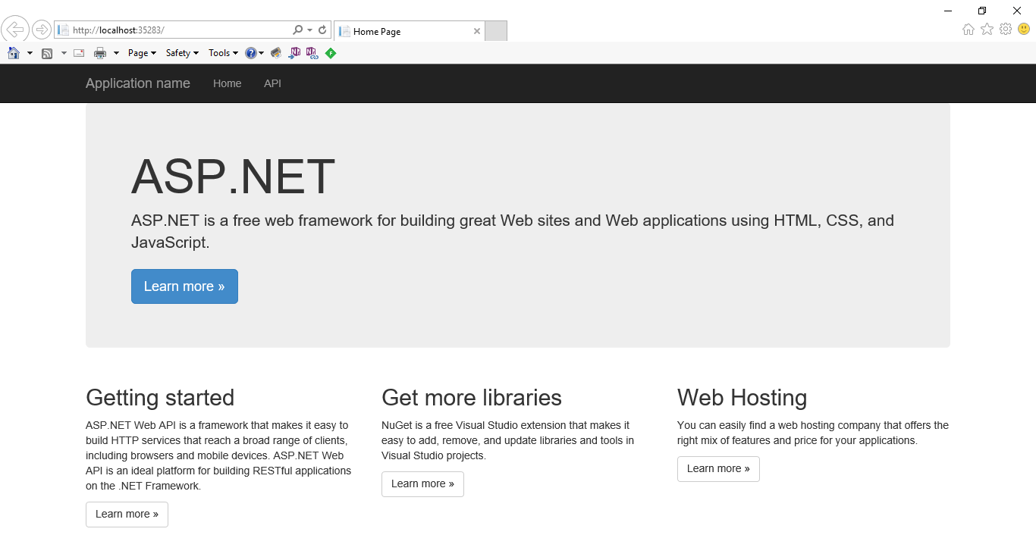

Host OWIN in IIS

In this section, we'll host OWIN in IIS. This option gives you the flexibility and composabity of an OWIN pipeline together with the mature feature set of IIS. Using this option, the OWIN application runs in the ASP.NET request pipeline. 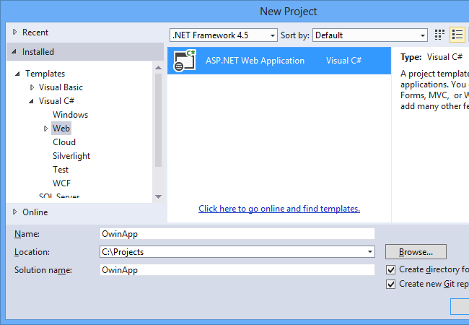

First, create a new ASP.NET Web Application project. (In Visual Studio 2012, use the ASP.NET Empty Web Application project type.)