

Tribhuvan University

**Nepal Commerce Campus**

**Min-bhavan, New Baneshwor, Kathmandu**

**An Intern Report On**

**Search Engine Optimization At**

**Ombryo Lab Pvt. Ltd**

Submitted by:Bijay Chaudhary(8449/17)

An Intern report submitted in the partial fulfillment of the requirement for

**Bachelor of Information Management (BIM) 8th Semester,**

**o**f Tribhuvan University, Nepal

Report of Internship for the period March 25, 2022 – July 7, 2022

July 21, 2022

# Mentor’s Recommendation

I hereby recommend that this report prepared under my mentorship by **Mr. Bijay Chaudhary** in partial fulfillment of the requirements for the degree of Bachelor of Information Management of Tribhuvan University be processed for evaluation.

………………………..

Mr. Arun Chaudhary

SEO Analyst,

(krispCall.com) Ombryo Lab Pvt. Ltd.

NEW BANESHWOR, KTM, NEPAL

# Supervisor’s Recommendation

I hereby recommend that this report prepared under my supervision by **Mr. Bijay Chaudhary** in partial fulfillment of the requirement for the degree of Bachelor of Information Management of Tribhuvan University be processed for the evaluation.

……………………….. Mr. Nipun Thapa

(Lecturer/Supervisor)

Nepal Commerce Campus

Min-bhavan, Kathmandu

# LETTER OF APPROVAL

This is to certify that this internship report prepared by **Mr. Bijay Chaudhary** in the partial fulfillment of the requirement for the degree of Bachelor of Information Management of Tribhuvan University be processed for the evaluation.

…………………………

Mr. Surya Prasad Devkota

BIM Coordinator (Program Director)

Nepal Commerce Campus

Min-bhavan, Kathmandu

# Weekly Timetable

Table 1: Weekly Timetable

|  |  |  |
| --- | --- | --- |
| **Week** | **Department** | **Activity** |
| First (March 25th – April 1st ) | Marketing | Performed Content Research and prepared content on different topics & watched preliminary SEO Tutorial videos review |
| Second (April 3rd – April 10th) | SEO | Obtained list of business competitors, performed SEO analysis, started using screaming frog tool for performing  competitor analysis |
| Third (April 11th – April 18th) | SEO | Performed SERP rank tracking using SERPfox&SEMrush, and performed keyword density check on competitor  Website |
| Fourth (April 19th – April 26th ) | Marketing | Advance SEMrush & ahrefs Tutorials & analysis. |
| Fifth (April 27th – May 4th ) | SEO | New Video Review, Performed Keyword Research using Google Adwords Keyword Planner,  Competitor Analysis using SEMrush |
| Sixth (May 5th – May 12th ) | SEO | Optimized title and meta description based on keyword research, SEO  friendly URL Structure |
| Seventh (May 13th – May 20th ) | SEO | Optimized page load speed, Content and Image Optimization, SEO  copywriting, Cross linking |
| Eighth (May 22nd – May 29th ) | SEO | Social Bookmarking, Directory Submission, Profile creation on Startup Marketplace, Email Outreach, Basic  Link Building |
| Ninth ( May 30th – June 6th ) | SMO | Optimization of host company’s Social Profiles: Facebook, Twitter, Google Plus, Competitor’s Social Media Analysis using SEMrush & ahrefs. |
| Tenth (June 7th–June 14th) | SMO | Creation of weekly Social Media posting routine, Used some Social Media Management tool |
| Eleventh (June 15th – June 30th ) | SEO/SMO | Reporting using Google Analytics, Twitter Analytics, Mention |

# Acknowledgement

The successful completion of this internship report would not have been possible without the support and assistance of many individuals and organizations. I feel immensely blessed to have gotten this during the course of my internship program. I would like to take this opportunity to offer my earnest admiration to each and every one of them.

First and foremost, I am highly indebted to **Mr. Bhuvan Dahal** who took confidence in me and provided me with the opportunity to work as an Intern at **Ombryo Lab Pvt. Ltd.** I had a wonderful and an unforgettable experience being part of such a lovely and lively team.

I express my sentiment of gratitude to Mr. **Arun Chaudhary**, an acclaimed Internet Marketer, who has been a continuous source of inspiration as my intern mentor. Without his constant guidance and suggestions, this report would have been nowhere near completion. My gratitude for his trust and generosity goes beyond words.

My special thanks to Mr. **Surya Prasad Devkota** and Mr. **Nipun Thapa** for their constant guidance towards preparing this report standard as per the norms and values.

I would not forget to remember the efforts of the **SEMrush** and **Screaming Frog**, pioneers in Internet Marketing Service, who provided me with an extended subscription to their renowned products, solely for the successful completion of my internship program and this report.

Finally, my thanks and appreciations go to each and every one of my colleagues, and the entire Ombryo team, who irrespective of the situation, always encouraged and supported me to prepare this report.

Bijay Chaudhary (8449/17)

# Executive Summary

Ombryo Lab is a Startup Incubator which aims in changing the IT Landscape of Nepal with the adoption of silicon-valley culture. It creates a long term impact by sprouting the right talent to a fully grown venture which is capable of driving the next generation innovation and developing cutting edge products.

Founded and backed by Serial Entrepreneurs, it brings together deep industry expertise and the latest IT advancements to deliver custom solutions to help grow the aspiring tech entrepreneur in Nepal and develop products that perfectly fit the needs and behaviour of the global audience.

The advent of Digital Marketing has fundamentally changed the way organizations approach their prospective customers. In today’s digital world, reachability and visibility are critical to the growth and success of any business, which is why increasing number of IT firms are employing various digital channels to appeal to sets of potential clients. One of these channels is the ‘Search Engines and the technique is the Search Engine Optimization’.

Search Engine Optimization (SEO) is the process of optimizing different aspects of a website so that it can be found easily in search engines based on certain search terms called keywords. The main objective of Search Engine Optimization is to organically improve the website’s ranking in the Search Engine Results Pages (SERPs). The higher the website ranks in SERP, the more exposure and traffic it gets.

The author completed his Internship program in Search Engine Optimization, and this report basically outlines SEO activities carried out by the author at Ombryo Lab Pvt. Ltd.’s one of the product named “**krispCall.com”.** It spans the use of Search Engine Optimization (SEO) strategy implemented to improve the overall online presence of websites, and tools that were used to monitor, analyze and test the results. But, this report is not limited to the use of SEO; it also covers some aspects of Social Media Optimization (SMO) that was performed on different social media profiles of the host company.

# Contents

Table of Contents

Mentor’s Recommendation i

Supervisor’s Recommendation ii

LETTER OF APPROVAL iii

Weekly Timetable iv

Acknowledgement vi

Executive Summary vii

Contents viii

List of Figures xi

List of Tables xii

List of Abbreviations xiii

Chapter I 1

Introduction of Internship 1

1.1 Purpose of Internship 2

1.2 Objective of Internship 3

1.3 Selection of Organization and Duration 4

Chapter II 5

Description of the Host Company 5

2.1 Introduction of Organization 5

2.1.1 Contact Information: 6

2.2 Types of Organization and Ownerships 7

2.3 Organization Chart 8

2.4 Major Function of Organization 9

2.4.1 JavaScript & Python Consulting Services 10

2.4.2 Other Services 10

2.4.3 Technology Used 10

2.4.4 Products Developed 11

Chapter III 12

Profile of the Department Trained in 12

3.1. Introduction of Department 12

3.2. Staff Scheduling 13

3.3. Major Function of the Department 14

Chapter IV 15

System Used in Department and Operation 15

4.1. SEO Tools and Software Used 15

4.1.1. SEMrush 15

4.1.2. SERPfox 15

4.1.3. Screaming Frog 15

4.1.4. Ahrefs for Keyword plans 15

4.1.5. Google Search Console 15

4.2. Hardware Equipments 16

4.2.1. PC Configuration 16

4.2.2. Network Hardware 16

4.3. Testing and Verification Methods 17

4.3.1. Google Analytics 17

4.3.2. Google Search Console 17

Chapter V 18

SWOT Analysis 18

Benefits of SWOT Analysis: 18

5.1. Strengths 20

5.2. Weaknesses 20

5.3. Opportunities 20

5.4. Threats 21

Chapter VI 22

Intern Activities 22

6.1. SEO Analysis 22

6.1.1. Website Analysis 22

6.1.2. Competitor Analysis 22

6.2 Keyword Research 23

6.3 Content Research 23

6.4 Content Creation and Optimization 23

6.5 Title and Meta Description Optimization 24

6.6 Image Optimization 24

6.7 Off-page Optimization 25

6.8 Case Study 26

6.9 Social Media Optimization 26

6.10 Monitoring and Reporting 26

6.11 Customer Communication 26

Chapter VII 28

An Assessment of the Internship 28

7.1 Learn from the Internship 28

7.1.1 Work in a Corporate Environment 28

7.1.2 Team Work and Collaboration 28

7.1.3 Working Mechanism of Search Engines 28

7.1.4 Finding Keywords for SEO Campaign 29

7.1.5 Create SEO Optimized Contents 29

7.1.6 Use Different SEO Tools 29

7.1.7 Monitor, Analyze and Test SEO Results 29

7.2 Challenges 29

7.2.1 A New Routine 29

7.2.2 Identity 30

7.2.3 Not Enough Work 30

7.2.4 Not Enough Direction 30

7.2.5 Not Enough Feedback 30

Chapter VIII 31

Conclusion 31

8.1 Summary 31

8.2 Recommendations 31

8.2.1 Paid Internship 31

8.2.2 Team of SEO Experts 31

8.2.4 Regular Contents 32

8.2.5 Weekly Meeting Session 32

Bibliography 33

Appendices 34

# List of Figures

Figure 1: Organization Chart – Ombryo Lab Pvt. Ltd. 8

Figure 2: Representation of SWOT Analysis (Source: Wikipedia) 18

Figure 3: Front-end view of krispCall.com 34

Figure 4: Content Backend view – krispCall.com 34

Figure 5: KrispCall organic Keywords 35

Figure 6: Meta tag (focused keywords) 35

Figure 7: Screaming Frog SEO Spider 36

Figure 8: SEMrush Dashboard 36

Figure 9: Ahrefs Dashboard- krispCall.com 37

Figure 10: Analysis of broken links using Ahrefs-krispCall.com 37

Figure 11: Title and Meta Description Optimization 38

Figure 12: Image Optimization – krispCall.com 39

Figure 13: Google Search Console 39

Figure 14: WordPress Dashboard – krispCall.com 40

Figure 15: Audience Growth using Google Analytics- krispCall.com 40

# List of Tables

Table 1: Weekly Timetable iv

Table 2: Abbreviations used in this report xiii

Table 3: Internship Duration 4

Table 4: Staff Scheduling – Ombryo Lab Pvt. Ltd. 13

# List of Abbreviations

Table 2: Abbreviations used in this report

|  |  |
| --- | --- |
| AJAX | Asynchronous JavaScript and XML |
| API | Application Programming Interface |
| AWS | Amazon Web Services |
| BIM | Bachelor of Information Management |
| CMS | Content Management System |
| CSS | Cascading Style Sheets |
| HTML | Hyper Text Markup Language |
| IT | Information Technology |
| JSON | JavaScript Object Notation |
| ONU | Optical Network Unit |
| OS | Operating System |
| PPC | Pay Per Click |
| RAM | Random Access Memory |
| SEM | Search Engine Marketing |
| SEO | Search Engine Optimization |
| SERP | Search Engine Results Page |
| SMO | Social Media Optimization |
| SQL | Structured Query Language |
| SWOT | Strength Weakness Opportunity Threat |
| UI | User Interface |
| URL | Uniform Resource Locator |
| UX | User Experience |

# Chapter I

# Introduction of Internship

Internships are formal programs designed to provide practical experience in real world environment to students who are new to that field. Internships help build competent résumé by giving students visible work experience. Although colleges and universities assists students in finding the right Internship programs, it is the responsibility of the would-be interns to carefully examine internship programs, and see if those programs actually offer the training(s) they need.

There is no standardized duration for how long an Internship program lasts but typically an Internship is the period of three to twelve months. During this period, interns have the opportunity to explore their field of interest, find out what future they are diving into and whether or not their skill sets match their path of career.

Internship program provides a distinct platform to interns to build a solid foundation to their career, understand the workplace culture, gain vital work related experience, develop relevant skills, and also presents the opportunity to find permanent employment in the host company.

Some of the major benefits of Internship program to students include:

* Students can learn about the workplace culture and gain much needed work experience to compete in the job market.
* Students can finally experience practical implementation of things they have been learning in the classroom.
* Students can build a strong foundation that will bolster their career.
* Good performance in the internship program can secure permanent employment with the host company.
* Some internship programs are paid programs meaning students can earn money while they get the necessary exposure.

## Purpose of Internship

Internship program provides a new perspective to the students. It provides learning opportunities outside the boundaries of the course curriculum and classroom activities. These opportunities enhances student’s capability to apply theoretical understanding into real-world scenarios, thereby enhancing the students’ academic and career goals

From the student perspective, internship assists with career development in different diverse fields such as coding, programming, networking, marketing, etc by providing vital work experience that allows students to explore their area of interests and develop relevant skills and competencies.

From the organization perspective, internship provides a unique opportunity to train fresh talents, enhance their professional development as well as aid the professional growth of the intern mentor/supervisor. Organizations can also find potential employees within the interns.

## Objective of Internship

The major objectives of internship are:

* To expose students to a particular job and a profession or industry.
* To provide students with opportunity to develop skills in the field of interest.
* To assist students in gaining vital work related experience and building strong résumé for bright career.
* To help students in developing business contacts i.e. creating network contacts.
* To help students potentially land permanent or contractual jobs from host company.

## Selection of Organization and Duration

The selection of organization is twofold. The first is the student’s area of interest and second is the willingness of the host company to take the student as an intern. As a student in search of a host company for internship program, students are required to prepare a competent résumé and perform well in the ‘interview’ and/or ‘assessment’.

Interested in the domains of Internet Marketing from a very early time, the author wanted to utilize internship program to explore and learn about this dynamic field. And, since Internet Marketing was something that wasn’t part of the curriculum, the author was in search of an IT company with a vibrant team and enviable workplace environment looking for fresh talent and energy to join them.

After exploring available options, author came to the conclusion that the opportunity to intern at Ombryo Lab Pvt. Ltd. under the guidance and mentorship of Mr. Arun Chaudhary would be a perfect match for author’s ambition to learn experience and develop skills in the domains of Digital Marketing.

Thus, author completed his Internship program in partial fulfillment of the requirement for the **Bachelor of Information Management (BIM)** 8th semester of Tribhuvan University, Nepal, on Search Engine Optimization from Ombryo Lab Pvt. Ltd. The information on duration, timing, and position is provided below:

Table 3: Internship Duration

|  |  |
| --- | --- |
| **Start date:** | 25th March, 2022 |
| **End date:** | 7th July, 2022 |
| **Total duration:** | Three months |
| **Intern Position:** | SEO Trainee |
| **Mentor:** | Mr. Arun Chaudhary (Digital Marketer/SEO Analyst) |
| **Office hour:** | 07:00 A.M – 15:00 P.M. |

# Chapter II

# Description of the Host Company

## Introduction of Organization

Ombryo Lab Pvt. Ltd (estd. 2020 july 19 ) is one of the fast growing IT firms operating in the country. In just the few year of inception, Ombryo Lab has established itself as a premium hub for JavaScript & Python consulting, Software Development and Start-ups incubator among startups and mid-sized businesses around the world.

Ombryo Lab Pvt. Ltd. specializes in JavaScript & Python web and mobile application development which coupled with other cutting edge technology caters the Information Technology requirement of businesses and provides a secure, functional and flawless digital experience.

The company strives in transforming ideas into successful business products. Some of the notable products developed by the company include timeTracko (online employee time tracking and analysis tool) and krispCall.com (a virtual cloud telephone system for business).

Besides developing digital applications and helping businesses, Ombryo Lab Pvt. Ltd. is committed to giving back to the JavaScript & Python community. Speaking of which, the company is continually involved in uplifting JavaScript & Python Nepal, the society of JavaScript & Python developers of Nepal and has contributed to several open source projects. It also organizes ‘hackathons’, meetups and talk programs related to JavaScript & Python and associated technologies.

### Contact Information:

[](https://ombryo.com.np/)

Ombryo Lab Pvt. Ltd.

Physical address: New Baneshwor, Kathmandu

Telephone: 9860336392

Website: https://ombryo.com.np/

Email: HR@OMBRYO.COM.NP  
VACANCY@OMBRYO.COM.NP

Facebook: https://www.facebook.com/Ombryo-Lab-Pvt-Ltd-103216612065097

## Types of Organization and Ownerships

Ombryo Lab Pvt. Ltd is a privately owned Start-up incubator consulting and Software Development Company established in 2020. It is located in New Baneshwor, Kathmandu, Nepal. The company focuses on, but is not limited to, building robust web and mobile applications for startups and midsized businesses from Europe, USA, UK, Australia, Canada and other parts of the world. The type of ownership in the company is a Limited Liability Partnership.

## Organization Chart

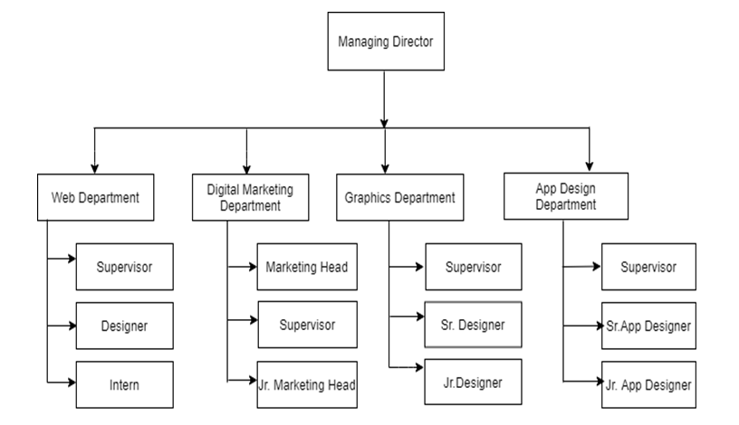

Figure 1: Organization Chart – Ombryo Lab Pvt. Ltd.

As of today, Ombryo Lab Pvt. Ltd. has a total of More than 100 employees.

## Major Function of Organization

Ombryo Lab Pvt. Ltd. is established with the objective of transforming ideas into successful business products. Ombryo Lab is a pure start-up incubation consulting and software development firm which primarily uses JavaScript & Python, and its frameworks, along with other front end and back end tools for robust web and mobile application development. The different functions and services provided by the company are listed as follows:

### JavaScript & Python Consulting Services

* + - * Business requirement analysis
      * Cloud Deployment consulting
      * Feasibility Analysis consulting
      * Solution Architecture consulting
      * Business process consulting
      * Code review consulting

### Other Services

* + - * Custom Software design and development
      * Web-based application design and development
      * Business Process Reengineering
      * Application Deployment and Migration
      * Application Customization and Feature Enhancement
      * UI/UX (User Interface/User Experience)
      * IT Support and maintenance

### Technology Used

* + - * Core Application Technologies: JavaScript & Python and its frameworks
      * Web Application Technologies: AJAX, CoffeeScript, JavaScript, JSON, jQuery, CSS3, HTML5
      * UI Frameworks: Twitter Bootstrap, Zurb Foundation, Backbone, Angular and Ember
      * Cloud Platforms: Heroku, AWS, DigitalOcean, Linode
      * Database Platforms: PostgreSQL, MySQL, MySQL Server, MongoDB, LevelDB
      * Blog/Content writing & analytics: WordPress & Analytics Plugin
      * Operating Systems: Linux, Windows, OS X
      * Testing Tools: RSpec, Cucumber, Watir, Capybara, MiniTest
      * Others: Stripe, PayPal, Checkout, Facebook API, Google Map API, CMS, Linked in API, Google API's , Twitter API

### Products Developed

* + - * Codavatar (<https://codavatar.com/>)
      * krispCall (<https://krispcall.com/>)
      * fenced.ai (<https://fenced.ai/>)
      * timeTracko (<https://timetracko.com/>)
      * OutInvoice (<https://outinvoice.com/>)

# Chapter III

# Profile of the Department Trained in

## Introduction of Department

The Search Engine Optimization department is led by Mr. Arun Chaudhary, Digital Marketing Consultant at Ombryo Lab Pvt. Ltd. The major objective of the department is to improve the visibility and reachability of client’s Web projects.

The SEO department is responsible to optimize WebPages and its contents based on keywords that are relevant to the client’s business, primarily aimed at improving the overall presence on the Internet, mainly on the Search Engine Results Pages (SERP). This department comprises of Search Engine Optimizers and SEO copywriters.

Search Engine Optimizers perform various optimization techniques for gaining better SERP rankings. These optimization techniques can be categorized into two broad categories:

* + - On-page Optimization
    - Off-page Optimization

On-page Optimization is the fundamental step in the Search Engine Optimization. It includes optimization techniques that are implemented within the website. On-page SEO is very important for better SERP rankings as well as for a successful Internet Marketing campaign. Some of the basic On-page optimization includes optimization of Titles, Meta Descriptions, URL, Image, web content, page load speed and others.

Off-page Optimization technique is implemented once the On-Page SEO is done for the website. Off-page optimization includes promotional methods that are implemented to compliment the On-page strategy for improved SERP rankings. Some of the basic Off-page optimization methods include: Link Building, Social Media, Social bookmarking, Email outreach and others.

SEO Copywriters are basically content writers who create optimized and well crafted SEO contents as instructed by Search Engine Optimizers. These contents are well formatted, easy to read & understand, as well as search engine friendly.

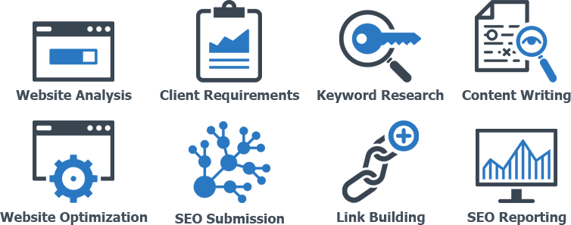

**Figure: I Basic SEO**

## Staff Scheduling

Table 4: Staff Scheduling – Ombryo Lab Pvt. Ltd.

|  |  |
| --- | --- |
| **Office Hours**: | 07:00A.M. – 03:00 P.M. |
| **Weekly Hours**: | Forty-Two Hours |
| **Weekdays**: | Sunday through Friday |
| **Weekends**: | Saturday |
| **Shift**: | Single shift as indicated by the office hour |

*As an SEO Intern, author was assigned the timing of 03:00 A.M – 15:00 P.M

## Major Function of the Department

* + - Perform SEO Audit of Ombryo Lab Pvt. Ltd. and client’s websites
    - Develop SEO strategy according to the nature of the project.
    - Ensure that all websites and internet properties under the influence of SEO department at Ombryo Lab Pvt. Ltd have been technically optimized.
    - Help set, and work to, performance indicators for SEO that everyone understands and which compliment overall marketing business objectives
    - Promote both offsite and onsite activities and also the interaction that build ranking, web presence and value added traffic.
    - Develop SEO optimized contents as required by the client.
    - Perform Social Media Optimization and develop Social Media strategy as required.

# Chapter IV

# System Used in Department and Operation

## SEO Tools and Software Used

### SEMrush

SEMrush is one of the highly acclaimed Search Engine Marketing tool available in the market. It is used for performing SEO site audit, keyword research, backlink analysis, competitor analysis and much more.

### SERPfox

It is a simple, powerful and automated search engine position tracking tool that provides service on a freemium model.

### Screaming Frog

The Screaming Frog SEO Spider allows users to efficiently and conveniently crawl, analyze and audit a website just like a web spider.

### Ahrefs for Keyword plans

Ahrefs is an SEO software suite that contains tools for link building, keyword research, competitor analysis, rank tracking and site audits. Most of the features inside of Ahrefs are designed for marketing professionals. In short: Ahrefs is a popular SEO tool that people use to get higher Google rankings.

Ahrefs is mainly used to analyze a website’s link profile, keyword rankings, and SEO health. You can also use Ahrefs to conduct keyword research for Google, YouTube, and Amazon.

### Google Search Console

Google Search Console is a free service provided by Google for Webmasters and SEO. It can be used to monitor and test different aspects of SEO. For example: create and test a robots.txt file or test and submit a sitemap.

## Hardware Equipments

### PC Configuration

* + - * RAM:8 Gigabytes
      * Processor: 8th Gen Intel core i5 processor
      * OS: 64 bit Windows 7 | 64 bit Windows 10
      * Model: Dell Inspiron N4110
      * Model: Acer E5-576G-517Z

### Network Hardware

* + - * Optical Network Unit (ONU) of Raisecom Technology Co. Ltd.
      * Optical Fiber Internet Connection (subscribed to Classic Tech)
      * Wireless Broadband Router

## Testing and Verification Methods

For SEO Testing and Verification, Google Analytics and Google Search Console (two most popular web services from Google) are used.

### Google Analytics

Google Analytics is a freemium web analytics service offered by Google that tracks and reports website traffic. Through Google Analytics, test for various SEO related aspects can be performed. For instance, popularity of a website can be determined by carefully examining the metric called ‘Bounce Rate’.

Bounce Rate basically describes the percentage of people who leave the website from the entrance page without interacting with any further WebPages. Generally, lower bounce rates are preferred.

Similarly, Google Analytics data can be used to test the effectiveness of different campaigns – paid campaigns (such as Adwords advertisement) and unpaid Campaigns (such as links from SERP pages).

### Google Search Console

Google Search Console (previously Google Webmaster Tool) is a free service by Google for Webmasters. Through Google Search Console, webmasters can perform a lot of different things. Some of them are as under:

* + - * Check search analytics (such as search queries, clicks, Impressions)
      * See backlinks to the website
      * Check index status, crawl errors, crawl stats, etc
      * Submit and Test a sitemap.
      * Write and test a robots.txt file.

# Chapter V

# SWOT Analysis

SWOT stands for Strength, Weakness, Opportunity and Threat. A SWOT analysis can be used to assess the strengths, weaknesses, opportunities and threats that are involved in an organization. Identification of SWOT is crucial as it assists in achieving the organizational goals and objectives.

An existing business can perform SWOT analysis anytime to assess the changes taking place while a new business can perform SWOT analysis as part of the planning process that helps business move on the right track right from the very beginning.

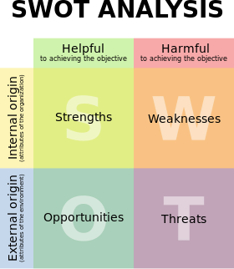

Figure 2: Representation of SWOT Analysis (Source: Wikipedia)

### Benefits of SWOT Analysis:

* Better understanding of business’ strengths and weaknesses.
* SWOT Analysis can be used to timely address the weaknesses.
* Helps capitalize on business opportunities
* Strategic advantage of strengths and make better use of opportunities.

## Strengths

Strengths are characteristics of the business or project that give it an advantage over others. The strengths of the department that the author completed his Internship included:

* + - ‘Unique’ and ‘Relevant’ contents have been published.
    - Industry Expertise.
    - Matching Domain and Brand name.
    - Daily visitors.

## Weaknesses

Weaknesses are characteristics that place the business or project at a disadvantage relative to others. The weaknesses that the author came included:

* + - Lack of proper SEO strategy.
    - Website not SEO optimized.
    - Lack of value based contents.
    - SEO department not active.

## Opportunities

Opportunities are elements that the business or project could exploit to its advantage. The opportunities of the department included:

* + - Perform On-page SEO
    - Low competition keyword targeting for quick SERP rank improvement
    - Publish value based unique and relevant contents
    - Link building
    - Social Media
    - Develop in-house SEO

## Threats

Threats are elements in the environment that could cause trouble for the business or project. The threats in the department included:

* + - Competitors have good web presence
    - Competitors have strong ‘Domain Authority’ and ‘Page Authority’
    - Competitors are well followed on Social Media
    - Competitors have SEO optimized contents
    - Competitors provide unique and value based contents
    - Well established in the industry

# Chapter VI

# Intern Activities

## SEO Analysis

SEO analysis uncovers different aspects of optimization that can be used to improve website’s SERP rank on popular search engines such as Google, Bing, Yahoo, etc. SEO analysis was core part of author’s intern activities. Under SEO analysis, author was involved in the following activities:

### Website Analysis

Website analysis included analysis of

* + - * Pages Title
      * Meta Description
      * Code-to-Text ratio
      * Page load speed
      * Sitemap
      * Duplicate content
      * Backlink analysis
      * follow and no-follow links

Tools such as Site-analyzer, PageSpeed Insights, and Siteliner were used.

### Competitor Analysis

Competitor analysis is the analysis of competitors in the same niche. Niche is basically a topic that can be targeted. For example, Search Engine Optimization can be a particular niche. Websites targeting the same keyword are competitors to each other.

Competitors can be SEO competitor (websites fighting for top SERP ranking) or Business competitors (competitors providing similar services or products). An example of an SEO competitor can be a blog about **Search Engine Optimization Tips** whereas a business competitor can be a direct market competitor providing Search Engine Optimization consulting and services**.**

Top five SERP results for the defined keywords were identified as SEO competitors. Tools such as **Buzzsumo**, **SEMrush**, and **Siteliner** were used for competitor analysis.

## Keyword Research

After the SEO analysis was completed, author was involved in Keyword Research which is one of the crucial activities in Search Engine Optimization. Keyword Research involves identifying sets of keywords that are used in optimization. From the bucket list of keywords provided, author performed keyword research using a popular tool called **Google Adwords Keyword Planner**.

Keyword research involves a great deal of time and effort. And, a lot has to be focused on the **competition** (low, medium or high) and **search volume** (average monthly searches). Since author was involved in a startup project, and the market competition for the niche was really high, initially, the keyword research focused on low competition keywords with more than 100 average searches per month.

## Content Research

Author performed content research based on keywords that were to be targeted and optimized. It included finding relevant contents that received the most engagement (likes and shares) on social media. Buzzsumo was used for content research particularly for finding the most engaging content over the past one year or so.

## Content Creation and Optimization

There is a popular saying: Content is King. Search Engines especially Google places a lot of weightage on contents. Not just random contents but to those contents that provide value to their readers. Author created few contents that included keywords (researched earlier) in strategic places such as the URL, Title, Meta Description, and Headings. **Headline Analyzer** by **Coschedule** was used to create catchy and better headlines.

## Title and Meta Description Optimization

Using a popular WordPress Plugin named Yoast SEO, author optimized the title and Meta descriptions for every pages. As per standard, the length of the title and Meta description were kept under 70 and 150 characters respectively.

Page title and Meta descriptions have strategic importance. Both of them appear in the SERPs. Optimized Page title is one of the many ranking factors in Google. While Meta descriptions aren’t a direct ranking factor, well written Meta descriptions can dramatically increase the click through rate of websites.

## Image Optimization

As part of the on-page optimization, author performed image optimization.

Image Optimization included the following:

* + - Every image file was provided with an SEO friendly name.
    - Each image was re-sized prior to the upload.
    - Optimized alternative text was written.
    - Descriptive captions were provided to the images as far as practicable.

The alternative text is a crucial part of ‘Image Optimization’. It tells search engines what the image is about. Moreover, alternative text also comes handy if and when the image gets corrupted. And, the text in the alternative text is used by programs such as screen readers for visually impaired readers.

## Off-page Optimization

The author performed basic off-page optimization strategies such as Search engine submission, Social Bookmarking, Directory submission, Email outreach, Blog commenting and Social Media.

## Case Study

The author did a case study on one of the host company’s product named krispCall.com – a virtual cloud telephone system for business.

## Social Media Optimization

The author performed SMO (Social Media Optimization) on three different social networking platforms namely Facebook, Twitter and Google+. As part of the SMO, author was responsible for creating a Social Media strategy. It included maintaining a weekly routine for posting on social media, finding buzzing and relevant contents, and engaging with audiences.

## Monitoring and Reporting

Author performed SEO monitoring using **Google Analytics** and **Google Search Console**. Monitoring basically focused on four major aspects:

* + - **Audience** (the visitors)
    - **Acquisition** (how did the visitors come),
    - **Behavior** (what did the visitors do)
    - **Search Analytics** (Click through Rate, Average position in the SERPs).

For Social Media Monitoring, different tools were used. Sprout Social, Mention, Twitter Analytics to name a few. Weekly report was submitted to the Intern Supervisor.

## Customer Communication

Effective and regular communication with the customer is important in order to provide a top level of customer service. How an organization communicates with their customers can make a world of difference in gaining, retaining or losing them to the competitors. Organizations must also ensure that they are communicating the right message with the right customer.

Customer Communication is a major responsibility. Given author’s position as an SEO trainee, author was understandably not part of direct communication with the client. The communication involved senior staff from the department and the clients that mostly took place over the Internet via emails and Skype.

# Chapter VII

# An Assessment of the Internship

## Learn from the Internship

The three months long internship program at Ombryo Lab Pvt. Ltd. was author’s first exposure in an IT company. Prior to that, author had no any experience working in a real world scenario. Author was lucky to be around very passionate, experienced and vibrant team at Ombryo Lab Pvt. Ltd., who all have enjoyed several years of experience in the business.

In those eleven weeks, the author believes to have developed several interpersonal and professional skills that will have a huge impact in the forthcoming days.

### Work in a Corporate Environment

The internship program presented author with the opportunity to work in a real world working scenario and experience the workplace culture and tradition.

### Team Work and Collaboration

Team work and collaboration is vital in context of an organization. The author experienced how a project is completed with the combined efforts of all the group members. Additionally, author came across several project management tools (like Slack) for collaboration in the group project.

### Working Mechanism of Search Engines

Good understanding of how search engines work is extremely important for the proper functioning of SEO. The internship program helped author become well versed in the working mechanism of search engines which majorly includes deploying of web spider, crawling, indexing, encoding, relevancy and ranking and serving the results though SERPs.

### Finding Keywords for SEO Campaign

Keyword research is an important part of SEO process. But, what’s more important is finding the right keywords. During the internship, author found out that the only way of finding the right keywords is research and some more research.

### Create SEO Optimized Contents

One of author’s major tasks during the internship was SEO copywriting. While very poor in the beginning, author has had an improvement in his copywriting skills. And, the author solely credits his Intern supervisor for constant support and guidance (and occasional rebukes).

### Use Different SEO Tools

During the course of the Internship author learnt his way across several SEO tools. While not every tool was easy to begin with, but strong desire and sheer willpower has made the author used-to with several SEO tools available in the market.

### Monitor, Analyze and Test SEO Results

Author learnt that a successful SEO is all about data and analytics. Timely monitoring, analysis and tests must be performed to ensure each data is properly measured, and necessary measures are taken.

## Challenges

The different challenges faced by the author during the course of Internship at Ombryo Lab Pvt. Ltd. included the following:

### A New Routine

Author had to adjust to the new routine and new lifestyle. For, the first couple of days, author found it extremely difficult being surrounded by strange people and sitting in front of a laptop for Six to Seven hours straight.

### Identity

In the beginning, author’s position wasn’t clear to most of the employees in the host company. On multiple occasions, author was mistaken for a content writer.

### Not Enough Work

The main reason author joined the Internship was to gain valuable work experience but at times author felt extremely dejected and frustrated with lack of relevant work opportunities, opportunities that added value to both the company and the author.

### Not Enough Direction

Occasionally, author was presented with unclear assignments to which he had absolutely no clue. Author’s reluctance to ask questions made the matter worse.

### Not Enough Feedback

Author lacked timely feedback from the supervisor and other staffs of the host company. Author believes weekly meetings with the supervisor would have helped foster the overall growth.

# Chapter VIII

# Conclusion

## Summary

The internship program has been an excellent and rewarding experience for the author. It has provided author with the opportunity to develop understanding of real world working environment as well as establish network contact with different personnel from the IT industry.

The author has gained valuable insights into the dynamic field of Search Engine Optimization. SEO is generally seen as a small phase in the web development technologies. But during this internship, the author learnt that SEO is in itself a vast field which can be considered a potential career choice.

Last but not the least, the internship has made one thing very clear to the author and that is there is no such thing as an overnight success when it comes to SEO. It is a slow process but done the right way the fruit it bears is really sweet.

## Recommendations

### Paid Internship

Students consider various factors (such as company reputation, work experiences offered) for an Internship program. Among them is the opportunity for a ‘paid internship’. The number of companies that pay their interns are on the rise. Paid internship programs boost performance and elevate commitment levels, eventually getting more out of interns.

### Team of SEO Experts

In a world dominated by digital technologies, blend of experienced and fresh SEO team can greatly influence company’s reach to the outside world. As SEO is organic way of increasing visibility, having a dedicated team of SEO experts will only help the company get more prospective customers.

* + 1. **SEO Friendly Website**

Website is the easiest way to establish an online presence. Website can be considered as a gateway to the customers. Speaking of which, the current krispCall’s (one of the Product of Ombryo Lab) website is not fully SEO optimized. The company is potentially losing out on a number of prospective customers as the company cannot be easily discovered on search engines (major source for website traffic).

### Regular Contents

Given the work force and time commitment, preparing content on a daily basis is not possible. But, creating one or two value added contents every week and posting it on the company’s website can be a great way to move higher in the SERPs.

### Weekly Meeting Session

Weekly meeting session is a weekly program conducted at Ombryo Lab at the end of the Week. The main objective of this, is to promote idea sharing and foster personal and professional development. Author provides following suggestions for improving the Weekly meeting session:

* Maintain a regular schedule such as regular date and time.
* Decide on topics and prepare presentations in advance.
* Keep it relevant (but off topics won’t hurt).
* Get creative with practical solutions to the aroused issue in works.

# Bibliography

*Challenges faced by interns*. (n.d.) retrieved March 2020, from Hubpages: https://toughnickel.com/business/Challenges-faced-by-interns-Problems-commonly-found-in-internships

*Common Challenges for Interns*. (n.d.) retrieved March 2020, from Georgia College Career Center: https://gcsucareercenter.wordpress.com/2011/06/13/common-challenges-for-interns/

*Google Analytics - Wikipedia*. (n.d.) retrieved February 2020, from Wikipedia: https://en.wikipedia.org/wiki/Google_Analytics

*How Internet Search Engines Work*. (n.d.) retrieved February 2020, from HowStuffWorks: https://computer.howstuffworks.com/internet/basics/search-engine1.htm

Beginner’s Guide to SEO. (n.d.) retrieved February 2020, from moz.com: https://moz.com/beginners-guide-to-seo

On Page SEO. (n.d.) retrieved March 2020, from- moz.com: https://moz.com/blog/category/on-page-seo

Technical SEO. (n.d.) retrieved April 2020, from backlinko.com: https://backlinko.com/technical-seo-guide

Screaming frog tutorial. (n.d.) retrieved April 2020, from seerinteractive.com: https://www.seerinteractive.com/blog/screaming-frog-guide/#:~:text=Upon%20clicking%20on%20any%20individual,directives%20used%20on%20those%20links

Search Engine Page Result (SERP). (n.d.) retrieved March 2020, from mailchimp.com: https://mailchimp.com/en-gb/marketing-glossary/serp/#:~:text=A%20search%20engine%20results%20page%2C%20or%20SERP%2C%20is%20the%20page,on%20their%20features%20and%20algorithms

*SWOT Analysis - Community Tool Box*. (n.d.) retrieved February 2020, from Community Tool Box: https://ctb.ku.edu/en/table-of-contents/assessment/assessing-community-needs-and-resources/swot-analysis/main

*SWOT analysis - Wikipedia*. (n.d.) retrieved February 2020, from Wikipedia: https://en.wikipedia.org/wiki/SWOT_analysis

*What Is a SWOT Analysis?* (n.d.) retrieved February 2020, from Bplans: Business Planning Resources and Free Business Plan Samples: https://articles.bplans.com/swot-analysis-identify-your-strengths/?_ga=2.21526460.60900650.1658312357-2029824757.1658312357&_gl=1*oi8gwm*_ga*MjAyOTgyNDc1Ny4xNjU4MzEyMzU3*_ga_6ZRJ6CFEQQ*MTY1ODMxMjM1Ny4xLjEuMTY1ODMxMzY0OS41OA..

# Appendices

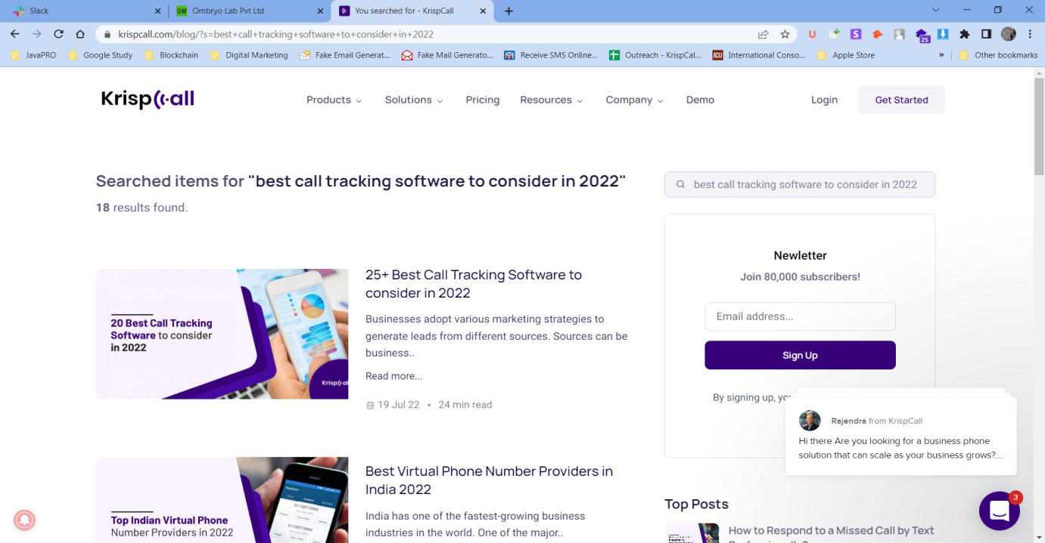

Figure 3: Front-end view of krispCall.com

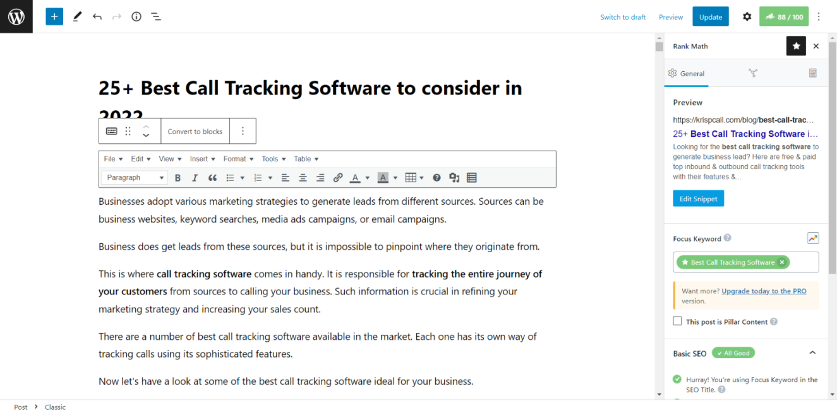

Figure 4: Content Backend view – krispCall.com

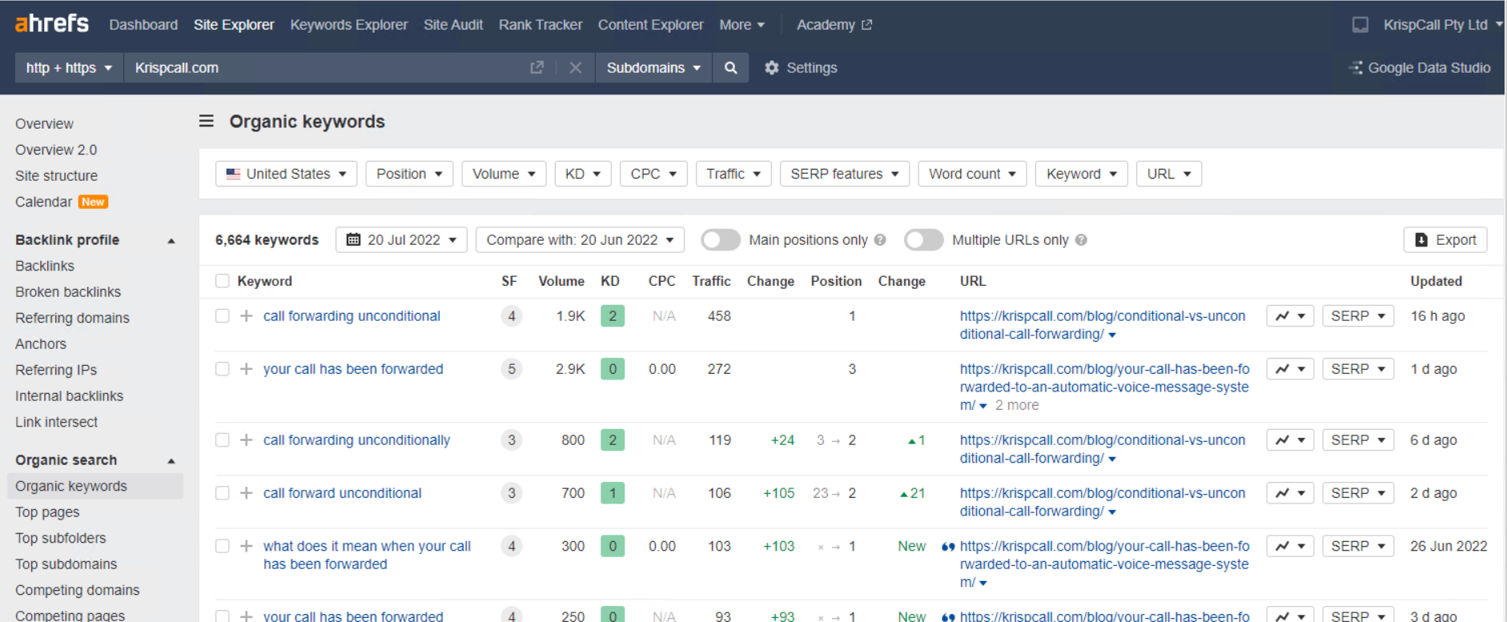

Figure 5: KrispCall organic Keywords

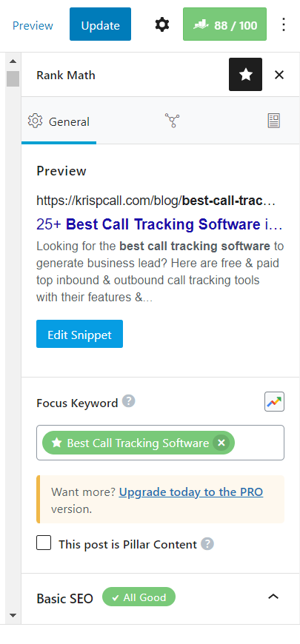

Figure 6**: Meta tag (focused keywords)**

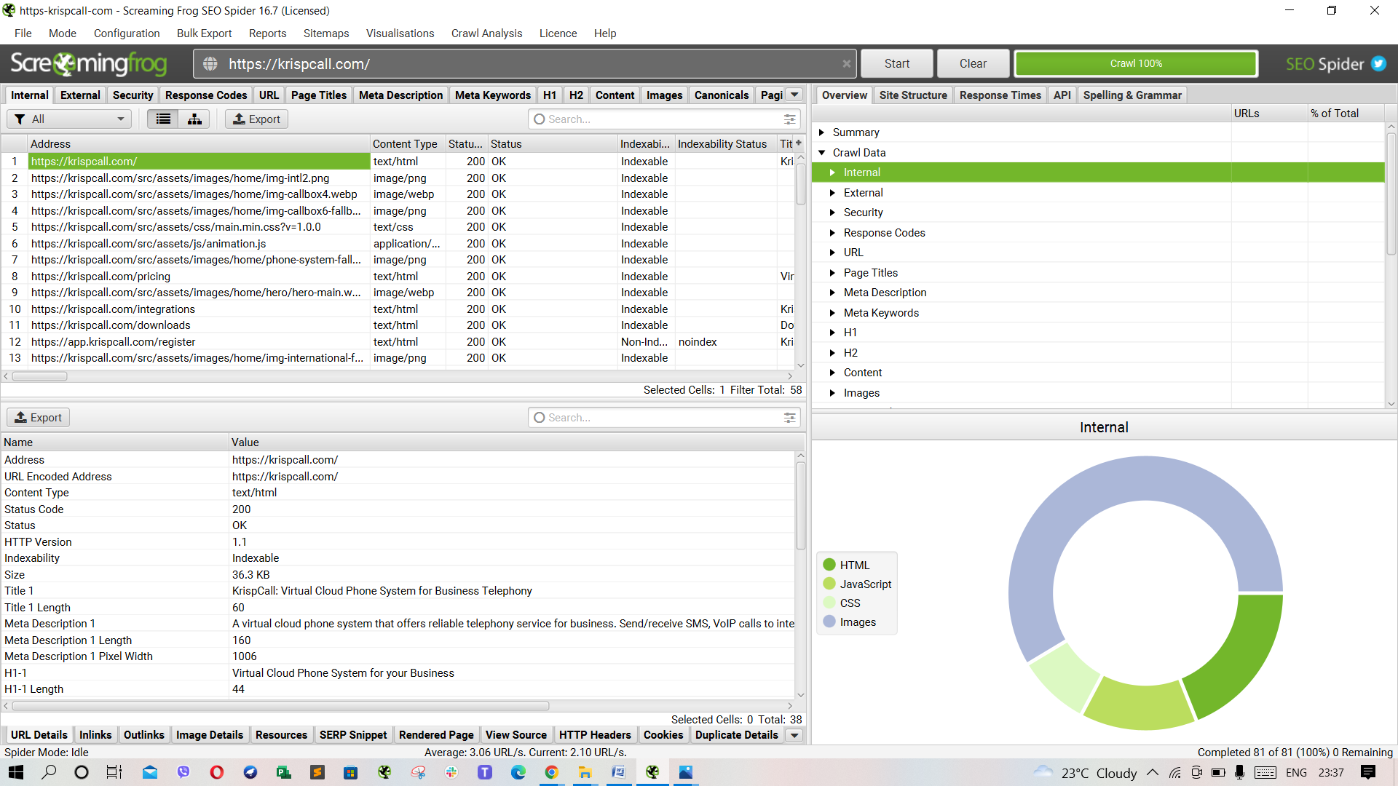

Figure 7: Screaming Frog SEO Spider

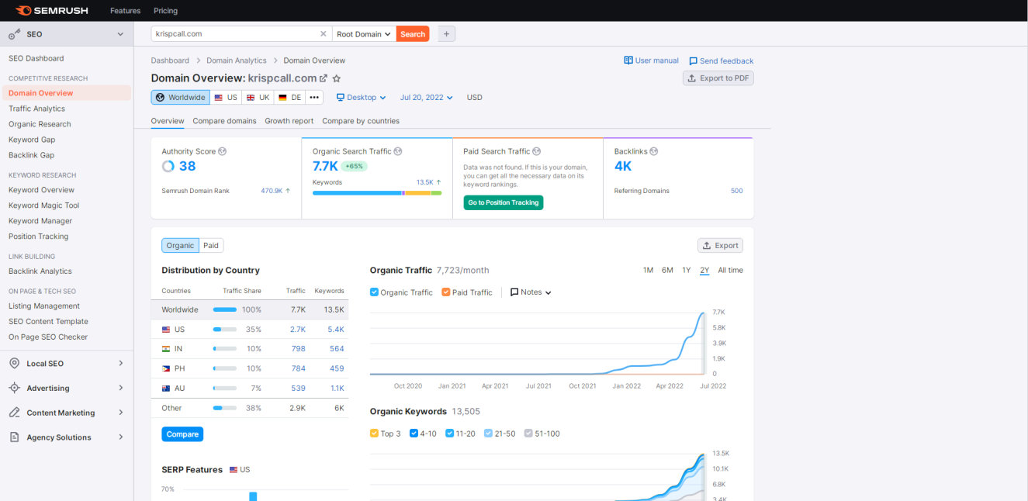

Figure 8: SEMrush Dashboard

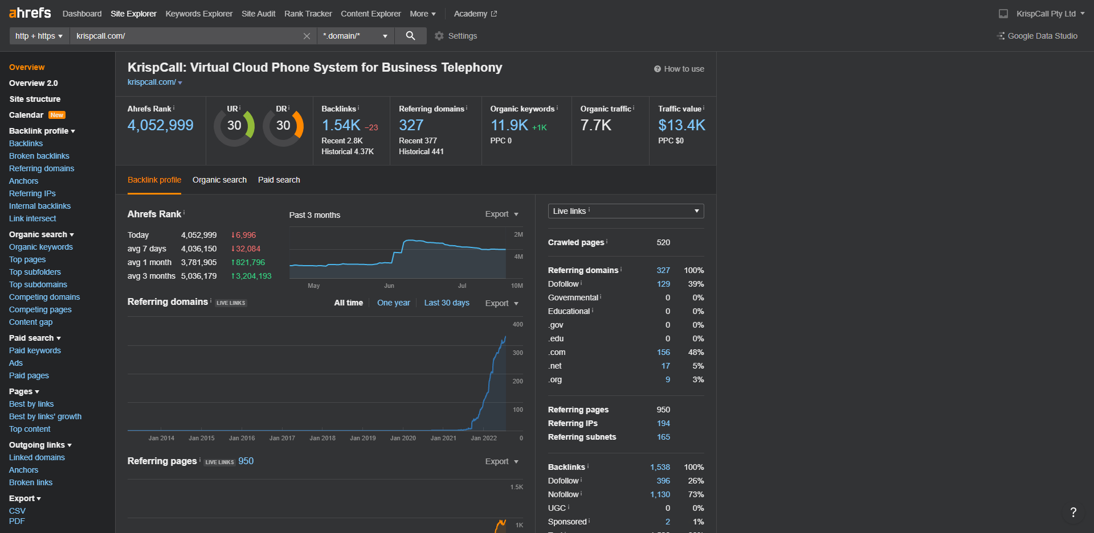

Figure 9: Ahrefs Dashboard- krispCall.com

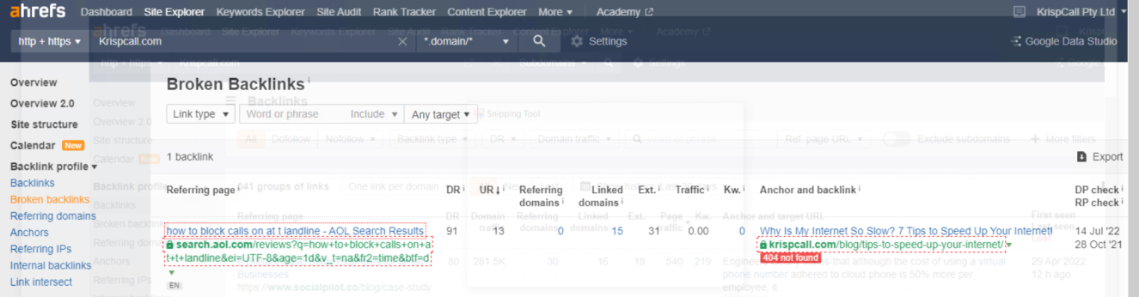

Figure 10: Analysis of broken links using Ahrefs-krispCall.com

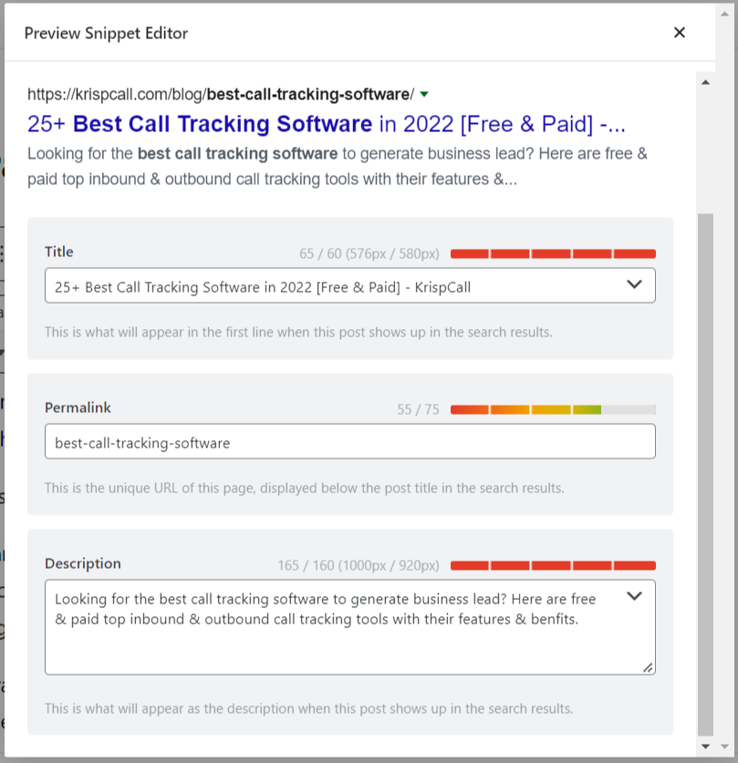

Figure 11: Title and Meta Description Optimization

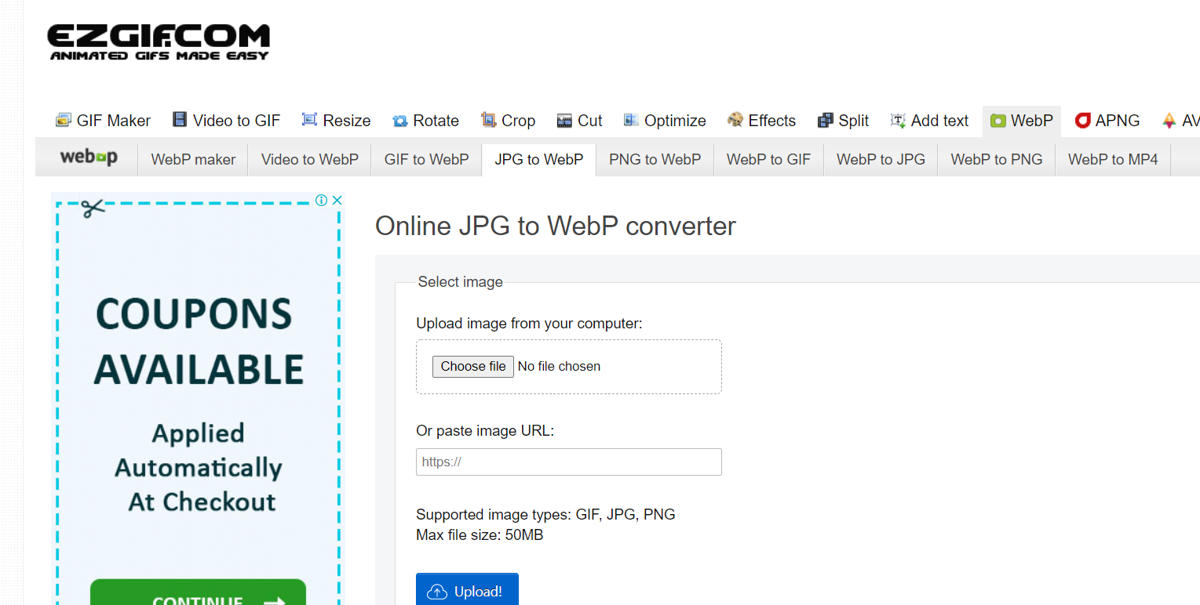

Figure 12: Image Optimization – krispCall.com

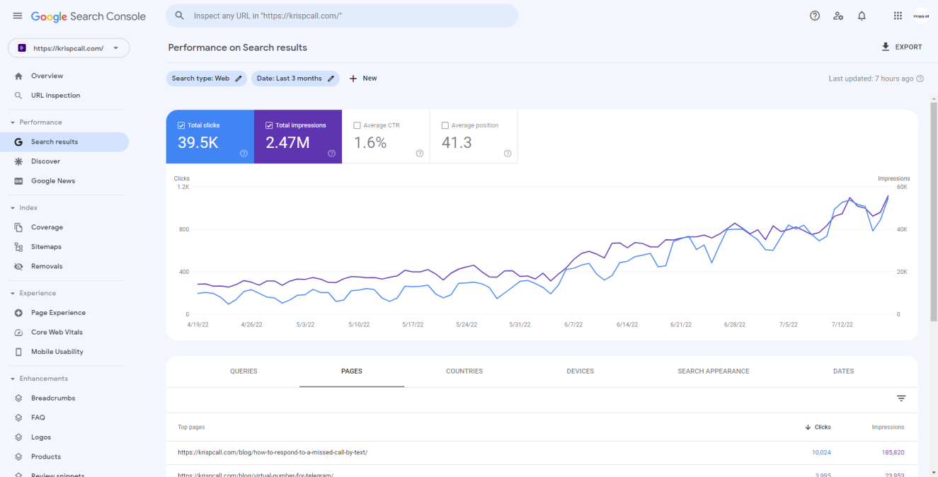

Figure 13: Google Search Console

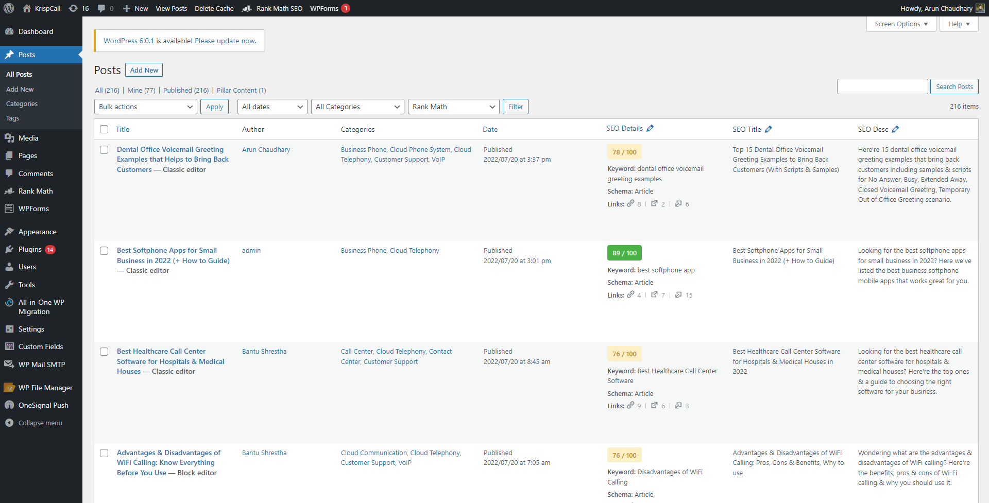

Figure 14: WordPress Dashboard – krispCall.com

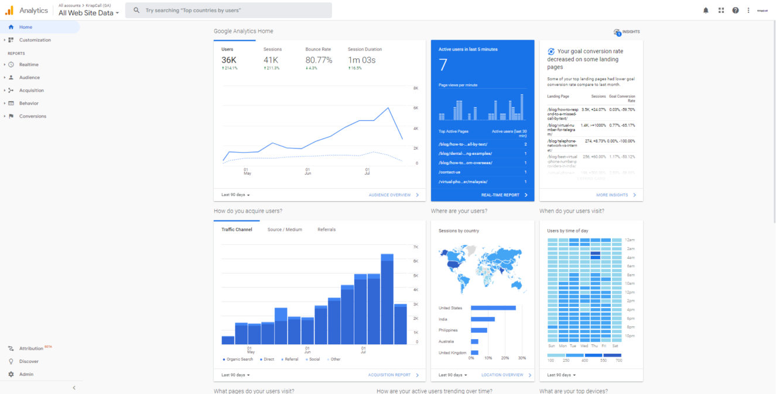

Figure 15: Audience Growth using Google Analytics- krispCall.com