## horizontal line



ADSA-Assignment

15.08.2016

**Insertion Sort**

Krima Doshi

ICT Semester 5

1401035

# Goal

To study the complexity of Insertion sort on different computers, proving that the complexity is dependent on the number of cores of the laptop, version of the laptop, software utilized and the algorithm used.

# Code

# 

# 

# 

# Specifications

Processor: intel Centrino

Programming Language Used: Java

# Analysis

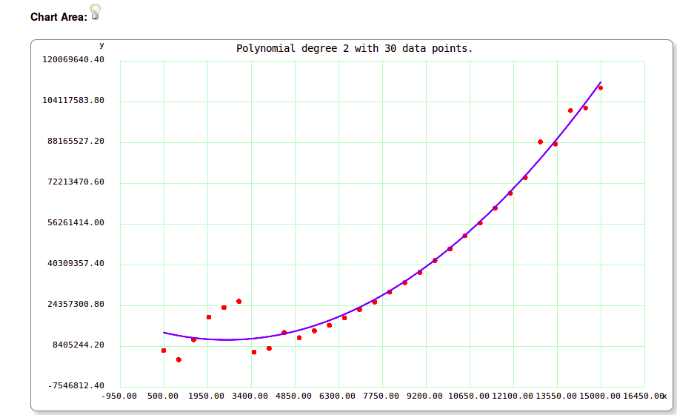

|  |  |
| --- | --- |
| **No. of elements** | **Time (in Nanoseconds)** |
| 500 | 6672217 |
| 1000 | 3087892 |
| 1500 | 10941335 |
| 2000 | 19720664 |
| 2500 | 23497052 |
| 3000 | 25888627 |
| 3500 | 6052585 |
| 4000 | 7493970 |
| 4500 | 13691336 |
| 5000 | 11637024 |
| 5500 | 14401902 |
| 6000 | 16552734 |
| 6500 | 19420626 |
| 7000 | 22701490 |
| 7500 | 25669046 |
| 8000 | 29545098 |
| 8500 | 33232299 |
| 9000 | 37223798 |
| 9500 | 41864821 |
| 10000 | 46431044 |
| 10500 | 51594690 |
| 11000 | 56550767 |
| 11500 | 62389289 |
| 12000 | 68200293 |
| 12500 | 74306376 |
| 13000 | 88323872 |
| 13500 | 87473693 |
| 14000 | 100581226 |
| 14500 | 101560750 |
| 15000 | 109434936 |

**f(x) = (1.5222180906403895e+007 * x^0 + -3.3868475979381692e+003 * x^1 + 6.5443388316383178e-001 * x^2) * e-009**on testing uptil 15000 starting from 500 with increment of 500.