**Software Requirement Specification**

**Project:** *Coca-Cola Warehouse Point of Sale System for Coca-Cola Company*

**Developer:** *Francis Nico Y. Abdon | BSCS-3A | PRMSU*

1. **Introduction**
   1. **Purpose**

**This section should describe the purpose of the document and the software that will be developed. It should also include a brief overview of the key features and functionality of the software.**

*The purpose of this Software Requirement Specification (SRS) document is to describe the requirements for developing a point-of-sale system for Coca-Cola warehouse. The software is intended to provide an efficient and user-friendly interface for managing sales, inventory, and employee information. It also aims to improve the overall customer experience and ensure that transactions are processed securely and accurately.*

* 1. **Scope**

**This section should define the scope of the project, including the features and functionality that will be included in the software. It should also describe any constraints or limitations that will impact the development of the software.**

*The software will include several forms, such as login and welcome page, verification form, user registration form, stocks registration form, cashier page, reports page, and main page. The software will be developed* ***using VB.NET2010, MSACCESS, MS EXCEL, CRYSTAL REPORTS and SQL technologies****. The system will be able to register products, track inventory, calculate sales, generate reports, and manage employee information. The software will also have pleasing photos, colors, fonts, and icons, as well as secured data.*

* 1. **Definitions, Acronyms, and Abbreviations**

**This section should include any relevant definitions, acronyms, or abbreviations that will be used in the document.**

* *SRS: Software Requirement Specification*
* *POS: Point of Sale*
* *CRUD: Create, Read, Update, and Delete*
* *UI: User Interface*
* *UX: User Experience*
* *SQL: Structured Query Language*
* *VB.NET2010: Visual Basic .NET 2010*
* *CR: CRYSTAL REPORTS*

1. **General Description**
   1. **Product Perspective**

**This section should describe how the software will fit into the larger system or environment in which it will be used. It should also describe any interfaces or dependencies that will impact the development of the software.**

*The software will be a standalone system that will be used within the Coca-Cola warehouse. It will be integrated with the existing inventory and employee management system of the company. The software will be used by employees with different access levels, such as managers with admin access and cashiers and stocks with user access.*

* 1. **Product Features**

**This section should provide a detailed description of the key features and functionality of the software.**

* ***Login and welcome page****: The page should include username, password, register now, show/hide password, and forgot password, and time feature.*
* ***Verification form****: The form should prompt a unique set of codes that only an admin has access to.*
* ***User registration form****: The form should include uploading a display profile photo, creating a unique employee ID, password and retype password, position (manager, cashier, stocks), and display registered, updated, and current employees.*
* ***Stocks registration form****: The form should include CRUD functionality, barcode, item name, description, quantity, buy and sell price, and critical (alerts if low on stock).*
* ***Cashier page****: The page should easily perform calculations for the customer, display the current cashier, include the current date and time, discounts and coupons, and provide superb payment processing.*
* ***Reports page****: The page should provide sales, inventory, employee, and customer reports and data analysis of the company with the use of Microsoft Excel and Crystal Reports.*
* ***Main page****: The page should provide choices for what page to go and have an excellent UI and UX providing real date and time feature.*
  1. **User Characteristics**

**This section should describe the target audience for the software, including their technical knowledge and any specific requirements or preferences they may have.**

*The target audience for the software is employees of the Coca-Cola warehouse. They should have basic technical knowledge and be familiar with the existing inventory and employee management system of the company. The software should be easy to use and navigate.*

1. **Specific Requirements**
   1. **Functional Requirements**

**This section should provide a detailed description of the functional requirements for the software, including any specific features or functionality that must be included.**

1. *The functional requirements of the software are as follows:*

***Form 1 - Login and Welcome Page:***

* *The form should have a field for entering a valid username and password.*
* *The form should have show/hide password feature.*
* *The form should provide a register now and forgot password option.*
* *The form should display a welcome message after successful login.*
* *The form should have validation for the username and password.*
* *The form should display the accurate complete date and time of the day.*

***Form 2 - Verification Form:***

* *The form should display a unique set of codes that only admin can access.*
* *The form should be accessible only by an authorized user.*
* *The form should be accessible to HR Manager with User Registration access.*

***Form 3 - User Registration Form:***

* *The form should allow the employee to upload a display profile photo.*
* *The form should generate a unique employee ID.*
* *The form should allow the employee to create and confirm a password.*
* *The form should provide different position options (Manager, Cashier, Stocks) with different access levels.*
* *The form should display the registered, updated, and current employees with their details.*
* *The form should have shortcut keys for easy access.*

***Form 4 - Stocks Registration Form:***

* *The form should have CRUD functionality.*
* *The form should allow the user to register different product varieties with details such as barcode, item name, description, quantity, buy and sell price, and critical (alerts if low on stock).*
* *The form should display official products of the company.*

***Form 5 - Cashier Page:***

* *The form should display the current cashier.*
* *The form should display the current date and time.*
* *The form should have discounts and coupons.*
* *The form should have superb payment processing.*
* *The form should be user-friendly, efficient, and secure.*
* *The form should handle transactions, manage inventory, and track sales within the day, weeks, months, and years.*

***Form 6 - Reports Page:***

* *The form should display sales, inventory, employee, and customer reports.*
* *The form should provide data analysis of the company.*

***Form 7 - Main Page:***

* *The form should provide choices of pages to access.*
* *The form should only display depending on the employee’s privilege.*
* *The form should be user-friendly and have excellent UI and UX.*

***Other Functional Requirements:***

* *The system should be able to handle concurrent users.*
* *The system should validate input data and display appropriate error messages.*
* *The system should have data backup and restore features.*
* *The system should provide data export to various formats such as Excel, CSV, and PDF.*
* *The system should provide data search and sorting functionalities.*
  1. **Non-Functional Requirements**

**This section should describe any non-functional requirements for the software, including performance, security, and usability requirements. (Use ISO 25010:2011 Software Quality Metrics).**

* ***Performance:*** *The software should be fast and responsive.*
* ***Security:*** *The software should be secure and protect customer and employee information.*
* ***Usability:*** *The software should be easy to use and navigate.*
* ***Maintainability:*** *The software should be easy to maintain and update.*
* ***Reliability:*** *The software should be reliable and accurate.*
* ***Compatibility:*** *The software should be compatible with existing systems and technologies.*
* ***Scalability:*** *The software should be scalable to accommodate increasing demands and a growing user base.*
* ***Accessibility:*** *The software should be accessible to users with disabilities.*
* ***Portability:*** *The software should be portable across different platforms and devices.*
* ***Data Integrity:*** *The software should ensure the accuracy and consistency of data.*
* ***Error Handling:*** *The software should handle errors gracefully and provide helpful error messages to users.*
* ***Backup and Recovery:*** *The software should have a backup and recovery system in place to prevent data loss in case of system failures or errors.*
* ***Performance Efficiency:*** *The software should be able to handle a large volume of transactions efficiently without any significant delays or system crashes.*
* ***Interoperability:*** *The software should be able to work seamlessly with other systems and technologies.*

1. **Appendices**

**This section should include any additional information that is relevant to the software requirement specification, such as diagrams, flowcharts, or mockups.**

*Appendix A: Use Case Diagrams*

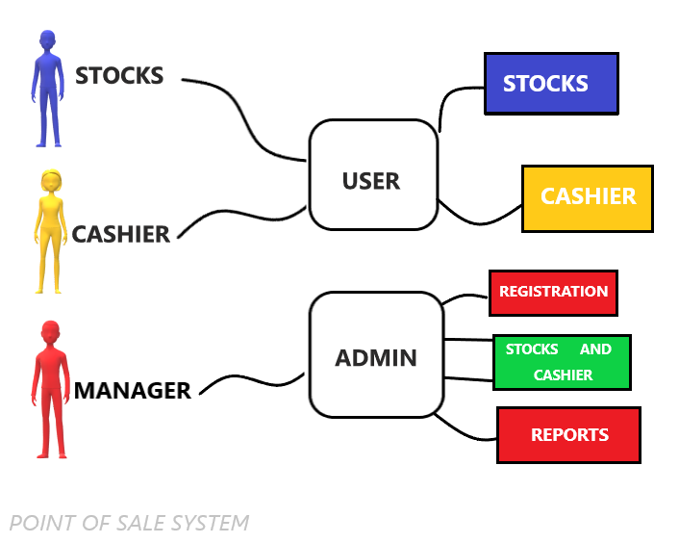

*Appendix B: Sequence Diagrams*

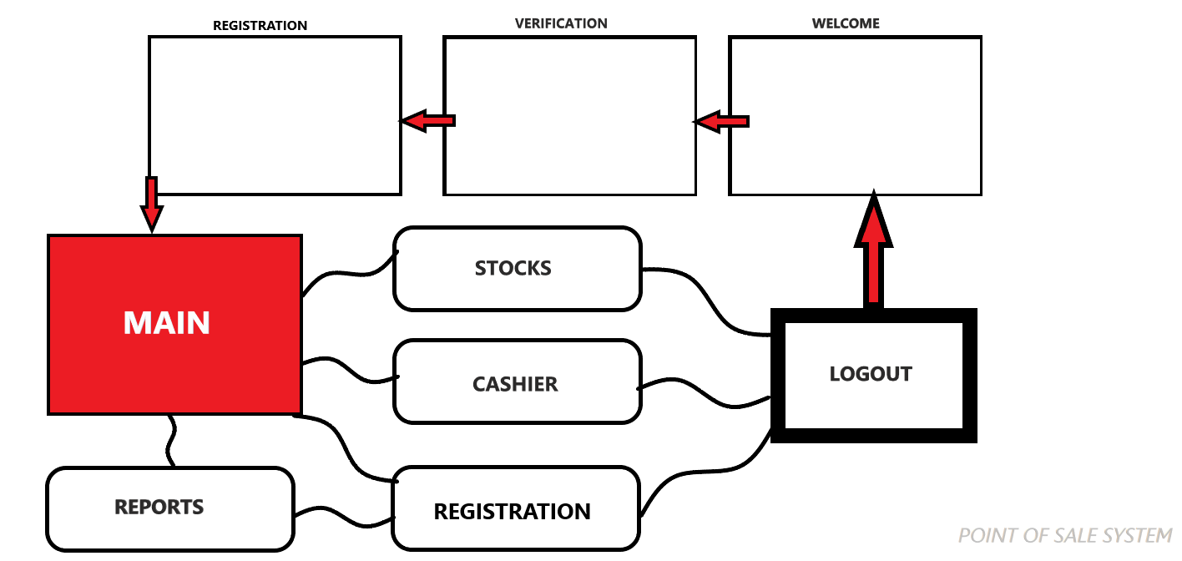

*Appendix C: Class Diagrams*

Class Diagram Description:

**1.Employee:**

* Attributes: employeeID, position, username, password
* Operations: register(), update(), delete(), login(), logout()

**2. Cashier:**

* Inherits from Employee
* Operations: processSale(), applyDiscount()

**3. Stock:**

* Attributes: barcode, itemName, description, quantity, buyPrice, sellPrice
* Operations: addStock(), updateStock(), deleteStock()

**4.Manager:**

* Operations: generateSalesReport(), generateInventoryReport(), generateEmployeeReport(), generateCustomerReport()

**5. Point of Sale System:**

* Attributes: employees, stocks, reports, managers
* Operations: login(), logout(), registerEmployee(), updateEmployee(), deleteEmployee(), addStock(), updateStock(), deleteStock(), processSale(), generateSalesReport(), generateInventoryReport(), generateEmployeeReport(), generateCustomerReport()

*Appendix D: User Interface Mockups*

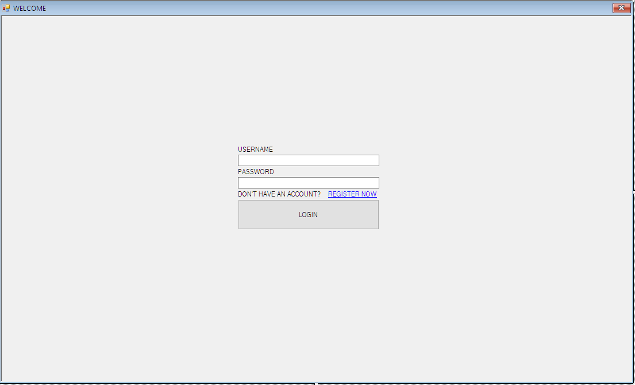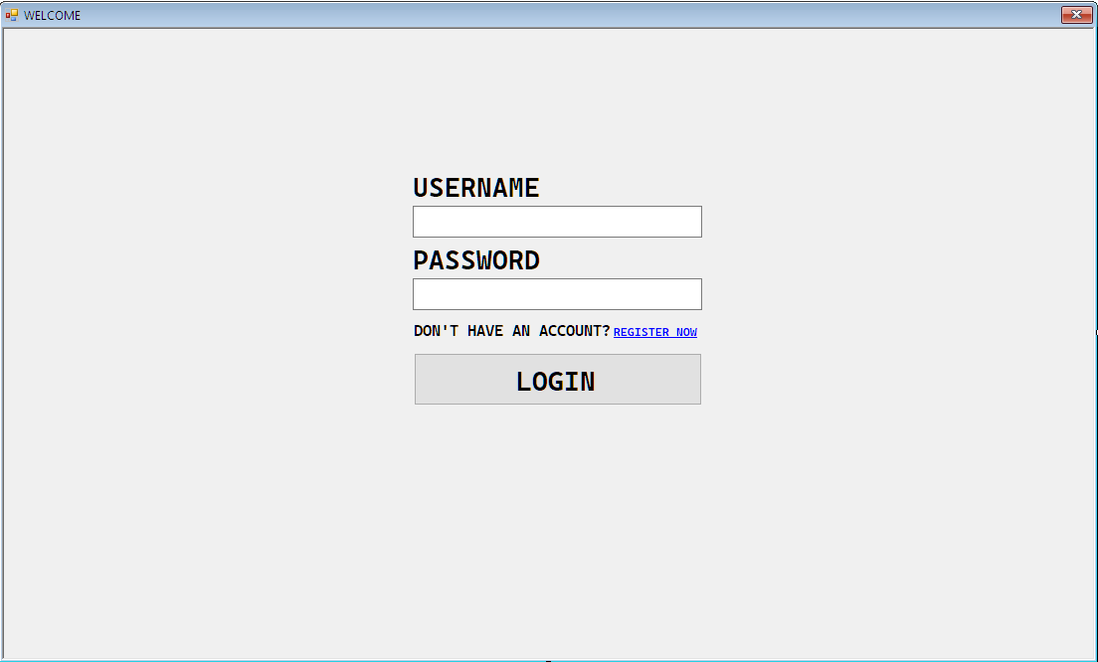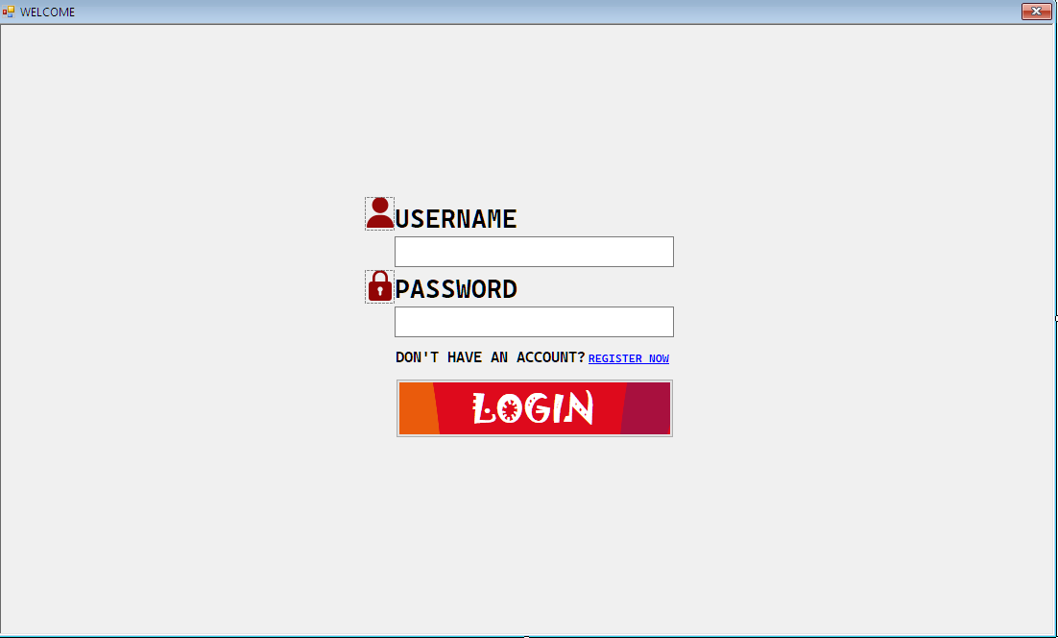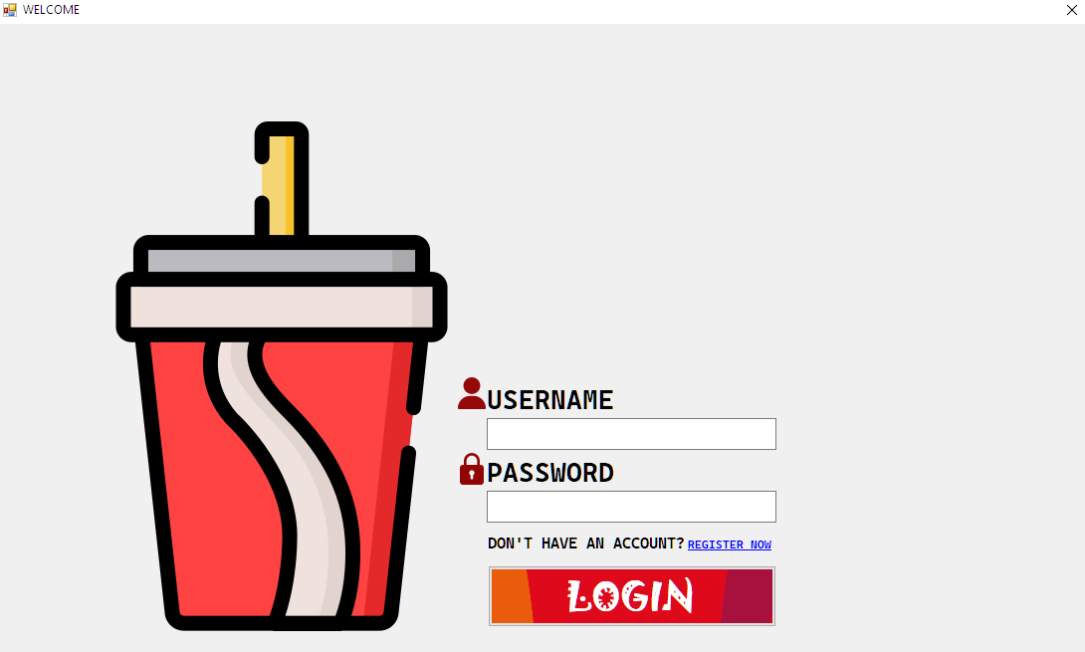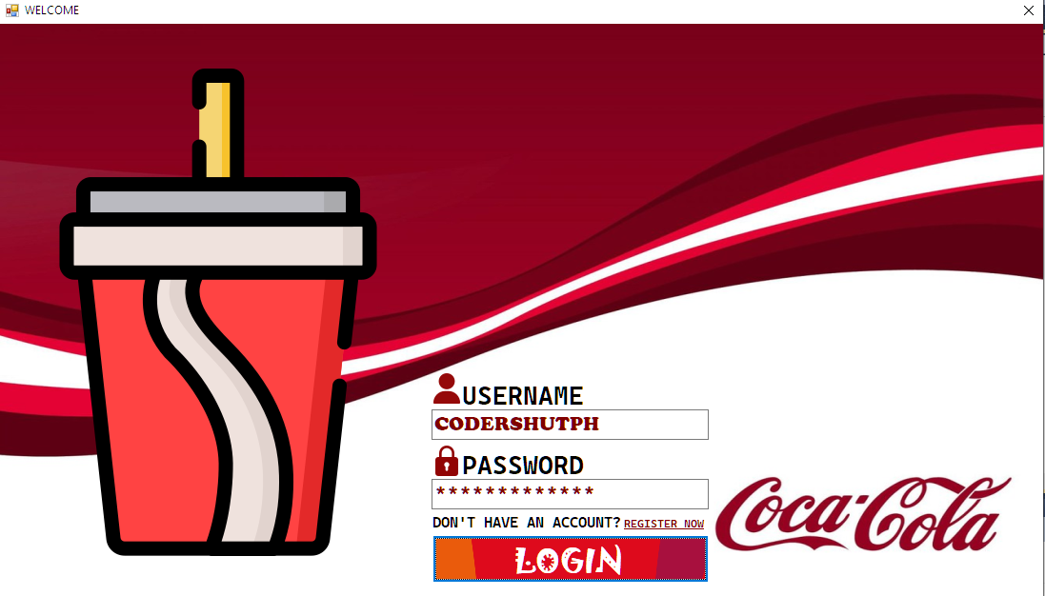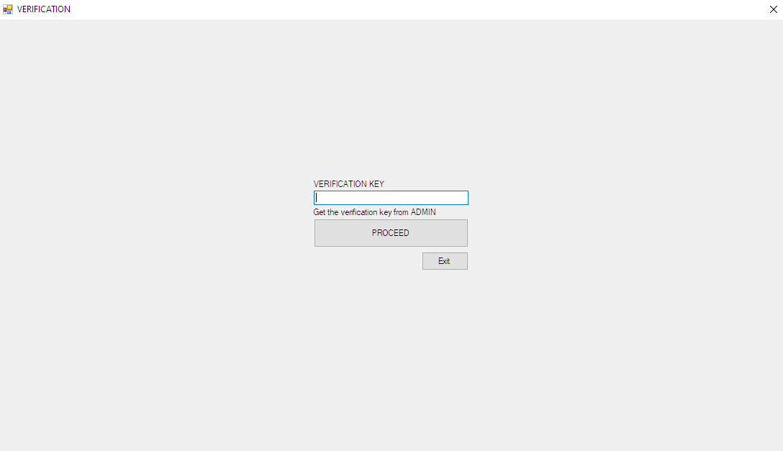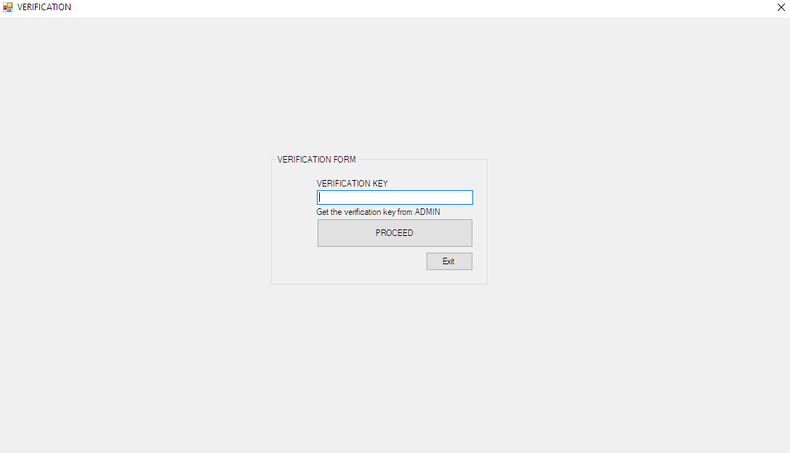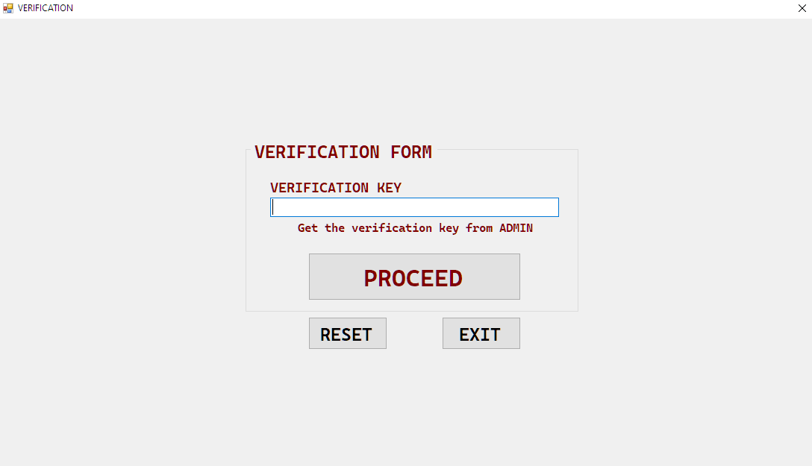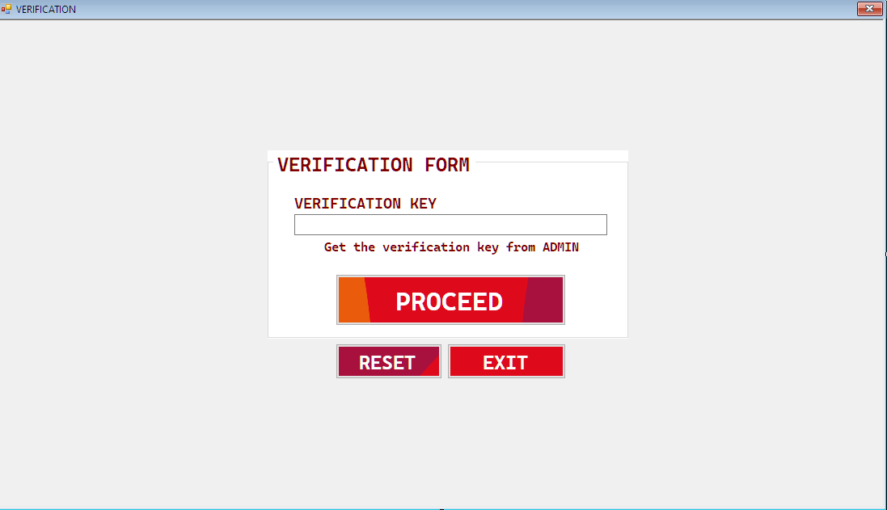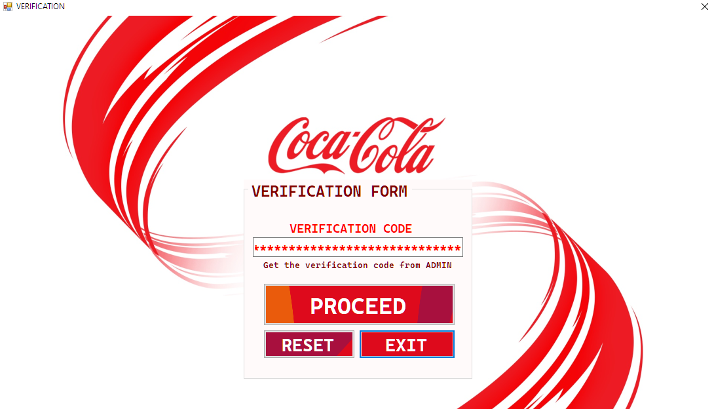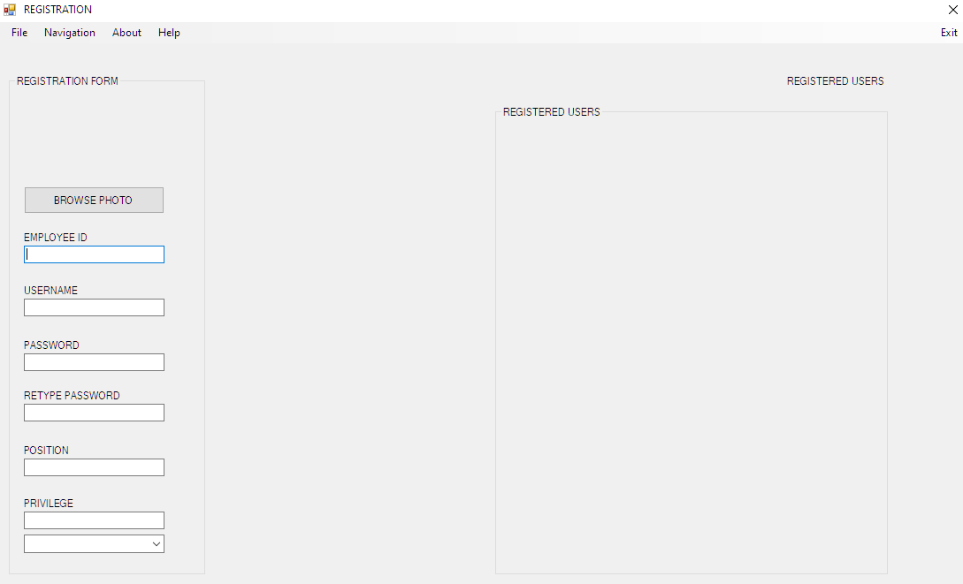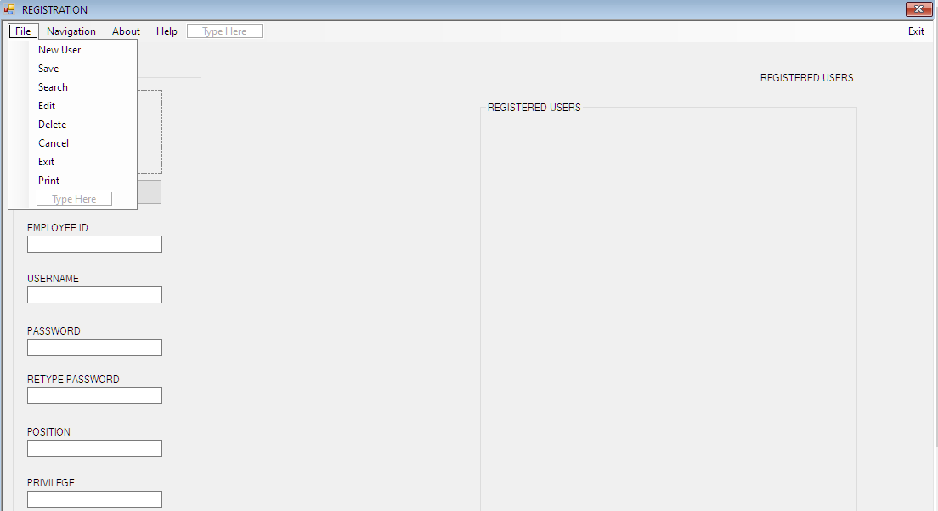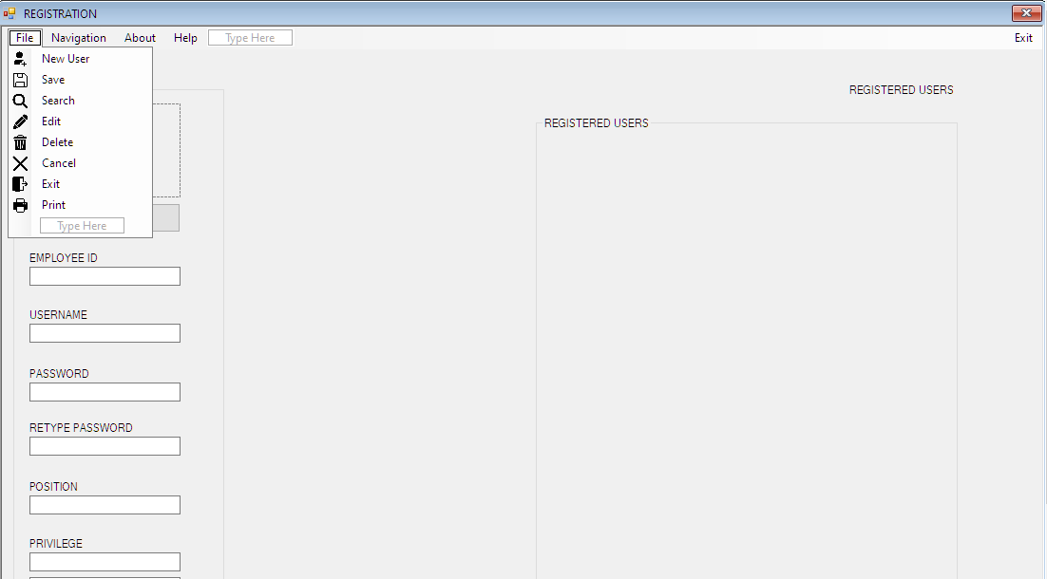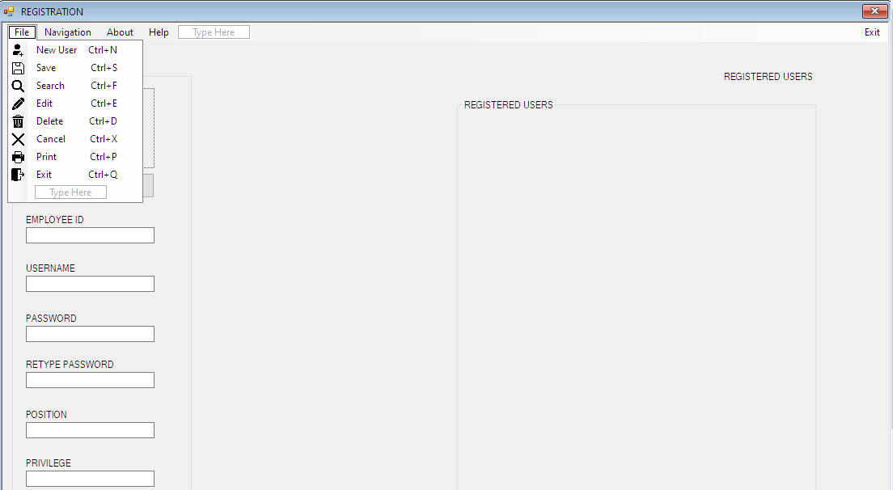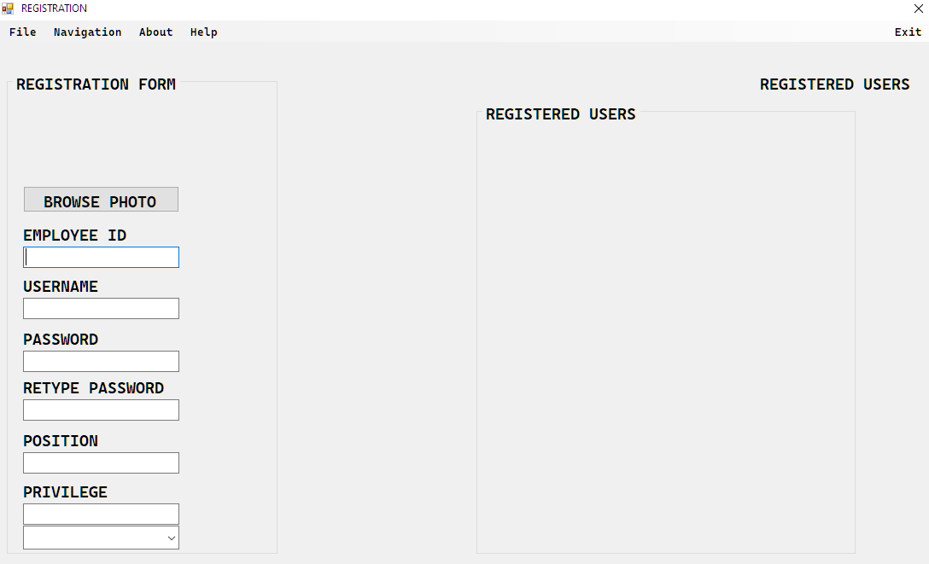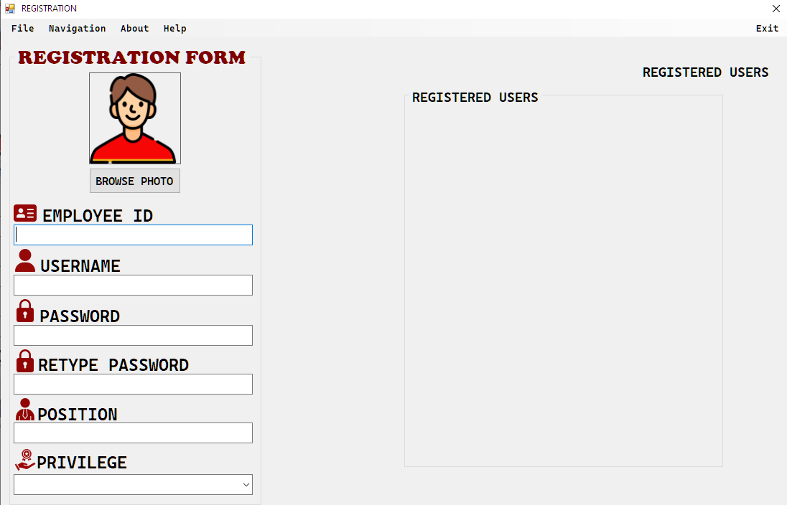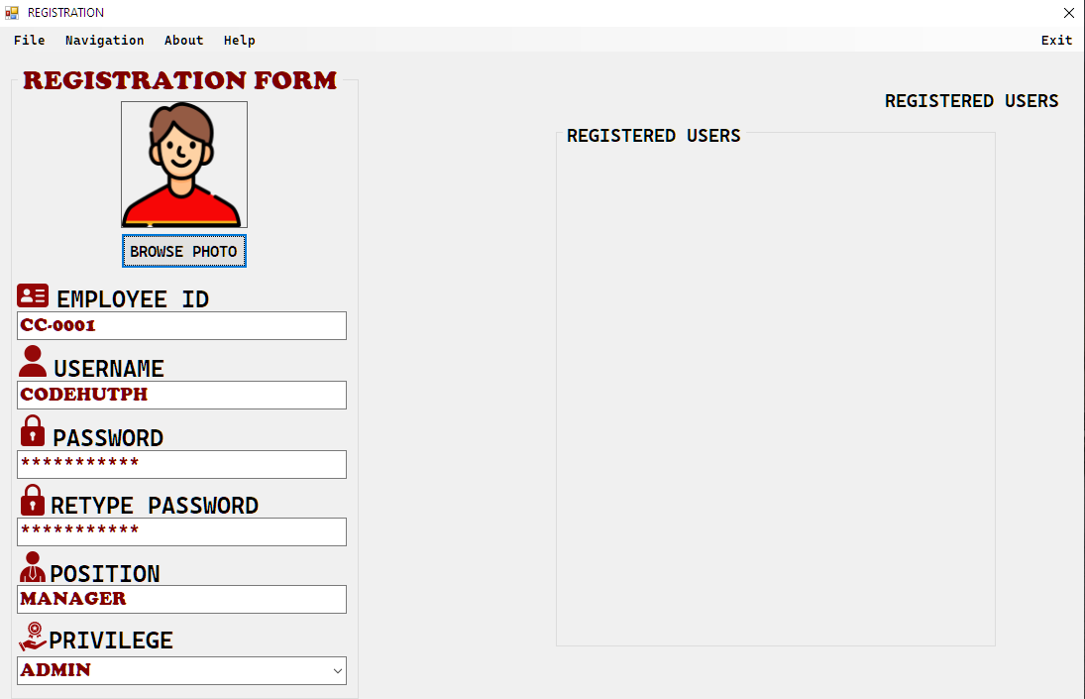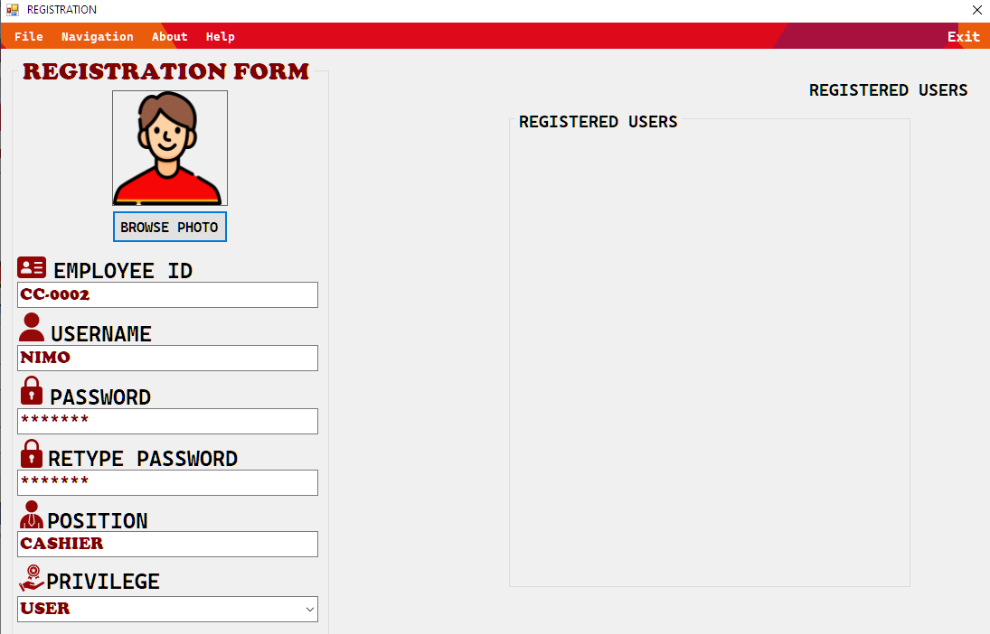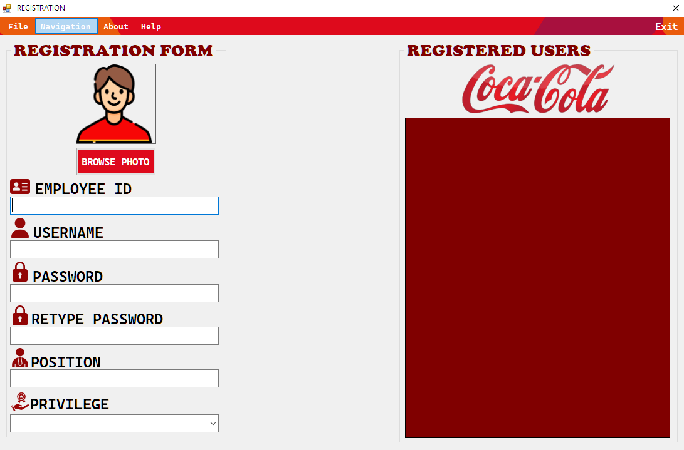

***UPDATED:***



