AIAA Telemetry Award
Rover Team UGHS
University Gardens High School

Why do we have sensors?
Our rover is capable of many things mechanically thanks to it’s drivers. Still, there is one thing the rover is incapable of; sensing it’s surroundings. Sensors give the people driving the rover (as well as the people watching) “eyes”. This gives the team information about the rover’s current environment even when it isn’t in view. With these sensors, we can get a better understanding of the unpredictable environment the rover is driven in, and we have more time to notice variable changes which we would normally not be able to perceive. This information can be taken into consideration when finding problems the driver had regarding the actual rover, like, going slower on a rainy day compared to a sunny day, because the data can be saved for later analysis. These are changes that can be deducted either way, but the sensor gives us concrete data on what changed and what didn’t. Currently, we have a distance sensor (HC-SRO4), humidity sensor (DHT11), and a gyroscope (GY-87).

Set-up and Usage
First of all, our rover only has one Arduino sensor. This sensor is connected in the middle of the rover (the middle metallic tube), a safe distance from any possible damage. It is equipped with a buzzer (a tiny thing that makes loud noise) that warns the drivers when they’re about to hit a wall nearby, from about 1’ distance, so they can remain focused on driving. Apart from the buzzer, the sensors also send information to a computer program made in the Processing IDE, which informs the humidity status of the environment. Finally, the gyro sensor, which provides data on the actual rover’s yaw roll, and pitch (rotation). All of this information can be visualized through a computer that receives the data through Wi-Fi.

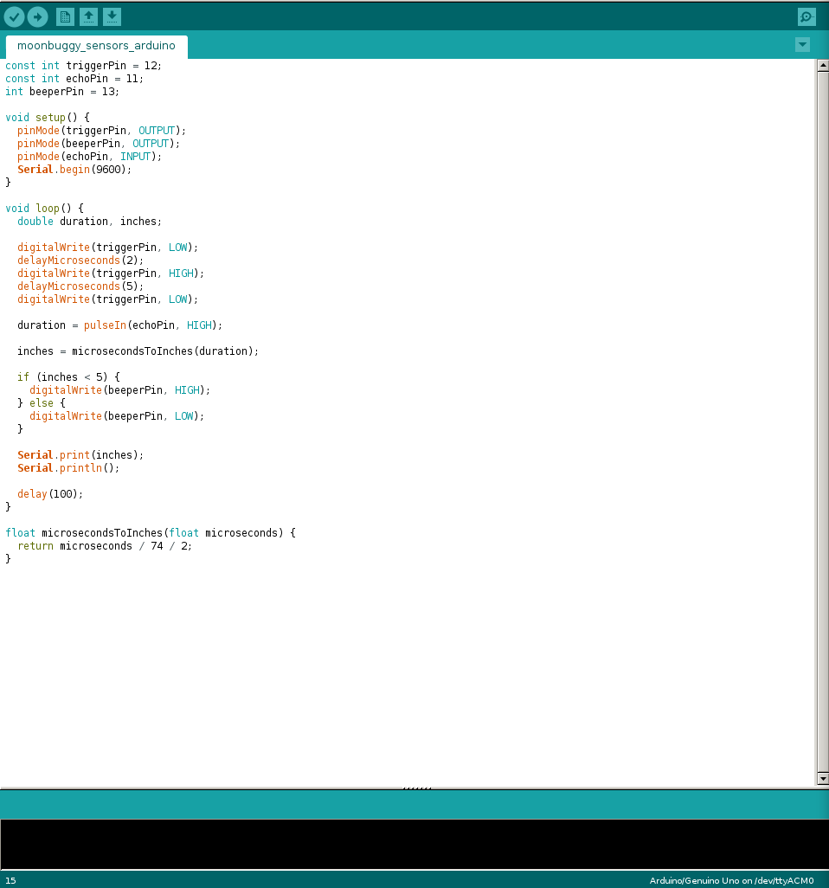

Programming
Distance sensor

Moonbuggy Computational Model (fake data example)

