CataTriage AI Implementation Report
  - Competition implementation milestone CodeJediX 30 October 2026
This report explains the implemented software, the reasons for its stack, the research data actually used and the remaining gaps against the proposal. The outcome is a working human reviewed hospital workflow and two modestly improved research models. It is not a clinically validated cataract decision system.
The application baseline is commit 9a1a414. GPU tuning and model integration were committed in 2c198d4. The final documentation commit and exact packaged file hashes are recorded in the submission manifest. The source ZIP contains the application, model checkpoints, native Android source, release APK, setup instructions and editable documents.

What was built
Component | Final implementation
Three web roles | Doctor, hospital admin and technician support with protected routes.
Research models | Tabular grading v2 and slit lamp image context fusion v2; separate legacy fundus baseline.
Four agent path | Preprocessing, model inference, safety validation and explanation with audit traces.
Scheduling | Doctor enters tier and approves month; admin chooses and confirms a free date inside that month.
Communication | Inbox and Sent, patient messages, doctor setup email flow and explicit notification delivery status.
Additional interfaces | Native doctor Android APK, editable profiles, persistent pending date bell and navigation guide.

Principal result and limits
On the unchanged historical tests, grading accuracy improved from 53.69% to 56.04%, and fusion from 52.50% to 55.00%. This means seven additional exact grades among 298 people and one additional correct image among 40 images. The intervals are wide and overlap earlier scores; statistical superiority is not established. Normal image recall remains only 2 of 8.
Workflow records and screenshots are fictional fixtures. Training and evaluation use the documented real retrospective datasets. The two cohorts are not linked to form full multimodal patients. A model score never selects clinical urgency or a safe waiting period.

Architecture and stack choices
FastAPI serves both browser pages and the native mobile API. Jinja2, bundled CSS and JavaScript provide the three web portals without a separate frontend build. Research inference is local to the server; optional free LLM calls only rank supplied scheduling candidates. The built in navigation guide does not contact an LLM.
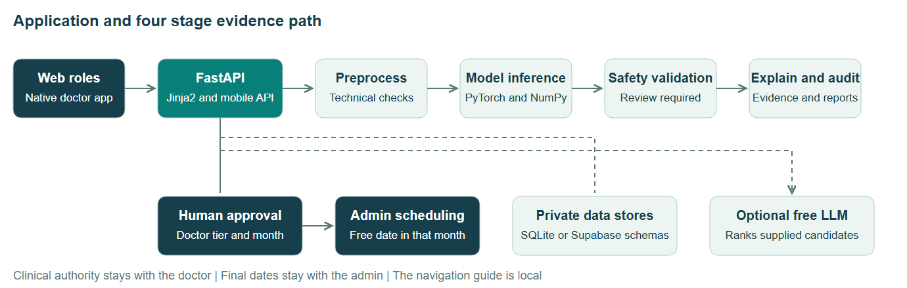
Figure 1 Request and evidence flow with separate human approval steps
Choice | Reason and tradeoff
FastAPI and Jinja2 | One Python codebase for inference, forms and APIs; simpler deployment, with server rendered interactions.
PyTorch and NumPy | Shared checkpoint inference on GPU locally and CPU on Vercel. Exported tree arrays avoid a CatBoost runtime dependency.
SQLite and Supabase | Three local files support an isolated demo. Cloud mode uses three private Postgres schemas in one project, not three hosted servers.
Vercel | Hosted FastAPI without a laptop tunnel. Free tier limits and cold starts remain operational constraints.
Native Java Android | Doctor focused touch UI, camera and device integration. It depends on the server and is not offline inference.
Optional providers | Gemma through OpenRouter with a configured free fallback; Firebase doctor setup; verified Business API required for automatic WhatsApp.

Implemented roles and workflow
Role | Main functions | Authority
Doctor | Assigned patients, notes, image review, reports, messages, leave, calendar and editable profile. | Enters tier and approves month.
Hospital admin | Accounts, queue, calendar, capacity, leave conflicts, audit and final booking. | Chooses date within approved month.
Technician | Structured intake and left right or unknown side image capture with immediate quality feedback. | Cannot set clinical priority.

The uploader declares eye side. Each original image is analysed separately, and empty fields do not add default photographs. For an unknown side, the model averages the left and right context hypotheses; it does not identify the anatomical eye. Unknown side performance has not been separately validated.
The scheduling proposal uses doctor recorded functional impact, progression and preference. Mild, stable Tier 3 cases can be proposed for a later month; model confidence is excluded from postponement logic. Acute warnings or missing assessments pause elective planning. The doctor must independently approve the month.
Admin date selection checks the approved month, working hours, leave, appointments, theatre capacity and beds. The 30 minute grid is an operational convention, not a predicted procedure duration. Changed evidence or doctor assignment requires fresh month approval. The red bell remains until pending cases have a confirmed date and time.
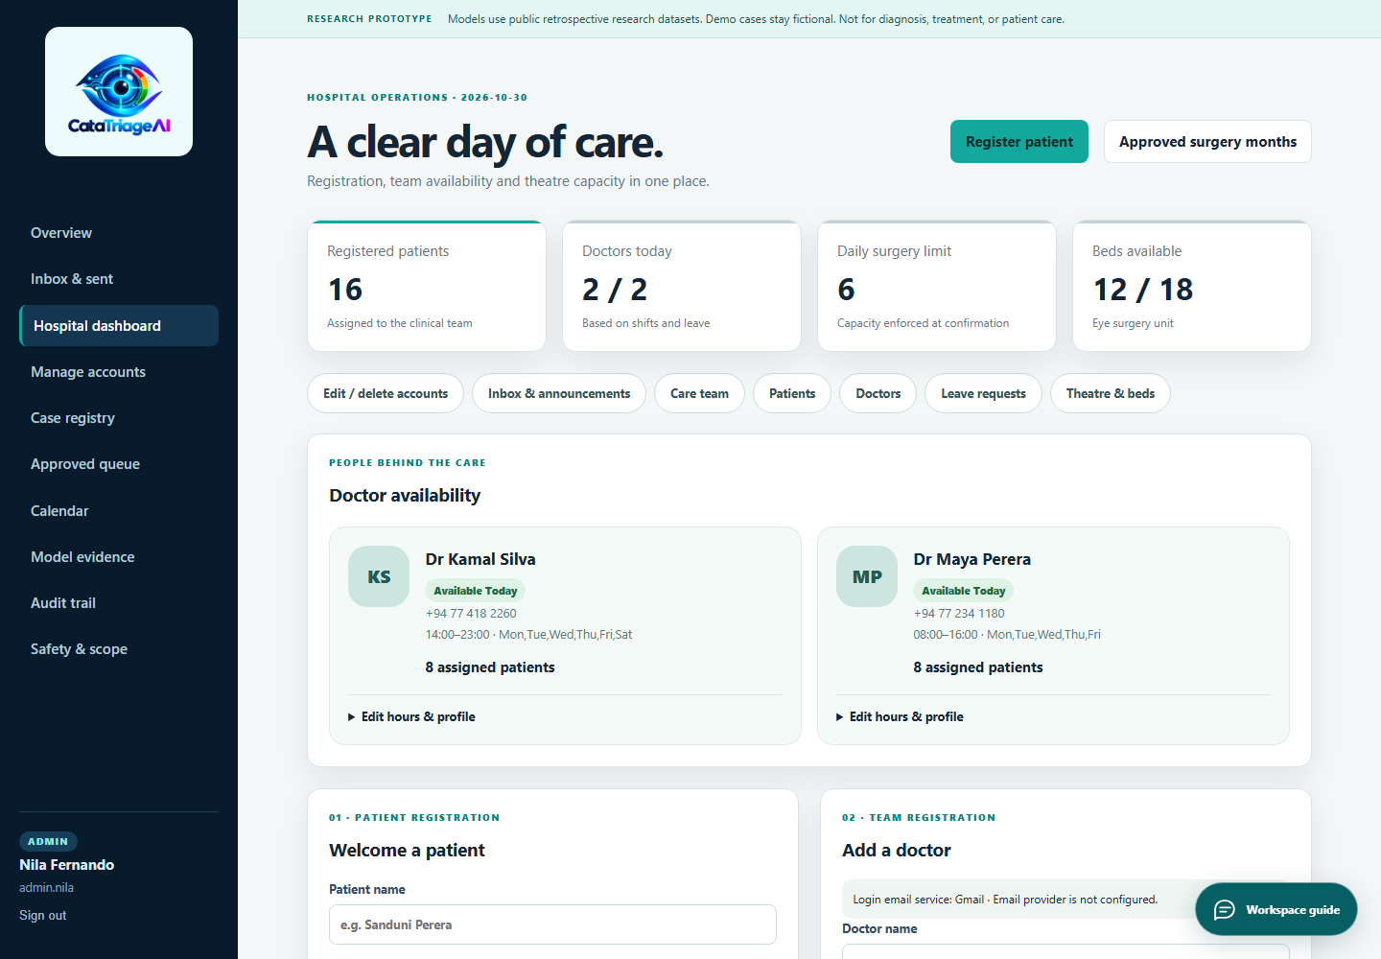
Figure 2 Admin workspace captured using isolated fictional fixtures

Data used and its temporality
Data | Actual training scope | Temporal facts
Taizhou Eye Study | 1,986 participants. Split 1,390 training, 298 validation, 298 test. Forty four structured source fields. | Source study July to September 2012; dataset published 7 August 2016; current tuning 30 October 2026.
CatScreen clean sample | 200 real slit lamp images. Split 140 training, 20 validation, 40 test. Participant counts 129, 19 and 37. | Snapshot downloaded 26 October 2026. Paper TMLR 2026. Acquisition dates not verified in the local sample.
Legacy fundus baseline | 601 images; 420 training, 90 validation, 91 test. Patient IDs unavailable. | Original acquisition dates unknown. Handover artifacts recorded through 24 October 2026.
Workflow fixtures | Sixteen built in fictional cases, plus isolated test registrations. Not model training data. | Current demo dates and waiting times are simulated, not longitudinal clinical outcomes.

Meaning of the dataset names
The grading model uses one clinical cohort with diverse variables; it is not multi cohort validation. Its target is the maximum available bilateral NO, NC, cortical and PSC grade, grouped as 0, 1, 2 or 3 plus. The fusion model uses images plus laterality, reflection, image quality and illumination. The public snapshot does not provide the full clinical history described for the licensed release.

Gaps and rights
The two sources are not patient linked. No chronological holdout, contemporary hospital cohort, prospective follow up or external validation is established. Data from 2012 may differ from current practice and the intended local population; download dates are not acquisition dates. Source and device shortcuts remain possible.
Taizhou is distributed through Dryad under CC0. CatScreen is restricted to research and education; the full release requires the provider institutional process and was not used. Raw datasets are excluded from this submission. Unverified slit lamp grading material, uncertain provenance collections and AUTO_PILOT labels were not used as new severity or urgency ground truth.

Model construction and GPU tuning

Grading model
A GPU CatBoost numerical ensemble contributes 75% of the output probabilities and the earlier neural classifier contributes 25%. Forty four raw fields produce 97 numerical and derived representations. Direct grades, cataract diagnoses, lens status and cataract history or surgery fields are excluded. Imputation fits training records only. Incomplete web inputs receive a warning because full record scores do not establish partial form accuracy.

Image context fusion model
The final output blends the existing MobileNetV3 Small context CNN at 75% with a ResNet 18 context CNN at 25%. Both accept the same three labels. The ResNet component uses ImageNet pretrained features and a trained context and classification head. Fine tuning that memorised the small training set was rejected.
Selection step | Recorded method
Compute | RTX 2050 with 4 GB VRAM; PyTorch CUDA training. Final benchmark inference used CPU float32 to match hosting.
Grading search | Six fixed CatBoost settings, three internal training folds, validation comparison and five fixed blend weights.
Fusion search | Three pretrained backbones, participant group folds, regularised heads, a rejected kernel trial and fixed blend weights.
Memory adaptation | Small batches, mixed precision, last block training and fixed BatchNorm statistics. No silent CPU training fallback.
Test protection | Selections were sealed before final test predictions. Historical test sets were reused once, not treated as new external validation.

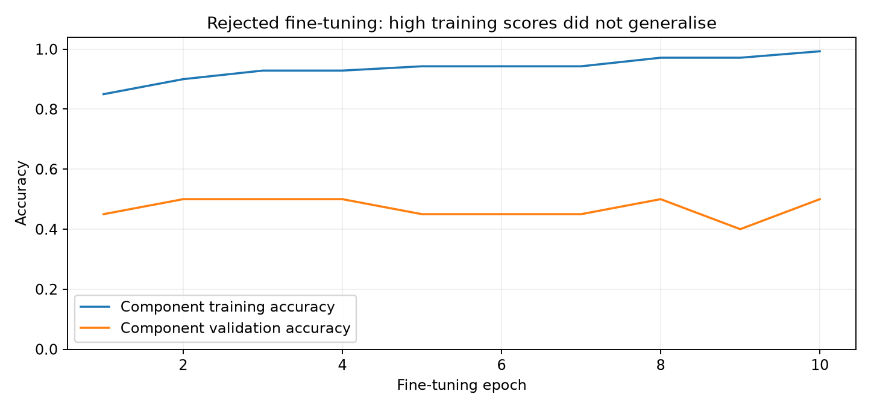
Figure 3 Rejected component fine tuning reached about 99 percent training accuracy while validation remained low

Measured evaluation and uncertainty
Current model | Training | Validation | Test | Previous test | Test macro F1
Grading v2 | 70.79% | 54.36% | 56.04% | 53.69% | 56.67%
Fusion v2 | 72.14% | 65.00% | 55.00% | 52.50% | 47.93%

Grading found 167 of 298 exact grades, with weighted kappa 0.698 and mean absolute grade error 0.510. Its approximate 95 percent participant bootstrap accuracy interval is 50.7 to 61.7 percent. Fusion found 22 of 40 labels; its participant cluster bootstrap interval is 37.5 to 71.4 percent.
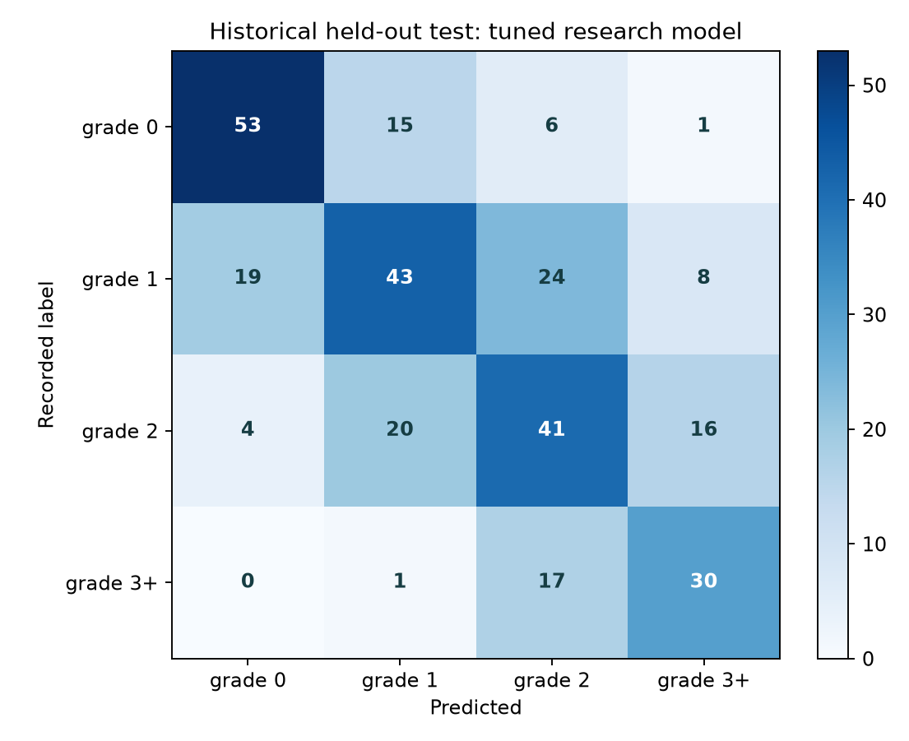 | 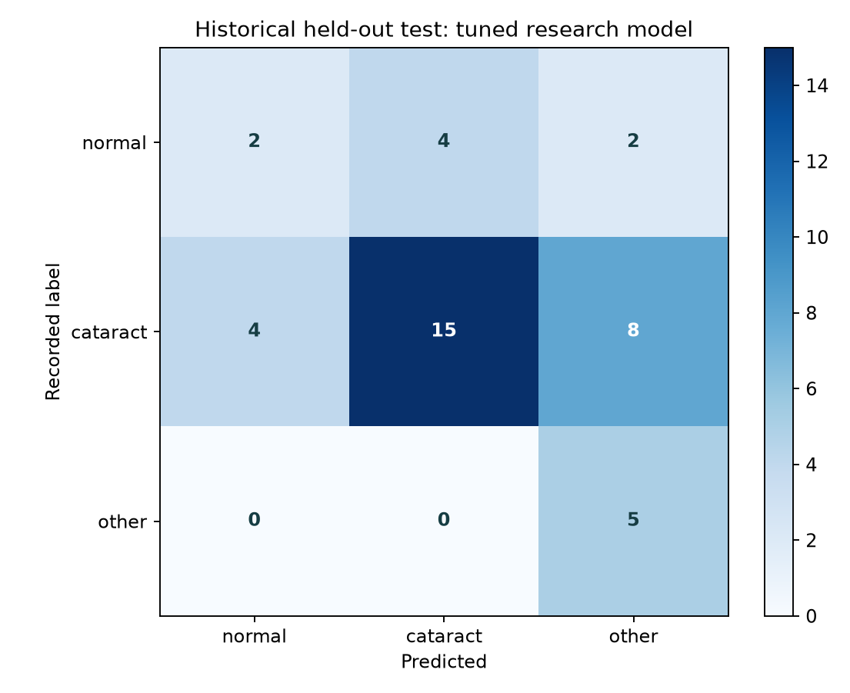
Figure 4 Actual recorded versus predicted labels on the original historical tests
Fusion recall is normal 2 of 8, cataract 15 of 27 and other 5 of 5. Normal recognition remains weak; a low cataract score cannot provide clinical reassurance. The previous fusion training score used random augmentation, while the new score uses deterministic evaluation, so the two training scores are not directly comparable.
The gains are small and confidence intervals overlap the earlier scores. No statistical superiority, calibration, subgroup safety, future time performance or clinical reliability is established. The older fundus model scored 72.53 percent on 91 image level examples, but it is a different task and cannot substitute for slit lamp grading. Synthetic simulation scores demonstrate pipeline operation only.

Evaluation against the proposal
Requirement | Status | Qualification
Three roles and stores | Implemented | Three local databases or three private cloud schemas.
Two real research models | Implemented with limits | Grading is derived tabular prediction; image fusion uses acquisition context.
Full clinical fusion and image severity | Partial | No verified paired cohort or independent image linked LOCS severity evaluation.
Four agents | Implemented | Four deterministic software stages, not independently trained medical agents.
Doctor tier month admin date | Implemented | Human approval with stale evidence and availability checks; not a trained safe wait model.
Messaging profiles accounts calendar | Implemented | Protected routes, temporary credential flow, leave and pending date bell.
Email and WhatsApp automation | Conditional | Firebase setup exists; WhatsApp Business sender and template must be verified.
Hosted site and Android APK | Implemented | Doctor only native APK 1.1.0 uses the server. No on device model.
Navigation chatbot | Implemented | Built in role scoped guide, without external LLM or medical decision authority.
Clinical deployment readiness | Not established | No external prospective or regulatory validation, and no live hospital integration.

Engineering verification
The recorded full workspace suite passed 110 backend tests. Tests cover roles, CSRF, account changes, image validation, per eye handling, messaging, date boundaries, stale evidence, capacity and conflicts, plus checkpoint compatibility and navigation. Source only reproduction skips one optional raw image smoke check when its original file is absent.
Isolated browser checks verified mobile overflow, keyboard focus, guide navigation, current metrics and a red bell that clears after admin confirmation. Android instrumentation and lint were recorded for release 1.1.0. Live lab checks loaded both v2 models using non persistent inputs without changing clinical records or sending messages.

Reproduction security and next work
The README gives a clean Python virtual environment setup and public local fixture credentials. The local app needs no raw training images or provider keys to start or load its checkpoints. The APK requires an authorized hosted doctor account. Dependencies must first be installed; they are not vendored in the ZIP.

Reproduce the judging workflow
- Run the local app and tools/judge_smoke.py using the README.
- Sign in as doctor, review a fictional case, enter a tier and approve a planning month.
- Sign in as admin, open the bell, inspect the month calendar and confirm a free date.
- Inspect model evidence and try the navigation guide. Original images are required for new image analysis; none are substituted by default.

Security and service boundaries
Passwords use salted PBKDF2 SHA256. Sessions are signed, HttpOnly and SameSite strict; state changing forms require CSRF tokens. Hosted TLS and private Postgres policies protect the application boundary. Upload checks limit types, size and dimensions. These mechanisms have engineering tests but do not establish compliance with clinical privacy law or a production security certification.
The ZIP excludes real records, user uploads, provider keys and Android signing material. Optional free LLM endpoints can be unavailable and fall back to labelled local rules. Automatic messaging requires separately configured providers. A useful next study would obtain verified labels and paired clinical metadata, reserve an independent contemporary cohort, and evaluate calibration, subgroups and prospective workflow outcomes.

Sources and implementation evidence
User supplied project status and roadmap prepared through 24 October 2026, implementation brief and later feature requests. Embedded execution prompts were treated as historical source material for this comparison.
Tang et al. Dryad dataset DOI 10.5061/dryad.gt410 and study DOI 10.1371/journal.pone.0135870.
CatScreen official dataset page https://www.iab-rubric.org/resources/healthcare-datasets/catscreen and Khurshid et al. TMLR 2026.
Distributed checkpoints, metrics.json, validation_search.json, tuning_protocol.json, test suite and current model evidence PDF.
Live application https://catatriage-ai.vercel.app and repository https://github.com/CodeJediX/CataTriage-AI. Access and final snapshot commit are recorded separately in the submission manifest.

