Historical archived report
This is an editable transcription of the original report retained for development history and archived app links. It is superseded by the current v2 model evidence. Original historical scores and readiness statements have not been relabelled as current results.
  - Source catatriage_full_agents_and_models_report.pdf

Original report page 1: four agents
Original publication: 25 October 2026. The readiness statements below describe that earlier snapshot, before the two current real data models were added.
Agent and input | What it does | Output | Safety
01 Data Preprocessing  Patient fields and an image | Checks missing fields, image format, size and basic technical quality. | Clean input plus quality notes | Stops corrupt or incomplete input.
02 Model Inference  Validated input from Agent 1 | Runs only the model allowed for that data type and records probabilities. | Model output or not_available | Never turns a score into urgency.
03 Safety and Rule Validation  Model output and scope information | Checks modality, model availability, uncertainty and fixed safety rules. | Flags and clinician-review requirement | Blocks unsupported clinical claims.
04 Explanation and Reporting  Validated evidence from Agents 1-3 | Writes an easy summary, limitations and an auditable report. | Doctor-facing explanation | No diagnosis or treatment advice.

Original flow: preprocessing > inference > safety validation > explanation and reporting. Every stored trace ends with clinical_priority = null and requires_clinician_review = true.

Original slit lamp behavior
At this historical snapshot, preprocessing checked the file, inference returned not_available because no validated real slit lamp grade model existed, safety required a doctor, and reporting recorded that limitation. The administrator saw only a tier manually entered by a doctor. This historical statement is superseded by the current model evidence, which still does not establish clinical validation.

Original report page 2: model inventory
Model | Status | Data | Accuracy | Macro F1 | Evaluation | Meaning
Fundus EfficientNet-B0 V3 | Trained / evaluated | Real dataset folder labels | 72.53% test | 66.03% test | 91 test images | Four-class fundus baseline; not cataract grading.
Legacy fundus EfficientNet-B0 | Preserved checkpoint | Real dataset folder labels | 63.33% validation | 60.15% validation | 90 validation images | Earlier model; no separate final-test metric recorded here.
Synthetic cataract grade CNN | Trained / education | Generated lens patterns | 100.00% test | 100.00% test | 800 synthetic tests | Learns four procedural grades; not human results.
Synthetic clinical fusion CNN | Trained / education | Generated image + 6 fields | 100.00% test | 100.00% test | 800 synthetic pairs | Shows CNN and structured-data fusion.
Real multi-data cataract grade | Not trained | Real slit-lamp + clinical | Not available | Not available | 0 linked labels | Blocked: labels and image-record crosswalk missing.
Real clinical fusion | Not trained | Real paired multimodal data | Not available | Not available | 0 verified pairs | Blocked: paired cohort, target and external validation missing.

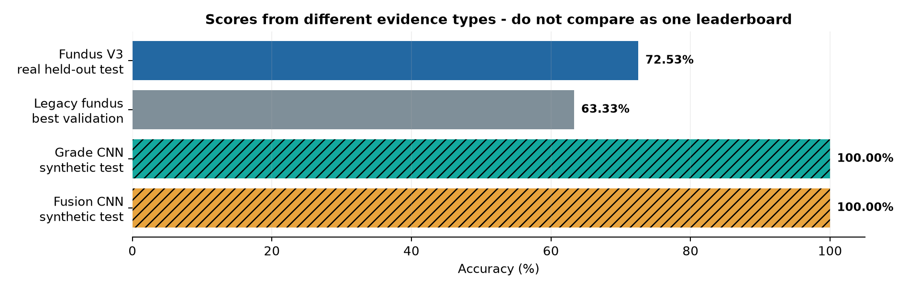
Original inventory chart: different evidence types, not a direct model ranking
The striped bars are synthetic results. The legacy value is validation accuracy, whereas fundus V3 uses a held out test. Original fundus V3 result: accuracy 72.5275%, macro F1 66.0338%, macro one versus rest ROC AUC 88.9266%, evaluated on 91 images.

Original report page 3: interpretation
The original fundus test found 66 of 91 labels, including normal 42 of 45 and retinal disease 5 of 15. The test was small and image level. Synthetic grade and fusion checkpoints reached perfect validation and test scores at saved epochs 18 and 13; RTX 2050 training took about 103 and 83 seconds. These generator scores are not human clinical results.
Metric | Meaning
Accuracy | Percentage of examples classified correctly.
Balanced accuracy | Recall averaged across classes so large classes do not dominate.
Macro F1 | Precision and recall combined, with equal weight for each class.
ROC AUC | How well each class separates across probability thresholds.

Historical conclusion: the application, GPU pipeline, audit trail and four stages worked, while real cataract grading required verified image linked labels and external validation. See the current reports for later research model measurements and remaining limits.
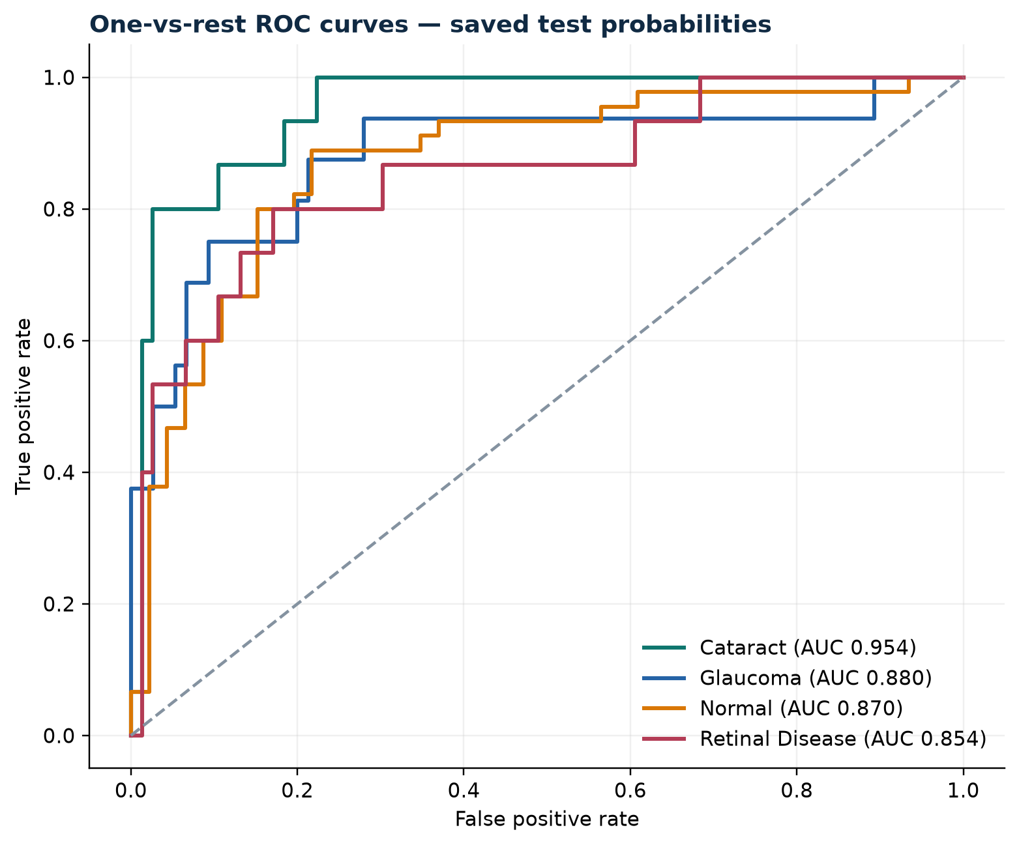 | 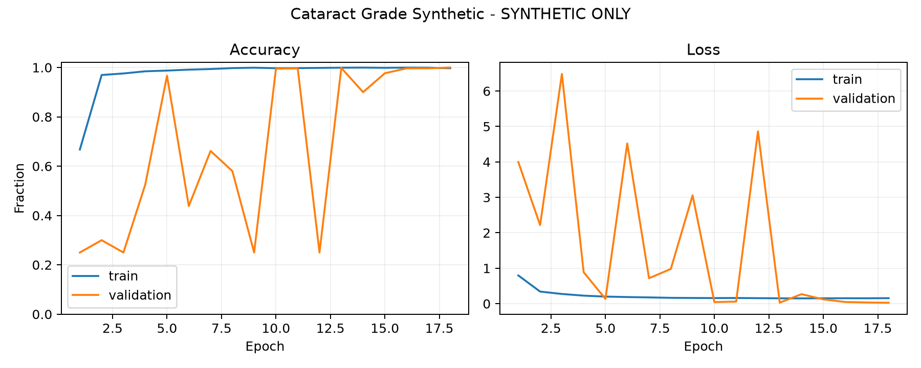
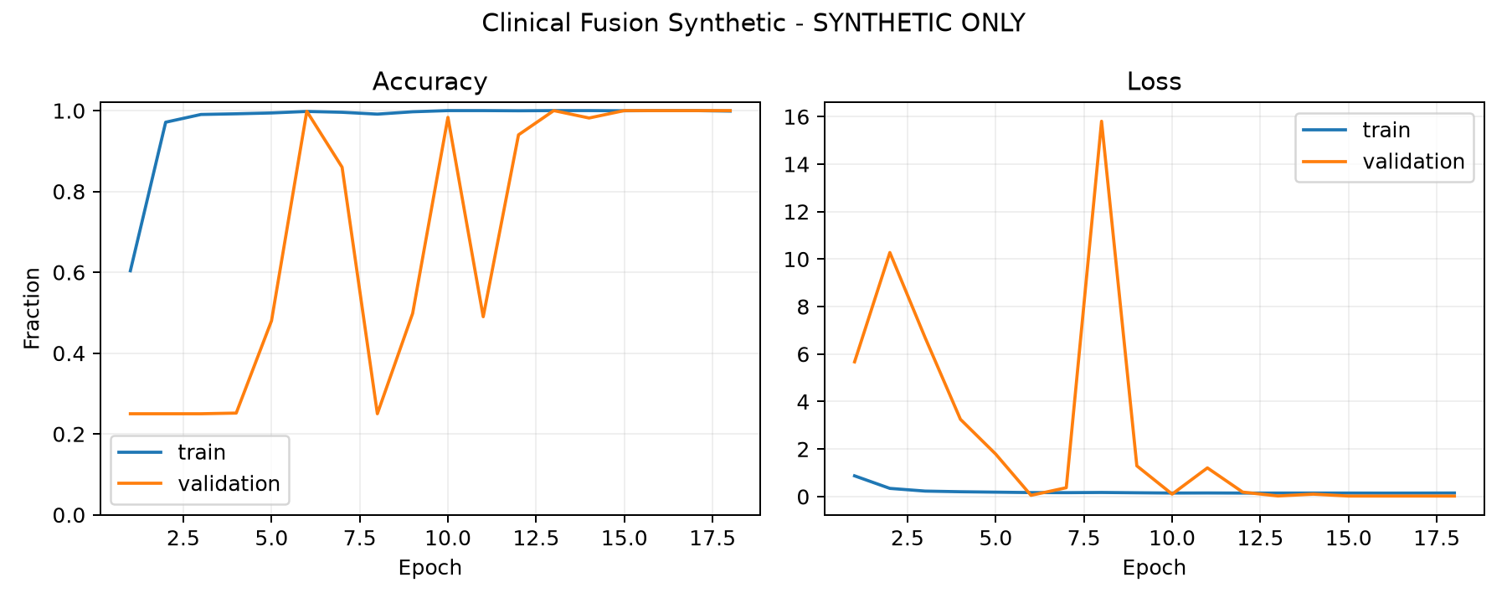 | 