Historical archived report
This is an editable transcription of the original report retained for development history and archived app links. It is superseded by the current v2 model evidence. Original historical scores and readiness statements have not been relabelled as current results.
  - Source fundus_v3_model_evidence.pdf

Original report page 1
CataTriage-AI · research evidence · simulated/demo context Page 1
VERIFIED EXISTING BASELINE EfficientNet-B0 V3 model evidence Four-folder fundus image classification · held-out image-level evaluation · not cataract grading
SCOPE Real measured results from the saved epoch-28 checkpoint. Development evidence only; not clinical validation and never used to assign urgency.
Held-out test results Metric Final test (n=91) Accuracy 72.5275% Balanced accuracy 62.2917% Macro F1 66.0338% Weighted F1 70.6214% Macro OvR ROC-AUC 88.9266% Figure 1. Final test metrics regenerated from saved evaluation artifacts.
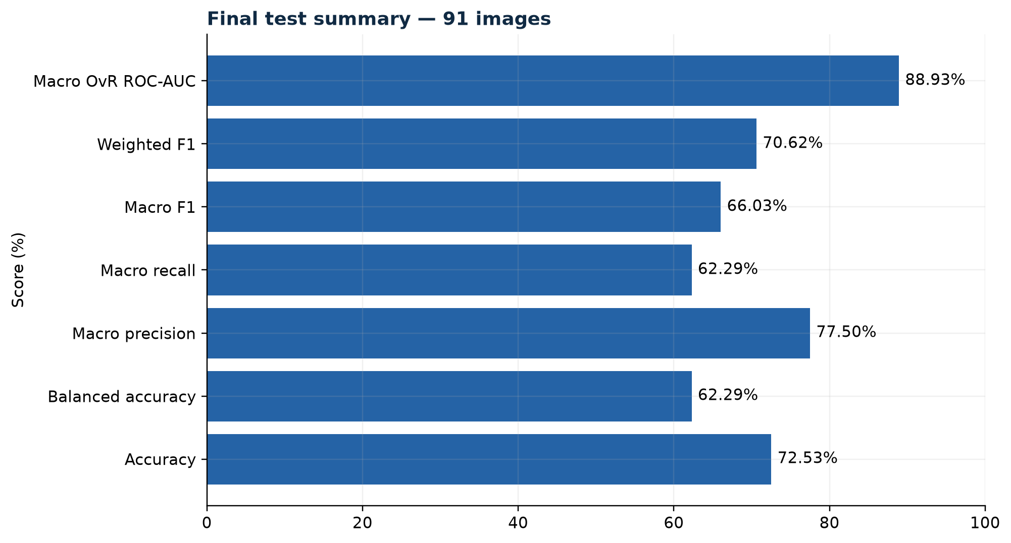
Original historical figure from page 1

Original report page 2
CataTriage-AI · research evidence · simulated/demo context Page 2
EVALUATION FIGURES Error structure and discrimination Exact confusion matrix and one-vs-rest ROC curves from saved final-test predictions Figure 2. Confusion matrix (left) and ROC curves (right). The retinal-disease recall is 0.333; small class supports and image-level splitting limit generalization claims.
Interpretation boundary The model predicts one of four dataset folder labels: cataract, glaucoma, normal or retinal disease. It does not grade cataract severity, fuse patient clinical records, diagnose disease, recommend treatment, or determine scheduling priority. All outputs require clinician review.
Reproducibility Checkpoint: best macro-F1 epoch 28. Validation accuracy 68.8889%; validation macro-F1 62.7075%. Final test contains 91 images. Figures and metric tables are stored under reports/model_evaluation_v3.
Original historical figures from page 2
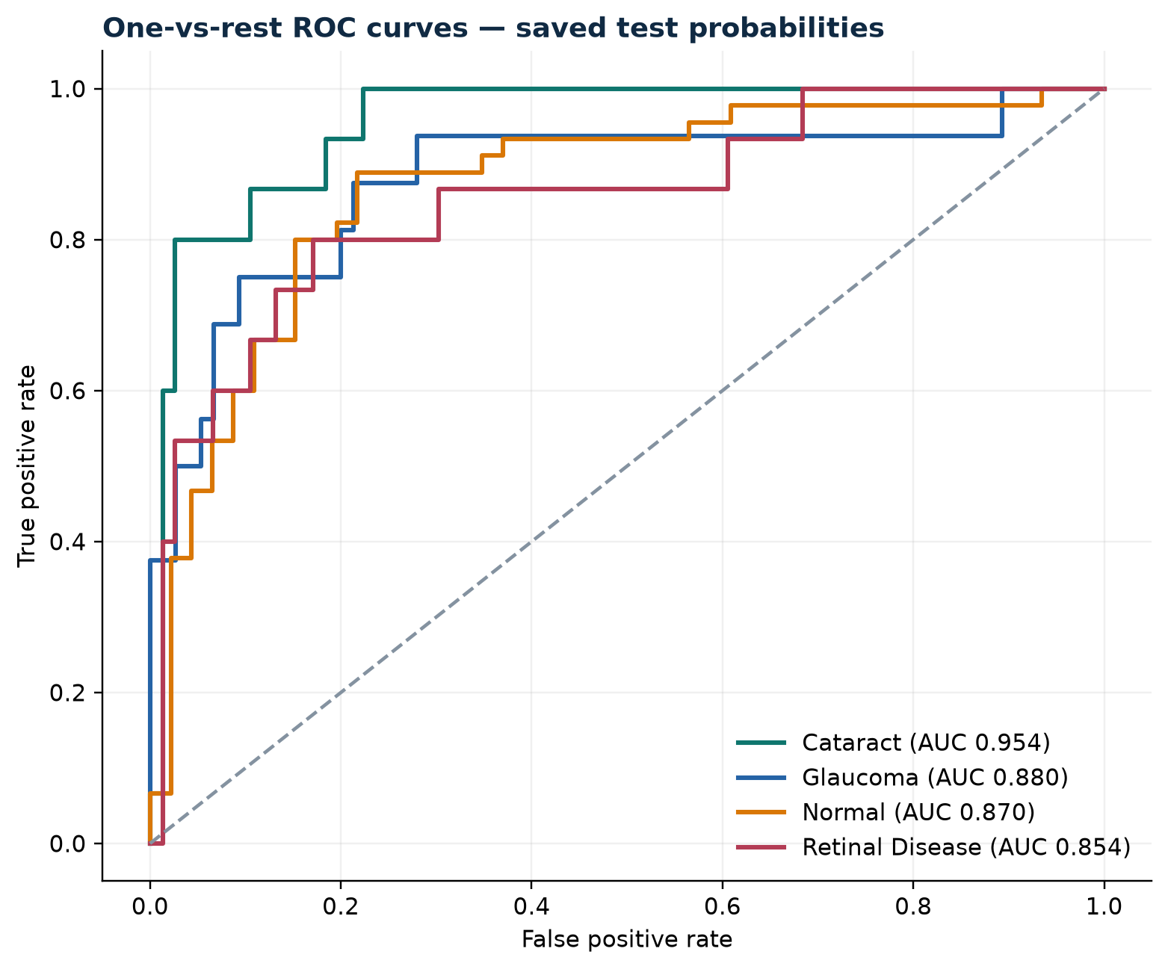 | 