CataTriage AI Model Evidence
  - Model 1 Multi data grading RTX 2050 tuning 30 October 2026
This report records actual research measurements. The models are not externally or prospectively validated and do not set diagnosis, treatment, urgency or surgical suitability.
GPU CatBoost numerical ensemble (75%) + existing grade neural network (25%).
Accuracy | Training | Validation | Historical test
Previous | 63.9% | 53.7% | 53.7%
Tuned | 70.8% | 54.4% | 56.0%

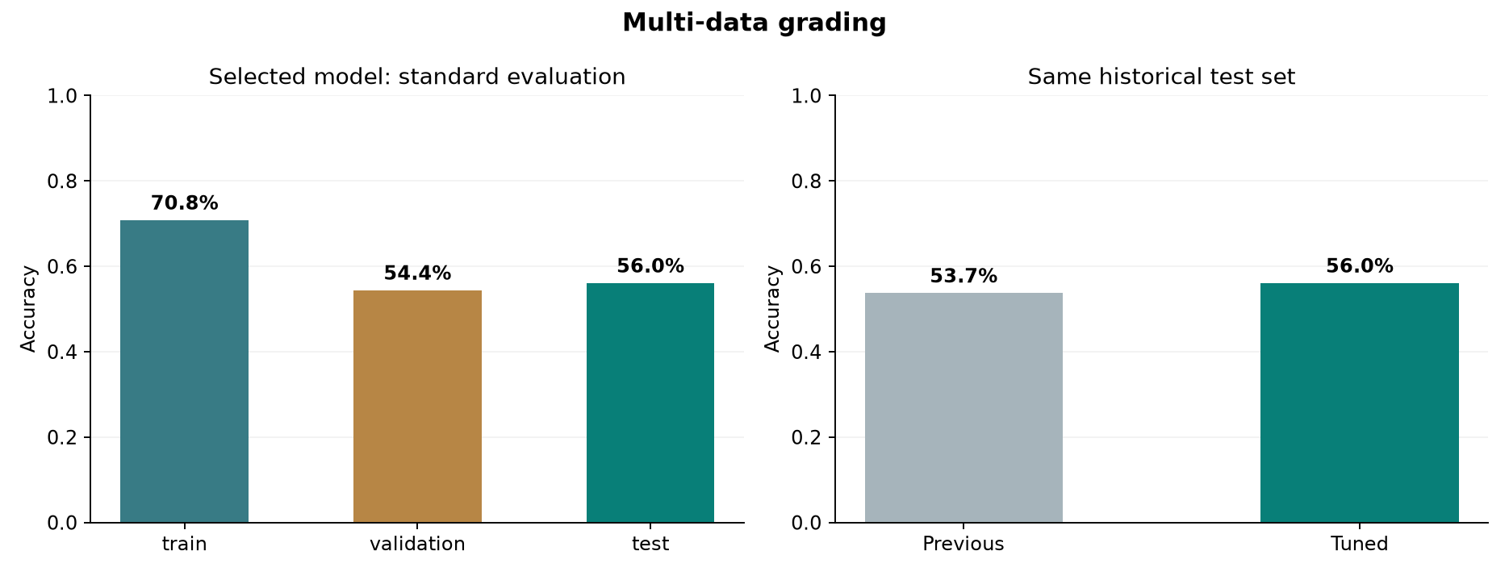
Data are 1,986 de identified Taizhou participants, split 1,390 training, 298 validation and 298 test. The four level target is derived from maximum available bilateral grades. Direct grade fields, cataract labels, lens status and cataract history or surgery are excluded from inputs.
The tuned model found 167 of 298 exact grades, seven more than before. Macro F1 is 56.7%, weighted kappa 0.698 and grade MAE 0.510. The approximate 95 percent accuracy interval is 50.7% to 61.7%. Missing form fields do not inherit the full record benchmark performance.

Image Context Fusion Results
  - Model 2 Image context fusion RTX 2050 tuning 30 October 2026
This report records actual research measurements. The models are not externally or prospectively validated and do not set diagnosis, treatment, urgency or surgical suitability.
Probability blend: existing MobileNetV3-Small context CNN (75%) + pretrained ResNet-18 context CNN (25%).
Accuracy | Training | Validation | Historical test
Previous | 75.7% | 65.0% | 52.5%
Tuned | 72.1% | 65.0% | 55.0%

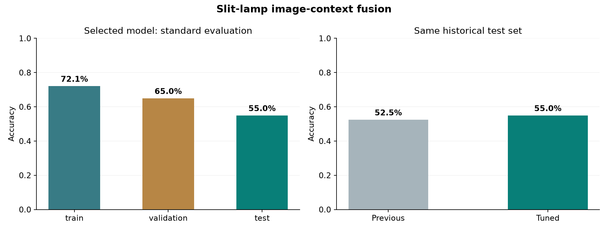
Only 200 CatScreen public sample images were used, split 140 training, 20 validation and 40 test. The full patient clinical metadata is absent. Context means laterality, reflection, quality and illumination. This is not a complete clinical fusion evaluation.
The tuned model found 22 of 40 test labels, one more than before. Macro F1 is 47.9%; balanced accuracy 60.2%. Recall is normal 2 of 8, cataract 15 of 27 and other 5 of 5. The participant cluster bootstrap interval is 37.5% to 71.4%. Normal recognition remains weak.
The old training score used random augmentation; the new training evaluation is deterministic and not directly comparable. Unknown side averages two context hypotheses, without inferring anatomical laterality.

Four Agents and Evaluation Limits
Stage | Role in the implementation
1 Preprocessing | Check file integrity, dimensions, lighting, required fields and declared modality.
2 Inference | Run the matching locked research model and return class scores without a workflow tier.
3 Safety validation | Flag uncertainty, unsupported input, missing information and known performance gaps. Require doctor review.
4 Explanation and reporting | Present the evidence, scope, limitations and audit record. Do not issue treatment instructions.

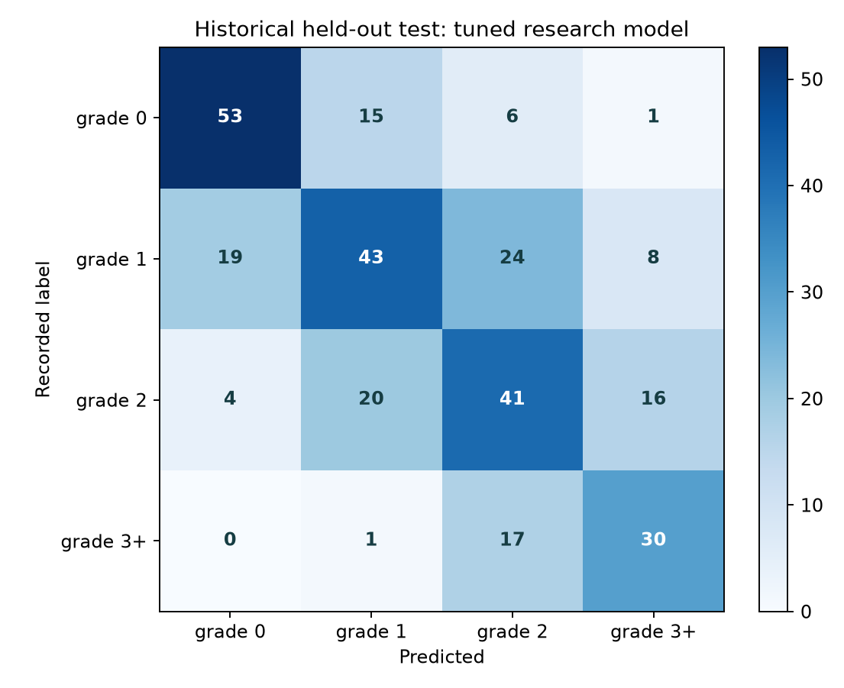 | 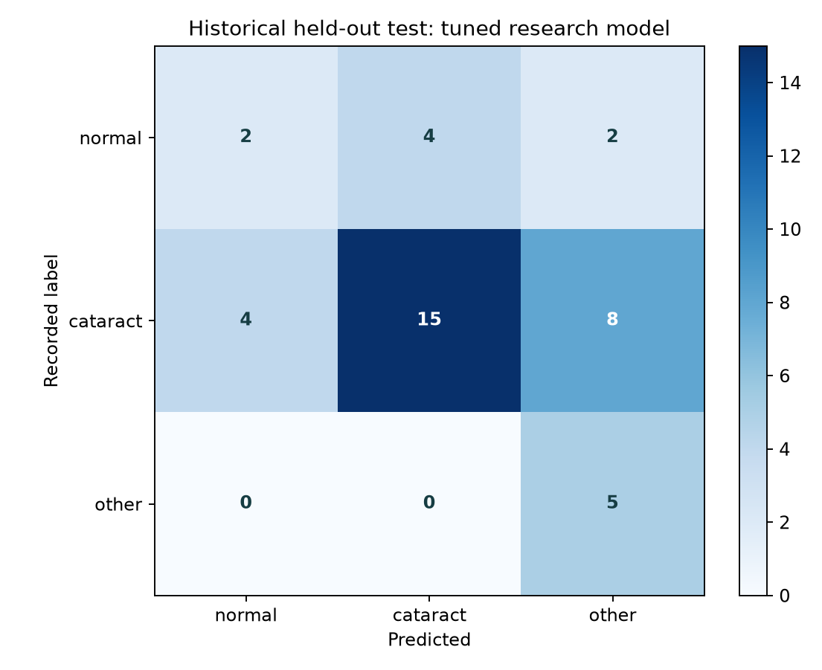
Actual confusion matrices on the historical tests. A component trial reached about 99 percent training accuracy while validation remained low and was rejected. Its curve is included in the full technical report.
The selection used training and validation data. Six CatBoost configurations, three pretrained CNN backbones, participant group folds and fixed blend weights were considered. Selections were sealed before the final historical test comparison. No additional tuning followed those test results.
The gains are small and intervals overlap prior scores. The historical tests are reused holdouts, not new external cohorts. There is no clinical, prospective, calibration, subgroup safety or future time validation. A doctor enters priority and approves a planning month; the admin confirms a date. The separate navigation chatbot supplies workspace help, not medical reasoning.
Sources Tang et al. Dryad DOI 10.5061/dryad.gt410. CatScreen official public sample and Khurshid et al. TMLR 2026. Dataset acquisition dates, rights and gaps are discussed in the implementation report and data provenance notes.

