Historical archived report
This is an editable transcription of the original report retained for development history and archived app links. It is superseded by the current v2 model evidence. Original historical scores and readiness statements have not been relabelled as current results.
  - Source synthetic_cataract_grade_model_evidence.pdf

Original report page 1
CataTriage-AI - synthetic education evidence - NOT CLINICAL Page 1
GPU-TRAINED EDUCATIONAL MODEL Synthetic cataract grade CNN Compact convolutional image classifier - four generated opacity grades
SYNTHETIC ONLY Every image, clinical value and target was generated procedurally. Results are not human annotations and do not measure performance on real patients.
Measured synthetic result Metric Held-out synthetic test Samples 800 Accuracy 100.00% Balanced accuracy 100.00% Macro F1 100.00% Best validation epoch 18 Training device NVIDIA GeForce RTX 2050 (cuda) Training time 103.2 seconds Why the score is perfect The procedural generator intentionally encodes separable opacity patterns and correlated fictional variables. A perfect held-out score shows reproducibility and successful pipeline integration; it is expected for this educational task and must not be generalized to real slit-lamp imaging.
CLINICAL CLAIM None. The model must remain inside the Simulation Lab and must never grade uploaded patient imagery.

Original report page 2
CataTriage-AI - synthetic education evidence - NOT CLINICAL Page 2
TRAINING DIAGNOSTICS Learning curves and error structure Figure 1. Training and validation traces. Instability in early validation reinforces that the selected checkpoint, not the final training state, is the evidence artifact.
Figure 2. Held-out synthetic confusion matrix (200 generated samples per class).
Reproducibility boundary Fixed random seed: 20261025. Four balanced grades. Training: 2,400 generated samples; validation: 600; test: 800.
The test generator uses disjoint seeds. The checkpoint records the class order, epoch and synthetic-only flag.
Original historical figures from page 2
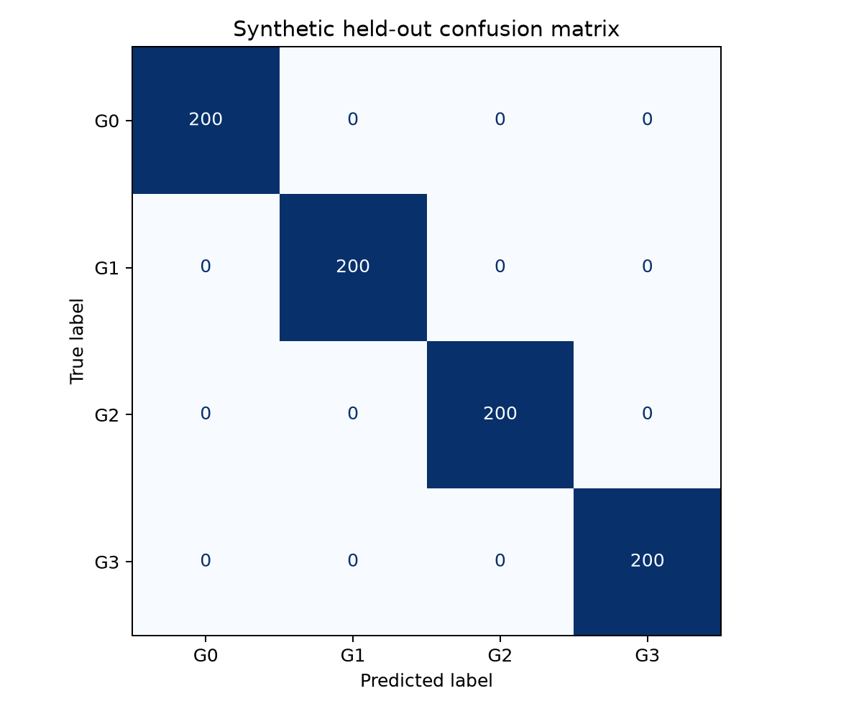 | 