# Content

Emphasis, aka italics, with *asterisks* or *underscores*. Strong emphasis, aka bold, with **asterisks** or **underscores**. Combined emphasis with **asterisks and *underscores***. Strikethrough uses two tildes. ~~Scratch this.~~

[I’m an inline-style link](https://www.google.com)

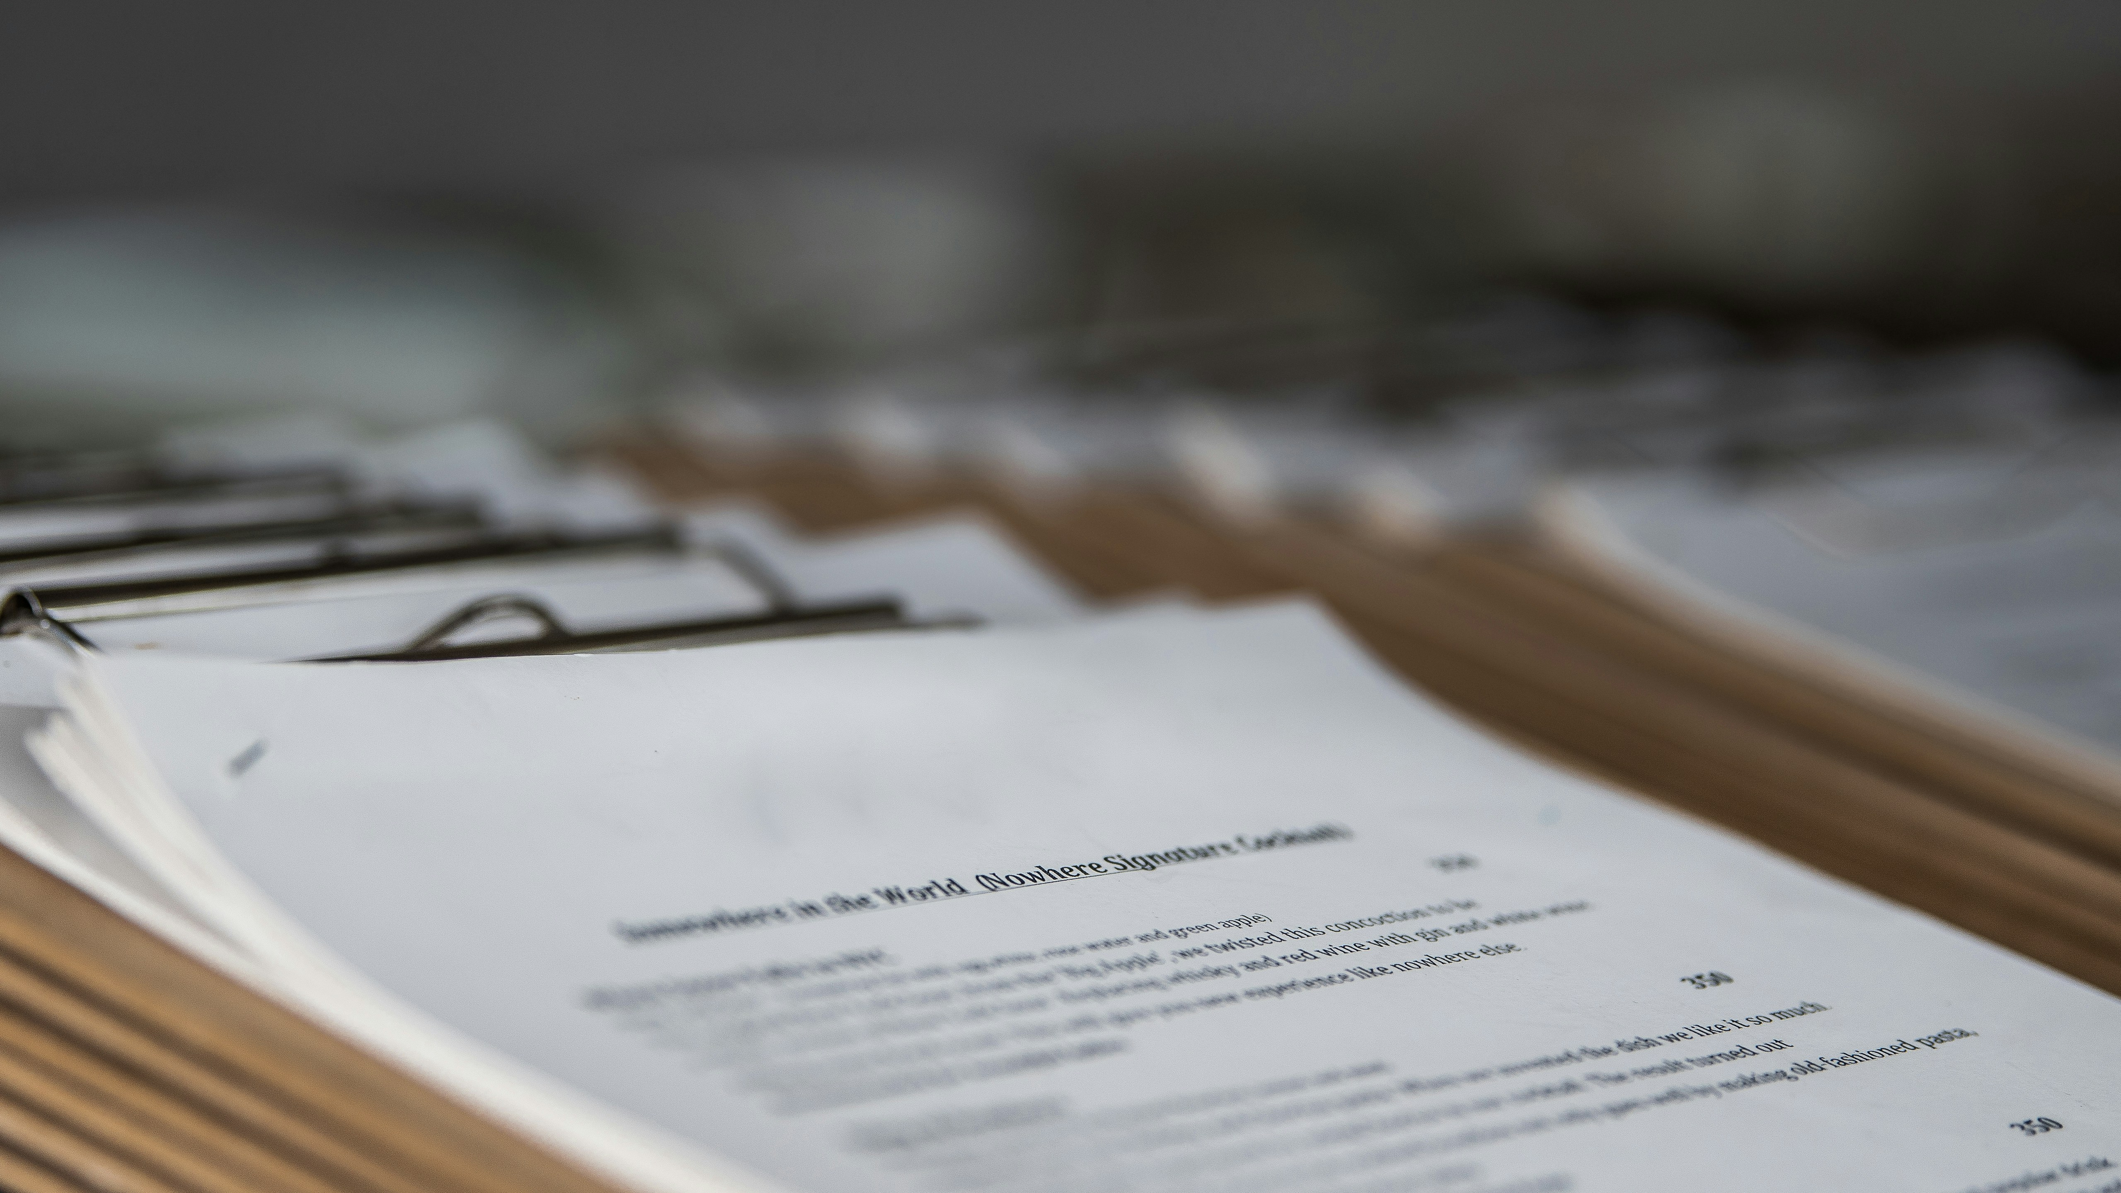

cover.jpg

# Lists

1. First ordered list item
2. Another item
   * Unordered sub-list.
3. Actual numbers don’t matter, just that it’s a number
   1. Ordered sub-list
4. And another item.

# Code and Syntax Highlighting

Inline code has back-ticks around it.

Use 3 backticks to create a code block

public class Code {  
 public static void main(String[] args) {  
 System.out.println("Hello World!");  
 }  
}

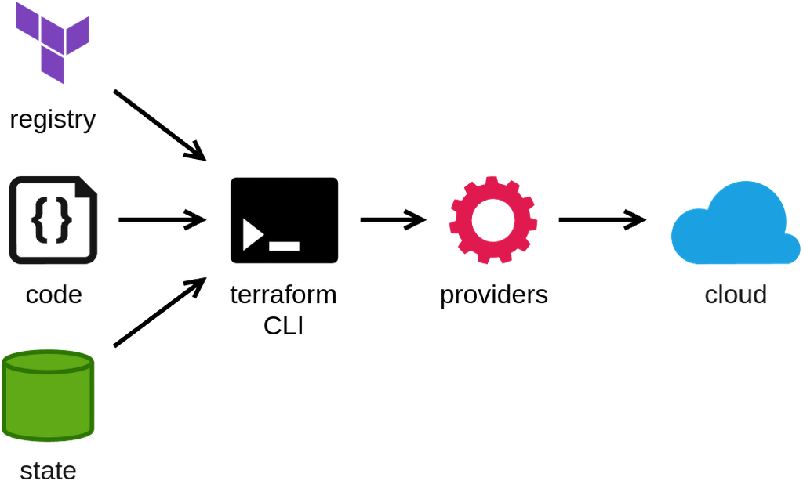

#!/bin/sh  
echo "Hello World"

# Blockquotes

Blockquotes are very handy in email to emulate reply text. This line is part of the same quote.

# Tables

| First Header | Second Header |
| --- | --- |
| Content Cell | Content Cell |