**Assignment2**

**6.1 Differentiate between the following:**

**a. “if” statement and “if-else” statement**

* **if statement**

if statement is the most simple decision making statement. It is used to decide whether a certain statement or block of statements will be executed or not i.e if a certain condition is true then a block of statement is executed otherwise not.  
**Syntax**:

1. if(condition)
2. {
3. // Statements to execute if
4. // condition is true
5. }

Here, **condition**after evaluation will be either true or false. if statement accepts boolean values – if the value is true then it will execute the block of statements below it otherwise not. If we do not provide the curly braces ‘{‘ and ‘}’ after if(condition) then by default if statement will consider the first immediately below statement to be inside its block.

* **if-else statement**

The *if*statement alone tells us that if a condition is true it will execute a block of statements and if the condition is false it won’t. But what if we want to do something else if the condition is false. Here comes the C *else*statement. We can use the *else*statement with *if*statement to execute a block of code when the condition is false.  
**Syntax**:

1. if (condition)
2. {
3. // Executes this block if
4. // condition is true
5. }
6. else
7. {
8. // Executes this block if
9. // condition is false
10. }

**b. Relational operators and Logical operators**

Relational operators compare values and return either TRUE or FALSE. Logical operators perform logical operations on TRUE and FALSE. Values used with a logical operator are converted into booleans prior to being evaluated. For numerical values, zero will be interpreted as FALSE, and other values will be TRUE.

**c. AND operator and OR operator**

* **AND** In case of AND operator, the output will be true only when all the input are true. It is symbolically denoted by “&&”.
* **OR** In case of OR operator, the output will be false only when all the inputs are false. It is symbolically denoted by “||”.

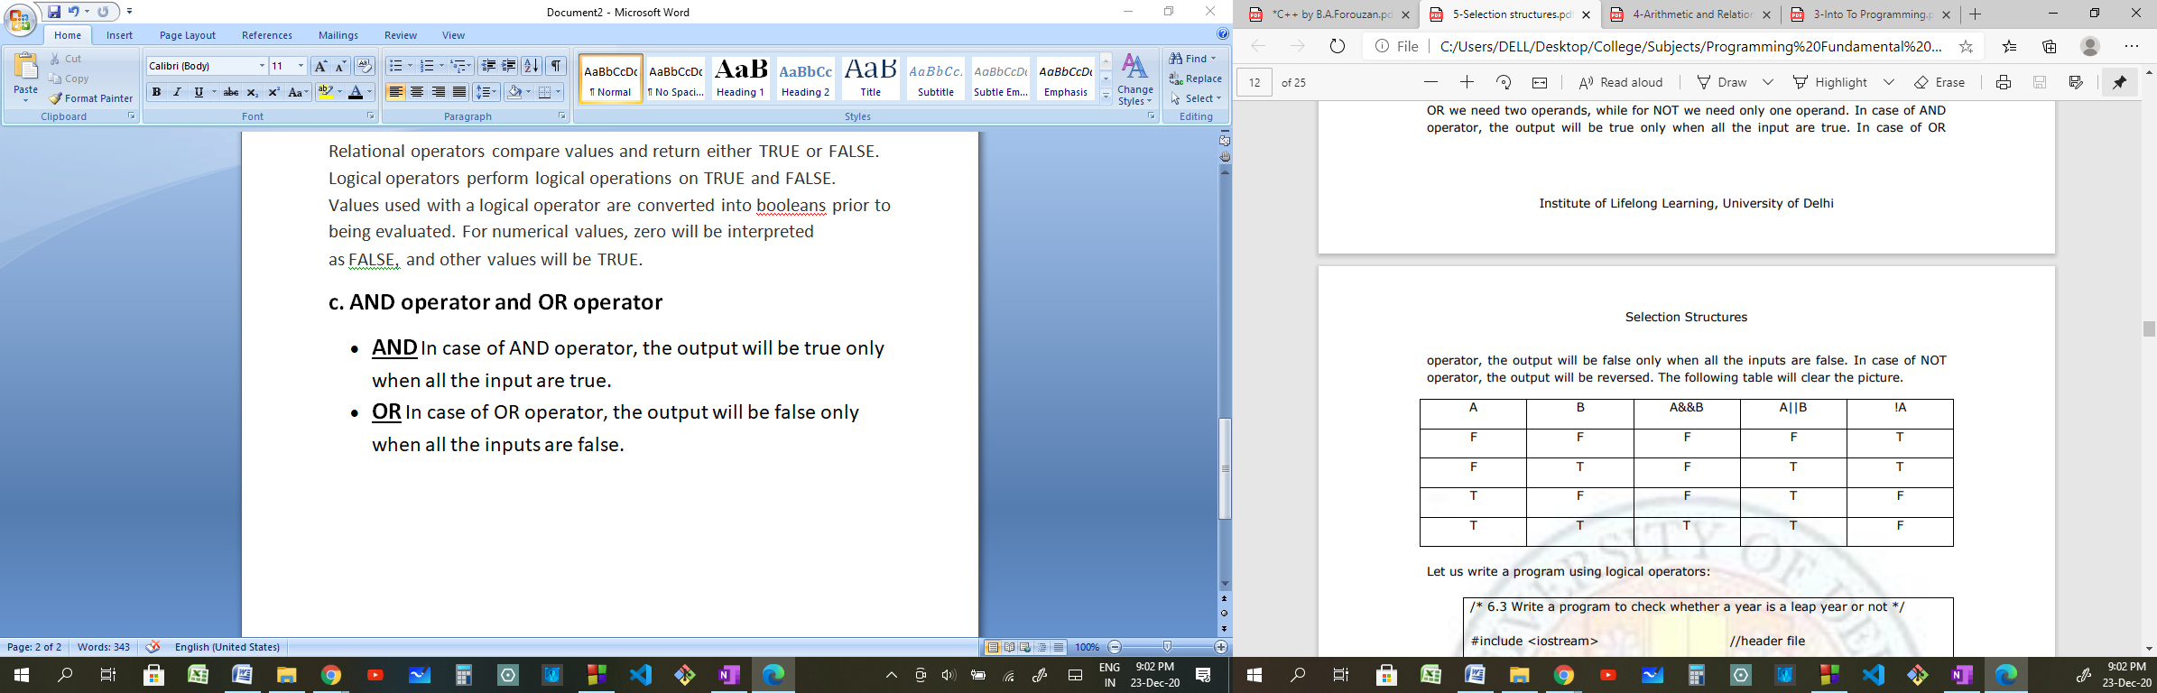

**6.2 Write a program in C++ to find the largest of three numbers.**

#include<iostream>

using namespace std;

int main()

{

float a,b,c;

cout<<"Enter your 3 numbers here\n";

cout<<"First number:";

cin>>a;

cout<<"Second number:";

cin>>b;

cout<<"Third number:";

cin>>c;

if(a>b)

if(a>c){

cout<<"Maximum Number is:"<<a<<endl;

}

else{

cout<<"Maximum Number is:"<<c<<endl;

}else if(b>c){

cout<<"Maximum Number is:"<<b<<endl;

}

else{

cout<<"Maximum Number is:"<<c<<endl;

}

system("pause");

return 0;

}

**6.3 Write a program in C++ to check whether a number is even or odd.**

#include<iostream>

using namespace std;

int main()

{

int n;

cout<<"Enter your number here:";

cin>>n;

if(n%2==0){

cout<<"The Number is even"<<endl;

}else{

cout<<"The Number is odd"<<endl;

}

system("pause");

return 0;

}

**6.4 Evaluate the following expression for the given values of x, y and z: (x>=y)||(!z==y)&&(z<x)**

**1. x=5, y=8, z=9**

(5>=8)||(!9==8)&&(9<5)

=> 0||0&&0 => 0&&0

=> 0

**2. x=7, y=10, z=2**

(7>=10)||(!2==10)&&(2<7)

=> 0||0&&1 => 0&&1

=> 0

**3. x=9, y=9, z=9**

(9>=9)||(!9==9)&&(9<9)

=> 1||0&&0 => 1&&0

=> 0

**6.5 What will be displayed when the following code is executed?**

#include<iostream>

using namespace std;

int main()

{

int i=0;

if (i=5)

cout<<i;

cout<<i;

return 0;

}

**OUTPUT:**  55

**7.1 Differentiate between the following:**

**a. Conditional operator and “if-else” construct**

* **Conditional Operator**

The conditional operator yields a value, and therefore both parts must be type compatible in some way in order for the compiler to determine the type of the expression.

Eg- bonus=(salary>5000)?5:0;

* **if-else**

The *if*statement alone tells us that if a condition is true it will execute a block of statements and if the condition is false it won’t. But what if we want to do something else if the condition is false. Here comes the C *else*statement. We can use the *else*statement with *if*statement to execute a block of code when the condition is false.

Eg. of if else - if (firstNum>secondNum)

{

largest=firstNum;

}

else

{

largest=secondNum;

}

**b. “if-else” and “switch”**

* **If else statement**

If and else are both reserved words.If the condition is true than the first statement will be executed and come out of the structure else it will go to second condition and than come out.

* **switch statement**

It is used when one alternative has to be selected from many alternatives. If the expression to be tested is of type integer or character, then this statement is much more useful than “if-else-if” ladder.

**7.2 Write a program in C++ to check whether a number is even/odd using conditional operator.**

**#include<iostream>**

**using namespace std;**

**int main()**

**{**

**int a ;**

**cout<<"\nEnter a number ";**

**cin>>a;**

**(a%2==0)?cout<<"\nEven":cout<<"\nOdd";**

**return o;**

**}**

**7.3 Write a program in C++ to find the largest of three numbers using conditional operator.**

**#include<iostream>**

**using namespace std;**

**int main()**

**{**

**int a,b,c,l;**

**cout<<"\nEnter three numbers ";**

**cin>>a>>b>>c;**

**(a>b&&a>c)?l=a:((b>a&&b>c)?l=b:l=c);**

**cout<<"The largest number is "<<l;**

**return 0;**

**}**

**7.4 Write a menu driven program in C++ using “switch” statement. The choices are:**

**a. Largest of two numbers**

**b. Largest of three numbers**

**c. Number is even/odd**

**#include<iostream>**

**using namespace std;**

**int main()**

**{**

**cout<<"The choices are:\na. Largest of two numbers \nb. Largest of three numbers \nc. Number is even/odd \n Enter a/b/c ";**

**char a;**

**cin>>a;**

**switch(a)**

**{**

**case 'a':**

**{**

**cout<<"\nEnter two numbers ";**

**int a,b,l;**

**cin>>a>>b;**

**(a>b)?l=a:l=b;**

**cout<<"The largest number is "<<l;**

**break;**

**}**

**case 'b':**

**{**

**cout<<"\nEnter three numbers ";**

**int a,b,c,l;**

**cin>>a>>b>>c;**

**(a>b&&a>c)?l=a:((b>a&&b>c)?l=b:l=c);**

**cout<<"The largest number is "<<l;**

**break;**

**}**

**case 'c':**

**{**

**cout<<"\nEnter a number ";**

**int a;**

**cin>>a;**

**if(a%2==0)**

**cout<<"The number is even";**

**else**

**cout<<"The number is odd";**

**break;**

**}**

**default:**

**{**

**cout<<"Invalid Input\nError\nShutting Down\n";**

**}**

**return 0;**

**}**

**7.5 What will be displayed when the following code is executed?**

#include <iostream>

using namespace std;

int main()

{

int i, j=5;

i=(j!=5)?5,0;

cout<<i<<j;

return 0;

}

**OUTPUT:**  05