“FortifAI: Next-Generation AI-Driven Cybersecurity Defense Framework”

SUBMITTED IN PARTIAL FULFILMENT OF THE REQUIREMENTS
OF THE DEGREE OF
Bachelor of Technology in Computer Science and Engineering (IoT and Cyber Security with Blockchain Technology)

by

Dhir Salvi | 60019220122
Parth Mehta | 60019220096
Raj Shah | 60019220115
Riddhesh Firake | 60019220114

Project Guide Name
Mrs. Shilpa Satre


Department of Computer Science and Engineering
(IoT and Cyber Security with Blockchain Technology)

SVKM's Dwarkadas Jivanlal Sanghvi College of Engineering
(Autonomous College Affiliated to the University of Mumbai)
No.U-15, J.V.P.D. Scheme, Bhaktivedanta Swami Marg, Opp. Cooper Hospital,
Vile Parle (West), Mumbai-400 056. India

Academic Year 2025-2026

Project Stage-I

FortifAI: Next-Generation AI-Driven Cybersecurity Defense Framework

Submitted in Partial fulfillment of the requirements of, Project Stage-I (DJS22ICP703) (Sem-VII) in the Department of Computer Science & Engineering (IoT and Cyber security with Blockchain Technology)

by

Dhir Salvi | 60019220122
Parth Mehta | 60019220096
Raj Shah | 60019220115
Riddhesh Firake | 60019220114

Project Guide Signature with Name and Date:

Mrs. Shilpa Satre

Date: ______________________________

Academic Year 2025-2026

Declaration

We declare that any and all sources utilized in the preparation of this report have been properly cited and referenced. The ideas, concepts, and research findings presented in this proposal are entirely our own, unless otherwise acknowledged and referenced. This report represents my genuine efforts to contribute to the field of Computer Science Engineering (IoT and Cyber security with Blockchain Technology) and to advance scholarly knowledge in a meaningful and ethical manner.

Dhir Salvi | 60019220122
Parth Mehta | 60019220096
Raj Shah | 60019220115
Riddesh Firake | 60019220014

Date:
Place:

 | Department of Computer Science and Engineering  (IoT and Cybersecurity with Blockchain Technology)
Certificate

This is to certify that, topic entitled “FortifAI: Next-Generation AI-Driven Cybersecurity Defense Framework” has been reviewed and evaluated by undersigned members, and is submitted as partial fulfillment of Project Stage-I (DJS22ICP703) (Semester-VII) in the Department of Computer Science and Engineering (IoT and Cybersecurity with Blockchain Technology)

External Examiner Signature:
External Examiner Name:
Internal Examiner Signature:
Internal Examiner Name:

_________________________________  Dr. Narendra Shekokar  (Vice Principal & Head of Department) | ______________________________  Dr. Hari Vasudevan (Principal)

Abstract

FortifAI is a smart defensive cybersecurity architecture that aims at offering real-time and adaptive anomaly detection of distributed enterprise and large-scale IT Infrastructure. The system uses a federated learning distributed client-server architecture with each endpoint locally broadcasting an AI-based intrusion detection along with the enhancement of models, rather than raw telemetry, to a central server that can securely aggregate and refine them globally with other models.

The system predominantly incorporates multi-modal behavioral monitoring such as network traffic monitoring, process execution monitoring, filesystem change monitoring and user activity profile monitoring. These are converted into sliding-window feature representations and processed with a multi-tier anomaly detection ensemble of Z-Score filtering, Isolation Forest and auto encoder based deep learning to detect zero-day and stealth attacks with high accuracy and speed.

The client is optimized to run on low-CPU, low-memory, and bandwidth edge devices to support deployment, including the use of AI inference on the device and sending only compact privacy-preserving model parameters when necessary. The federated learning module uses trimmed-mean aggregation, differential privacy noise and reputation-based weighting system to protect against poisoning and reliable convergence of global models.

Experimental evaluation using industry-standard datasets demonstrates ensemble detection and anomaly detection rate of 12% in windows workstations and 20% in linux workstations, outperforming several traditional IDS/EDR baselines such as Snort, Suricata, and Zeek. FortifAI aims to provide decentralized, explainable, and scalable cybersecurity operations which enables organizations to ensure data security and regulatory compliance.

Keywords: Federated Learning, Edge AI, Intrusion Detection, Anomaly Detection, Autoencoder, Privacy-Preserving Security, Distributed Defense Framework.

Table of Contents

Chapter | Contents | Page No.
i | List of Tables | 4
ii | List of Figures | 5
1 | INTRODUCTION | 6
2 | LITERATURE SURVEY | 8
 | 2.1 Survey Table | 8
 | 2.2 Research Gap | 15
3 | PROBLEM DEFINITION | 17
 | 3.1 Problem Statement | 17
 | 3.2 Objectives | 18
4 | METHODOLOGY | 21
 | 4.1 System Architecture | 21
 | 4.2 System Algorithm | 22
 | 4.3 Requirements | 25
5 | RESULTS | 29
6 | CONCLUSION | 34
7 | REFERENCES | 35

List of Tables

Table. No. | Table Name | Page. No.
2.1 | Literature Survey | 8

List of Figures
Fig. No. | Diagram Name | Page No.
1 | Proposed System Architecture | 21
2 | Algorithm Logic | 23
3 | Federated Learning Training | 29
4 | Anomaly Rate and Federated Model Thresholding | 30
5 | Federated & ML Models Training | 31
6 | Server Multi-Model Analysis | 32
7 | Anomaly Detection Alerts | 33

Chapter 1
Introduction
Contemporary enterprise infrastructures are more and more dispersed as organizations outgrow the conventional on-premises infrastructures to the workplaces and distant digital operations that are interconnected with a cloud. This development has resulted in the use of various specialized cybersecurity tools to track various areas like network usage, process usage, filesystem usage and user usage patterns. Nonetheless, the use of such tools as Splunk, Wazuh System Monitor, and other IDS monitoring systems in isolation makes them more complicated to operate, introduces alert fatigue, and restricts the correlated insights that are essential to determine the cybersecurity threats in IT administrations.
FortifAI is created to overcome this difficulty by providing an end-to-end, smart cybersecurity protection framework that centralizes visibility and threat detection to all the workstations tracked within IT infrastructure. It is powered by an architecture with a distributed client-server implementation and a built-in federated learning system such that local agents can conduct real-time anomaly analytics on the endpoint and send model updates securely without the transmission of raw telemtry data to the central server. Such privacy-saving strategy minimizes centralized processing, lowers the bandwidth consumption and provides protection as long as connectivity to the server is available.
The lightweight agent of FortifAI conducts multi-modal behavioral surveillance on every endpoint device of an infrastructure; these behaviors are network connections, process executions, filesystem changes and user session. These observations are transformed into machine-learning feature vectors and tested on a multi-tier anomaly detection ensemble comprising of statistical Z-Score filtering, unsupervised Isolation Forest modeling, and deep autoencoder-based reconstruction methods. This multi-layered approach to detection increases detection accuracy and responsiveness to detect abnormal behavior, including previously unknown (zero-day) attack patterns.

FortifAI uses federated aggregation at the server level, which includes methods like trimmed-mean averaging, noise injection under differential privacy, and contribution scoring based on reputation to avoid malicious data poisoning or poor-quality model updates to be passed through the global model. The platform provides a real-time monitoring dashboard which uses risk scores to ensure easy decision-making and quicker incident response.
FortifAI combines AI inference, security analytics, and privacy-preserving federated learning, which creates a unified cybersecurity ecosystem. This improves the detection capabilities, minimizes the operation overhead, and eases the task of managing security across the enterprise, making FortifAI very useful in the context of tackling the current cybersecurity challenges that require flexibility, scalability, and visibility.

Chapter 2
Literature Survey

The design of FortifAI Next-Generation AI-driven Cybersecurity Framework relies on existing research in federated learning and intelligent cyber-defence strategies which provides information regarding fields like, privacy-preserving model sharing, anomaly detection, and distributed threat monitoring. While there are existing solutions, most of them either remain limited to specific intrusion detection scenarios or struggle with scalability, different environments, and practical deployment. The following table shows different research papers, highlighting their methodologies and research gaps that directly shape and motivate the approach of FortifAI.
2.1 Survey Table

S.No. | Paper Title | Year | Algorithms / Techniques Used | Detailed Methodology Summary | Research Gap / Future Scope Identified
1 | Intrusion Detection based on Federated Learning: A Systematic Review | 2023 | Federated Learning Architectures (Horizontal / Vertical), CNN / Autoencoders in FL-IDS | This paper provides a systematic taxonomy of FL-based intrusion detection systems, outlining model training structures, communication strategies, and privacy-preserving methods. It evaluates existing implementations across client device categories, datasets, and aggregation algorithms, while highlighting how FL enables distributed anomaly detection without sharing raw telemetry. | Identifies a key limitation in real-world security deployment, particularly inconsistent client hardware capabilities and heterogeneous behavioral data, reducing the stability of joint model training. Calls for scalable frameworks and adaptive aggregation to handle enterprise-grade deployments.
2 | Decentralized Online Federated G-Network Learning for Lightweight IDS | 2023 | G-Network based online FL, Lightweight Neural Models | The study proposes a decentralized FL-based detection scheme using G-Networks to dynamically optimize model learning. It focuses on lightweight anomaly models for constrained nodes and evaluates how distributed learning improves detection performance while reducing server dependency. | Requires improvement to handle non-IID data distributions and adaptation to rapidly changing operational environments.
3 | FEDGAN-IDS: Privacy Preserving IDS using GAN & FL | 2022 | GAN-based Data Augmentation + FL Aggregation | The framework utilizes GANs to enrich training samples for minority attack behaviors while applying FL for collaborative learning. It reduces data imbalance and enhances classification accuracy for rare threat types. | GAN training introduces high-frequency communication overhead and latency challenges; optimization needed for efficient deployment in production security SOCs.
4 | Deep Reinforcement Learning for Cybersecurity Threat Detection and Protection: A Review | 2022 | RL Algorithms (Q-Learning, DDPG, Multi-Agent RL) | This review evaluates the applicability of reinforcement learning for adaptive cyber defense. It highlights RL’s ability to automatically update policies based on attacker movement and environmental change, enabling proactive defense strategies. | Future work should explore multi-agent RL integrated into enterprise SOCs and test computational efficiency in live operational networks.
5 | Federated Learning for IDS: Concepts, Challenges and Future Directions | 2021 | FL + Classical ML Models (SVM, RNN, DNN) | Focuses on the architectural design of FL-enabled detection frameworks, analyzing challenges such as gradient exchange stability, privacy leakage through updates, and communication bottlenecks. Proposes secure aggregation as a foundational requirement. | Strong emphasis on resolving model poisoning, concept drift, and robust trust scoring mechanisms — areas highly relevant to FortifAI’s federated trust evaluation layer.
6 | Enhancing Privacy-Preserving Intrusion Detection through FL | 2022 | Secure Aggregation + Autoencoder-based Anomaly Models | Implements secure aggregation techniques through gRPC channels and autoencoder-based unsupervised threat identification. Demonstrates privacy-preserving anomaly detection while reducing reliance on labeled datasets. | Highlights scalability limitations — performance degradation occurs when expanding deployments to larger enterprise networks with high event velocity.
7 | Secure Intrusion Detection by Differentially Private FL for Vehicular Networks | 2023 | Differential Privacy + LSTM Models | Introduces DP mechanisms in the FL loop to preserve user confidentiality in mobile edge environments. LSTM-based temporal detection improves accuracy in mobility-driven traffic behavior. | A critical tradeoff exists between stronger privacy guarantees and higher model latency, affecting responsiveness in real-time security operational conditions.
8 | Advancements in Securing Federated Learning with IDS: Neural Networks & Feature Engineering | 2024 | MLP, CNN, Intelligent Feature Selection | The paper evaluates FL-IDS performance using varying deep models and feature engineering pipelines for anomaly detection. It also explores strategies to handle device heterogeneity in collaborative cybersecurity networks. | Calls for edge computational load reduction, efficient update compression and hardware-aware model acceleration — aligning with FortifAI’s lightweight endpoint inference objective.
Table 2.1 Literature Survey

2.2 Research Gap
Challenges Addressed by FortifAI

In a more distributed and sophisticated environment of security infrastructures, organizations are likely to use various specialized tools to safeguard various elements of their digital ecosystem. Nevertheless, disjointed surveillance and lack of flexibility lower the efficiency of the current cybersecurity controls. The creation of FortifAI is grounded on key constraints that have consistently been raised in the recent studies on cybersecurity, where the design is directly informed by the reality issues that affect enterprises.

1. Absence of Integrated and Multidimensional Cybersecurity Surveillance:
The current enterprise security heavily relies on several isolated security tools that individually analyze the events based on network traffic, processes, user activity, or filesystem changes. Such isolation prevents the security systems from knowing the larger context of operation and hence they cannot counter, distributed multi-step attacks like lateral movement or privilege abuse. FortifAI overcomes this drawback by incorporating multi-modal monitoring into a single behavioral intelligence layer that identifies the patterns of activities across endpoints to increase contextual detection accuracy.

2. Ineffective Adaptability to Uncertain and Evasive Threats:
The current cybersecurity systems are highly dependent on the signature databases or label datasets that quickly become old-fashioned as hackers create new, obfuscated methods. This makes it impossible to recognize variation of threats, and threat breaches go undetected. FortifAI includes unsupervised anomaly detection models, which are trained to learn normal operational patterns at each endpoint and identify any new deviations without referring to predetermined attack signatures.

3. High False Positive Rates and Absence of Event Correlation Mechanisms:
Security devices based on machine learning often have too many independent alerts, many of which are not actually attacks, just minor anomalies, and without the provision to match anomalies and gauge contextual relevance, these tools evoke a flood of noise events. FortifAI uses a scoring methodology which is a combination of various anomaly indicators. This minimizes ambiguity and helps it to focus on high impact security events that need the attention of human users.

4. Low Interpretability and Response time to security:
A large portion of anomaly detection outputs are raw alerts which do not give enough details about underlying causes. Due to this, the analyst has to manually read system logs to authenticate and act upon threats which slows down the mitigation process and adds to the workload. FortifAI makes the process easier and understandable by giving detailed metadata of every flagged activity through which valuable context can be obtained, including behavioral deviation warnings, event traceability, and approximate threat level, allowing the analyst to make a decision.

5. Scalability issues in Distributed Enterprise environment:
Conventional cybersecurity solutions generally need centralized processing which leads to high computational and bandwidth needs that are not feasible in geographically dispersed enterprise end points. This results in performance deterioration and slow discovery when the network connection is not reliable. This gap is closed by FortifAI using resources on endpoints and only sharing compact model updates during collaborative learning, which helps in a wide range of services.

6. Lack of End-to-End Integration:
Conventional academic solutions generally fail to provide a detailed view of real-world workflow capabilities, this includes ongoing event logging, feature derivation, model re-training and alerts to take action. These differences bring about a difference between studies, performance and actual deployments. FortifAI provides a combination which integrates data collection, anomaly analysis, federated learning input, and alert reporting. This guarantees automation as well as human-friendly security interfaces.

7. Lack of Detailed Assessment:
Many research papers assess cybersecurity models using accuracy or recall as their main metrics, but not the key aspects of deployment which include latency, memory footprint, communication cost, and operating in a distributed load. This leads to models which perform well during testing, but fail during real world scenarios. FortifAI focuses on measuring all standards to guarantee application sustainability while taking into account detection quality, resource utilization, scalability and responsiveness in real world environments.

As observed in the above analysis, the existing cybersecurity tools are not able to balance their detection capability, privacy, scalability, operational efficiency, and real-time deployment needs. By filling these background research gaps, FortifAI strives to build a next-generation unified defense framework capable of driving adaptive, intelligent and enterprise-ready cybersecurity operations.
Chapter 3
Problem Definition
Conventional enterprise security is based on various stand-by tools that operate independently and monitor network traffic, system processes, user activity, and file system operations. Such fragmentation generally results in significant gaps in visibility which makes it hard to correlate actions across various endpoints. This makes it difficult to identify multi-phase assaults . With the distributed infrastructures that come with the adoption of cloud and remote access technologies, organizations are becoming more operationally complex, have larger attack surfaces, and the threats posed by cyber-attacks are becoming more dynamic.

The development of artificial intelligence has also made it possible to have automated behavioral analytics which can continuously train the enterprise-specific patterns of operations and signal deviations. Federated learning also enhances the privacy compliance as it allows the joint enhancement of a model without revealing sensitive raw data. Nonetheless, the implementation of AI-based cybersecurity in operational enterprise is still facing significant challenges in the form of computational load, bandwidth limitations, centralized processing, and non-homogenous endpoint data processing.

A typical workflow in the current cybersecurity is that of constantly monitoring multi-modal system behavior, dynamically extracting of relevant features, local anomaly analytics, and the creation of contextualized alerts to facilitate quick decision-making. This can be effective at enhancing the ability to adapt to the threats that are not known, but current solutions may not be combined throughout the security lifecycle, generate high false-positive noise, and offer little interpretability - resulting in sluggish or erroneous security team responses.

In spite of notable advancements in AI-based detection, existing applications in enterprise usage in practice cannot reconcile scalability, real-time response, privacy protection and usability by analysts. Older assessment tools only focus on the accuracy but fail to take important parameters like latency, memory footprint, communication cost and robustness into consideration.

In conclusion, an integrated cybersecurity defense system which is capable of providing real time monitoring, adaptive anomaly detection and privacy aware learning is urgently needed. FortifAI combines scalable federated learning, effective behavioral analytics and contextual alerting to make this possible.

3.2 Objectives
The core objectives of FortifAI focus on delivering a unified, intelligent, and scalable protection service for multiple real world scenarios. Each objective addresses essential challenges of modern cybersecurity environments which includes fragmentation, privacy, adaptability and operational efficiency.

i. Unified Real-Time Threat Monitoring:

FortifAI will provide continuous, real-time surveillance across endpoints without needing to rely only on centralized analysis. This is achieved through:

● Multi-modal behavioral monitoring which covers network activity, file system modifications, process execution, and user interactions.
● On-device anomaly analytics which use optimized statistical and machine learning models for threat detection.
● Rapid behavioral deviation identification can be implemented to detect unauthorized access, lateral movement, or ransomware activity as it occurs.
● By ensuring timely visibility across the enterprise, which helps incident response teams to react instantly and prevent difficulties.

ii. Intelligent Threat Assessment and Prioritization:

FortifAI doesn’t just detect anomalies, it also focuses on classifying risks and prioritizing analyst attention towards critical security events. This is supported by:

● Integrated anomaly scoring and threat evaluation which allows comparison between multiple behavioral signals.
● Automatically assigning severity levels on the basis of behavioral deviation and potential impact on business activities.
● Reduces alert fatigue by showing only the relevant and high-risk incidents to the analyst for review.

iii. Scalable and Resource-Efficient Endpoint Analytics:

FortifAI is designed for efficient deployment across various real world scenarios without too many compute or bandwidth demands. Its architecture includes:

● Lightweight ML inference models are optimized for distributed systems and can handle different hardware requirements.
● Federated learning that shares only model updates without showing raw telemetry which reduces network overhead.
● A robust framework which ensures operation even with unreliable connectivity or decentralized infrastructures.
● Efficient scalability allowing it to suit the needs of large organizations with hundreds or thousands of endpoints.

iv. Actionable and Interpretable Security Insights

FortifAI tries to reduce analyst workload by transforming complex machine-learning outputs into useful and interpretable intelligence. This is enabled through:

● Generation of detailed metadata which includes triggering features, attack context, and event lineage.
● A clear explanation of suspicious activities which helps improve security analyst understanding and response accuracy.
● Accelerated improvement using insights into subjects like severity, affected assets and recommended mitigation steps.
● A strong support system which allows informed decision-making even for operators with limited cyber expertise.

Together, these objectives make FortifAI a unified, adaptable and analyst-friendly cybersecurity platform. By integrating federated learning, multi-modal behavioral intelligence, and scalable deployment capabilities, FortifAI aims to deliver future-ready security protection that strengthens resilience against both known and emerging cyber threats.

Chapter 4
Methodology

4.1 System Architecture
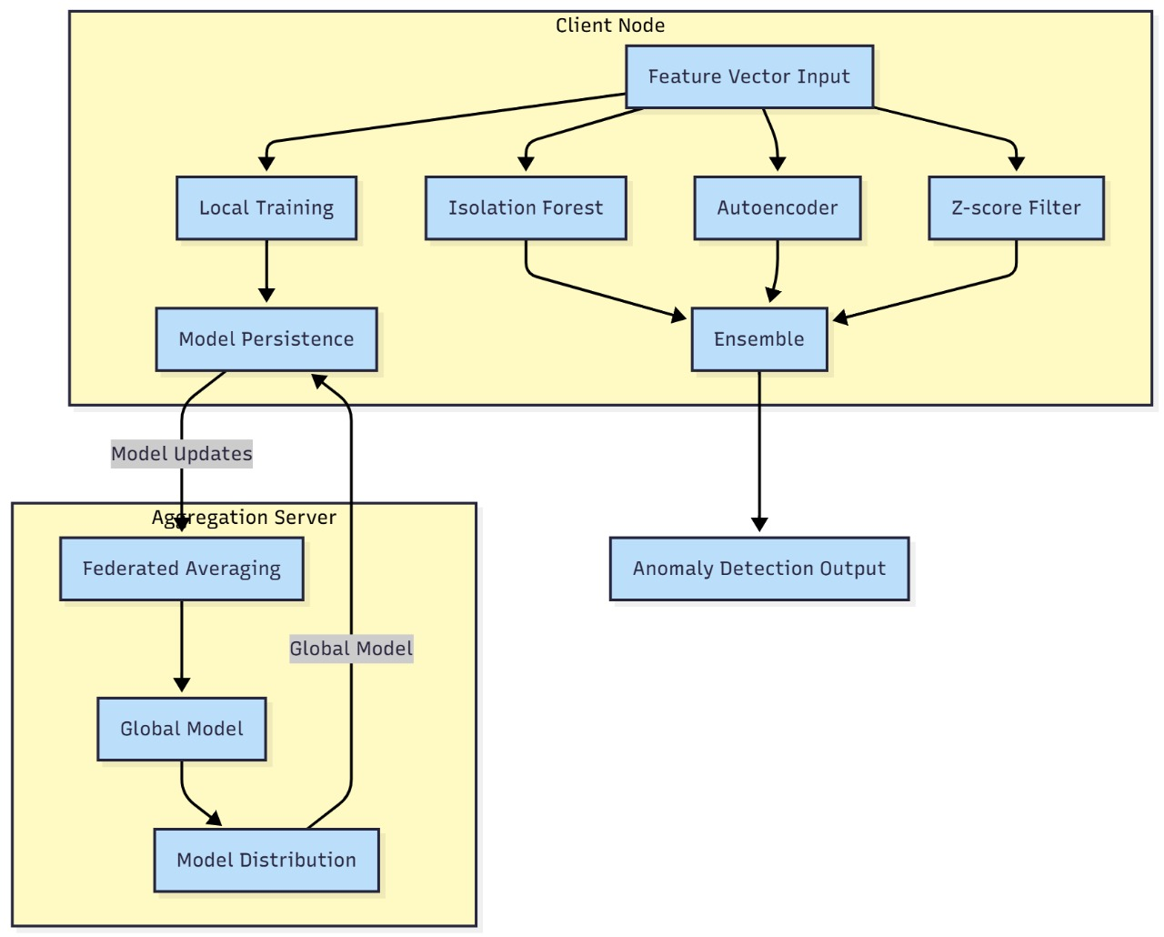
Fig. 4.1 Proposed System Architecture

The FortifAI system architecture is implemented as a distributed client-server structure that is enhanced with federated intelligence, which allows real-time detection of anomalies at the endpoint devices with protection of user privacy. On the client endpoint, a small FortifAI Agent continuously reads live events on the system, including network flows, process behavior, file system changes, and user activity. These occurrences are handed over to the Feature Window Manager which is used to carry out sliding-window aggregation, normalization and entropy-based statistical computation to transform raw telemetry into useful behavioral features. The data are then processed and converted to structured vectors by the feature vectorization module.
After feature preparation, it is locally analyzed with a three-tier machine learning ensemble of a Z-Score statistical outlier filter, an Isolation Forest of unsupervised anomaly detection, and a Deep Autoencoder, which learns subtle variations in terms of reconstruction error. The results of these models are used to create a local anomaly amount and risk level. The client produces a privacy-sensitive model update comprising of local statistics, modified thresholds, and learned patterns instead of sending raw logs or sensitive data. This update is coded to be sent to the server in an encrypted communication layer.
The server serves as the Federated Learning center of operation, which coordinates the generation of the global model and its enhancement. When the server is fed with model updates by several clients, it processes them with the Federated Learning Core which performs FedAvg aggregation, applies trimmed-mean defense to remove abnormal contributions, adds differential privacy noise to hide client identities and uses reputation scoring to give more weight to client contributions depending on their reliability. The resultant is its sophisticated global model version, redistributed to all the interconnected customers to strengthen their own detection.
The server, furthermore, has a dashboard that can administratively give real-time visibility of alerts that are happening in the entire system, client states, risk trends, and the overall performance of the model. The architecture guarantees a self-perpetuating learning cycle between clients and the server and has a high degree of data privacy as well as a scalable, low-latency, and flexible cybersecurity system that has been optimized to operate in current distributed settings.

4.2 System Algorithm
FortifAI is designed as a full end-to-end cybersecurity pipeline, which combines edge-level anomaly detection, privacy-preserving federated learning, and multi-model risk scoring to ensure the security of distributed environments. Such an approach describes the entire detection and learning process- starting with raw behavioral cues observed at the endpoints, and how these are improved on the central-server global model. Each of the phases in the FortifAI methodology is broken down in the following subsections.

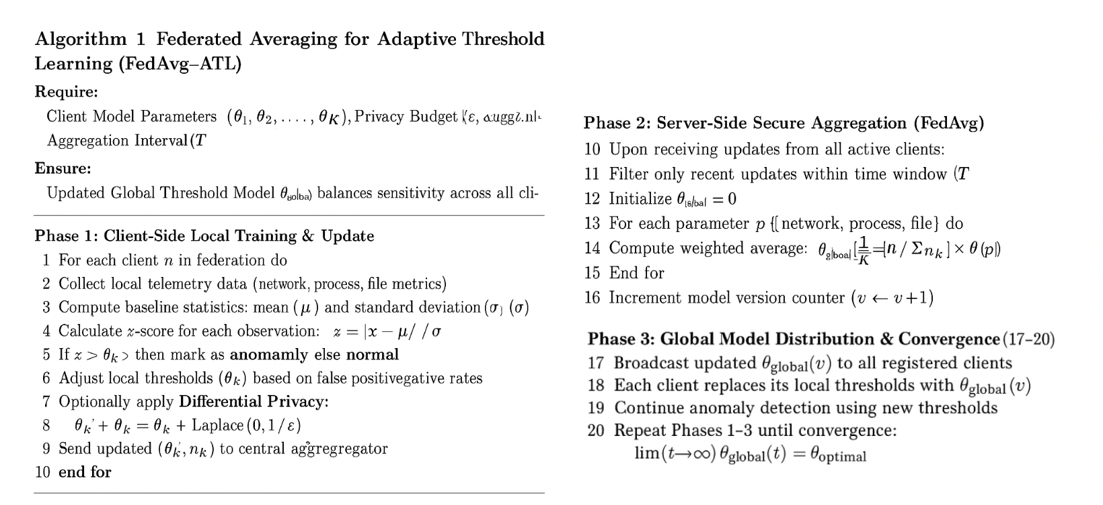

Fig 4.2 Algorithm Logic

4.2.1 Live System Telemetry Extraction (Preprocessing)
The initial phase of the FortifAI pipeline consists of the sustained extraction of rich behavioral features of the real-time activity in the system at every endpoint. The Client Agent records four significant telemetry streams, namely, network connections, running processes, filesystem events, and user activity patterns. Every event is real-time decoded and converted to a structured representation. In particular, network events have the count of connections, unique destinations, malicious-port indicators, and domain reputation checks whereas process-level data have the counts of CPU usage, memory usage, child/parent relationships, and command-line attributes.

Due to the noisiness and lack of consistency of raw telemetry over time, the Feature Window Manager will group these events into 60-second sliding windows. FortifAI calculates normalized metrics, entropy measures, temporal distributions and statistical summaries within each window. The preprocessing stage transforms raw logs which are heterogeneous and have different features into machine-interpretable feature vectors which give a stable base upon which future anomaly detection can be applied.

4.2.2 Unsupervised Anomaly Detection using Autoencoder
FortifAI uses a deep autoencoder which is only trained on the typical system behavior in order to identify abnormalities that indicate possible threats. Because the compact latent representations of benign activity are learned by the autoencoder, the model is very sensitive to behavioral patterns that are not similar to those that have been trained in the past. Upon inputting live windowed feature vectors through the model, reconstruction is sought by the autoencoder, and the resulting error of the reconstruction is a measure of the abnormality of the current system condition.

When this error score is high, it means that the behavior is unfamiliar or suspicious but when it is low, it means that the behavior is routine. The unsupervised detection mechanism is specifically efficient at detecting new, sneaky or zero-day attacks that are not discussed by signature-based or labelled datasets. The autoencoder is thus a general anomaly gate, indicating system actions which need further consideration.

4.2.3 Multi-Model Threat Assessment using Z-Score and Isolation Forest
Simultaneously with the autoencoder, FortifAI employs more detection layers to boost the reliability and decrease false positives. The Z-Score filter offers a statistical verification of extreme deviations against local baselines, i.e. sudden spikes or abnormal frequency distributions. An unsupervised tree-based model, Isolation Forest, is based on multidimensional behavior analysis and isolates anomalies based on how readily they can be separated, as opposed to normal points.

This multi-model ensemble allows FortifAI to identify not only the minor deviations (through autoencoder) and dramatic statistical outliers (through Z-Score) but also multidimensional anomalies with the help of Isolation Forest. The combination also increases the coverage of the detection as well as enable the system to differentiate between the occasional malicious occurrences and benign variation.

4.2.4 Local Risk Scoring and Model Update Preparation
All the streams of the detection models Autoencoder, Z-Score, and Isolation Forest are inputted to the local ensemble decision engine. The module combines the score of anomalies, combines the contributions of the score, and produces a final risk level, which is either Low, Medium, High, or Critical. FortifAI also calculates local threshold modifications and statistical summaries, which are sent to the server instead of the raw logs, and this is based on the behavioral trends of the endpoint.

The federated learning contribution is based on these updates. FortifAI produces a privacy-preserving update of models with local threshold updates, environment-specific patterns, and contribution weights. Differential Privacy may also inject tuned noise to protect sensitive data prior to the transmission of updates to the central server.

4.2.5 Federated Aggregation and Global Model Optimization
All the active clients update the central server and process them on the Federated Learning Core. To ensure reliability, first, the stale or incomplete updates are filtered. The server subsequently undergoes strong aggregation through a FedAvg-based system in which the clients make their contribution weighted by their volume of data and reputation. A trimmed-mean defense filters out high-extremity or poisonous updates, a differential privacy noise is such that no internal behavior of a client can be recuperated.

The resultant aggregated parameters are a new version of Global Model; this involves the learning that is combined with all the clients involved. With the contributions of different environments, the system is able to get more generalized and able to identify anomalies in a broad spectrum of endpoint behaviors.

4.2.6 Global Model Distribution and Continual Convergence
After completing the global model, it is re-sent to all the clients who update their local thresholds to the new values. This makes sure that endpoints can enjoy shared learning instead of utilizing isolated information only. The national thresholds are once again used immediately in anomaly detection to produce enhanced sensitivity and reduced false positives.

FortifAI is a three phase cycle-local training, secure aggregation and global model distribution-which is repeated until convergence on a model. The global threshold model converges to an optimal value with robustness, accuracy of detection and environmental adaptation of all clients.

4.3 Requirements
This section outlines the hardware and software requirements essential for implementing the Federated Multi-Model Endpoint Anomaly Detection System. The agent integrates real-time system monitoring, feature-windowing, ensemble ML anomaly detection (Isolation Forest + Autoencoder), GUI visualization, and federated learning support. The development and execution rely on the project codebase hosted at your repository (placeholder) and are designed to ensure deployability across diverse endpoint environments, scalability for fleet deployments, and efficient ML-assisted anomaly detection.

4.3.1 Software Requirements
i. Programming Language
- Python 3.10+
Used for implementing realtime collectors, feature extraction, anomaly detection pipelines (AE/ISO), GUI interface, federated learning, model caching, and server communication.

ii. Core Libraries
- Machine Learning & Statistical Models
  - scikit-learn — Isolation Forest, StandardScaler, preprocessing
  - TensorFlow / Keras or PyTorch (whichever your AE uses) — Autoencoder training + inference
  - NumPy, SciPy — numerical computation and vectorization
  - pandas — storage, processing, and formatting of feature windows
- System Monitoring & Data Collection
  - psutil — CPU, memory, process, handle, I/O metrics
  - os, subprocess, platform — system data extraction
  - socket, hashlib — system identity, hashing, network querying
- Networking & Communication
  - pickle — serialization of model weights + telemetry
  - socket — client-server communication (TCP)
  - requests (optional) — fallback for HTTP-based telemetry
- User Interface (GUI)
  - tkinter — native GUI for anomaly visualization
  - ttk — treeview tables and structured visualization components
- Utilities & Parallel Execution
  - threading — collection loop, heartbeat loop, FL updates, training loop
  - deque — sliding anomaly buffers and window queues
  - collections — structured event storage

iii. ML Models and Detection Components
- Isolation Forest:
Lightweight unsupervised anomaly detector trained locally over feature windows.
- Deep Autoencoder:
Neural reconstruction-based anomaly detector trained on benign feature distributions.
- Hybrid Ensemble Detection Engine:
Combines Z-score, ISO score, and AE reconstruction error into:
  - unified severity scoring
  - feature-level explainability
  - deduped anomaly alerts
  - model-driven thread-level risk estimation
- Federated Learning Client Module:
  - Generates model updates (weights or deltas)
  - Applies aggregated global models
  - Performs model caching using server-side storage

iv. Environment Management
Recommended environment setup:
python -m venv env
source env/bin/activate (Linux/macOS)
env\Scripts\activate (Windows)
pip install -r requirements.txt

v. Development Tools
- IDE: VS Code / PyCharm / Jupyter Lab
- Version Control: Git & GitHub
- Debugging Utilities: Logging, Tkinter debug console, packet/process simulators

vi. Testing Tools
- unittest / pytest — validation of detectors, collectors, and ML modules
- Simulated System Events — mock filesystem/network/process events for testing
- Replay Datasets — recorded feature windows for AE/ISO re-training

vii. Server-Side Components (For Federated Learning)
- Supports:
  - model aggregation
  - caching of client-generated models
  - reception of telemetry
  - registration & heartbeat management
- Pickle-based model serialization module
- FL aggregator logic (FedAvg or custom delta-based)

4.3.2 Hardware Requirements
i. Client Endpoint Device
The system is designed to run on standard enterprise or consumer endpoints.
Minimum:
- CPU: 2-core processor (Intel/AMD/ARM)
- RAM: 4 GB
- Storage: 5 GB free
- OS: Windows / Linux machine for endpoint monitoring
Recommended:
- 4-core CPU
- 8–16 GB RAM (for smoother AE training)
- SSD storage (for fast model caching + logs)

ii. Server / FL Aggregation Node
Responsible for model aggregation, model caching, and telemetry processing.
- CPU: Quad-core
- RAM: 8 GB
- Storage: 20 GB
- Network: Low-latency connection (≥10 Mbps)
Optional:
- GPU (NVIDIA 4–8 GB VRAM) — speeds up federated Autoencoder aggregation
- Containerization via Docker/Kubernetes for scaling multi-client FL setups
iii. Network Requirements
- Stable connectivity for:
  - model uploads/downloads
  - telemetry streaming
  - periodic heartbeats
- Minimum recommended: 5–10 Mbps
iv. Optional Hardware for Advanced Scenarios
- Edge Accelerator / NPU: For ultra-low power endpoints
- Dedicated Storage Partition: For high-volume telemetry/log archival
- Isolated testbed: To replay attack traffic or simulate anomalies

5. Results
The first phase of the evaluation focused on the unsupervised learning component. The Autoencoder was trained on benign network traffic flows to learn a compressed representation of "normal" behavior.
5.1 Model Training and Convergence
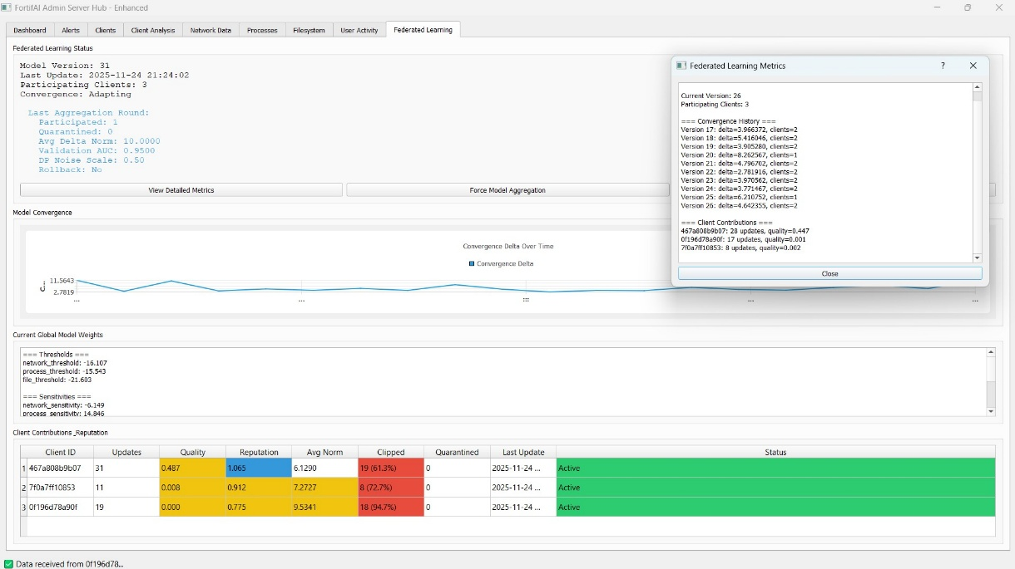
Fig. 5.1 Federated Learning Training
Figure 5.1 displays the live Federated Learning (FL) training process in the FortifAI Admin Server Hub. The server is constantly updated with models over the network with three clients involved, each of which provides locally trained thresholds and statistical parameters but does not provide any actual data. The interface presents the version of the current global model, the recent time of update and the number of clients participating as well as the convergence status. The convergence history window shows that the delta values between local and global models decline with a round, showing how the federated model is stabilized as explained in the FedAvg workflow. The client contribution table also shows the quality of each of the clients updates as well as the number of updates placed, L2 norm differences, and percentage clipping and the reputation score assigned. These measurements are associated with the sound FL pipeline, in which the updates are clipped with norm, aggregated with trimmed-mean, and injected with noise through differential privacy as in the implementation. In general, this number proves the fact that the federated aggregation mechanism is functioning properly, and adaptive learning takes place between distributed clients.
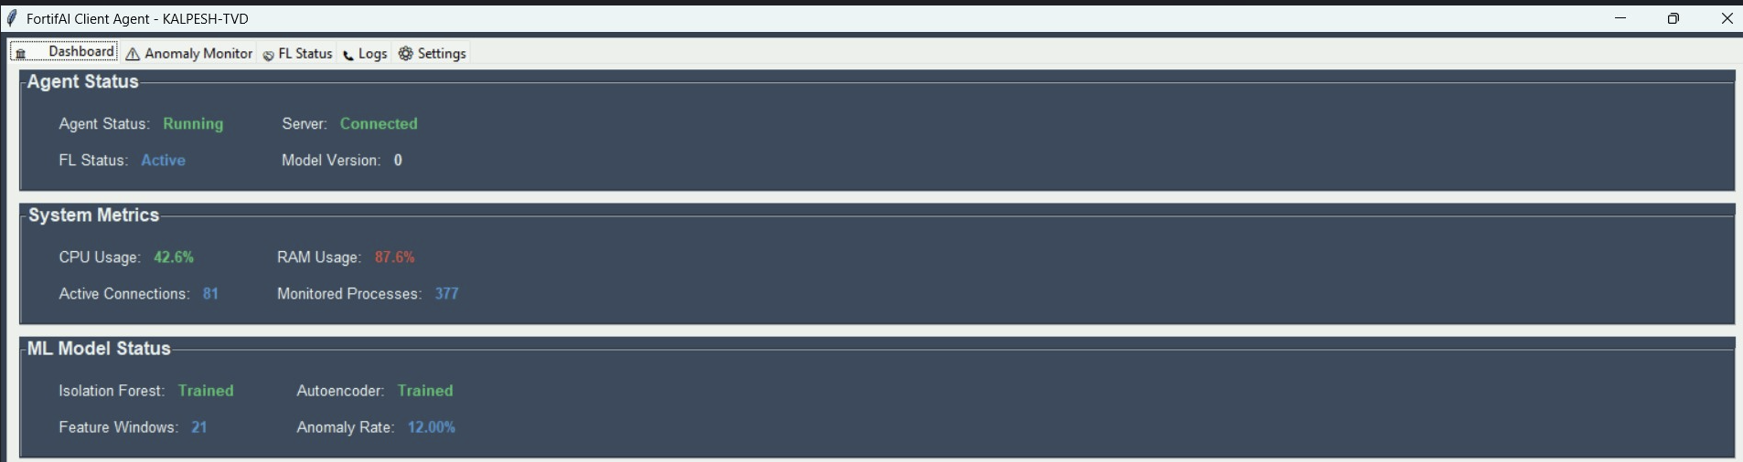
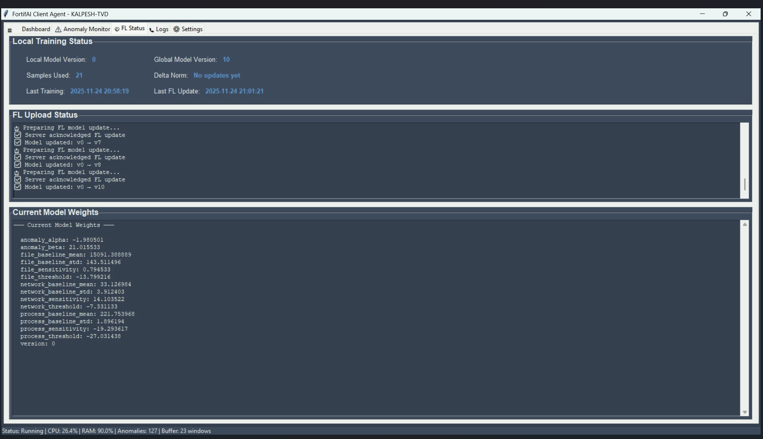
5.2 Anomaly Rate and Federated Model Thresholding
Figure 5.2 represents the operational status of an endpoint system within FortifAI Client Agent. The agent is depicted running and linked to the central server, and systems metrics of CPU usage, RAM utilization, current network connections, and processes under monitoring justifies the lightweight characteristics of the client runtime. The Local training status panel shows the version of the local model, the number of samples gathered, delta norms and last training and upload times. These values would be used in the client-side learning step, during which the system computes baseline statistics, identifies anomalies with Z-score filters, Isolation Forest, and Autoencoder models and changes threshold parameters based on them. The FL Upload Status log illustrates the repetitive nature of the process of making model updates, publishing them via the server and getting feedback- directly corresponding to Steps 2 and 3 of the federated workflow outlined in the uploaded FedAvg documentation. The Current Model Weights panel shows the acquired thresholds and sensitivity scores in the network, process, and filesystem domains, which proves that local pattern of behavior is shaping the parameters of anomaly-detection used by the client.
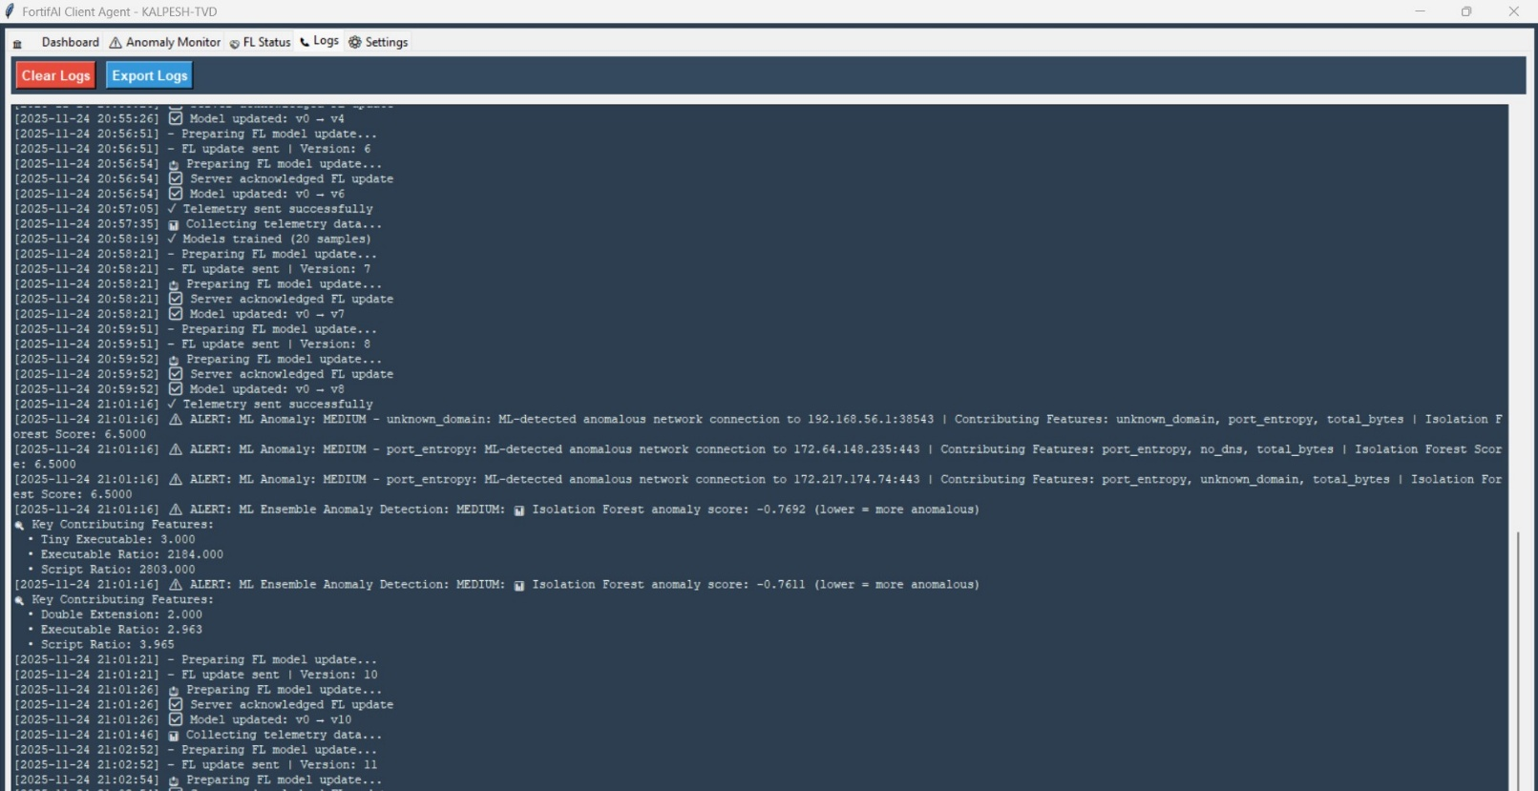
Fig. 5.3 Federated & ML Models Training
Figure 5.3 displays the chronological summary of federated learning updates and machine learning-generated anomaly detections logged by the FortifAI Client Agent. The log lines record recursive cycles of model updates; preparation of local model updates, server returns, and reconciliation of versions of the updated global model. Such communications confirm correct client-server communication in the federated learning cycle. The log also captures the various anomaly alerts produced by the ML ensemble pipeline such as anomalies identified by the Isolation Forest and Autoencoder models. The alert items have the anomaly score, the level of severity or the important contributory features of unknown domains, port entropy, unusual volume of bytes, script ratio, or the existence of double extensions. Such patterns are consistent with 14-dimensional feature vectors and model-based anomaly-detection systems outlined in the FortifAI architecture file, indicating that the multi-tier ML system is currently processing network, process, and file events and generating actionable, interpretable security alerts.
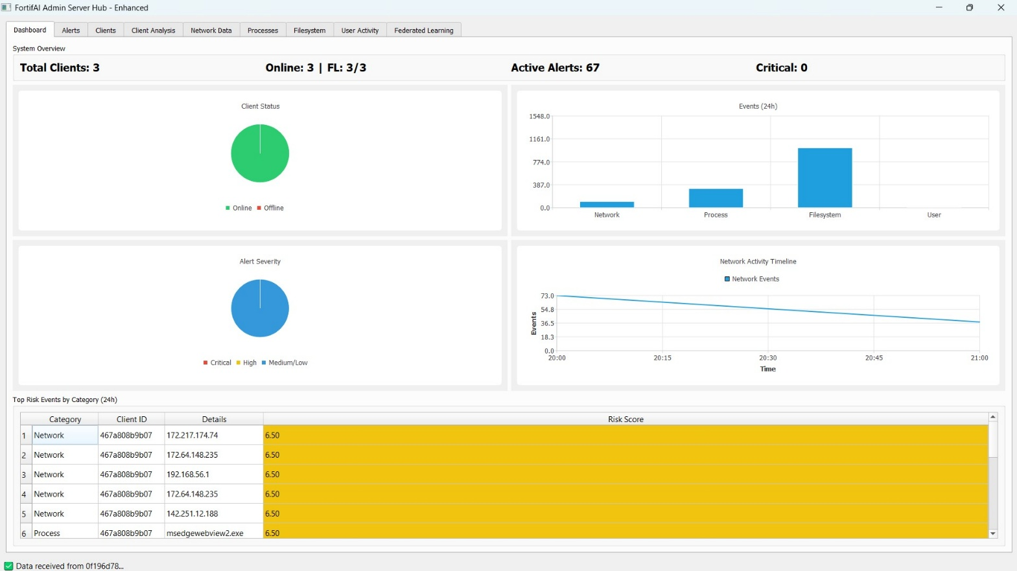
Fig. 5.4 Server Multi-Model Analysis
Figure 5.4 shows the main screen of the FortifAI Admin Server Hub, which is used to monitor the aggregated intelligence of all client devices in a graphic manner. It is shown on the dashboard that all three deployed clients are online and engaged in federated learning. Finally, there are different graphical panels to show distribution of client statuses, severity of active alerts and event categories perceived in the last 24 hours in the network, process, filesystem and user activities. The network activity timeline is used to see the trend of activities over time, enabling analysts to be able to correlate the abnormal spikes or decreases in behavior. The bottom part provides a list of the high level of risk events identified throughout the clients, such as suspicious IP connections and possibly malicious processes. Such risk scores are obtained as the result of the integrated multi-modal anomaly detection pipeline, which integrates the ML-based anomaly scoring with the rule-based threat indicators as defined in the FortifAI specification. This number confirms that the server is successful in combining telemetry and ML signals of every client and offering a single, real-time perspective of security posture.
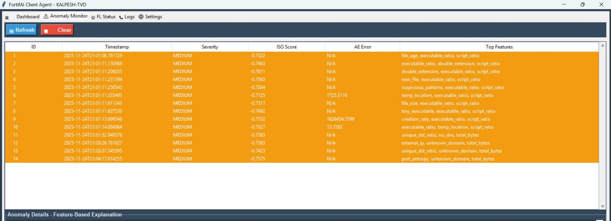
Fig. 5.5 Anomaly Detection Alerts
Figure 5.5 shows the anomaly alerts that occurred on the client-side showing the list of identified events with the timestamps, the severities, the Isolation Forest anomaly scores, the Autoencoder reconstruction errors, and the most influential features. The above anomalies are listed: file-age anomalies, executable ratios, suspicious file extensions, unknown network domains, and abnormal port entropy- each of them is directly related to feature-engineering and anomaly-detection logic as implemented in the FortifAI architecture. The fact that negative Isolation Forest scores are present and the error in reconstruction is high indicates that the ML ensemble is detecting events which are not following the existing behavioral baseline. This gives FortifAI the explainability component as the characteristics that were added to each alert help the analyst to identify why an alert was activated instead of viewing the model as a black box. This number confirms the overall processing of the anomaly detection pipeline, which demonstrates its capacity to detect, rank, and reason abnormal activity on an endpoint.
6. Conclusion

The FortifAI framework shows how artificial intelligence techniques manage to solve different challenges that are present in cybersecurity, especially problems related to distributed and privacy-sensitive environments. Our framework combines multi-modal anomaly detection, federated learning, and explainable AI to create a system that allows effective and real-time monitoring of network, process, filesystem, and user-activity patterns without needing to rely on centralized data collection. By combining methods like Z-Score filtering, Isolation Forest, and Deep Autoencoders we managed to identify difficult and previously unseen threats that traditional security tools generally fail to catch. Meanwhile, including federated learning in our framework ensures that each client can contribute to the model without needing to show raw telemetry while following data protection and compliance requirements.

It also enhances automation, scalability and intelligence of the process flows of endpoint defense. FortifAI also helps in reducing the cost and time spent on a manual threat analysis and also, it brings a more flexible and privacy ensuring methodology which can be applied to different real world scenarios. FortifAI offers as a better alternative to the traditional centralized models, as it allows continuous learning on the edge and still manages to provide some form of resilience to model poisoning using techniques like clipping, reputation scoring, and strong aggregation. In addition, explainability features allow security analysts to have a clear understanding by providing reasons behind each alert that is sent.

In the future we aim at adding other flexible architectures like Graph Neural Networks and sequence model Transformers which enhances inference efficiency and multi-client threat pattern correlation. We also check real-world applicability using the concept of SIEM integration and federated training and applying it to hundreds of nodes. Overall, FortifAI is an effective alternative which is built using current literature on AI-powered cybersecurity as a reference and has a good potential for further research in privacy-friendly threat detection.

7. References

[1] M. M. A. al-Rakhami, “Intrusion Detection based on Federated Learning: A Systematic Review,” 2023.
[2] C. Zoppi, E. Mariconti, and G. Russo, “Decentralized Online Federated G-Network Learning for Lightweight IDS,” 2023.
[3] Z. B. Khan and T. Mahmood, “FEDGAN-IDS: Privacy Preserving IDS using GAN & Federated Learning,” 2022.
[4] H. Du, X. Liu, and J. Zhang, “Deep Reinforcement Learning for Cybersecurity Threat Detection and Protection: A Review,” 2022.
[5] R. S. Rathee, S. Garg, and N. Kumar, “Federated Learning for IDS: Concepts, Challenges and Future Directions,” 2021.
[6] H. L. Nguyen, T. A. Bui, and K. R. Pham, “Enhancing Privacy-Preserving Intrusion Detection through Federated Learning,” 2022.
[7] L. Liu, W. Wu, and S. Zhang, “Secure Intrusion Detection by Differentially Private Federated Learning for Vehicular Networks,” 2023.
[8] A. Alsaedi and M. H. Rehmani, “Advancements in Securing Federated Learning with IDS: Neural Networks & Feature Engineering,” 2024.

