**MOTILAL NEHRU NATIONAL INSTITUTE OF TECHNOLOGY ALLAHABAD**

**Department of Computer Science & Engineering**

**BTech-I Semester**

**Computer Programming (CSN11101)**

**Lab Assignment -8**

**Functions, Array, Pointers**

1. 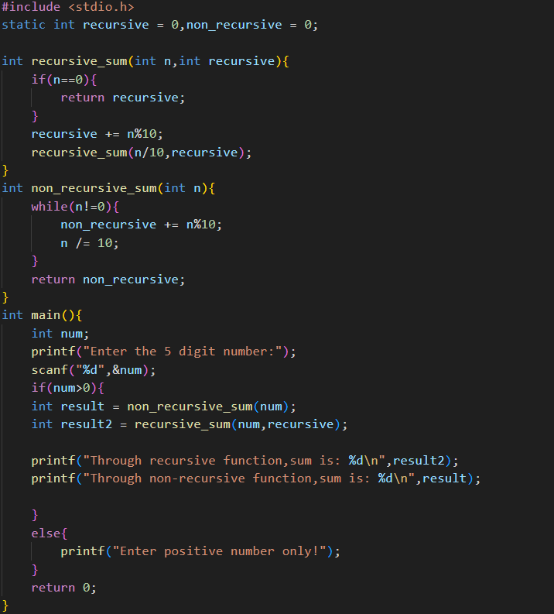Write a program to calculate the sum of digits of a 5-digit positive integer entered through the keyboard using both recursive and non-recursive functions.

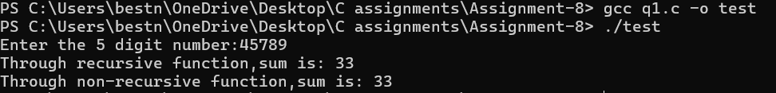

1. Write a C program to reverse an array using

a) Recursive function

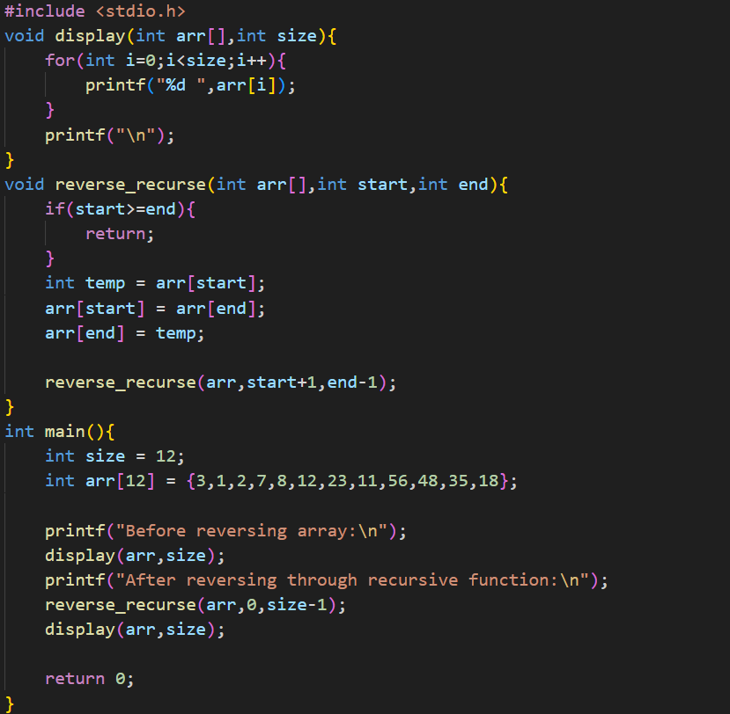

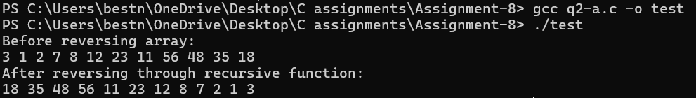

b) Non-recursive function

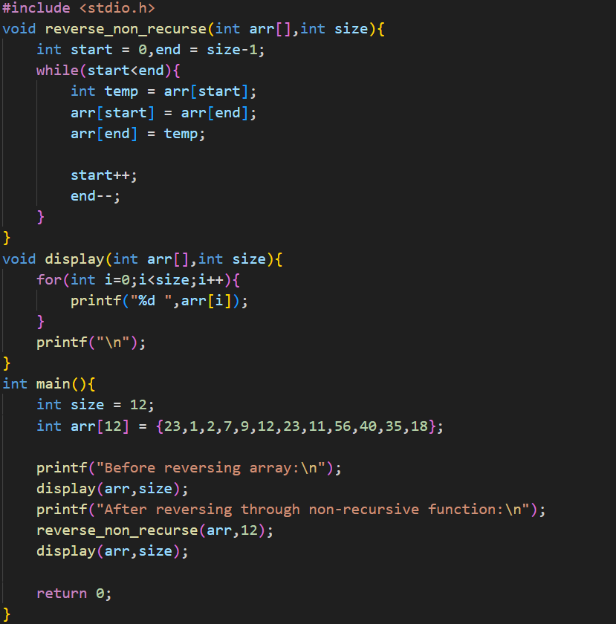

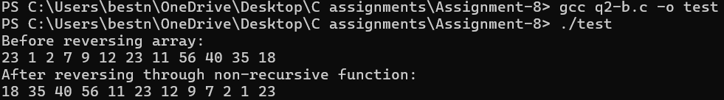

1. Write a program to obtain the prime factors of a positive integer entered through the keyboard. Modify the function suitably to obtain the prime factors recursively.

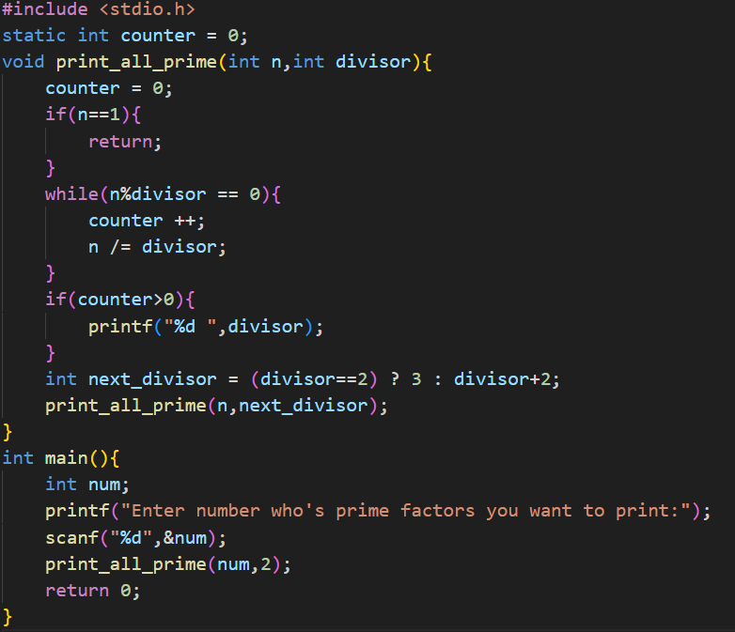

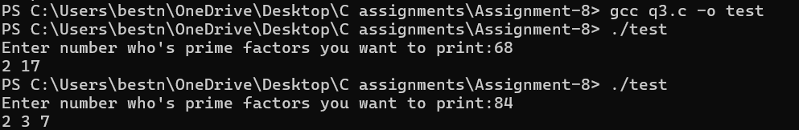

1. 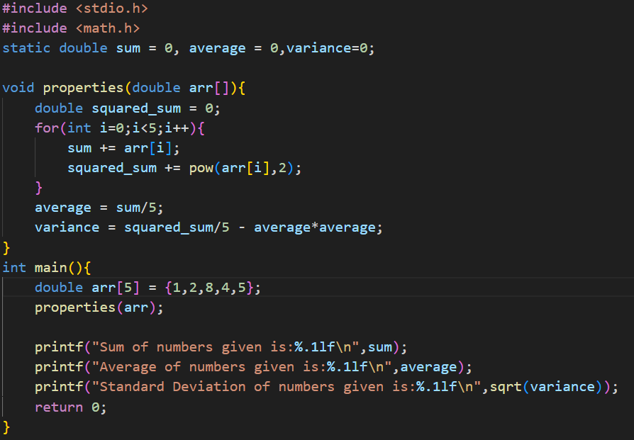Write a program to define a function that receives 5 integers and returns the sum (without using the return statement), average, and standard deviation of these numbers. Call this function from the main() and print the result in main().

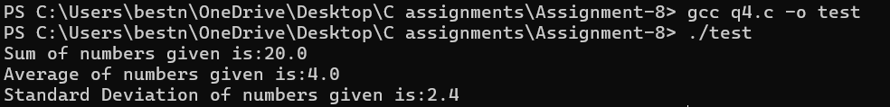

1. Tower of Hanoi is a mathematical puzzle where we have three pegs (A, B, and C) and N disks. Initially, all the disks are stacked in decreasing value of diameter i.e., the smallest disk is placed on the top and they are on peg A. The objective of the puzzle is to move the entire stack to another peg (here considered C), obeying the following simple rules:

* Only one disk can be moved at a time.
* Each move consists of taking the upper disk from one of the stacks and placing it on top of another stack i.e. a disk can only be moved if it is the uppermost disk on a stack.
* 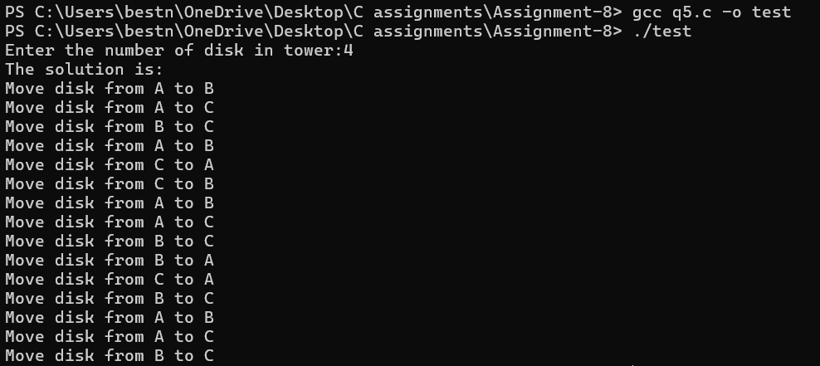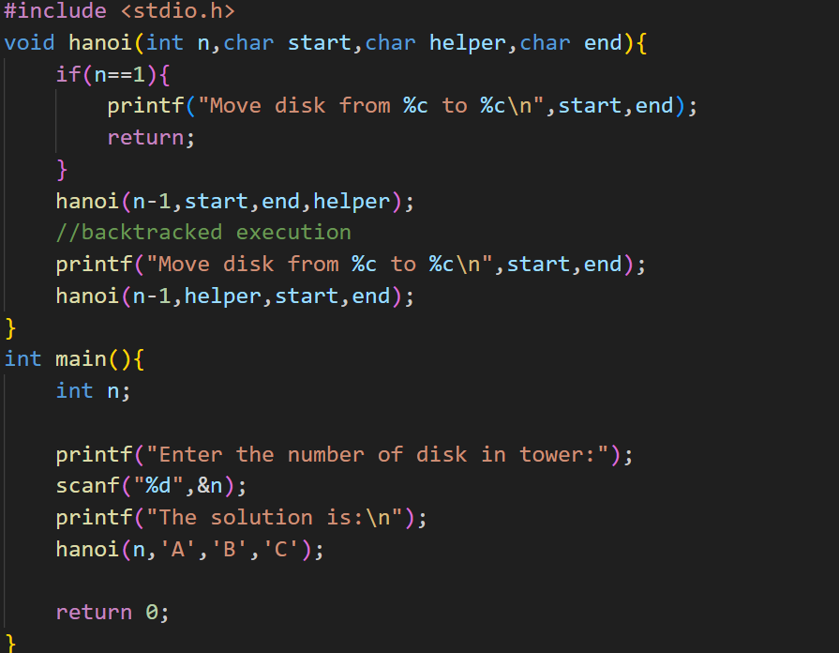No disk may be placed on top of a smaller disk.