**Requirements:**

1. Raspberry Pi
2. Memory card
3. Charging cable for power
4. HDMI cable
5. Keyboard
6. Mouse
7. LCD with HDMI port

**Installing Raspbian OS on Raspberrypi3:**

<https://www.raspberrypi.org/downloads/raspbian/> link to Os and Download this -> Raspbian Buster with desktop and recommended software (size 2541MB) (Remember username and password while installing → Suggestion Username: root & password: root

<https://www.raspberrypi.org/documentation/installation/installing-images/README.md> Installation guide to install os

**Process to execute code on raspberrypi3:**

* Open chromium on raspberrypi3
* Download code(pda.py)
* ctrl+Alt+t -> to open the terminal
* Use this command to get root access: sudo bash → after this press enter if password and username is needed enter username and password that you set before.
* Install Python3 latest version by entering: apt install python3
* To verify Python3’s version use: python3 --version
* Navigate to the Downloads folder: cd Downloads
* Execute the downloaded code by using this command: python3 pda.py

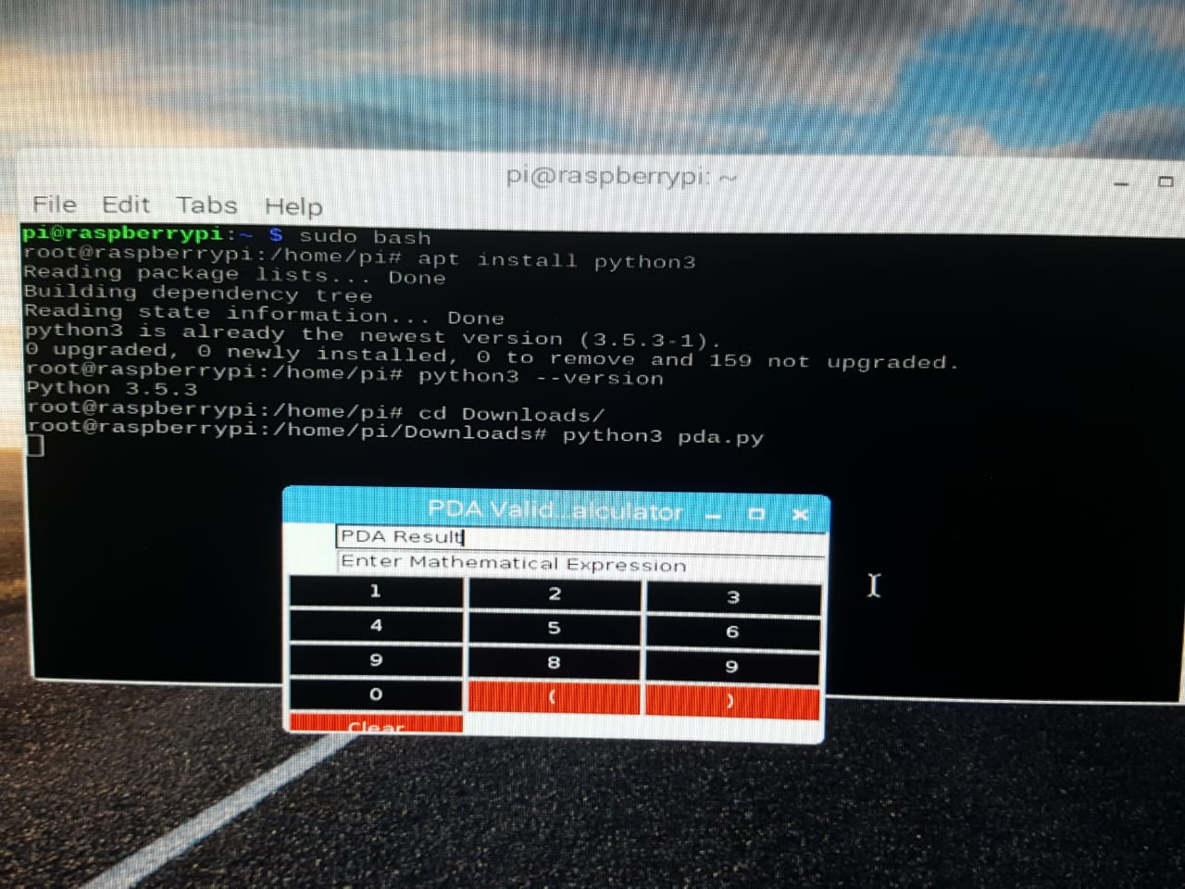

**Commands are marked with the orange line**

