WPMS — Use Case & Activity Diagrams
Prepared by: Aman Kumar Yadav

Use Case Diagram
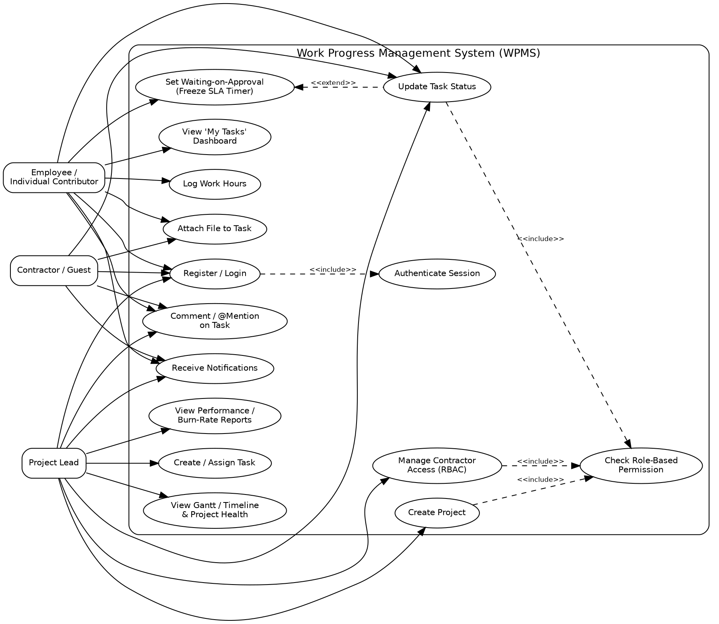
Figure 1 — Use Case Diagram for WPMS

Activity Diagram — Task Lifecycle
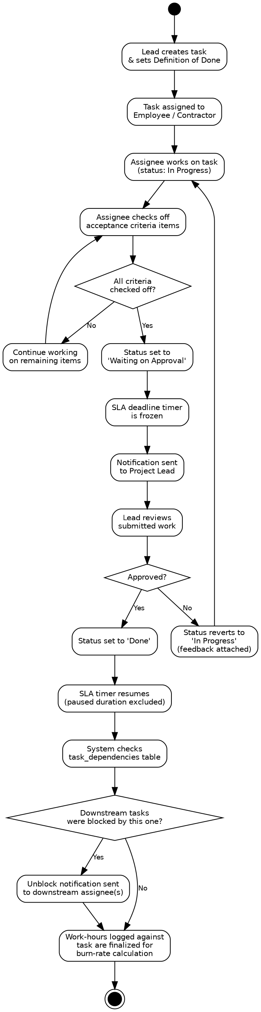
Figure 2 — Activity Diagram: Task Lifecycle (Creation → Completion)

