Supply Chain Analytics
Identifying Cost, Quality, and Inventory Risks Across the Supply Chain
Prepared by: Fatima Shafique
Tools Used: Python (Jupyter Notebook) MySQL · Power BI
Date: June 2026

Executive Summary
This project analyzes a 100-SKU supply chain dataset spanning haircare, skincare, and cosmetics products to identify where the business is losing money or facing operational risk across supplier quality, logistics cost, and inventory management. Data was cleaned and explored in Python (Jupyter Notebook), loaded into a MySQL database for structured querying, and visualized in an interactive Power BI dashboard.
Across $577.60K in total revenue and 46K units sold, the analysis surfaces three actionable findings: (1) defect rates vary meaningfully by supplier, with Supplier 5 nearly 50% above the best performer; (2) Road and Rail transport carry the highest cumulative cost; and (3) a large share of SKUs fall outside a healthy stock-to-sales range, indicating inventory imbalance. Recommendations are detailed in Section 5.

1. Business Problem
The company is experiencing inconsistent product availability, fluctuating defect rates, and unclear cost drivers across its supply chain spanning suppliers, carriers, transportation modes, and manufacturing. Leadership lacks visibility into where money is being lost: through high shipping costs, underperforming suppliers, inefficient routes, or stock imbalances. This project was scoped to close that visibility gap and surface concrete, data-backed recommendations.

2. Objectives
- Cost efficiency: identify which suppliers, carriers, and transport modes drive the highest cost relative to volume
- Quality control: identify which suppliers have the highest defect rates and whether inspection outcomes reflect that risk
- Inventory health: flag SKUs at risk of overstock (tied-up capital) or stockout (lost sales)
- Revenue performance: determine which product types and suppliers generate the most profit, not just revenue
- Logistics performance: comparing cost and speed across shipping carriers, routes, and transport modes

3. Methodology & Tools
The project followed a standard analytics pipeline, using a different tool for each stage of the workflow:
Stage | Tool | Purpose
Data Cleaning & EDA | Python (pandas, seaborn) in Jupyter Notebook | Cleaned column names, engineered new metrics (profit, cost per unit, stock-to-sales ratio), and explored initial patterns
Data Storage & Querying | MySQL | Hosted the cleaned dataset relationally and answered targeted business questions via SQL
Visualization & Reporting | Power BI | Built an interactive, filterable dashboard with DAX measures for profit, defect rate, and inventory risk

Key engineered metrics used throughout the analysis:
- Estimated Profit = Revenue Generated − (Manufacturing Cost + Shipping Cost + Transportation Cost)
- Cost per Unit Sold = Total Cost ÷ Units Sold
- Stock-to-Sales Ratio = Stock Level ÷ Units Sold (used to flag overstock/stockout risk)

4. Key Findings
The dashboard below (Page 1) summarizes overall performance and supplier quality; Page 2 focuses on profitability and inventory risk.
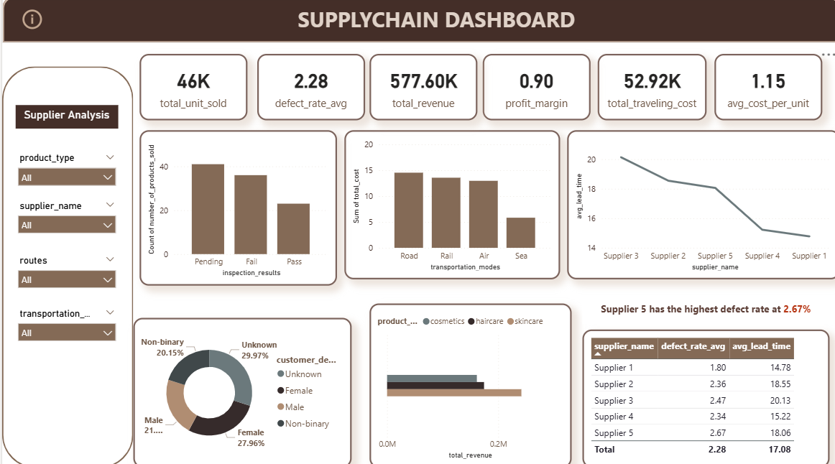
Figure 1: Supply Chain Dashboard — Overview, Quality, and Logistics (Page 1)

4.1 Overall Performance
- Total Revenue: $577.60K across 46K units sold
- Average Defect Rate: 2.28%
- Average Cost per Unit: $1.15 | Total Transportation Cost: $52.92K

4.2 Supplier Quality & Lead Time
Defect rates and average lead time vary meaningfully across the five suppliers:
Supplier | Avg. Defect Rate | Avg. Lead Time (days)
Supplier 1 | 1.80% | 14.78
Supplier 2 | 2.36% | 18.55
Supplier 3 | 2.47% | 20.13
Supplier 4 | 2.34% | 15.22
Supplier 5 | 2.67% | 18.06

Supplier 5 has the highest defect rate (2.67%) roughly 48% higher than Supplier 1, the best performer (1.80%). Supplier 1 also has the shortest average lead time (14.78 days), making it the strongest performer on both quality and speed.

4.3 Logistics Cost
Road and Rail transport account for the largest share of total transportation cost, followed by Air, with Sea the lowest. Since cost generally tracks inversely with delivery speed, Road's high cost despite being a typically faster mode is worth investigatingit may reflect route inefficiency rather than necessity.

4.4 Profitability by Supplier
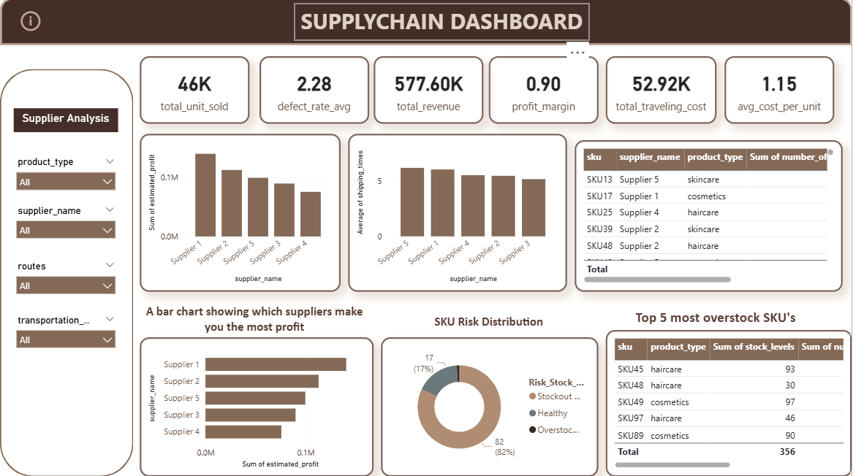
Figure 2: Supply Chain Dashboard, Profitability & Inventory Risk (Page 2)
Supplier 1 generates the highest total estimated profit, followed by Supplier 2 and Supplier 5; Supplier 4 generates the least. Notably, Supplier 5 ranks third in profit despite having the highest defect rate and among the slowest shipping times it remains profitable today, but carries the most quality and speed risk of any supplier in the portfolio.

4.5 Inventory Risk
The dashboard's stock-to-sales ratio analysis flags a large share of SKUs as outside a healthy stock range (most heavily skewed toward potential stockout risk), with a small number of SKUs including SKU45, SKU48, SKU49, SKU97, and SKU89 holding the highest absolute stock levels. This signals uneven inventory allocation: some products may be overstocked while many others run lean. See Section 6 for a caveat on calibrating the risk thresholds used here.

4.6 Customer Segment
Revenue is fairly evenly split across the three product categories (cosmetics, haircare, skincare), with no single category dominating. Customer demographic data shows a notably large “Unknown” segment (29.97% of records) larger than any single known demographic group which limits how confidently customer-segment conclusions can be drawn (see Section 6).

5. Recommendations
- Audit Supplier 5: its defect rate (2.67%) is the highest in the portfolio and its shipping times are among the slowest recommend a quality review or renegotiated terms, despite its current profitability.
- Investigate Road transport costs: it carries the highest cumulative cost of any transportation mode confirm whether this reflects necessary routing or an opportunity to shift volume to a cheaper mode without materially hurting delivery time.
- Rebalance inventory: prioritize the SKUs flagged as highest stockout risk for replenishment, and review the highest-stock SKUs (e.g., SKU45, SKU49, SKU89) for potential overstock before next reorder cycle.
- Replicate Supplier 1's model: it leads on profit, has the lowest defect rate, and the shortest lead time worth understanding what this supplier does differently (e.g., contract terms, location, production process) and whether it can be extended to other product lines.
- Improve customer demographic data capture: nearly 30% of records are “Unknown” fixing this at the point of data collection would unlock more reliable customer-segment analysis going forward.

6. Limitations & Next Steps
- Profit margin (reported at 0.90) appears high for a typical supply chain business and should be re-verified against the underlying cost components before being presented externally it may indicate the cost fields captured here don't represent all real-world cost categories (e.g., overhead, labor).
- The stock-to-sales ratio thresholds used to flag “overstock” vs. “stockout risk” were set provisionally; with ~82% of SKUs currently flagged as at-risk, the thresholds likely need recalibration against real historical demand patterns rather than fixed cutoffs, so the flagged list reflects relative risk rather than precise stockout predictions.
- This dataset covers a single snapshot in time (no dates), so trends over time (seasonality, improvement/decline) could not be analyzed a valuable extension would be tracking these same metrics monthly.
- Customer demographic analysis is limited by the high proportion of “Unknown” values.

Conclusion
This project demonstrates a complete, end-to-end supply chain analytics workflow from raw data cleaning in Python, through structured querying in MySQL, to an interactive decision-support dashboard in Power BI. The analysis identifies specific, named suppliers and cost centers driving risk and inefficiency, translating raw data into recommendations a supply chain manager could act on directly.

