Classification of Oral Cancer Into Pre-Cancerous Stages From White Light Images Using LightGBM Algorithm

Cancer remains one of the leading causes of death worldwide, accounting for nearly 10 million fatalities in 2020. Among cancers, oral cancer ranks as the sixth most prevalent globally. The high mortality rate is primarily due to late-stage detection, which could be significantly reduced through early screening and treatment during the pre-cancerous stages. This study introduces a novel approach to distinguish between benign and malignant oral cavity lesions and classify their pre-cancerous stages. The proposed method explores five unique color spaces and extracts color and texture features, which are then analyzed using the Light Gradient Boosting Machine (LightGBM) classifier. Experimental results demonstrate exceptional performance, surpassing existing state-of-the-art methods. The approach relies on hand-crafted features and an efficient machine-learning classifier, offering a resource-friendly and time-efficient solution for oral cancer classification.
Extension Concept
The extension of the proposed system integrates a hybrid deep learning model combining MobileNetV2 with a Support Vector Machine (SVM) classifier, enhanced through Histogram of Oriented Gradients (HOG) feature extraction. Unlike the primary LightGBM-based framework that relies on hand-crafted color and texture features, this extension leverages deep feature representations learned by MobileNetV2, which are further enriched by HOG descriptors to capture detailed edge and structural information relevant to oral lesion patterns. The extracted deep-HOG feature vector is then fed into an SVM classifier to achieve improved discriminative capability, especially in complex multi-class scenarios. This hybrid approach bridges traditional feature engineering and deep learning, offering a more robust, scalable, and generalizable solution, while maintaining computational efficiency suitable for real-time clinical applications.

MODULE DESCRIPTION
- Upload Dataset: Using this module we will upload our Oral cancer Dataset to application and then application read all the files in the dataset.
- Preprocess Dataset: Using this module we will replace missing values and normalize the extracted features and then split dataset into train and test where application used 80% dataset for training and 20% for testing.
- TrainLightGBM: using this module we will train TrainLightGBM with processed train data and then apply trained model on 20% test data to calculate prediction accuracy.
- Train Deep Model (MobileNetV2 + SVM): using this module we will train Train Deep Model (MobileNetV2 + SVM) with processed train data and then apply trained model on 20% test data to calculate prediction accuracy.
- Comparison Graph: using this module we will plot comparison graph between all models.
- Predict: using this module we will upload test data and then extract features and then apply trained model on extracted features to predict weather test data images have oral cancer or non cancer.
To Run this project Double click on “Run.bat” to get the Below screen.
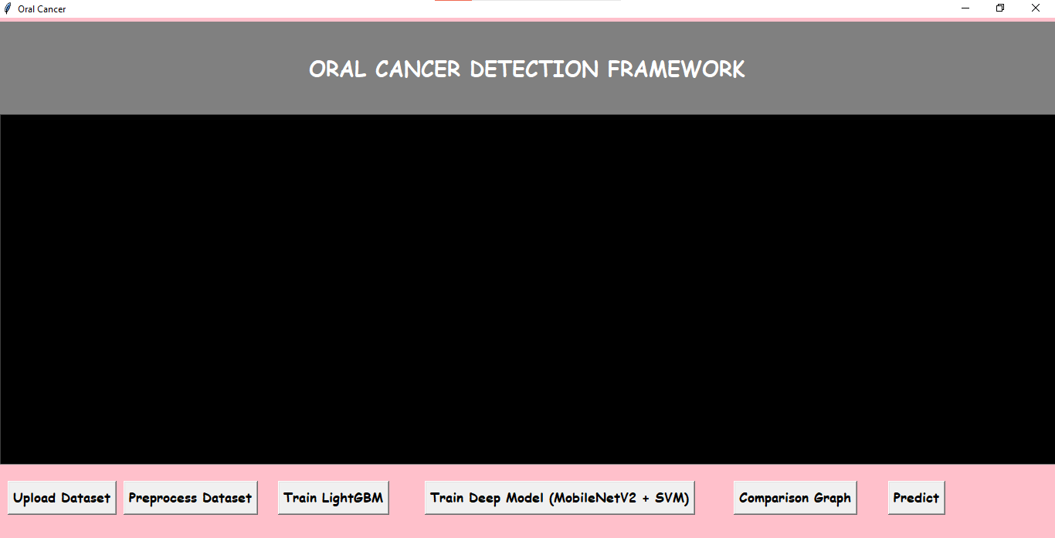
In the above screen we can see the user interface and now here click on ‘upload dataset’ button to get below screen
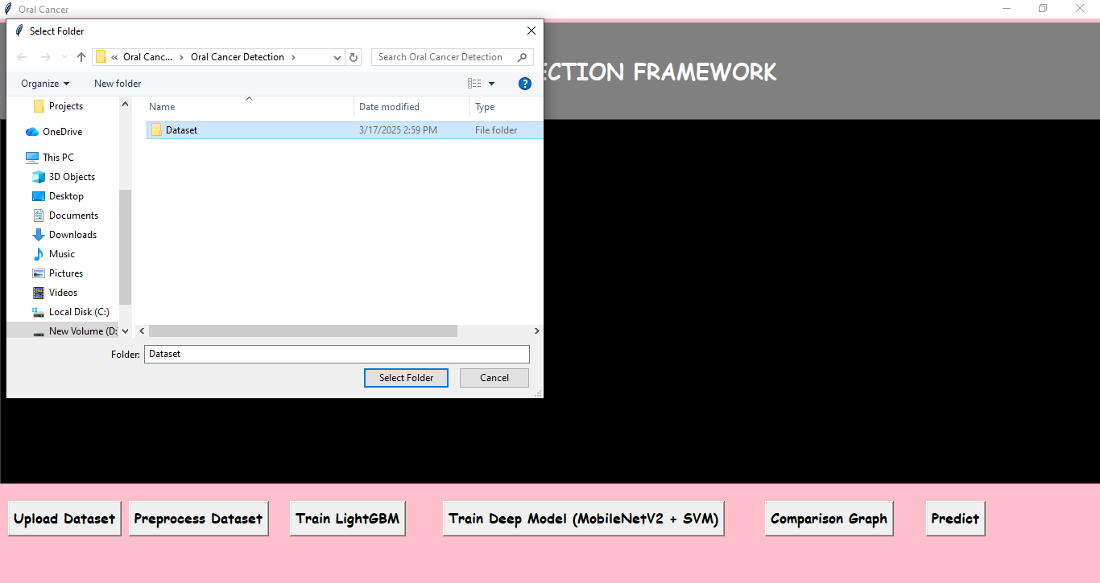
In the above screen select ‘Dataset’ folder and then click on ‘select folder’ to load dataset and to get below output

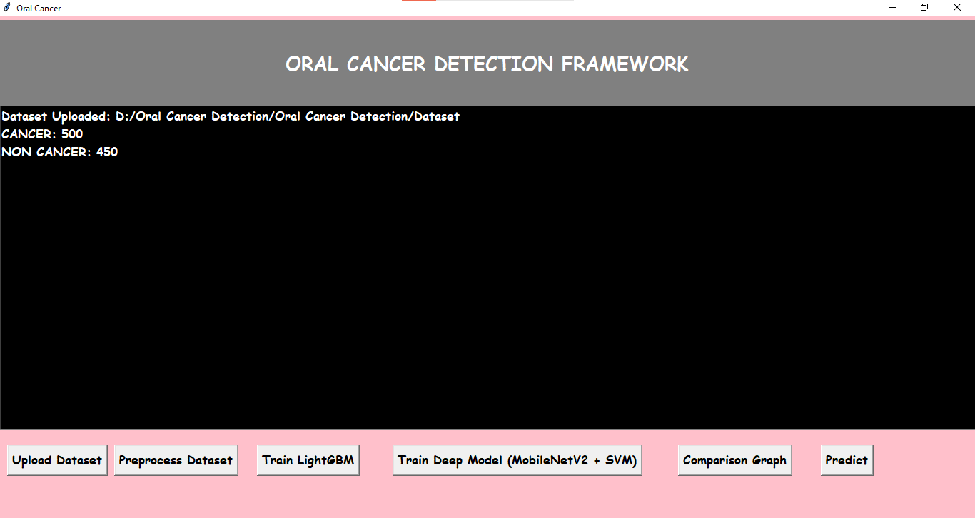
In the above screen we can see that dataset is uploaded and in that uploaded dataset we have 500 images of cancer and 450 images of non-cancer, now click on ‘preprocess dataset’ button to get below output.
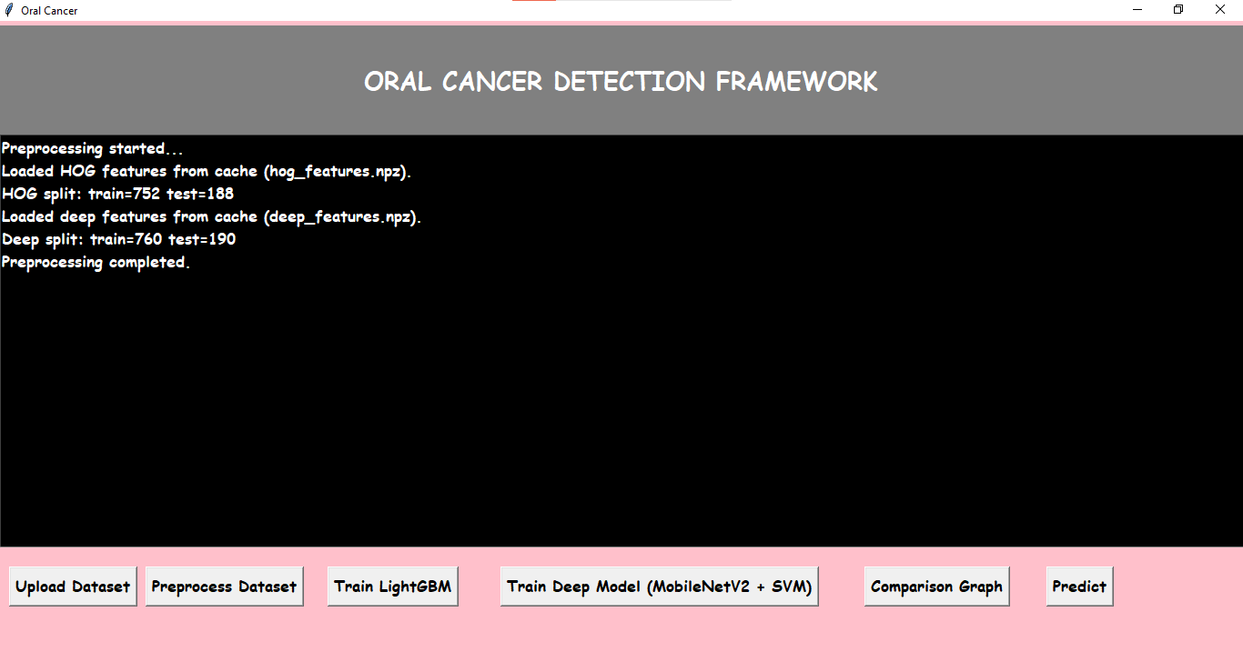
In the above screen we can see that the dataset is preprocessed and splitted for training and testing , now click on ‘Train LightGBM’ button to train LightGBM on Hog Features.
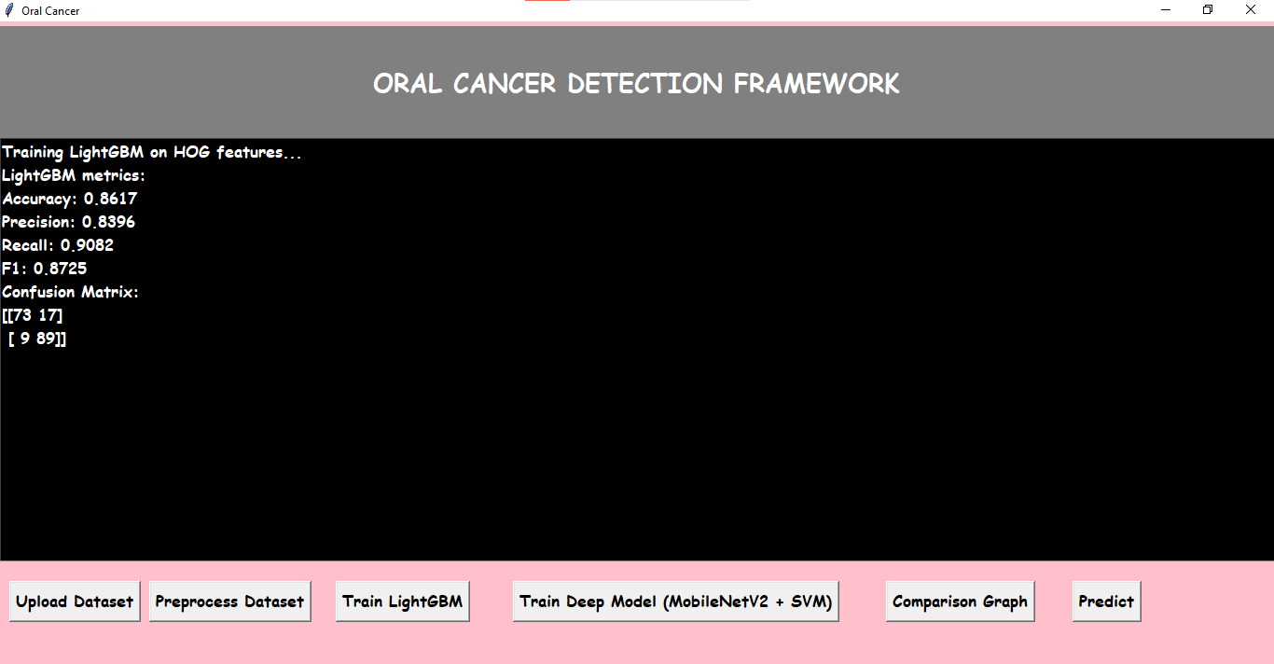
In the above screen with the LightGBM we got 86% accuracy, 83% precision, 90% Recall, 87% F1Score. Now click on ‘Train Deep Model (MobilNetV2 + SVM)’ button to get below output.
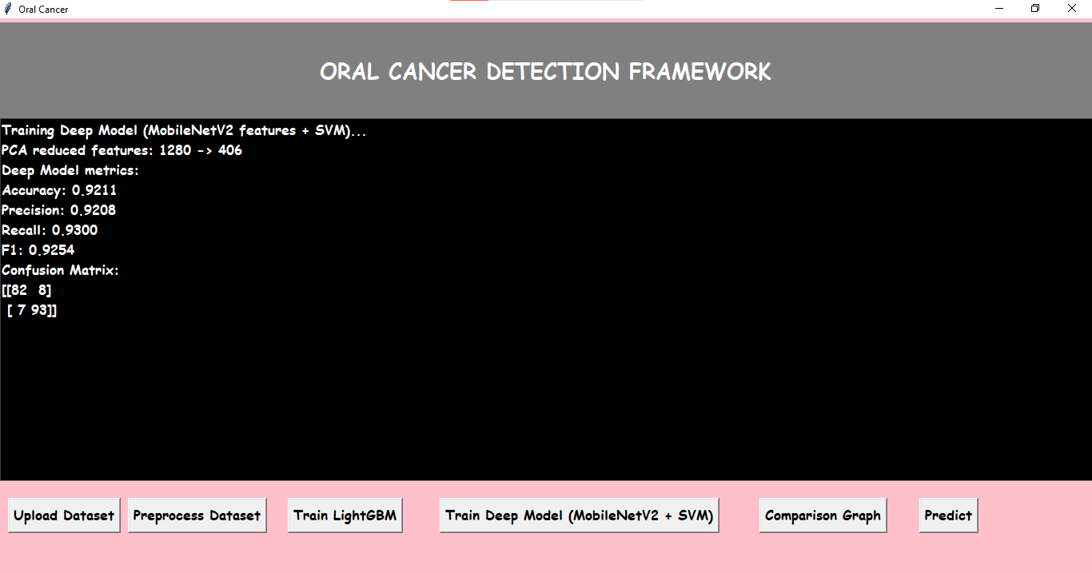
In the above screen we can see that MonileNetV2 + SVM gave 92% Accuracy by Reducing the features from 1280 to 406 using PCA, and we got 92% precision, 93% Recall, 92% F1score.
Now click on ‘comparison Graph’ button to compare the accuracy, precision, recall and F1score of both LightGBM and MobileNetV2 + SVM Algorithms.
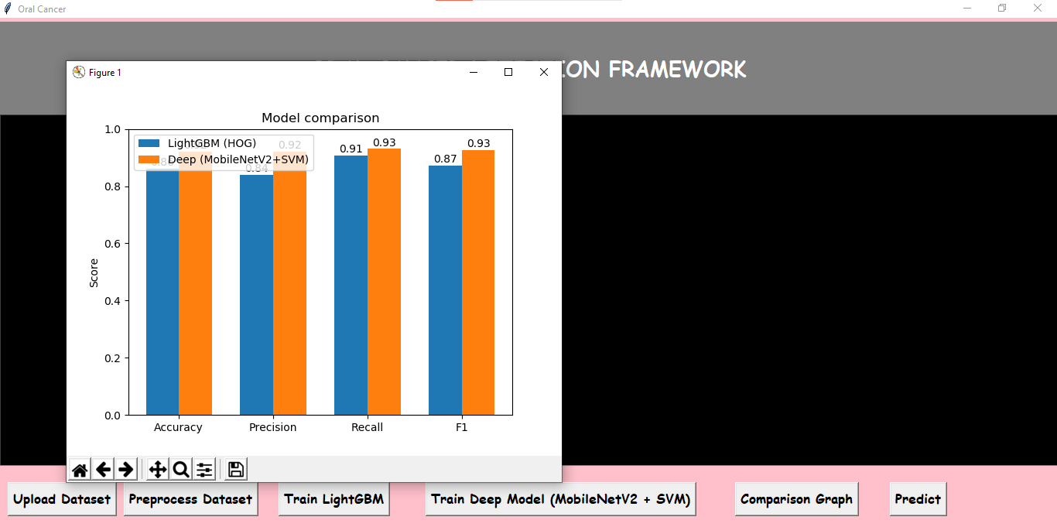
In the above screen we can see the comparison graph between LightGBM and deep(MobileNetV2+SVM). Now click on ‘predict’ button to predict the Oral Cancer
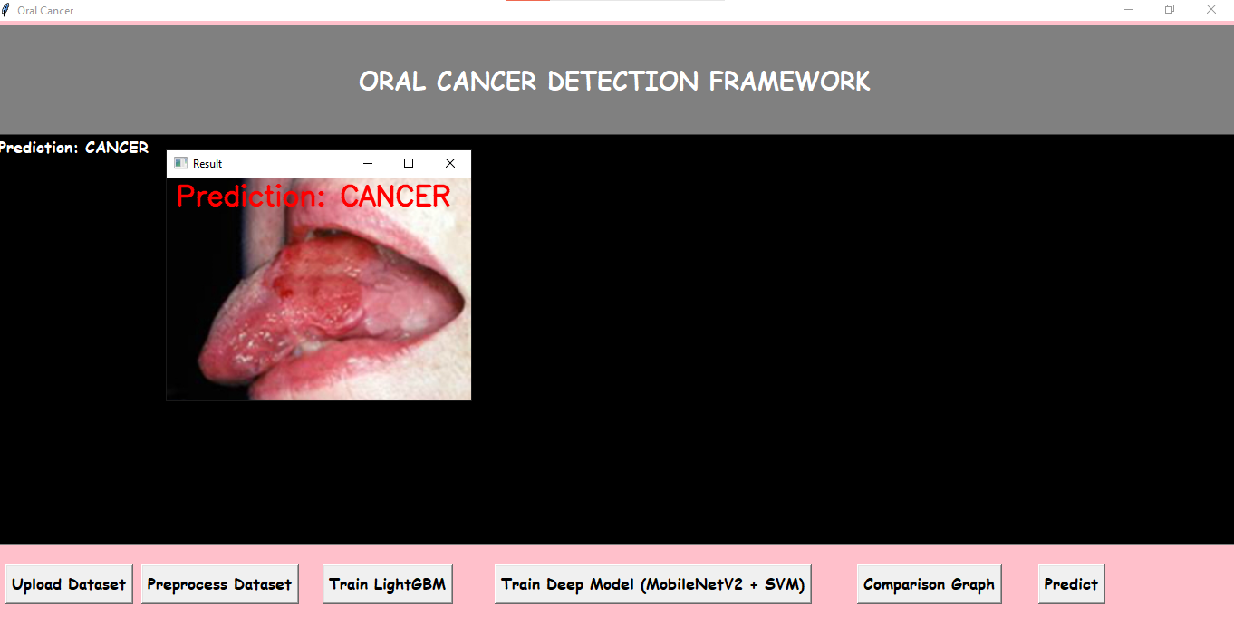
In the above screen we can see that when we upload a image it is giving result as cancer prediction.
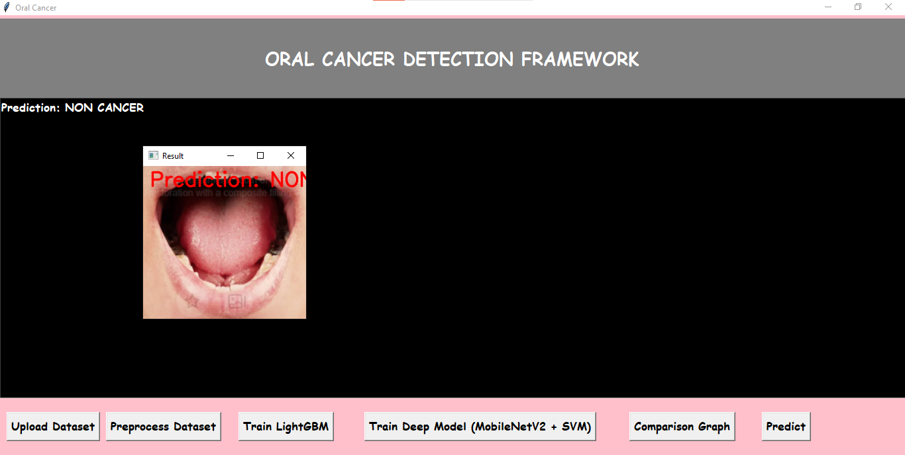
In the above screen when we upload a no cancer image it is predicting as non cancer. Similarly we can upload other images and predict the oral cancer.

