FinPilot AI: Member 3 Evaluation Guide
Financial Intelligence and Privacy · Evaluation Tasks 3 to 8
Member 3: Rahul Akshath Rajendran (3122235002095) · UIT2739 Full Stack Development Project · Department of Information Technology, SSN College of Engineering · October 2026
How this guide was checked (18 Oct 2026). Every error message below was captured from a running copy of the app, every SQL query was run against the current schema (migrations 0001 and 0002), the backend test suite passed (82 of 82), the browser suite passed (23 of 23), and the Android app passed its on-device check on an Android 15 emulator (17 of 17). Code references point at the current source. Demo numbers change slightly each day, because the demo data is regenerated for the current date.
What changed since the 14 Oct version. FinPilot now runs on real data: an Android app reads the bank SMS on the phone, a mailbox connection reads bank and shop email, and the laptop runs the server. Smart Picks (which crawled demo stores) was replaced by a real Wishlist. The simulators and every “sample inbox” button were removed; the demo is a separate, clearly labelled account. The previous guide is kept in fsd/previous/.
Legend: ✅ handled · ⚠️ partly handled · ❌ not handled (an improvement to suggest)

Contents
- Quick start and cheat sheet
- Task 3: Individual contribution
- Task 4: Backend files
- Task 5: Exception handling and logging
- Task 6: Database demonstration
- Task 7: Code demonstration
- Task 8: Edge cases
- Appendix A: ChatGPT conversation prompts (Task 1)

Quick start and cheat sheet

Start the app
- From the project folder, run python3 run.py (on Windows, py run.py). Keep this terminal visible: the logs appear here. It also prints the address the phone uses and a QR code.
- The browser opens at http://localhost:8000. Click Explore the demo account (sample data), or sign in as demo@finpilot.ai with password demo1234.
- If the demo data is older than today, it is rebuilt automatically when the app starts. While that happens, the login button reads “Preparing the demo account…” for about a minute.
- The phone app (to show real SMS). With the phone on USB and USB debugging on, run python3 run.py install-android. Open FinPilot AI, scan the QR code (or type the address), create an account, and allow SMS. Phone and laptop must be on the same Wi-Fi, or the laptop on the phone’s hotspot; on college Wi-Fi, start the server with python3 run.py --tunnel.
All API endpoints live under /api/v1. The interactive API docs are at http://localhost:8000/api/docs.

My six features at a glance
Feature | Where in the app | Main endpoints | Backend files
Forecasting and insights | Forecast, Insights & coach, Dashboard tiles | GET /forecast, GET /forecast/whatif, GET /insights, POST /insights/{id}/dismiss, POST /coach/ask | api/v1/analysis.py, api/v1/dashboard.py, services/forecasting/, services/recurring.py, services/insights.py, services/coach.py
Subscriptions | Subscriptions | GET /subscriptions, POST /subscriptions/{id}/action | api/v1/analysis.py, services/subscriptions.py, services/recurring.py
Tax | Tax | GET /tax, PUT /tax/profile, GET /tax/export.csv, GET /tax/export.pdf | api/v1/analysis.py, services/tax.py, services/tax_export.py
Wishlist and affordability | Wishlist, the dashboard tile “Safe to spend this month” | GET and POST /wishlist, PATCH and DELETE /wishlist/{id}, POST /wishlist/{id}/refresh, POST /wishlist/{id}/goal, POST /afford/check | api/v1/wishlist.py, services/wishlist.py, services/affordability.py, services/price_fetch.py
Authentication | Login, Register, Sign out; the phone app’s Connect screen | POST /auth/register, /auth/login, /auth/demo, /auth/refresh, /auth/logout, GET and PATCH /auth/me | api/v1/auth.py, core/security.py, core/deps.py, main.py (CSRF and CORS), frontend/src/lib/api.ts, frontend/src/lib/platform.ts
Consent and privacy | Onboarding, Connections, Settings, the phone app | /sources (list, history, notice, grant, pause, resume, revoke, purposes, delete-data, sms/sync-state, email/mailbox, email/sync), POST /ingest/sms/device, POST /ingest/{kind}/import, PATCH /auth/me, /settings/export, /settings/account | api/v1/sources.py, services/consent.py, api/v1/ingest.py, services/ingestion/device.py, services/ingestion/imap_sync.py, services/privacy.py, api/v1/settings.py, the Android SmsInboxPlugin.java
Where things actually live. These locations differ from the task sheet:
- The insights feed and the coach are served by dashboard.py, not analysis.py.
- Settings such as the safety buffer and take-home pay are saved by PATCH /auth/me in auth.py.
- settings.py handles data export, account deletion, the demo reset and the model-evaluation report.
- The affordability rules (safety buffer, safe-to-spend, tiers) are in services/affordability.py, shared by the Wishlist, the dashboard, the coach and the Forecast page.
- Recurring-payment detection (services/recurring.py) is shared by forecasting, subscriptions, tax and affordability.

Checklist for the evaluation
- Start the app about two minutes early, and wait until Explore the demo account (sample data) is enabled.
- Open two terminals: one running the app (for the logs), and one with sqlite3 data/finpilot.db (for Task 6).
- Keep the browser’s DevTools → Network tab open, so you can show status codes.
- If you show the phone: install the app beforehand, keep the phone on the laptop’s Wi-Fi or hotspot, and keep the QR code from the terminal on screen.
- Don’t enter wrong passwords ten times before demonstrating login. The rate limiter then blocks logins from that address for five minutes (see Task 8).
- When you are done, use Settings → Reset the demo to restore everything. It takes about a minute and signs you out.

Task 3: Individual contribution
My area is financial intelligence and privacy. The four analysis features turn the user’s transactions into decisions. Authentication and consent decide who may see the data and what the data may be used for. Each subsection below gives what the feature does, where it is, what is on screen, the demo steps and one line to say.

3.1 Forecasting and insights
What it does
- Projects the total savings-account balance 90 days ahead, with an 80% likely range.
- Checks a one-off purchase: “what if I spend ₹X?”.
- Lists the payments scheduled for the next 30 days.
- Reports how accurate the forecast has been against two simpler baseline models.
- Insights & coach turns the same numbers into a ranked feed and answers questions in plain English.
- For a new user it says what it is doing: a simple model until there are 120 days of history (“you have N”), and accuracy figures once there are 400 days.
Where: sidebar → Forecast (/forecast) and Insights & coach (/insights), plus the dashboard tiles “Safe to spend this month” and “Next 30 days”.
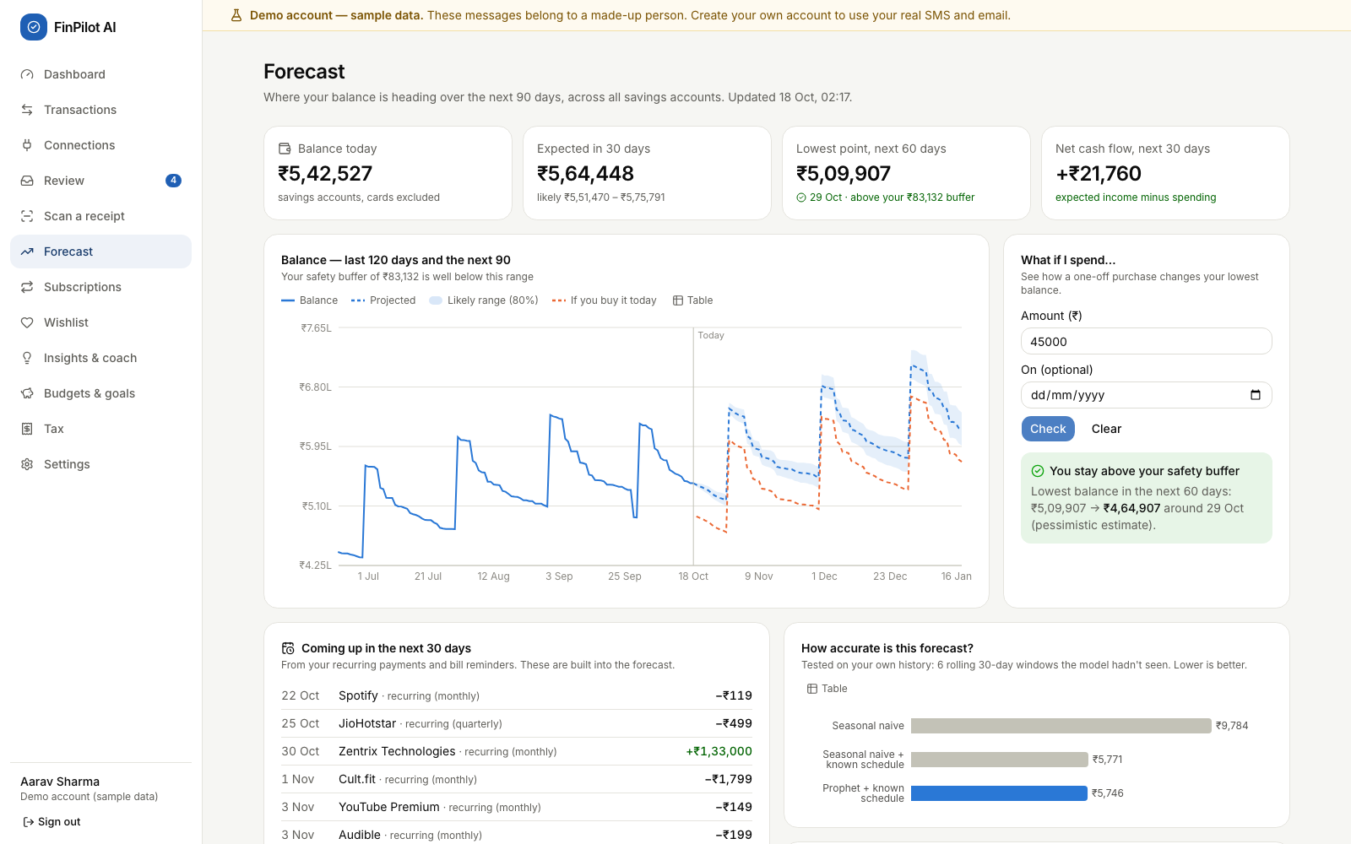
Forecast page after a what-if check of ₹45,000
Element on screen | Inputs and buttons | What it shows
Four stat tiles | none | Balance today; Expected in 30 days (with the likely range); Lowest point in the next 60 days (green or red against the safety buffer); Net cash flow for the next 30 days
Balance chart | Table toggle | The last 120 days, the next 90 days (dashed median), the 80% band, and an orange “If you buy it today” line after a what-if
What if I spend… | Amount (₹) (required), On (optional) date, Check, Clear | “You stay above your safety buffer” or “This would take you below your safety buffer”, with the lowest balance before → after
Coming up in the next 30 days | none | Recurring payments and announced bills that the forecast already includes
How accurate is this forecast? and Backtest details | none | MAE, RMSE, WAPE and 30-day balance error for three models; the model in use is marked. Before 400 days of history: why there is no figure yet
Known schedule | none | Detected recurring income and payments
Coach (Insights page) | Your question (up to 500 characters), suggestion chips built from the user’s own data, Send, Clear | An answer from the user’s own data, with a chart or table, and “Understood as “…” · N% sure”
Insights list (Insights page) | Open, dismiss (×) | Observations ranked by severity
Demo steps
- Open Forecast and walk through the four tiles. On 18 Oct the demo showed:
  - balance ₹5,42,527;
  - in 30 days ₹5,64,448, likely between ₹5,51,470 and ₹5,75,791;
  - lowest point ₹5,09,907 on 29 Oct, above the ₹83,132 buffer;
  - net cash flow for the next 30 days +₹21,760.
- Under What if I spend…, type 45000 and click Check. A green box appears: the lowest balance goes from ₹5,09,907 to ₹4,64,907, and an orange dashed line is added to the chart.
- Type 450000 and click Check. The box turns red: “This would take you below your safety buffer” (the lowest balance would be ₹59,907).
- Scroll to Backtest details. On 18 Oct the average daily error was:
Model | Error per day
Seasonal naive | ₹9,784
Seasonal naive + known schedule | ₹5,771
Prophet + known schedule | ₹5,746
- Open Insights & coach, type Can I afford a ₹60,000 laptop? and send it. Point to “Understood as “Affordability Check””. The answer: “Not today without stretching. If you save ₹17,215/month for 2 month(s), you can buy something for ₹60,000 without touching your ₹83,132 buffer or your goals.”
- Type what's the weather in Paris?. The coach gives an honest fallback answer instead of making one up.
- Dismiss an insight with ×. It disappears and stays dismissed (shown in the database in Task 6).
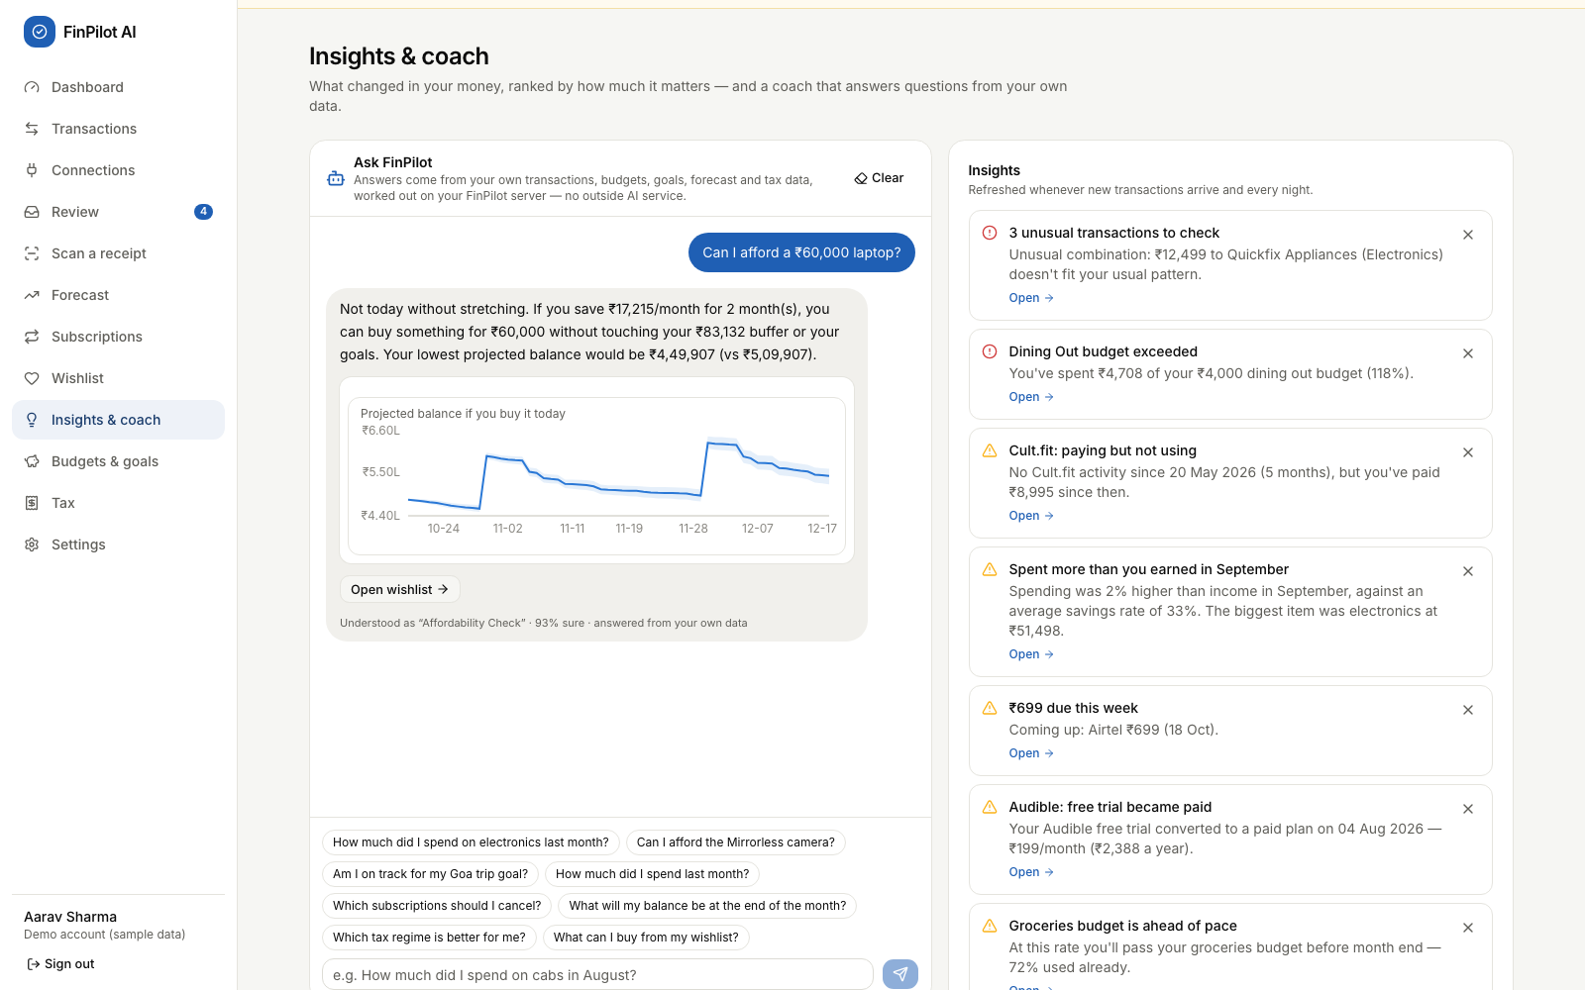
Insights & coach answering an affordability question
What to say: “The forecast is the known schedule (salary, rent, EMIs, SIPs, subscriptions, bills) plus Prophet for the day-to-day spending. I report its error against two baselines using a rolling backtest, and each backtest fold learns the schedule only from data before its own start date, so the test can’t see the future. The schedule alone cuts the error by about 41%; Prophet adds a little on top. If Prophet can’t run, or the history is under 120 days, the page uses the baseline and says so.”

3.2 Subscription management
What it does
- Finds recurring charges from the interval and amount of the user’s payments, including UPI AutoPay, e-mandate and standing-instruction debits whose merchant isn’t a known subscription service.
- Uses emails as evidence to flag four kinds of waste:
  - a price increase;
  - a dormant subscription (paid for but not used);
  - a free trial that became paid;
  - overlapping services.
- Ranks the suggestions by ₹ saved per year, and totals the monthly and yearly cost.
Where: sidebar → Subscriptions (/subscriptions).
Element | Inputs and buttons | What it shows
Four tiles | none | Active subscriptions (active or dormant, not ended), Per month, Per year, You could save …/yr
Suggestions, biggest saving first | I’ll cancel it, Keep it, See the email, Undo | One finding per subscription, with “save ₹X/yr” (or “costs ₹X/yr more” for a price rise)
Where the money goes | Table toggle | Yearly cost per subscription
All subscriptions | none | Plan, since when, next charge, notes such as Not used, Trial → paid, Overlaps, Price up
Demo steps
- Open Subscriptions. The tiles read 9 subscriptions, ₹5,084 per month, ₹61,011 per year, and “You could save ₹28,899/yr”.
- Read the findings: “Cult.fit: Paying but not using” (₹21,588/yr), “Audible: Free trial became paid”, “Netflix: Price went up 30%”, “Spotify: Two music services”, and two of three video services (JioHotstar, Amazon Prime).
- On Netflix, click See the email. The price-change email opens with the extracted fields highlighted.
- On Cult.fit, click I’ll cancel it.
  - The toast reads “Marked to cancel — remember to cancel it with the provider”.
  - The pill changes to “You plan to cancel”.
  - Click Undo.
- Click Keep it on another subscription. It leaves the suggestions list, and the toast reads “Got it — we won’t suggest this again”.
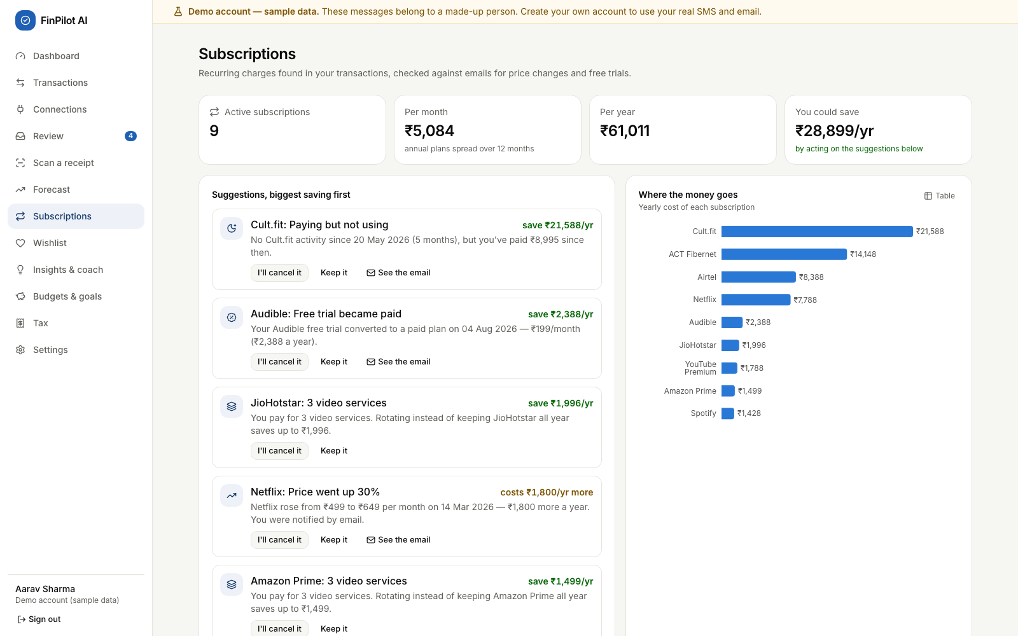
Subscriptions page
What to say: “Detection is purely algorithmic: the same merchant, a regular interval from weekly to annual, and a stable recent amount. For real users I also count AutoPay and e-mandate debits, because an unknown merchant on a mandate is almost always a subscription. Suggestions are ranked by money saved per year. A price rise is shown as an extra cost and isn’t added to the savings total. A ‘Keep it’ choice survives every recalculation.”

3.3 Tax analysis
What it does
- Estimates income tax for two years: FY 2025-26 (Income-tax Act, 1961) and Tax Year 2026-27 (Income-tax Act, 2025).
- Compares the old and new regimes, including the 87A rebate, marginal relief, surcharge and 4% cess.
- Detects deductions from the user’s transactions: 80C (s.123 from 2026-27), 80D, HRA and 80TTA, with 80E, 24(b), other 80C, NPS (80CCD(1B)) and parents’ health insurance taken from the salary details.
- Works out HRA with the right metro list for each year: four metros for FY 2025-26, eight from Tax Year 2026-27 (adding Bengaluru, Hyderabad, Pune and Ahmedabad), from the city the user enters.
- Shows the remaining headroom and, once the TDS is entered, the advance-tax schedule. Exports a CSV or PDF.
Where: sidebar → Tax (/tax).
Element | Inputs and buttons | What it shows
Year tabs | FY 2025-26, Tax Year 2026-27 | Switches the year
Recommendation banner | none | “The new regime costs ₹X less for you this year.” For the current year it also shows “in progress”, meaning figures to date plus scheduled payments
New regime and Old regime columns | none | Salary, deductions, taxable income, slab tax, rebate, cess, total, effective rate; “Better for you” pill
Total tax, Advance tax | none | A bar comparison; the instalments if more than ₹10,000 is due, or “Enter the TDS your employer deducts…” while TDS is unknown
Section 80C / Section 123 card | none | A progress bar against the ₹1,50,000 limit, with the parts that make it up
HRA exemption card | none | HRA received, rent paid, the exempt amount, and headroom tips
Evidence from your transactions | click a row | The individual payments that were counted
Your salary details | City you live in, 12 number fields (gross, basic, HRA, rent, PF, professional tax, TDS, other 80C, NPS, parents’ health insurance, education-loan and home-loan interest), the senior-parents switch, Save and recalculate | Form 16 inputs; a blank field clears the value
Header buttons | CSV, PDF summary | Downloads finpilot-tax-<year>.csv or .pdf (on the phone: Android’s share sheet)
Demo steps
- Open Tax. The 2026-27 banner reads “The new regime costs ₹92,286 less for you this year · in progress”.
- Click FY 2025-26.
  - New regime ₹1,89,292 against old regime ₹2,72,126, so the new regime saves ₹82,834.
- Explain 80C: ₹1,79,040 was invested (PF ₹95,040 + ELSS ₹60,000 + LIC ₹24,000), so the ₹1,50,000 cap is fully used.
- Explain HRA (city Chennai, a metro in both years). It is the least of three amounts:
  - HRA received: ₹3,96,000;
  - rent minus 10% of basic: ₹3,03,000 − ₹79,200 = ₹2,23,800;
  - 50% of basic: ₹3,96,000.
- So ₹2,23,800 is exempt.
- Under Evidence, expand ELSS SIPs to show the 12 payments that were counted.
- Click PDF summary (it downloads finpilot-tax-2025-26.pdf), then CSV.
- Click Tax Year 2026-27. Under Your salary details, enter 150000 for TDS deducted by your employer this year and click Save and recalculate.
  - The toast reads “Tax details saved”.
  - Advance tax now shows ₹80,861 still due, in instalments of ₹12,129 (15 Jun), ₹36,387 (15 Sep), ₹60,646 (15 Dec) and ₹80,861 (15 Mar), cumulative.
  - Clear the TDS field and save again: the card goes back to asking for TDS.
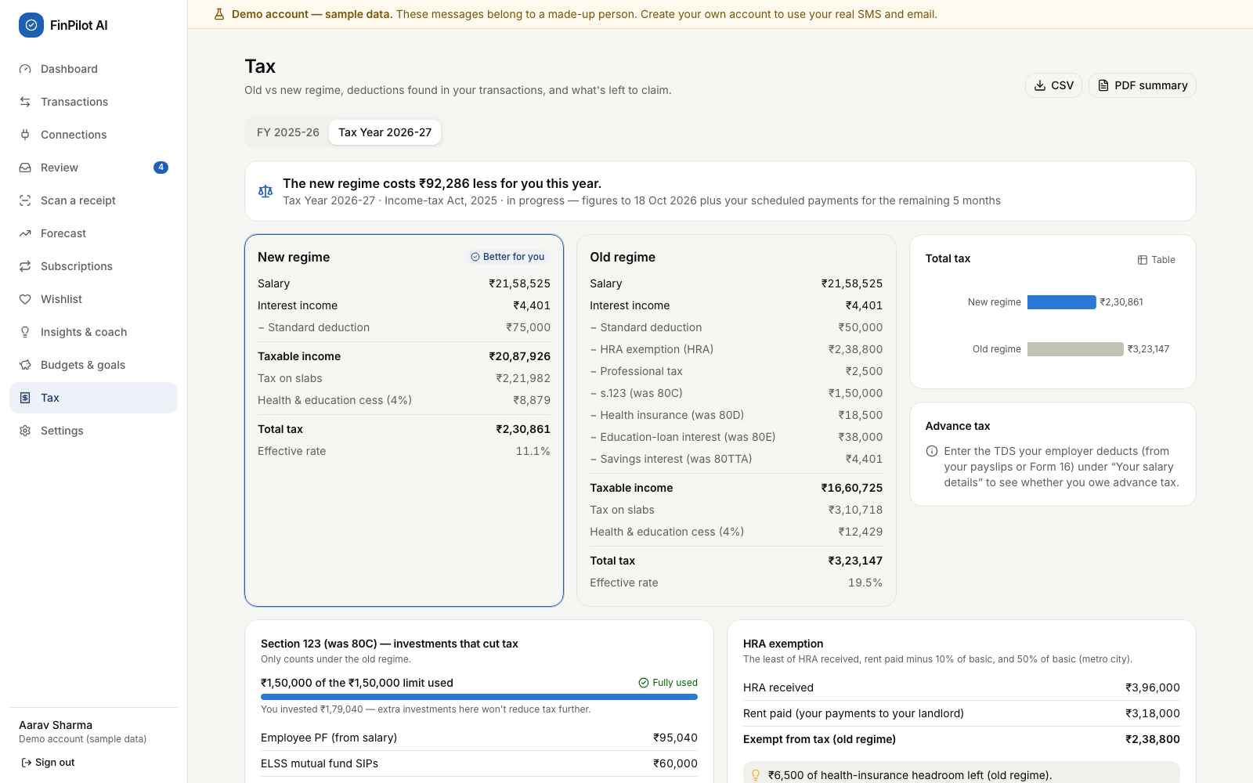
Tax page, Tax Year 2026-27
What to say:
- “All rates and limits live in one YEARS table and are unit-tested. For example, a taxable income of ₹12,10,000 under the new regime gives ₹10,400 because of marginal relief.”
- “Without the TDS figure I don’t guess whether advance tax is due; the page asks for it.”
- “Every view says ‘estimates for planning, not tax advice’.”

3.4 Wishlist and affordability
What it does
- Works out how much the user can safely spend: never the safety buffer, the bills due before the next income, or the goal savings, and never below the pessimistic 60-day forecast.
- Keeps a wishlist of things the user wants, with a price or a product link. For a link, FinPilot reads the price when the store publishes it as structured data (schema.org JSON-LD, then price meta tags, then microdata) and its robots.txt allows it, and re-checks it daily with a price history. Otherwise the user enters the price.
- Puts every item in a tier with reasons: Buy now, For your goals, Save up for (with a monthly plan), Not yet, or Needs a price. Any item can become a goal.
- Can I afford…? checks any price the user types.
- It never recommends products: there is no catalogue, no affiliate link and no paid placement. (This replaced Smart Picks, which only crawled demo stores.)
Where: sidebar → Wishlist (/wishlist); the dashboard tile Safe to spend this month; the coach.
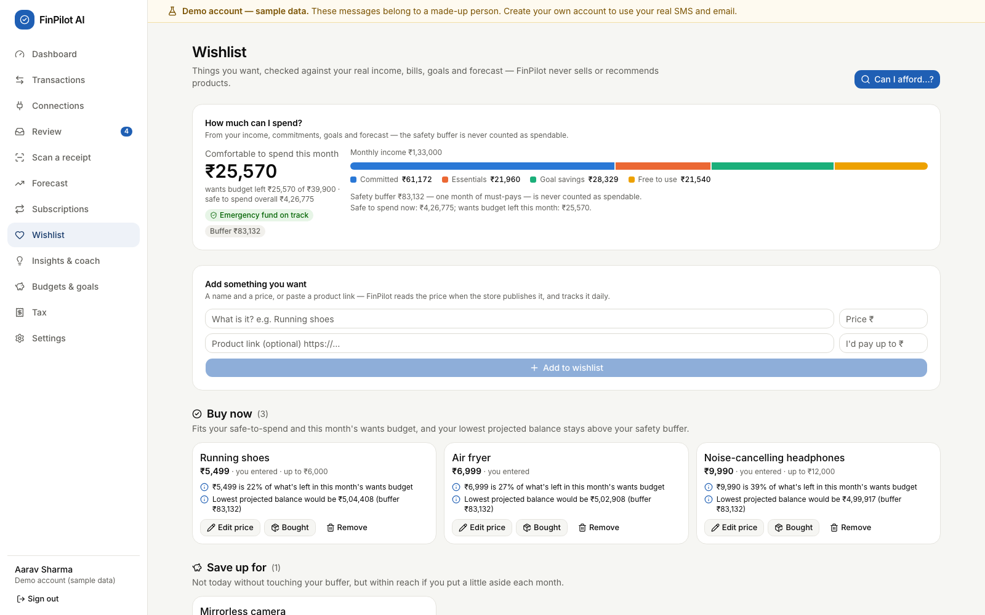
Wishlist with the affordability breakdown
Element | Inputs and buttons | What it shows
How much can I spend? | none | “Comfortable to spend this month” (safe to spend, capped by what’s left of this month’s wants budget when the income is known), the buffer, the emergency-fund pill, income split into Committed / Essentials / Goal savings / Free to use, and the explanation lines
Add something you want | What is it?, Price ₹, Product link, I’d pay up to ₹, Add to wishlist | The new item, placed in its tier; for a link, the store’s price or why it couldn’t be read
Tier sections and item cards | Make it a goal (Save up for / Not yet), Edit price / Add price, Check price (items with a link), Bought, Remove, the link icon | Price and where it came from, reasons, the lowest projected balance after buying it
Can I afford…? dialog | What is it? (optional), Price (₹), Check | The verdict, plus the lowest projected balance before → after
Demo steps
- Open Wishlist. On 18 Oct the card read:
  - “Comfortable to spend this month ₹25,570”;
  - wants budget left ₹25,570 of ₹39,900;
  - safe to spend overall ₹4,26,775;
  - buffer ₹83,132, monthly income ₹1,33,000.
- Walk through the tiers: Buy now (3): Running shoes ₹5,499 (“22% of what’s left in this month’s wants budget”), Air fryer ₹6,999, Noise-cancelling headphones ₹9,990. Save up for (1): Mirrorless camera ₹74,990, “Save ₹16,473/month for 3 month(s) to buy it without touching your buffer”.
- Click Can I afford…?, enter 60000 and click Check. The answer is “Save ₹17,215/month for 2 month(s) and you can buy it without touching your buffer.”
- Enter 5000000 and click Check. The answer is “Not right now — it would cut into money you need for bills, goals or your safety buffer.”
- On the Mirrorless camera, click Make it a goal. The toast gives the target month, and the item moves to For your goals (“₹0 of ₹74,990 saved, ₹24,997/month until Jan 2027”). The goal also appears under Budgets & goals.
- Optional, with internet: add an item by pasting a product link. If the store publishes its price, it appears with the store’s name; if not, the card says why (“…asks automated tools not to read this page (robots.txt). Enter the price yourself.”) and offers Add price.
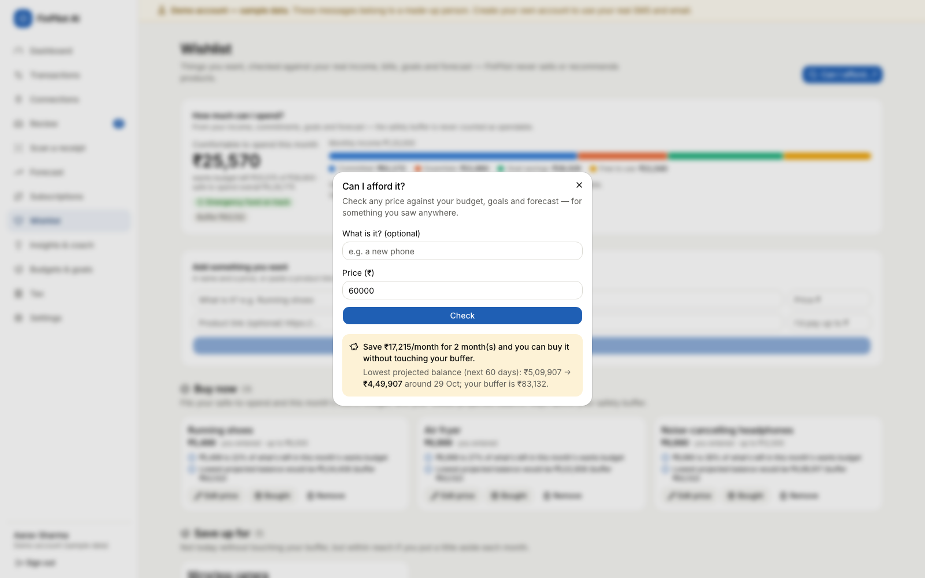
Can I afford…? check for ₹60,000
What to say:
- “The money that’s safe to spend never touches the safety buffer, the dues before the next salary, or the goal savings. It also respects the pessimistic 60-day forecast. The buffer is the larger of the user’s floor and one month of must-pay costs.”
- “A property-based test with Hypothesis checks 300 random cases, and in every one ‘Buy now’ never breaks the buffer.”
- “For a new user I never show a misleading ₹0: with no income known yet there is no wants budget, so safe-to-spend comes from the balance alone, and with no balance either the dashboard says ‘Not known yet’.”
- “Price checks are polite: one page per day, an honest user agent, robots.txt respected, and links to private or local addresses refused, including through redirects.”

3.5 Authentication
What it does
- Registration, login and a one-click demo login (the labelled demo account).
- In the browser, sessions are kept in httpOnly cookies: a 30-minute access token and a 14-day refresh token. The refresh token is rotated every time it is used.
- In the Android app, there are no cookies. The app marks its requests with X-FinPilot-Client: android, so register, login and refresh return {access_token, refresh_token, expires_in} in the body. The app keeps them in its private storage and sends Authorization: Bearer …. The refresh token lasts 90 days and is rotated too.
- Logout revokes the refresh token. Failed logins are rate-limited.
Where: - /login and /register (and, in the app, the Connect screen first, which stores the server address); - Sign out at the bottom of the sidebar (on a phone: More → Sign out).
Every signed-in page goes through the (app) layout, which sends the user to /login if /auth/me fails, and to /onboarding if they haven’t finished onboarding yet. If the server can’t be reached, it says so (“Can’t reach your FinPilot server at …”) instead of signing the user out.
Page | Inputs and buttons | Results
Login | Explore the demo account (sample data) (disabled and showing progress while the demo is prepared), Email, Password, Sign in, link Create an account | Goes to the dashboard, or shows a red error message
Register | Name, Email, Password (at least 8 characters, with the hint “At least 8 characters.”), Create account | Goes to onboarding, or shows a red error message
Connect (phone app only) | Scan the QR code, Or type the address, Connect | Checks /api/v1/health and saves the address; a wrong address says what to check
Demo steps
- Click Sign out. On the login page, enter demo@finpilot.ai with a wrong password and click Sign in.
  - The page shows “Wrong email or password.”
  - DevTools → Network shows 401.
- Click Explore the demo account (sample data) to reach the dashboard. Point to the yellow banner “Demo account — sample data.”
- Register a new account (name, a new email, a password of 8 or more characters). It opens onboarding.
- Register the same email again: “An account with this email already exists. Sign in instead.” (409)
- Optional: in DevTools → Application → Cookies, show the two cookies.
  - fp_at has path / and fp_rt has path /api/v1/auth. Both are HttpOnly.
  - Point out that JavaScript cannot read them.
- Optional, to show the phone path without a phone:
- curl -s -X POST localhost:8000/api/v1/auth/login -H 'X-FinPilot-Client: android' -H 'Content-Type: application/json' \
-d '{"email":"demo@finpilot.ai","password":"demo1234"}' | python3 -m json.tool | grep -E 'token|expires'
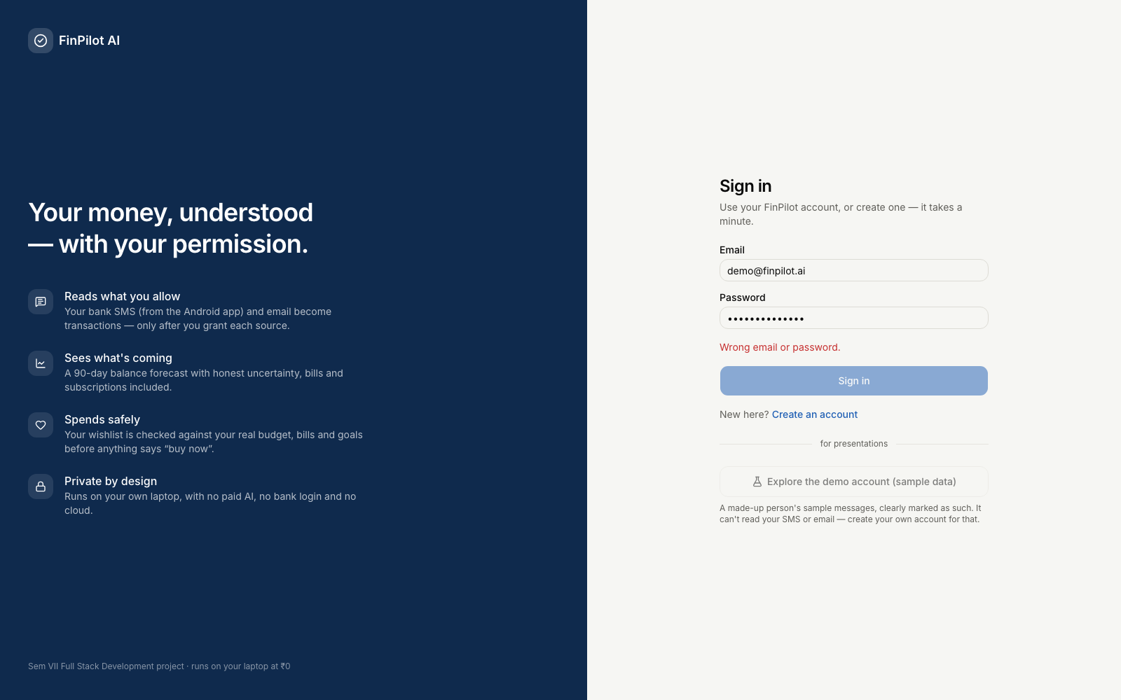
Login error for a wrong password
What to say:
- “Passwords are hashed with bcrypt at 12 rounds.”
- “In the browser, tokens are HS256 JWTs in httpOnly, SameSite=Lax cookies, and every request that changes data must carry an X-Requested-With header, which guards against CSRF.”
- “The phone uses Bearer tokens instead. A Bearer header is never sent automatically by a browser, so it can’t be forged cross-site; CORS lets only the app’s own origin call the API.”
- “On a 401, api.ts silently refreshes the session once. Two refreshes with the same token can’t both succeed, because the token is revoked with a conditional UPDATE.”

3.6 Consent and privacy
What it does
- SMS and email are separate sources. Nothing is read until the user grants a source. The grant dialog lists:
  - what is read and what is never read;
  - what is stored;
  - what the app will never do;
  - the purpose, which must be ticked: record my transactions… and use them for my balance, forecast, budgets, insights and affordability checks;
  - a backfill window (default 12 months).
- SMS are read on the phone, by the Android app. After the consent dialog, Android’s own permission dialog appears. The app reads the inbox month by month within the window, and filters on the phone: messages from personal numbers, promotional (-P) senders and OTPs never leave it. Only bank and payment alerts are uploaded. New SMS are picked up when the app opens, when it comes back to the front, and every minute while it is open. Capture health shows what the last sync read, skipped, created and sent to review.
- Email is read from the user’s mailbox with an app password: only allowlisted senders (banks, cards, shops, billers) are opened, nothing is marked read, and the password is stored encrypted. Revoking email deletes it.
- Files (an SMS backup, .eml/.mbox, a bank statement) go through the same filters and consent checks.
- Every change is logged. Granting, pausing, resuming, revoking and deleting data all add a row to the consent history, with the notice version and its SHA-256 fingerprint.
- The demo account can’t connect real sources: the SMS upload, mailbox and file imports refuse it (403).
- Settings controls cover how long the original message text is kept, the safety buffer, the emergency-fund months, take-home pay and payday, rent and landlord, the monthly wants budget, accounts and balances, extra email sender domains, exporting all data and deleting the account.
Where: - Onboarding, shown on first login (About you → Bank SMS → Email → Done); - Connections (/connections); - Settings (/settings); - the Android app (the same pages, plus the SMS permission and sync).
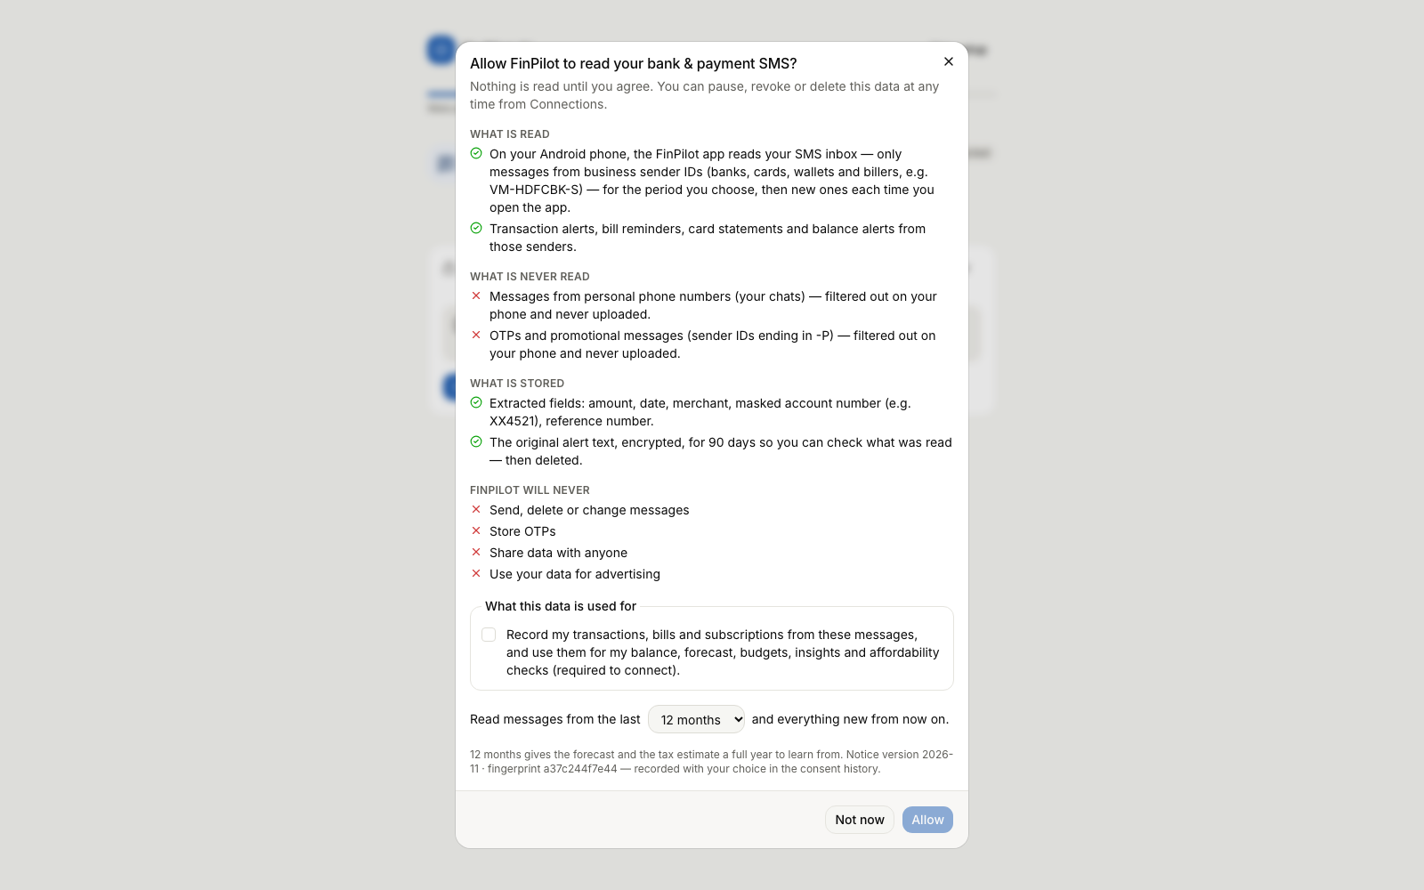
The consent dialog: Allow stays disabled until the purpose is ticked
Element | Inputs and buttons | What it shows
SMS card (Connections) | Connect / Reconnect, Import a file, Pause, Resume, Revoke, Delete data; in the app: Allow SMS access, Sync now | Status pill, Messages kept / Linked to payments / In review, when it was allowed, the backfill window; in the app, Capture health (read on phone, chats/OTPs/promos skipped, new transactions, sent to review) and help when Android restricts the permission
Email card (Connections) | Connect, Connect mailbox (email service, address, app password, IMAP server for others), Sync now, Change password, Disconnect, extra sender domains | When the mailbox was last read and what was found, or the last error
Consent history | none | When, source, event, purposes, notice version and fingerprint
Preferences (Settings) | Safety buffer floor (₹), Emergency fund target (months), Keep original message text for (days), Save preferences; and, under your money details, take-home pay, payday, rent, landlord and Monthly “wants” budget (₹) | Saved preferences, confirmed by a toast
Accounts (Settings) | add an account, set Balance today | Accounts and where each balance came from
Connect your phone (Settings, browser) | none | A QR code and the addresses the phone can use
Your data (Settings) | Export all my data (JSON), Reset the demo (demo account) / Delete my account (others) | A download, a reset, or a deleted account
Demo steps
- Grant consent as a new user, in the browser.
  - Register a new user and click Get started. Fill or skip About you.
  - On Bank & payment SMS, click Review and allow. Show that Allow stays disabled until the purpose is ticked. Tick it and click Allow.
  - Click Import a file instead and choose samples/imports/sms_backup.xml. The result reads “302 messages read: … new transactions · … OTPs, promos & non-financial messages ignored”.
- On the phone (if installed), do the same as a new account. After Allow, tap Allow SMS access: Android asks “Allow FinPilot AI to send and view SMS messages?”. Tap Allow. The app shows a progress bar, then a line such as “5 alerts read: 4 new transactions, 0 linked to ones already recorded, 0 to review” and the Capture health counts.
- Pause a source. On Connections, click Pause on the SMS card. New messages are now refused until you resume: the phone’s next sync and any file import get 409. Click Resume.
- Revoke and delete a source.
  - Click Revoke and confirm.
  - Click Delete data and confirm.
  - The toast gives the number of messages deleted, and how many transactions were kept because another source also confirms them. The history gains a Data deleted row with the counts.
- Change and save preferences.
  - Under Settings → Preferences, set Safety buffer floor to 20000 and click Save preferences.
  - Try 3 for Keep original message text for. The browser blocks it (the minimum is 7), and the backend would also return 422 (see Task 5).
- Click Export all my data (JSON). It downloads finpilot-export.json.
- As the demo user, open Connections: “The demo account holds a made-up person’s sample messages and can’t connect real ones.” Finish with Settings → Reset the demo.
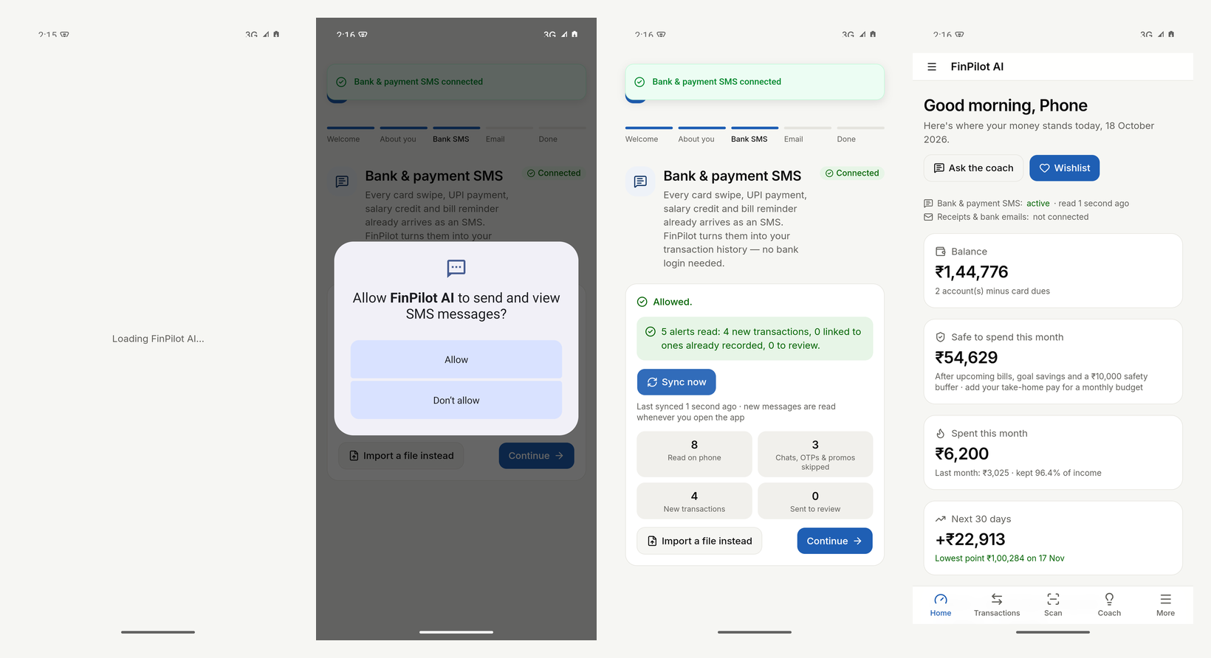
The phone app: pairing, Android’s SMS permission, the first sync, and the dashboard (Android 15 emulator)
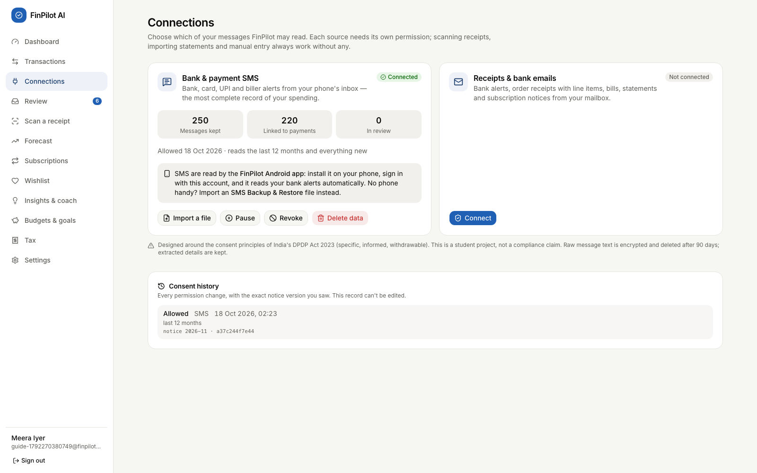
Connections for a new user after importing an SMS backup
What to say:
- “Consent is per source, it can be withdrawn as easily as it was given, and every decision is audited.”
- “Data minimisation happens on the phone: personal chats, OTPs and promotions are dropped before anything is sent, and messages older than the window the user chose are never even read.”
- “The design follows the consent principles of India’s DPDP Act 2023, but it doesn’t claim compliance.”
- “The original message text is encrypted with Fernet and deleted after the retention period. The extracted fields stay. The mailbox password is encrypted too, and deleted on revoke.”
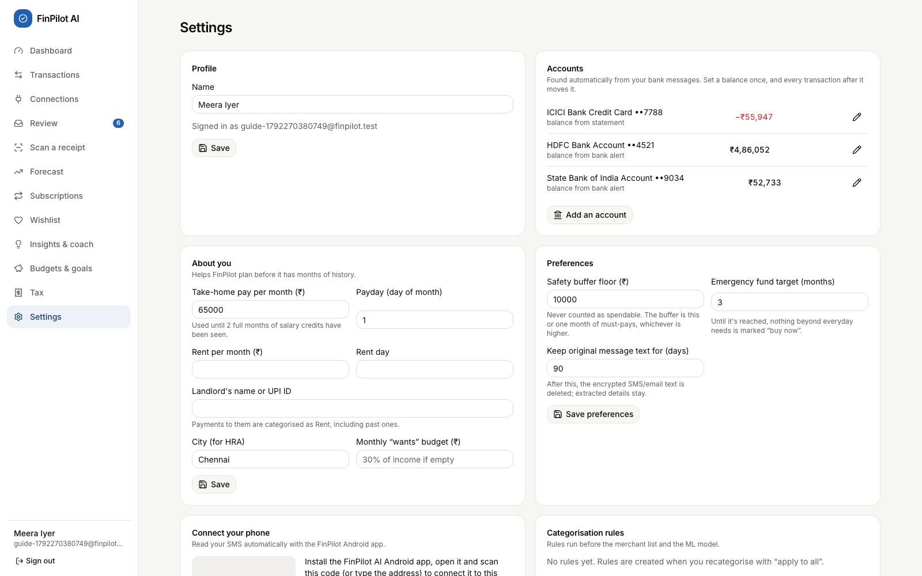
Settings: accounts, preferences, the phone pairing card and data controls

Task 4: Backend files

Request path (shared by every feature)
Browser page (React 19 + TanStack Query) Android app (the same pages, bundled in the APK by Capacitor 8)
└─ frontend/src/lib/api.ts same-origin fetch, └─ frontend/src/lib/api.ts fetch to the paired server address,
cookies + X-Requested-With Authorization: Bearer + X-FinPilot-Client: android
└─ backend/app/main.py create_app(): CORS (app origins only), CSRF guard, exception handler, routers, static site
└─ api/v1/router.py mounts the feature routers under /api/v1
└─ api/v1/<feature>.py endpoint: Pydantic validation, ownership checks, HTTP errors
├─ core/deps.py CurrentUser (Bearer or cookie JWT → User) and DB (one session per request,
│ committed before the response is sent)
└─ services/*.py business logic (no HTTP), shared metrics, recurring detection, affordability
└─ models/*.py → SQLAlchemy 2 → db/session.py → SQLite (data/finpilot.db, WAL mode)
Background: jobs/runner.py (thread pool, `jobs` table) ← jobs/tasks.py (job functions) ← jobs/scheduler.py
Phone SMS: SmsInboxPlugin.java (READ_SMS, filters on the phone) → lib/native/sms.ts → POST /ingest/sms/device → job ingest_device

Shared files I rely on
File | Responsibility
main.py | create_app(); the csrf_guard middleware (L60) for cookie requests; CORSMiddleware (L78) for the app’s origins; the unhandled exception handler (L88); a lifespan (L24) that starts the job runner and the scheduler
core/deps.py | bearer_token() (L13) and current_user() read the Bearer header or the fp_at cookie, decode the JWT and load the User. SESSION (L24) makes the database session commit when the endpoint returns, before the response is sent; it also defines the DB and CurrentUser aliases
core/security.py | bcrypt (hash_password, verify_password) and JWT (create_access_token, create_refresh_token, decode_token)
db/session.py | get_db(): commits on success, rolls back on any exception, always closes; SQLite pragmas WAL, foreign_keys=ON, busy_timeout (L19)
core/money.py | The Money column type (integer paise ↔ Decimal rupees) and fmt_inr() Indian digit grouping
services/metrics.py | Shared figures (rows, complete_months (L80), median_monthly (L136), goals_status (L172)); income counts only months the user’s records cover
services/recurring.py | detect_recurring(), the Recurring class with occurrences() and monthly_equivalent
services/affordability.py | affordability() builds the Snapshot (L45) used by the Wishlist, dashboard, coach and Forecast; safety_buffer() (L101)
services/analytics.py | run_user_analytics(): isolated stages (anomalies → subscriptions → forecast → insights)
jobs/runner.py, tasks.py, scheduler.py | Background jobs (each one a row in jobs). The scheduler reads connected mailboxes every 30 minutes, re-checks wishlist prices every 24 h, and runs the nightly analytics and the retention purge

Forecasting and insights
File | What it does | Key functions and endpoints
api/v1/analysis.py | Forecast endpoints | get_forecast (L57): the stored forecast + the lowest point in 60 days compared with the buffer + the backtest. If there is no forecast yet, it queues user_analytics and returns {"status": "computing"}. forecast_whatif (L77): 0 < amount < 1e9; returns 409 if there is no forecast
services/forecasting/engine.py | The model | _declared (L44, salary and rent the user entered), build_series (L90), future_schedule (L106), baseline_forecast (L132), prophet_fit_predict (L146), backtest (L169), forecast (L208), lowest_point (L267), what_if (L273)
services/forecasting/service.py | Saving and loading | refresh_forecast replaces the user’s forecasts and forecast_metrics rows; latest
services/forecasting/prophet_model.py | Prophet wrapper | load_prophet (a lazy import), tiny_fit (capability check)
services/system.py | Capability gate | check_prophet sets CAPABILITIES["prophet"]["ok"], which decides whether to fall back
api/v1/dashboard.py | Dashboard, insights and coach endpoints | dashboard (L61, with safe_basis at L105), list_insights (L129), dismiss_insight (L136), coach_suggestions (L161), coach_history (L166), coach_ask (L172), clear_history (L184)
services/insights.py | Insight rules | generate: rule groups for spending spikes, budgets, savings rate, the forecast warning (only when the balance is known, L95), bills due, anomalies, subscription waste, 50/30/20, goal pace, wishlist price drops, the review queue and tax season. refresh_insights (L190) keeps dismissed insights dismissed
services/coach.py | Coach | Coach.ask (L188): the intent model chooses a handler and falls back below 35% confidence. suggestions_for (L39) builds the chips from the user’s own data. Slot parsers parse_period (L111), parse_amount (L149), parse_category (L169)

Subscriptions
File | What it does | Key functions and endpoints
api/v1/analysis.py | Subscription endpoints | list_subscriptions (L88): the items, one suggestion per merchant (the largest saving), and the totals. subscription_action (L110): keep, cancel or null, after an ownership check
services/subscriptions.py | Detection and findings | refresh_subscriptions rebuilds the rows and keeps user_action; AutoPay and e-mandate merchants count as evidence (L62). _price_change (L45), _evidence (L33) and the MUSIC / VIDEO sets (L28)
services/recurring.py | Cadence rules | CADENCES (L19), detect_recurring (L75)

Tax
File | What it does | Key functions and endpoints
api/v1/analysis.py | Tax endpoints | get_tax (L119), update_tax_profile (L126; an explicit null clears a value), tax_csv (L140), tax_pdf (L148). Any year not in YEARS returns 404. The TaxProfile model (L30) requires every number to be ≥ 0
services/tax.py | Calculation | METROS per year (L31); YEARS (L39) holds the slabs and limits; slab_tax (L57); compute (L69) applies rebate, marginal relief, surcharge and cess; tax_summary (L106) works out deductions, evidence, HRA, headroom and advance tax (only with a known TDS, L225)
services/tax_export.py | Exports | export_csv (L31), export_pdf (L53, ReportLab)

Wishlist and affordability
File | What it does | Key functions and endpoints
api/v1/wishlist.py | Wishlist endpoints | wishlist (L58), add_item (L63), update_item (L90), refresh_price (L115), delete_item (L124), item_to_goal (L131), check_price (L154, POST /afford/check). CheckBody (L24) limits the price to 0 < price < 1e9
services/affordability.py | The rules | Snapshot (L45) and spendable (L70); safety_buffer (L101); monthly_income (L109); affordability (L119, wants_known at L149); evaluate_price (L191) decides the tier
services/wishlist.py | Tiers and reasons | evaluate (L125) places each item; _reasons (L79); refresh_item (L49) re-reads a price and keeps the history
services/price_fetch.py | Reading a price from a link | fetch_price (L172): validate_url (L59) → _public_host (L47) → _robots_allows (L160) → _get (L145, redirects checked hop by hop) → parse_price (L98: JSON-LD, then meta tags, then microdata, rupees only)
jobs/tasks.py | Jobs | wishlist_prices re-checks linked items once a day

Authentication
File | What it does | Key functions and endpoints
api/v1/auth.py | Auth endpoints | register (L147), login (L162), demo_login (L172), refresh (L182), logout (L202), update_me (L218). is_native (L117) spots the app; start_session (L121) returns cookies (browser) or tokens (app). _check_limit / _count (L106, L112) do the rate limiting
core/security.py | Hashing and tokens | bcrypt through pwdlib (12 rounds); HS256 JWTs whose secret is generated on first run in data/secret.json
core/deps.py | Guard | current_user returns 401 “Not signed in”
main.py | CSRF and CORS | Cookie requests need X-Requested-With; Bearer and app requests don’t; CORS allows only http://localhost, https://localhost and capacitor://localhost
services/users.py | Account creation | create_user sets neutral default preferences (DEFAULT_PREFERENCES, L10); a real account never inherits demo data

Consent and privacy
File | What it does | Key functions and endpoints
api/v1/sources.py | Consent centre API | list_sources (L85), history (L91), get_notice (L102), grant (L108), pause (L116), resume (L123), revoke (L130), purposes (L137), delete_data (L144), the phone’s sms/sync-state (L153), and the mailbox: get_mailbox (L164), connect_mailbox (L169), sync_mailbox (L199), disconnect_mailbox (L209). _check (L43) returns 404 for an unknown source
services/consent.py | Consent rules | NOTICE_VERSION / PURPOSES / NOTICES (L22–27), notice_hash (L70), _event (L75), grant (L89), backfill_start / within_backfill (L108, L114), require_active (L119), set_status (L127), update_purposes (L146), delete_source_data (L158), history (L188)
api/v1/ingest.py | Consent enforcement | refuse_demo (L22); upload_device_sms (L44, the phone’s SMS) and the file import (L70) call consent.require_active first
services/ingestion/device.py | Phone SMS | append_chunk (L33) stages each upload; run_device_batch (L59) applies the consent window, ingests, and saves the Capture health counts in data_sources.sync_state
services/ingestion/imap_sync.py | Mailbox | PROVIDERS (L25), connect (L73, friendly errors), find_folder (L102), search_uids (L138, Gmail X-GM-RAW at L144), sync_user (L199)
services/privacy.py | Retention | purge_expired_bodies deletes raw message text older than retention_days (a daily job)
api/v1/settings.py | Data controls | export_all (L47), delete_account (L87, also removes receipt files, staged uploads and the mailbox password), reset_demo (L114), system_quality (L121)
api/v1/auth.py | Preferences | PREF_RANGES (L59), ALLOWED_PREFS (L65), _clean_pref (L71)
core/crypto.py | Encryption | Fernet encrypt_text / decrypt_text for message bodies and the mailbox password

The phone app (frontend and Android)
File | What it does
SmsInboxPlugin.java | The native plugin: the READ_SMS permission, read (L136) of one time window, senderKind (L51) and isOtpOnly (L58) filter on the phone
lib/native/sms.ts | run (L84): reads month by month from the consent window or the last cursor, uploads in chunks of 500, waits for the job; syncSms (L131) lets only one sync run at a time
components/app-shell.tsx | SmsAutoSync: syncs on start, on resume and every minute while the app is open
lib/platform.ts | The server address and tokens in the app’s storage (Capacitor Preferences)
lib/api.ts | Absolute URLs and Bearer headers in the app; cookies in the browser (Task 7.1)

How the files work together
- Forecast
  - New data arrives (the phone’s SMS, a mailbox sync or a file import) → a user_analytics job → run_user_analytics → refresh_forecast → engine.forecast. The result is stored in forecasts and forecast_metrics.
  - Opening the page → GET /forecast → latest + lowest_point + safety_buffer.
  - A what-if → GET /forecast/whatif → what_if on the stored projection. Prophet is not re-fitted, so this is fast.
- Insights
  - The last analytics stage → refresh_insights → insights table → GET /insights.
  - × → POST /insights/{id}/dismiss sets dismissed=1.
  - The coach: POST /coach/ask → Coach.ask → a handler that uses metrics, the forecast, tax and the affordability snapshot. Both the question and the answer are saved in chat_messages.
- Subscriptions
  - Analytics stage 2 → refresh_subscriptions → the subscriptions table.
  - Opening the page → GET /subscriptions.
  - Keep or cancel → POST /subscriptions/{id}/action updates user_action, which is carried into every later refresh.
- Tax
  - On each request, tax_summary reads transactions and users.tax_profile. No tax result is stored.
  - The exports call tax_summary again.
- Wishlist and affordability
  - GET /wishlist → affordability() (the snapshot) → evaluate() puts each item in a tier.
  - Adding a link → fetch_price → wishlist_items.price and a wishlist_price_points row; the wishlist_prices job repeats it daily.
  - Can I afford…? → POST /afford/check → evaluate_price straight away.
  - Make it a goal → a goals row with wishlist_item_id, whose monthly saving the snapshot then reserves.
- Authentication
  - Register or login → start_session (cookies, or tokens for the app, and a refresh_tokens row).
  - Every protected request → current_user (Bearer header or cookie).
  - A 401 → api.ts → POST /auth/refresh, which rotates the refresh token.
- Consent
  - Grant, pause, resume, revoke → services/consent.py updates data_sources and appends to consent_events.
  - Every feed (the phone’s SMS, the mailbox, file imports) calls require_active first and keeps only messages inside the consent window.
  - Delete data → removes the messages and the transactions that only that source supports → a user_analytics job.
  - The scheduler runs retention_purge daily.

Task 5: Exception handling and logging

5.1 How errors are handled, layer by layer
Layer | Mechanism | Code | What the client sees
Browser form | HTML validation: required, type="email", minLength={8}, min/max on number fields | e.g. register/page.tsx, settings/page.tsx | The browser blocks the submit before any request is sent
CORS | Only the app’s own origins may call the API cross-origin | main.py:78 | Another site’s request fails in the browser
CSRF guard | Middleware rejects POST, PUT, PATCH and DELETE to /api/ without X-Requested-With: finpilot, unless the request carries a Bearer token or comes from the app | main.py:60 | 403 “Missing X-Requested-With header”
Authentication | The current_user dependency (Bearer header or cookie) | deps.py:35 | 401 “Not signed in”
Input validation | Pydantic Field and Query limits (for example gt=0, ge=0, max_length, pattern) | e.g. analysis.py:30, wishlist.py:24, auth.py:43, sources.py | 422 with a list of {loc, msg} items
Business rules | raise HTTPException(status, "message") | consent.py, auth.py, analysis.py, wishlist.py, sources.py, ingest.py, settings.py | 400 / 401 / 403 / 404 / 409 / 413 / 422 / 429 / 503 with a readable detail
Anything unexpected | @app.exception_handler(Exception) writes the traceback with log.exception and returns a generic message | main.py:88 | 500 “Something went wrong on the server. Check the terminal log.” No stack trace reaches the browser
Database | get_db() commits only if the request succeeds, otherwise it rolls back. It commits before the response is sent, so a client acting on the response at once (the next page load, a sign-out right after deleting the account) sees the change | session.py:63, deps.py:24 | No half-written rows after a failure
Background jobs | JobRunner catches the exception, logs it, and stores the traceback | runner.py:151 | The jobs row gets status='failed' and error = the traceback. The UI polls /jobs/{id}
App restart | Jobs that were running are marked interrupted | runner.py:77 | message = “App was restarted”
Analytics pipeline | Each stage has its own try/except and its own DB session | analytics.py:33 | The other stages still run; the failed stage’s result is {"error": …}
Forecast model | Under 120 days of history, or if Prophet is missing or fails, the baseline is used and the page says why | engine.py:220, L231 | “Using a simple model … you have N.” or “Prophet couldn’t run on your FinPilot server, so the seasonal baseline is shown.”
Mailbox sync | Wrong password, unreachable server and timeouts become friendly messages; each sync failure is logged and kept | imap_sync.py:73 | 422 with the reason on connect; mailbox_connections.last_error shown on the card
Price reading | Invalid links, private addresses (also through redirects), robots.txt, blocking and missing prices each become a status and a note | price_fetch.py:172 | wishlist_items.fetch_status and fetch_note, shown on the item card
Tokens and crypto | decode_token returns None on any JWT error; verify_password returns False for a malformed hash; decrypt_text returns None on InvalidToken | security.py:60, crypto.py:19 | Treated as “not signed in”, “wrong password” or “text no longer available”, never as a crash
Frontend | ApiError(status, message) takes the message from detail (a string, or a list joined with “;”). A 401 triggers a refresh, a retry, then a sign-out event. A network failure is reported as “Can’t reach your FinPilot server at …” (status 0), not as signed out | api.ts:98 | onError shows a toast (sonner) or red text; the app shows a “can’t reach the server” screen with Try again

5.2 Error responses for my endpoints
These were all captured from a running copy on 18 Oct 2026. Pydantic 422 responses carry a list, and the table shows each item’s msg.
Forecasting and insights
Request | Condition | Status | detail
GET /forecast/whatif?amount=0 | amount ≤ 0 | 422 | Input should be greater than 0
GET /forecast/whatif?amount=abc | not a number | 422 | Input should be a valid number, unable to parse string as a number
GET /forecast/whatif?amount=45000&on=2026-13-01 | invalid date | 422 | Input should be a valid date or datetime, month value is outside expected range of 1-12
GET /forecast/whatif?amount=45000 | user has no forecast yet | 409 | The forecast is still being computed.
GET /forecast | user has no forecast yet | 200 | {"status": "computing"}, and a job is queued
POST /coach/ask with "" | empty question | 422 | String should have at least 1 character
POST /coach/ask with 501 characters | too long | 422 | String should have at most 500 characters
POST /coach/ask with “what’s the weather in Paris?” | out of scope | 200 | intent: "fallback" with the honest fallback text
POST /insights/999999/dismiss | doesn’t exist or belongs to someone else | 404 | Insight not found
Subscriptions and tax
Request | Condition | Status | detail
POST /subscriptions/999999/action | doesn’t exist or belongs to someone else | 404 | Subscription not found
POST /subscriptions/{id}/action with {"action": "delete"} | not keep, cancel or null | 422 | String should match pattern ‘^(keep|cancel)$’
GET /tax?year=2030-31 (also export.csv and export.pdf) | unsupported year | 404 | Unsupported year
PUT /tax/profile with {"gross_salary": -5} (or a negative TDS) | negative amount | 422 | Input should be greater than or equal to 0
PUT /tax/profile with a 61-character city | too long | 422 | String should have at most 60 characters
Wishlist and affordability
Request | Condition | Status | detail
POST /afford/check with {"price": 0} | price ≤ 0 | 422 | Input should be greater than 0
POST /afford/check with {"price": 1e9} | too large | 422 | Input should be less than 1000000000
POST /wishlist with {"text": " "} | neither a name nor a link | 422 | Say what you want, or paste a product link.
POST /wishlist with {"text": "Phone", "price": -1} | price ≤ 0 | 422 | Input should be greater than 0
POST /wishlist with {"url": "ftp://example.com/x"} | not a web link | 422 | Paste a full product link starting with https://
POST /wishlist with {"url": "http://127.0.0.1:8123/"} | a private or local address | 200 | Added without fetching: fetch.status "invalid", “That link points to a private or local address.”
PATCH or DELETE /wishlist/999999 | not found | 404 | Wishlist item not found
POST /wishlist/{id}/goal | the item has no price | 422 | Add a price first, so the goal knows how much to save.
POST /wishlist/{id}/refresh | the item has no link | 422 | This item has no product link to check.
Authentication and preferences
Request | Condition | Status | detail
POST /auth/register | invalid email | 422 | Enter a valid email address.
POST /auth/register | password shorter than 8 characters | 422 | Use a password with at least 8 characters.
POST /auth/register | empty name | 422 | String should have at least 1 character
POST /auth/register | email already exists | 409 | An account with this email already exists. Sign in instead.
POST /auth/login | wrong password or unknown email | 401 | Wrong email or password.
POST /auth/login | 11th failed attempt in 5 minutes from one address | 429 | Too many attempts. Please wait a few minutes.
POST /auth/demo | demo still being generated (from the code, not triggered here) | 503 | The demo is still being prepared — this takes about a minute on first start.
POST /auth/refresh | refresh token missing, expired or already used | 401 | Session expired — please sign in again.
GET /auth/me | no session cookie or Bearer token | 401 | Not signed in
any POST with a cookie but without X-Requested-With | CSRF guard | 403 | Missing X-Requested-With header
PATCH /auth/me with a Bearer token and no X-Requested-With | the phone app | 200 | (allowed: a Bearer header can’t be forged cross-site)
OPTIONS /api/v1/auth/me from https://evil.example | CORS preflight | 200 | no Access-Control-Allow-Origin header, so the browser blocks the call (http://localhost gets one)
PATCH /auth/me with emergency_months: 99 | out of range | 422 | emergency_months must be a number between 1 and 12
PATCH /auth/me with retention_days: 3 | out of range | 422 | retention_days must be a number between 7 and 365
PATCH /auth/me with buffer_floor: -1 | out of range | 422 | buffer_floor must be a number between 0 and 1e+08
PATCH /auth/me with payday: 40 | out of range | 422 | payday must be a number between 1 and 31
Consent and privacy
Request | Condition | Status | detail
POST /sources/whatsapp/grant | unknown source | 404 | Unknown source
POST /sources/sms/grant with {"purposes": []} | required purpose missing | 400 | The ‘record transactions’ purpose is required to connect this source.
POST /sources/sms/grant with backfill_months: 36 | more than 24 | 422 | Input should be less than or equal to 24
POST /sources/sms/pause | source never connected | 404 | Source not connected
PUT /sources/sms/purposes with [] | removing the purpose | 400 | To stop recording transactions, pause or revoke the source instead.
POST /sources/sms/resume | after a revoke | 409 | This source was revoked — grant permission again to reconnect.
POST /ingest/sms/device (the phone’s upload) | source not connected | 409 | Bank & payment SMS is not connected. Grant permission on the Connections page first.
POST /ingest/sms/device | source paused | 409 | Bank & payment SMS is paused. Grant permission on the Connections page first.
POST /ingest/sms/device | as the demo user | 403 | The demo account only holds sample data. Create your own account to connect your real SMS and email.
POST /sources/email/mailbox | email not allowed yet | 409 | Receipts & bank emails is not connected. Grant permission on the Connections page first.
POST /sources/email/mailbox with an @outlook.com address | not supported | 422 | Outlook.com and Hotmail no longer allow app passwords for IMAP (Microsoft requires its own sign-in). Forward bank emails to a Gmail address, or import them as .eml/.mbox files.
POST /sources/email/mailbox with an unreachable server | network | 422 | Couldn’t reach 127.0.0.1 — check that the computer running FinPilot is online, then try again.
POST /sources/email/mailbox with provider custom and no server | missing input | 422 | Enter your mail server’s IMAP address (for example imap.example.com).
POST /sources/email/sync | no mailbox connected | 404 | No mailbox connected yet.
DELETE /settings/account with confirm: "nope" | not confirmed | 422 | Type DELETE to confirm.
DELETE /settings/account | as the demo user | 409 | The demo account can be reset, not deleted.
POST /settings/reset-demo | as a normal user | 403 | Only the demo account can be reset.

5.3 Logging
Setup: - Logging is configured in server.py _configure_logging():
logging.basicConfig(level=logging.INFO, format="%(asctime)s %(levelname)-7s %(name)s: %(message)s", datefmt="%H:%M:%S")
for noisy in ("uvicorn.error", "uvicorn.access", "httpx", "cmdstanpy", "prophet", "alembic"):
logging.getLogger(noisy).setLevel(logging.WARNING)
- The logs are written to the terminal that runs python3 run.py. The app does not write a log file.
- It uses named loggers: finpilot, finpilot.jobs, finpilot.analytics, finpilot.forecast, finpilot.imap, finpilot.wishlist, finpilot.network, finpilot.scheduler, finpilot.system, finpilot.quality, finpilot.settings, finpilot.demo and finpilot.ml.
Event | Level and logger | Example line
Models trained at start-up | INFO finpilot.ml | 23:16:11 INFO finpilot.ml: trained coach_intents in 0.1s: {… 'intents': 13, 'heldout_accuracy': 0.8462 …}
Demo data ready | INFO finpilot.demo | 02:17:15 INFO finpilot.demo: demo ready: {'sms': {'total': 2169, …}}
Mailbox read | INFO finpilot.imap | mailbox sync for user 7 (imap.gmail.com, [Gmail]/All Mail): {'emails': 41, 'transactions': 3, …}
Mailbox failure | WARNING finpilot.imap | mailbox sync for user 7 (imap.gmail.com) failed: Gmail didn't accept that password. …
Cloudflare tunnel | INFO / WARNING finpilot.network | tunnel ready: https://….trycloudflare.com → http://127.0.0.1:8000
Wishlist price check failure | ERROR finpilot.wishlist, with traceback | price check failed for wishlist item 12
Forecast fallback | WARNING finpilot.forecast | forecast falling back to baseline: …
Prophet missing | WARNING finpilot.system | prophet unavailable: …
Job failure | ERROR finpilot.jobs, with traceback | job 42 (imap_sync) failed
Analytics stage failure | ERROR finpilot.analytics, with traceback | analytics stage forecast failed
Unhandled request error | ERROR finpilot, with traceback | unhandled error on /api/v1/…
Lasting records in the database. These survive a restart, so they work as the app’s log tables:
- jobs: every background job, with its status (queued, running, done, failed or interrupted), progress, message, result, and error (the last 4,000 characters of the traceback).
- consent_events: the append-only audit trail of consent decisions.
- data_sources.sync_state: the phone’s last SMS sync (read, skipped, uploaded, became transactions, review) and running totals.
- mailbox_connections: last_synced_at, last_counts and last_error for the mailbox.
- import_batches: every file import and phone upload, with its counts.
- wishlist_items.fetch_status / fetch_note and wishlist_price_points: every price check.

5.4 How to demonstrate it
- Errors in the UI
  - A wrong password shows red text, and the Network tab shows 401 with {"detail": "Wrong email or password."}.
  - On Wishlist, Can I afford…? with a price of 0 is blocked by the form; the API would return 422.
  - Connect mailbox with provider Other (IMAP), server 127.0.0.1 and port 9 shows “Couldn’t reach 127.0.0.1 — …”, and the terminal shows nothing alarming because the error was handled.
- Backend validation without the UI. Run this in terminal 2. -w prints the status code.
- B=http://localhost:8000/api/v1; H='X-Requested-With: finpilot'; J='Content-Type: application/json'
# CSRF guard: a cookie-style request without X-Requested-With -> 403
curl -s -w ' -> %{http_code}\n' -X POST $B/auth/login -H "$J" -d '{"email":"demo@finpilot.ai","password":"demo1234"}'
# sign in as the demo user and keep the session cookies in a file
curl -s -o /dev/null -c /tmp/fp.txt -X POST $B/auth/demo -H "$H"
curl -s -w ' -> %{http_code}\n' -b /tmp/fp.txt "$B/forecast/whatif?amount=0"
curl -s -w ' -> %{http_code}\n' -b /tmp/fp.txt "$B/tax?year=2030-31"
curl -s -w ' -> %{http_code}\n' -b /tmp/fp.txt -X POST $B/afford/check -H "$H" -H "$J" -d '{"price":0}'
curl -s -w ' -> %{http_code}\n' -b /tmp/fp.txt -X PATCH $B/auth/me -H "$H" -H "$J" -d '{"preferences":{"emergency_months":99}}'
# the demo can't upload real SMS -> 403
curl -s -w ' -> %{http_code}\n' -b /tmp/fp.txt -X POST $B/ingest/sms/device -H "$H" -H "$J" -d '{"session":"demo-check-1","messages":[],"final":false}'
- You can also open the API docs at /api/docs.
  - GET requests work from “Try it out”.
  - POST, PUT, PATCH and DELETE requests return 403, because Swagger doesn’t send the X-Requested-With header.
- Logs
  - Import a file on Connections (or sync the phone) and point to the job appearing in jobs.
  - Then show the stored traces in sqlite3:
  - SELECT id, kind, status, progress, substr(coalesce(error,''),1,60) AS error, created_at FROM jobs ORDER BY id DESC LIMIT 8;
SELECT kind, filename, status, total, imported, duplicates, ignored FROM import_batches ORDER BY id DESC LIMIT 4;
- If an examiner asks for a log file
  - Explain that logs go to the terminal and that the lasting traces are the tables above.
  - Optionally, start the app with python3 run.py 2>&1 | tee fsd/demo-run.log to keep a copy. This is the terminal output captured by the shell, not a feature of the app.

5.5 Improvements (not implemented)
- Write logs to a rotating file, for example by adding a logging.handlers.RotatingFileHandler for data/logs/finpilot.log in _configure_logging().
- Add a request ID to every log line, and log each 4xx and 5xx with the user ID and path.
- Store the rate-limit counters in the database, so a restart doesn’t clear them, and count per account too.
- Turn Pydantic’s raw messages (for example “Input should be greater than 0”) into friendlier text before they reach the UI.
- Ask the user to consent again when the notice version changes: the API already reports notice_current, but the UI doesn’t act on it.

Task 6: Database demonstration

6.1 Facts to know
- Storage and schema
  - SQLite file data/finpilot.db in WAL mode (you will also see -wal and -shm files).
  - The schema comes from the Alembic migrations 0001_initial_schema.py and 0002_real_data.py, and has 29 tables. 0002 dropped the six Smart Picks tables and added the mailbox, wishlist price history, the phone’s sync state and balance sources.
  - Access goes through the SQLAlchemy models in backend/app/models/.
- Money is stored as integer paise, so ₹1,799.00 is stored as 179900. Divide by 100 in SQL.
- JSON columns (preferences, tax_profile, purposes, findings, payload, sync_state, last_counts) are stored as text. Read them with json_extract().
- Booleans are stored as 0/1. Timestamps are UTC with no time zone; India is UTC+5:30. Transaction dates are Indian local dates.
- Cascading deletes: every table that belongs to a user has user_id … ON DELETE CASCADE, so deleting a user removes all of their rows.
- The demo user is recreated when the demo is regenerated, so its ID changes. Always look it up by email.

6.2 Tables used by my features
Feature | Table (key columns) | Created, updated or deleted by | Read by
Forecast | forecasts (model, horizon_days, payload JSON with history, projection p10/p50/p90, events, recurring, metrics, note, history_days) | DELETE + INSERT in refresh_forecast (the user_analytics job) | GET /forecast, what-if, dashboard, insights, affordability
Forecast | forecast_metrics (model, mae, rmse, wape, folds) | DELETE + INSERT when a backtest runs | GET /forecast, /system/quality
Insights | insights (kind, key, severity, title, body, link, dismissed) | DELETE (except dismissed) + INSERT in refresh_insights; UPDATE dismissed=1 on dismiss | GET /insights, dashboard
Coach | chat_messages (role, text, intent, data) | INSERT 2 rows per question; DELETE on Clear | GET /coach/history
Subscriptions | subscriptions (merchant_name, cadence, amount, annual_cost, status, flags, findings, evidence, user_action) | DELETE + INSERT in refresh_subscriptions, keeping user_action; UPDATE user_action | GET /subscriptions, insights, coach
Tax | users.tax_profile (city, gross_salary, basic_salary, hra_received, rent_monthly, employee_pf, tds_deducted, …) | UPDATE through PUT /tax/profile (a null removes a key) | GET /tax, exports. The transactions table is only read; no tax result is stored
Wishlist | wishlist_items (text, price, price_source, url, store, fetch_status, fetch_note, last_checked_at, max_price, active, bought_at) | INSERT through POST /wishlist; UPDATE through PATCH, price checks and Bought; DELETE through Remove | GET /wishlist, the coach, insights
Wishlist | wishlist_price_points (item_id, price, observed_on, source) | INSERT when a price is entered or read from the link | the item’s price history, price-drop insights
Wishlist | goals (name, target, saved, target_date, wishlist_item_id) | INSERT through Make it a goal (POST /wishlist/{id}/goal) | affordability (goal savings)
Affordability | accounts, balance_snapshots (balance, as_of, source: alert, statement or manual) | INSERT from “Avl Bal” in alerts, statement balance columns, and Balance today in Settings | the balance, safe-to-spend, the forecast’s starting point
Authentication | users (email, name, password_hash, is_demo, onboarded, preferences) | INSERT on register; UPDATE through PATCH /auth/me; DELETE through DELETE /settings/account | everything
Authentication | refresh_tokens (jti, expires_at, revoked_at) | INSERT on login and refresh (14 days in the browser, 90 days in the app); UPDATE revoked_at on refresh (rotation) and logout | POST /auth/refresh
Consent | data_sources (kind, status, purposes, backfill_months, granted_at, paused_at, revoked_at, sync_state) | INSERT/UPDATE on grant; UPDATE on pause, resume and revoke; sync_state after each phone sync | every ingestion (require_active)
Consent | consent_events (event, purposes, notice_version, notice_hash, details, ip, user_agent) | INSERT only (append-only) | Consent history, export
Consent | mailbox_connections (provider, host, username, secret_enc, folder, uidvalidity, last_uid, last_synced_at, last_error, last_counts) | INSERT on Connect mailbox; UPDATE after each sync; DELETE on Disconnect, on revoke and with the account | the mailbox sync job
Privacy | ingested_messages (body_enc, body_purged_at, status, transaction_id) | DELETE on Delete data; UPDATE body_enc=NULL in the retention purge | Connections counts, evidence
Privacy | transactions, transaction_items | DELETE the transactions that only that source supported; DELETE email line items | all analysis

6.3 Open the database (terminal 2)
sqlite3 data/finpilot.db # run from the project folder; reading while the app runs is fine (WAL mode)
.headers on
.mode box
.parameter set @uid "(SELECT id FROM users WHERE email='demo@finpilot.ai')"
SELECT @uid AS demo_user_id;
SELECT count(*) AS tables FROM sqlite_master WHERE type='table' AND name NOT LIKE 'sqlite_%' AND name <> 'alembic_version';
.parameter set saves the demo user’s ID once, so every query below can use @uid. Run it again after Reset the demo. The second query should return 29. For a real account (for example the one on your phone), set @me the same way with that email.

6.4 Before and after, one feature at a time
For each one, run the query, do the action in the browser, then run the query again.
A. Consent (the best one to show) — use a real account, because the demo can’t change its sources:
.parameter set @me "(SELECT id FROM users WHERE email='YOUR-EMAIL')"
SELECT kind, status, purposes, backfill_months, granted_at, paused_at, revoked_at FROM data_sources WHERE user_id=@me;
SELECT id, source_kind, event, purposes, substr(notice_hash,1,12) AS notice, details, created_at
FROM consent_events WHERE user_id=@me ORDER BY id DESC LIMIT 5;
- On Connections, click Pause on the SMS card.
- Run the queries again: the status is paused, paused_at is filled in, and a paused event appears.
- Click Resume to restore the source (a resumed event).
To demonstrate deleting data, run this before and after Revoke and Delete data on a source:
SELECT channel, count(*) AS messages FROM ingested_messages WHERE user_id=@me GROUP BY channel;
SELECT origin, count(*) AS transactions FROM transactions WHERE user_id=@me GROUP BY origin;
The messages disappear, the transactions that existed only because of them go too, and the data_deleted event stores the counts in details.
B. The phone’s SMS sync
SELECT json_extract(sync_state,'$.last') AS last_sync, json_extract(sync_state,'$.last_sync_at') AS at,
json_extract(sync_state,'$.device') AS phone
FROM data_sources WHERE user_id=@me AND kind='sms';
After a sync, last_sync holds what the phone read and skipped (read, skipped_personal, skipped_otp, skipped_promo) and what the server did (uploaded, transactions, linked, review). On the emulator check it was read 8, skipped 1 + 1 + 1, uploaded 5, transactions 4.
C. Settings (privacy and money preferences)
SELECT json_extract(preferences,'$.buffer_floor') AS buffer_floor, json_extract(preferences,'$.retention_days') AS retention_days,
json_extract(preferences,'$.take_home_monthly') AS take_home, json_extract(preferences,'$.payday') AS payday FROM users WHERE id=@uid;
Under Settings → Preferences, set Safety buffer floor to 20000 and click Save preferences. Run the query again: buffer_floor is now 20000.
To see the retention policy at work, look at how many message bodies are still encrypted and how many have been purged:
SELECT channel, SUM(body_enc IS NOT NULL) AS encrypted_bodies, SUM(body_purged_at IS NOT NULL) AS purged
FROM ingested_messages WHERE user_id=@uid GROUP BY channel;
D. Authentication
SELECT id, email, name, is_demo, onboarded, substr(password_hash,1,7) AS hash_prefix, created_at FROM users ORDER BY id DESC LIMIT 3;
SELECT id, user_id, substr(jti,1,8) AS jti, expires_at, revoked_at FROM refresh_tokens ORDER BY id DESC LIMIT 4;
- Register a new user.
  - A new users row appears. Its hash starts with $2b$12$ (bcrypt), and the plain password is never stored.
  - A new refresh_tokens row appears, expiring in 14 days (90 days for a phone sign-in).
- Click Sign out. That token’s revoked_at is now filled in.
E. Subscriptions
SELECT id, merchant_name, cadence, amount/100.0 AS amount_rs, annual_cost/100.0 AS annual_rs, status, flags, user_action
FROM subscriptions WHERE user_id=@uid ORDER BY annual_cost DESC;
Click I’ll cancel it on Cult.fit: user_action becomes cancel. Click Undo and it returns to empty (NULL).
F. Tax
SELECT json_extract(tax_profile,'$.city') AS city, json_extract(tax_profile,'$.hra_received') AS hra_received,
json_extract(tax_profile,'$.tds_deducted') AS tds FROM users WHERE id=@uid;
SELECT c.name AS category, t.merchant_name, count(*) AS payments, sum(t.amount)/100.0 AS total_rs
FROM transactions t JOIN categories c ON c.id = t.category_id
WHERE t.user_id=@uid AND t.txn_date BETWEEN '2025-04-01' AND '2026-03-31' AND c.name IN ('Investments','Insurance','Rent')
GROUP BY 1, 2;
- Enter a TDS figure and click Save and recalculate: tds changes. Clear it and save: the key disappears.
- Compare the second query with the Evidence card.
  - The ELSS SIPs total ₹60,000, LIC ₹24,000 and rent ₹3,03,000.
  - The Nifty 50 index SIP is listed but does not count for 80C, because only ELSS or tax-saver schemes are counted.
G. Wishlist
SELECT id, text, price/100.0 AS price_rs, price_source, store, fetch_status, substr(fetch_note,1,40) AS note
FROM wishlist_items WHERE user_id=@uid AND active=1;
SELECT p.item_id, p.observed_on, p.price/100.0 AS price_rs, p.source
FROM wishlist_price_points p JOIN wishlist_items w ON w.id = p.item_id WHERE w.user_id=@uid ORDER BY p.id DESC LIMIT 5;
SELECT id, name, target/100.0 AS target_rs, saved/100.0 AS saved_rs, target_date, wishlist_item_id FROM goals WHERE user_id=@uid;
Each action changes a different table:
- Add “Bike helmet” at ₹2,499: a new wishlist_items row and its first wishlist_price_points row.
- Edit price: the item’s price changes and another price point is added.
- Make it a goal on the camera: a new goals row, with wishlist_item_id filled in.
- Bought: active becomes 0 and bought_at is filled in.
H. Forecast and insights
SELECT id, model, horizon_days, generated_at, note FROM forecasts WHERE user_id=@uid;
SELECT model, round(mae,2) AS mae, round(rmse,2) AS rmse, round(wape,3) AS wape, folds FROM forecast_metrics WHERE user_id=@uid;
SELECT id, kind, severity, substr(title,1,40) AS title, dismissed FROM insights WHERE user_id=@uid ORDER BY severity DESC LIMIT 6;
SELECT id, role, intent, substr(text,1,50) AS text FROM chat_messages WHERE user_id=@uid ORDER BY id DESC LIMIT 4;
- Ask the coach a question: two new chat_messages rows, the user’s question and the assistant’s answer with its intent.
- Dismiss an insight: dismissed becomes 1, and the insight stays dismissed after the next refresh.
- Refresh the forecast:
  - On Transactions, click Add manually and add a payment.
  - The new transaction queues user_analytics.
  - The forecasts row is replaced by one with a new id and a new generated_at.

Task 7: Code demonstration

7.1 The shared API client: frontend/src/lib/api.ts
Every page, in the browser and in the phone app, talks to the backend through this file (api.ts):
function authHeaders(): Record<string, string> {
if (!isNative()) return { "X-Requested-With": "finpilot" };
const token = accessToken();
return { "X-FinPilot-Client": "android", ...(token ? { Authorization: `Bearer ${token}` } : {}) };
}
export async function apiFetch(path: string, opts: Options = {}): Promise<Response> {
await loadNativeState();
const { body, params, headers, timeoutMs, noRedirect, ...rest } = opts;
const isForm = typeof FormData !== "undefined" && body instanceof FormData;
const build = (): RequestInit => ({
credentials: isNative() ? "omit" : "same-origin",
...rest,
headers: { ...authHeaders(), ...(body !== undefined && !isForm ? { "Content-Type": "application/json" } : {}), ...(headers || {}) },
body: body === undefined ? undefined : isForm ? (body as FormData) : JSON.stringify(body),
});
const url = apiUrl(path, params);
let res = await send(url, build(), timeoutMs ?? (isForm ? 120_000 : DEFAULT_TIMEOUT));
if (res.status === 401 && !path.startsWith("/auth/")) {
if (await refreshSession()) res = await send(url, build(), timeoutMs ?? DEFAULT_TIMEOUT);
}
if (res.status === 401 && !noRedirect && !path.startsWith("/auth/")) {
await clearTokens();
authEvents?.dispatchEvent(new Event("signed-out"));
throw new ApiError(401, "Not signed in");
}
return res;
}
export async function api<T = unknown>(path: string, opts: Options = {}): Promise<T> {
const res = await apiFetch(path, opts);
const text = await res.text();
const data = text ? safeJson(text) : null;
if (!res.ok) {
const detail = (data as { detail?: unknown })?.detail;
const message = typeof detail === "string" ? detail : Array.isArray(detail) ? detail.map((d) => d.msg).join("; ") : res.statusText;
throw new ApiError(res.status, message || `Request failed (${res.status})`, data);
}
return data as T;
}
Points to explain:
- Two ways in. In the browser, FastAPI serves both the site and /api/v1, so requests are same-origin and the session lives in httpOnly cookies, sent automatically. In the app, apiUrl (L31) builds an absolute URL to the paired server, cookies are omitted, and the Bearer token is added from the app’s storage.
- CSRF. Browser requests carry X-Requested-With: finpilot; the backend rejects state-changing cookie requests without it. App requests carry X-FinPilot-Client: android and a Bearer token instead.
- Body handling. Objects are sent as JSON with Content-Type: application/json. FormData (file uploads) is passed through untouched, so the browser can set the multipart boundary itself.
- Silent refresh. A 401 calls refreshSession() (L69), which sends POST /auth/refresh (cookie in the browser, the refresh token in the body in the app) and retries once. Several 401s at the same moment share one refresh promise (refreshing).
- Signing out without a reload. If the request still fails, a signed-out event sends the user to /login/ through the router. A full page load is avoided because the phone app serves the same index.html for every path.
- Unreachable server. send turns a network failure or timeout into ApiError(0, "Can't reach your FinPilot server at …"), so a laptop that is asleep is never mistaken for a signed-out user.
- Errors. FastAPI sends {"detail": "…"}, or a list of {msg} for 422. The client turns either into ApiError(status, message). Pages show error.message in a toast or on the form.
- Helpers. get, post, put, patch and del are one-line wrappers; startSession (L148) stores the app’s tokens after login, and endSession (L156) revokes them.
- With TanStack Query
  - Reads use useQuery({queryKey, queryFn: () => get(...)}). Writes use useMutation({mutationFn: () => post(...)}).
  - After a write, the page calls invalidateQueries, so the data is fetched again.
  - Background jobs are polled with useJob (hooks.ts) every 0.8 s until done, failed or interrupted.

7.2 Forecasting: a what-if from start to finish
Frontend: forecast/page.tsx loads GET /forecast. While the status is computing, it polls every 3 s.
The what-if form only sets submitted. A second query then runs:
const wi = useQuery({
queryKey: ["whatif", submitted],
queryFn: () => get<WhatIf>("/forecast/whatif", { amount: submitted!.amount, on: submitted!.on || undefined }),
enabled: submitted !== null,
});
Endpoint: analysis.py:77 validates amount (gt=0, lt=1e9) and on (a date). It returns 409 if there is no forecast. Otherwise it calls what_if and compares the result with safety_buffer().
Model: engine.py forecast does the heavy work in a background job:
resid = series.daily - series.scheduled # remove salary, rent, EMIs, SIPs, subscriptions, bills
if len(resid) < MIN_PROPHET_DAYS: # 120 days
model_name = "baseline"
note = (f"Using a simple model (recent averages plus your known schedule) until there are {MIN_PROPHET_DAYS} days of "
f"history — you have {len(resid)}. Prophet takes over after that.")
yhat = baseline_forecast(resid, HORIZON)
else:
try:
if not prophet_available:
raise RuntimeError("Prophet unavailable")
yhat, samples = prophet_fit_predict(resid, HORIZON, samples=300)
except Exception as exc: # fallback keeps the page working on any machine
log.warning("forecast falling back to baseline: %s", exc)
model_name, note = "baseline", "Prophet couldn't run on your FinPilot server, so the seasonal baseline is shown."
yhat = baseline_forecast(resid, HORIZON)
...
paths = balance_now + np.cumsum(sched_future.to_numpy()[:, None] + samples, axis=0)
p10, p50, p90 = (np.percentile(paths, q, axis=1) for q in (10, 50, 90))
How to explain it:
- Splitting the cash flow
  - The daily net cash flow is split into the known schedule, which comes from detect_recurring (plus the salary and rent the user entered, until they have been seen three times), and a residual, the day-to-day spending.
  - Prophet models only the residual, with weekly seasonality, yearly seasonality once there are 400 or more days, and Indian holidays.
- The likely range
  - 300 sampled futures are added to today’s balance day by day.
  - The 10th, 50th and 90th percentiles of those paths give the band. It gets wider the further ahead it looks.
- The fallback
  - Under 120 days of history, or if Prophet is missing, a seasonal-naive baseline is used, and the note says so.
  - Its band comes from resampling the user’s own past residuals.
- The backtest (L169)
  - Six rolling 30-day windows the model hadn’t seen, once there are 400 days of history.
  - In each fold the schedule is detected from the training window only, so the test never sees future payments:
  - known = [r for r in detect_recurring(db, user_id, origin_day, until=origin_day) if r.cadence != "weekly"]
  - It reports MAE, RMSE, WAPE and the end-of-period error. WAPE replaces MAPE, which divides by the actual value, and daily net cash flow is often zero.
The what-if itself is simple and needs no new model fit (engine.py:273):
shifted = [{**p, "p10": p["p10"] - amount, "p50": p["p50"] - amount, "p90": p["p90"] - amount} if p["date"] >= on_iso else p
for p in projection]
before = lowest_point(projection, days) # lowest p10 in the next 60 days (pessimistic)
after = lowest_point(shifted, days)
The full flow: 1. Typing 45000 and clicking Check → GET /api/v1/forecast/whatif?amount=45000. 2. forecast_whatif → latest() reads forecasts.payload. 3. what_if() shifts the projection → safety_buffer() → JSON. 4. The green or red box appears and the orange line is drawn.
Insights and coach - insights.py generate builds the ranked list from the same metric functions as the dashboard. The low-balance warning is raised only when the balance is actually known. - refresh_insights remembers dismissed keys. - coach.py Coach.ask: - a TF-IDF + logistic-regression model predicts one of 13 intents; - below 35% confidence, or for out_of_scope, it gives the honest fallback; - otherwise the matching method answers from the user’s own data, and the UI shows the intent and the confidence. The suggestion chips come from the user’s own top category last month, a wishlist item and the nearest goal.

7.3 Subscriptions: from payments to findings
recurring.py detect_recurring groups posted, non-transfer payments by merchant and direction, then:
med = statistics.median(intervals)
cad = _classify(med) # weekly 7±2, monthly 30.4±4, bimonthly, quarterly 91.3±8, annual 365.2±12
...
regular = sum(1 for iv in intervals if abs(iv - period) <= tol or abs(iv - 2 * period) <= tol)
needed = 2 if name == "annual" else min_count # min_count = 3
if len(items) < needed or regular < 0.75 * len(intervals):
continue
recent = amounts[-4:]
spread = (max(recent) - min(recent)) / max(Decimal(1), statistics.median(recent))
if spread > Decimal("0.15"):
continue
subscriptions.py refresh_subscriptions keeps the recurring debits in the subscription-like categories, plus any merchant paid by UPI AutoPay or e-mandate:
autopay = set(db.scalars(select(Transaction.merchant_name).where(Transaction.user_id == user_id,
Transaction.notes == AUTOPAY_NOTE).distinct()).all())
recs = [r for r in detect_recurring(db, user_id, today) if r.direction == "debit" and (
r.category in SUBSCRIPTION_CATEGORIES or (r.merchant in autopay and r.category not in NOT_SUBSCRIPTIONS))]
It computes annual = amount × factor (×12 for monthly) and adds findings:
- price_increase. _price_change (L45) checks that the last change was upward and that the higher amount has stuck. It links the price-change email when there is one.
- dormant. There are usage emails, but none in the last 60 or more days. The status becomes dormant.
- trial_converted. A trial notice email arrived just before the first charge.
- overlap. Two or more music services, or three or more video services. The most expensive one is kept and the rest are flagged.
The endpoint (analysis.py:88):
- keeps the largest finding per merchant;
- hides subscriptions the user chose to keep;
- adds up the totals over active and dormant subscriptions (the page’s tile counts the same ones);
- leaves price increases out of potential_saving.
The full flow: 1. Clicking I’ll cancel it → POST /subscriptions/{id}/action {"action":"cancel"}. 2. Ownership is checked → user_action is saved. 3. invalidateQueries(["subscriptions"]) → the list is fetched again. 4. Because refresh_subscriptions copies user_action back by merchant name, the choice survives every recalculation.

7.4 Tax: from slabs to total
tax.py compute:
base = slab_tax(taxable, r["slabs"])
rebate = Decimal(0)
if taxable <= r["rebate_limit"]:
rebate = min(base, Decimal(r["rebate_max"])) # 87A rebate
elif regime == "new" and base > taxable - r["rebate_limit"]:
rebate = base - (taxable - r["rebate_limit"]) # marginal relief just above ₹12 lakh
after_rebate = base - rebate
... surcharge by income band (capped at 25% new / 37% old) ...
cess = ((after_rebate + surcharge) * Decimal(cfg["cess"]) / 100).quantize(Decimal("1"), ROUND_HALF_UP)
An example to say out loud: - A taxable income of ₹12,10,000 under the new regime gives a slab tax of ₹61,000. Marginal relief caps it at the income above ₹12 lakh, which is ₹10,000. - With 4% cess, the total is ₹10,400. This is a unit test in test_tax.py.
tax_summary builds everything else:
- Deductions from transactions: ELSS = Investments whose merchant or scheme name has an ELSS or tax-saver word; life insurance = Insurance with a life insurer’s name (LIC, HDFC Life, SBI Life, …); health insurance = Insurance with a health insurer’s name (Star Health, Niva Bupa, …); rent = Rent debits; savings interest = Interest credits.
- Years still in progress: the remaining scheduled SIPs, premiums and rent are projected to 31 March, and the interest is annualised.
- Salary: taken from the profile. If it’s missing, it is estimated by grossing up the net salary credits by ÷ 0.74 and flagged as estimated.
- HRA: the least of HRA received, rent − 10% of basic, and 50% (metro) or 40% of basic. Whether the city is a metro depends on the year (METROS, L31).
- Caps: 80C ₹1.5 L, 80D ₹25 k (₹50 k for senior parents), 80CCD(1B) ₹50 k, 24(b) ₹2 L, 80TTA ₹10 k, professional tax ₹2.5 k.
- Recommendation: the regime with the lower total. Headroom tips suggest a monthly ELSS SIP to fill 80C.
- Advance tax: only when the TDS is known (L225); otherwise the page asks for it instead of assuming.
Exports: tax_export.py reuses tax_summary. The PDF is built with ReportLab and swaps “₹” for “Rs”, because the standard PDF fonts have no rupee glyph. On the phone, the file is downloaded with the app’s sign-in and handed to Android’s share sheet.
The full flow: 1. A year tab → GET /tax?year=2025-26 (TanStack Query key ["tax", year]) → tax_summary → the columns and cards. 2. The salary form → PUT /tax/profile, which sets the fields that were sent, and removes those sent as null (tax/page.tsx) → invalidateQueries(["tax"]) → the page recalculates.

7.5 Wishlist and affordability
affordability.py affordability works out what the user can spend:
income, income_source, months = monthly_income(db, user, today) # complete months of records, else the take-home pay entered
...
surplus = income - committed - essential - goals
must_pay = committed + essential
buffer = max(_floor(user), must_pay) # the user's floor (₹10,000 by default) or one month of must-pays
...
wants_known = bool(prefs.get("wants_budget")) or income > 0
wants_budget = Decimal(str(prefs["wants_budget"])) if prefs.get("wants_budget") else (income * Decimal("0.30")).quantize(Decimal("1"))
...
if known: # a balance from an alert, a statement or the user
safe_a = liquid - buffer - dues - goals
safe = max(Decimal(0), min(safe_a, f_low - buffer) if f_low is not None else safe_a)
else:
safe = wants_left # no balance yet: the monthly wants budget is the only honest limit
and the one figure every screen uses (Snapshot.spendable):
@property
def spendable(self) -> Decimal:
return min(self.safe_to_spend, self.wants_left) if self.wants_known else self.safe_to_spend
evaluate_price decides the tier:
limit = snap.spendable
... stays = lowest projected balance after the purchase >= buffer ...
if price <= limit and stays and (snap.emergency_ok or replenish or not snap.balance_known):
return {"tier": "buy_now", ...}
capacity = max(snap.surplus, Decimal(0))
gap = max(price - limit, Decimal(0))
if capacity > 0:
months = max(1, math.ceil(gap / capacity))
if months <= 12:
return {"tier": "save_up", "months": months, "monthly": float((gap / months).quantize(Decimal("1"))), ...}
return {"tier": "not_now", ...}
The ₹60,000 check on 18 Oct, worked through:
- limit = min(₹4,26,775 safe overall, ₹25,570 wants left) = ₹25,570.
- gap = ₹60,000 − ₹25,570 = ₹34,430. With a surplus of ₹21,540 a month, that takes 2 months.
- ₹34,430 ÷ 2 = ₹17,215/month, which is the number shown on screen.
wishlist.py evaluate applies this to every item: an item linked to a goal goes to For your goals, one with no price to Needs a price, the rest by evaluate_price. _reasons (L79) writes the lines on each card.
Reading a price from a link (price_fetch.py fetch_price):
- validate_url accepts only http(s) links.
- _public_host refuses private, loopback and link-local addresses, so a link can’t make the laptop reach devices on the home network.
- robots.txt is read with Protego; a disallowed page is never fetched.
- _get follows redirects one hop at a time and refuses a redirect to a private address before requesting it.
- parse_price reads schema.org Product/Offer JSON-LD, then product:price:amount / og:price:amount meta tags, then microdata, accepting rupee prices only.
The property test (test_wishlist.py): Hypothesis generates 300 random combinations of price, safe-to-spend, wants budget, surplus, buffer and forecast path, and checks that a “Buy now” verdict never takes the projected balance below the buffer.
The full flow for Can I afford…?: 1. The dialog → post("/afford/check", {price, label}) (wishlist/page.tsx:57). 2. → check_price → affordability() + snapshot_projection() + evaluate_price() → verdict_text(). 3. → The VerdictBox component shows green (buy now), amber (save up) or red (not now).

7.6 Authentication
auth.py:
@router.post("/login")
def login(body: Credentials, response: Response, request: Request, db: DB) -> dict:
_check_limit("login_failed", request) # only failed attempts count, so a typo-prone user isn't locked out
user = db.scalar(select(User).where(User.email == body.email.lower().strip()))
if user is None or not verify_password(body.password, user.password_hash):
_count("login_failed", request)
raise HTTPException(401, "Wrong email or password.")
return user_out(user) | start_session(response, db, user, is_native(request))
Sessions (start_session) issue two tokens:
access, _ = create_access_token(user.id)
refresh, jti, exp = create_refresh_token(user.id, settings.native_refresh_ttl_days if native else None)
db.add(RefreshToken(user_id=user.id, jti=jti, expires_at=exp.astimezone(timezone.utc).replace(tzinfo=None)))
if native:
return {"access_token": access, "refresh_token": refresh, "expires_in": settings.access_ttl_minutes * 60}
response.set_cookie(ACCESS_COOKIE, access, httponly=True, samesite="lax", secure=False,
max_age=settings.access_ttl_minutes * 60, path="/")
response.set_cookie(REFRESH_COOKIE, refresh, httponly=True, samesite="lax", secure=False,
max_age=settings.refresh_ttl_days * 86400, path="/api/v1/auth")
- In the browser: an access JWT valid for 30 minutes in the fp_at cookie (path /), and a refresh JWT with a unique jti (also stored in refresh_tokens) valid for 14 days in the fp_rt cookie (path /api/v1/auth).
- In the app: the same two tokens in the response body; the refresh token lasts 90 days.
Rotation (refresh) works like this:
used = db.execute(update(RefreshToken).where(RefreshToken.id == row.id, RefreshToken.revoked_at.is_(None))
.values(revoked_at=utcnow())).rowcount
if used != 1:
raise HTTPException(401, "Session expired — please sign in again.")
- The stored jti must exist, must not be revoked and must not be expired.
- It is then revoked with a conditional UPDATE, and a new pair of tokens is issued. A stolen refresh token works at most once, and two simultaneous refreshes with the same token can’t both succeed.
The guard (deps.py:35): every protected endpoint declares user: CurrentUser. current_user reads the Authorization: Bearer … header first, then the cookie. A missing or invalid token, the wrong token type, or a deleted user gives 401.
Frontend: - login/page.tsx calls startSession, clears the query cache and goes to /dashboard/. In the app, startSession also stores the tokens. - (app)/layout.tsx guards every page with useMe().

7.7 Consent and privacy
consent.py:
def grant(db, user, kind, purposes, backfill_months, request=None):
purposes = [p for p in purposes if p in PURPOSES] # unknown purposes dropped
if "transactions" not in purposes:
raise HTTPException(400, "The 'record transactions' purpose is required to connect this source.")
...
_event(db, user, src, kind, "granted", purposes, request, {"backfill_months": backfill_months})
def within_backfill(source, messages): # every feed keeps only the consented window
start = backfill_start(source)
return [m for m in messages if m.received_at.date() >= start]
def require_active(db, user, kind): # called before ANY ingestion
src = get_source(db, user, kind)
if src is None or src.status != "active":
state = "not connected" if src is None else src.status
raise HTTPException(409, f"{NOTICES[kind]['title']} is {state}. Grant permission on the Connections page first.")
return src
On the phone, before anything is sent (SmsInboxPlugin.java):
static String senderKind(String address) { // "business" | "personal" | "promo"; only business senders are read
String a = address == null ? "" : address.trim().toUpperCase();
if (a.isEmpty() || !hasLetter(a)) return "personal";
if (PROMO.matcher(a).matches()) return "promo";
return "business";
}
static boolean isOtpOnly(String body) { // an OTP, unless the message also reports a completed payment
return OTP.matcher(body).find() && !MOVED.matcher(body).find();
}
The upload endpoint (ingest.py:44):
@router.post("/sms/device")
def upload_device_sms(body: DeviceUpload, db: DB, user: CurrentUser) -> dict:
"""The FinPilot Android app uploads financial SMS read from the phone's inbox (already filtered on the phone)."""
refuse_demo(user)
consent.require_active(db, user, "sms")
...
Points to explain:
- _event (L75) appends a ConsentEvent holding the purposes, NOTICE_VERSION, the notice’s SHA-256 notice_hash (L70), the IP address and the user agent. Nothing updates or deletes these rows.
- set_status (L127) handles pause, resume and revoke. A revoked source can’t be resumed: the user must grant again and see the notice again. Revoking email also deletes the stored mailbox password.
- The phone reads only the consented window. The app asks the server for the window’s start and its last cursor, reads month by month from there, uploads in chunks of 500 and finishes with one job; the server applies the window again (within_backfill), so a file or mailbox can’t bring in older messages either.
- delete_source_data (L158)
  - For each linked transaction, it checks whether a message from another source also supports it.
  - If not, and the transaction came from this source, it is deleted.
  - Otherwise it is kept, and only its email line items are removed.
  - Finally the source’s messages are deleted and a data_deleted event records the counts.
- Retention (privacy.py): a daily job nulls body_enc for messages older than each user’s retention_days.
- Preferences (auth.py:71): only ALLOWED_PREFS are saved, each validated against PREF_RANGES. Changing a money preference re-runs the analytics.
Frontend: - sources.tsx ConsentDialog fetches the notice from the server. The purpose starts unticked. Allow is disabled={!purposes.transactions} (L108). - sources.tsx SmsPhoneSync asks for Android’s permission, explains “restricted settings” and Xiaomi’s hidden SMS when needed, runs the sync and shows Capture health. - connections/page.tsx posts /sources/{kind}/{pause|resume|revoke|delete-data}. After each call it invalidates the sources, history, transactions and dashboard queries.
The full flow for Pause: 1. Clicking Pause → POST /sources/sms/pause. 2. set_status sets data_sources.status='paused' and paused_at, and appends a paused event. 3. On the phone’s next sync (or a file import), require_active → 409, and nothing is read until Resume.

Task 8: Edge cases
Status: ✅ handled · ⚠️ partly handled · ❌ not handled (improvement). The “Demo” column says how to show it.

8.1 Forecasting and insights
Edge case | How it is handled | Status | Demo
User has no forecast yet | GET /forecast returns computing, queues the job, and the page polls every 3 s; the what-if returns 409 (analysis.py:57) | ✅ | New user → Forecast shows “Building your forecast…”
Prophet missing or failing | The baseline is used, and a note is shown (engine.py:231); a test covers it | ✅ | test_baseline_fallback_when_prophet_unavailable
Under 120 days of history (every new user) | The baseline is used and the note says “you have N” (engine.py:220); tested | ✅ | A new account
Under 400 days of history | The backtest is skipped, and the page explains that accuracy needs 400 days and how many there are | ✅ | A new account → How accurate is this forecast?
A new user’s salary not seen three times yet | The take-home pay and payday (and rent) from onboarding seed the schedule until it is detected (engine.py:44) | ✅ | “Salary (you told us)” in Known schedule
Daily net flow crosses zero | WAPE is used instead of MAPE, with a denominator of max(1, Σ\|actual\|) | ✅ | Explain it with the backtest table
What-if amount ≤ 0, not a number, or ≥ ₹1e9; invalid date | 422 from Query(gt=0, lt=1e9) and the date type | ✅ | curl in Task 5
What-if dated after day 60 | Accepted, but the “lowest in 60 days” can’t change. on isn’t checked against the projection range; the date picker limits it to 90 days | ⚠️ | Pick a date 75 days ahead: no change
Pessimistic buffer check | The low point uses p10, not the median (engine.py:267) | ✅ | Explain the “(pessimistic estimate)” note
Balance not known yet | No “balance could run low” alarm until a balance exists (insights.py:95); tested | ✅ | A new account with no balance
Question outside the coach’s scope, or low confidence | Honest fallback below 35%; tested | ✅ | Ask “what’s the weather in Paris?”
Ambiguous wording | “may I buy” is not read as the month of May; “last 3 months” is not ₹3; years aren’t amounts; tested | ✅ | test_coach.py
Empty question, or more than 500 characters | 422; the UI disables Send and limits the input to 500 characters | ✅ | Try to send an empty box
Dismissed insight | Its key is remembered and it is skipped on refresh (insights.py:190). Many keys include the month, so a similar insight can come back next month (by design) | ✅ | Dismiss, then import a file
Noisy “spending spike” alerts | Only from day 7 of the month, a usual spend ≥ ₹1,000, ≥ 1.5×, and ≥ ₹2,000 above usual (insights.py:54) | ✅ | Explain it
Another user’s insight | 404 “Insight not found” | ✅ | curl

8.2 Subscriptions
Edge case | How it is handled | Status | Demo
No subscriptions | Empty state: “No subscriptions found yet”; the API returns zero totals | ✅ | New user
Irregular repeat purchases | 3 or more charges needed (2 for annual), 75% regular intervals, and recent amounts within 15% (recurring.py:110) | ✅ | Groceries are not listed
An unknown merchant paid by AutoPay or e-mandate | Counted as a subscription even outside the usual categories (subscriptions.py:62) | ✅ | A real user’s “UPI-Mandate” debit
A plan that got more expensive | Only the last 4 amounts must be stable, so the plan is still detected and flagged (subscriptions.py:45) | ✅ | Netflix +30%
A subscription that stopped | No charge for 1.5 periods → ended; no next date; left out of the totals and of the “Active subscriptions” tile (subscriptions/page.tsx:68) | ✅ | API totals
User choice after recalculation | user_action is copied back by merchant name | ✅ | Keep, then import a file (re-analysis)
Two music or three video services | The most expensive one is kept; the others are flagged as overlaps | ✅ | Spotify flagged, YouTube Premium kept
Dormant or trial findings without emails | They need usage or trial emails as evidence; with SMS only, they are simply not shown | ⚠️ | By design
Evidence email already purged | The dialog says the text was deleted under the retention setting | ✅ | Set retention to 7 days and wait for the purge
“I’ll cancel it” | Only records intent; the app can’t cancel with the provider (the toast says so) | ⚠️ | By design
Invalid action, or another user’s subscription | 422 / 404 | ✅ | curl

8.3 Tax
Edge case | How it is handled | Status | Demo
Unsupported year | 404 for the page and both exports | ✅ | ?year=2030-31
Negative numbers, overlong city | 422 (ge=0, max_length=60) | ✅ | curl
No Form 16 figures | Gross salary estimated from salary credits (÷ 0.74) and flagged on screen | ✅ | Banner: “salary estimated from your take-home pay”
No salary at all | Taxable income is never below 0, and the effective rate guards against division by 0 | ✅ | New user → Tax
Income just above ₹12 lakh (new regime) | Marginal relief; tested | ✅ | ₹12,10,000 → ₹10,400
Deduction limits | 80C ₹1.5 L, 80D ₹25 k (₹50 k senior parents), 80CCD(1B) ₹50 k, 24(b) ₹2 L, 80TTA ₹10 k, PT ₹2.5 k | ✅ | 80C ₹1,79,040 → ₹1,50,000
Year still in progress | The remaining scheduled payments are projected and interest is annualised | ✅ | 2026-27 banner “in progress”
A city that became a metro (Bengaluru, Hyderabad, Pune, Ahmedabad) | 40% of basic in FY 2025-26, 50% from Tax Year 2026-27 (METROS, tax.py:31) | ✅ | Set the city to Bengaluru and switch years
TDS unknown | Advance tax is not assumed: the card asks for the TDS (tax.py:225) | ✅ | Advance tax card
No rupee glyph in the PDF fonts | ₹ is replaced with “Rs” | ✅ | Open the PDF
Clearing a salary field | A blank field is sent as null, which removes the value (analysis.py:126) | ✅ | Clear TDS and save
Surcharge just above ₹50 lakh and other thresholds | The surcharge applies in full; there is no marginal relief on surcharge | ❌ | Improvement for high incomes
Deduction detection | Depends on the category plus fund and insurer names. A fund whose name has no ELSS or tax-saver word would be missed unless recategorised | ⚠️ | The Nifty SIP is correctly left out

8.4 Wishlist and affordability
Edge case | How it is handled | Status | Demo
Buy now could break the buffer | Never above spendable, the forecast must stay above the buffer, and the emergency fund must be in place (unless it is a replenishment). A Hypothesis property test runs 300 cases (test_wishlist.py:118) | ✅ | Explain the test
A new user whose income isn’t known yet | There is no wants budget to cap with, so safe-to-spend comes from the balance alone (affordability.py:149); tested | ✅ | A new account with SMS but no take-home pay
No balance known yet | Only the wants budget limits spending, and the card says so | ✅ | A new account with take-home pay but no balance
Neither a balance nor an income | The dashboard says “Not known yet” and links to Settings, never ₹0 | ✅ | A brand-new account
Price ≤ 0 or ≥ ₹1e9 | 422 | ✅ | curl
Too expensive for 12 months, or no surplus | not_now: “Not right now — …” | ✅ | Check ₹50,00,000
An item with no name and no link | 422 “Say what you want, or paste a product link.” | ✅ | curl
A link that isn’t http(s) | 422 “Paste a full product link starting with https://” | ✅ | curl
A link to a private or local address, or a redirect to one | Never fetched: “That link points to (or redirects to) a private or local address.” (price_fetch.py:145); tested | ✅ | Add http://127.0.0.1:8000/
robots.txt disallows the page | Not fetched: “… asks automated tools not to read this page (robots.txt). Enter the price yourself.”; tested | ✅ | Explain it
The store blocks bots or hides its price | “didn’t let FinPilot read the page” / “doesn’t publish its price in a form FinPilot can read”; the user enters the price | ✅ | A large marketplace link
A price in another currency | Not used: “The page lists the price in USD, not rupees.” | ✅ | Explain it
Making a goal from an item with no price | 422 “Add a price first, so the goal knows how much to save.” | ✅ | curl
A price that drops | Kept in the price history; an insight flags it (more strongly when it becomes affordable) | ✅ | Edit a price down

8.5 Authentication
Edge case | How it is handled | Status | Demo
Invalid email, short password, empty name | 422 with clear messages (also blocked in the browser) | ✅ | Register page
Duplicate email (any letter case) | Emails are lower-cased and trimmed → 409 | ✅ | Register twice
Unknown email and wrong password | The same message for both, so attackers can’t find which emails exist | ✅ | Try both
Brute force | 10 failed logins per address per 5 minutes → 429; tested | ✅ | (Avoid during the demo)
Behaviour after the limit is hit | Even the correct password gets 429 for up to 5 minutes. The counter is in memory, so a restart resets it, and it is per IP | ⚠️ | Improvement: store it, and count per account as well
Expired access token | api.ts refreshes once and retries; simultaneous 401s share one refresh | ✅ | Wait 30 minutes, then navigate
Refresh token reused, expired, or used twice at once | 401; the conditional UPDATE lets only one use succeed | ✅ | Explain rotation
Signing out right after deleting the account | Harmless: logout skips a token that no longer exists; tested | ✅ | Delete an account
Deleted user with a valid token | current_user returns 401 | ✅ | Explain it
Tampered JWT or wrong token type | decode_token returns None → 401 | ✅ | Edit the cookie in DevTools
Cross-site form post | 403 without X-Requested-With; CORS blocks other origins; tested | ✅ | curl
The laptop is off or unreachable (phone) | “Can’t reach your FinPilot server at …” with Try again; the user stays signed in | ✅ | Stop the server, reopen the app
Tokens on the phone | Kept in the app’s private storage, readable only by the app (not httpOnly, unlike cookies) | ⚠️ | Explain the trade-off
Demo login before the data is ready | 503; the button is disabled with progress shown | ✅ | First start
After logout | The refresh token is revoked, but an already-issued access token stays valid until it expires (≤ 30 minutes), because JWTs are stateless | ⚠️ | Explain it
Password strength, email verification, password reset, Secure cookies | Not implemented: only the 8-character minimum, and cookies use secure=False for local HTTP | ❌ | Improvements for a hosted version

8.6 Consent and privacy
Edge case | How it is handled | Status | Demo
Reading without consent | require_active → 409 before any ingestion (phone, mailbox, files); tested | ✅ | curl in Task 5
The demo account and real sources | 403 for the phone upload, mailbox and file imports | ✅ | curl in Task 5
Granting without the required purpose | 400; Allow is disabled until it is ticked | ✅ | Consent dialog
Personal chats, OTPs and promotions on the phone | Dropped on the phone before upload (SmsInboxPlugin.java:51); the server drops OTPs again as a safety net; checked on the emulator | ✅ | Capture health “Chats, OTPs & promos skipped”
Messages older than the consent window | Never read on the phone; dropped on the server for files and mail (consent.py:114) | ✅ | Emulator check: the 14-month-old alert is not read
Android refuses the permission (Android 13+ “restricted settings”, or “don’t ask again”) | The app explains App info → ⋮ → Allow restricted settings → Permissions → SMS, with Open app settings | ⚠️ | Can’t be done by the app itself
Phone makers that hide bank SMS (Xiaomi, Redmi, POCO) | Detected (permission granted but no business senders visible); the app shows where to allow “notification SMS” | ⚠️ | Explain it
Backfill outside 0–24 months | 422 | ✅ | curl
Paused or revoked source | Every message is refused (409), including the phone’s sync | ✅ | Pause, then sync
Resuming a revoked source | 409, so the user must grant again and see the notice again | ✅ | Revoke → API resume
Revoking email | The stored mailbox password is deleted at once | ✅ | SELECT count(*) FROM mailbox_connections WHERE user_id=@me;
Deleting data that another source also supports | Only transactions that exist solely because of this source are deleted; others are kept, without their email line items; tested | ✅ | Delete data
Audit trail | Every decision is appended with the notice version, SHA-256 fingerprint, IP and user agent. It is append-only by API design (no edit or delete endpoint), not enforced by database triggers, and deleting the account removes it (by design) | ⚠️ | Consent history
Notice text changes | The API returns notice_current, but the UI never asks the user to consent again | ⚠️ | Improvement
Invalid preference values | 422 with the allowed range; unknown keys are silently ignored | ✅ | curl
Original text past the retention period | A daily purge nulls body_enc and sets body_purged_at; the extracted fields stay | ✅ | SQL in 6.4 C
Deleting the account | The user must type DELETE. It also removes receipt files, staged uploads and the mailbox password. The demo can’t be deleted (409), and a normal user can’t reset the demo (403) | ✅ | Settings

Appendix A: ChatGPT conversation prompts (Task 1)
Use one new ChatGPT conversation per block. Paste the file or function named in brackets where shown. The prompts go from understanding the code, to edge cases, to practising answers.

Conversation 1: Forecasting and insights
- Hi! I’m getting ready for my full-stack project review. One of my parts is a cash-flow forecast for a personal finance app. I’ll paste the main function. Can you walk me through it step by step, like you’re explaining it to a classmate? [paste forecast() from backend/app/services/forecasting/engine.py]
- Why would we take out the “known schedule” (salary, rent, EMIs, SIPs) before fitting Prophet? Why not just fit Prophet on the raw daily cash flow?
- I don’t fully get the p10/p50/p90 part. How do 300 predictive samples turn into an 80% range for the balance, and why does it get wider further out?
- Here’s our backtest code [paste backtest() and _metrics()]. What’s a rolling-origin backtest, why must the schedule be detected only from each fold’s training window, and why is WAPE better than MAPE when the daily net cash flow is sometimes zero?
- This is the what-if function [paste what_if()]. Is it actually correct to subtract the purchase from p10, p50 and p90 for every day after the purchase? Explain why.
- My examiner might ask what happens if Prophet isn’t installed, or if a user only has a few weeks of data. Here’s the code [paste the MIN_PROPHET_DAYS check and the try/except in forecast()]. How should I answer?
- Can you give me 5 tricky viva questions about this forecasting approach, with short honest answers?

Conversation 2: Subscription detection
- I built subscription detection from bank transactions. Can you explain what this function does and why each rule exists? [paste detect_recurring() from backend/app/services/recurring.py]
- Why use the median interval and a tolerance per cadence (like monthly = 30.4 ± 4 days)? Why not just check whether the dates are exactly a month apart?
- Here’s how we flag price rises, dormant subscriptions, trials that became paid, and overlaps [paste refresh_subscriptions() and _price_change()]. Walk me through each finding with an example. Why does a UPI AutoPay or e-mandate debit count as evidence?
- What edge cases could break this? For example, a price change, a paused subscription, two charges on the same day, or annual plans with only two charges so far.
- Our “potential saving” total leaves out price increases [paste list_subscriptions() from backend/app/api/v1/analysis.py]. How would I explain that design choice?
- Quiz me with 5 questions an examiner might ask about this feature, and check my answers.

Conversation 3: Tax analysis
- I’m explaining an Indian income-tax estimator in my project review. Can you explain this code line by line, especially the rebate and marginal relief part? [paste slab_tax() and compute() from backend/app/services/tax.py]
- Work through an example with me: a taxable income of ₹12,10,000 under the new regime. Why does it come to ₹10,400 and not ₹61,000 + cess?
- Here’s how deductions are detected from transactions [paste the deduction part of tax_summary()]. How does the HRA least-of rule work? Can you check it with HRA ₹3,96,000, rent ₹3,03,000 and basic ₹7,92,000? Why does the metro list depend on the year?
- What are the limitations of detecting 80C/80D from merchant names and categories, and what would make it more reliable?
- Our surcharge has no marginal relief. Explain simply what surcharge marginal relief is and why it matters for incomes just above ₹50 lakh.
- What questions could an examiner ask about the tax module, and what’s a good honest answer to “is this tax advice?” and “why don’t you assume the employer withholds the full tax?”

Conversation 4: Wishlist and affordability
- My feature decides whether a user can afford something on their wishlist. Here’s the affordability code. Can you explain each number (income, committed, essential, goals, buffer, safe to spend, wants budget)? [paste affordability() and Snapshot.spendable from backend/app/services/affordability.py]
- Now here’s how the tier is decided [paste evaluate_price()]. Work through it for a price of ₹60,000 with safe-to-spend ₹4,26,775, wants budget left ₹25,570, and a surplus of ₹21,540 a month.
- Why take the minimum of “liquid − buffer − dues − goals” and “lowest forecast − buffer”? What would go wrong if we used only one of them? And why must a new user with an unknown income not get a wants budget of ₹0?
- We test “buy now never breaks the buffer” with Hypothesis [paste test_buy_now_never_breaks_the_buffer]. What is property-based testing, and why is it a good fit here?
- Here’s how we read a price from a product link [paste fetch_price(), _get() and _public_host() from backend/app/services/price_fetch.py]. How does it respect robots.txt, why read JSON-LD instead of CSS selectors, and what is SSRF and how does checking every redirect prevent it?
- Give me 5 viva questions on this feature, including ethics (no affiliate links, no urgency wording, no recommendations), with short answers.

Conversation 5: Authentication
- Can you review our FastAPI login and registration code and explain the flow end to end? [paste backend/app/api/v1/auth.py up to logout]
- In the browser we keep JWTs in httpOnly cookies instead of localStorage. What attacks does that help with, and why do we also need the X-Requested-With header check? [paste the csrf_guard middleware from main.py]
- Our Android app can’t use those cookies, so it gets the tokens in the response body and sends a Bearer header [paste start_session() and bearer_token()]. Why is a Bearer request safe from CSRF, and what does our CORS setting add?
- Explain refresh-token rotation using our code [paste refresh()]. What happens if someone steals and reuses an old refresh token, and why do we revoke it with a conditional UPDATE?
- Our rate limiter counts failed logins per IP in memory [paste _check_limit and _count]. What are its weaknesses, and how would I improve it?
- Ask me 5 security questions an examiner might ask about this login system.

Conversation 6: Consent and privacy
- Our app reads bank SMS and emails only after per-source consent. Explain this service and the design ideas behind it. [paste backend/app/services/consent.py]
- Why store a SHA-256 hash of the notice with every consent event? What does an append-only audit log protect against?
- The Android app filters SMS on the phone before uploading them [paste senderKind(), isOtpOnly() and read() from SmsInboxPlugin.java]. Why is filtering on the device better for privacy than filtering on the server? What could it get wrong?
- Walk me through delete_source_data(). Why don’t we delete a transaction that another source (like a bank SMS) also confirms?
- Here’s how ingestion checks consent [paste require_active(), within_backfill() and the upload_device_sms endpoint from ingest.py]. What happens when a source is paused or revoked, or a message is older than the window the user chose?
- We encrypt raw message text and the mailbox app password with Fernet, and purge message text after 90 days [paste crypto.py and privacy.py]. Explain what Fernet gives us, and why we keep the extracted fields but delete the raw text.
- How does this relate to India’s DPDP Act 2023 principles? I want to describe it honestly, without claiming compliance. Then give me likely viva questions on privacy and consent, with short answers.

Conversation 7: The shared API client (api.ts)
- This is our frontend’s fetch wrapper, used by both the website and our Android app. Can you explain every part of it? [paste frontend/src/lib/api.ts]
- How does the “refresh once and retry” logic work, and why is there a shared refreshing promise? What would happen without it if three requests got a 401 at the same time?
- Why does it send the user to the login page through a router event instead of a full page load (window.location.href)? (Hint: the Android app serves the same index.html for every path.)
- Why does it treat “can’t reach the server” differently from “signed out”?
- Show me how a page would use this with TanStack Query’s useQuery and useMutation, including invalidateQueries after a change.
- What questions might an examiner ask about this file?

