FinPilot AI: Member 3 Evaluation Guide
  - Financial Intelligence and Privacy · Evaluation Tasks 3 to 8
Member 3: Rahul Akshath Rajendran (3122235002095)
UIT2739 Full Stack Development Project · Department of Information Technology, SSN College of Engineering · October 2026
How this guide was checked (14 Oct 2026). Every error message below was captured from a running copy of the app, every SQL query was run against the real schema, and the backend test suite passed (59 of 59). Code references point at the current source. Demo numbers change slightly each day, because the demo data is regenerated for the current date.
Legend: ✅ handled · ⚠️ partly handled · ❌ not handled (an improvement to suggest)

Contents
- Quick start and cheat sheet
- Task 3: Individual contribution
- Task 4: Backend files
- Task 5: Exception handling and logging
- Task 6: Database demonstration
- Task 7: Code demonstration
- Task 8: Edge cases
- Appendix A: ChatGPT conversation prompts (Task 1)

Quick start and cheat sheet

Start the app
- From the project folder, run python3 run.py (on Windows, py run.py). Keep this terminal visible: the logs appear here.
- The browser opens at http://localhost:8000. Click Try the demo, or sign in as demo@finpilot.ai with password demo1234.
- If the demo data is older than today, it is rebuilt automatically when the app starts. While that happens, the login page shows “Preparing demo data…” for about a minute.
All API endpoints live under /api/v1. The interactive API docs are at http://localhost:8000/api/docs.

My six features at a glance
Feature | Where in the app | Main endpoints | Backend files
Forecasting and insights | Forecast, Insights & coach, Dashboard tiles | GET /forecast, GET /forecast/whatif, GET /insights, POST /insights/{id}/dismiss, POST /coach/ask | api/v1/analysis.py, api/v1/dashboard.py, services/forecasting/, services/recurring.py, services/insights.py, services/coach.py
Subscriptions | Subscriptions | GET /subscriptions, POST /subscriptions/{id}/action | api/v1/analysis.py, services/subscriptions.py, services/recurring.py
Tax | Tax | GET /tax, PUT /tax/profile, GET /tax/export.csv, GET /tax/export.pdf | api/v1/analysis.py, services/tax.py, services/tax_export.py
Smart Picks and affordability | Smart Picks | GET /picks, POST /picks/check, GET /picks/products/{id}, POST /picks/{id}/status, POST /picks/{id}/goal, /wishlist, GET /picks/stores, POST /picks/crawl | api/v1/picks.py, services/picks.py, services/scraper.py, services/metrics.py
Authentication | Login, Register, Sign out | POST /auth/register, /auth/login, /auth/demo, /auth/refresh, /auth/logout, GET and PATCH /auth/me | api/v1/auth.py, core/security.py, core/deps.py
Consent and privacy | Onboarding, Connections, Settings | /sources (list, history, notice, grant, pause, resume, revoke, purposes, delete-data), PATCH /auth/me (preferences), /settings/export, /settings/account | api/v1/sources.py, services/consent.py, services/privacy.py, api/v1/settings.py, api/v1/auth.py
Where things actually live. These locations differ from the task sheet:
- The insights feed and the coach are served by dashboard.py, not analysis.py.
- Settings such as the safety buffer are saved by PATCH /auth/me in auth.py.
- settings.py handles data export, account deletion, the demo reset and the model-quality report.
- Recurring-payment detection (services/recurring.py) is shared by forecasting, subscriptions, tax and Smart Picks.

Checklist for the evaluation
- Start the app about two minutes early, and wait until Try the demo is enabled.
- Open two terminals: one running the app (for the logs), and one with sqlite3 data/finpilot.db (for Task 6).
- Keep the browser’s DevTools → Network tab open, so you can show status codes.
- Don’t enter wrong passwords ten times before demonstrating login. The rate limiter then blocks logins from that address for five minutes (see Task 8).
- When you are done, use Settings → Reset the demo to restore everything. It takes about a minute and signs you out.

Task 3: Individual contribution
My area is financial intelligence and privacy. The four analysis features turn the user’s transactions into decisions. Authentication and consent decide who may see the data and what the data may be used for. Each subsection below gives what the feature does, where it is, what is on screen, the demo steps and one line to say.

3.1 Forecasting and insights
What it does
- Projects the total savings-account balance 90 days ahead, with an 80% likely range.
- Checks a one-off purchase: “what if I spend ₹X?”.
- Lists the payments scheduled for the next 30 days.
- Reports how accurate the forecast has been against two simpler baseline models.
- Insights & coach turns the same numbers into a ranked feed and answers questions in plain English.
Where: sidebar → Forecast (/forecast) and Insights & coach (/insights), plus the dashboard tiles “Safe to spend this month” and “Next 30 days”.
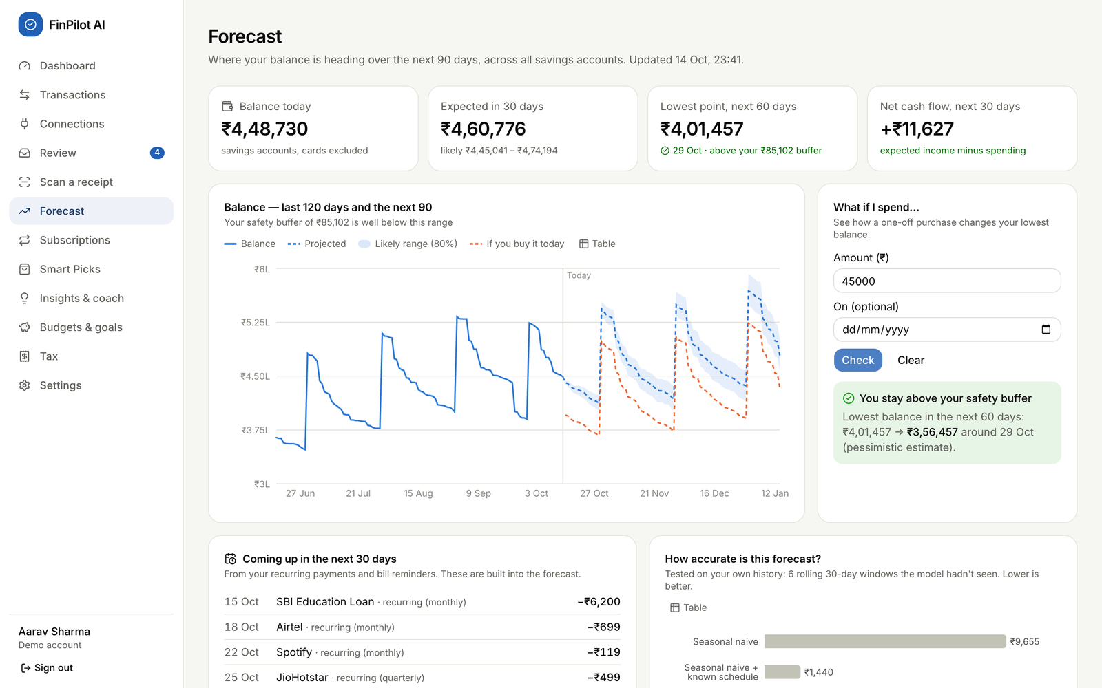
Forecast page after a what-if check of ₹45,000
Element on screen | Inputs and buttons | What it shows
Four stat tiles | none | Balance today; Expected in 30 days (with the likely range); Lowest point in the next 60 days (green or red against the safety buffer); Net cash flow for the next 30 days
Balance chart | Table toggle | The last 120 days, the next 90 days (dashed median), the 80% band, and an orange “If you buy it today” line after a what-if
What if I spend… | Amount (₹) (required), On (optional) date, Check, Clear | “You stay above your safety buffer” or “This would take you below your safety buffer”, with the lowest balance before → after
Coming up in the next 30 days | none | Recurring payments and announced bills that the forecast already includes
How accurate is this forecast? and Backtest details | none | MAE, RMSE, WAPE and 30-day balance error for three models; the model in use is marked
Known schedule | none | Detected recurring income and payments
Coach (Insights page) | Your question (up to 500 characters), suggestion chips, Send, Clear | An answer from the user’s own data, with a chart or table, and “Understood as “…” · N% sure”
Insights list (Insights page) | Open, dismiss (×) | Observations ranked by severity
Demo steps
- Open Forecast and walk through the four tiles. On 14 Oct the demo showed:
  - balance ₹4,48,730;
  - in 30 days ₹4,60,776, likely between ₹4,45,041 and ₹4,74,194;
  - lowest point ₹4,01,457 on 29 Oct, above the ₹85,102 buffer.
- Under What if I spend…, type 45000 and click Check. A green box appears: the lowest balance goes from ₹4,01,457 to ₹3,56,457, and an orange dashed line is added to the chart.
- Type 450000 and click Check. The box turns red: “This would take you below your safety buffer”.
- Scroll to Backtest details. On 14 Oct the average daily error was:
Model | Error per day
Seasonal naive | ₹9,655
Seasonal naive + known schedule | ₹1,440
Prophet + known schedule | ₹1,329
- Open Insights & coach and click the chip Can I afford a ₹60,000 laptop?. Point to “Understood as “Affordability Check””.
- Type what's the weather in Paris?. The coach gives an honest fallback answer instead of making one up.
- Dismiss an insight with ×. It disappears and stays dismissed (shown in the database in Task 6).
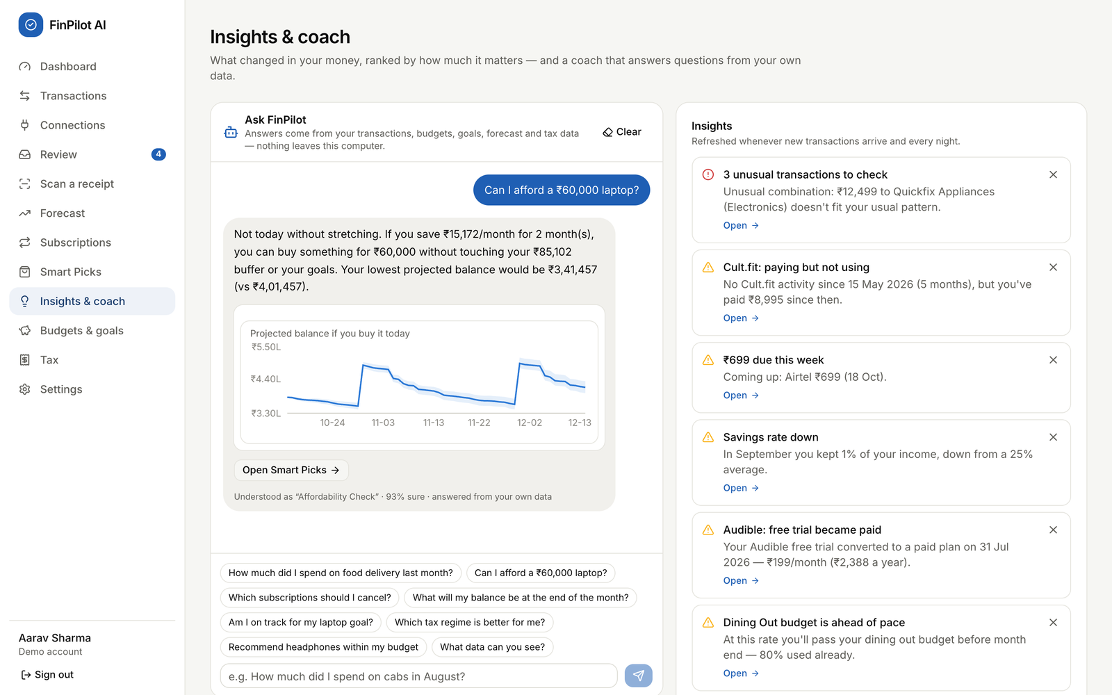
Insights & coach answering an affordability question
What to say: “The forecast is the known schedule (salary, rent, EMIs, SIPs, subscriptions, bills) plus Prophet for the day-to-day spending. I report its error against two baselines using a rolling backtest. If Prophet can’t run, the page automatically uses the baseline and says so.”

3.2 Subscription management
What it does
- Finds recurring charges from the interval and amount of the user’s payments.
- Uses emails as evidence to flag four kinds of waste:
  - a price increase;
  - a dormant subscription (paid for but not used);
  - a free trial that became paid;
  - overlapping services.
- Ranks the suggestions by ₹ saved per year, and totals the monthly and yearly cost.
Where: sidebar → Subscriptions (/subscriptions).
Element | Inputs and buttons | What it shows
Four tiles | none | Active subscriptions, Per month, Per year, You could save …/yr
Suggestions, biggest saving first | I’ll cancel it, Keep it, See the email, Undo | One finding per subscription, with “save ₹X/yr” (or “costs ₹X/yr more” for a price rise)
Where the money goes | Table toggle | Yearly cost per subscription
All subscriptions | none | Plan, since when, next charge, notes such as Not used, Trial → paid, Overlaps, Price up
Demo steps
- Open Subscriptions. The tiles read 9 subscriptions, ₹5,084 per month, ₹61,011 per year, and “You could save ₹28,899/yr”.
- Read the findings: “Cult.fit: Paying but not using”, “Audible: Free trial became paid”, “Netflix: Price went up 30%” and “Spotify: Two music services”.
- On Netflix, click See the email. The price-change email opens with the extracted fields highlighted.
- On Cult.fit, click I’ll cancel it.
  - The toast reads “Marked to cancel — remember to cancel it with the provider”.
  - The pill changes to “You plan to cancel”.
  - Click Undo.
- Click Keep it on another subscription. It leaves the suggestions list, and the toast reads “Got it — we won’t suggest this again”.
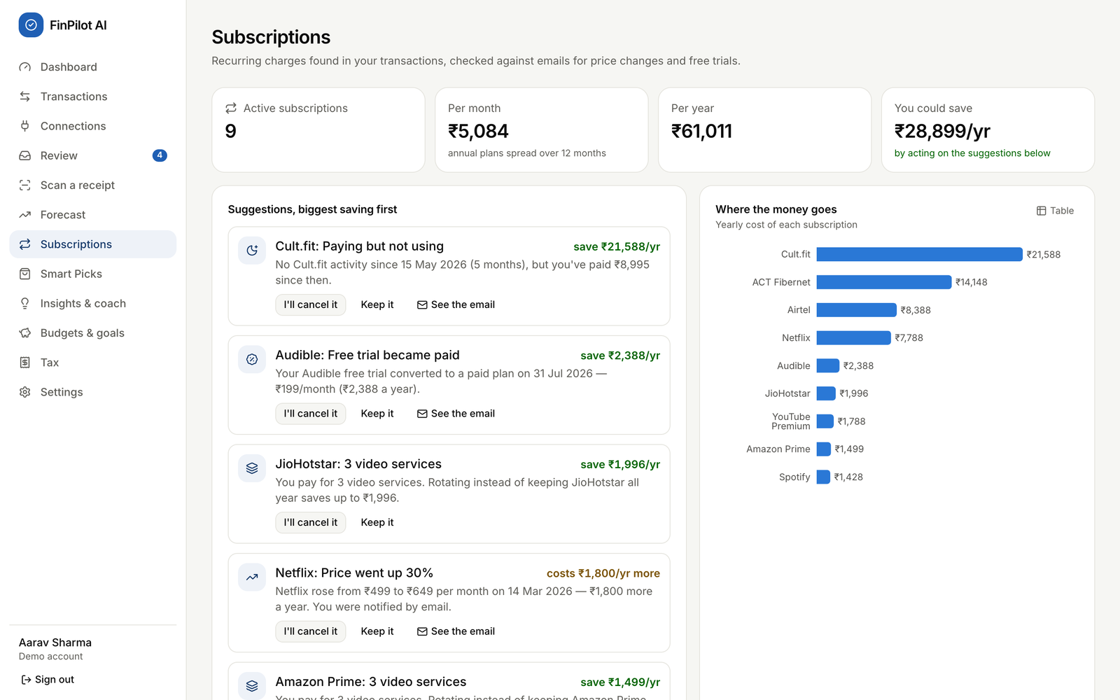
Subscriptions page
What to say: “Detection is purely algorithmic: the same merchant, a regular interval from weekly to annual, and a stable recent amount. Suggestions are ranked by money saved per year. A price rise is shown as an extra cost and isn’t added to the savings total. A ‘Keep it’ choice survives every recalculation.”

3.3 Tax analysis
What it does
- Estimates income tax for two years: FY 2025-26 (Income-tax Act, 1961) and Tax Year 2026-27 (Income-tax Act, 2025).
- Compares the old and new regimes, including the 87A rebate, marginal relief, surcharge and 4% cess.
- Detects deductions from the user’s transactions: 80C (s.123 from 2026-27), 80D, HRA and 80TTA, with 80E and 24(b) taken from the salary profile.
- Shows the remaining headroom and the advance-tax schedule, and exports a CSV or PDF.
Where: sidebar → Tax (/tax).
Element | Inputs and buttons | What it shows
Year tabs | FY 2025-26, Tax Year 2026-27 | Switches the year
Recommendation banner | none | “The new regime costs ₹X less for you this year.” For the current year it also shows “in progress”, meaning figures to date plus scheduled payments
New regime and Old regime columns | none | Salary, deductions, taxable income, slab tax, rebate, cess, total, effective rate; “Better for you” pill
Total tax, Advance tax | none | A bar comparison, and the instalments if more than ₹10,000 is due
Section 80C / Section 123 card | none | A progress bar against the ₹1,50,000 limit, with the parts that make it up
HRA exemption card | none | HRA received, rent paid, the exempt amount, and headroom tips
Evidence from your transactions | click a row | The individual payments that were counted
Your salary details | 8 number fields, the metro switch, Save and recalculate | Form 16 inputs
Header buttons | CSV, PDF summary | Downloads finpilot-tax-<year>.csv or .pdf
Demo steps
- Open Tax. The 2026-27 banner reads “The new regime costs ₹92,373 less for you this year · in progress”.
- Click FY 2025-26.
  - New regime ₹1,89,277 against old regime ₹2,72,126, so the new regime saves ₹82,849.
- Explain 80C: ₹1,79,040 was invested (PF ₹95,040 + ELSS ₹60,000 + LIC ₹24,000), so the ₹1,50,000 cap is fully used.
- Explain HRA. It is the least of three amounts:
  - HRA received: ₹3,96,000;
  - rent minus 10% of basic: ₹3,03,000 − ₹79,200 = ₹2,23,800;
  - 50% of basic: ₹3,96,000.
- So ₹2,23,800 is exempt.
- Under Evidence, expand ELSS SIPs to show the 12 payments that were counted.
- Click PDF summary (it downloads finpilot-tax-2025-26.pdf), then CSV.
- Under Your salary details, set HRA received to 300000 and click Save and recalculate.
  - The toast reads “Tax details saved” and the figures change.
  - Change the value back to 396000.
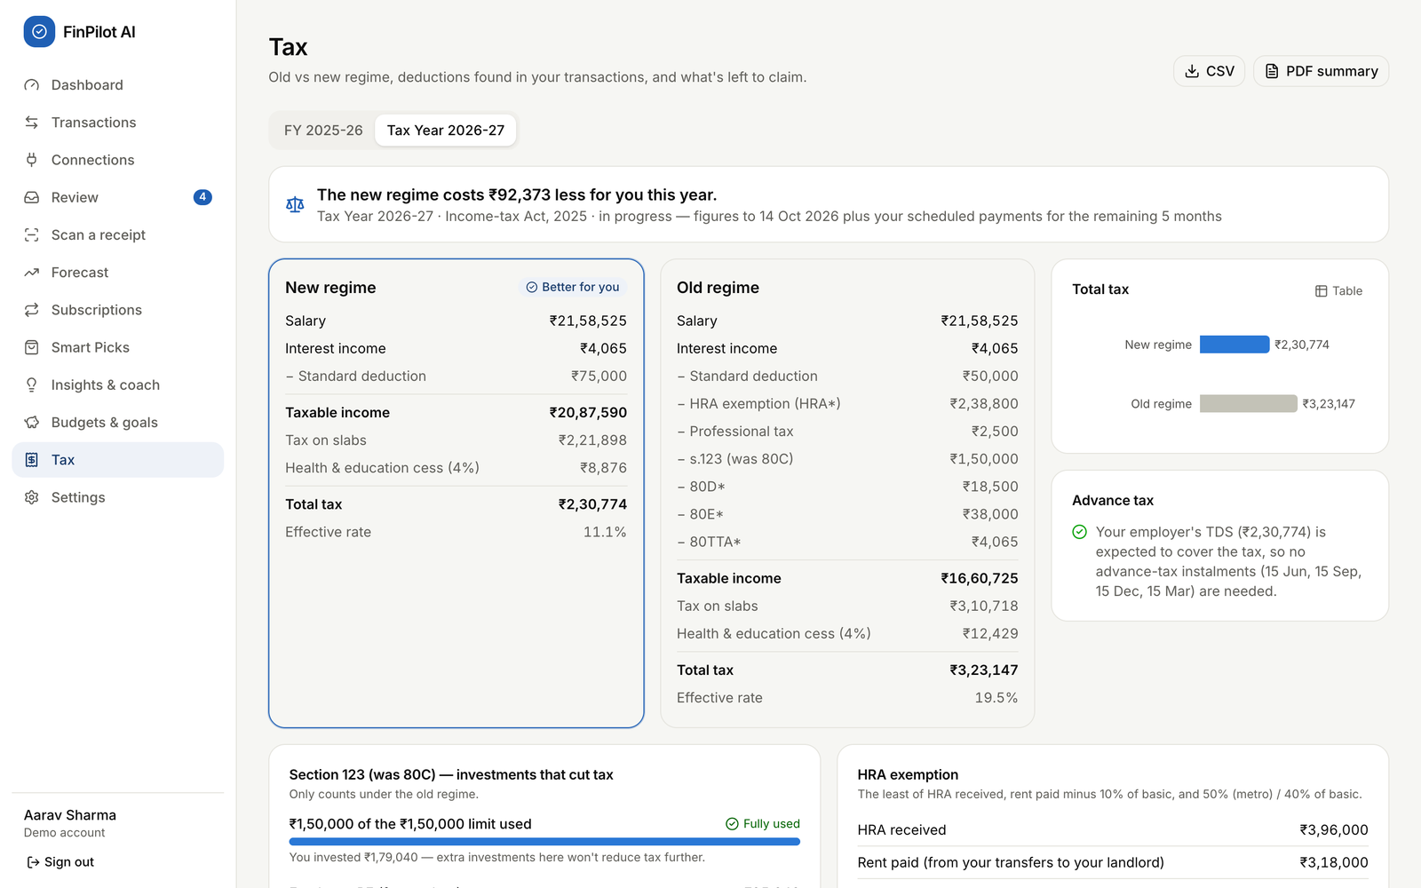
Tax page, Tax Year 2026-27
What to say:
- “All rates and limits live in one YEARS table and are unit-tested. For example, a taxable income of ₹12,10,000 under the new regime gives ₹10,400 because of marginal relief.”
- “Every view says ‘estimates for planning, not tax advice’.”

3.4 Smart Picks and affordability
What it does
- Works out how much the user can safely spend.
- Crawls the bundled demo stores politely: it obeys robots.txt and reads the sitemap and JSON-LD.
- Recommends products in three tiers: Buy now, For your goals and Save up for. Every product is checked against the safety buffer and the forecast.
- Can I afford…? checks any price the user types.
Where:
- sidebar → Smart Picks (/picks);
- the Smart Picks switch in Settings;
- “Also use for Smart Picks recommendations” on Connections.
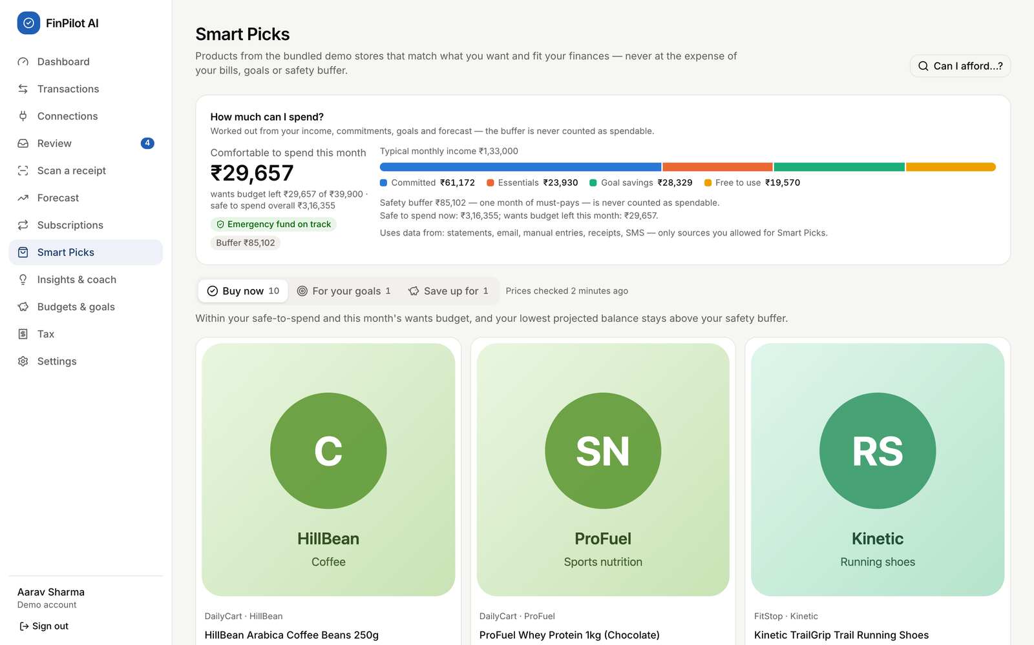
Smart Picks with the affordability breakdown
Element | Inputs and buttons | What it shows
How much can I spend? | none | “Comfortable to spend this month” (= min(safe to spend, wants budget left)), buffer, emergency-fund pill, income split into Committed / Essentials / Goal savings / Free to use, and which sources were used
Tier tabs | Buy now, For your goals, Save up for (with counts) | Pick cards: price, rating, 30-day sparkline, reasons, impact on the lowest balance
Pick card buttons | Make it a goal (Save up tier), Save, Not for me | Saves, hides, or creates a goal
Product dialog | click a card; Open in | A 90-day price chart, the verdict, and “Why it was picked for you”
Can I afford…? dialog | What is it?, Price (₹), Check | Verdict text, plus the lowest projected balance before → after
Your wishlist | text, Max ₹, Add, trash icon | Items the crawler looks for
Stores & crawling | Crawl now, a crawl row to expand its log | robots.txt status per store, and the recent crawls
Demo steps
- Open Smart Picks. On 14 Oct the card read:
  - “Comfortable to spend this month ₹29,657”;
  - safe to spend overall ₹3,16,355;
  - wants budget left ₹29,657;
  - buffer ₹85,102.
- Click Can I afford…?, enter 60000 and click Check. The answer is “Save ₹15,172/month for 2 month(s) and you can buy it without touching your buffer.”
- Enter 5000000 and click Check. The answer is “Not right now — …”.
- Walk through the tabs: Buy now (10), For your goals (1, the laptop goal) and Save up for (1, the mirrorless camera). Open one card to show its price history and verdict.
- Click Crawl now. The progress bar fills.
  - In Recent crawls, BlockedMart shows “robots.txt disallows — skipped”.
  - Expand the run to see its log.
- To show purpose limitation:
  - On Connections, switch off “Also use for Smart Picks recommendations” for SMS.
  - Back on Smart Picks, a warning appears and Buy now is empty.
  - Switch it back on.
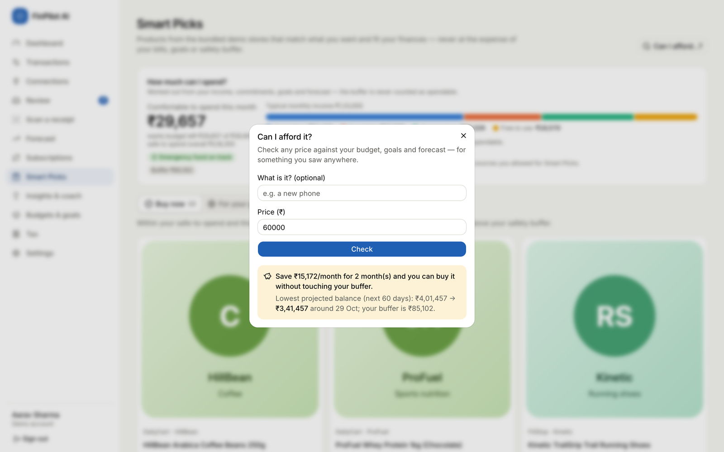
Can I afford…? check for ₹60,000
What to say:
- “The money that’s safe to spend never touches the safety buffer, the dues before the next salary, or the goal savings. It also respects the pessimistic 60-day forecast. The buffer is the larger of the user’s floor and one month of must-pay costs.”
- “A property-based test with Hypothesis checks 300 random cases, and in every one ‘Buy now’ never breaks the buffer.”

3.5 Authentication
What it does
- Registration, login and a one-click demo login.
- Sessions are kept in httpOnly cookies: a 30-minute access token and a 14-day refresh token. The refresh token is rotated every time it is used.
- Logout.
- Failed logins are rate-limited.
Where:
- /login and /register;
- Sign out at the bottom of the sidebar.
Every signed-in page goes through the (app) layout, which sends the user to /login if /auth/me fails, and to /onboarding if they haven’t finished onboarding yet.
Page | Inputs and buttons | Results
Login | Try the demo (disabled and showing progress while the demo is prepared), Email, Password, Sign in, link Create an account | Goes to the dashboard, or shows a red error message
Register | Name, Email, Password (at least 8 characters, with the hint “At least 8 characters.”), Create account | Goes to onboarding, or shows a red error message
Demo steps
- Click Sign out. On the login page, enter demo@finpilot.ai with a wrong password and click Sign in.
  - The page shows “Wrong email or password.”
  - DevTools → Network shows 401.
- Click Try the demo to reach the dashboard.
- Register a new account (name, a new email, a password of 8 or more characters). It opens onboarding.
- Register the same email again: “An account with this email already exists. Sign in instead.” (409)
- Optional: in DevTools → Application → Cookies, show the two cookies.
  - fp_at has path / and fp_rt has path /api/v1/auth. Both are HttpOnly.
  - Point out that JavaScript cannot read them.
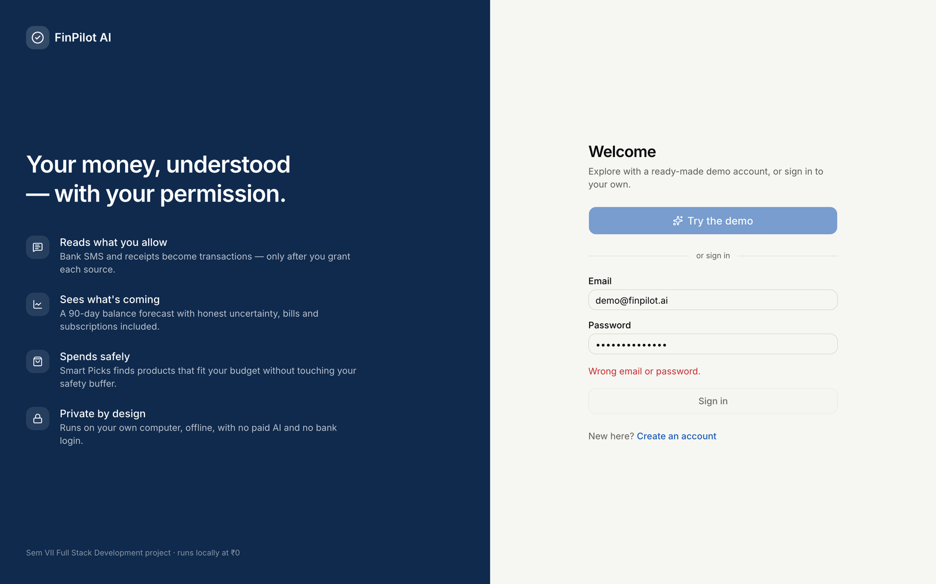
Login error for a wrong password
What to say:
- “Passwords are hashed with bcrypt at 12 rounds.”
- “Tokens are HS256 JWTs in httpOnly, SameSite=Lax cookies.”
- “Every request that changes data must also carry an X-Requested-With header, which guards against CSRF.”
- “On a 401, api.ts silently refreshes the session once before sending the user to the login page.”

3.6 Consent and privacy
What it does
- SMS and email are separate sources. Nothing is read until the user grants a source. The grant dialog lists:
  - what is read and what is never read;
  - what is stored;
  - what the app will never do;
  - two unticked purposes: record transactions (required) and Smart Picks (optional);
  - a backfill window.
- Every change is logged. Pause, resume, revoke, changing purposes and deleting data all add a row to the consent history, with the notice version and its SHA-256 fingerprint.
- Settings controls cover:
  - how long the original message text is kept;
  - Smart Picks on or off;
  - the safety buffer, emergency-fund months and picks per week;
  - exporting all data and deleting the account.
Where:
- Onboarding, shown on first login;
- Connections (/connections);
- Settings (/settings).
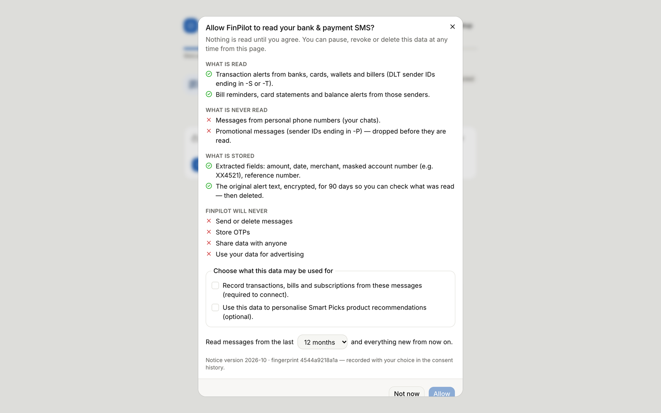
The consent dialog: Allow stays disabled until “Record transactions” is ticked
Element | Inputs and buttons | What it shows
Source card (Connections) | Connect / Reconnect, Load sample inbox / Load sample mailbox, Import a file, Pause, Resume, Revoke, Delete data, and the switch “Also use for Smart Picks recommendations” | Status pill, Messages kept / Linked to payments / In review, when it was allowed, the backfill window, when it was last read
Phone and Mailbox simulators | template chips, Send SMS, Deliver email | The outcome: created / duplicate / enriched / ignored / dropped. A paused or revoked source refuses every message
Consent history | none | When, source, event, purposes, notice version and fingerprint
Preferences (Settings) | Smart Picks switch, Safety buffer floor (₹), Emergency fund target (months), Smart Picks per week (max), Keep original message text for (days), Save preferences | Saved preferences, confirmed by the “Saved” toast
Your data (Settings) | Export all my data (JSON), Reset the demo (demo account) / Delete my account (others) | A download, a reset, or a deleted account
Demo steps
- Grant consent as a new user.
  - Register a new user and click Get started → Review and allow.
  - Show that Allow stays disabled until “Record transactions…” is ticked.
  - Tick it, click Allow, then click Use the sample inbox.
- Pause a source as the demo user.
  - On Connections, click Pause on the SMS card.
  - The Phone simulator now says that a paused source refuses every message, including simulated ones.
  - Click Resume.
- Switch “Also use for Smart Picks recommendations” off and on again. Each change adds a Purposes changed row to the Consent history.
- Revoke and delete a source.
  - On the email card, click Revoke and confirm.
  - Click Delete data and confirm.
  - The toast gives the number of messages deleted, and how many transactions were kept because another source also confirms them. The history gains a Data deleted row with the counts.
- Change and save preferences.
  - Under Settings → Preferences, set Safety buffer floor to 20000 and click Save preferences.
  - Try 3 for Keep original message text for. The browser blocks it (the minimum is 7), and the backend would also return 422 (see Task 5).
- Click Export all my data (JSON). It downloads finpilot-export-<date>.json.
- Finish with Reset the demo.
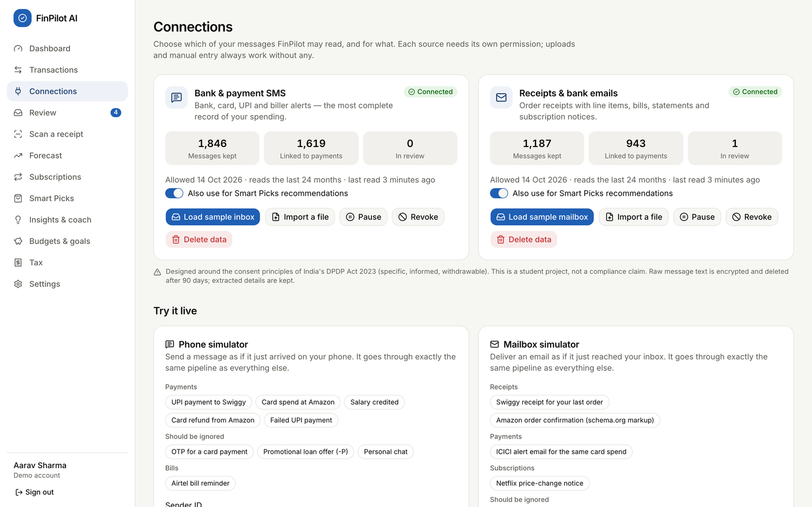
Connections: per-source consent and the live simulators
What to say:
- “Consent is per source and per purpose, it can be withdrawn as easily as it was given, and every decision is audited.”
- “The design follows the consent principles of India’s DPDP Act 2023, but it doesn’t claim compliance.”
- “The original message text is encrypted with Fernet and deleted after the retention period. The extracted fields stay.”
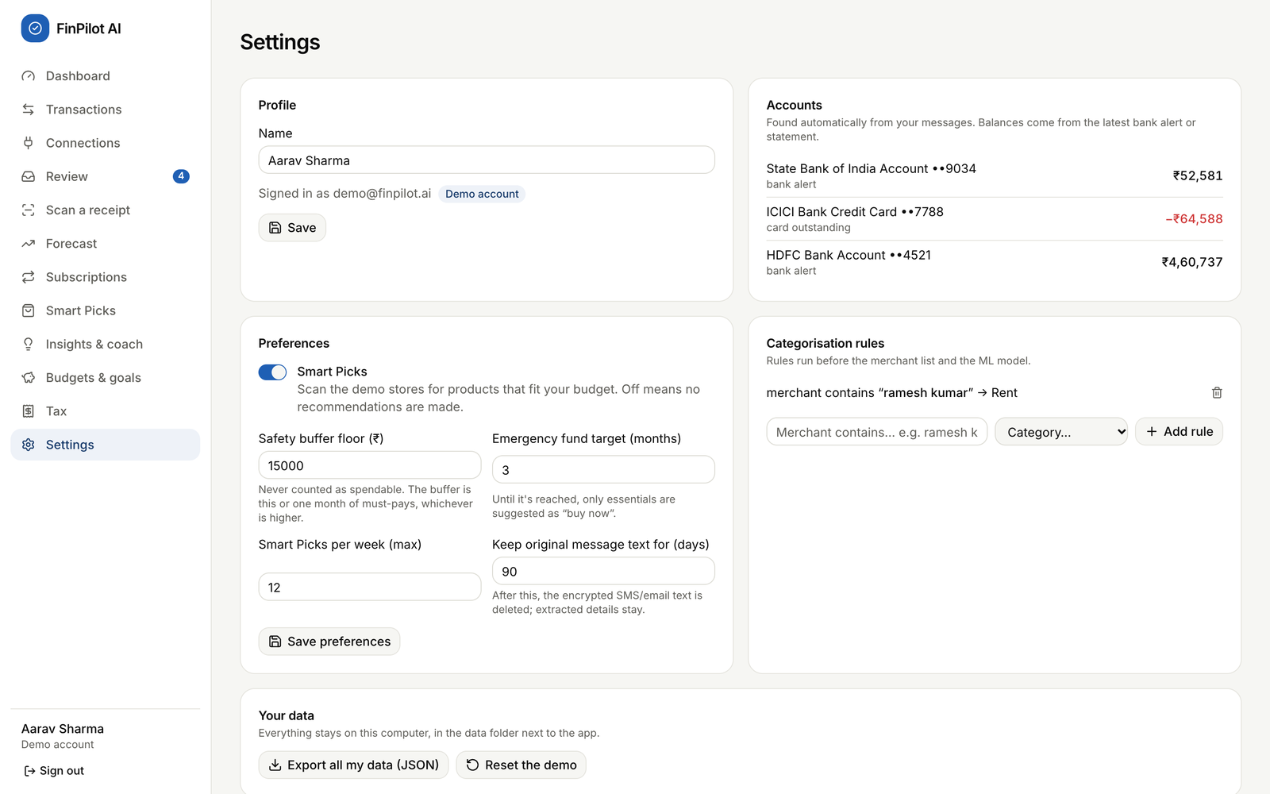
Settings: privacy and Smart Picks preferences

Task 4: Backend files

Request path (shared by every feature)
Browser page (React 19 + TanStack Query)
└─ frontend/src/lib/api.ts fetch('/api/v1/…') with cookies + X-Requested-With header
└─ backend/app/main.py create_app(): CSRF middleware, global exception handler, routers, static site
└─ api/v1/router.py mounts the 15 feature routers under /api/v1
└─ api/v1/<feature>.py endpoint: Pydantic validation, ownership checks, HTTP errors
├─ core/deps.py CurrentUser (cookie JWT → User) and DB (one session per request)
└─ services/*.py business logic (no HTTP), shared metrics and recurring detection
└─ models/*.py → SQLAlchemy 2 → db/session.py → SQLite (data/finpilot.db, WAL mode)
Background: jobs/runner.py (thread pool, `jobs` table) ← jobs/tasks.py (job functions) ← jobs/scheduler.py

Shared files I rely on
File | Responsibility
main.py | create_app(); the csrf_guard middleware (L58); the unhandled exception handler (L70); a lifespan that starts the job runner and the scheduler
core/deps.py | current_user() reads the fp_at cookie, decodes the JWT and loads the User; it also defines the DB and CurrentUser dependency aliases
core/security.py | bcrypt (hash_password, verify_password) and JWT (create_access_token, create_refresh_token, decode_token)
db/session.py | get_db(): commits on success, rolls back on any exception, always closes; SQLite pragmas WAL, foreign_keys=ON, busy_timeout (L17)
core/money.py | The Money column type (integer paise ↔ Decimal rupees) and fmt_inr() Indian digit grouping
services/metrics.py | Shared figures (rows, spend, income, median_monthly, goals_status), plus picks_origins() for purpose limitation (L56)
services/recurring.py | detect_recurring(), the Recurring class with occurrences() and monthly_equivalent
services/analytics.py | run_user_analytics(): five isolated stages (anomalies → subscriptions → forecast → picks → insights)
jobs/runner.py, tasks.py, scheduler.py | Background jobs (each one a row in jobs). The scheduler crawls every 6 h, and runs the nightly analytics and the retention purge every 24 h

Forecasting and insights
File | What it does | Key functions and endpoints
api/v1/analysis.py | Forecast endpoints | get_forecast (L52): the stored forecast + the lowest point in 60 days compared with the buffer + the backtest. If there is no forecast yet, it queues user_analytics and returns {"status": "computing"}. forecast_whatif (L72): 0 < amount < 1e9; returns 409 if there is no forecast
services/forecasting/engine.py | The model | build_series (L41), future_schedule (L62), baseline_forecast (L88), prophet_fit_predict (L102), backtest (L125), forecast (L155), lowest_point (L206), what_if (L212)
services/forecasting/service.py | Saving and loading | refresh_forecast replaces the user’s forecasts and forecast_metrics rows; latest
services/forecasting/prophet_model.py | Prophet wrapper | load_prophet (a lazy import), tiny_fit (capability check)
services/system.py | Capability gate | check_prophet sets CAPABILITIES["prophet"]["ok"], which decides whether to fall back
api/v1/dashboard.py | Insights and coach endpoints | dashboard (L58), list_insights (L111), dismiss_insight (L118), coach_suggestions (L143), coach_history (L148), coach_ask (L154), clear_history (L166)
services/insights.py | Insight rules | generate: 12 rule groups (spending spikes, budgets, savings rate, forecast warning, bills due, anomalies, subscription waste, 50/30/20, goal pace, price drops, review queue, tax season). refresh_insights (L187) keeps dismissed insights dismissed
services/coach.py | Coach | Coach.ask: the intent model chooses a handler and falls back below 35% confidence. Slot parsers parse_period (L84), parse_amount (L122), parse_category (L142). There are 12 handlers plus the fallback (13 intents in total)

Subscriptions
File | What it does | Key functions and endpoints
api/v1/analysis.py | Subscription endpoints | list_subscriptions (L83): the items, one suggestion per merchant (the largest saving), and the totals. subscription_action (L105): keep, cancel or null, after an ownership check
services/subscriptions.py | Detection and findings | refresh_subscriptions rebuilds the rows and keeps user_action. _price_change (L43), _evidence (L31) and the MUSIC / VIDEO sets (L26–27)
services/recurring.py | Cadence rules | CADENCES (L19), detect_recurring (L75)

Tax
File | What it does | Key functions and endpoints
api/v1/analysis.py | Tax endpoints | get_tax (L114), update_tax_profile (L121), tax_csv (L131), tax_pdf (L139). Any year not in YEARS returns 404. The TaxProfile model (L30) requires every number to be ≥ 0
services/tax.py | Calculation | YEARS (L30) holds the slabs and limits; slab_tax (L42); compute (L54) applies rebate, marginal relief, surcharge and cess; tax_summary (L91) works out deductions, evidence, HRA, headroom and advance tax
services/tax_export.py | Exports | export_csv (L31), export_pdf (L53, ReportLab), category_totals (L22)

Smart Picks and affordability
File | What it does | Key functions and endpoints
api/v1/picks.py | Picks endpoints | get_picks (L62), set_status (L82), pick_to_goal (L91), product_detail (L107), check_price (L117), stores (L125), crawl_now (L141), search_products (L146), wishlist (L152–174)
services/picks.py | Affordability and ranking | Snapshot (L65), safety_buffer (L104), affordability (L110), snapshot_projection (L163), interests (L187), evaluate_price (L237), refresh_picks (L257)
services/scraper.py | Polite crawler | Crawl.get (L73): retries and backoff. Crawl.run (L95): robots.txt → sitemaps → JSON-LD. _upsert (L150) records price history. run_crawl (L206), backfill_history (L232)
jobs/tasks.py | Jobs | crawl_all (L24) then refreshes picks for each user; refresh_picks_job (L41)

Authentication
File | What it does | Key functions and endpoints
api/v1/auth.py | Auth endpoints | register (L115), login (L131), demo_login (L142), refresh (L152), logout (L168), me (L180), update_me (L185). start_session (L98) sets the cookies. _check_limit / _count (L87, L93) do the rate limiting
core/security.py | Hashing and tokens | bcrypt through pwdlib (12 rounds); HS256 JWTs whose secret is generated on first run in data/secret.json
core/deps.py | Guard | current_user returns 401 “Not signed in”
services/demo.py | Account creation | create_user sets the default preferences; Smart Picks is off for new users

Consent and privacy
File | What it does | Key functions and endpoints
api/v1/sources.py | Consent centre API | list_sources (L48), history (L53), get_notice (L59), grant (L65), pause (L72), resume (L79), revoke (L86), purposes (L93), delete_data (L102). _check (L27) returns 404 for an unknown source
services/consent.py | Consent rules | NOTICES / PURPOSES (L21–55), notice_hash (L63), _event (L68), grant (L82), require_active (L100), set_status (L108), update_purposes (L124), delete_source_data (L136), history (L165)
api/v1/ingest.py | Consent enforcement | Calls consent.require_active before the sample inbox (L37), a file import (L46) or a simulated message (L75)
services/privacy.py | Retention | purge_expired_bodies deletes raw message text older than retention_days (a daily job)
api/v1/settings.py | Data controls | export_all (L41), delete_account (L67), reset_demo (L79), system_quality (L86)
api/v1/auth.py | Preferences | ALLOWED_PREFS, PREF_RANGES, _clean_pref (L51–73)
core/crypto.py | Encryption | Fernet encrypt_text / decrypt_text for message bodies

How the files work together
- Forecast
  - New data arrives (sample inbox, file import or simulator) → a user_analytics job → run_user_analytics → refresh_forecast → engine.forecast. The result is stored in forecasts and forecast_metrics.
  - Opening the page → GET /forecast → latest + lowest_point + safety_buffer.
  - A what-if → GET /forecast/whatif → what_if on the stored projection. Prophet is not re-fitted, so this is fast.
- Insights
  - The last analytics stage → refresh_insights → insights table → GET /insights.
  - × → POST /insights/{id}/dismiss sets dismissed=1.
  - The coach: POST /coach/ask → Coach.ask → a handler that uses metrics, the forecast, tax and picks. Both the question and the answer are saved in chat_messages.
- Subscriptions
  - Analytics stage 2 → refresh_subscriptions → the subscriptions table.
  - Opening the page → GET /subscriptions.
  - Keep or cancel → POST /subscriptions/{id}/action updates user_action, which is carried into every later refresh.
- Tax
  - On each request, tax_summary reads transactions and users.tax_profile. No tax result is stored.
  - The exports call tax_summary again.
- Smart Picks
  - The crawler job (crawl_all) runs every 6 hours or on Crawl now → products and prices → for each user, refresh_picks → affordability → evaluate_price for each candidate → product_recommendations.
  - GET /picks recomputes the snapshot live.
  - Can I afford…? → POST /picks/check → evaluate_price straight away.
- Authentication
  - Register or login → start_session (cookies and a refresh_tokens row).
  - Every protected request → current_user.
  - A 401 → api.ts → POST /auth/refresh, which rotates the refresh token.
- Consent
  - Grant, pause, resume, revoke and purposes → services/consent.py updates data_sources and appends to consent_events.
  - Ingestion calls require_active first.
  - Delete data → removes the messages and the transactions that only that source supports → a user_analytics job.
  - The scheduler runs retention_purge daily.

Task 5: Exception handling and logging

5.1 How errors are handled, layer by layer
Layer | Mechanism | Code | What the client sees
Browser form | HTML validation: required, type="email", minLength={8}, min/max on number fields | e.g. register/page.tsx, settings/page.tsx | The browser blocks the submit before any request is sent
CSRF guard | Middleware rejects POST, PUT, PATCH and DELETE to /api/ without X-Requested-With: finpilot | main.py:58 | 403 “Missing X-Requested-With header”
Authentication | The current_user dependency | deps.py:13 | 401 “Not signed in”
Input validation | Pydantic Field and Query limits (for example gt=0, ge=0, max_length, pattern) | e.g. analysis.py:30, picks.py:24, auth.py:36, sources.py:18 | 422 with a list of {loc, msg} items
Business rules | raise HTTPException(status, "message") | consent.py, auth.py, analysis.py, picks.py, settings.py | 400 / 401 / 404 / 409 / 422 / 429 / 503 with a readable detail
Anything unexpected | @app.exception_handler(Exception) writes the traceback with log.exception and returns a generic message | main.py:70 | 500 “Something went wrong on the server. Check the terminal log.” No stack trace reaches the browser
Database | get_db() commits only if the request succeeds, otherwise it rolls back | session.py:63 | No half-written rows after a failure
Background jobs | JobRunner.execute catches the exception, logs it, and stores the traceback | runner.py:138 | The jobs row gets status='failed' and error = the traceback. The UI polls /jobs/{id}
App restart | Jobs that were running are marked interrupted | runner.py:70 | message = “App was restarted”
Analytics pipeline | Each stage has its own try/except and its own DB session | analytics.py:30 | The other stages still run; the failed stage’s result is {"error": …}
Forecast model | If Prophet is missing or fails, the baseline is used; a backtest failure is caught too | engine.py:164, L141 | The note on the Forecast page reads “Prophet couldn’t run on this machine, so the seasonal baseline is shown.”
Crawler | 3 attempts with backoff on 429, 5xx and network errors; errors are counted; a failure of the whole run is caught | scraper.py:73, L206 | crawl_runs.status, errors, log
Tokens and crypto | decode_token returns None on any JWT error; verify_password returns False for a malformed hash; decrypt_text returns None on InvalidToken | security.py:60, crypto.py:23 | Treated as “not signed in”, “wrong password” or “text no longer available”, never as a crash
Frontend | ApiError(status, message) takes the message from detail (a string, or a list joined with “;”). A 401 triggers a refresh, a retry, then /login | api.ts:48 | onError shows a toast (sonner) or red text on the form

5.2 Error responses for my endpoints
These were all captured from a running copy on 14 Oct 2026. Pydantic 422 responses carry a list, and the table shows each item’s msg.
Forecasting and insights
Request | Condition | Status | detail
GET /forecast/whatif?amount=0 | amount ≤ 0 | 422 | Input should be greater than 0
GET /forecast/whatif?amount=abc | not a number | 422 | Input should be a valid number, unable to parse string as a number
GET /forecast/whatif?amount=45000&on=2026-13-01 | invalid date | 422 | Input should be a valid date or datetime, month value is outside expected range of 1-12
GET /forecast/whatif?amount=45000 | user has no forecast yet | 409 | The forecast is still being computed.
GET /forecast | user has no forecast yet | 200 | {"status": "computing"}, and a job is queued
POST /coach/ask with "" | empty question | 422 | String should have at least 1 character
POST /coach/ask with 501 characters | too long | 422 | String should have at most 500 characters
POST /coach/ask with “what’s the weather in Paris?” | out of scope | 200 | intent: "fallback" with the honest fallback text
POST /insights/999999/dismiss | doesn’t exist or belongs to someone else | 404 | Insight not found
Subscriptions and tax
Request | Condition | Status | detail
POST /subscriptions/999999/action | doesn’t exist or belongs to someone else | 404 | Subscription not found
POST /subscriptions/{id}/action with {"action": "delete"} | not keep, cancel or null | 422 | String should match pattern ‘^(keep|cancel)$’
GET /tax?year=2030-31 (also export.csv and export.pdf) | unsupported year | 404 | Unsupported year
PUT /tax/profile with {"gross_salary": -5} | negative amount | 422 | Input should be greater than or equal to 0
PUT /tax/profile with a 61-character city | too long | 422 | String should have at most 60 characters
Smart Picks
Request | Condition | Status | detail
POST /picks/check with {"price": 0} | price ≤ 0 | 422 | Input should be greater than 0
POST /picks/999999/status | doesn’t exist or belongs to someone else | 404 | Pick not found
POST /picks/{id}/status with {"status": "maybe"} | invalid status | 422 | String should match pattern ‘^(new|saved|dismissed|bought)$’
POST /wishlist with {"text": "a"} | fewer than 2 characters | 422 | String should have at least 2 characters
DELETE /wishlist/999999 | not found | 404 | Not found
GET /picks/products/999999 | unknown product | 404 | Product not found
GET /products?q=a | search shorter than 2 characters | 422 | String should have at least 2 characters
Authentication and preferences
Request | Condition | Status | detail
POST /auth/register | invalid email | 422 | Enter a valid email address.
POST /auth/register | password shorter than 8 characters | 422 | Use a password with at least 8 characters.
POST /auth/register | empty name | 422 | String should have at least 1 character
POST /auth/register | email already exists | 409 | An account with this email already exists. Sign in instead.
POST /auth/login | wrong password or unknown email | 401 | Wrong email or password.
POST /auth/login | 11th failed attempt in 5 minutes from one address | 429 | Too many attempts. Please wait a few minutes.
POST /auth/demo | demo still being generated (from the code, not triggered here) | 503 | The demo is still being prepared — this takes about a minute on first start.
POST /auth/refresh | refresh cookie missing, expired or already used | 401 | Session expired — please sign in again.
GET /auth/me | no session cookie | 401 | Not signed in
any POST without X-Requested-With | CSRF guard | 403 | Missing X-Requested-With header
PATCH /auth/me with emergency_months: 99 | out of range | 422 | emergency_months must be a number between 1 and 12
PATCH /auth/me with picks_enabled: "yes" | not a boolean | 422 | picks_enabled must be true or false
PATCH /auth/me with retention_days: 3 | out of range | 422 | retention_days must be a number between 7 and 365
PATCH /auth/me with buffer_floor: -1 | out of range | 422 | buffer_floor must be a number between 0 and 1e+08
Consent and privacy
Request | Condition | Status | detail
POST /sources/whatsapp/grant | unknown source | 404 | Unknown source
POST /sources/sms/grant with {"purposes": ["picks"]} | required purpose missing | 400 | The ‘record transactions’ purpose is required to connect this source.
POST /sources/sms/grant with backfill_months: 36 | more than 24 | 422 | Input should be less than or equal to 24
POST /sources/sms/pause | source never connected | 404 | Source not connected
PUT /sources/sms/purposes with ["picks"] | removing the transactions purpose | 400 | To stop recording transactions, pause or revoke the source instead.
POST /sources/sms/resume | after a revoke | 409 | This source was revoked — grant permission again to reconnect.
POST /ingest/simulate (SMS) | source not connected | 409 | Bank & payment SMS is not connected. Grant permission on the Connections page first.
POST /ingest/simulate (SMS) | source paused | 409 | Bank & payment SMS is paused. Grant permission on the Connections page first.
DELETE /settings/account with confirm: "nope" | not confirmed | 422 | Type DELETE to confirm.
DELETE /settings/account | as the demo user | 409 | The demo account can be reset, not deleted.
POST /settings/reset-demo | as a normal user | 403 | Only the demo account can be reset.

5.3 Logging
Setup:
- Logging is configured in server.py _configure_logging():
- logging.basicConfig(level=logging.INFO, format="%(asctime)s %(levelname)-7s %(name)s: %(message)s", datefmt="%H:%M:%S")
for noisy in ("uvicorn.error", "uvicorn.access", "httpx", "cmdstanpy", "prophet", "alembic"):
logging.getLogger(noisy).setLevel(logging.WARNING)
- The logs are written to the terminal that runs python3 run.py. The app does not write a log file.
- It uses named loggers: finpilot, finpilot.jobs, finpilot.analytics, finpilot.forecast, finpilot.crawler, finpilot.scheduler, finpilot.system, finpilot.demo and finpilot.ml.
Event | Level and logger | Example line (from the verification run)
Models trained at start-up | INFO finpilot.ml | 23:41:42 INFO finpilot.ml: trained coach_intents in 0.1s: {… 'intents': 13, 'heldout_accuracy': 0.8462 …}
Demo data ready | INFO finpilot.demo | 23:41:46 INFO finpilot.demo: demo ready: {'sms': {'total': 2242, …}}
Crawler progress | INFO finpilot.crawler | 23:42:19 INFO finpilot.crawler: BlockedMart: disallowed by robots.txt — skipped without fetching
Forecast fallback | WARNING finpilot.forecast | forecast falling back to baseline: …
Prophet missing | WARNING finpilot.system | prophet unavailable: …
Job failure | ERROR finpilot.jobs, with traceback | job 42 (crawl_all) failed
Analytics stage failure | ERROR finpilot.analytics, with traceback | analytics stage forecast failed
Unhandled request error | ERROR finpilot, with traceback | unhandled error on /api/v1/…
Lasting records in the database. These survive a restart, so they work as the app’s log tables:
- jobs: every background job, with its status (queued, running, done, failed or interrupted), progress, message, result, and error (the last 4,000 characters of the traceback).
- crawl_runs: one row per crawl, with counters and a log JSON list holding the crawler’s lines.
- consent_events: the append-only audit trail of consent decisions.

5.4 How to demonstrate it
- Errors in the UI
  - A wrong password shows red text, and the Network tab shows 401 with {"detail": "Wrong email or password."}.
  - Pausing SMS makes the Phone simulator refuse messages.
  - Removing a source’s Smart Picks purpose triggers the yellow warning on Smart Picks.
- Backend validation without the UI. Run this in terminal 2. -w prints the status code.
- B=http://localhost:8000/api/v1; H='X-Requested-With: finpilot'; J='Content-Type: application/json'
# CSRF guard: no X-Requested-With header -> 403
curl -s -w ' -> %{http_code}\n' -X POST $B/auth/login -H "$J" -d '{"email":"demo@finpilot.ai","password":"demo1234"}'
# sign in as the demo user and keep the session cookies in a file
curl -s -o /dev/null -c /tmp/fp.txt -X POST $B/auth/demo -H "$H"
curl -s -w ' -> %{http_code}\n' -b /tmp/fp.txt "$B/forecast/whatif?amount=0"
curl -s -w ' -> %{http_code}\n' -b /tmp/fp.txt "$B/tax?year=2030-31"
curl -s -w ' -> %{http_code}\n' -b /tmp/fp.txt -X POST $B/picks/check -H "$H" -H "$J" -d '{"price":0}'
curl -s -w ' -> %{http_code}\n' -b /tmp/fp.txt -X PATCH $B/auth/me -H "$H" -H "$J" -d '{"preferences":{"emergency_months":99}}'
curl -s -w ' -> %{http_code}\n' -b /tmp/fp.txt -X PUT $B/sources/sms/purposes -H "$H" -H "$J" -d '{"purposes":["picks"]}'
- You can also open the API docs at /api/docs.
  - GET requests work from “Try it out”.
  - POST, PUT, PATCH and DELETE requests return 403, because Swagger doesn’t send the X-Requested-With header.
- Logs
  - Click Crawl now on Smart Picks and point to the crawler lines appearing in terminal 1.
  - Then show the stored traces in sqlite3:
  - SELECT id, kind, status, progress, substr(coalesce(error,''),1,60) AS error, created_at FROM jobs ORDER BY id DESC LIMIT 8;
SELECT id, trigger, status, pages_fetched, skipped_robots, errors FROM crawl_runs ORDER BY id DESC LIMIT 3;
SELECT value AS crawl_log FROM crawl_runs, json_each(crawl_runs.log) WHERE crawl_runs.id = (SELECT max(id) FROM crawl_runs);
- If an examiner asks for a log file
  - Explain that logs go to the terminal and that the lasting traces are the tables above.
  - Optionally, start the app with python3 run.py 2>&1 | tee fsd/demo-run.log to keep a copy. This is the terminal output captured by the shell, not a feature of the app.

5.5 Improvements (not implemented)
- Write logs to a rotating file, for example by adding a logging.handlers.RotatingFileHandler for data/logs/finpilot.log in _configure_logging().
- Add a request ID to every log line, and log each 4xx and 5xx with the user ID and path.
- Store the rate-limit counters in the database, so a restart doesn’t clear them.
- Turn Pydantic’s raw messages (for example “Input should be greater than 0”) into friendlier text before they reach the UI.
- Mark interrupted crawl runs as interrupted when the app restarts, as is already done for jobs.

Task 6: Database demonstration

6.1 Facts to know
- Storage and schema
  - SQLite file data/finpilot.db in WAL mode (you will also see -wal and -shm files).
  - The schema comes from the Alembic migration 0001_initial_schema.py and has 33 tables.
  - Access goes through the SQLAlchemy models in backend/app/models/.
- Money is stored as integer paise, so ₹1,799.00 is stored as 179900. Divide by 100 in SQL.
- JSON columns (preferences, tax_profile, purposes, findings, payload, log) are stored as text. Read them with json_extract().
- Booleans are stored as 0/1. Timestamps are UTC with no time zone; India is UTC+5:30.
- Cascading deletes: every table that belongs to a user has user_id … ON DELETE CASCADE, so deleting a user removes all of their rows.
- The demo user is recreated when the demo is regenerated, so its ID changes. Always look it up by email.

6.2 Tables used by my features
Feature | Table (key columns) | Created, updated or deleted by | Read by
Forecast | forecasts (model, horizon_days, payload JSON with history, projection p10/p50/p90, events, recurring and metrics, note) | DELETE + INSERT in refresh_forecast (the user_analytics job) | GET /forecast, what-if, dashboard, insights, picks
Forecast | forecast_metrics (model, mae, rmse, wape, folds) | DELETE + INSERT when a backtest runs | GET /forecast, /system/quality
Insights | insights (kind, key, severity, title, body, link, dismissed) | DELETE (except dismissed) + INSERT in refresh_insights; UPDATE dismissed=1 on dismiss | GET /insights, dashboard
Coach | chat_messages (role, text, intent, data) | INSERT 2 rows per question; DELETE on Clear | GET /coach/history
Subscriptions | subscriptions (merchant_name, cadence, amount, annual_cost, status, flags, findings, evidence, user_action) | DELETE + INSERT in refresh_subscriptions, keeping user_action; UPDATE user_action | GET /subscriptions, insights, coach
Tax | users.tax_profile (gross_salary, basic_salary, hra_received, employee_pf, …, metro) | UPDATE through PUT /tax/profile | GET /tax, exports. The transactions table is only read; no tax result is stored
Smart Picks | wishlist_items | INSERT through POST /wishlist; DELETE through DELETE /wishlist/{id} | refresh_picks
Smart Picks | product_recommendations (tier, score, reasons, impact, status) | DELETE (except saved) + INSERT in refresh_picks; UPDATE status | GET /picks, dashboard
Smart Picks | goals | INSERT through Make it a goal (POST /picks/{id}/goal) | affordability (goal savings)
Smart Picks | affordability_snapshots (inputs, outputs) | INSERT on every refresh_picks, as an audit trail | the database only
Smart Picks | product_sources, products, product_price_history, crawl_runs | INSERT and UPDATE by the crawler; products not seen again are marked stale | stores, picks
Authentication | users (email, name, password_hash, is_demo, onboarded, preferences) | INSERT on register; UPDATE through PATCH /auth/me; DELETE through DELETE /settings/account | everything
Authentication | refresh_tokens (jti, expires_at, revoked_at) | INSERT on login and refresh; UPDATE revoked_at on refresh (rotation) and logout | POST /auth/refresh
Consent | data_sources (kind, status, purposes, backfill_months, granted_at, paused_at, revoked_at) | INSERT/UPDATE on grant; UPDATE on pause, resume, revoke and purpose changes | every ingestion (require_active)
Consent | consent_events (event, purposes, notice_version, notice_hash, details, ip, user_agent) | INSERT only (append-only) | Consent history, export
Privacy | ingested_messages (body_enc, body_purged_at, status, transaction_id) | DELETE on Delete data; UPDATE body_enc=NULL in the retention purge | Connections counts, evidence
Privacy | transactions, transaction_items | DELETE the transactions that only that source supported; DELETE email line items | all analysis

6.3 Open the database (terminal 2)
sqlite3 data/finpilot.db # run from the project folder; reading while the app runs is fine (WAL mode)
.headers on
.mode box
.parameter set @uid "(SELECT id FROM users WHERE email='demo@finpilot.ai')"
SELECT @uid AS demo_user_id;
SELECT count(*) AS tables FROM sqlite_master WHERE type='table' AND name NOT LIKE 'sqlite_%' AND name <> 'alembic_version';
.parameter set saves the demo user’s ID once, so every query below can use @uid. Run it again after Reset the demo. The second query should return 33.

6.4 Before and after, one feature at a time
For each one, run the query, do the action in the browser, then run the query again.
A. Consent (the best one to show)
SELECT kind, status, purposes, paused_at, revoked_at FROM data_sources WHERE user_id=@uid;
SELECT id, source_kind, event, purposes, substr(notice_hash,1,12) AS notice, details, created_at
FROM consent_events WHERE user_id=@uid ORDER BY id DESC LIMIT 5;
- On Connections, switch off “Also use for Smart Picks recommendations” for SMS, then click Pause.
- Run the queries again.
  - purposes is now ["transactions"] and the status is paused.
  - Two new events appear: purposes_changed and paused.
- Click Resume and switch the purpose back on to restore the source.
To demonstrate deleting data, run this before and after Revoke and Delete data on the email card:
SELECT channel, count(*) AS messages FROM ingested_messages WHERE user_id=@uid GROUP BY channel;
SELECT origin, count(*) AS transactions FROM transactions WHERE user_id=@uid GROUP BY origin;
The email messages disappear, and the data_deleted event stores the counts in details. In the demo, transactions come from SMS (emails only enrich them with line items), so they are kept.
B. Settings (privacy and Smart Picks preferences)
SELECT json_extract(preferences,'$.buffer_floor') AS buffer_floor, json_extract(preferences,'$.retention_days') AS retention_days,
json_extract(preferences,'$.picks_enabled') AS picks_enabled FROM users WHERE id=@uid;
Under Settings → Preferences, set Safety buffer floor to 20000 and click Save preferences. Run the query again: buffer_floor is now 20000.
To see the retention policy at work, look at how many message bodies are still encrypted and how many have been purged:
SELECT channel, SUM(body_enc IS NOT NULL) AS encrypted_bodies, SUM(body_purged_at IS NOT NULL) AS purged
FROM ingested_messages WHERE user_id=@uid GROUP BY channel;
C. Authentication
SELECT id, email, name, is_demo, onboarded, substr(password_hash,1,7) AS hash_prefix, created_at FROM users ORDER BY id DESC LIMIT 3;
SELECT id, user_id, substr(jti,1,8) AS jti, expires_at, revoked_at FROM refresh_tokens ORDER BY id DESC LIMIT 4;
- Register a new user.
  - A new users row appears. Its hash starts with $2b$12$ (bcrypt), and the plain password is never stored.
  - A new refresh_tokens row appears.
- Click Sign out. That token’s revoked_at is now filled in.
D. Subscriptions
SELECT id, merchant_name, cadence, amount/100.0 AS amount_rs, annual_cost/100.0 AS annual_rs, status, flags, user_action
FROM subscriptions WHERE user_id=@uid ORDER BY annual_cost DESC;
Click I’ll cancel it on Cult.fit: user_action becomes cancel. Click Undo and it returns to empty (NULL).
E. Tax
SELECT json_extract(tax_profile,'$.hra_received') AS hra_received, json_extract(tax_profile,'$.gross_salary') AS gross FROM users WHERE id=@uid;
SELECT c.name AS category, t.merchant_name, count(*) AS payments, sum(t.amount)/100.0 AS total_rs
FROM transactions t JOIN categories c ON c.id = t.category_id
WHERE t.user_id=@uid AND t.txn_date BETWEEN '2025-04-01' AND '2026-03-31' AND c.name IN ('Investments','Insurance','Rent')
GROUP BY 1, 2;
- Change HRA received and click Save and recalculate. The JSON value changes.
- Compare the second query with the Evidence card.
  - The ELSS SIPs total ₹60,000, LIC ₹24,000 and rent ₹3,03,000.
  - The Nifty 50 index SIP is listed but does not count for 80C, because only merchants containing “elss” are counted.
F. Smart Picks
SELECT id, text, max_price/100.0 AS max_price_rs FROM wishlist_items WHERE user_id=@uid;
SELECT r.id, r.tier, r.status, round(r.score,3) AS score, substr(p.title,1,32) AS product, p.price/100.0 AS price_rs
FROM product_recommendations r JOIN products p ON p.id = r.product_id WHERE r.user_id=@uid ORDER BY r.tier, r.score DESC;
SELECT id, name, target/100.0 AS target_rs, saved/100.0 AS saved_rs, target_date, product_id FROM goals WHERE user_id=@uid;
SELECT id, trigger, status, pages_fetched, products_upserted, prices_changed, skipped_robots, errors FROM crawl_runs ORDER BY id DESC LIMIT 3;
Each action changes a different table:
- Add “smartwatch” to the wishlist: a new wishlist_items row, and the recommendations are rebuilt a few seconds later.
- Save a pick: its status becomes saved.
- Make it a goal: a new goals row, with product_id filled in.
- Crawl now: a new crawl_runs row whose trigger is manual.
G. Forecast and insights
SELECT id, model, horizon_days, generated_at, note FROM forecasts WHERE user_id=@uid;
SELECT model, round(mae,2) AS mae, round(rmse,2) AS rmse, round(wape,3) AS wape, folds FROM forecast_metrics WHERE user_id=@uid;
SELECT id, kind, severity, substr(title,1,40) AS title, dismissed FROM insights WHERE user_id=@uid ORDER BY severity DESC LIMIT 6;
SELECT id, role, intent, substr(text,1,50) AS text FROM chat_messages WHERE user_id=@uid ORDER BY id DESC LIMIT 4;
- Ask the coach a question: two new chat_messages rows, the user’s question and the assistant’s answer with its intent.
- Dismiss an insight: dismissed becomes 1, and the insight stays dismissed after the next refresh.
- Refresh the forecast:
  - On Connections, send the Phone simulator’s UPI payment to Swiggy template.
  - The new transaction queues user_analytics.
  - The forecasts row is replaced by one with a new id and a new generated_at.

Task 7: Code demonstration

7.1 The shared API client: frontend/src/lib/api.ts
Every page talks to the backend through this file (api.ts). It is about 90 lines:
export async function api<T = unknown>(path: string, opts: Options = {}): Promise<T> {
const { body, params, noRedirect, headers, ...rest } = opts;
const isForm = typeof FormData !== "undefined" && body instanceof FormData;
const init: RequestInit = {
credentials: "same-origin",
...rest,
headers: {
"X-Requested-With": "finpilot",
...(body !== undefined && !isForm ? { "Content-Type": "application/json" } : {}),
...(headers || {}),
},
body: body === undefined ? undefined : isForm ? (body as FormData) : JSON.stringify(body),
};
let res = await fetch(buildUrl(path, params), init);
if (res.status === 401 && !path.startsWith("/auth/")) {
if (await refreshSession()) res = await fetch(buildUrl(path, params), init);
}
if (res.status === 401 && !noRedirect && !path.startsWith("/auth/")) {
if (!window.location.pathname.startsWith("/login")) window.location.href = "/login/";
throw new ApiError(401, "Not signed in");
}
const text = await res.text();
const data = text ? safeJson(text) : null;
if (!res.ok) {
const detail = (data as { detail?: unknown })?.detail;
const message = typeof detail === "string" ? detail : Array.isArray(detail) ? detail.map((d) => d.msg).join("; ") : res.statusText;
throw new ApiError(res.status, message || `Request failed (${res.status})`, data);
}
return data as T;
}
Points to explain:
- Same origin, no tokens in JavaScript. FastAPI serves both the site and /api/v1. The session lives in httpOnly cookies, which are sent automatically because of credentials: "same-origin". There is no CORS and nothing in localStorage.
- CSRF. Every request carries X-Requested-With: finpilot. The backend middleware rejects state-changing calls that don’t.
- Body handling. Objects are sent as JSON with Content-Type: application/json. FormData (file uploads) is passed through untouched, so the browser can set the multipart boundary itself.
- Silent refresh. A 401 calls refreshSession() (L32), which sends POST /auth/refresh and retries once. Several 401s at the same moment share one refresh promise (refreshing). If the request still fails, the app does a full page load to /login/, which also clears every cached query.
- Errors. FastAPI sends {"detail": "…"}, or a list of {msg} for 422. The client turns either into ApiError(status, message). Pages show error.message in a toast or on the form.
- Helpers. get, post, put, patch and del (L89–93) are one-line wrappers.
  - buildUrl (L21) skips empty query parameters. That is how the optional what-if date on is left out.
- With TanStack Query
  - Reads use useQuery({queryKey, queryFn: () => get(...)}). Writes use useMutation({mutationFn: () => post(...)}).
  - After a write, the page calls invalidateQueries, so the data is fetched again.
  - Background jobs are polled with useJob (hooks.ts) every 0.8 s until done, failed or interrupted.

7.2 Forecasting: a what-if from start to finish
Frontend: forecast/page.tsx loads GET /forecast. While the status is computing, it polls every 3 s.
The what-if form only sets submitted. A second query then runs:
const wi = useQuery({
queryKey: ["whatif", submitted],
queryFn: () => get<WhatIf>("/forecast/whatif", { amount: submitted!.amount, on: submitted!.on || undefined }),
enabled: submitted !== null,
});
Endpoint: analysis.py:72 validates amount (gt=0, lt=1e9) and on (a date). It returns 409 if there is no forecast. Otherwise it calls what_if and compares the result with safety_buffer().
Model: engine.py forecast does the heavy work in a background job:
resid = series.daily - series.scheduled # remove salary, rent, EMIs, SIPs, subscriptions, bills
prophet_ok = CAPABILITIES.get("prophet", {}).get("ok", True) and len(resid) >= 120
try:
if not prophet_ok:
raise RuntimeError("Prophet unavailable")
yhat, samples = prophet_fit_predict(resid, HORIZON, samples=300)
except Exception as exc: # fallback keeps the page working on any machine
log.warning("forecast falling back to baseline: %s", exc)
model_name, note = "baseline", "Prophet couldn't run on this machine, so the seasonal baseline is shown."
yhat = baseline_forecast(resid, HORIZON)
...
paths = balance_now + np.cumsum(sched_future.to_numpy()[:, None] + samples, axis=0)
p10, p50, p90 = (np.percentile(paths, q, axis=1) for q in (10, 50, 90))
How to explain it:
- Splitting the cash flow
  - The daily net cash flow is split into the known schedule, which comes from detect_recurring, and a residual, the day-to-day spending.
  - Prophet models only the residual, with weekly seasonality, yearly seasonality once there are 400 or more days, and Indian holidays.
- The likely range
  - 300 sampled futures are added to today’s balance day by day.
  - The 10th, 50th and 90th percentiles of those paths give the band. It gets wider the further ahead it looks.
- The fallback
  - If Prophet is missing, or there are fewer than 120 days of history, a seasonal-naive baseline is used.
  - Its band comes from resampling the user’s own past residuals.
- The backtest (L125)
  - Six rolling 30-day windows the model hadn’t seen.
  - It reports MAE, RMSE, WAPE and the end-of-period error. WAPE replaces MAPE, which divides by the actual value, and daily net cash flow is often zero.
The what-if itself is simple and needs no new model fit (engine.py:212):
shifted = [{**p, "p10": p["p10"] - amount, "p50": p["p50"] - amount, "p90": p["p90"] - amount} if p["date"] >= on_iso else p
for p in projection]
before = lowest_point(projection, days) # lowest p10 in the next 60 days (pessimistic)
after = lowest_point(shifted, days)
The full flow:
- Typing 45000 and clicking Check → GET /api/v1/forecast/whatif?amount=45000.
- forecast_whatif → latest() reads forecasts.payload.
- what_if() shifts the projection → safety_buffer() → JSON.
- The green or red box appears and the orange line is drawn.
Insights and coach
- insights.py generate builds the ranked list from the same metric functions as the dashboard.
- refresh_insights remembers dismissed keys.
- coach.py Coach.ask:
  - a TF-IDF + logistic-regression model predicts one of 13 intents;
  - below 35% confidence, or for out_of_scope, it gives the honest fallback;
  - otherwise the matching method answers from the user’s own data, and the UI shows the intent and the confidence.

7.3 Subscriptions: from payments to findings
recurring.py detect_recurring groups posted, non-transfer payments by merchant and direction, then:
med = statistics.median(intervals)
cad = _classify(med) # weekly 7±2, monthly 30.4±4, bimonthly, quarterly 91.3±8, annual 365.2±12
...
regular = sum(1 for iv in intervals if abs(iv - period) <= tol or abs(iv - 2 * period) <= tol)
needed = 2 if name == "annual" else min_count # min_count = 3
if len(items) < needed or regular < 0.75 * len(intervals):
continue
recent = amounts[-4:]
spread = (max(recent) - min(recent)) / max(Decimal(1), statistics.median(recent))
if spread > Decimal("0.15"):
continue
subscriptions.py refresh_subscriptions keeps the recurring payments in the subscription-like categories. It computes annual = amount × factor (×12 for monthly) and adds findings:
- price_increase. _price_change (L43) checks that the last change was upward and that the higher amount has stuck. It links the price-change email when there is one.
- dormant. There are usage emails, but none in the last 60 or more days. The status becomes dormant.
- trial_converted. A trial notice email arrived just before the first charge.
- overlap. Two or more music services, or three or more video services. The most expensive one is kept and the rest are flagged.
The endpoint (analysis.py:83):
- keeps the largest finding per merchant;
- hides subscriptions the user chose to keep;
- adds up the totals over active and dormant subscriptions;
- leaves price increases out of potential_saving.
The full flow:
- Clicking I’ll cancel it → POST /subscriptions/{id}/action {"action":"cancel"}.
- Ownership is checked → user_action is saved.
- invalidateQueries(["subscriptions"]) → the list is fetched again.
- Because refresh_subscriptions copies user_action back by merchant name, the choice survives every recalculation.

7.4 Tax: from slabs to total
tax.py compute:
base = slab_tax(taxable, r["slabs"])
rebate = Decimal(0)
if taxable <= r["rebate_limit"]:
rebate = min(base, Decimal(r["rebate_max"])) # 87A rebate
elif regime == "new" and base > taxable - r["rebate_limit"]:
rebate = base - (taxable - r["rebate_limit"]) # marginal relief just above ₹12 lakh
after_rebate = base - rebate
... surcharge by income band (capped at 25% new / 37% old) ...
cess = ((after_rebate + surcharge) * Decimal(cfg["cess"]) / 100).quantize(Decimal("1"), ROUND_HALF_UP)
An example to say out loud:
- A taxable income of ₹12,10,000 under the new regime gives a slab tax of ₹61,000. Marginal relief caps it at the income above ₹12 lakh, which is ₹10,000.
- With 4% cess, the total is ₹10,400. This is a unit test in test_tax.py.
tax_summary builds everything else:
- Deductions from transactions: ELSS = Investments whose merchant contains “elss”; LIC = Insurance with “lic” or “life”; health insurance = Insurance with “health”; rent = Rent debits; savings interest = Interest credits.
- Years still in progress: the remaining scheduled SIPs, premiums and rent are projected to 31 March, and the interest is annualised.
- Salary: taken from the profile. If it’s missing, it is estimated by grossing up the net salary credits by ÷ 0.74 and flagged as estimated.
- HRA: the least of HRA received, rent − 10% of basic, and 50% (metro) or 40% of basic.
- Caps: 80C ₹1.5 L, 80D ₹25 k, 24(b) ₹2 L, 80TTA ₹10 k, professional tax ₹2.5 k.
- Recommendation: the regime with the lower total. Headroom tips suggest a monthly ELSS SIP to fill 80C.
- Advance tax: if no TDS figure is given, it assumes the employer withholds the full tax.
Exports: tax_export.py reuses tax_summary. The PDF is built with ReportLab and swaps “₹” for “Rs”, because the standard PDF fonts have no rupee glyph.
The full flow:
- A year tab → GET /tax?year=2025-26 (TanStack Query key ["tax", year]) → tax_summary → the columns and cards.
- The salary form → PUT /tax/profile, which merges only the fields that were sent → invalidateQueries(["tax"]) → the page recalculates.

7.5 Smart Picks: affordability and tiers
picks.py affordability works out what the user can spend:
origins = metrics.picks_origins(db, user.id) if for_picks else None # purpose limitation
used = set(db.scalars(select(Transaction.origin).where(Transaction.user_id == user.id).distinct()).all())
complete = origins is None or used <= origins
income = metrics.median_monthly(db, user.id, 6, lambda r: r.kind == "income" and r.amount > 0, today, origins)
...
surplus = income - committed - essential - goals
buffer = max(Decimal(str(prefs.get("buffer_floor", 15000))), must_pay) # must_pay = committed + essential
...
safe_a = liquid - buffer - dues - goals
safe = max(Decimal(0), min(safe_a, f_low - buffer) if f_low is not None else safe_a) if complete else Decimal(0)
wants_budget = ... (income * Decimal("0.30")) unless the user set one
evaluate_price decides the tier:
limit = min(snap.safe_to_spend, snap.wants_left)
... stays = lowest projected balance after the purchase >= buffer ...
if price <= limit and stays and (snap.emergency_ok or replenish):
return {"tier": "buy_now", ...}
capacity = max(snap.surplus, Decimal(0))
gap = max(price - limit, Decimal(0))
if capacity > 0:
months = max(1, math.ceil(gap / capacity))
if months <= 12:
return {"tier": "save_up", "months": months, "monthly": float((gap / months).quantize(Decimal("1"))), ...}
return {"tier": "not_now", ...}
The ₹60,000 check on 14 Oct, worked through:
- limit = min(₹3,16,355, ₹29,657) = ₹29,657.
- gap = ₹30,343. With a surplus of ₹19,570 a month, that takes 2 months.
- ₹30,343 ÷ 2 = ₹15,172/month, which is the number shown on screen.
refresh_picks produces the recommendation list:
- Interests: the wishlist (weight 3.0), goals (2.5), premium items bought again and again (2.2), and merchant interest tags (1.2). Healthcare is never used to infer interests.
- Matching: products are matched to interests with TF-IDF.
- Scoring: 0.45 × relevance + 0.25 × budget headroom + 0.2 × value (discount and a Bayesian rating), plus 0.1 for goal matches.
- Limits: a weekly cap (12 by default), with round-robin across interests.
- Remembered choices: dismissed and bought items are never suggested again, and saved ones are kept.
The full flow for Can I afford…?:
- The dialog → post("/picks/check", {price, label}) (picks/page.tsx:178).
- → check_price → affordability() + snapshot_projection() + evaluate_price() → _verdict_text().
- → The VerdictBox component shows green (buy now), amber (save up) or red (not now).
Crawler: scraper.py Crawl.run works in this order:
- Reads robots.txt with Protego, including the Crawl-delay.
- Lists products from the sitemap index.
- Skips any store robots.txt disallows (can_fetch), without fetching it.
- Reads the schema.org Product/Offer JSON-LD on each page, accepting INR prices only.
- Saves one price per day in product_price_history.

7.6 Authentication
auth.py:
@router.post("/login")
def login(body: Credentials, response: Response, request: Request, db: DB) -> dict:
_check_limit("login_failed", request) # only failed attempts count, so a typo-prone user isn't locked out
user = db.scalar(select(User).where(User.email == body.email.lower().strip()))
if user is None or not verify_password(body.password, user.password_hash):
_count("login_failed", request)
raise HTTPException(401, "Wrong email or password.")
start_session(response, db, user)
return user_out(user)
Sessions (start_session, L98) issue two tokens, both in httpOnly, SameSite=Lax cookies:
- an access JWT valid for 30 minutes, in the fp_at cookie with path /;
- a refresh JWT with a unique jti (also stored in refresh_tokens), valid for 14 days, in the fp_rt cookie with path /api/v1/auth.
Rotation (refresh, L152) works like this:
- The stored jti must exist, must not be revoked and must not be expired.
- It is then revoked straight away, and a new pair of tokens is issued. A stolen refresh token therefore works at most once.
The guard (deps.py:13): every protected endpoint declares user: CurrentUser. A missing or invalid cookie, the wrong token type, or a deleted user gives 401.
Frontend:
- login/page.tsx posts the credentials, clears the query cache and goes to /dashboard/.
- (app)/layout.tsx guards every page with useMe().

7.7 Consent and privacy
consent.py:
def grant(db, user, kind, purposes, backfill_months, request=None):
purposes = [p for p in purposes if p in PURPOSES] # unknown purposes dropped
if "transactions" not in purposes:
raise HTTPException(400, "The 'record transactions' purpose is required to connect this source.")
...
_event(db, user, src, kind, "granted", purposes, request, {"backfill_months": backfill_months})
def require_active(db, user, kind): # called before ANY ingestion
src = get_source(db, user, kind)
if src is None or src.status != "active":
state = "not connected" if src is None else src.status
raise HTTPException(409, f"{NOTICES[kind]['title']} is {state}. Grant permission on the Connections page first.")
return src
Points to explain:
- _event (L68) appends a ConsentEvent holding the purposes, NOTICE_VERSION, the notice’s SHA-256 notice_hash (L63), the IP address and the user agent. Nothing updates or deletes these rows.
- set_status (L108) handles pause, resume and revoke. A revoked source can’t be resumed: the user must grant again and see the notice again.
- delete_source_data (L136)
  - For each linked transaction, it checks whether a message from another source also supports it.
  - If not, and the transaction came from this source, it is deleted.
  - Otherwise it is kept, and only its email line items are removed.
  - Finally the source’s messages are deleted and a data_deleted event records the counts.
- Purpose limitation (metrics.py:56) lets Smart Picks use only sources that have the picks purpose, plus uploads and manual entries.
- Retention (privacy.py): a daily job nulls body_enc for messages older than each user’s retention_days.
- Preferences (auth.py:59): only ALLOWED_PREFS are saved, each validated against PREF_RANGES. Changing a Smart Picks preference re-ranks the picks.
Frontend:
- sources.tsx ConsentDialog fetches the notice from the server. Both purposes start unticked. Allow is disabled={!purposes.transactions} (L97).
- connections/page.tsx posts /sources/{kind}/{pause|resume|revoke|delete-data} and PUT /sources/{kind}/purposes. After each call it invalidates the sources, history, transactions and dashboard queries.
The full flow for Pause:
- Clicking Pause → POST /sources/sms/pause.
- set_status sets data_sources.status='paused' and paused_at, and appends a paused event.
- On the next simulated SMS, require_active → 409. The UI shows the paused message.

Task 8: Edge cases
Status: ✅ handled · ⚠️ partly handled · ❌ not handled (improvement). The “Demo” column says how to show it.

8.1 Forecasting and insights
Edge case | How it is handled | Status | Demo
User has no forecast yet | GET /forecast returns computing, queues the job, and the page polls every 3 s; the what-if returns 409 (analysis.py:53) | ✅ | New user → Forecast shows “Building your forecast…”
Prophet missing or failing | The baseline is used, and a note is shown (engine.py:164); a test covers it | ✅ | test_baseline_fallback_when_prophet_unavailable
Little or no history | No transactions → a flat 30-day series. Under 120 days → the baseline (engine.py:45) | ✅ | New user with a short history
Under 400 days of history | The backtest is skipped (return {}), and the accuracy chart and table are simply empty with no explanation (engine.py:128) | ⚠️ | Improvement: show “not enough history yet”
Daily net flow crosses zero | WAPE is used instead of MAPE, and its denominator is max(1, Σ\|actual\|) (engine.py:118) | ✅ | Explain it with the backtest table
What-if amount ≤ 0, not a number, or ≥ ₹1e9; invalid date | 422 from Query(gt=0, lt=1e9) and the date type | ✅ | curl in Task 5
What-if dated after day 60 | Accepted, but the “lowest in 60 days” can’t change. on isn’t checked against the projection range; the date picker limits it to 90 days | ⚠️ | Pick a date 75 days ahead: no change
Pessimistic buffer check | The low point uses p10, not the median (engine.py:206) | ✅ | Explain the “(pessimistic estimate)” note
Question outside the coach’s scope, or low confidence | Honest fallback below 35% (coach.py:164); tested | ✅ | Ask “what’s the weather in Paris?”
Ambiguous wording | “may I buy” is not read as the month of May; “last 3 months” is not ₹3; years aren’t amounts (coach.py:113); tested | ✅ | test_coach.py
Empty question, or more than 500 characters | 422; the UI disables Send and limits the input to 500 characters | ✅ | Try to send an empty box
Dismissed insight | Its key is remembered and it is skipped on refresh (insights.py:189). Many keys include the month, so a similar insight can come back next month (by design) | ✅ | Dismiss, then send a simulated SMS
Noisy “spending spike” alerts | Only from day 7 of the month, a usual spend ≥ ₹1,000, ≥ 1.5×, and ≥ ₹2,000 above usual (insights.py:49) | ✅ | Explain it
Another user’s insight | 404 “Insight not found” | ✅ | curl

8.2 Subscriptions
Edge case | How it is handled | Status | Demo
No subscriptions | Empty state: “No subscriptions found yet”; the API returns zero totals | ✅ | New user
Irregular repeat purchases | 3 or more charges needed (2 for annual), 75% regular intervals, and recent amounts within 15% (recurring.py:102) | ✅ | Groceries are not listed
A plan that got more expensive | Only the last 4 amounts must be stable, so the plan is still detected and flagged (subscriptions.py:43) | ✅ | Netflix +30%
A subscription that stopped | No charge for 1.5 periods → ended; no next date; left out of the totals | ✅ | API totals
UI counting of ended subscriptions | The page counts every status except “cancelled”, a value the backend never uses, so ended ones would count as active in the tile and chart (subscriptions/page.tsx:68) | ❌ | Not visible with the demo data; the fix is to filter on active or dormant
User choice after recalculation | user_action is copied back by merchant name (subscriptions.py:55) | ✅ | Keep, then send an SMS (re-analysis)
Two music or three video services | The most expensive one is kept; the others are flagged as overlaps | ✅ | Spotify flagged, YouTube Premium kept
Evidence email already purged | The dialog says the text was deleted under the retention setting | ✅ | Set retention to 7 days and wait for the purge
“I’ll cancel it” | Only records intent; the app can’t cancel with the provider (the toast says so) | ⚠️ | By design
Invalid action, or another user’s subscription | 422 / 404 | ✅ | curl

8.3 Tax
Edge case | How it is handled | Status | Demo
Unsupported year | 404 for the page and both exports | ✅ | ?year=2030-31
Negative numbers, overlong city | 422 (ge=0, max_length=60) | ✅ | curl
No Form 16 figures | Gross salary estimated from salary credits (÷ 0.74) and flagged on screen (tax.py:141) | ✅ | Banner: “salary estimated from your take-home pay”
No salary at all | Taxable income is never below 0, and the effective rate guards against division by 0 (verified: ₹0 under both regimes) | ✅ | New user → Tax
Income just above ₹12 lakh (new regime) | Marginal relief (tax.py:61); tested | ✅ | ₹12,10,000 → ₹10,400
Deduction limits | 80C ₹1.5 L, 80D ₹25 k, 24(b) ₹2 L, 80TTA ₹10 k, PT ₹2.5 k | ✅ | 80C ₹1,79,040 → ₹1,50,000
Year still in progress | The remaining scheduled payments are projected and interest is annualised (tax.py:117) | ✅ | 2026-27 banner “in progress”
No rupee glyph in the PDF fonts | ₹ is replaced with “Rs” (tax_export.py:59) | ✅ | Open the PDF
TDS unknown | Assumes the employer withholds everything; advance tax only if more than ₹10,000 is due | ✅ | Advance tax card
Clearing a salary field | The frontend drops blank fields and the backend ignores missing keys, so the old value stays; the user must type 0 (tax/page.tsx:45, analysis.py:123) | ⚠️ | Clear HRA received and save: the old value comes back
Surcharge just above ₹50 lakh and other thresholds | The surcharge applies in full; there is no marginal relief on surcharge (tax.py:64) | ❌ | Improvement for high incomes
Deduction detection | Depends on the category plus merchant keywords. An ELSS fund whose name lacks “elss” would be missed unless recategorised | ⚠️ | The Nifty SIP is correctly left out

8.4 Smart Picks and affordability
Edge case | How it is handled | Status | Demo
Smart Picks turned off | The API returns no picks; the page shows “Smart Picks is off” and Turn on Smart Picks | ✅ | Settings switch
Nothing crawled yet | preparing, so the page polls; the refresh is skipped (“No products crawled yet”) | ✅ | First start
Price ≤ 0 or ≥ ₹1e9 | 422 | ✅ | curl
Too expensive for 12 months, or no surplus | not_now: “Not right now — …” | ✅ | Check ₹50,00,000
Buy now could break the buffer | Never above min(safe to spend, wants left), the forecast must stay above the buffer, and the emergency fund must be in place (unless it is a replenishment). A Hypothesis property test runs 300 cases (test_picks.py:64) | ✅ | Explain the test
A source not allowed for Smart Picks | Balance and forecast aren’t used, nothing is “Buy now”, and a warning is shown (picks.py:117); tested | ✅ | Switch on Connections
robots.txt disallows a store | Skipped without fetching (BlockedMart) (scraper.py:117); tested | ✅ | Crawl now
Network errors, 429 or 5xx | 3 attempts with backoff; errors counted in the run | ✅ | crawl_runs.errors
Non-INR or missing price | The product is ignored (scraper.py:153) | ✅ | Explain it
Product removed from a store | Marked stale and no longer recommended | ✅ | Explain it
Product dismissed or bought | Never suggested again; saved picks survive refreshes | ✅ | Not for me
Repeat purchases (replenishment) | Never suggested at more than 105% of the usual price | ✅ | “cheaper than the ₹… you usually pay”
Sensitive categories | Healthcare is never used to infer interests | ✅ | Explain it
Too many picks | A weekly cap of 1–30 (default 12), with round-robin so every interest appears | ✅ | Settings
Repeated Crawl now | The button is disabled while running, and identical queued jobs are de-duplicated (runner.py:107) | ✅ | Click twice
App stopped during a crawl | The job becomes interrupted on restart, but the crawl_runs row stays running. Your current data/finpilot.db has one (run #5) | ⚠️ | SELECT id, status FROM crawl_runs;
Wishlist text of 1 character, or max price ≤ 0 | 422 | ✅ | curl

8.5 Authentication
Edge case | How it is handled | Status | Demo
Invalid email, short password, empty name | 422 with clear messages (also blocked in the browser) | ✅ | Register page
Duplicate email (any letter case) | Emails are lower-cased and trimmed → 409 | ✅ | Register twice
Email typed in a different case at login | Lower-cased and trimmed; tested | ✅ | DEMO@finpilot.ai
Unknown email and wrong password | The same message for both, so attackers can’t find which emails exist | ✅ | Try both
Brute force | 10 failed logins per address per 5 minutes → 429; tested | ✅ | (Avoid during the demo)
Behaviour after the limit is hit | Even the correct password gets 429 for up to 5 minutes (verified). The counter is in memory, so a restart resets it, and it is per IP, so all local users share 127.0.0.1 | ⚠️ | Improvement: store it, and count per account as well
Expired access token | api.ts refreshes once and retries; simultaneous 401s share one refresh | ✅ | Wait 30 minutes, then navigate
Refresh token reused or expired | 401, and the cookies are cleared; each refresh token works once | ✅ | Explain rotation
Deleted user with a valid cookie | current_user returns 401 | ✅ | Explain it
Tampered JWT or wrong token type | decode_token returns None → 401 | ✅ | Edit the cookie in DevTools
Cross-site form post | 403 without X-Requested-With; tested | ✅ | curl
Demo login before the data is ready | 503; the button is disabled with progress shown | ✅ | First start
After logout | The refresh token is revoked and the cookies deleted, but an already-issued access token stays valid until it expires (≤ 30 minutes), because JWTs are stateless | ⚠️ | Explain it
Password strength, email verification, password reset, Secure cookies | Not implemented: only the 8-character minimum, and cookies use secure=False for local HTTP | ❌ | Improvements for a hosted version

8.6 Consent and privacy
Edge case | How it is handled | Status | Demo
Reading without consent | require_active → 409 before any ingestion (ingest.py:75); tested | ✅ | Simulator on a new user
Granting without the required purpose | 400; Allow is disabled until it is ticked | ✅ | Consent dialog
Unknown purpose or source | Unknown purposes are dropped; an unknown source returns 404 | ✅ | curl
Backfill outside 0–24 months | 422 | ✅ | curl
Paused or revoked source | Every message is refused, including simulated ones (409) | ✅ | Pause, then the simulator
Resuming a revoked source | 409, so the user must grant again and see the notice again | ✅ | Revoke → API resume
Removing the transactions purpose | 400: “pause or revoke the source instead” | ✅ | curl
Deleting data that another source also supports | Only transactions that exist solely because of this source are deleted; others are kept, without their email line items; tested | ✅ | Delete data on email
Audit trail | Every decision is appended with the notice version, SHA-256 fingerprint, IP and user agent. It is append-only by API design (no edit or delete endpoint), not enforced by database triggers, and deleting the account removes it (by design) | ⚠️ | Consent history
Notice text changes | The API returns notice_current, but the UI never asks the user to consent again | ⚠️ | Improvement
Invalid preference values | 422 with the allowed range; unknown keys are silently ignored | ✅ | curl
Original text past the retention period | A daily purge nulls body_enc and sets body_purged_at; the extracted fields stay | ✅ | SQL in 6.4 B
Deleting the account | The user must type DELETE. The demo account can’t be deleted (409), and a normal user can’t reset the demo (403) | ✅ | Settings
A Smart Picks purpose change | Queues a picks refresh, so the recommendations follow the new permission | ✅ | Switch on Connections

Appendix A: ChatGPT conversation prompts (Task 1)
Use one new ChatGPT conversation per block. Paste the file or function named in brackets where shown. The prompts go from understanding the code, to edge cases, to practising answers.

Conversation 1: Forecasting and insights
- Hi! I’m getting ready for my full-stack project review. One of my parts is a cash-flow forecast for a personal finance app. I’ll paste the main function. Can you walk me through it step by step, like you’re explaining it to a classmate? [paste forecast() from backend/app/services/forecasting/engine.py]
- Why would we take out the “known schedule” (salary, rent, EMIs, SIPs) before fitting Prophet? Why not just fit Prophet on the raw daily cash flow?
- I don’t fully get the p10/p50/p90 part. How do 300 predictive samples turn into an 80% range for the balance, and why does it get wider further out?
- Here’s our backtest code [paste backtest() and _metrics()]. What’s a rolling-origin backtest, and why is WAPE better than MAPE when the daily net cash flow is sometimes zero?
- This is the what-if function [paste what_if()]. Is it actually correct to subtract the purchase from p10, p50 and p90 for every day after the purchase? Explain why.
- My examiner might ask what happens if Prophet isn’t installed, or if a user only has a few weeks of data. Here’s the fallback code [paste the try/except in forecast()]. How should I answer?
- Can you give me 5 tricky viva questions about this forecasting approach, with short honest answers?

Conversation 2: Subscription detection
- I built subscription detection from bank transactions. Can you explain what this function does and why each rule exists? [paste detect_recurring() from backend/app/services/recurring.py]
- Why use the median interval and a tolerance per cadence (like monthly = 30.4 ± 4 days)? Why not just check whether the dates are exactly a month apart?
- Here’s how we flag price rises, dormant subscriptions, trials that became paid, and overlaps [paste refresh_subscriptions() and _price_change()]. Walk me through each finding with an example.
- What edge cases could break this? For example, a price change, a paused subscription, two charges on the same day, or annual plans with only two charges so far.
- Our “potential saving” total leaves out price increases [paste list_subscriptions() from backend/app/api/v1/analysis.py]. How would I explain that design choice?
- Quiz me with 5 questions an examiner might ask about this feature, and check my answers.

Conversation 3: Tax analysis
- I’m explaining an Indian income-tax estimator in my project review. Can you explain this code line by line, especially the rebate and marginal relief part? [paste slab_tax() and compute() from backend/app/services/tax.py]
- Work through an example with me: a taxable income of ₹12,10,000 under the new regime. Why does it come to ₹10,400 and not ₹61,000 + cess?
- Here’s how deductions are detected from transactions [paste the deduction part of tax_summary()]. How does the HRA least-of rule work? Can you check it with HRA ₹3,96,000, rent ₹3,03,000 and basic ₹7,92,000?
- What are the limitations of detecting 80C/80D from merchant names and categories, and what would make it more reliable?
- Our surcharge has no marginal relief. Explain simply what surcharge marginal relief is and why it matters for incomes just above ₹50 lakh.
- What questions could an examiner ask about the tax module, and what’s a good honest answer to “is this tax advice?”

Conversation 4: Smart Picks and affordability
- My feature decides whether a user can afford a product. Here’s the affordability code. Can you explain each number (income, committed, essential, goals, buffer, safe to spend)? [paste affordability() from backend/app/services/picks.py]
- Now here’s how the tier is decided [paste evaluate_price()]. Work through it for a price of ₹60,000 with safe-to-spend ₹3,16,355, wants budget left ₹29,657, and a surplus of ₹19,570 a month.
- Why take the minimum of “liquid − buffer − dues − goals” and “lowest forecast − buffer”? What would go wrong if we used only one of them?
- We test “buy now never breaks the buffer” with Hypothesis [paste test_buy_now_never_breaks_the_buffer]. What is property-based testing, and why is it a good fit here?
- Explain the purpose-limitation logic: if a source isn’t allowed for Smart Picks, why do we stop using the balance and forecast entirely? [paste picks_origins() from metrics.py]
- Here’s our crawler [paste Crawl.run() from backend/app/services/scraper.py]. How does it respect robots.txt and Crawl-delay, and why use JSON-LD instead of CSS selectors?
- Give me 5 viva questions on this feature, including ethics (affiliate links, urgency wording), with short answers.

Conversation 5: Authentication
- Can you review our FastAPI login and registration code and explain the flow end to end? [paste backend/app/api/v1/auth.py up to logout]
- We keep JWTs in httpOnly cookies instead of localStorage. What attacks does that help with, and why do we also need the X-Requested-With header check? [paste the csrf_guard middleware from main.py]
- Explain refresh-token rotation using our code [paste refresh() and start_session()]. What happens if someone steals and reuses an old refresh token?
- Our rate limiter counts failed logins per IP in memory [paste _check_limit and _count]. What are its weaknesses, and how would I improve it?
- What edge cases should I mention? For example, email case, a user deleted while still logged in, an expired access token, or a tampered JWT.
- Ask me 5 security questions an examiner might ask about this login system.

Conversation 6: Consent and privacy
- Our app reads bank SMS and emails only after per-source consent. Explain this service and the design ideas behind it. [paste backend/app/services/consent.py]
- Why store a SHA-256 hash of the notice with every consent event? What does an append-only audit log protect against?
- Walk me through delete_source_data(). Why don’t we delete a transaction that another source (like a bank SMS) also confirms?
- Here’s how ingestion checks consent [paste require_active() and the simulate endpoint from ingest.py]. What happens when a source is paused or revoked?
- We encrypt raw message text with Fernet and purge it after 90 days [paste crypto.py and privacy.py]. Explain what Fernet gives us, and why we keep the extracted fields but delete the raw text.
- How does this relate to India’s DPDP Act 2023 principles? I want to describe it honestly, without claiming compliance.
- Give me likely viva questions on privacy and consent, with short answers.

Conversation 7: The shared API client (api.ts)
- This is our frontend’s fetch wrapper. Can you explain every part of it? [paste frontend/src/lib/api.ts]
- How does the “refresh once and retry” logic work, and why is there a shared refreshing promise? What would happen without it if three requests got a 401 at the same time?
- Why does it use a full page load (window.location.href) on a final 401 instead of the Next.js router?
- How does it turn FastAPI errors (a string detail, or a list of {msg} for 422) into one error message?
- Show me how a page would use this with TanStack Query’s useQuery and useMutation, including invalidateQueries after a change.
- What questions might an examiner ask about this file?

