Pre-production Plan

o The aim and content of the website

Website is dedicated for tourists visiting Cobh Co.Cork. There will be section-stating history of town. You will be able to see what is currently happening in town and near future events planed. In addition, there will be section with hotels and guesthouses available, when you find a place to stay then you can look for places to eat, drink and visit some great tourist attractions as well. In addition website will have maps how to get to Cobh and current weather conditions, so visitors can plan to take the umbrella or the sunglasses.

o Any user requirements

* The website must open and function in Internet Explorer and Chrome
* All navigation links between the 5 web pages must work
* The website must contain two interactive features
* There must be an email link
* The website must contain at least one animation
* Layout of each page (must have 5 pages)
* Navigation diagram/storyboard (site map)
* Format of content including CSS on each of the 5 pages (fonts, colours, backgrounds etc).
* Interactive features (must have 2)
* Email link for enquiries
* Images
* Animation (one will do)

1. Home page

• Welcome the user to the town or city website

• What’s on in the next week in the town or city

• What can the user see and do and experience when in the town or city

2. Stay

• List of guesthouses

• List of hotels

• For each establishment show:

* Photograph
* Brief description
* Name
* Address
* Phone number
* Email
* Website

3. Eat & Drink

• List of cafes and wine bars

• List of restaurants and bars

• For each establishment show:

* Photograph
* Brief description
* Name
* Address
* Phone number
* Email
* Website

4. About page:

• Several paragraphs about the town or city

• How to get to the town or city

• History of the town or city

• Weather of the town or city

5. Contact Page

• Contact information for the town or city tourist office

• Name & address/phone/email of the town or city tourist office

• Form for general enquiries with the following fields

* Client name
* Client email
* Enquiry category

1. Information request
2. Website changes
3. Event or news
4. Other

* Subject
* Message
* Submit button (to submit the enquiry form via email)

o Timescales for completing the website (dates and times)

* Website planning (1h)
* Research (1h)
* Coding (1h)
* Testing (1h)

Deadline: 12th Feb 2019

Website design

Home Page:

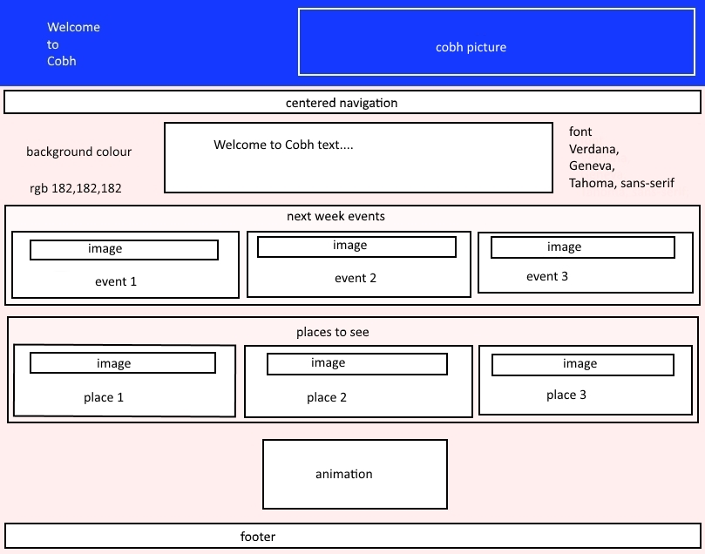

Eat & Drink Page: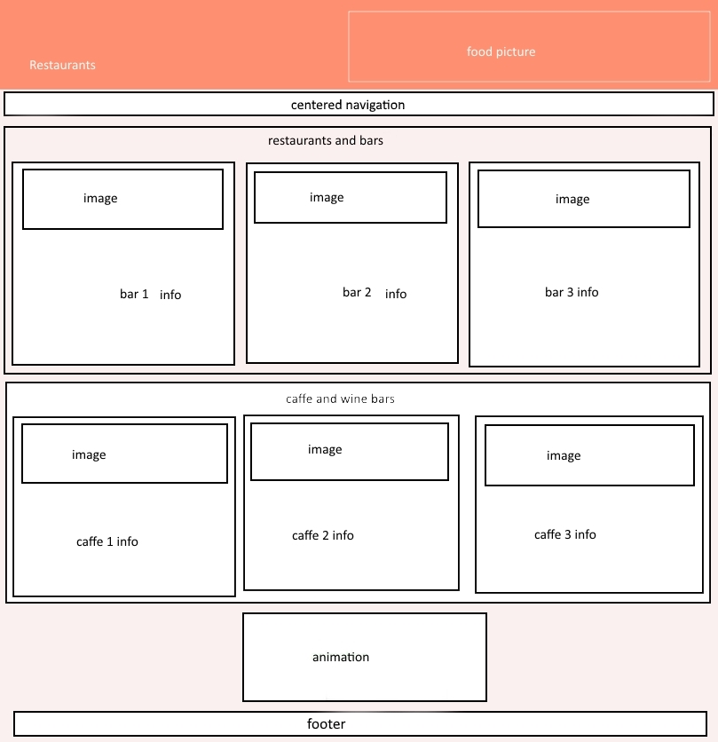

Stay Page: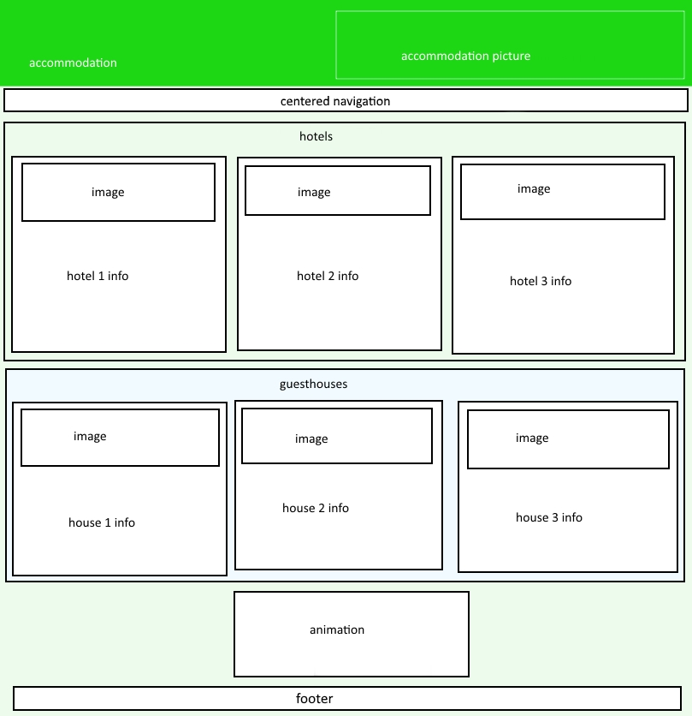

About Page: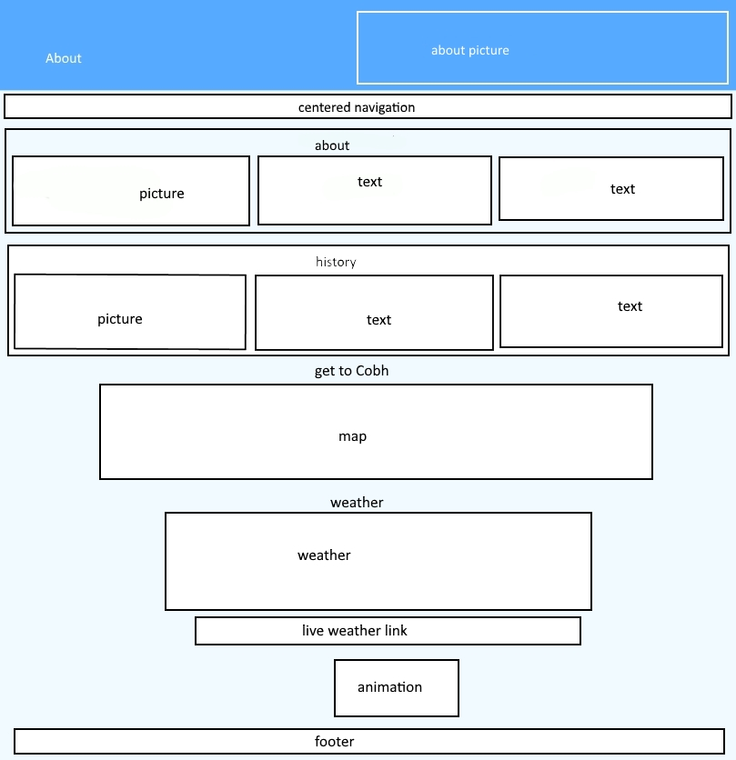

Contact Page: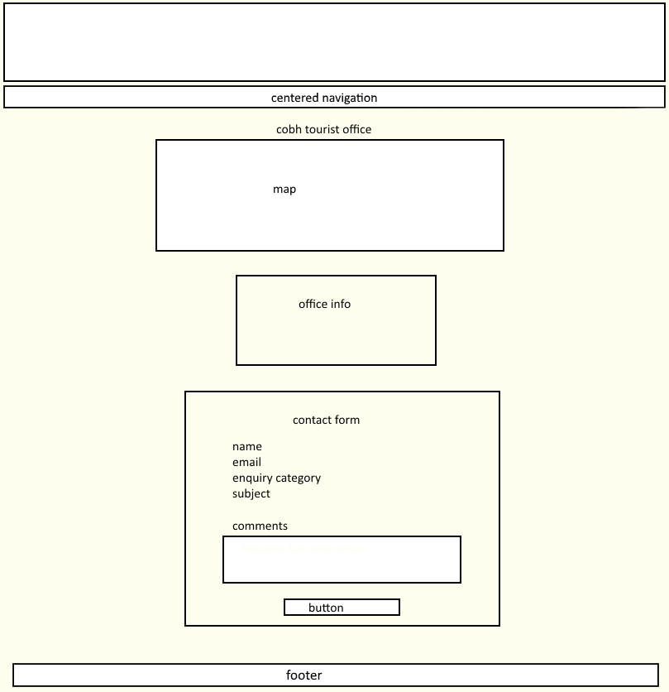

Navigation diagram: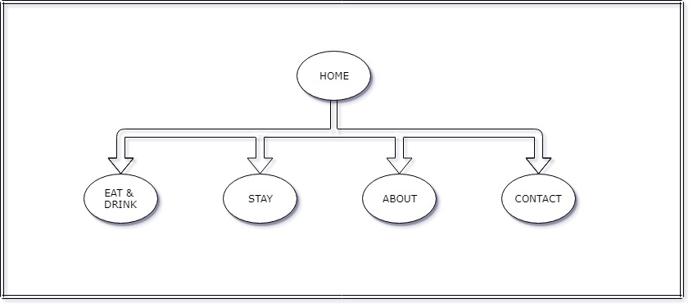

Format of content:

Font: Verdana, Geneva, Tahoma, sans-serif;

Home background colour: rgba(182, 182, 182, .2);

Eat & Drink background colour: rgba(250, 65, 85, .2);

Stay background colour: rgba(30, 215, 20, .2);

About background colour: rgba(65, 200, 250, .2);

Contact background colour: rgba(240, 250, 40, .2);