Why windows and not Linux?
Bcoz of GUI and Linux are CLI based so not user friendly.
L1
Why to prefer Linux?
- It is open-source OS …easy to read code, modify it and contribute in it.
- It is free OS.
- It supports both CLI and GUI.
- Compatibility
- It is only used at server level
- Reliability, Efficiency, Performance, Fast
- In Linux , everything is considered as file/process. Eg ls, pwd,mkdir
- Mostly commands are in lowercase
- Linux is case sensitive.
- It is multi-tasking, multi-processing, multi-user
- Linux is master in web services and Mail services.
Founder of LINUX Linus B Torvalds. Wrote kernel of Linux

History
1960 UNIX by AT & T Labs in C language high-cost OS

GNU GNU is not Linux
GNU – GPL mein 80% free s/w registered the….Richard Stallman
Andrew Tanenbaum lightweight version of UNIX called MINIX …sasta unix ..used in college, offices, education etc.

Windows is a product[OS]/flavor of Microsoft ..

Flavors of LINUX
Debian
Suse
Ubantu
Kali Linux
Mint Linux
Centos
RedHat Linux We are going to use it.
Fedora
Mandriva
Slackware

Install Linux
RHEL 8 onwards :Ansible …scripting language
RHCSA certificate
Password recovery?

Min HW requirement
CPU= PII
RAM=256 MB
DISK=3GB

Pre-requisite HW
CPU = 1 Processor 1vCPU
RAM= 2GB/ 4GB
DISK= 100GB

Ways to install Linux
1.Text based
2.Gui based
3.Network based/ Kick start

RHEL 7 64 Bit
Anaconda is Linux Installer
In Linux there are 2 desktops called GNOME ..by default
GNU Network Object Model Environment
and KDE …if you install optional K Desktop
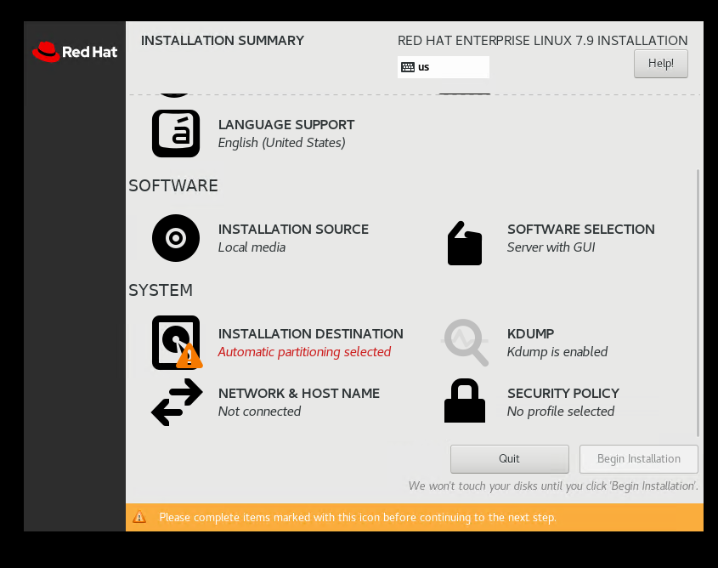
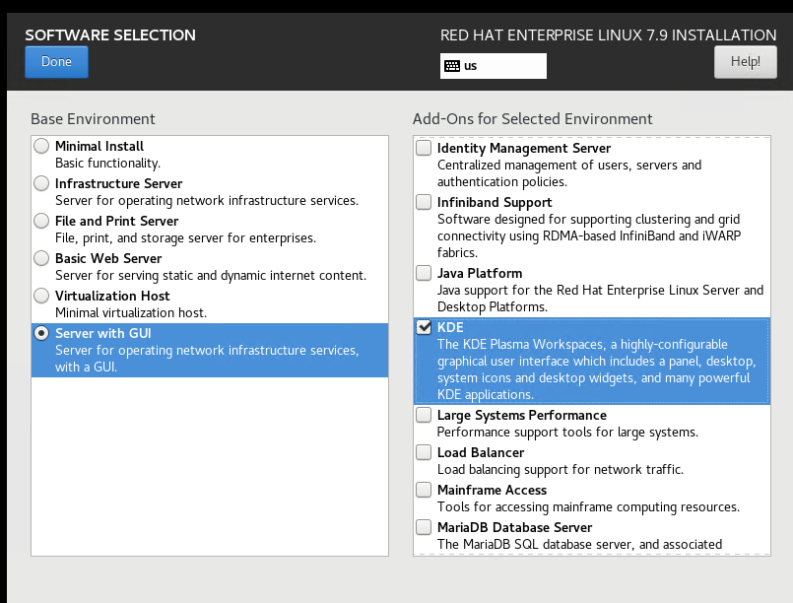
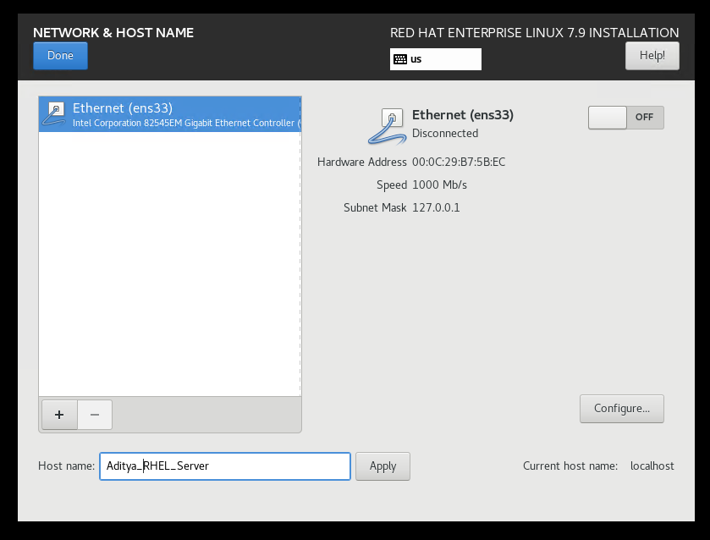
Don’t give IP just give server name.
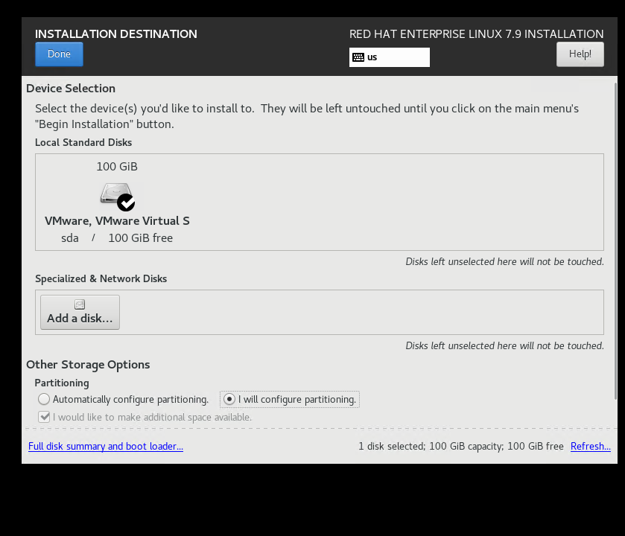
SDA - partitions
I will configure partition
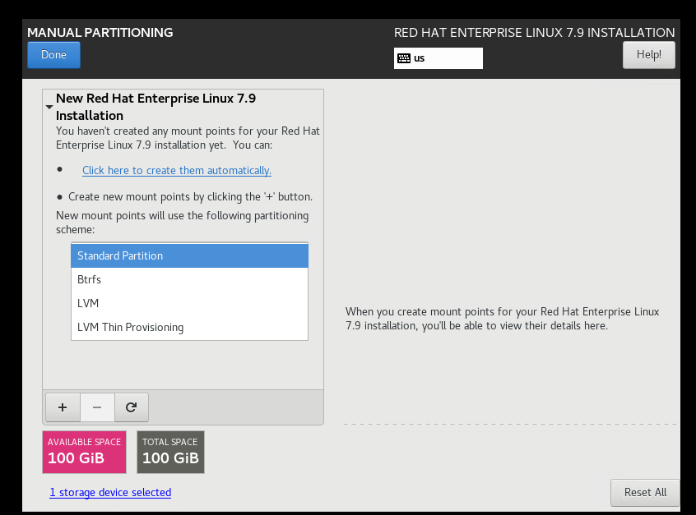
Standard Partition ..Then click on + sign
Q.Partitions:
1. / Mount Point [Top-level] like C: drive in windows ….It contains OS files
2. /boot It contains booting files the files required to start Linux
3. swap It contains virtual memory ….portion of hard disk acting as RAM
Q] Make the partition as follows:
Partition = 100GB
Mandatory-
/ =70GB
/boot =2GB
Swap[Equal to RAM or Double of RAM]=4GB
Optional-
/home=5GB
/var=5GB
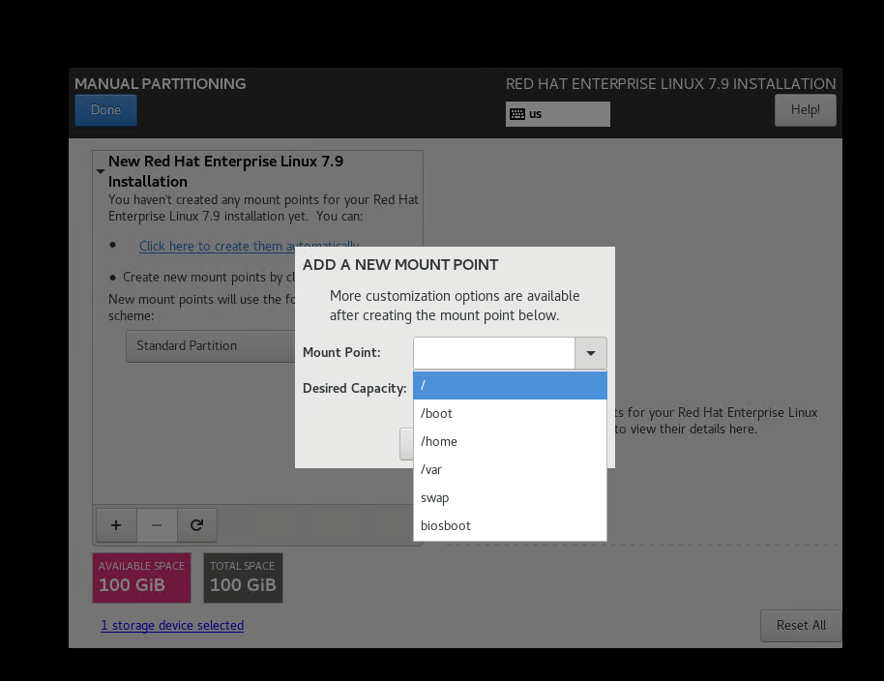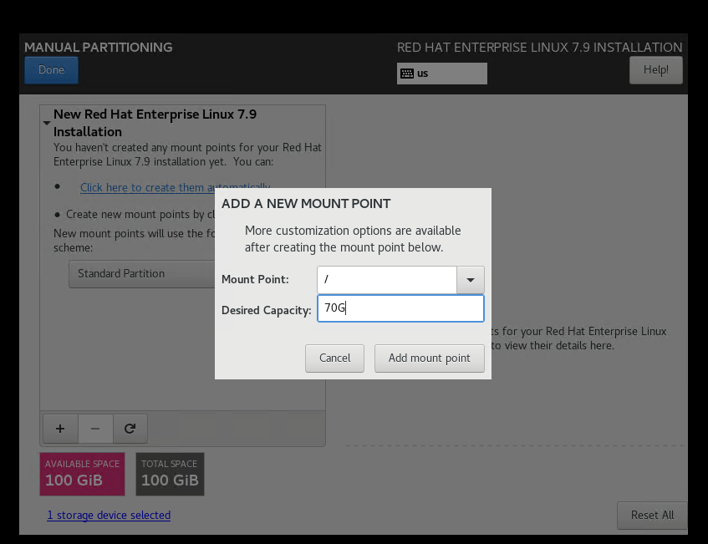
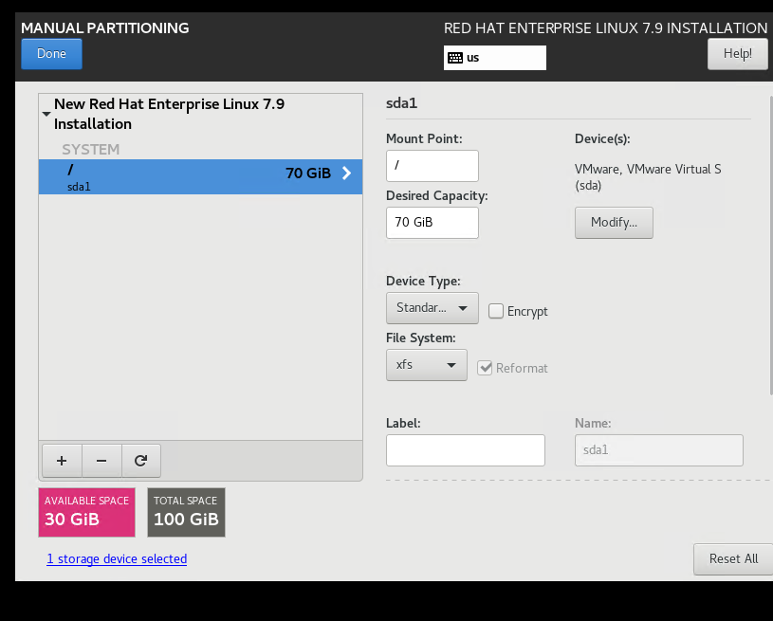
Similarly the rest pls…
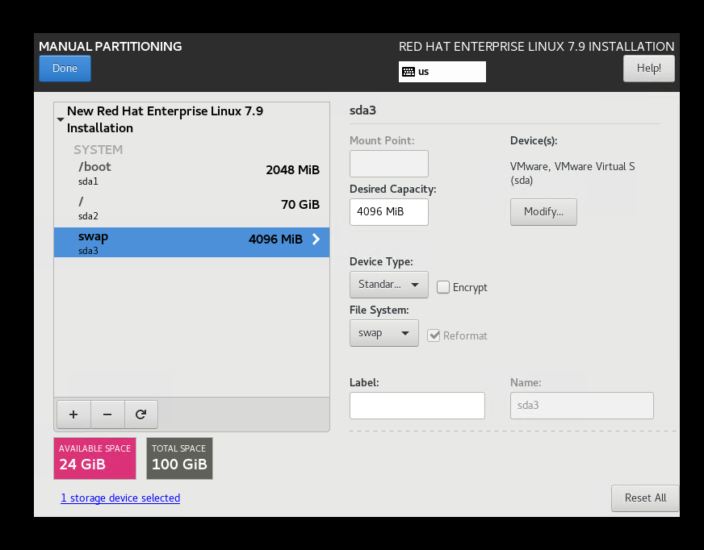…done

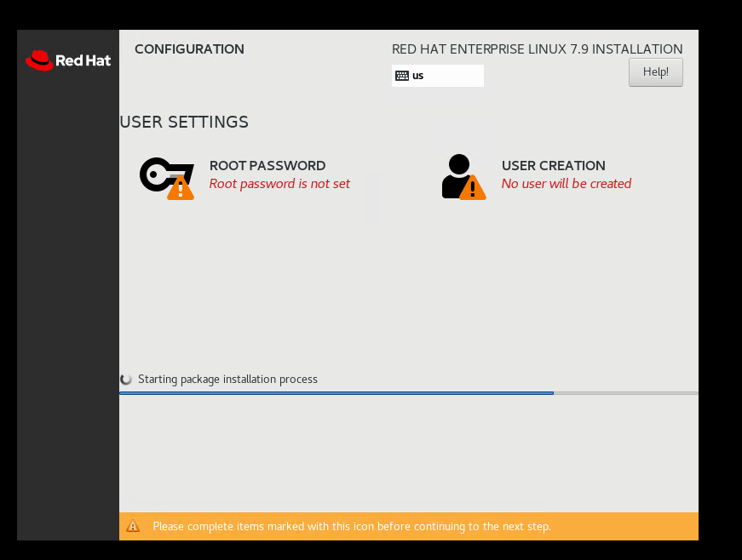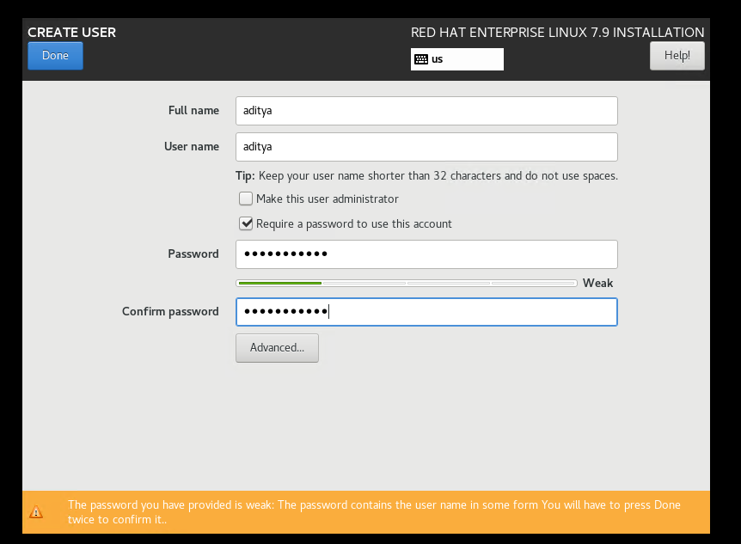
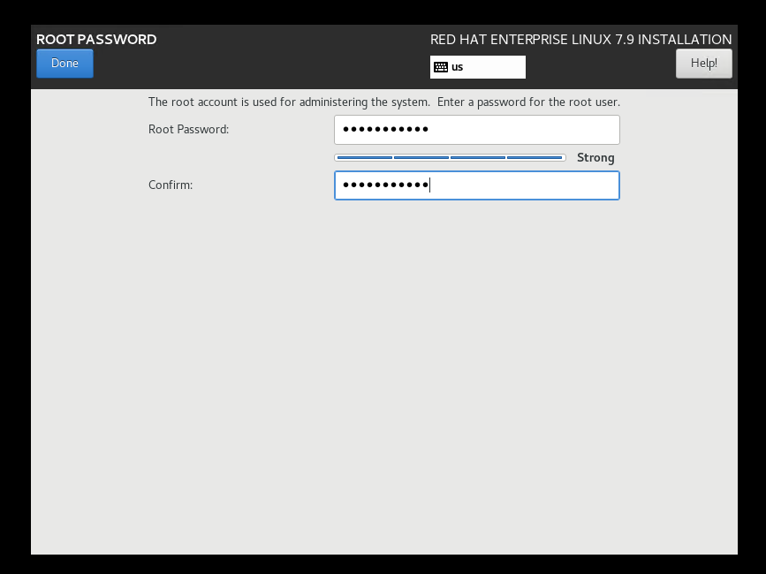
Administrator -2 types
Super user root(admin) all privileges
Standard User the one you created Aditya ….least preveilages

Important Folders/File Structure
Folder name | What do they stand for? | Description
/bin | binary | Contains command/files used by standard user
/sbin | Super binary | Contains commands/files used by super user(admin)
/boot | boot | Contains booting files(GRUB, kernel file, etc)
/home | home | It is a home folder of every(standard) user
/root |  | Home folder of a root user[admin]  In windows all goes in USERS
/dev | device | Contains device files[cpu,ram,storage files,terminal info,etc]
/etc |  | Contains system configuration(control panel like windows)
/lib | 32 bit | Contains library files/supporting files(in windows like .dll)
/lib64 | 64 bit
tmp |  | Contains temporary file(cookies, downloaded files)…In windows TEMP  %temp%  Don’t store any data in tmp its volatile
/var | variable | It contains values which keeps on changing(Printing queue ka count)
/sys | system | Contains system files
/mnt |  | They are empty folder  Used for mounting partition purpose
/usr |  | Contains server related files(dhcp, dns, mail , web servers)
/media |  | They are empty folder  Used for mounting partition purpose
/proc | process | Contains kernel modules, CPU and RAM files, etc
/opt | Optional | The data which is to be saved temporarily. After restart the data won’t be lost ..but if you keep in temp folder it after restarting it will lose the data  We prefer /opt  If you want to store data for temporary period
/run |  | Used to access dvd data drive
/srv |  | Contains services related file  services== required to run your application
L1name of Linux Kernal is vmlinuz
Concept of mounting

Types of prompt
# = super user
$ = standard user
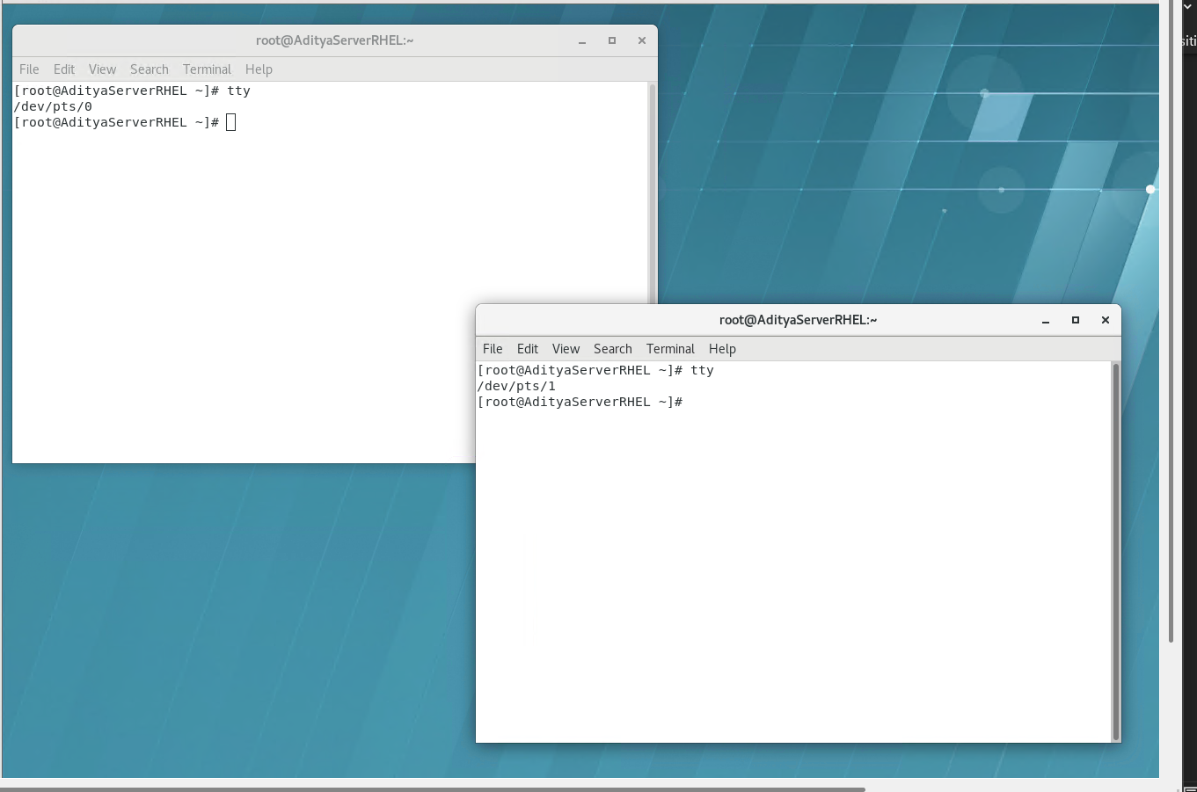
1.tty it is used to view terminal name and number
Ptsgraphical UI
Types of terminal in Linux
crtl+alt+f1 GUI
crtl+alt+f2 CLI terminal no 2
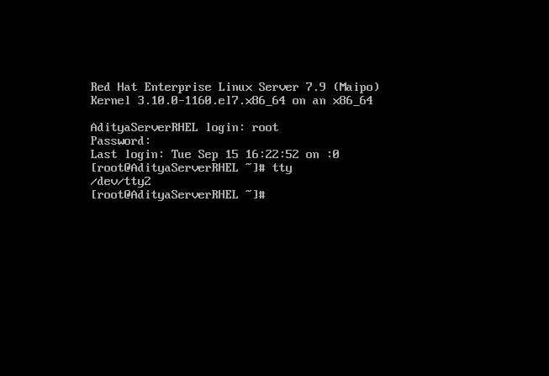
crtl+alt+(Function)+f3 CLI terminal no 3
crtl+alt+f4 CLI terminal no 4
crtl+alt+f5 CLI terminal no 5
crtl+alt+f6 CLI terminal no 6
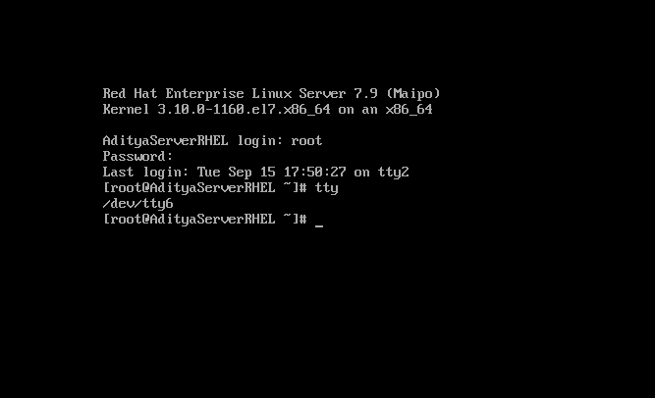
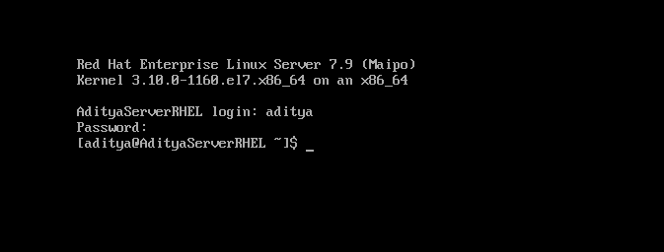
2.whoami
3.who shows the list of users logged in on different terminal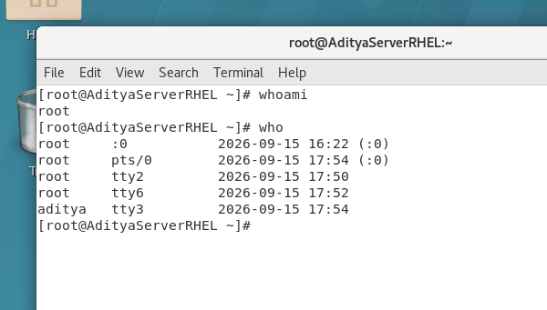
4.who -r
-r is a argument / parameter
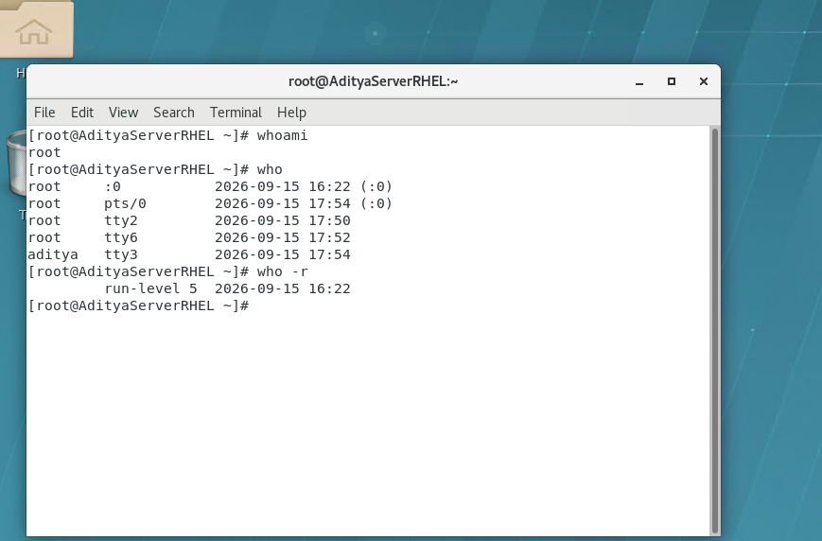
uptime and run-level 5
tilde ~ it is home folder of this user
# is used for comment

5.pwd present working directory
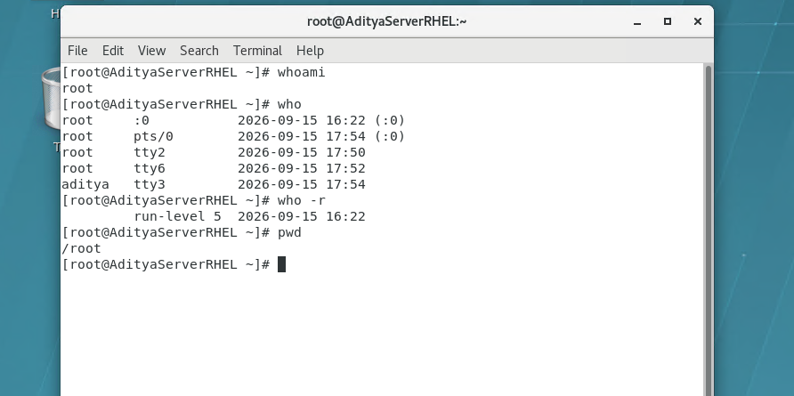
6.uptime shows when your system is up or running
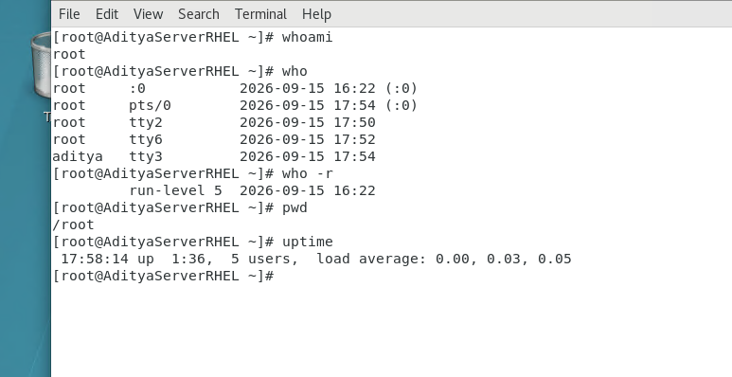
7.date shows system date and time
8. timedatectl its command of rhel 7
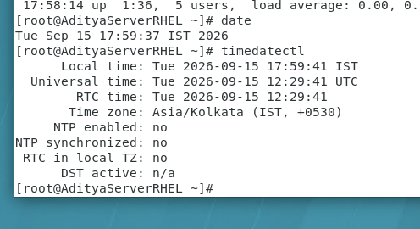

Q2] To change the date and time to 1 oct 2030 and time 3:30pm
date mmddhourminyear.sec [hour is in 24 hour format]
date 100115302030.45
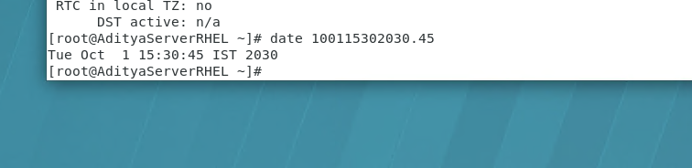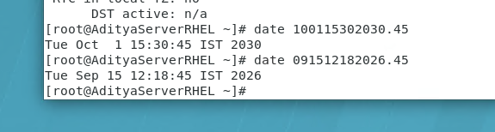

Q3] Ways to logout
1.ctrl+d
2.exit
3.logout
Q4] Ways to shutdown
1.poweroff
2.halt
3.init 0
4.shutdown -h now
5.shutdown -h 2 “hardware maintenance” #Here 2 is in minutes and the description . -h stands for halt.
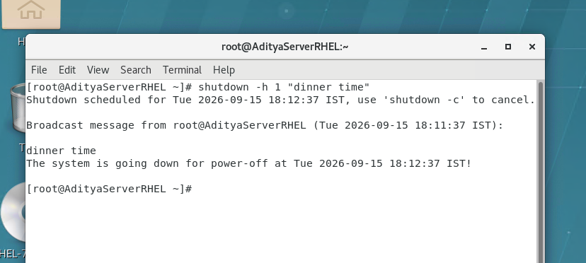
shutdown -c # to cancel the shutdown
Q5] Ways to restart
1.reboot
2.reboot -f #-f for forcefully
3. init 6
4. shutdown -r now
5.shutdown -r 2 “good night” # 2 is in minutes 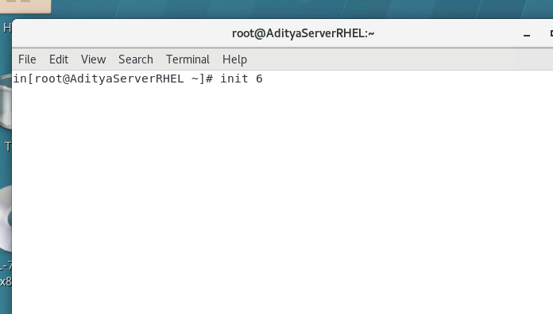
9.history used to show the list of commands on this terminal
It is terminal specific
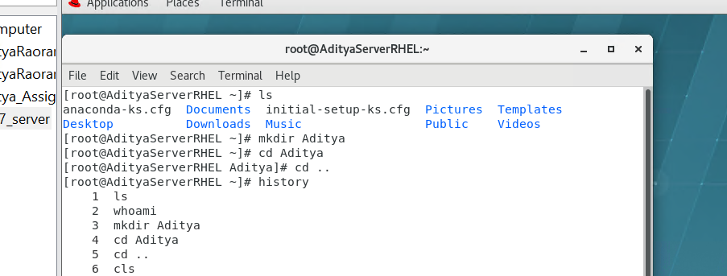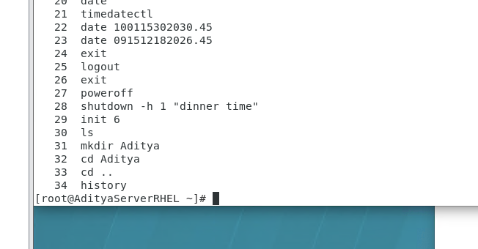
It’s a glitch
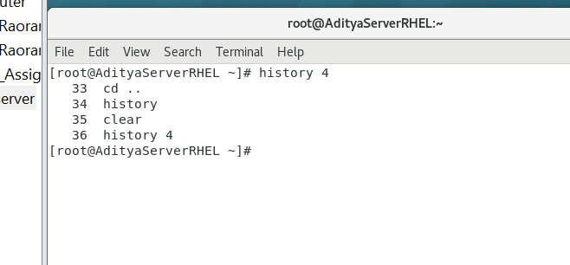
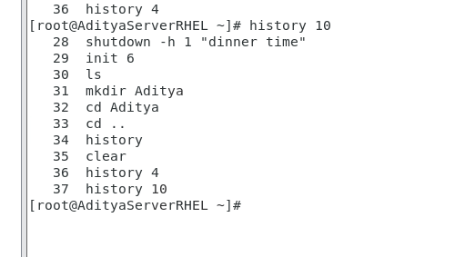
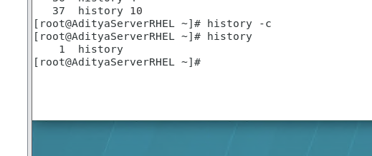
history
history 4
history -c #to clear the history of a specific terminal
10. ls Its shows the list of files and folders.
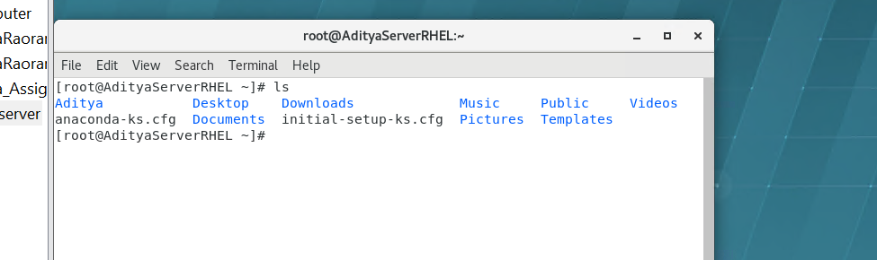
blue = folders
pink /yellow/green/all colors = files

ls -r # to show files in reverse order
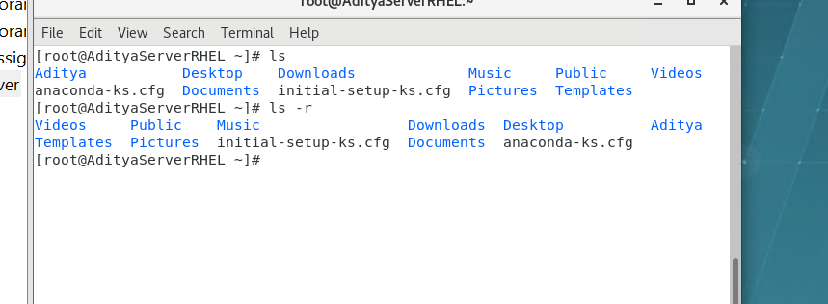
ls -l # to show long listing
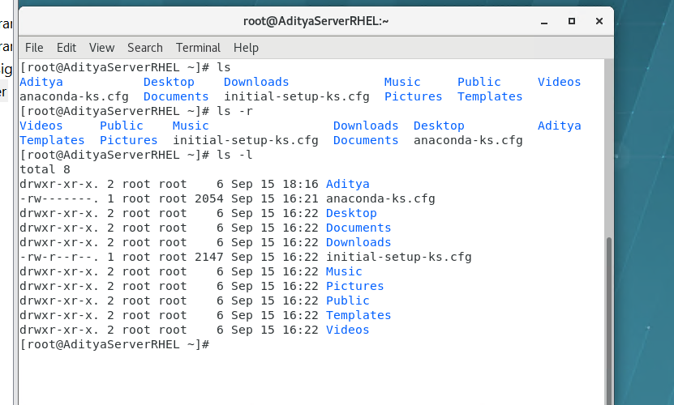
1 = file
2 = folder
D directory …folder if not then a file…
Long Listing ???
ls -l -h # human readable format
ls -lh
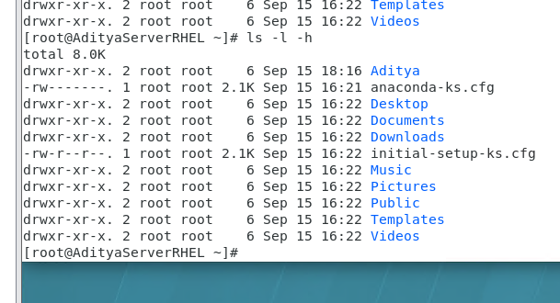

ls -lh Desktop #pls remember its case sensitive
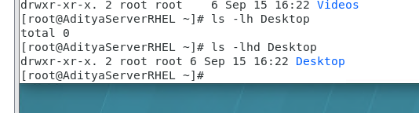

ls -lhd Desktop # d for directory

ls -a # all including hidden data
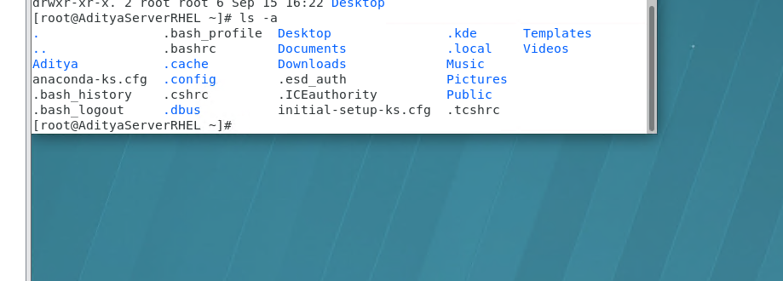
Summary
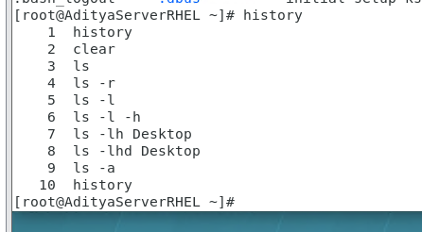

Ways to take help in Linux
1.whatis
whatis ls
whatis pwd
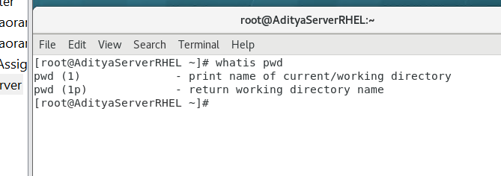
2.man
Man stands for manual pages
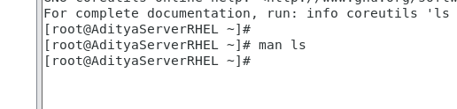
man ls
man pwd
3.info
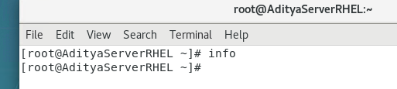
4.—help
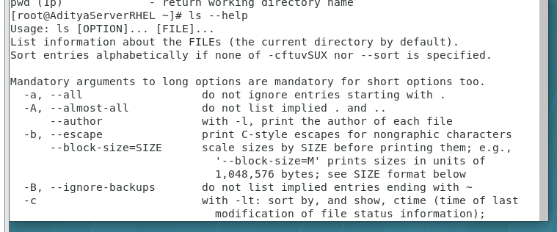

12.clear or ctrl+L to clear the screen

Files and folder related commands 10 mks imp
Folder related commands
1.mkdir = make directory 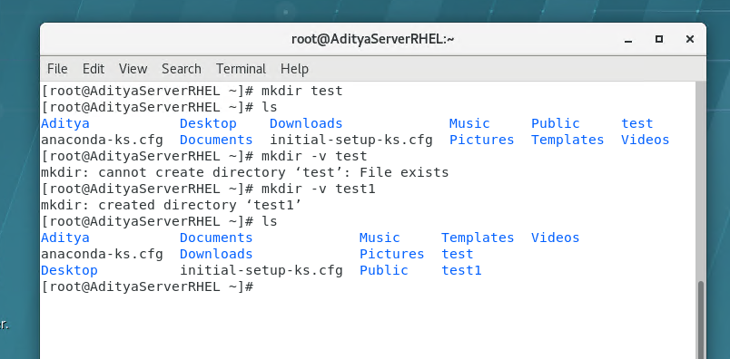
-v means verbose i.e show/display
To make directory somewhere
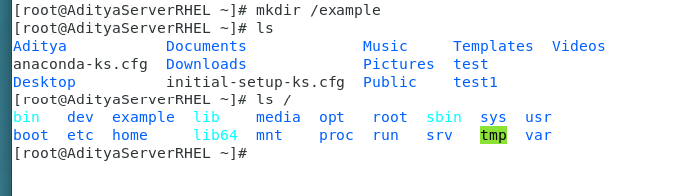
To make folder in home
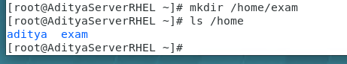
To make a folder hello kitty
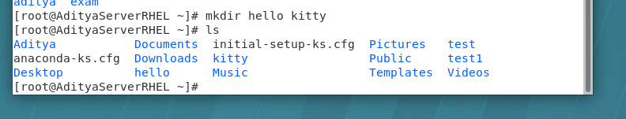
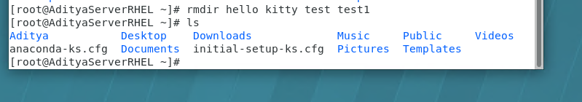
rmdir removes empty folders only by default
Make single folder named hello kitty…inside quotes ‘ ‘
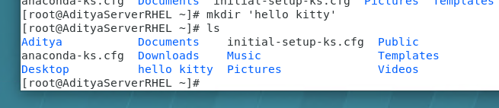

To remove it …
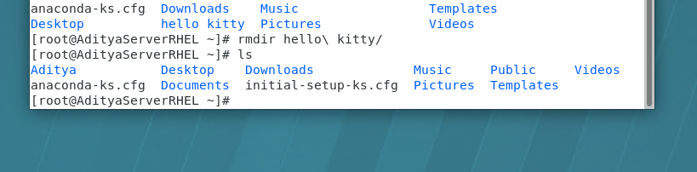
2.cd = change directory
3.rmdir = remove empty directory
4.cp -r = copy the files/directory
5.mv = move(cut-paste)/rename
6.rm -r = remove directory (empty or directory with sub directory/files)

Absolute path
Relative path

To create folder inside folders
Method 1: ls -R
mkdir -p /hw/cpu/intel/i5/2nd-gen -p is parent directory and the addres is absolute path
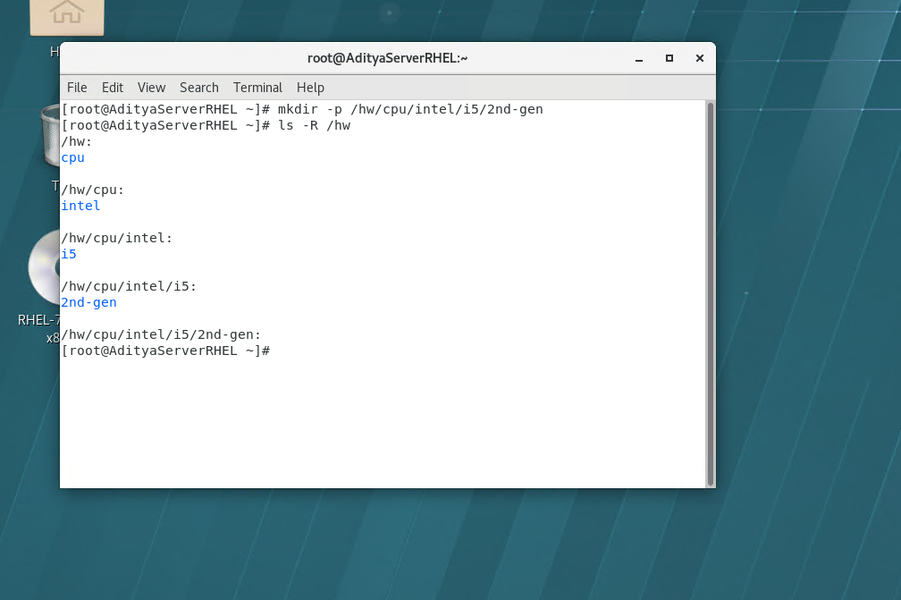
-R is for Recursive

Method 2:
To install tree command
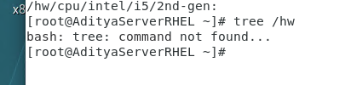

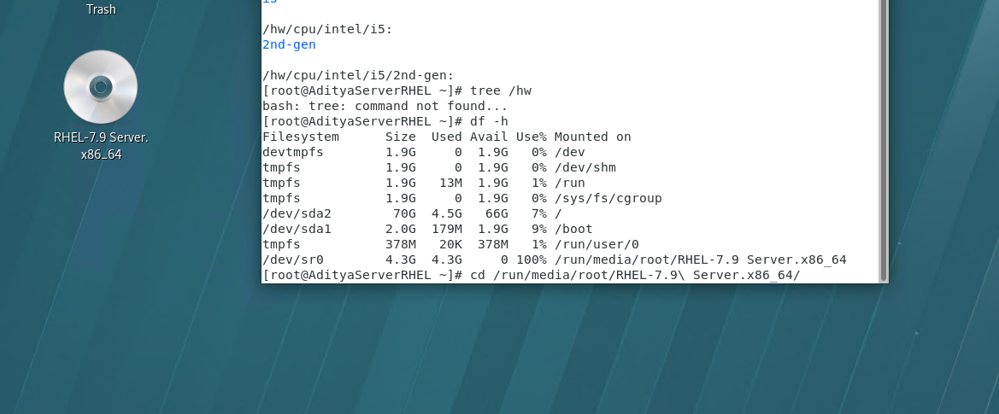
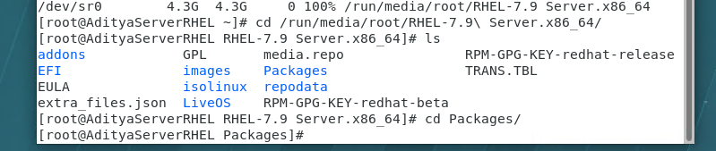
Df -h
Cd /run/media…
Cd packages
Rpm -ivh tree -1.6
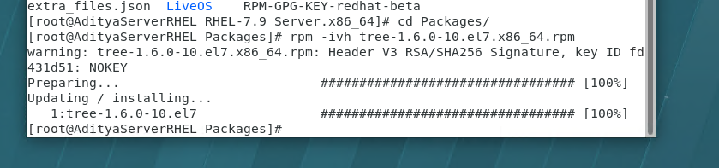
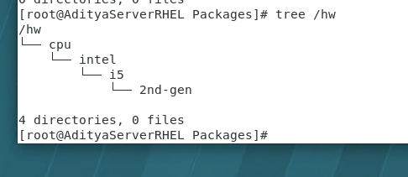
2.cd = change directory
3.rmdir = remove empty directory
4.cp -r = copy the files/directory
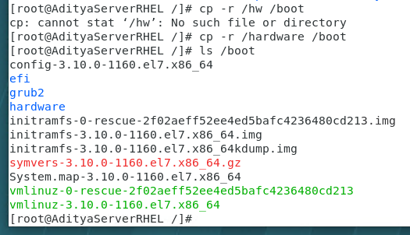
5.mv = move(cut-paste)/rename
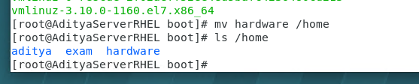
Or
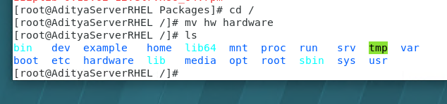
6.rm -r = remove directory (empty or directory with sub directory/files)
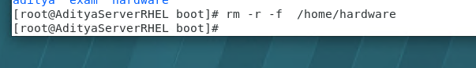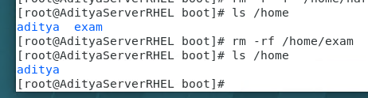
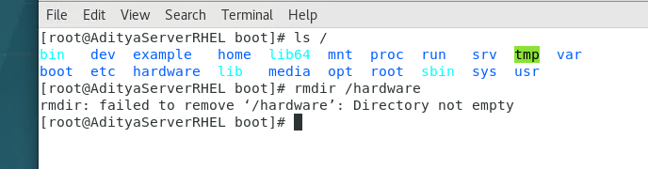

Create these 3 folders at once…
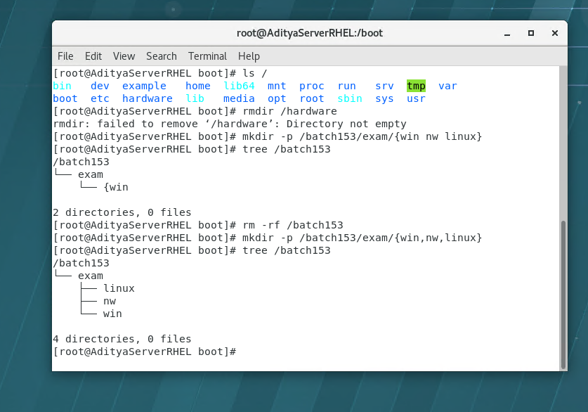

File related commands
1.touch to create blank files
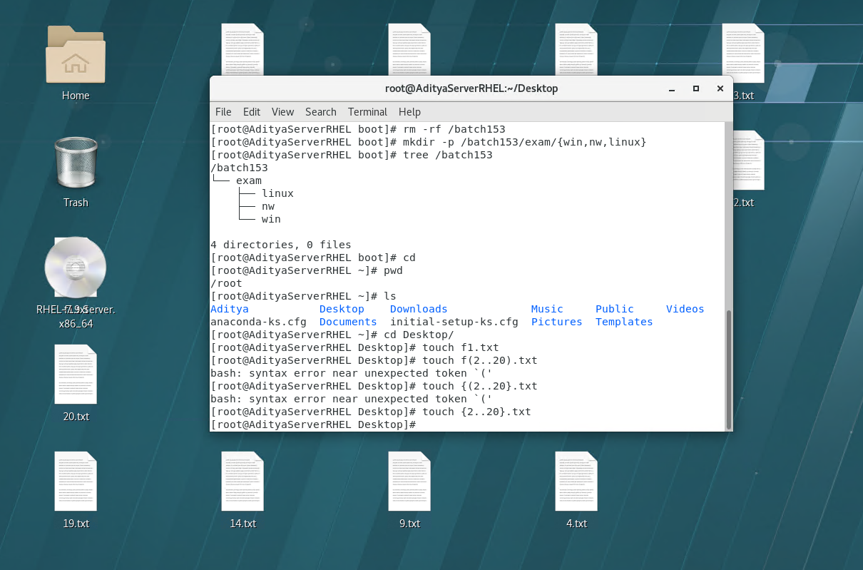
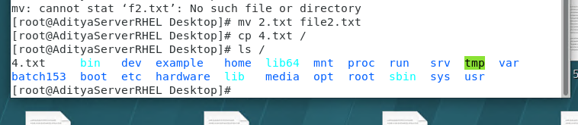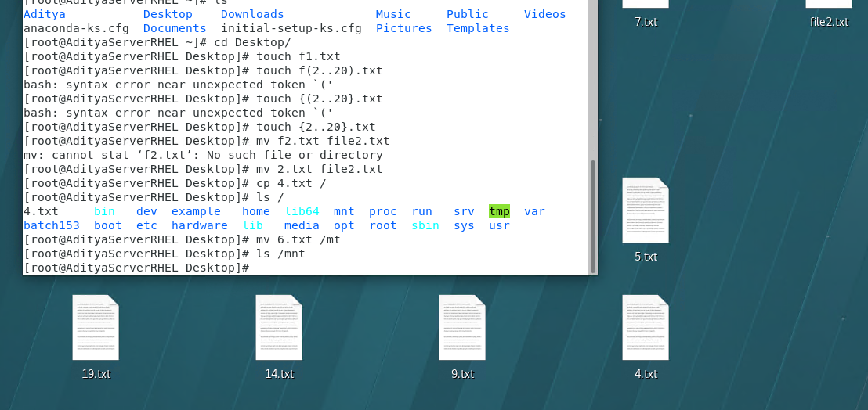

2.cat
View file contents, create a new file, append data in existing file
//not for modifying
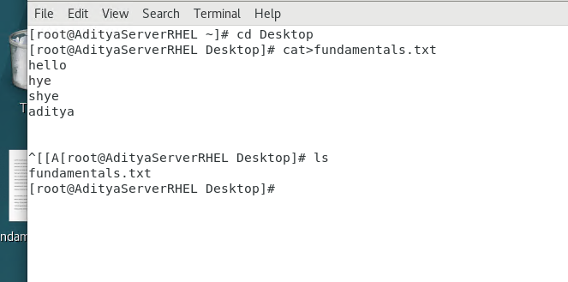
For viewing
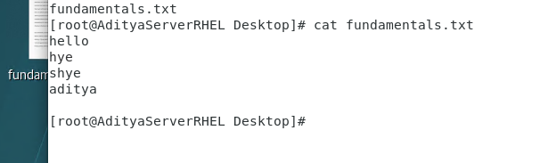
To append
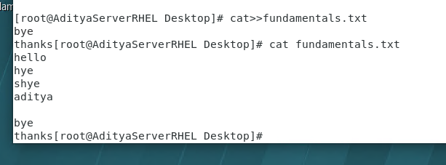
not to change or delete previous text

If file is not present it will create and append a file ..cat ….supremacy
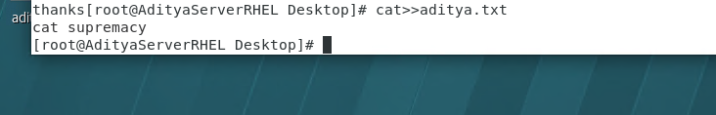
if file exists already it overrides the existing file
It is not used large files ..only for small files
so the solution for viewing large files is :-
a.head It shows only first few lines of file. By default value is 10.[1st 10 lines]
Including empty spaces lines too.
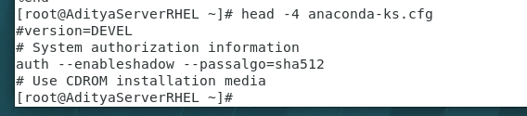
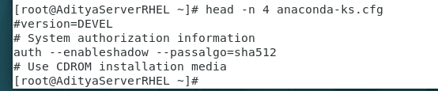
b.tail It shows only last few lines of file. By default value is 10.[last 10 lines]
Including empty spaces lines too.
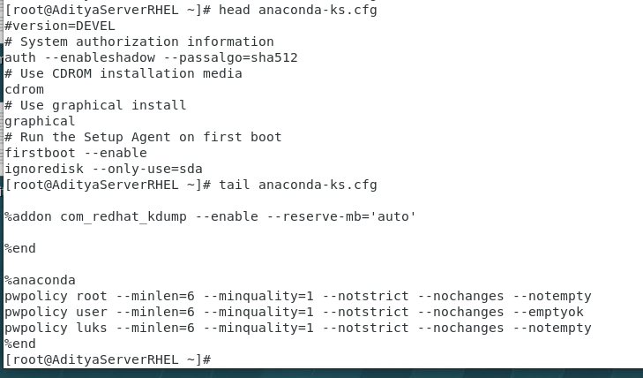

c.less It is best for big files and shows content page wise and we can scroll up and down ..to view large files
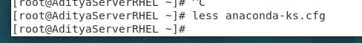
d.more-It allows you to see content page wise but it is one way like only go down and not up the document
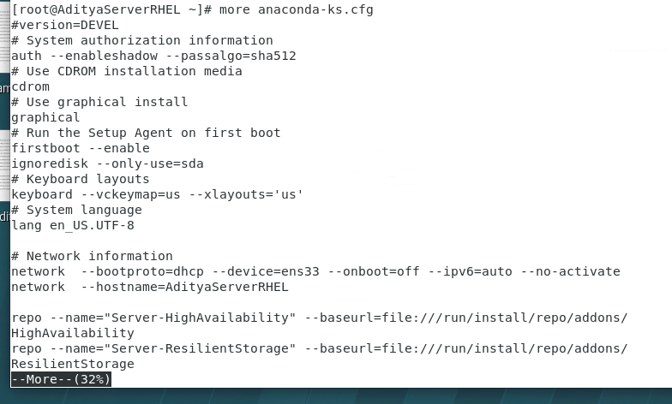
tac --- cat //it prints in reverse order
through file editors:
a. vi/vim
//won’t come in exam …b.nanoIt is a file editor
you can CRUD ..modify..etc
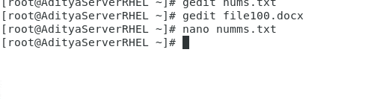
c.emacs
d.geditOnly works in GUI
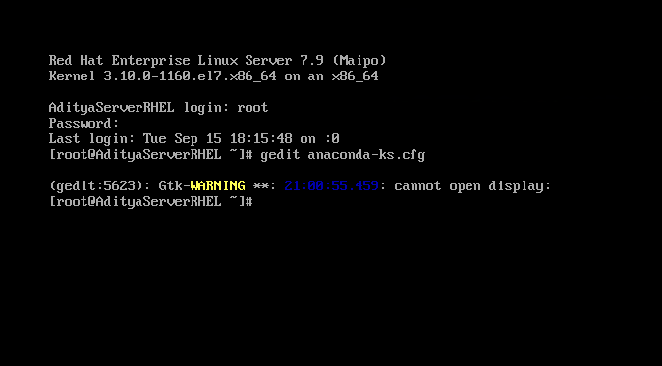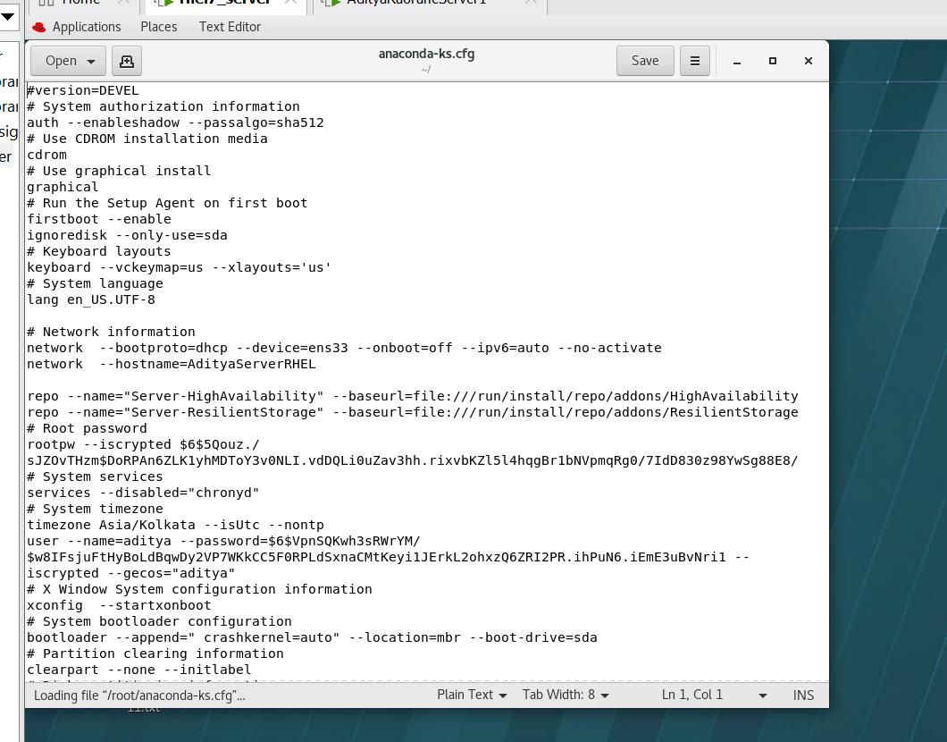
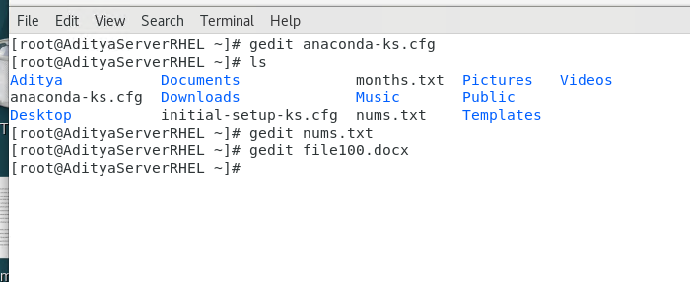

15. sort
for numbers
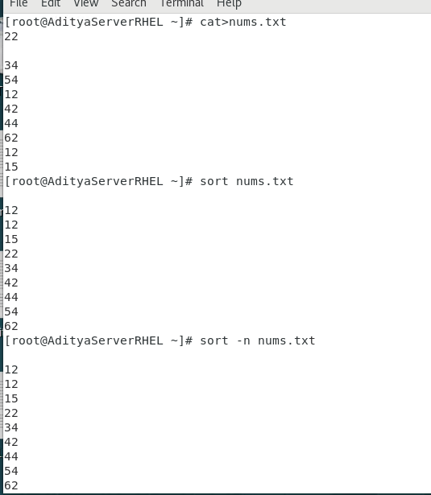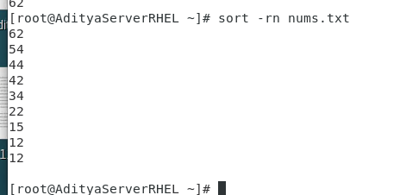
-r ..reverse ..in descending order

For alphabets
