Virtual Files System in Linux VFS
/proc
It interacts with physical file system and is available in kernel
It is a layer between apps and physical file system
Physical File System in Linux
vFAT, ext, ext2, ext3, ext4, XFS

What is kernel and shell?
Kernel is an main code of OS or heart of OS ------ vmlinuz
CPU DEVICE I/O PROCESS VIRTUAL MEMORY Management ETC are all managed by kernel .

uname #it only shows hostname
uname -a # it shows hostname,OS,Kernel version,release date,SMP ---x86, x64[symmetry]
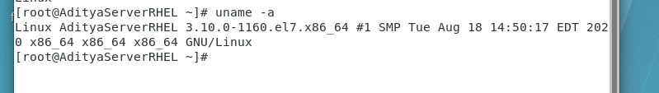
uname -r #shows the kernel version
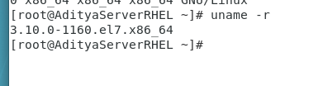

Shell is CLI command line interpreter {compiler vs interpreter}
Shell interprets and pass it to the kernel if I wrote wrong command it gives error.
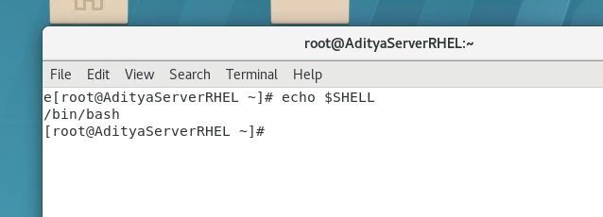
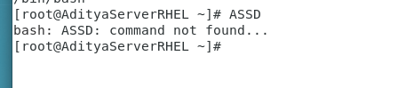
Types of SHELL:-
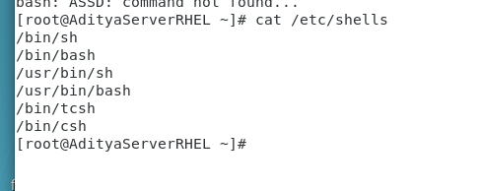
SH stands for shell..
BASH stands for BOURNE Again Shell …mostly used
GUI CLI KERNEL HARDWARE
cd ../../..

IMP:- VI/VIM editor
VI is visual improve
It’s a mostly used file editor
It supports only CLI no GUI
Create a file, modify and give file contents for a file
Modes of VI:-
1.Command cut copy paste search delete data (default)
2.Insert we can write
3.Exit quit save/exit/search

#vimtutor it is the help about vim
esc : q! [! forrcefully] to quit

To create a vim file
vim vim-demo.txt
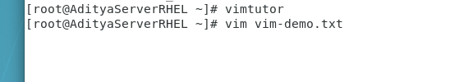
By default command mode
i for insert
a for append
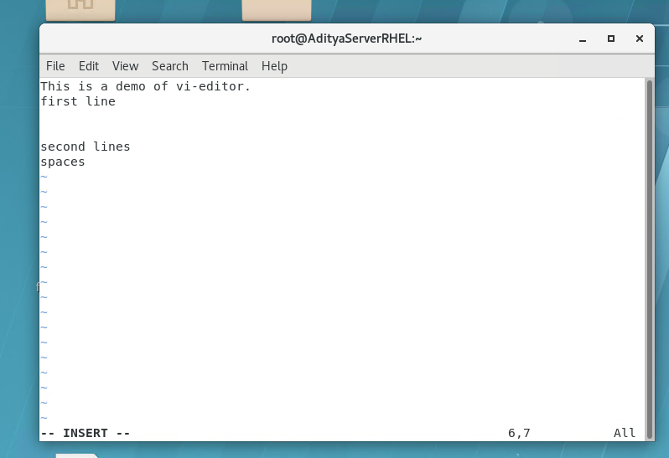
esc : w w is for write to save the file
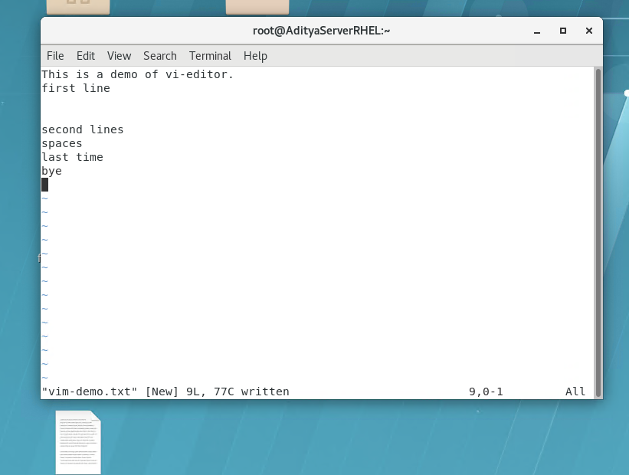
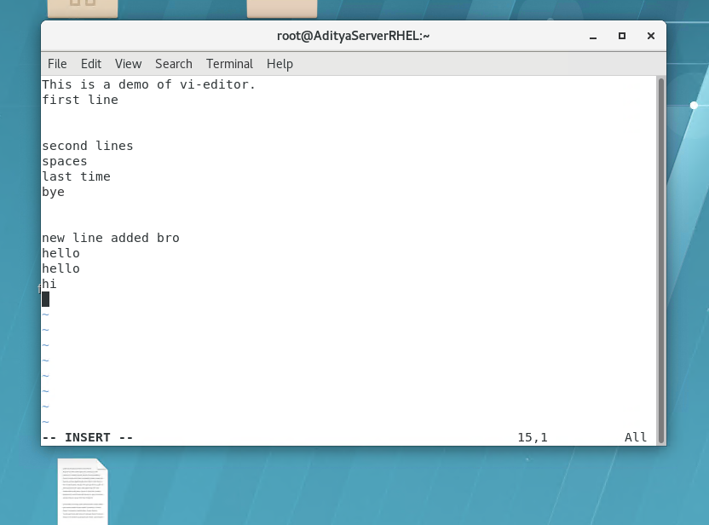
esc : q! to quit without saving the file
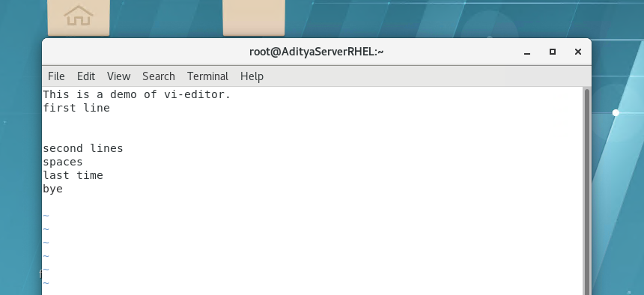
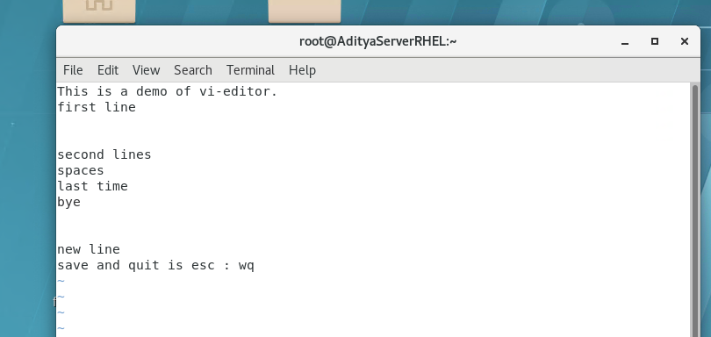
To save and quit is esc : x
To copy a single line in file
esc (to come in command mode) yy(to copy single file)
To paste
Esc p
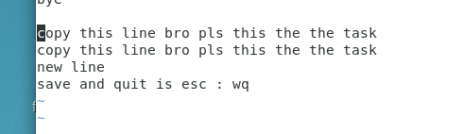
To copy 3 lines from cursor position
Esc3yy
Esc100yy
Esc10yy
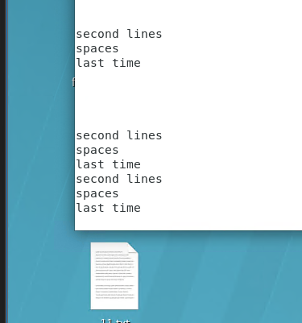

To delete a single line
Escdd
To delete 5 lines
Esc5dd [it counts blank lines also ]

Shift+gg last line fo the file
Gg last line of the file

Imp to generate a line number
Esc : se nu
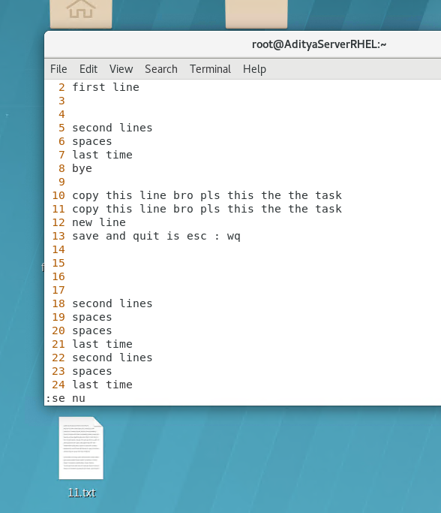

To remove line number
Esc:se nonumber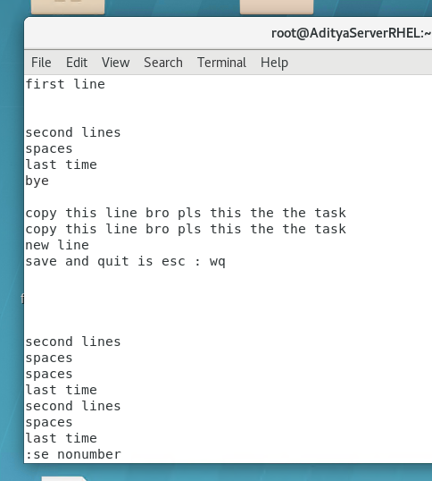

To search a particular string
suppose I want to search “line”

Esc:/line
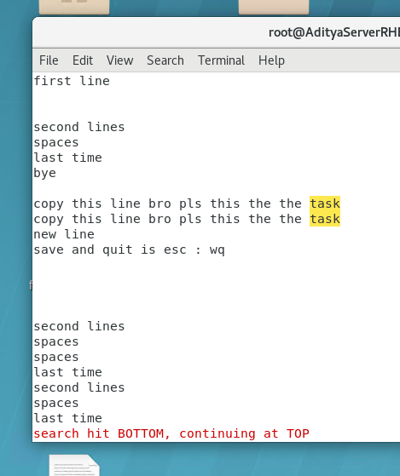
To remove the searched highlight
Esc:nohlserach
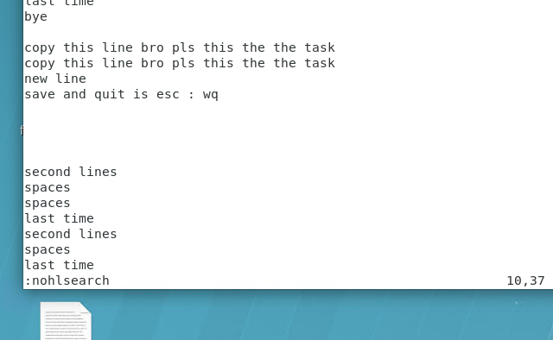
Create
Insert
Save
Quit sans saving
How to remove file no and insert file no
Copy paste …

One question tomorrow

Hard Link and Soft Link:
/dev devices…
Types of devices :- character and block
Character - one bit at a time sequentially i/o devices
Block - group of data at a time ..parallel transmission storage
block devices are faster

Types of files suppoted in Linux:-
Regularvi cat gedit se banaye file denoted by (-)
Directory(d) har cheez ko file bolte hai
Special 5 categories
block (b) inter process communiaction
character (c)
name (n)
socket (s) inter process communiaction
we are focusing on Symbolic link file(l) :-

| pipeline…combine 2 or more commands
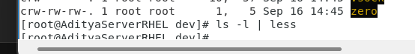

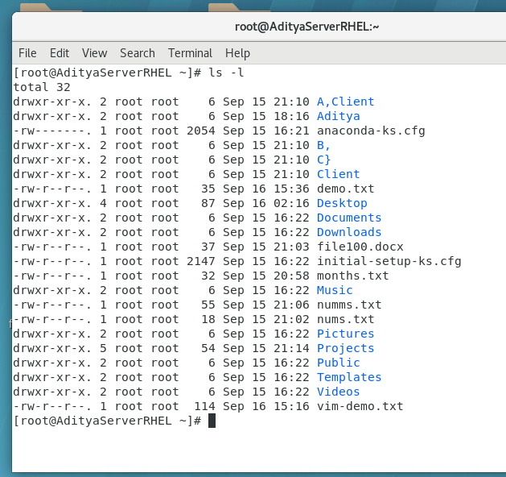
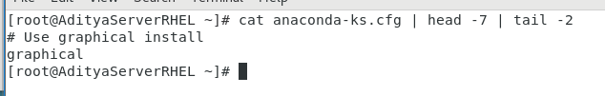

Very important
Soft link vs Hard Link
What’s a link link is a connection between two or more files / folders

HardLink
mkdir /link
cd link
cat>h1.txt
This is an demo of hard link
Ctrl+d save
ls to verify or cat h1.txt to view the contents
ls -i i is inode number .Inode number is location of file on the storage
ls -i h1.txt

ln to create a link
ln h1.txt h2.txt
ln org_file dest_file hardlink
In hardlink inodes numbers are same for both file.The content will also be same

rm -f h1.txt
cat h2.txt
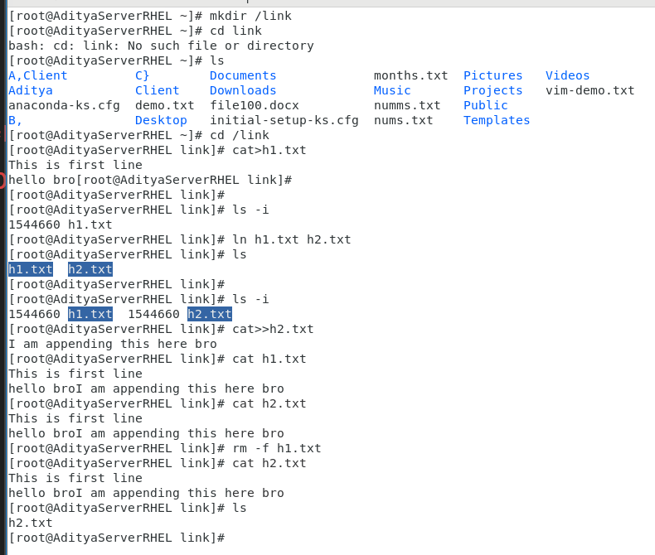

Hard links only works with files and not folders MF!!

Soft-link
It is pointer towards the original file 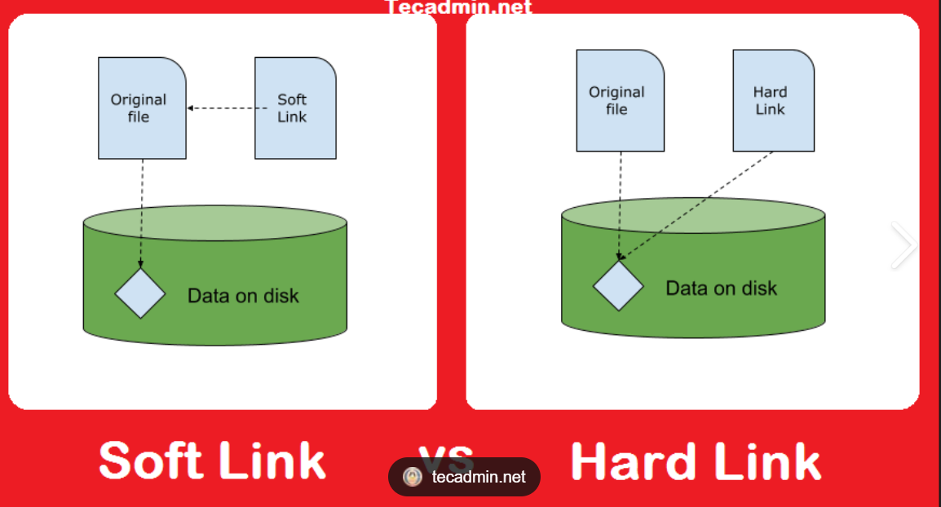
It has no data .
It has pointer ka address only…
if you delete og then the soft link is unaccessible

ln -s s1.txt s.txt

ls -il
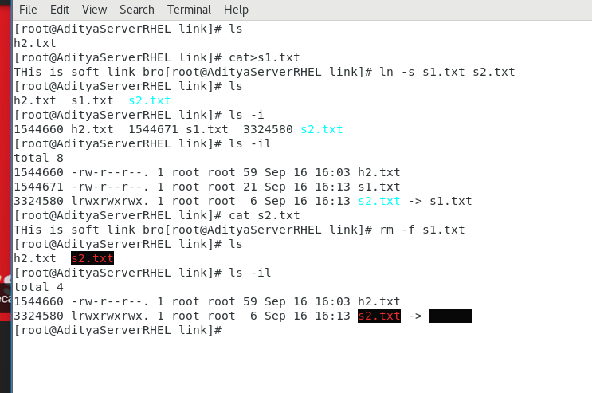

Difference between hard and soft link

After break
cal command calender of current month
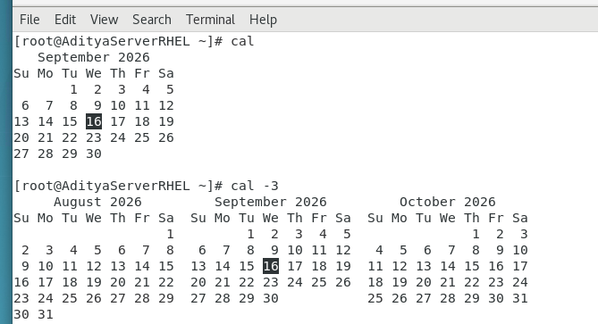
cal -3
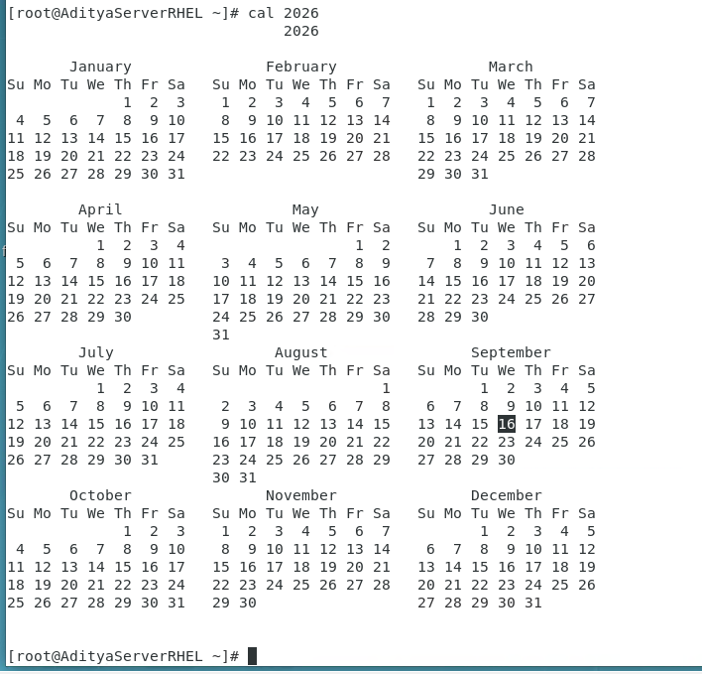
cal 2 2026 february ka calender
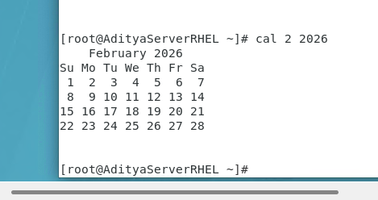
cal -j
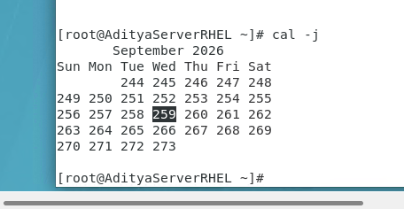

cal –-help
To set the password
passwd -d

--password

Q]Booting process of Linux
Power on
|
|
BIOS/UEFI+POST[check fucntionality of h/w or os]
|
|
GRUB2[in RHEL it’s a boot loader….Grand Unified Bootloader]
MBR[Boot loader info and partition info]
GRUB2 ka kaam hai to select/boot the run menu and select the kernel
Pass control of h/w to kernel of linux…which it took it from BIOS
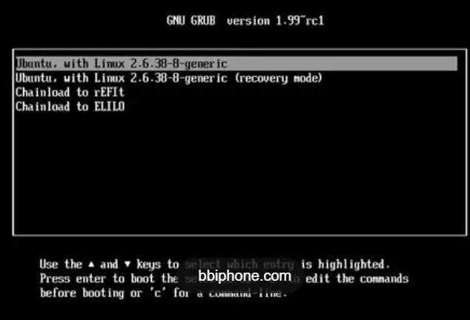
|
|
|
Kernel
Kernel is in harddrive.drurnig booting prcess kernel is brought to ram.
Initalize the hardware..
|
|
Init ram fs
Initailized RAM FileSystem….a temporary file system
It is loaded into RAM
It loads linux a file system into RAM in a read-only format .
|
|
Systemd + services
Systemd is the first proecss of linux with process_id as 1
System deamon(background services)
It is also called init.
It is started by kernel in RAM.
It handles all services of h/w.
Firewall internet ssh db etc
|
|
Login prompt
Username and password authenticate..

Practical

/boot/grub2/grub.cfg main file of grub

For knowledge
/etc/grub.cfg linked file(soft link)

Find command
find / -name grub.cfg
find /etc -name grub.cfg
find / -type c
find / -type b
find / -type l
find / -type d
find / -type c

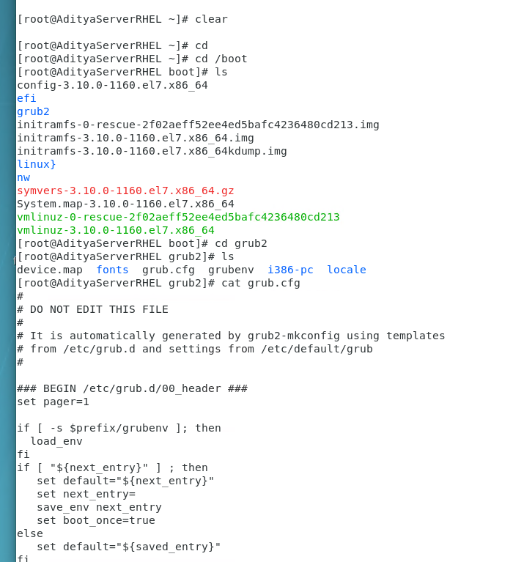
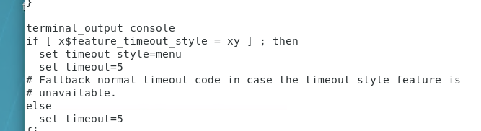

Aayega kal bkl
AIM: Run levels
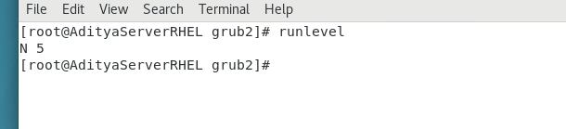
Run levels are from 0 to 6 so 7 run levels.
0 shutdown/halt 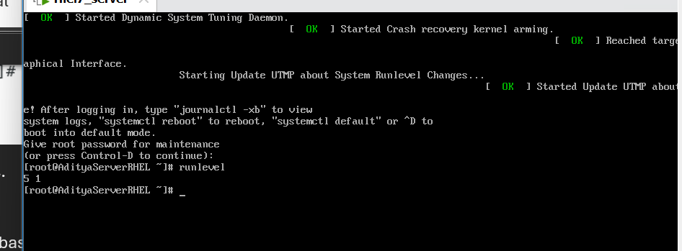
1 single-user mode [CLI based only, TROUBLESHOOTING]
2 multi-user mode [CLI, no networking / NFS]
3 multi-user mode [CLI, supports networking]
4 Unused[customized] used by developers
5 default runlevel [CLI,GUI,Network]
It is full flezed linux machine
6 reboot

To view the run levels cat /etc/inittab
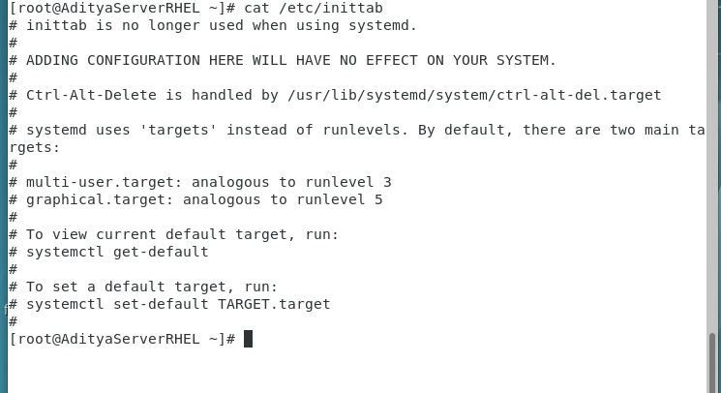
Runlevels are responsible for ki kis system/settings mein system ko run karna hai …bisi

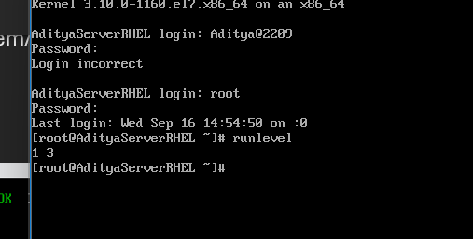
Init does it on temporary basis
its by default on run level 5

/etc/rc0.d kill all services and start the service that halts the machine [K kill S start]
/etc/rc1.d
/etc/rc2.d
/etc/rc3.d
/etc/rc4.d
And so on…

VERY IMP show working of Run levels…
Concept == Target …run level replacement

Commonly used target:
0[halt] poweroff.target
1[single user] rescue.target
3[multi user CLI] multi-user.target
4[multi-user GUI] graphical.target
6[reboot] reboot.target

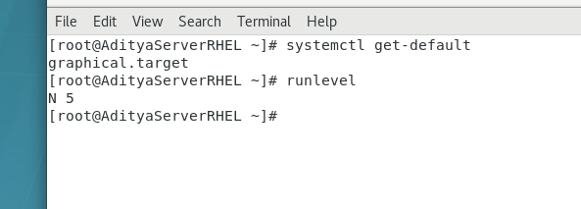
For knowledge so ignore ..
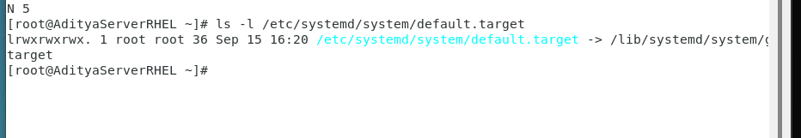
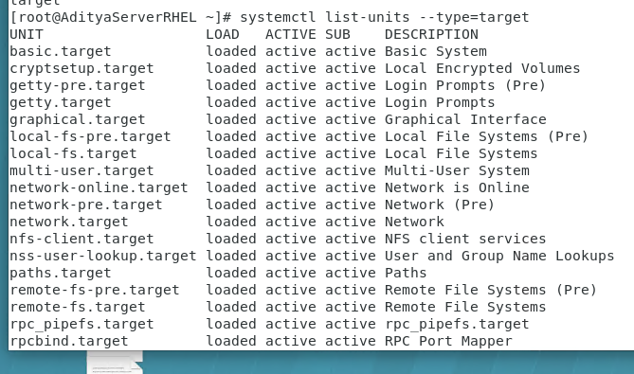
This is imp
Aim to change the target to multi-user.target permenatatly.
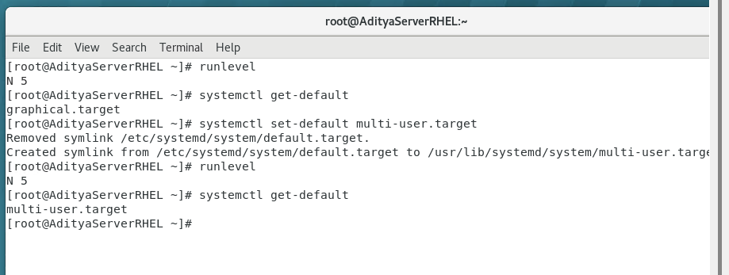
to see the effect pls reboot
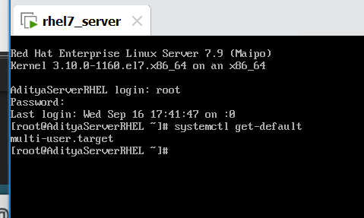
Verification
To chang back
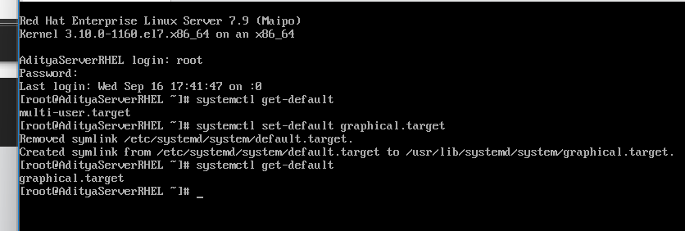
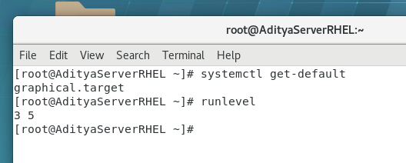
Aim to change temporarily …its equivalent to init 3
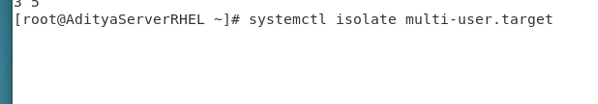
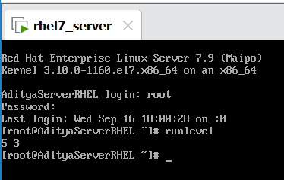
systemctl
Set-default
Get-default
Isolate

Second last parctaical is Troubleshoting of targets..
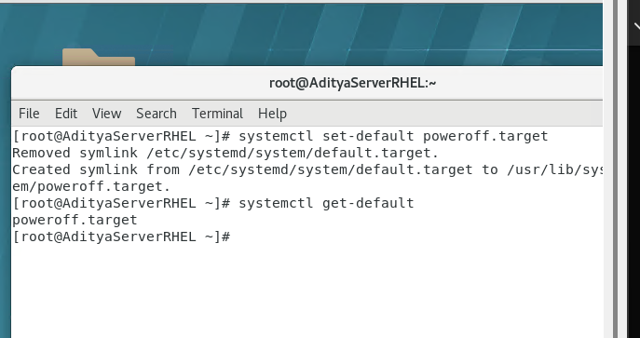
#reboot pls
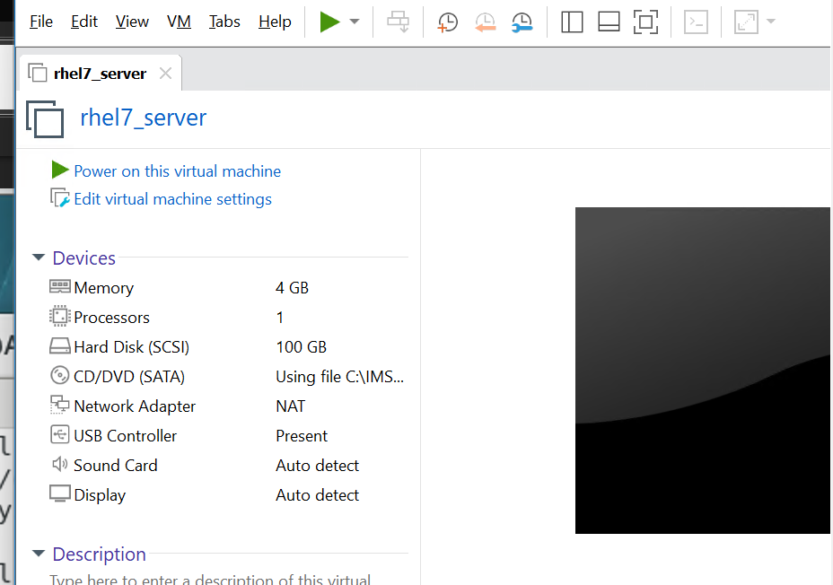
it goes to power off..

So how to trouble shoot?
Steps1:
Reboot the system
Step 2:
…very imp

systemd.unit=rescue.target

Last Practical 5 marks
Root password recovery..

Targets
Root pass recover
Troubleshoot
File/folder
Vim
Installation of OS
Links
Help [whatis, info, --help, man]

