1. Create VM with below specifications:
1 processor, 5GB RAM, 120GB Disk, Windows Server 2016 Datacentre KMS
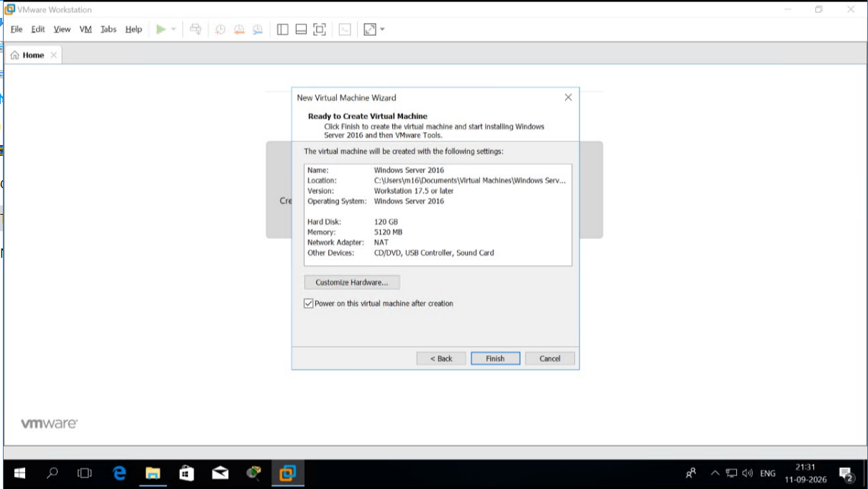

2. Configure the Newly created machine as given below
Task1:
Machine Name: CG-Server1
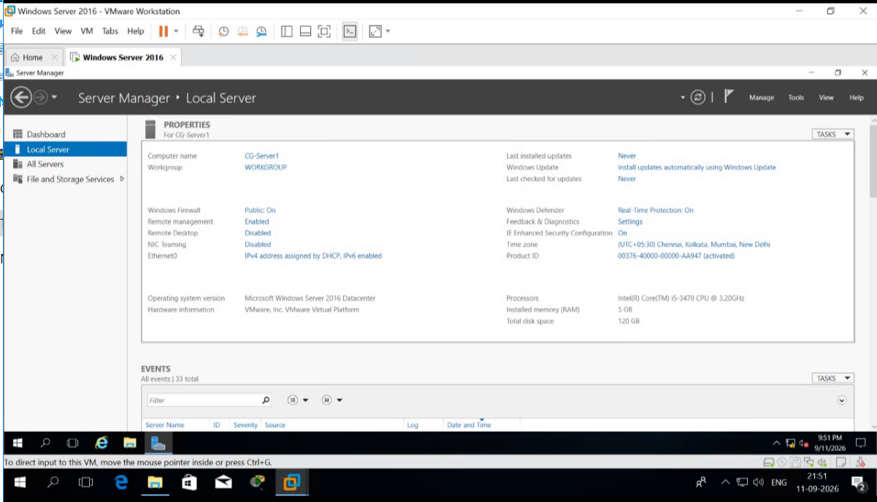
Task 3: IP address: 172.19.10.1
Subnet Mask:255.255.0.0 GW:172.19.10.100
Preferred DNS: 8.8.8.8 Alternate DNS: 8.8.4.4
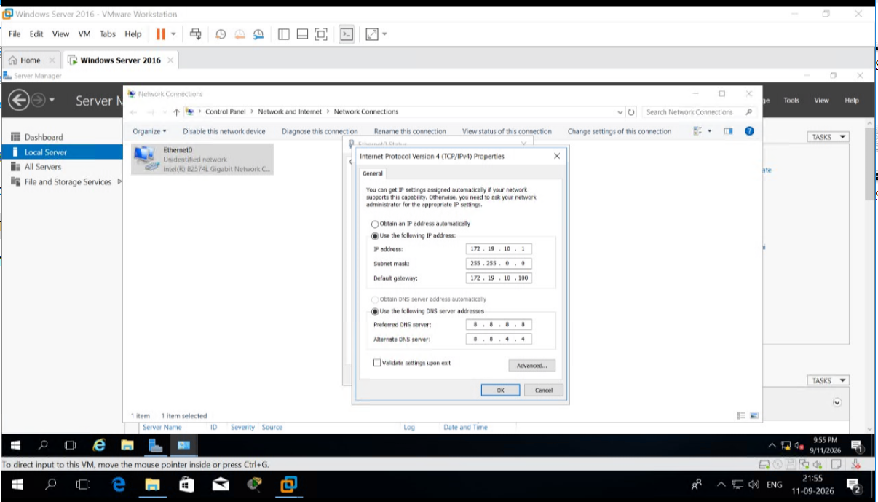

Task 4:
Set the System Firewall off.
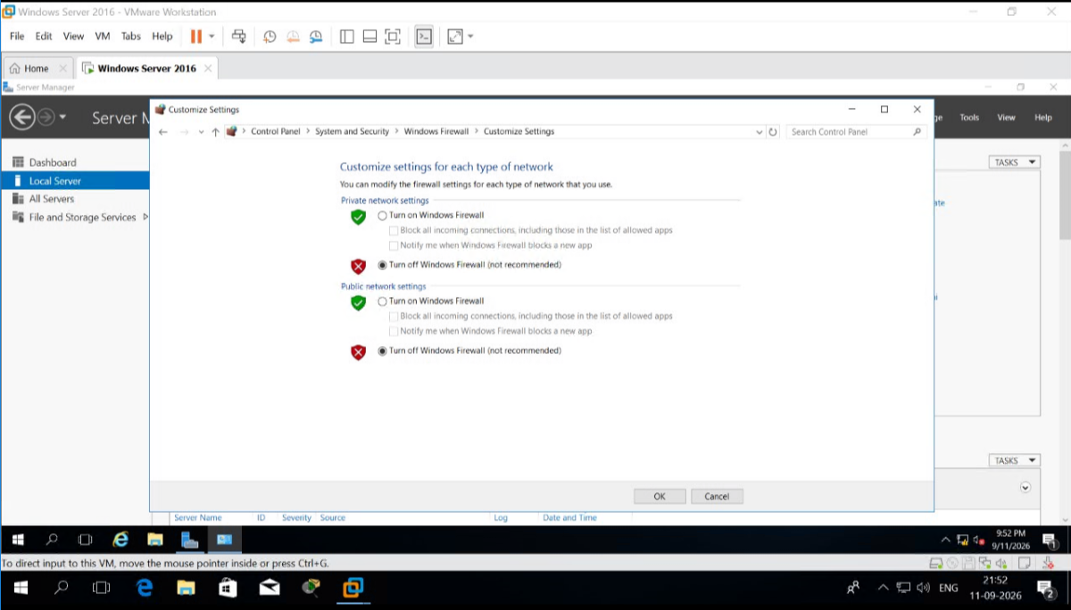
Task5: Verify the same through Server manager page.
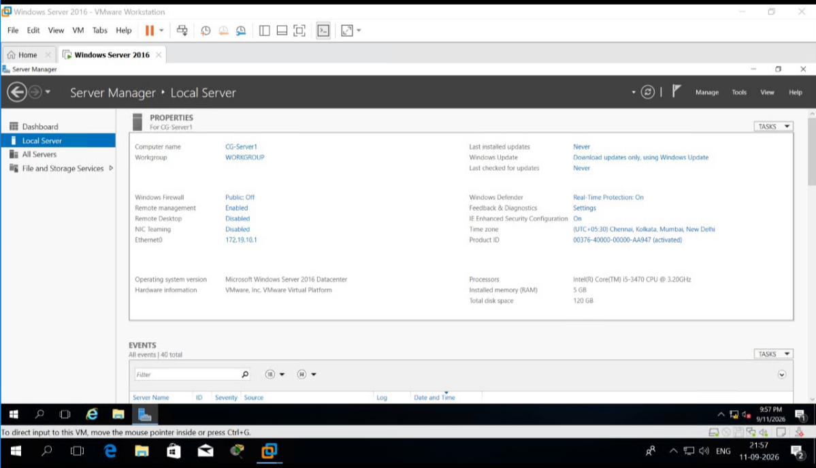
Task 6:
Create windows 10 VM with below specification, 1 Processor, 2 GB RAM, 50GB disk
b. Set the password and enable administrator account
c. login as administrator
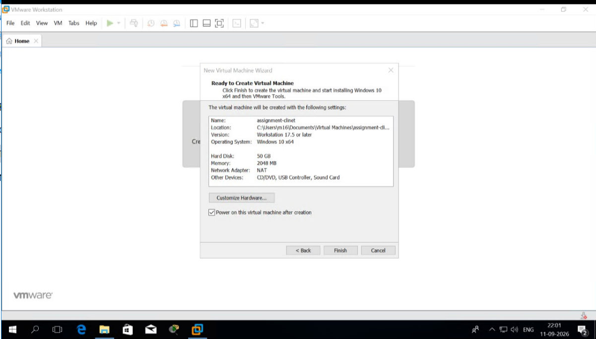

d. Set the hostname as c1
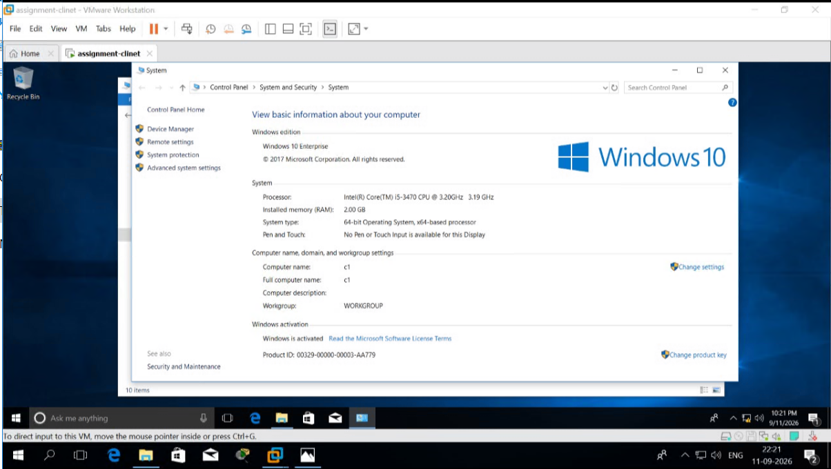
e. turn off the firewall
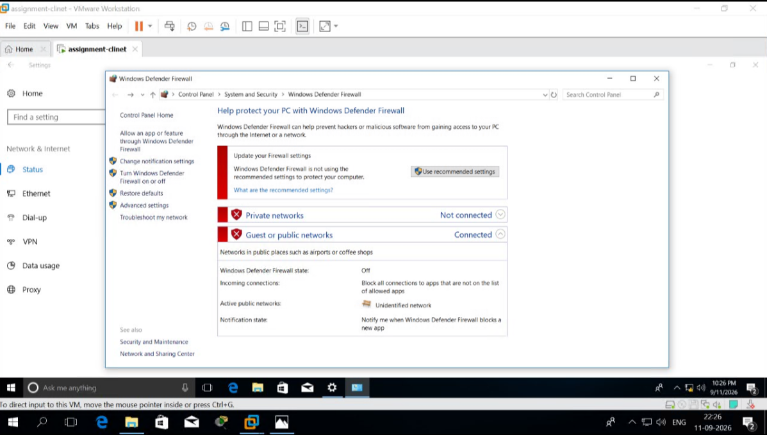

f. Set the IP as below
IP address: 172.19.10.1 Subnet Mask:255.255.0.0
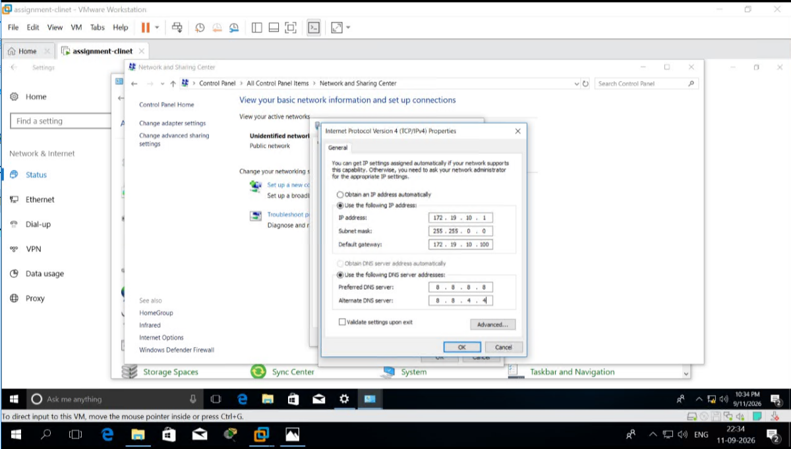

2. Add 2 hard disk on CG-Server1 of size 10GB, 20GB. Create a FAT32 partition of size on Disk1 of size 5GB with the drive letter as f: Convert the partition to NTFS. verify the same using file explorer. Create a NTFS partition on Disk2 of size 12GB with drive letter as g: Extend g drive by 2GB and shrink f drive by 1.5GB. Verify the same using file explorer.
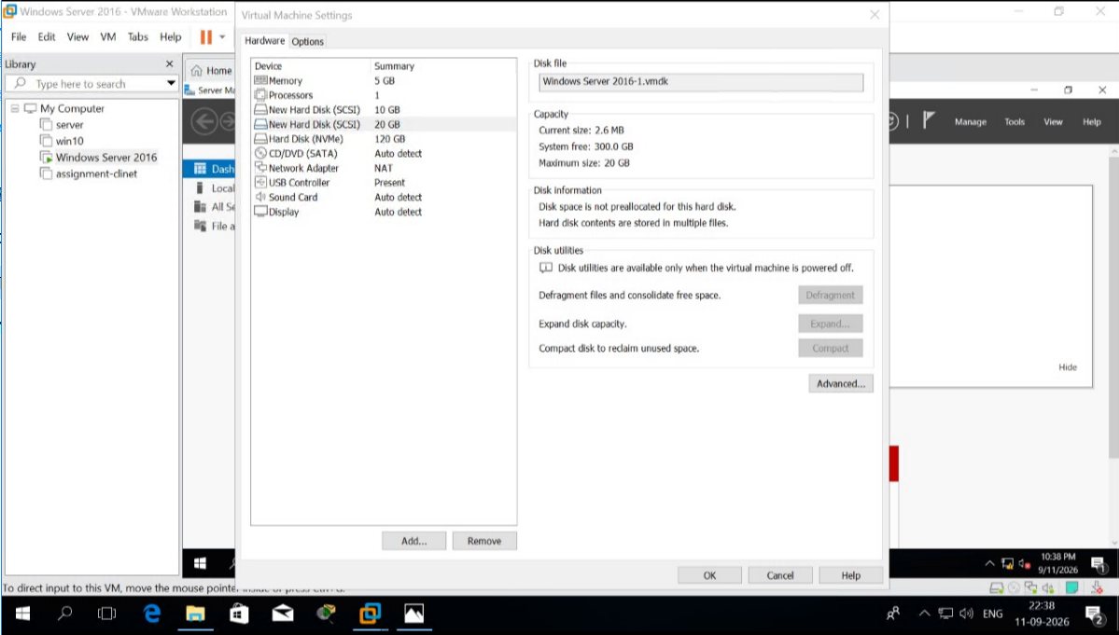

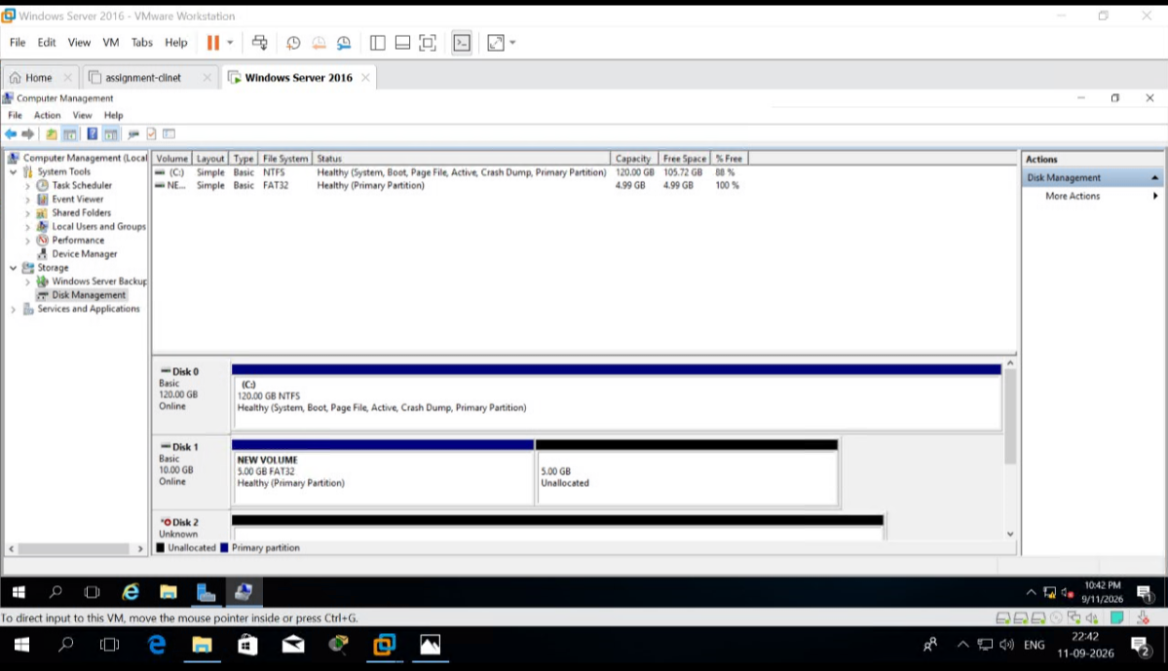

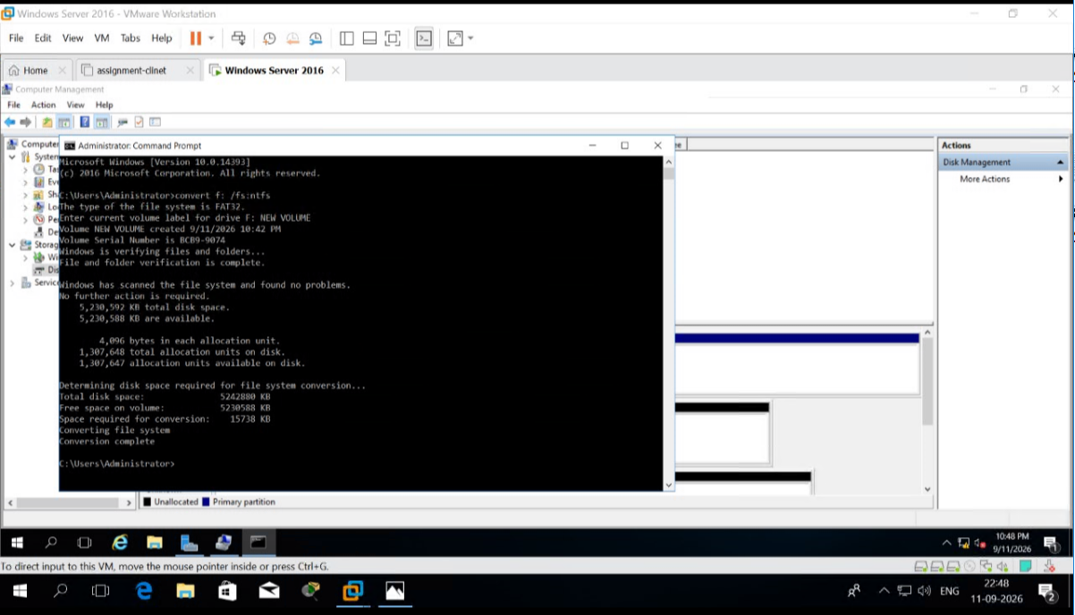
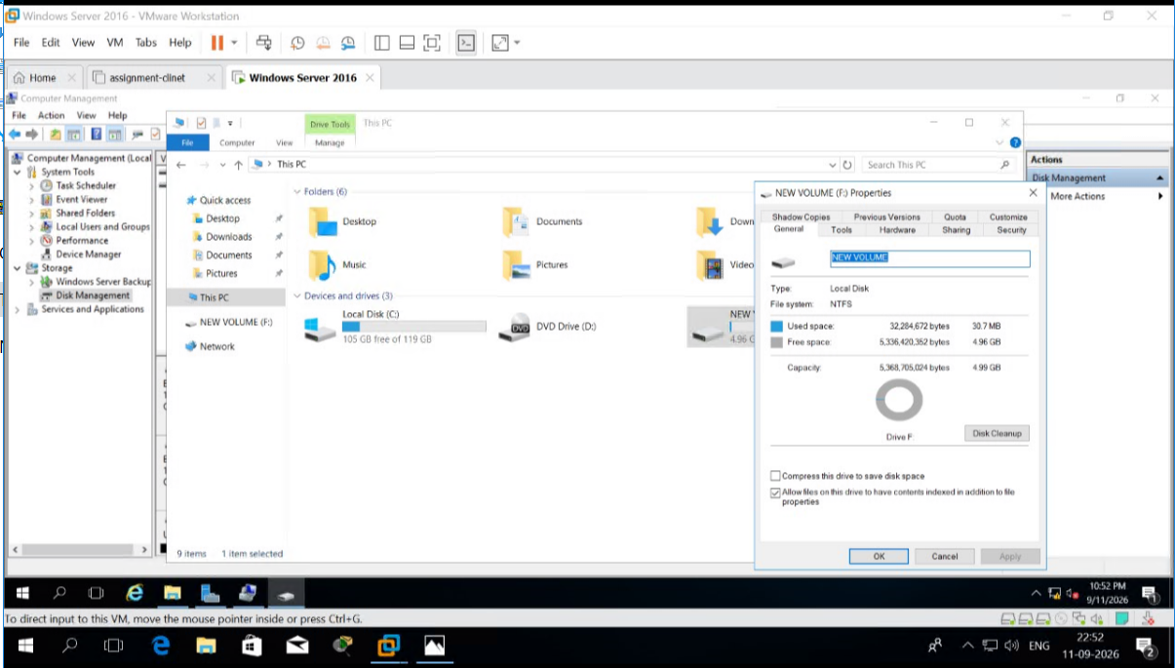
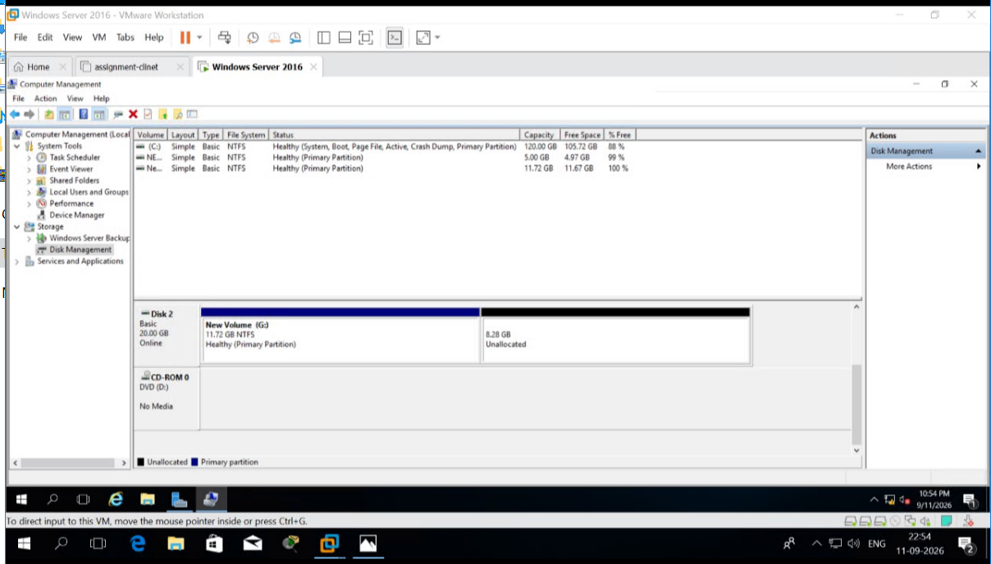
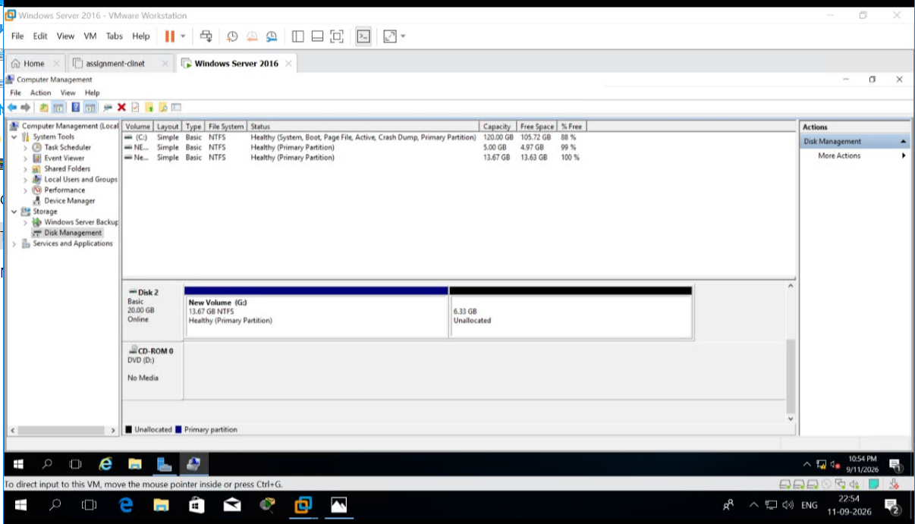
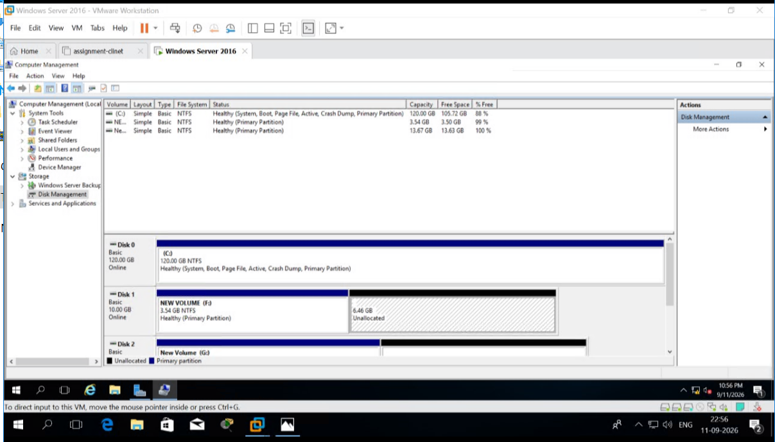
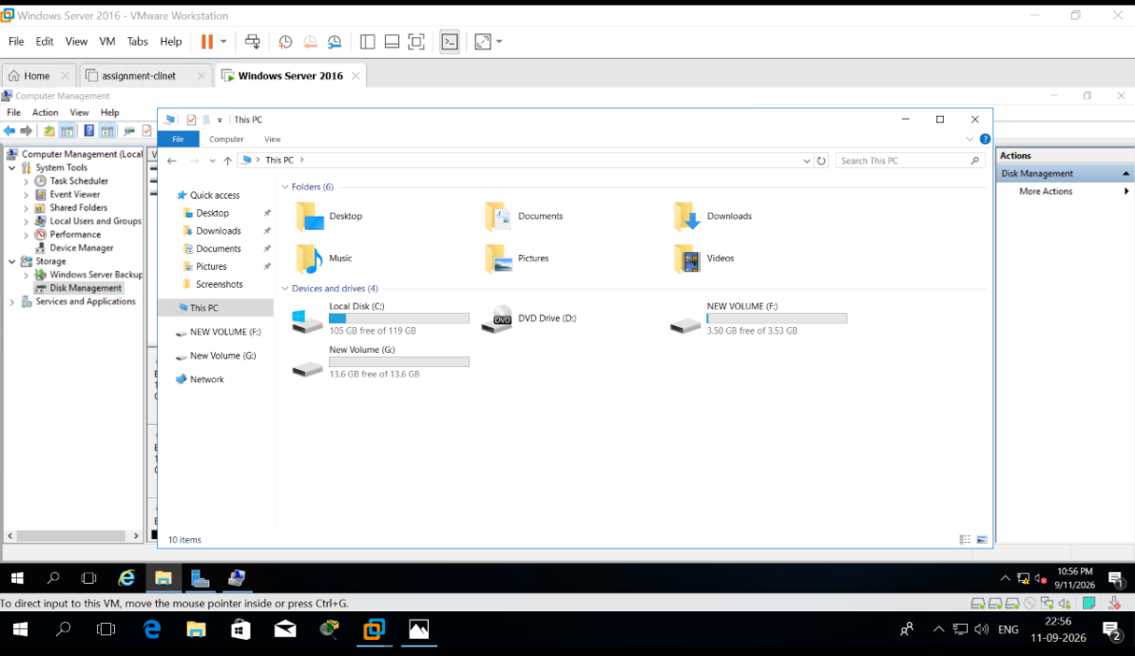

3. Demonstrate the Working of Registry with any one example. Verify the same, if it is working.
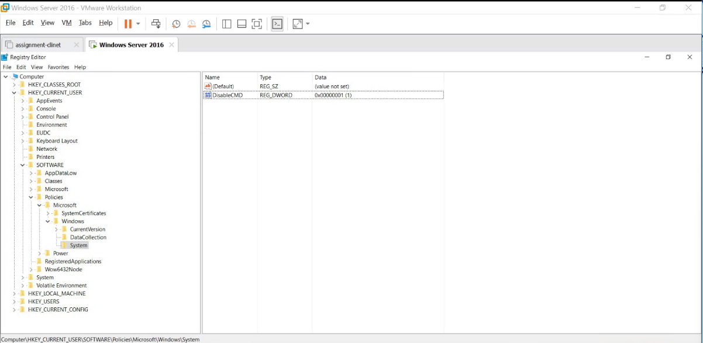

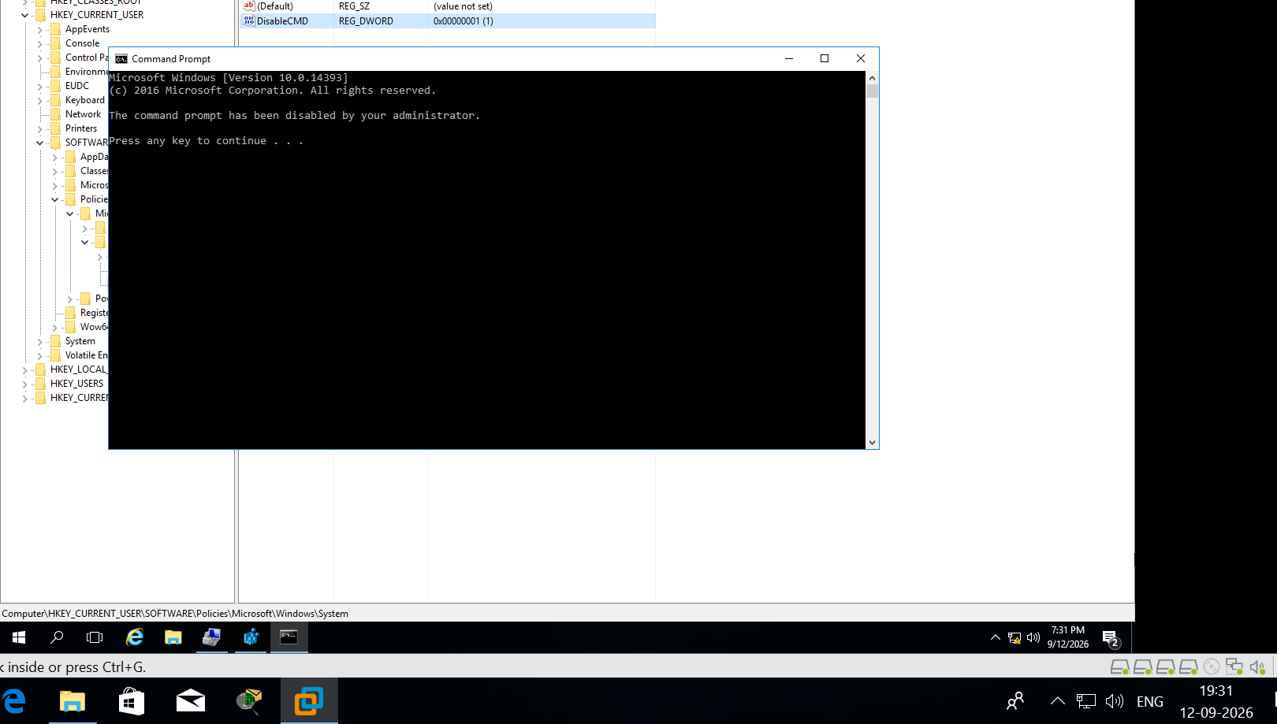

4. Demonstrate the use of Task Manager by creating new process, killing a process. Also show the RAM and CPU consumption by application Server Manager.
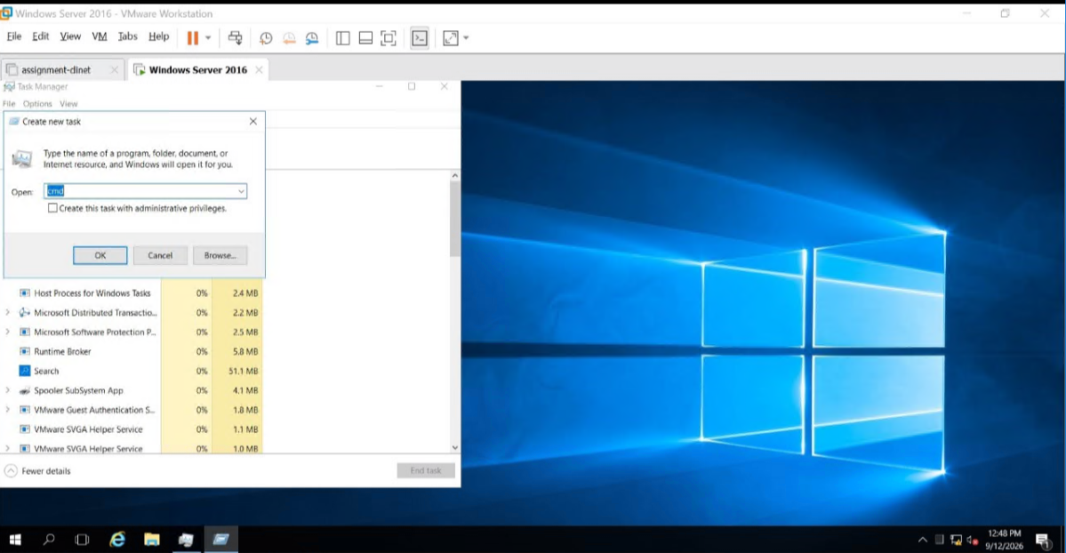

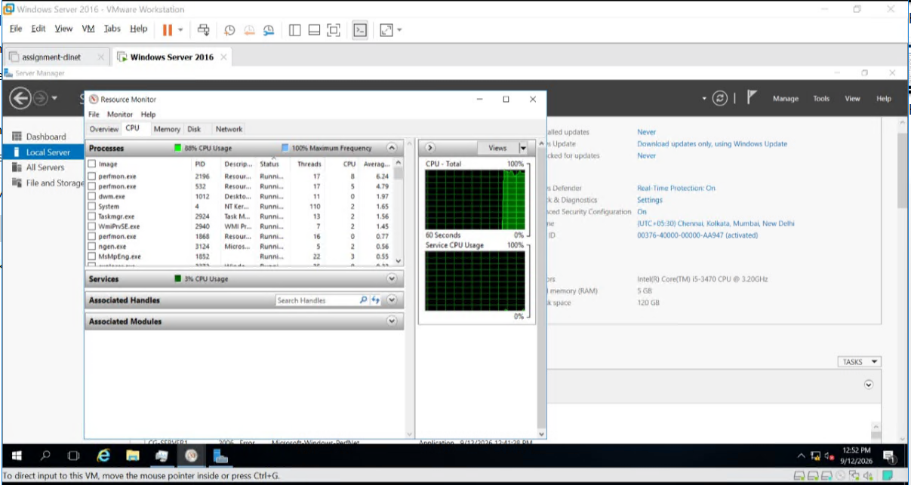
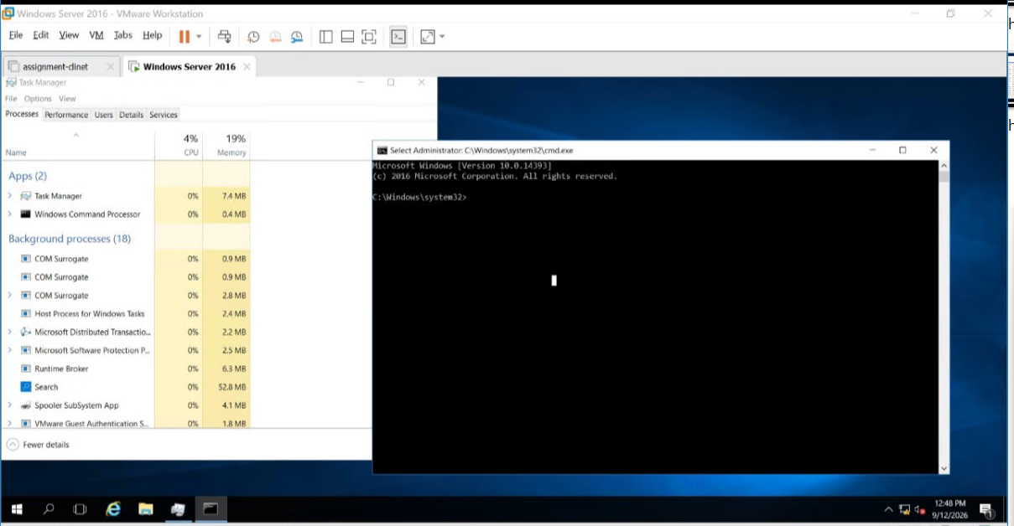
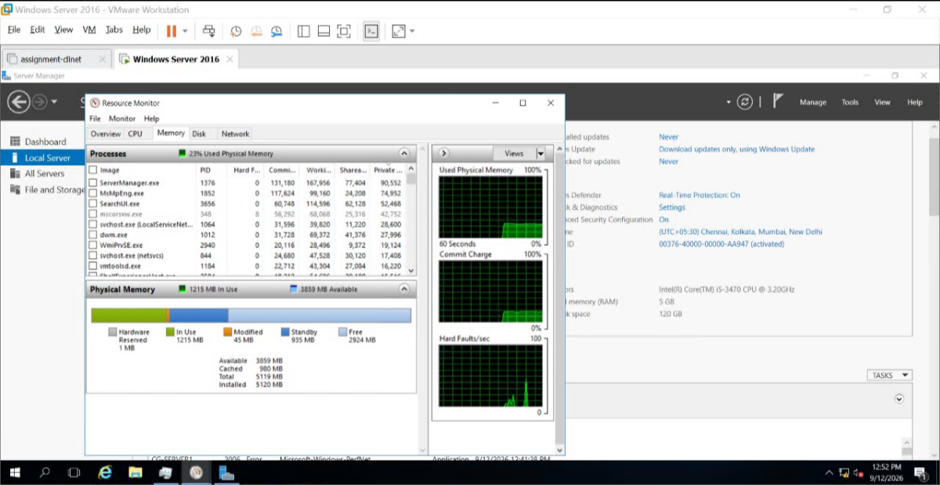

5. Demonstrate the use of event viewer with any two examples. Also demonstrate the use of Filter log.
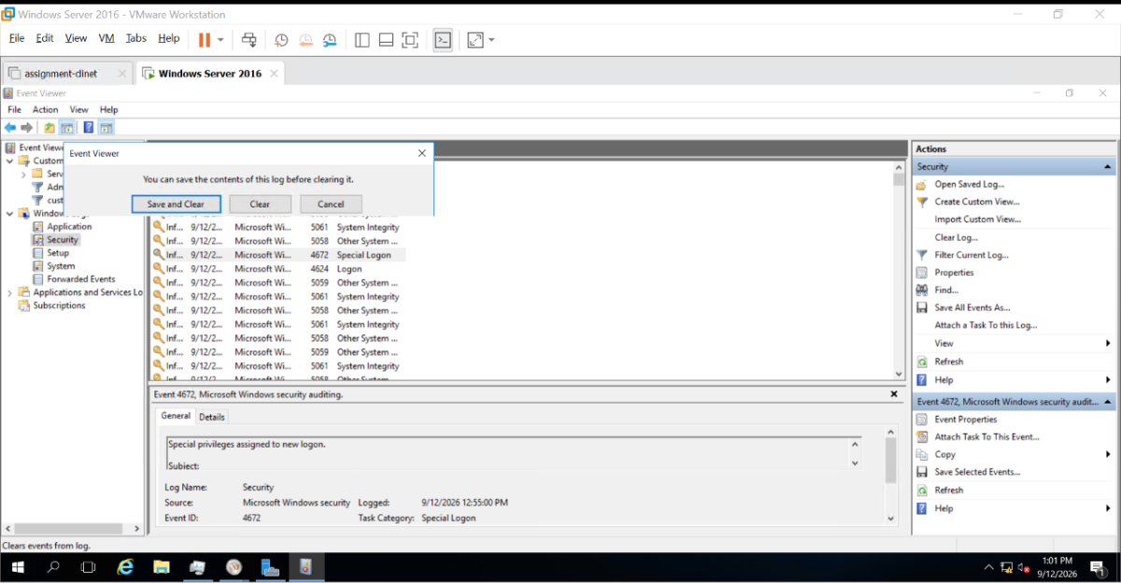
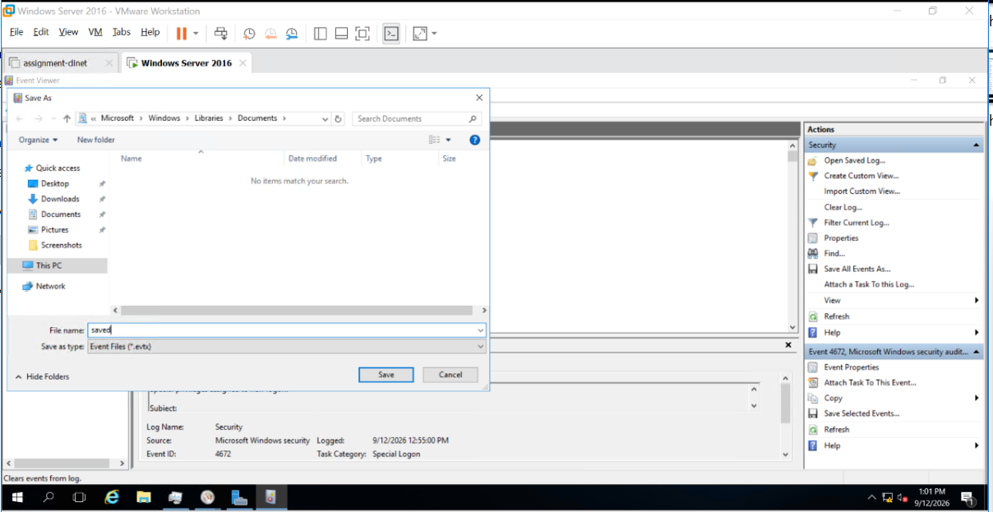

1.filter warning logs from System (windows logs)
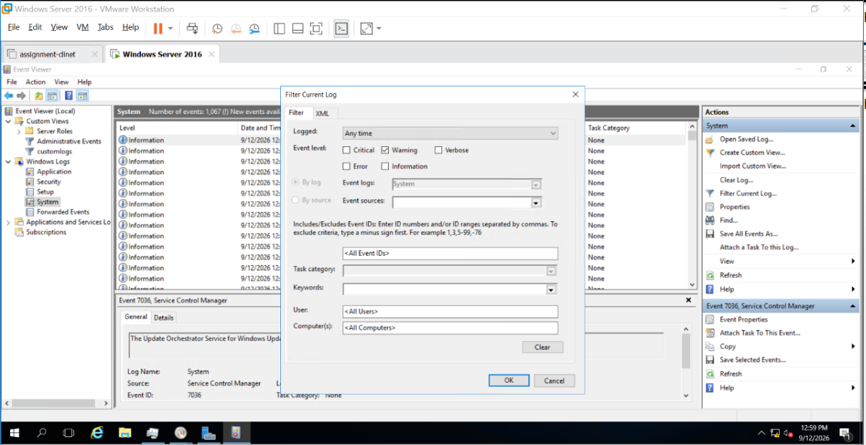
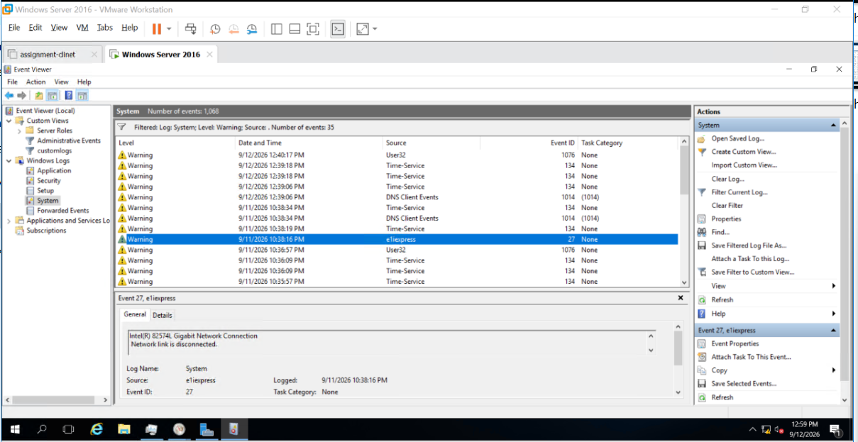

2.filter applications logs created in last one hour
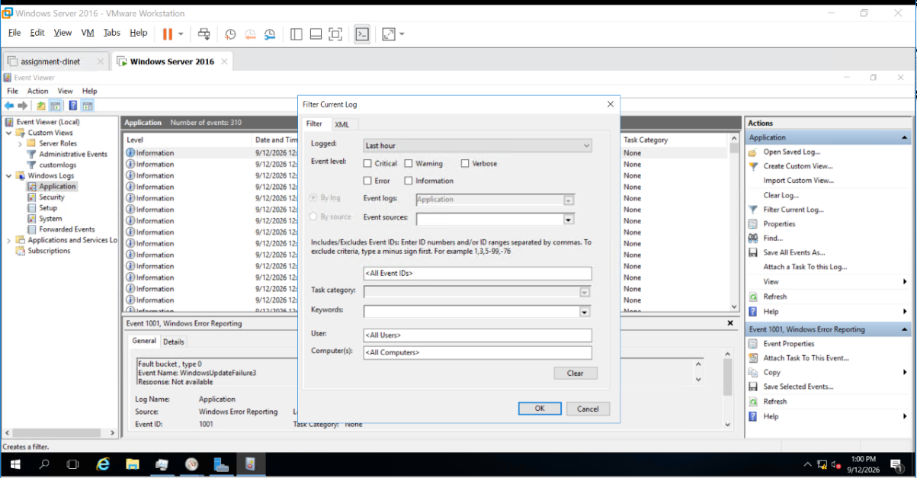
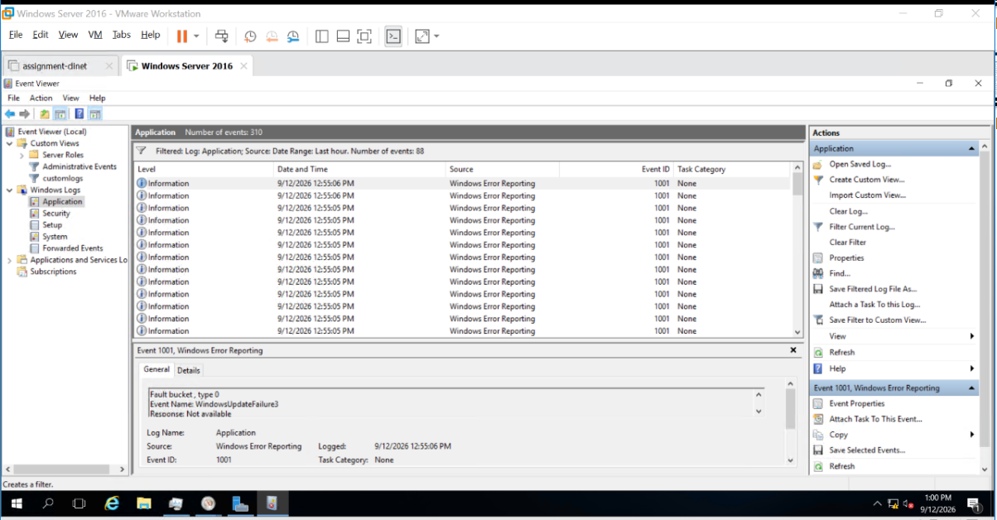

3.create a custom view for
event logs: system and application
event level: warning and error
logs created in last 12 hours
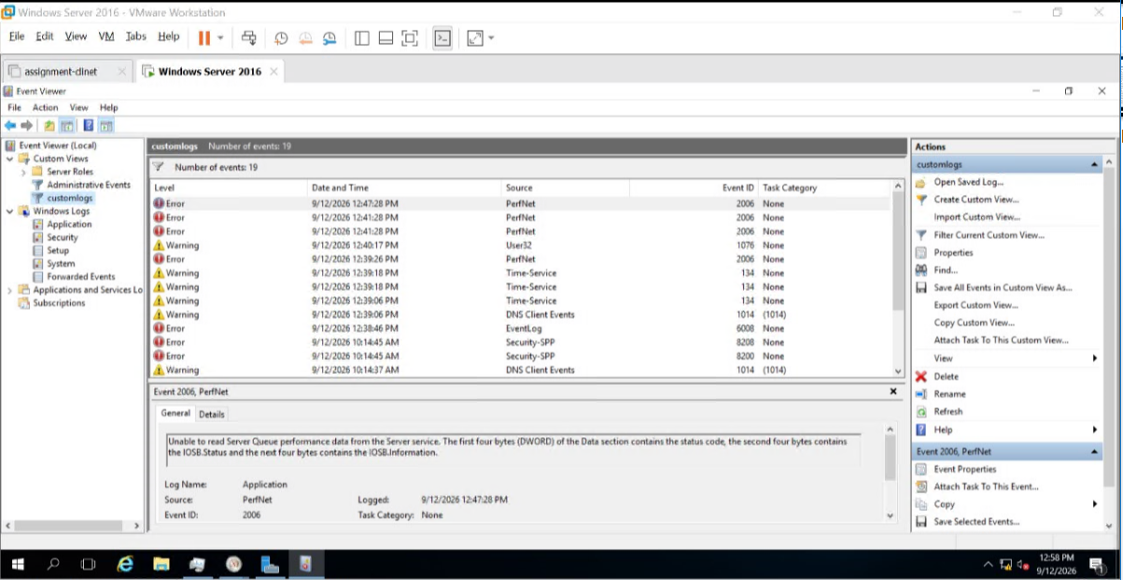
4.save custom view logs with filename customlogs.evtx

1.Create a custom power plan with name ServerPlan1 with existing plan balanced
1.1 turnoff the display after 15 minutes
1.2 power button action-"do nothing"
1.3 turn off hard disk after 45 minutes
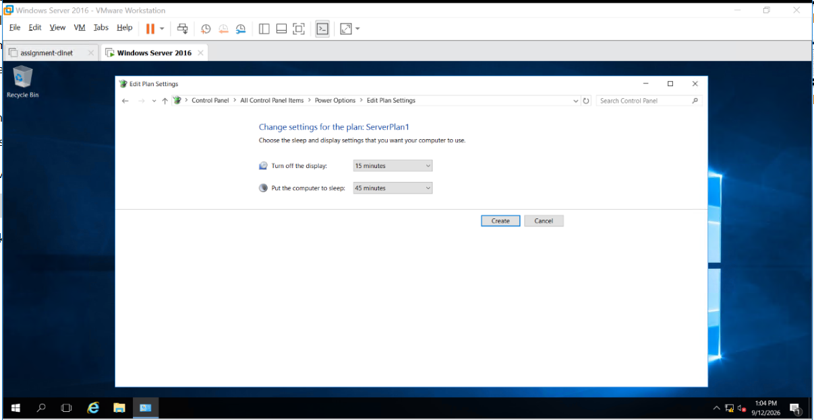

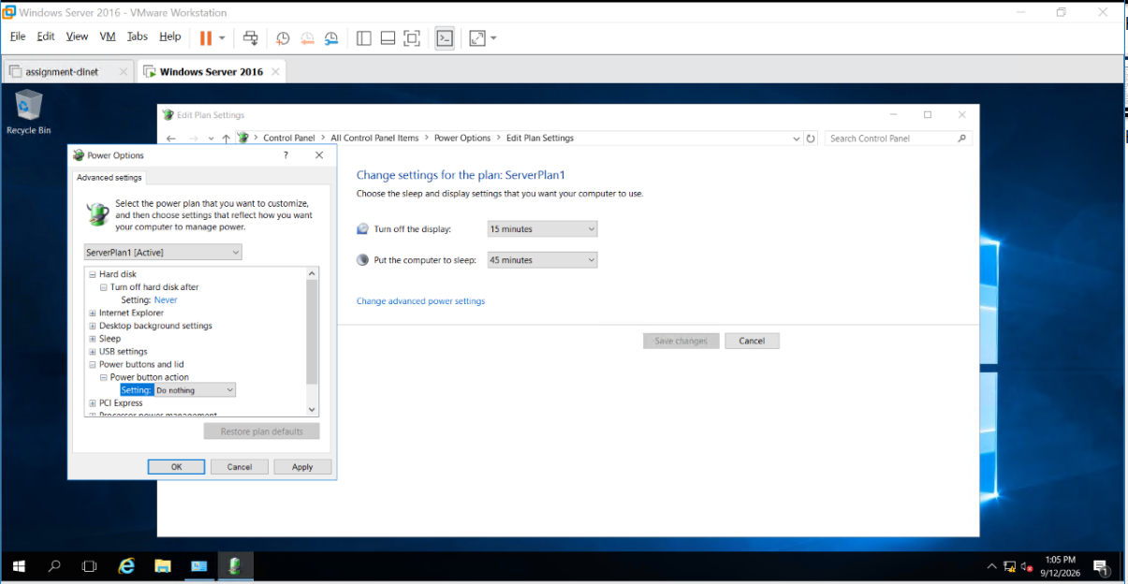

7. Add 4 hard disk with a size of 15GB each.
Create the Volumes as given below.
1. Spanned Volume: T: size should be 5.5GB in file explorer shrink the x drive by 200MB. Verify each using File Explorer.
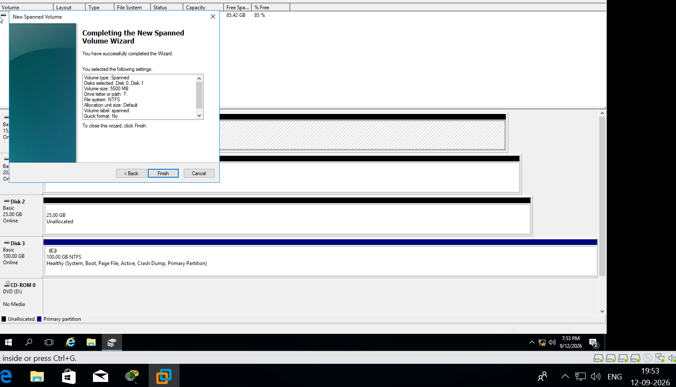
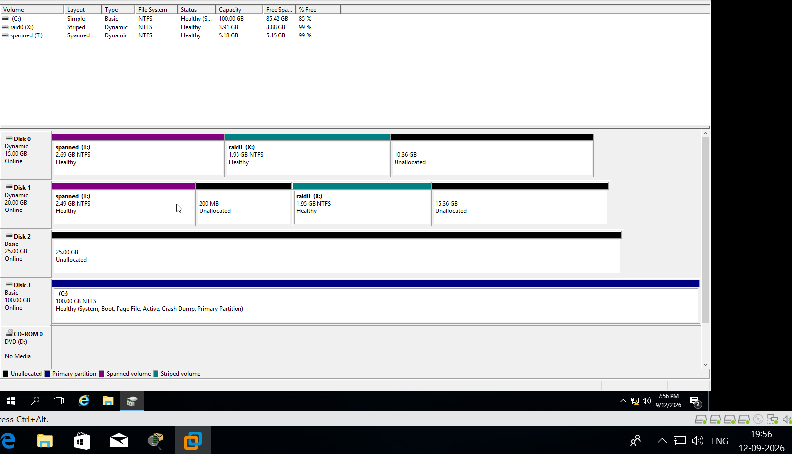

2. RAID 0 X: size should be 4GB in file explorer
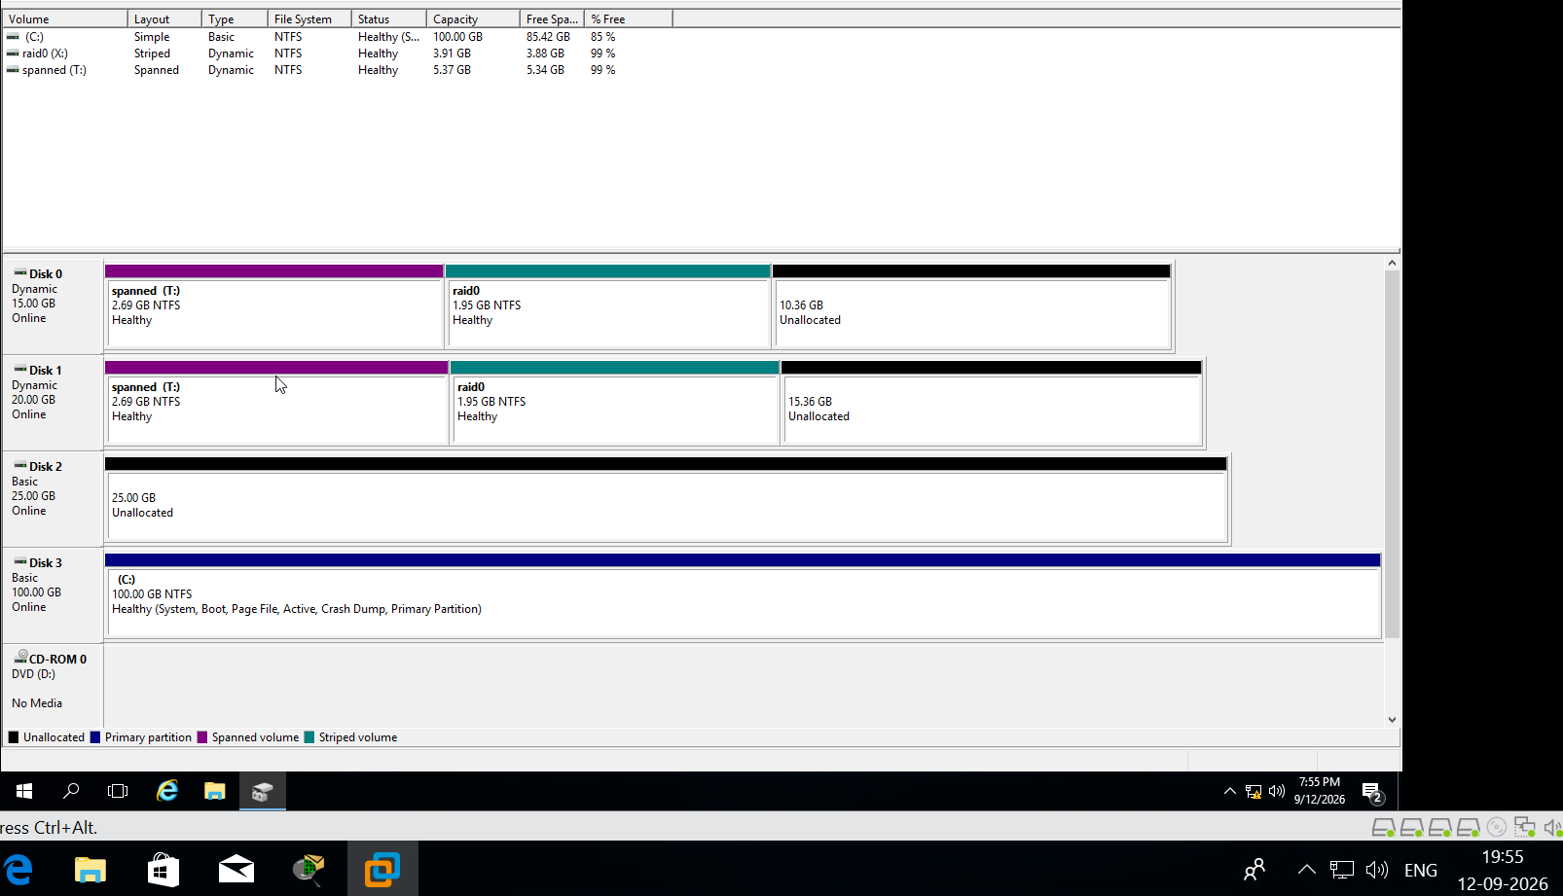

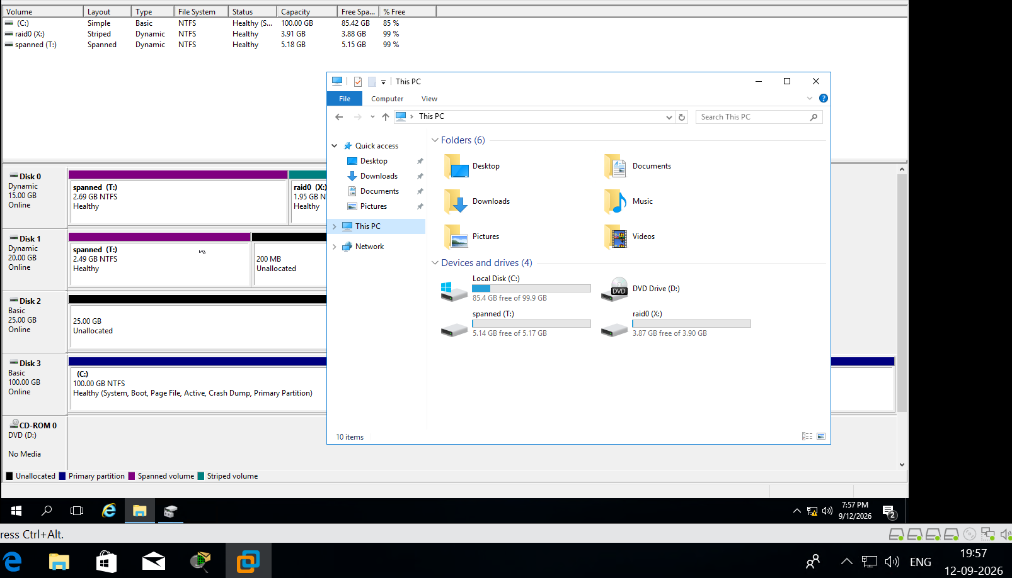

3. RAID1
Y: size should be 2.5GB in file explorer, try breaking the mirror and verify if data is still accessible. Repair the mirror by adding another disk to have Mirrored volume.
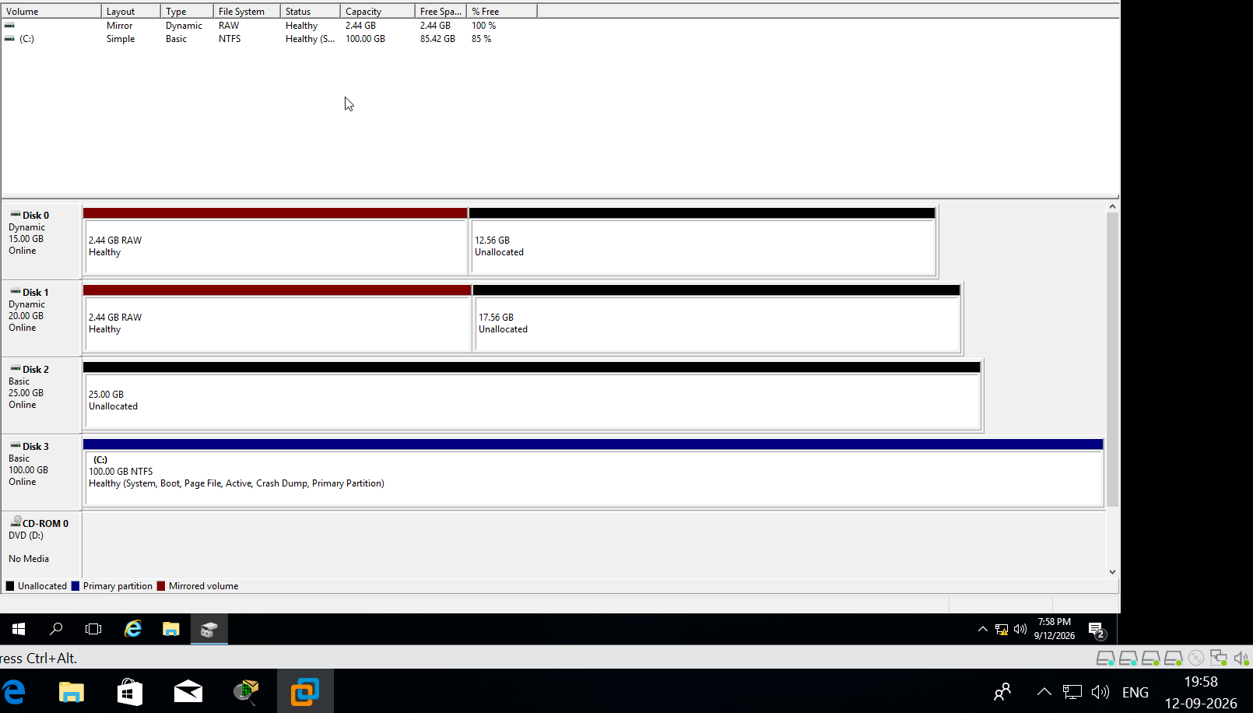
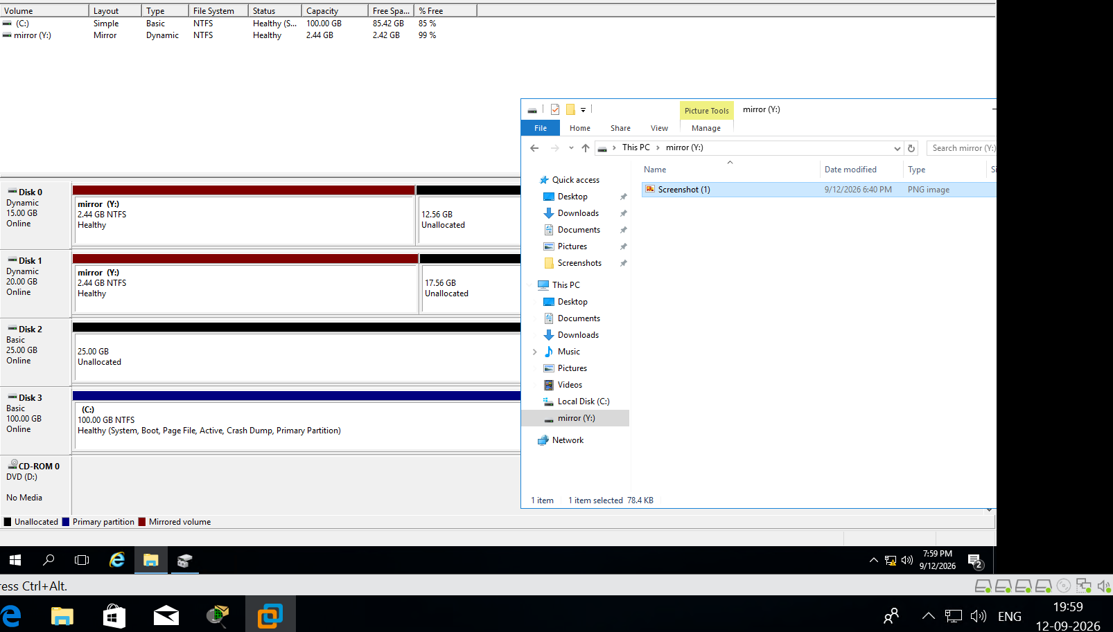

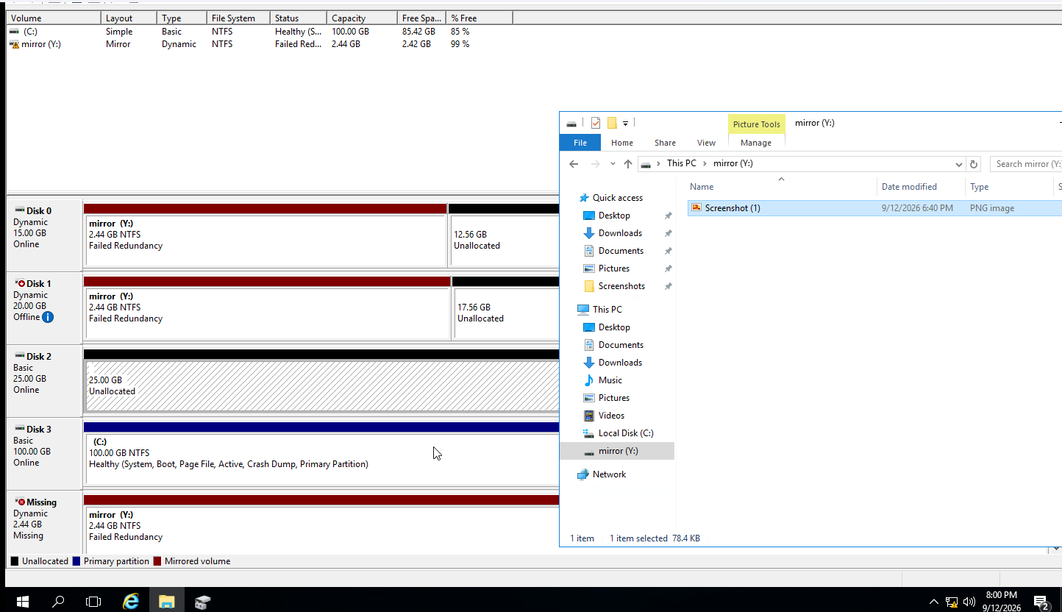

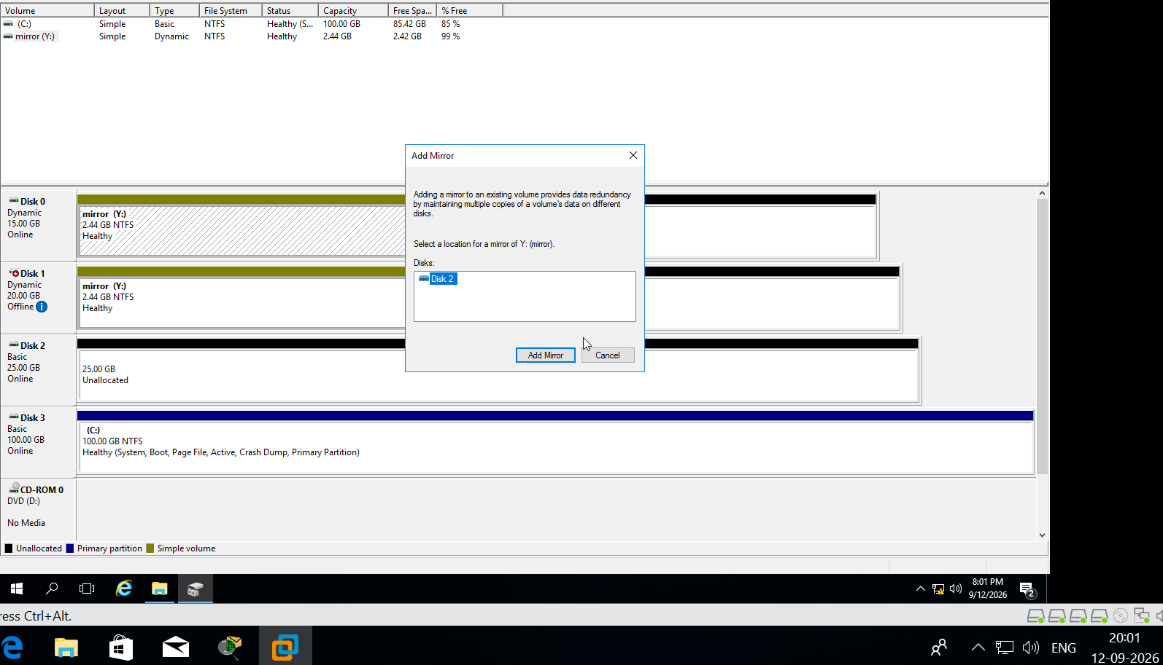

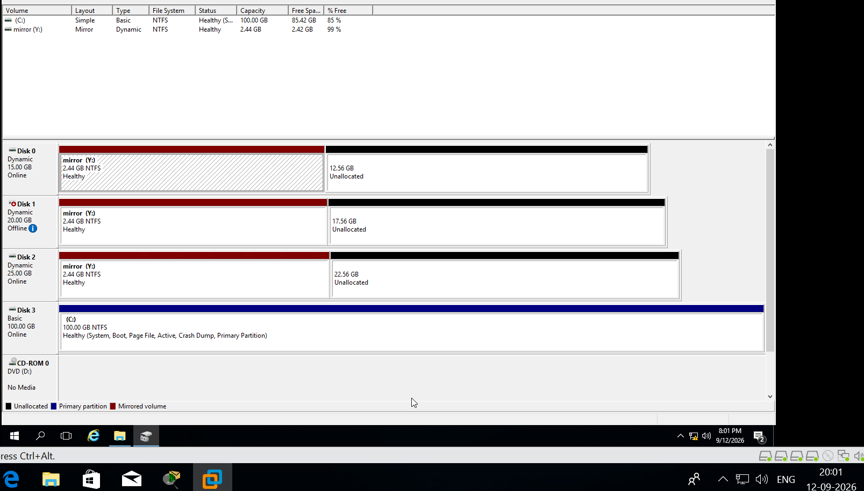

4. RAID5
Z: size should be 5 GB in file explorer, try failing one of the disks, and verify if data is still accessible.
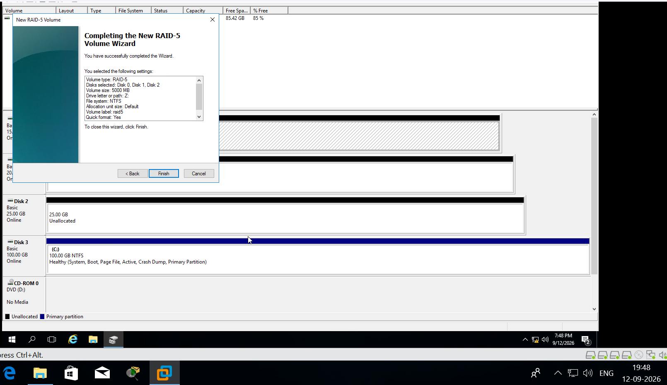
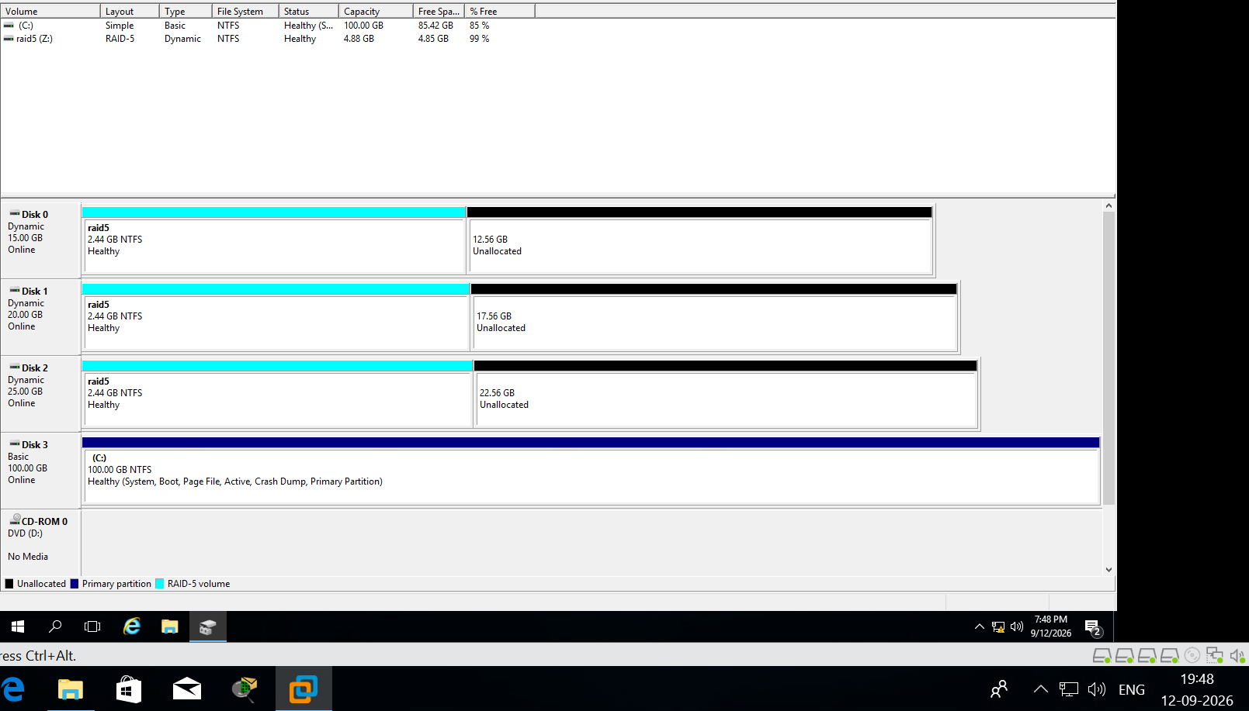
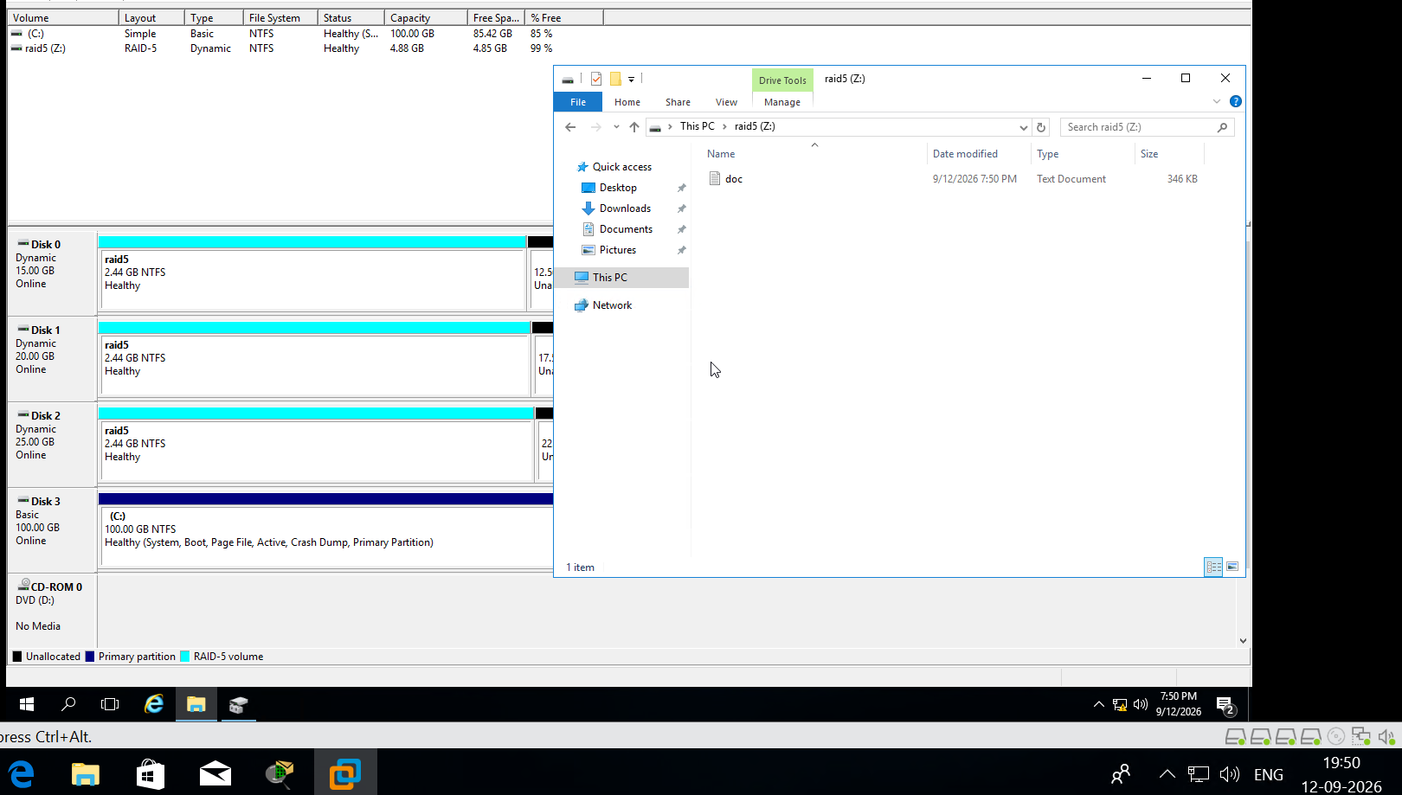

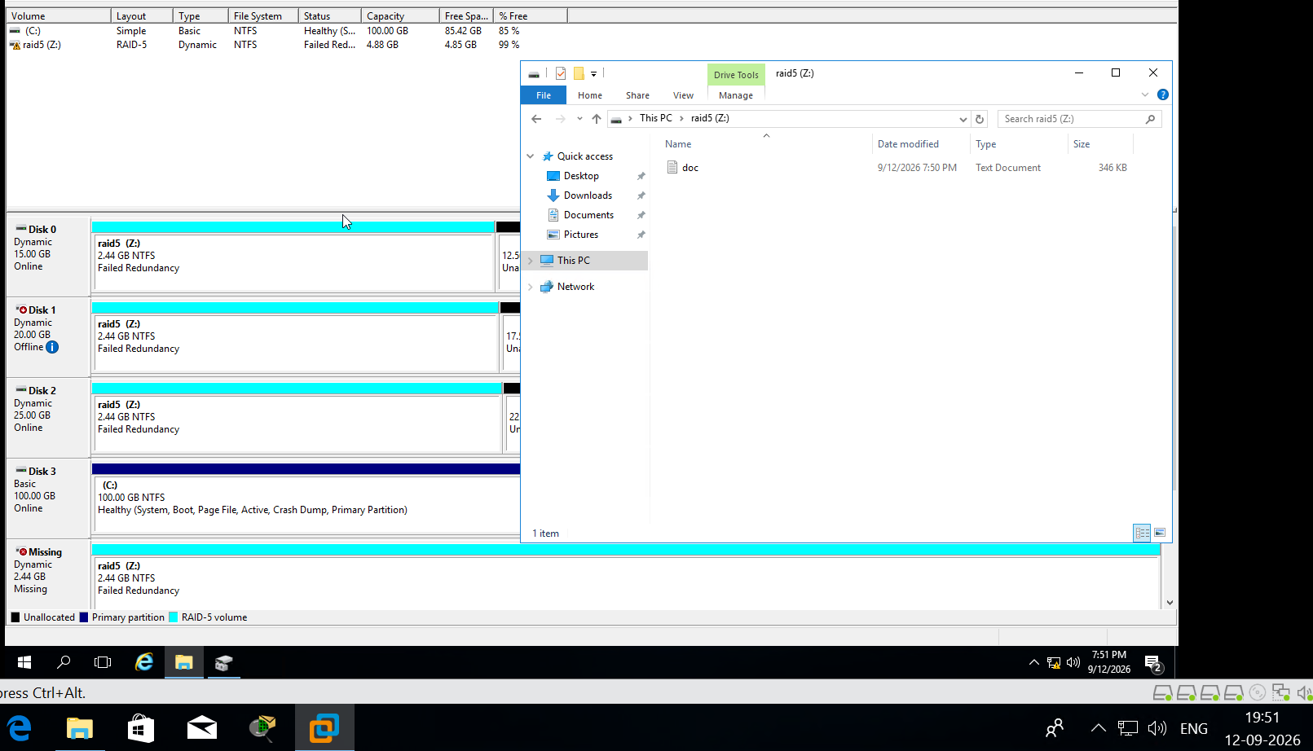

8. Demonstrate the use of Device manager by installing, uninstalling, disabling/enabling sound of system.
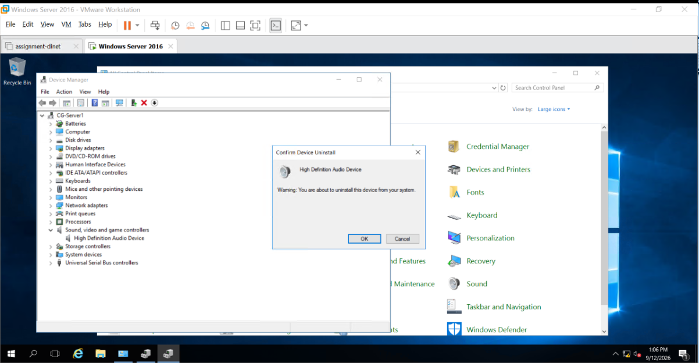
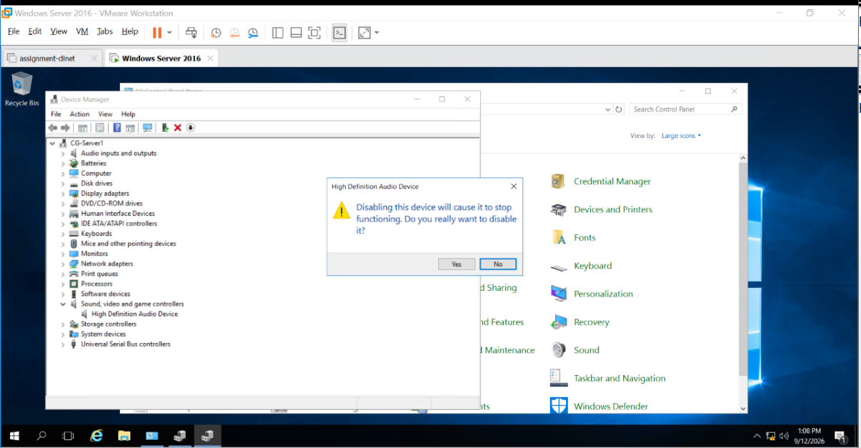

9. Demonstrate the working of Windows Services with different parameters (Manual/Automatic/disabled/start/stop).
