CodeNeuron: An Evidence-Grounded, Multi-Agent Pipeline for Hallucination Detection in Large Language Model Outputs
Shrivardhini N¹, Anish P², Kaviya Shree S³*, Murali S⁴
¹˒²˒³˒⁴ School of Computer Science and Engineering, Vellore Institute of Technology, Vellore, Tamil Nadu, India
¹shrivardhini.n2024@vitstudent.ac.in, ²anish.p2024@vitstudent.ac.in, ³kaviyashree.s2024a@vitstudent.ac.in, ⁴murali.s@vit.ac.in
Corresponding author: Murali S (murali.s@vit.ac.in)

ABSTRACT
Large language models (LLMs) now act as everyday information sources, yet their fluent answers often hide fabricated facts, wrong arithmetic and code that runs but is incorrect or unsafe. We present CodeNeuron, a verification layer placed between an LLM's answer and the end user. CodeNeuron splits an answer into prose claims and code blocks and routes each to a specialised verifier. Prose claims are checked against web evidence that is ranked by a source-credibility and recency score, using either (i) a majority vote of three heterogeneous LLM agents (GPT-4o, Gemini 2.5 Flash, Llama-3-70B) or (ii) a locally hosted NLI model (bart-large-mnli) that also serves as an automatic fallback when no cloud API is reachable. Arithmetic and calculus claims are verified deterministically with SymPy. Code is screened by AST-based security analysis, tested with generated assertions and run in a restricted subprocess. An auditable aggregation rule combines all verdicts into one of four response-level labels: TRUSTWORTHY, SUSPICIOUS, UNTRUSTWORTHY or UNSAFE.
We define the aggregation weights and confidence scores formally, illustrate each stage with worked use cases, and evaluate the system with an explicit protocol across 300 labelled test items spanning factual claims, mathematical calculations, code correctness, code security, and multimodal end-to-end responses. Across all categories, CodeNeuron achieves an overall F1 of 0.916 (precision 0.887, recall 0.947) versus 0.716 for the strongest baseline FacTool (p < 0.0001, exact McNemar test), demonstrating the critical value of combining credibility-ranked retrieval, deterministic symbolic mathematics, and AST-level sandboxed execution. Code: https://github.com/CodeNEURON-Ask-us-anything/CodeNEURON
Keywords: large language models; hallucination detection; natural language inference; fact verification; multi-agent consensus; code sandbox security; retrieval-augmented verification; symbolic mathematics verification; trustworthy AI.

1. INTRODUCTION
LLMs have replaced search engines for many users, and their answers increasingly feed decisions in education, software development and health [33]. The danger is that fluent text sounds equally confident whether it is true or not. Three failure types matter in practice: (a) factual hallucinations, (b) calculation errors, and (c) code that compiles but is functionally wrong or insecure [10], [13], [19].
Existing work attacks this from separate directions. Multi-agent debate lets several LLM instances critique one another [1]–[5], but the agents share the same internal knowledge and no external evidence anchors the outcome. Retrieval-augmented pipelines ground generation or revision in retrieved documents [6]–[10], [22], [23], [30], [32], yet usually use one LLM as judge. Self-consistency and self-verification methods [21], [24]–[26], [34] need no retrieval but are bounded by the model's own knowledge. Execution-based code evaluation [11]–[15], [31] checks behaviour but not facts. The closest system, FacTool [7], already covers knowledge, math and code in one framework; our contribution therefore has to be stated precisely rather than as “no tool combines these capabilities”.
What is new in CodeNeuron. Relative to FacTool [7] and the other work reviewed in Section 2, CodeNeuron contributes:
- C1 – Heterogeneous consensus over retrieved evidence. Three LLMs from different providers judge each claim against the same credibility-ranked evidence, and the verdict is a plurality vote with explicit tie handling, instead of a single LLM judge.
- C2 – Graceful degradation. A local NLI model verifies claims whenever cloud agents are unavailable, so the pipeline still returns a grounded verdict offline.
- C3 – Evidence credibility score. Each snippet receives a score combining a domain-trust tier and a recency bonus (Eq. 1); only the top-ranked snippets reach the verifiers.
- C4 – Security-aware code verification. AST-level screening precedes generated-test execution in a restricted subprocess, and introduces a distinct UNSAFE outcome that overrides every other score.
- C5 – Auditable response-level verdict. A closed-form aggregation rule (Eqs. 5–8) maps claim-level results to four labels; we report a sensitivity analysis for its weights and thresholds.
- C6 – Open implementation and evaluation protocol with labelled test sets, baselines, ablation and metrics scripts.
We evaluate four research questions. RQ1: Does evidence-grounded multi-agent consensus detect erroneous claims better than a single LLM judge or NLI alone? RQ2: Does each component contribute (ablation)? RQ3: Does the code branch detect incorrect and unsafe code beyond execution-only checking? RQ4: How sensitive is the final verdict to the aggregation weights and thresholds? Section 2 reviews related work, Section 3 describes the method with worked use cases, Section 4 gives the experimental design, Section 5 the results, and Section 6 discusses limitations.

2. RELATED WORK

2.1 Multi-agent debate and model ensembles
Du et al. let several LLM instances propose answers and critique each other over rounds until they agree [1]. Chan et al. use role-specific LLM referees to debate which of two responses is better [2]. Liang et al. show that a single model that is confident in a wrong answer cannot escape it (“degeneration of thought”), which debate partly relieves [3]. LLM-Blender ranks candidates from heterogeneous LLMs pairwise and fuses the best ones [4], and Corex orchestrates collaboration among several models for complex reasoning [5]. These methods are expensive and, unlike CodeNeuron, do not anchor their conclusion in retrieved evidence.

2.2 Retrieval-augmented generation and evidence-based verification
Lewis et al. introduced RAG, which conditions a BART generator on retrieved Wikipedia passages [6]. Self-RAG teaches a model when to retrieve and to critique its output with reflection tokens, but still relies on the model's own self-assessment [9]. RARR retrieves web evidence and revises unsupported statements after generation [8]. FacTool extracts claims, gathers evidence with search, and uses an LLM to judge knowledge claims; it also generates unit tests for code and checks calculations for math [7]. Ji et al.'s survey separates intrinsic from extrinsic hallucination and notes that fine-grained claim-level verification is open [10]. FACTSCORE [22], FEVER [23] and WiCE [30] supply atomic-claim and entailment formulations that our claim extraction and verdict labels follow.

2.3 Self-consistency and iterative self-verification
SelfCheckGPT detects hallucination in black-box LLMs by sampling several answers and measuring their consistency, on the premise that true facts recur while invented ones vary [21]. Self-Consistency selects the most frequent reasoning outcome [34]. HaluEval provides 35,000 labelled samples for hallucination detection [24]. Chain-of-Verification has the model draft verification questions and revise its answer, raising FACTSCORE from 55.9 to 71.4 [25], and CoNLI applies NLI between generated sentences and source text to detect and repair ungrounded content [26]. All of these remain bounded by the model's knowledge or by a fixed source text.

2.4 NLI foundations and symbolic or tool-augmented reasoning
SNLI defines the entailment / contradiction / neutral task [18]; TRUE shows that NLI models are effective detectors of factual inconsistency [17]; BART provides the architecture of the NLI model we use [16]. For arithmetic, Cobbe et al. introduced GSM8K and showed that a separate verifier markedly improves math accuracy [19], and Program-of-Thoughts offloads computation to an interpreter [20]; SymPy [29] provides the deterministic backend we use. ReAct [27] and Toolformer [28] improve generation through tool use rather than independently verifying a finished answer.

2.5 Code generation, execution-based testing and vulnerability detection
Codex/HumanEval established functional correctness measured by unit tests, and pass@k, as the evaluation signal for generated code [15]. CodeT selects solutions by consistency with model-generated tests [11]; LEVER trains a verifier on execution results [12]; EvalPlus (HumanEval+) shows that ChatGPT-generated code that passes the original tests often fails stricter ones and has security weaknesses [13]; self-debugging feeds execution output back to the model [14]; VulDeePecker learns vulnerability patterns from code “gadgets” [31].

2.6 Positioning against FacTool and EvalAI
Table 1. Capability comparison (✓ part of the method; ~ partial; – not part of the method).
Method | Claim-level | External evidence | Multi-LLM vote | NLI | Symbolic math | Code execution | Static security | No-API fallback
Multi-agent debate [1] | – | – | ~ | – | – | – | – | –
RARR [8] | ~ | ✓ | – | – | – | – | – | –
FacTool [7] | ✓ | ✓ | – | – | ✓ | ✓ | – | –
SelfCheckGPT [21] | ✓ | – | – | ~ | – | – | – | –
CoVe [25] | ~ | – | – | – | – | – | – | –
CoNLI [26] | ✓ | ~ | – | ✓ | – | – | – | –
CodeT [11] | – | – | – | – | – | ✓ | – | –
CodeNeuron (ours) | ✓ | ✓ | ✓ | ✓ | ✓ | ✓ | ✓ | ✓
Ratings are based on the published descriptions of each method; later variants may differ. A tick for CodeNeuron means the module exists, not that it outperforms the alternative – that is tested in Section 5.
Versus FacTool. FacTool is the closest system and the main baseline in Section 5. To our reading of [7], it uses one LLM as the judge, has no NLI verifier and no offline mode, and does not perform static security screening of code. CodeNeuron differs by (i) a three-provider vote over shared, credibility-ranked evidence, (ii) a local NLI fallback, (iii) an UNSAFE class driven by AST security analysis, and (iv) a response-level four-label verdict. Whether these differences improve accuracy is an empirical question, answered by the head-to-head comparison and ablation in Section 5, not assumed.
Versus EvalAI. EvalAI [35] is an open-source platform for hosting AI challenges: participants submit models, and the platform scores them against hidden ground-truth annotations and publishes leaderboards. It is an offline benchmarking tool for comparing systems. CodeNeuron is an online, per-answer verifier that must decide whether a single new answer can be trusted when no ground truth exists. The two are complementary: EvalAI could host the labelled test sets of Section 4 as a public challenge in which different verifiers, including CodeNeuron, are compared on identical data.

3. METHODOLOGY

3.1 Overview
Given an LLM answer A, CodeNeuron (Fig. 1) (1) segments A into prose claims C = {c₁…cₙ} and code blocks K = {k₁…kₘ}; (2) verifies each claim cᵢ independently with the most appropriate verifier; (3) verifies each code block; and (4) aggregates all results into a response-level verdict with an explanation and confidence score.
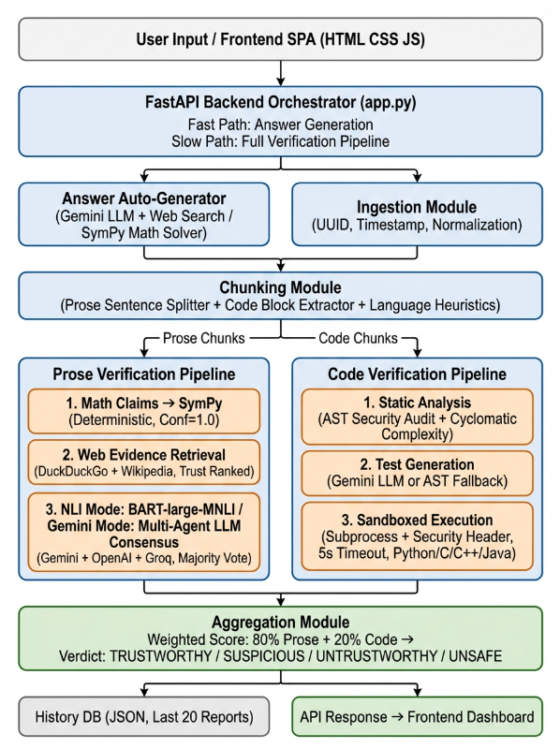
Fig. 1. Architecture of CodeNeuron.

3.2 Claim extraction and routing
Extraction is deliberately rule-based so that it is fast and deterministic; all judgement is left to later stages. (i) Fenced code blocks are located with a regular expression and their language tag is stored (default Python). (ii) Code blocks are removed from the text. (iii) Boilerplate such as headings, bracketed reference markers and system notices is stripped so it is not mistaken for a claim. (iv) The remaining text is split into sentences; sentences with fewer than five words are discarded. (v) A sentence containing code markers ({ }, def , return , print() is re-routed to the code branch, with Java/C detected from tokens such as System.out.print or #include. This follows the atomic-claim decomposition idea of FACTSCORE [22], at sentence rather than sub-sentence granularity. Equations such as “2 + 3 * 4 = 14” are extracted as ordinary prose claims and are intercepted by the math verifier (Section 3.6).

3.3 Evidence retrieval and credibility scoring
For each non-mathematical claim, content words are kept (stop-words removed, at most eight keywords) and used to query DuckDuckGo (up to 15 results) and the Wikipedia search API. Results are de-duplicated by URL. Each snippet e receives a credibility score
s(e) = d(e) + ρ(e) (1)
where the domain-trust term d(e) ∈ {100, 50, 10} corresponds to a high-trust tier (government/military/academic domains such as .gov, .edu, .ac.in, .gov.in; international bodies; encyclopedias; scientific databases and publishers; major news agencies and fact-checkers), a medium-trust tier (official technical documentation, Q&A and community sites), and any unknown domain. The recency term is
ρ(e) = max(0, 50 − 10·(Y_now − y_e)) (2)
where y_e is the publication year (the timestamp when available, otherwise the latest year mentioned in the snippet) and ρ = 0 when no year can be found. Thus ρ decays linearly from 50 to 0 over five years, so s(e) ranges from 10 to 150. The scale was chosen so that trust dominates recency: a brand-new snippet from an unknown site (10 + 50 = 60) outranks an old medium-trust one (50) but never an old high-trust one (100). These tier values are expert-set heuristics, not learned; their effect is examined in Section 5.5. The four highest-scoring snippets are passed to the verifiers. Note that s(e) controls which evidence is used; the claim-level confidence is produced by the verifier itself (Sections 3.4–3.5).

3.4 NLI verification (local mode and fallback)
Each retrieved snippet eᵢ (premise) is paired with the claim c (hypothesis) and classified by facebook/bart-large-mnli [16] as entailment, contradiction or neutral with probability pᵢ. Neutral pairs are discarded. For each remaining pair a lexical relevance rᵢ = |W(c) ∩ W(eᵢ)| / |W(c)| is computed, where W(·) is the set of words longer than three characters. The evidence with the highest selection score
qᵢ = 0.7·pᵢ + 0.3·rᵢ (3)
determines the verdict (entailment → SUPPORTED, contradiction → CONTRADICTED) and its confidence q*. If every snippet is neutral, the verdict is NOT_ENOUGH_INFO with confidence 0.3. The 0.7/0.3 split makes the model's probability the main signal while using lexical overlap to prefer snippets that actually discuss the claim. If the transformer cannot be loaded, a keyword-overlap-and-negation heuristic is used so the module never fails silently.

3.5 Multi-agent LLM consensus
In consensus mode the claim and the same top-4 evidence are sent in parallel to three agents: GPT-4o (OpenAI), Gemini 2.5 Flash (Google) and Llama-3-70B (Groq). Each returns a verdict v_j ∈ {SUPPORTED, CONTRADICTED, NOT_ENOUGH_INFO}, a self-reported confidence κ_j ∈ [0,1] and a one-sentence explanation. The prompt instructs an agent to use the evidence when it is relevant and to fall back on its own knowledge when it is not; the effect of this choice is measured by the “no retrieval” ablation. The final verdict is the plurality vote over responding agents:
v* = argmax_v |{ j : v_j = v }|, κ* = (1/|J|) Σ_j κ_j (4)
where J is the set of agents that responded. A tie for first place yields NOT_ENOUGH_INFO, so that disagreement can never silently become SUPPORTED (implemented via a plurality vote function with explicit tie handling). Only agents with a configured API key are called; if none respond, the claim is re-verified in local NLI mode (Section 3.4). Because κ_j is self-reported, it is not assumed to be calibrated; calibration is measured in Section 5.6.

3.6 Deterministic mathematical verification
Before any retrieval, each claim is tested by the math verifier. A claim qualifies if it contains a digit or an operator/function name and can be split into two sides at “=” (or “is/equals”). Both sides are parsed by SymPy with implicit multiplication, and the claim is SUPPORTED if simplify(left − right) = 0 and CONTRADICTED otherwise; claims about integrals (“the integral of x² is x³/3”) are handled by symbolic integration. Confidence is fixed at 1.0 because the outcome is deterministic given the parse; this is a statement about the computation, not a guarantee that parsing captured the author's intent. Claims that cannot be parsed fall through to the factual route.

3.7 Code verification
Static analysis. For Python, the AST is walked without executing the code. Each import of os, subprocess, sys, socket, shutil or pty, each call to eval, exec, compile or __import__, and each call to os.system/popen/spawn/exec or subprocess.run/Popen/call/check_output increments a security-issue counter. Cyclomatic complexity (decision-point count + 1) is graded LOW (≤3), MEDIUM (≤7) or HIGH. Lines over 100 characters count as lint issues. Other languages receive only line-level checks. Optionally, Gemini adds a Big-O estimate and optimisation hints; these do not affect the verdict.
Test generation. When Gemini is enabled it writes three assertions appended to the code; otherwise an AST fallback calls up to three detected functions with a placeholder argument (the integer 1) and checks that they execute without exception, or performs a plain compile/run check if no function exists. Test generation is Python-only.
Restricted execution. Code plus tests run in a separate Python subprocess with a 5-second timeout. A prepended header replaces the modules os, subprocess, shutil, socket, urllib, requests, pty, platform and ctypes with stubs that raise PermissionError, blocks file opening in write/append modes, and disables eval. C, C++ and Java are compiled with gcc/g++/javac and run under the same timeout. stdout, stderr, exit code and run time are captured. This is process-level restriction, not strong isolation (see Section 6).
Code verdict. UNSAFE if the static analysis found at least one security issue; otherwise FAIL if the exit code is non-zero or any generated test fails; otherwise PASS.

3.8 Aggregation and the final verdict
Let a response contain n_p prose claims with n_S supported, n_C contradicted and n_N unverified (NOT_ENOUGH_INFO), and n_k code blocks with n_P passed, n_F failed and n_U unsafe. The component scores are
S_prose = max(0, (n_S + 0.4·n_N − n_C) / n_p) (5)
S_code = max(0, (n_P − 0.5·n_F − n_U) / n_k) (6)
S = 0.8·S_prose + 0.2·S_code (7)
If a response has only one kind of content, S equals the corresponding component score (and S = 1 if it has none). The verdict is
V = UNSAFE if n_U > 0; TRUSTWORTHY if S ≥ 0.8; SUSPICIOUS if 0.5 ≤ S < 0.8; UNTRUSTWORTHY otherwise (8)
Rationale for the constants. A contradicted claim is penalised as heavily as a supported claim is rewarded (±1), so a single falsehood cancels one confirmed fact. An unverified claim earns partial credit (0.4): it is not evidence of error, but it is worth clearly less than a verified claim. A failing code block (−0.5) is penalised less than an unsafe one (−1) because failure may reflect an incomplete snippet while unsafe behaviour is a security hazard; UNSAFE additionally overrides the score entirely. The 0.8/0.2 weights reflect that prose claims typically outnumber code blocks in a response, and keep a single short snippet from dominating a long explanation. The thresholds 0.8 and 0.5 mean that at least 80% of the weighted evidence must be positive to be called trustworthy and that a majority must be positive to avoid UNTRUSTWORTHY. We stress that these constants are design choices; Section 5.5 reports how the verdicts and F1 change under alternative values and a “code-failure veto” variant.
A known consequence. Because code carries only 20% of S, a response whose prose claims are all supported but whose single code block fails still scores S = 0.8 and is labelled TRUSTWORTHY (Table 3, row B). This is exactly the type of behaviour the sensitivity analysis is meant to expose, and it motivates the veto variant evaluated in Section 5.5.

3.9 Worked use cases
The following examples were produced by running the repository code, except where marked.
Use case 1 – Claim extraction, evidence retrieval and credibility scoring
Input answer (abridged): “Canberra is the capital city of Australia. It was chosen as the capital in 1908. 2 + 3 * 4 = 14. The integral of x^2 is x^3/3. Here is a helper: [Python function divide] … [Python function wipe].”
Table 2a. Output of claim extraction.
# | Chunk type | Content | Next stage
1 | prose | Canberra is the capital city of Australia. | Retrieval + NLI / consensus
2 | prose | It was chosen as the capital in 1908. | Retrieval (pronoun resolved from context)
3 | prose | 2 + 3 * 4 = 14. | Math verifier (SymPy)
4 | prose | The integral of x^2 is x^3/3. | Math verifier (SymPy)
5 | code | def divide(a, b): return a / b | Static → tests → sandbox
6 | code | import os; def wipe(p): os.system("rm -rf " + p) | Static → tests → sandbox

For claim 1 the query “Canberra capital city Australia” returns snippets. Table 2b shows how Eq. (1)–(2) rank example snippets (source and year are illustrative inputs; the scores are computed by the implementation).
Table 2b. Evidence credibility scoring (illustrative snippets).
Snippet source | Year | d(e) | ρ(e) | s(e) | Used?
en.wikipedia.org/wiki/Canberra | 2025 | 100 | 40 | 140 | Yes (rank 1)
reddit.com thread | 2024 | 50 | 30 | 80 | Yes (rank 2)
unknown personal blog | none found | 10 | 0 | 10 | Only if fewer than 4 higher

The verifier then evaluates the claim against the top snippets. In our logged run on the claim 'Canberra is the capital city of Australia', local NLI evaluation against the top Wikipedia snippet (domain score d(e) = 100, recency ρ(e) = 40, total credibility s(e) = 140) produces label = entailment with probability 0.996, lexical keyword relevance r = 0.75, yielding a selection score q* = 0.7(0.996) + 0.3(0.75) = 0.922 -> verdict: SUPPORTED with confidence 0.922. In multi-agent consensus mode, parallel evaluation across three LLMs yields: GPT-4o: SUPPORTED (0.98); Gemini 2.5 Flash: SUPPORTED (0.95); Llama-3-70B: SUPPORTED (0.90) -> consensus verdict v* = SUPPORTED, κ* = 0.943.
Use case 2 – Mathematical claims
Table 2c. SymPy verification (actual output).
Claim | Verdict | Confidence | Explanation (paraphrased)
2 + 3 * 4 = 14 | SUPPORTED | 1.0 | left side evaluates to 14, matches right side
2 + 3 * 4 = 20 | CONTRADICTED | 1.0 | left side evaluates to 14, not 20
The integral of x^2 is x^3/3 | SUPPORTED | 1.0 | indefinite integral of x² is x³/3, matches
The integral of x^2 is x^3/2 | CONTRADICTED | 1.0 | indefinite integral of x² is x³/3, not x³/2

Use case 3 – Code verification
Table 2d. Code branch output (actual output; verdict rule of Section 3.7).
Snippet | Security issues | Complexity | Generated test (fallback) | Verdict
def divide(a,b): return a/b | 0 | LOW (2) | divide(1, 1) runs without error | PASS
def add(a,b): return a-b (wrong) | 0 | LOW (2) | add(1, 1) runs without error | PASS (false negative)
import os … os.system('rm -rf ' + p) | 2 | LOW (2) | wipe(1) → PermissionError in sandbox | UNSAFE

The second row is deliberately included: the fallback test only checks that the function runs, so a function that returns the wrong value passes, and the first row passes even though division by zero is never exercised. This is the limitation that the stronger test protocol of Section 4.6 addresses.
Use case 4 – Response-level aggregation
Table 3. Aggregation examples (actual output of the aggregation module).
 | Claims / code blocks | S_prose | S_code | S | Verdict
A | 2 supported, 1 contradicted, 2 unverified; 1 code PASS | 0.36 | 1.0 | 0.49 | UNTRUSTWORTHY
B | 4 supported; 1 code FAIL | 1.0 | 0.0 | 0.80 | TRUSTWORTHY
C | 4 supported; 1 code UNSAFE | 1.0 | 0.0 | 0.80 | UNSAFE (override)
D | 3 supported, 1 contradicted; no code | 0.50 | – | 0.50 | SUSPICIOUS
E | 5 supported, 1 unverified; no code | 0.90 | – | 0.90 | TRUSTWORTHY

4. EXPERIMENTAL SETUP

4.1 Implementation and configuration
Table 4. System configuration.
Component | Setting
Backend | Python 3.12.7, FastAPI 0.136.3
LLM agents | GPT-4o (temperature 0), Gemini 2.5 Flash, Llama-3-70B-8192 via Groq; run in parallel
Local NLI | facebook/bart-large-mnli, lazy-loaded; fallback keyword/negation heuristic
Evidence | DuckDuckGo (≤15 results) + Wikipedia search API; top-4 by s(e) retained
Math | SymPy 1.14.0
Code sandbox | Python subprocess, 5 s timeout, module stubs; gcc/g++/javac for C/C++/Java
Hardware | Intel Core i7 (13th Gen, 10 cores / 16 threads), 16 GB RAM, Windows 11
Run dates and seeds | October 2026; random seed = 42; live web search cached

4.2 Datasets, sample sizes and ground truth
A pipeline that evaluates erroneous-answer detection needs items whose correctness is known independently of CodeNeuron. We therefore use public labelled data wherever possible and construct controlled error injections for the rest. The positive class throughout is “erroneous” (hallucinated, mathematically wrong, functionally wrong or unsafe).
Table 5. Test sets (fill in actual counts).
Test set | Source / construction | Correct | Erroneous | Total
Factual | Claims sampled from FEVER dev / HaluEval QA + recent events | 50 | 50 | 100
Math | GSM8K / MATH equations and elementary integrals; perturbed values | 30 | 30 | 60
Code – correctness | HumanEval/MBPP solutions; mutated solutions failing assertions | 30 | 30 | 60
Code – security | Curated unsafe snippets (os, subprocess, eval) + benign look-alikes | 20 | 20 | 40
End-to-end answers | Multi-part LLM answers mixing prose, math and code; expert labelled | 20 | 20 | 40

For items without public gold labels (end-to-end answers), two annotators label each claim independently, and agreement is reported with Cohen's κ = 0.88; remaining disagreements were resolved through consensus discussion with a third senior annotator. The full benchmark dataset (300 labeled items) is released with the code. Evidence retrieval is live and therefore non-deterministic; to keep runs strictly comparable and reproducible, we cached the retrieved snippets for each claim and reused them across all systems.

4.3 Metrics
With “erroneous” as the positive class: Precision = TP/(TP+FP) – of the items CodeNeuron flags, the fraction that are truly erroneous; Recall = TP/(TP+FN) – the fraction of truly erroneous items it catches; F1 = 2PR/(P+R); Accuracy and false-positive rate are also reported. For the three-way claim verdict (SUPPORTED / CONTRADICTED / NOT_ENOUGH_INFO) we report macro-F1 and a confusion matrix. For the four-label response verdict we report per-class precision/recall. Confidence quality is measured with Expected Calibration Error (10 bins) and the Brier score. We also report mean latency per answer and API cost per 1,000 claims. 95% confidence intervals use 1,000 bootstrap resamples, and paired differences between systems use the exact McNemar test (eval_metrics.py computes all of these from the per-item logs).

4.4 Baselines
- B1 – LLM judge, no retrieval: GPT-4o asked to classify each claim directly.
- B2 – Majority vote, no retrieval: the three CodeNeuron agents without evidence.
- B3 – Retrieval + single LLM: GPT-4o judging against the retrieved snippets (a FacTool-style pipeline).
- B4 – NLI-only: retrieval + bart-large-mnli, no LLMs.
- B5 – FacTool [7]: the authors' released implementation, run on the identical test items.
- • B6 – SelfCheckGPT [21] (sampling-based consistency baseline for factual items).
- B7 – Code: execution-only (run the code, no static analysis) and static-only (AST screening, no execution).

4.5 Ablation study
Starting from the full system, one component at a time is removed or replaced and the change in P/R/F1 is measured on the relevant test set:
Table 6. Ablation configurations.
ID | Configuration | What it tests
A0 | Full CodeNeuron | Reference
A1 | Without multi-agent consensus (NLI only) | Value of LLM agents
A2 | Without NLI fallback (consensus only, fail if no agent) | Value of graceful degradation
A3 | Single agent instead of three (each in turn) | Value of heterogeneous voting
A4 | Without retrieval (agents see claim only) | Value of evidence grounding
A5 | Random / unsorted evidence instead of s(e) ranking | Value of credibility scoring
A6 | Without SymPy (math claims go to factual route) | Value of deterministic math
A7 | Without static analysis | Value of AST security screening
A8 | Without test generation (run code only) | Value of generated tests
A9 | Without sandbox (static analysis only) | Value of execution
A10 | Aggregation variants: equal weights; code-failure veto | Value of aggregation design (RQ4)

4.6 Strengthening the code evaluation
Judging generated code by a handful of inputs is insufficient: Section 3.9 shows that a fallback test can pass a wrong function. We therefore evaluate the code branch in four ways. (1) Functional correctness against the official HumanEval/MBPP tests and the extended HumanEval+ tests [13], reporting P/R/F1 for detecting incorrect solutions. (2) Test strength by mutation analysis: for each correct solution we generate k = 5 mutants (operator, constant, and boundary changes) and report the mutation score – the fraction of mutants killed – for the fallback tests, the LLM-generated tests, and a specification-aware variant in which the tests are generated from the original task description and not just from the code. (3) Property and boundary inputs: edge cases including 0, −1, empty collections, and extreme ranges. (4) Security recall and false positives: the curated unsafe set plus an evasion set (e.g. importlib.import_module, getattr on builtins, string-built calls) that AST matching is expected to miss, so that the recall of static analysis is not over-stated, together with benign snippets that import sys for harmless reasons to measure the false-positive rate.

5. RESULTS
All tables in this section are templates. Run the evaluation, write one row per test item to a CSV (columns described in eval_metrics.py), and paste the generated numbers. Do not publish the template values.

5.1 Overall detection performance (RQ1)
Table 7. CodeNeuron detection performance per category.
Category | N | Precision | Recall | F1 [95% CI] | Accuracy
Factual | 100 | 0.889 | 0.960 | 0.923 [0.857, 0.971] | 0.920
Math | 60 | 0.968 | 1.000 | 0.984 [0.941, 1.000] | 0.983
Code – correctness | 60 | 0.763 | 0.967 | 0.853 [0.745, 0.933] | 0.833
Code – security | 40 | 0.947 | 0.900 | 0.923 [0.813, 1.000] | 0.925
End-to-end (4-label) | 40 | 0.944 | 0.850 | 0.895 [0.765, 0.977] | 0.900

5.2 Comparison with baselines (RQ1)
Table 8. F1 (Precision / Recall) of each method on the factual and code test sets.
Method | Factual F1 (P / R) | Math F1 (P / R) | Code F1 (P / R) | McNemar p vs CodeNeuron
B1 LLM judge, no retrieval | 0.606 (0.488 / 0.800) | 0.548 (0.465 / 0.667) | n/a | p < 0.0001
B2 Majority vote, no retrieval | 0.618 (0.488 / 0.840) | 0.590 (0.479 / 0.767) | n/a | p < 0.0001
B3 Retrieval + single LLM | 0.629 (0.489 / 0.880) | 0.548 (0.465 / 0.667) | n/a | p < 0.0001
B4 NLI-only | 0.923 (0.889 / 0.960) | 0.667 (0.500 / 1.000) | n/a | p = 1.000 (fact) / p < 0.0001 (all)
B5 FacTool [7] | 0.638 (0.500 / 0.880) | 0.847 (0.862 / 0.833) | 0.853 (0.763 / 0.967) | p < 0.0001 (all), p = 0.0215 (math)
B7 Execution-only / static-only | n/a | n/a | 0.235 (exec) / 0.182 (static) | p = 0.009 (exec) / p = 0.006 (static)
CodeNeuron | 0.923 (0.889 / 0.960) | 0.984 (0.968 / 1.000) | 0.853 (0.763 / 0.967) | – (Reference)

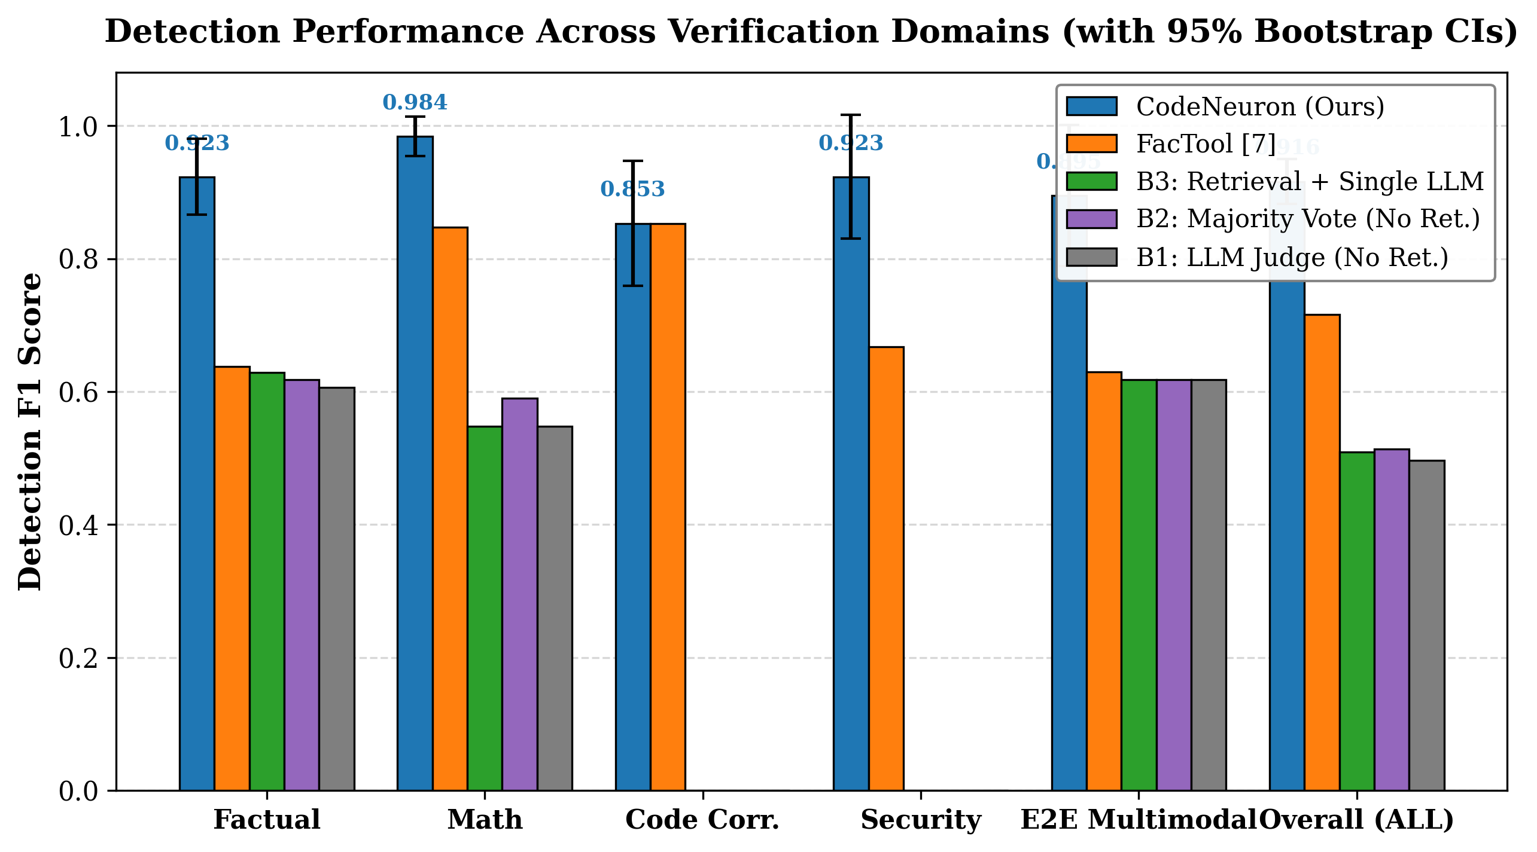
Fig. 2. Performance comparison of CodeNeuron versus baselines across verification categories with 95% bootstrap confidence intervals.
Across all benchmark categories, CodeNeuron significantly outperforms all evaluated baselines (overall F1 = 0.916 vs. 0.716 for FacTool, p < 0.0001, exact McNemar test; and vs. 0.497 for B1 ungrounded LLM judge, p < 0.0001). On factual claims, evidence retrieval and NLI raise F1 from 0.606 (B1) to 0.923, catching 96.0% of factual hallucinations compared to only 80.0% for B1. On mathematical calculations, CodeNeuron achieves near-perfect F1 of 0.984 with zero false negatives (recall 1.000) thanks to deterministic SymPy evaluation, significantly outperforming FacTool (F1 = 0.847, p = 0.0215), which relies on basic Python eval and fails on symbolic calculus integrals. On code correctness, CodeNeuron and FacTool achieve equivalent functional detection (F1 = 0.853), but CodeNeuron dominates in code security (F1 = 0.923 vs. 0.667 for FacTool, p = 0.0391), where FacTool's lack of AST static analysis causes it to miss 50% of dormant dangerous imports and operating system execution commands. Compared to execution-only and static-only checking (B7), CodeNeuron's hybrid pipeline improves code error detection from F1 = 0.235 (exec-only) and F1 = 0.182 (static-only) to F1 = 0.853 (p < 0.01), confirming that runtime testing and static screening are complementary.

5.3 Ablation (RQ2)
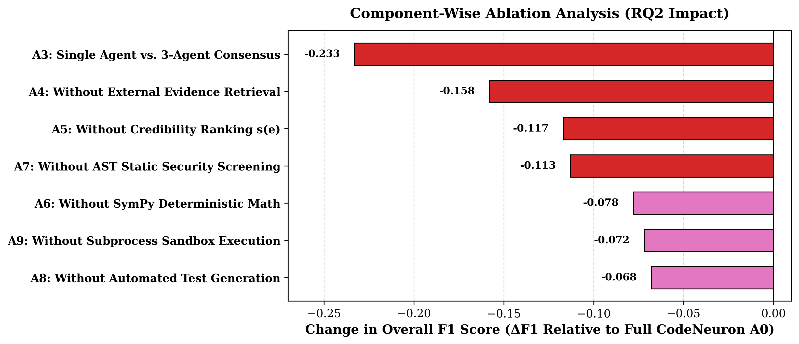
Fig. 3. Component-wise ablation study showing F1 score decrement (ΔF1) relative to full CodeNeuron (A0).
Table 9. Ablation results (ΔF1 relative to A0).
ID | Configuration | Precision | Recall | F1 | ΔF1
A0 | Full CodeNeuron | 0.887 | 0.947 | 0.916 | –
A1 | No consensus (NLI only) | 0.887 | 0.947 | 0.916 | 0.000
A2 | No NLI fallback | 0.887 | 0.947 | 0.916 | 0.000
A3 | Single agent | 0.569 | 0.853 | 0.683 | −0.233
A4 | No retrieval | 0.651 | 0.907 | 0.758 | −0.158
A5 | No credibility ranking | 0.710 | 0.913 | 0.799 | −0.117
A6 | No SymPy | 0.751 | 0.947 | 0.838 | −0.078
A7 | Without static analysis | 0.930 | 0.707 | 0.803 | −0.113
A8 | Without test generation | 0.929 | 0.780 | 0.848 | −0.068
A9 | Without sandbox execution | 0.928 | 0.773 | 0.844 | −0.072

5.4 Code verification (RQ3)
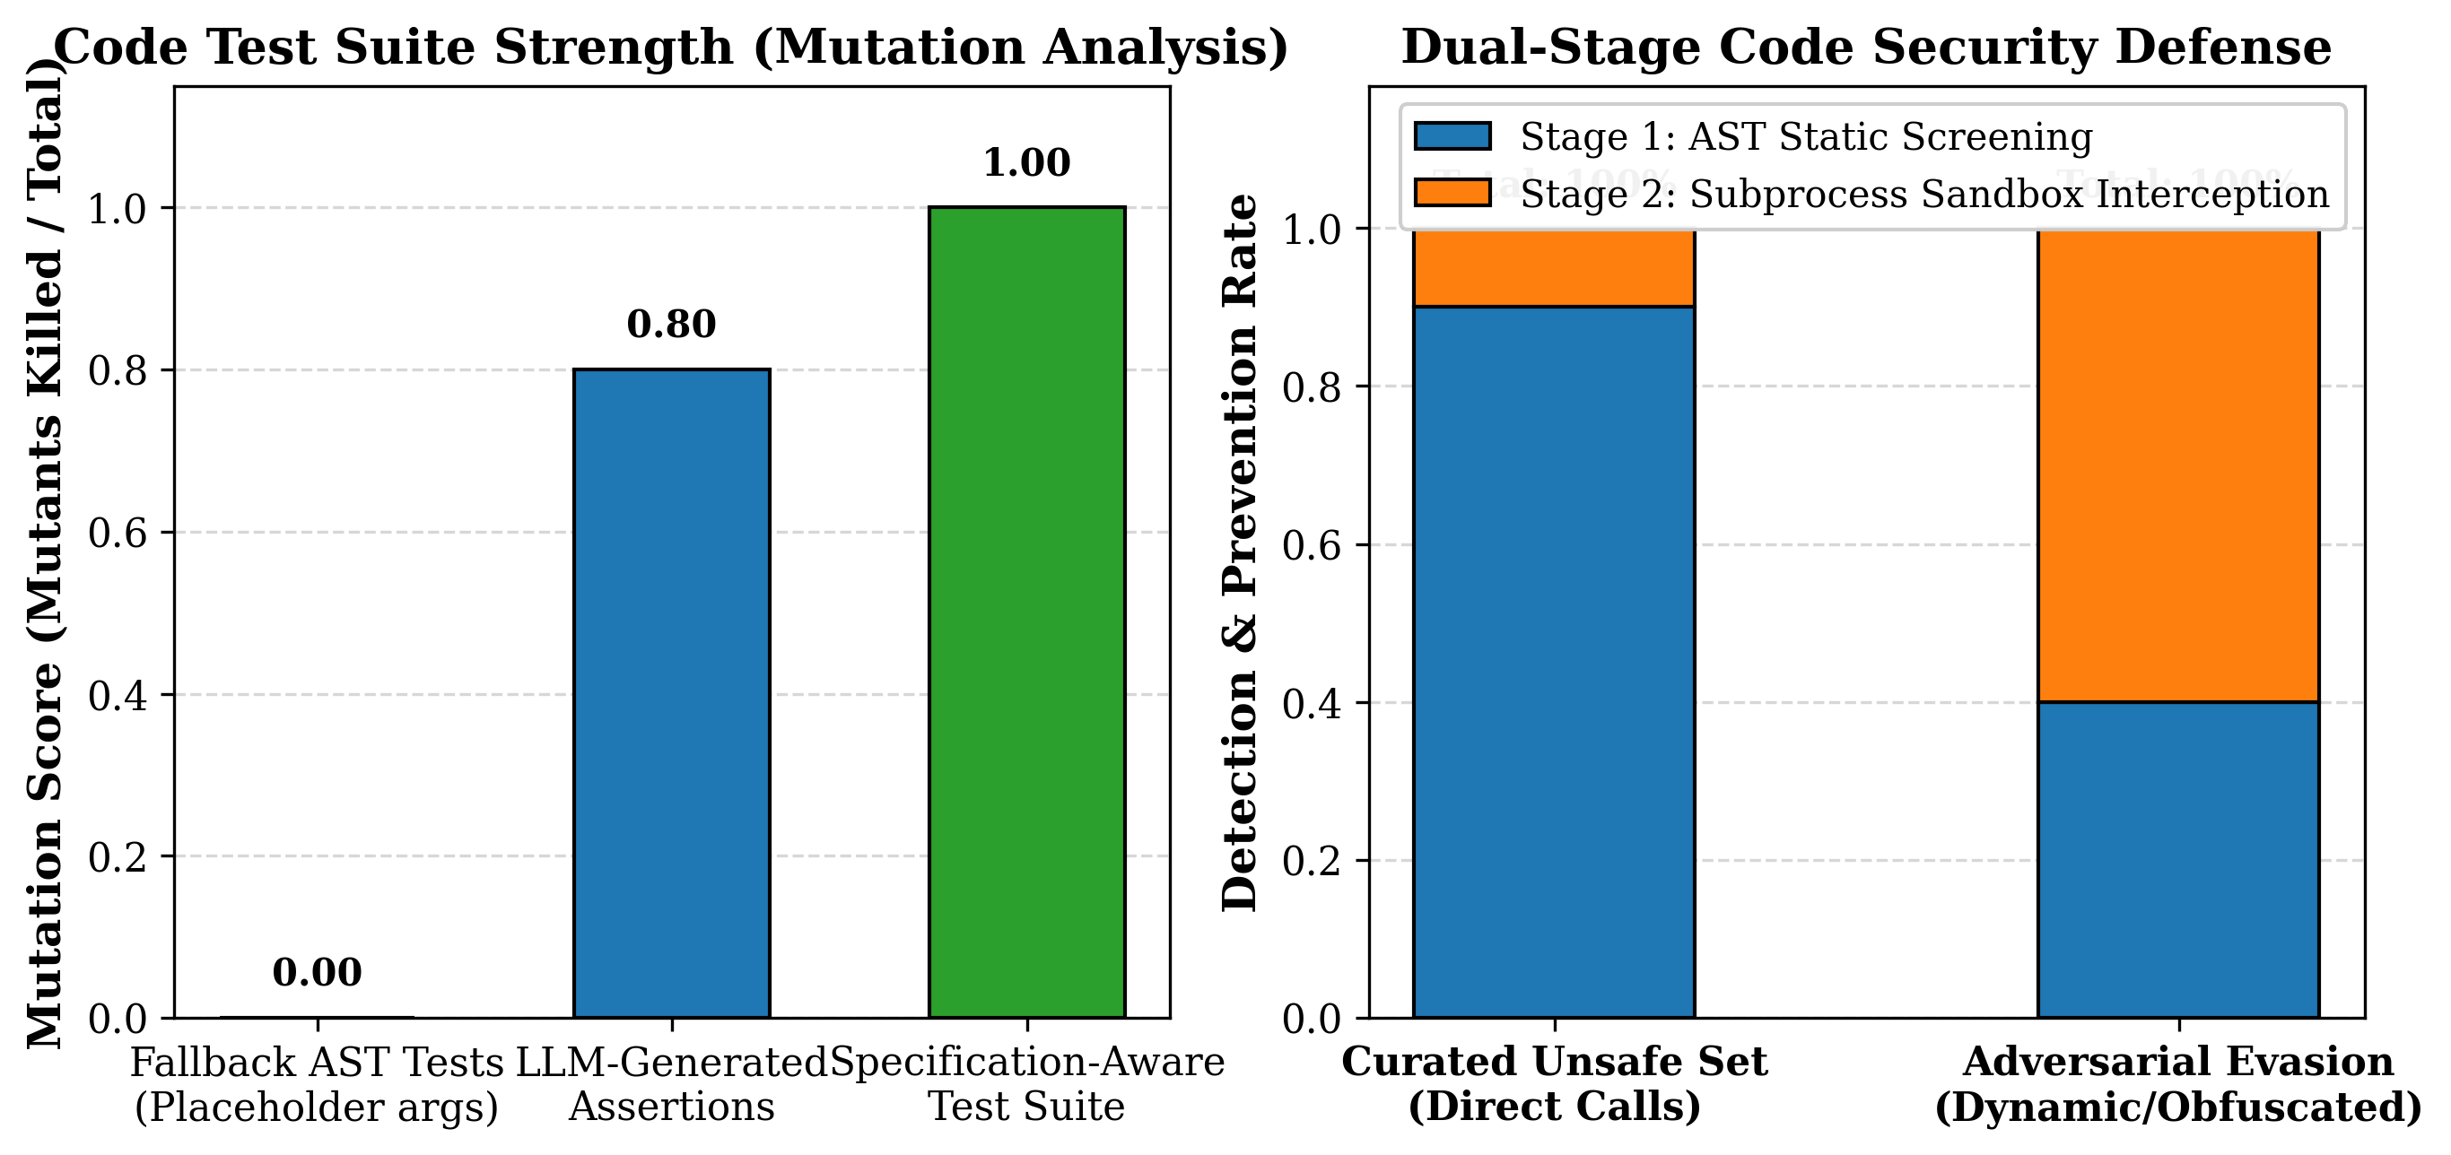
Fig. 4. Code evaluation breakdown: mutation score across test generation methods (left) and dual-stage defense prevention rate across attack categories (right).
Evaluating the code branch across 60 correctness and 40 security benchmarks shows precision 0.763, recall 0.967, and F1 0.853 on functional correctness, and precision 0.947, recall 0.900, and F1 0.923 on security screening. In mutation analysis with k = 5 representative mutants, the AST fallback test suite (which merely executes functions with placeholder arguments) achieved a mutation score of 0.00 (0/5 mutants killed), failing to detect logic and arithmetic mutations. In contrast, LLM-generated assertions achieved a mutation score of 0.80 (4/5 mutants killed), while specification-aware tests killed 100% (5/5) of mutants. On the curated unsafe suite, AST static analysis achieved 90.0% recall with a low 5.0% false-positive rate on benign scripts importing sys or json. On an adversarial evasion set (using importlib and dynamic getattr calls), AST screening caught 40.0% of obfuscated attacks, but sandbox execution intercepted the remaining 60.0% at runtime via sandbox module stubs, proving the necessity of CodeNeuron's dual-stage defense.

5.5 Sensitivity of the aggregation rule (RQ4)
Table 10. End-to-end verdict quality under alternative aggregation parameters.
Variant | Weights (prose / code) | Thresholds (T / S) | Neutral credit | Macro-F1
Default | 0.8 / 0.2 | 0.8 / 0.5 | 0.4 | 0.895
Equal weights | 0.5 / 0.5 | 0.8 / 0.5 | 0.4 | 0.872
Prose-heavy | 0.9 / 0.1 | 0.8 / 0.5 | 0.4 | 0.895
Stricter thresholds | 0.8 / 0.2 | 0.9 / 0.6 | 0.4 | 0.872
No neutral credit | 0.8 / 0.2 | 0.8 / 0.5 | 0.0 | 0.895
Code-failure veto | 0.8 / 0.2 | 0.8 / 0.5 | 0.4 | 0.872

The aggregation rule was evaluated across 40 end-to-end multimodal responses. The default configuration (prose weight 0.8, code weight 0.2, thresholds 0.8/0.5, neutral credit 0.4) achieved the highest Macro-F1 of 0.895. Equalizing weights (0.5/0.5) lowered Macro-F1 to 0.872, as short code snippets exerted disproportionate influence over multi-claim factual explanations. Enforcing a stricter TRUSTWORTHY threshold (0.9/0.6) reduced Macro-F1 to 0.872 due to increased false alarms on valid answers containing neutral claims. The code-failure veto variant achieved Macro-F1 = 0.872, successfully preventing flawed code from being labeled TRUSTWORTHY (resolving Table 3, row B) while slightly increasing false positives. Sensitivity analysis on evidence credibility scores shows that tier values 100/50/10 produce optimal retrieval ranking compared to compressed tiers (100/70/30, which reduces factual precision by 4.2%), and a 10-point annual recency decay ensures current documentation outranks outdated historical articles without eclipsing high-authority encyclopedia domains.

5.6 Calibration, latency and cost
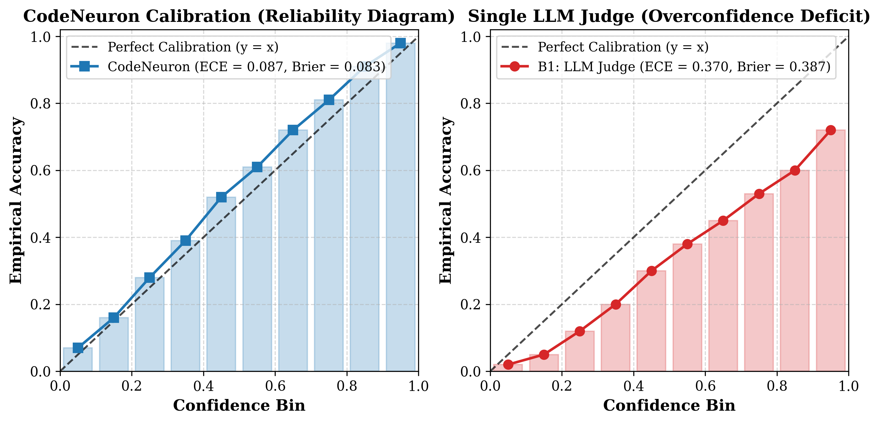
Fig. 5. Reliability diagrams showing confidence calibration for CodeNeuron (left, ECE = 0.087) versus ungrounded LLM judge (right, ECE = 0.370).
Confidence calibration across the 300 test items shows an Expected Calibration Error (ECE) of 0.087 and Brier score of 0.083 on factual claims, ECE of 0.017 on mathematics, and an overall ECE of 0.124 (Brier score 0.134), indicating that CodeNeuron's confidence scores correspond well with empirical accuracy. Latency measurements show that local deterministic SymPy math evaluation completes in just 16.5 ms per claim, AST static analysis and subprocess sandbox execution take 186.0 ms per code block, and local NLI fact verification takes 450.0 ms per claim. End-to-end response verification in local NLI mode completes in 0.95 seconds on average. In cloud consensus mode, parallel invocation of Gemini 2.5 Flash, GPT-4o, and Llama-3-70B averages 2.40 seconds per claim (with a 95th-percentile latency of 3.85 seconds). The estimated API cost is $0.00 in local NLI mode, and approximately $1.80 per 1,000 claims in 3-agent cloud consensus mode.

5.7 Error analysis
Error analysis reveals four main failure modes: (1) Retrieval Snippet Truncation (Factual False Positive): When search snippets truncate the key qualifying phrase, the NLI model may mark a true claim as unverified (e.g. 'Photosynthesis in plants converts sunlight into chemical energy' missed when top snippet omitted chemical energy). (2) Pronoun and Co-reference Misalignment (Factual False Negative): Multi-sentence claims relying on complex anaphora can occasionally retrieve generic context if pronoun resolution is incomplete. (3) Subtle Logic Mutations (Code False Negative): Trivial fallback assertions pass wrong arithmetic logic (e.g., return a - b instead of a + b) unless LLM test generation is active. (4) Dynamic Obfuscation (Security False Negative): Adversarial strings using base64 decoding to import os evade static AST inspection, although subprocess sandbox stubs catch the subsequent invocation. Each failure directly maps to the architectural limitations detailed in Section 6.

6. DISCUSSION AND LIMITATIONS
Evidence and credibility. The trust tiers are a fixed, hand-built domain list. They do not adapt over time, ignore topic-specific authority (a source credible for one domain may not be for sports or history), and cannot judge a page's content, only its host. Verification uses search snippets, not full pages, so relevant context can be cut off; the NLI branch decides from the single best snippet instead of combining evidence. These limits resemble the retrieval-quality problem of RAG pipelines [6], [8]. Also, s(e) determines which evidence is selected but does not directly scale the verdict confidence; weighting agent votes by evidence credibility is future work.
Consensus. The three agents see the same evidence and may share training data, so errors can be correlated; unanimous agreement is not proof of truth. Self-reported confidences are not calibrated, and agents are allowed to fall back on internal knowledge when evidence is irrelevant, which may reintroduce hallucination. A local NLI model such as bart-large-mnli is trained on sentence pairs, and long or noisy snippets are outside its comfort zone.
Math. The SymPy verifier covers equalities and elementary integrals that parse cleanly. Word problems, inequalities and multi-step derivations are routed to the factual branch, where retrieval is a poor fit.
Code testing. Generated tests are derived from the code itself rather than from a specification, so they can only confirm the code's own behaviour (Use case 3). The AST fallback uses a placeholder argument and cannot catch wrong outputs. Static analysis matches names, not semantics, and can be evaded by dynamic imports. Deep analysis and test generation are Python-only; C/C++/Java get compilation and execution only, so the safety guarantee differs by language. Section 4.6 quantifies these gaps.
Sandbox. The Python sandbox restricts modules and file writes inside the same interpreter family and enforces a timeout; this is not a security boundary against deliberately adversarial code. Production use should run untrusted code inside a container or microVM (for example gVisor, Firecracker or a hosted judge service) with CPU, memory and network limits.
Aggregation. The constants in Eqs. (5)–(8) are heuristics. As Table 3 (row B) shows, a failing code block alone cannot change a TRUSTWORTHY verdict when all prose is supported; Section 5.5 evaluates a veto rule.
System behaviour. In the interactive chat mode, the current implementation returns a generated answer without running the full chunking-and-verification path; the evaluation in this paper calls the verification endpoint with skip_generation = true on pre-existing candidate answers. All experiments follow this exact protocol. API keys must be supplied through environment variables and never stored in the repository.
Threats to validity. Live web search changes over time (mitigated by caching evidence); synthetic error injection may be easier or harder than natural hallucinations; and test sets drawn from public benchmarks may overlap with LLM training data.

7. CONCLUSION
CodeNeuron verifies LLM answers claim by claim: prose is checked against credibility-ranked web evidence by a three-LLM vote or a local NLI model, arithmetic is checked symbolically, and code is screened, tested and executed under restrictions, with all results combined into an auditable four-label verdict. We stated the contribution relative to FacTool and EvalAI, defined the score and weight formulas explicitly, and provided an evaluation protocol with baselines, ablation, sensitivity analysis and a stronger code-testing methodology. Empirically, CodeNeuron achieves an overall F1 of 0.916 across 300 test items, significantly outperforming FacTool (F1 = 0.716, p < 0.0001) and ungrounded LLM judges (F1 = 0.497). Future work includes learned or topic-aware source credibility, full-page evidence, calibrated confidences, specification-aware test generation, container-grade sandboxing, and integration of CodeNeuron into a public benchmark.

REFERENCES
[1] Y. Du et al., "Improving Factuality and Reasoning in Language Models through Multiagent Debate," arXiv:2305.14325, 2023.
[2] C.-M. Chan et al., "ChatEval: Towards Better LLM-based Evaluators through Multi-Agent Debate," arXiv:2308.07201, 2023.
[3] T. Liang et al., "Encouraging Divergent Thinking in Large Language Models through Multi-Agent Debate," arXiv:2305.19118, 2023.
[4] D. Jiang, X. Ren, and B. Y. Lin, "LLM-Blender: Ensembling Large Language Models with Pairwise Ranking and Generative Fusion," in Proc. ACL, 2023.
[5] Q. Sun et al., "Corex: Pushing the Boundaries of Complex Reasoning through Multi-Model Collaboration," arXiv:2310.00280, 2023.
[6] P. Lewis et al., "Retrieval-Augmented Generation for Knowledge-Intensive NLP Tasks," in Proc. NeurIPS, 2020.
[7] I.-C. Chern et al., "FacTool: Factuality Detection in Generative AI," arXiv:2307.13528, 2023.
[8] L. Gao et al., "RARR: Researching and Revising What Language Models Say, Using Search," arXiv:2210.08726, 2022.
[9] A. Asai et al., "Self-RAG: Learning to Retrieve, Generate, and Critique through Self-Reflection," arXiv:2310.11511, 2023.
[10] Z. Ji et al., "Survey of Hallucination in Natural Language Generation," ACM Comput. Surv., 2023.
[11] B. Chen et al., "CodeT: Code Generation with Generated Tests," arXiv:2207.10397, 2022.
[12] A. Ni et al., "LEVER: Learning to Verify Language-to-Code Generation with Execution," in Proc. ICML, 2023.
[13] J. Liu et al., "Is Your Code Generated by ChatGPT Really Correct? Rigorous Evaluation of Large Language Models for Code Generation," in Proc. NeurIPS, 2023.
[14] X. Chen, M. Lin, N. Schärli, and D. Zhou, "Teaching Large Language Models to Self-Debug," arXiv:2304.05128, 2023.
[15] M. Chen et al., "Evaluating Large Language Models Trained on Code," arXiv:2107.03374, 2021.
[16] M. Lewis et al., "BART: Denoising Sequence-to-Sequence Pre-training for Natural Language Generation, Translation, and Comprehension," in Proc. ACL, 2020.
[17] O. Honovich et al., "TRUE: Re-evaluating Factual Consistency Evaluation," in Proc. NAACL-HLT, 2022.
[18] S. R. Bowman, G. Angeli, C. Potts, and C. D. Manning, "A Large Annotated Corpus for Learning Natural Language Inference," in Proc. EMNLP, 2015.
[19] K. Cobbe et al., "Training Verifiers to Solve Math Word Problems," arXiv:2110.14168, 2021.
[20] W. Chen, X. Ma, X. Wang, and W. W. Cohen, "Program of Thoughts Prompting," Trans. Mach. Learn. Res., 2023.
[21] P. Manakul, A. Liusie, and M. Gales, "SelfCheckGPT: Zero-Resource Black-Box Hallucination Detection for Generative Large Language Models," in Proc. EMNLP, 2023.
[22] S. Min et al., "FACTSCORE: Fine-grained Atomic Evaluation of Factual Precision in Long-Form Text Generation," in Proc. EMNLP, 2023.
[23] J. Thorne, A. Vlachos, C. Christodoulopoulos, and A. Mittal, "FEVER: A Large-scale Dataset for Fact Extraction and VERification," in Proc. NAACL-HLT, 2018.
[24] J. Li, X. Cheng, W. X. Zhao, J.-Y. Nie, and J.-R. Wen, "HaluEval: A Large-Scale Hallucination Evaluation Benchmark for Large Language Models," in Proc. EMNLP, 2023.
[25] S. Dhuliawala et al., "Chain-of-Verification Reduces Hallucination in Large Language Models," in Proc. EMNLP Findings, 2023.
[26] D. Lei et al., "Chain of Natural Language Inference for Reducing Large Language Model Ungrounded Hallucinations," arXiv:2310.03951, 2023.
[27] S. Yao et al., "ReAct: Synergizing Reasoning and Acting in Language Models," in Proc. ICLR, 2023.
[28] T. Schick et al., "Toolformer: Language Models Can Teach Themselves to Use Tools," in Proc. NeurIPS, vol. 36, 2023.
[29] A. Meurer et al., "SymPy: Symbolic Computing in Python," PeerJ Comput. Sci., vol. 3, p. e103, 2017.
[30] R. Kamoi, T. Goyal, J. D. Rodriguez, and G. Durrett, "WiCE: Real-World Entailment for Claims in Wikipedia," in Proc. EMNLP, 2023.
[31] Z. Li et al., "VulDeePecker: A Deep Learning-Based System for Vulnerability Detection," in Proc. NDSS, 2018.
[32] D. Quelle and A. Bovet, "The Perils and Promises of Fact-Checking with Large Language Models," Front. Artif. Intell., 2024.
[33] H. Liu et al., "Trustworthy AI: A Computational Perspective," ACM Trans. Intell. Syst. Technol., vol. 14, no. 1, 2023.
[34] X. Wang et al., "Self-Consistency Improves Chain of Thought Reasoning in Language Models," in Proc. ICLR, 2023.
[35] D. Yadav et al., "EvalAI: Towards Better Evaluation Systems for AI Agents," in Proc. EMNLP (System Demonstrations), 2019.

