DBMS Practical 1 – Screenshot Portfolio
Submission format: Create a separate Word document containing the 13 required screenshots in order.
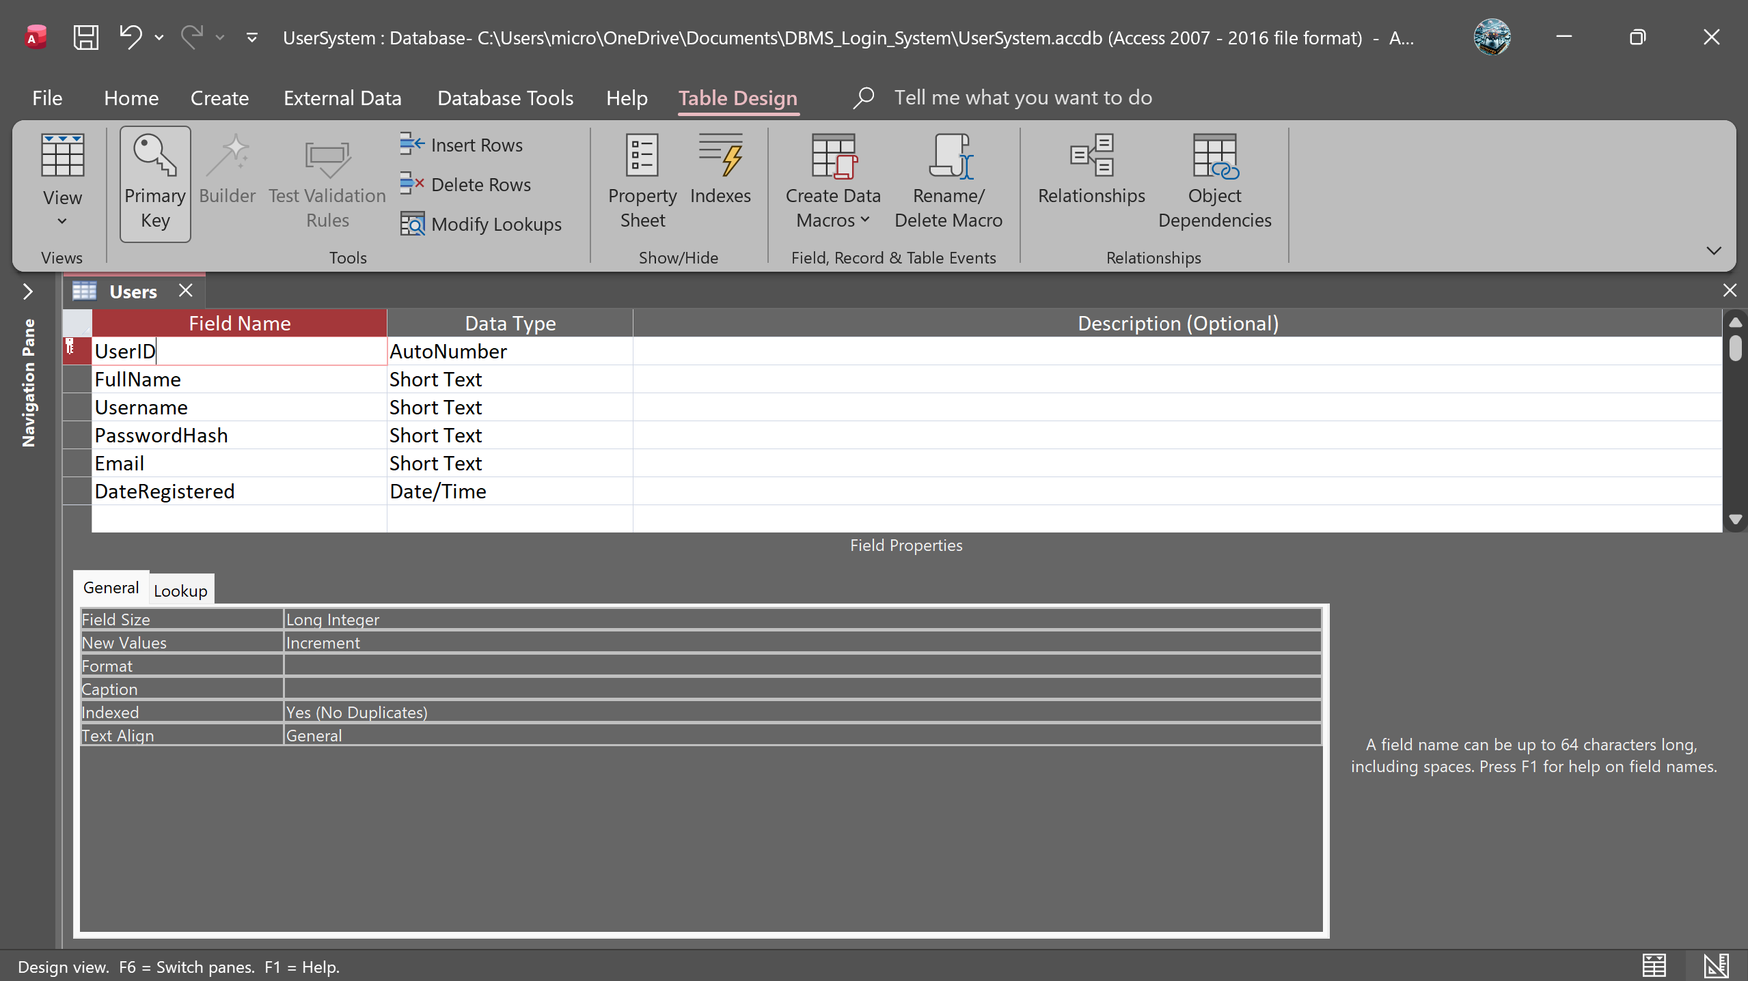
- Screenshot 1 – Microsoft Access Users Table Design View

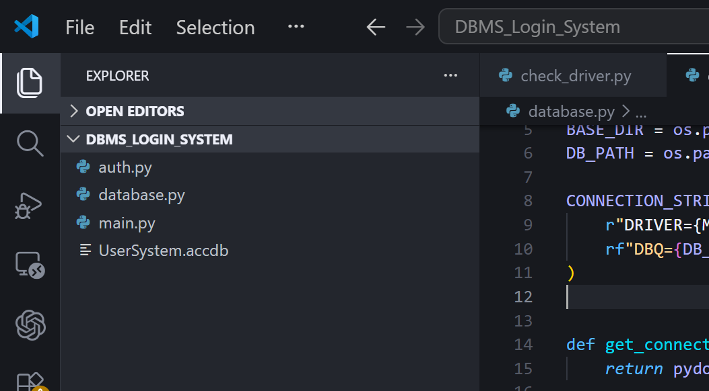
- Screenshot 2 – Project Folder Structure

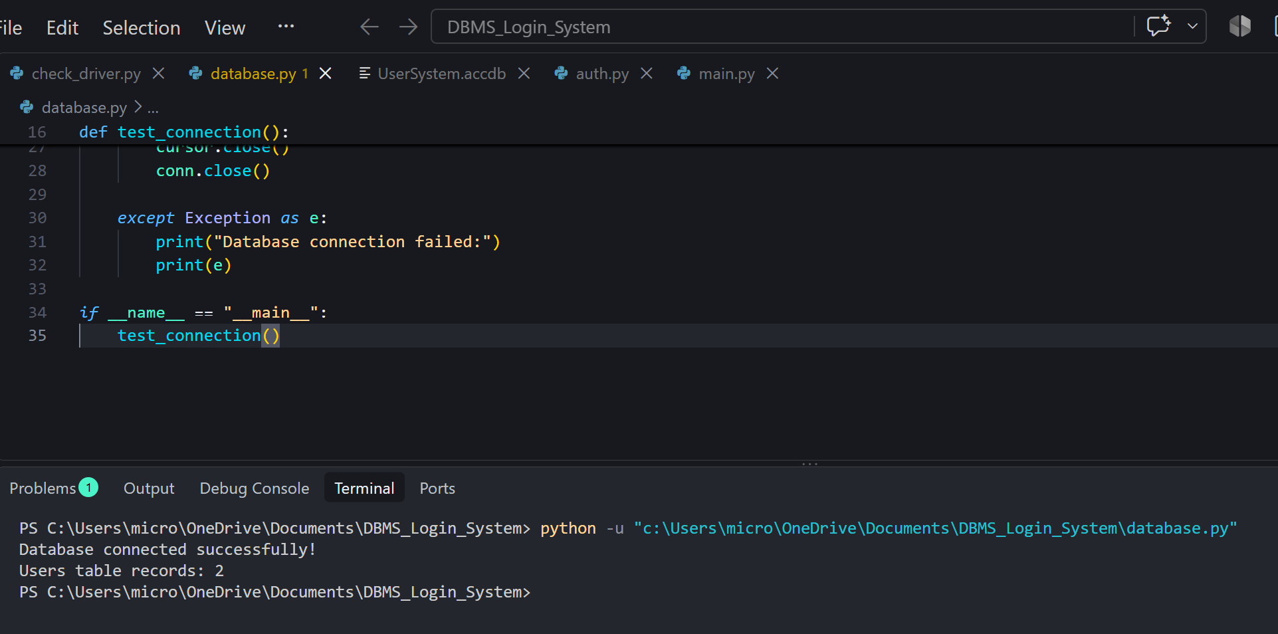
- Screenshot 3 – Database Connection – “Database connected successfully!”

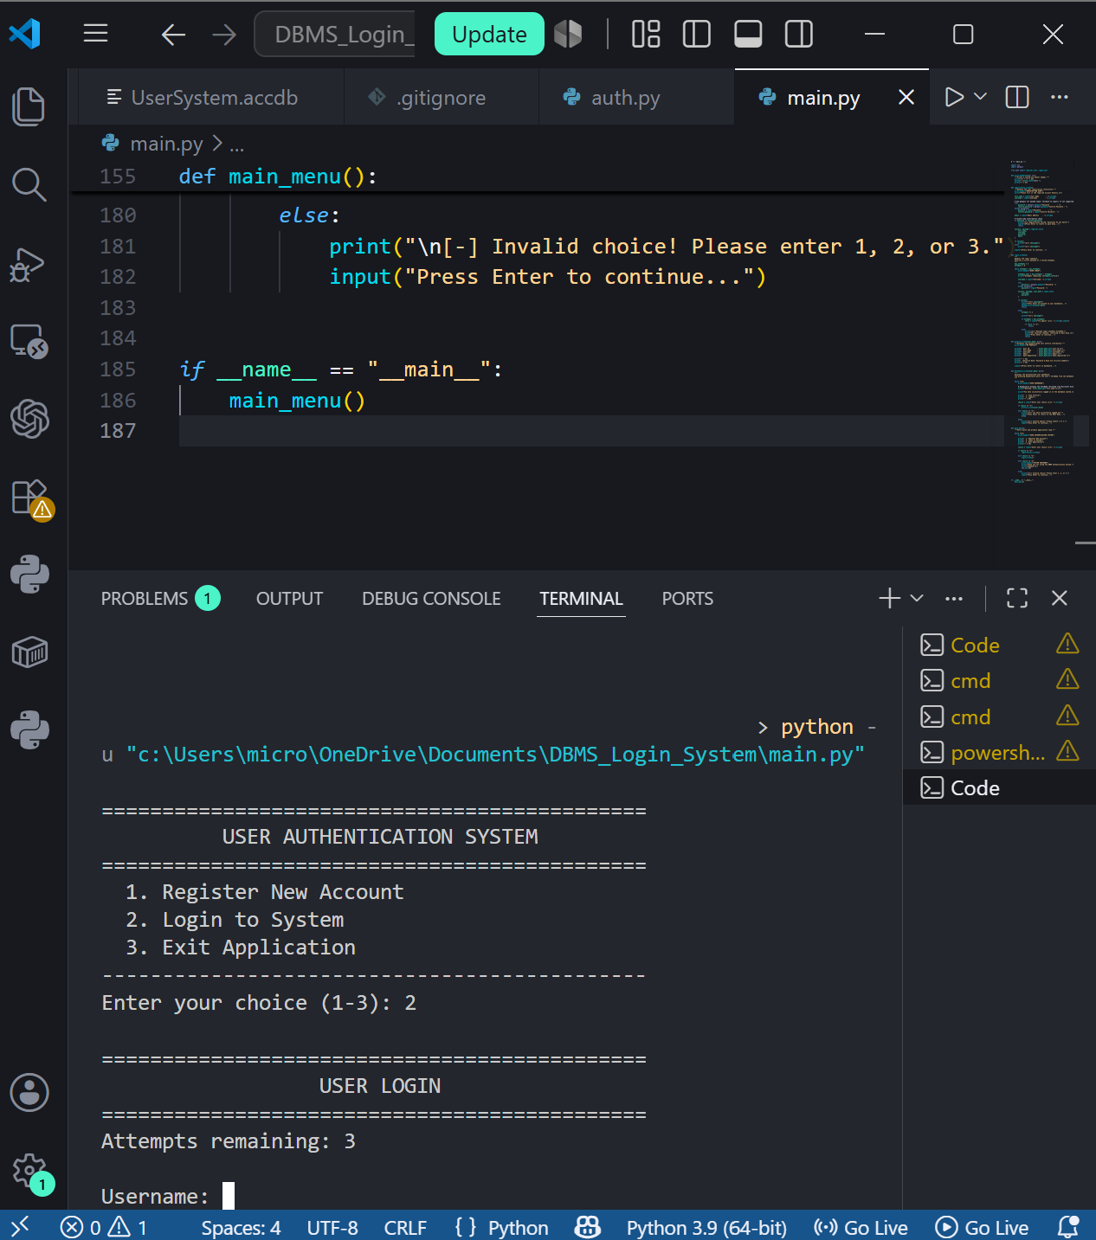
- Screenshot 4 – Registration CLI – Inputs Filled In

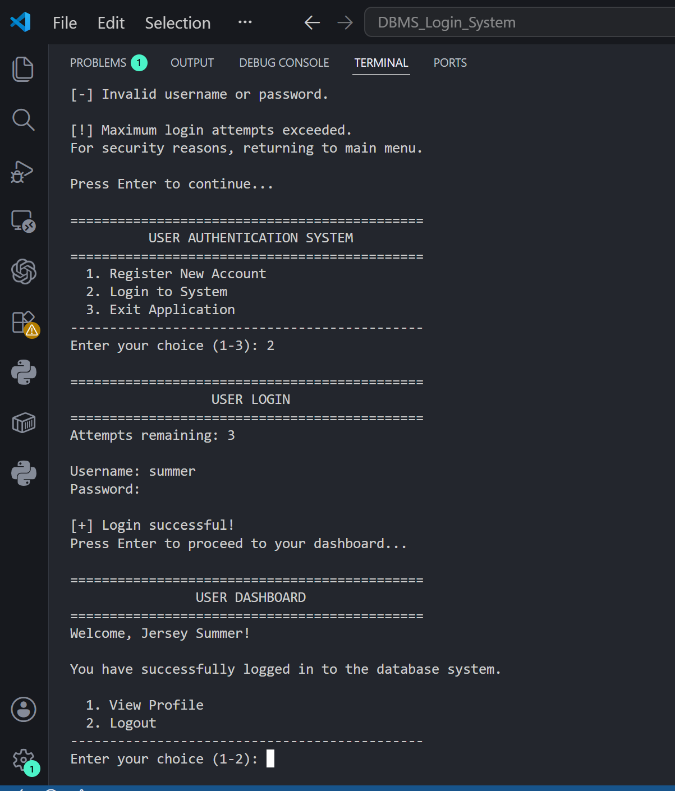

- Screenshot 5 – Registration Successful

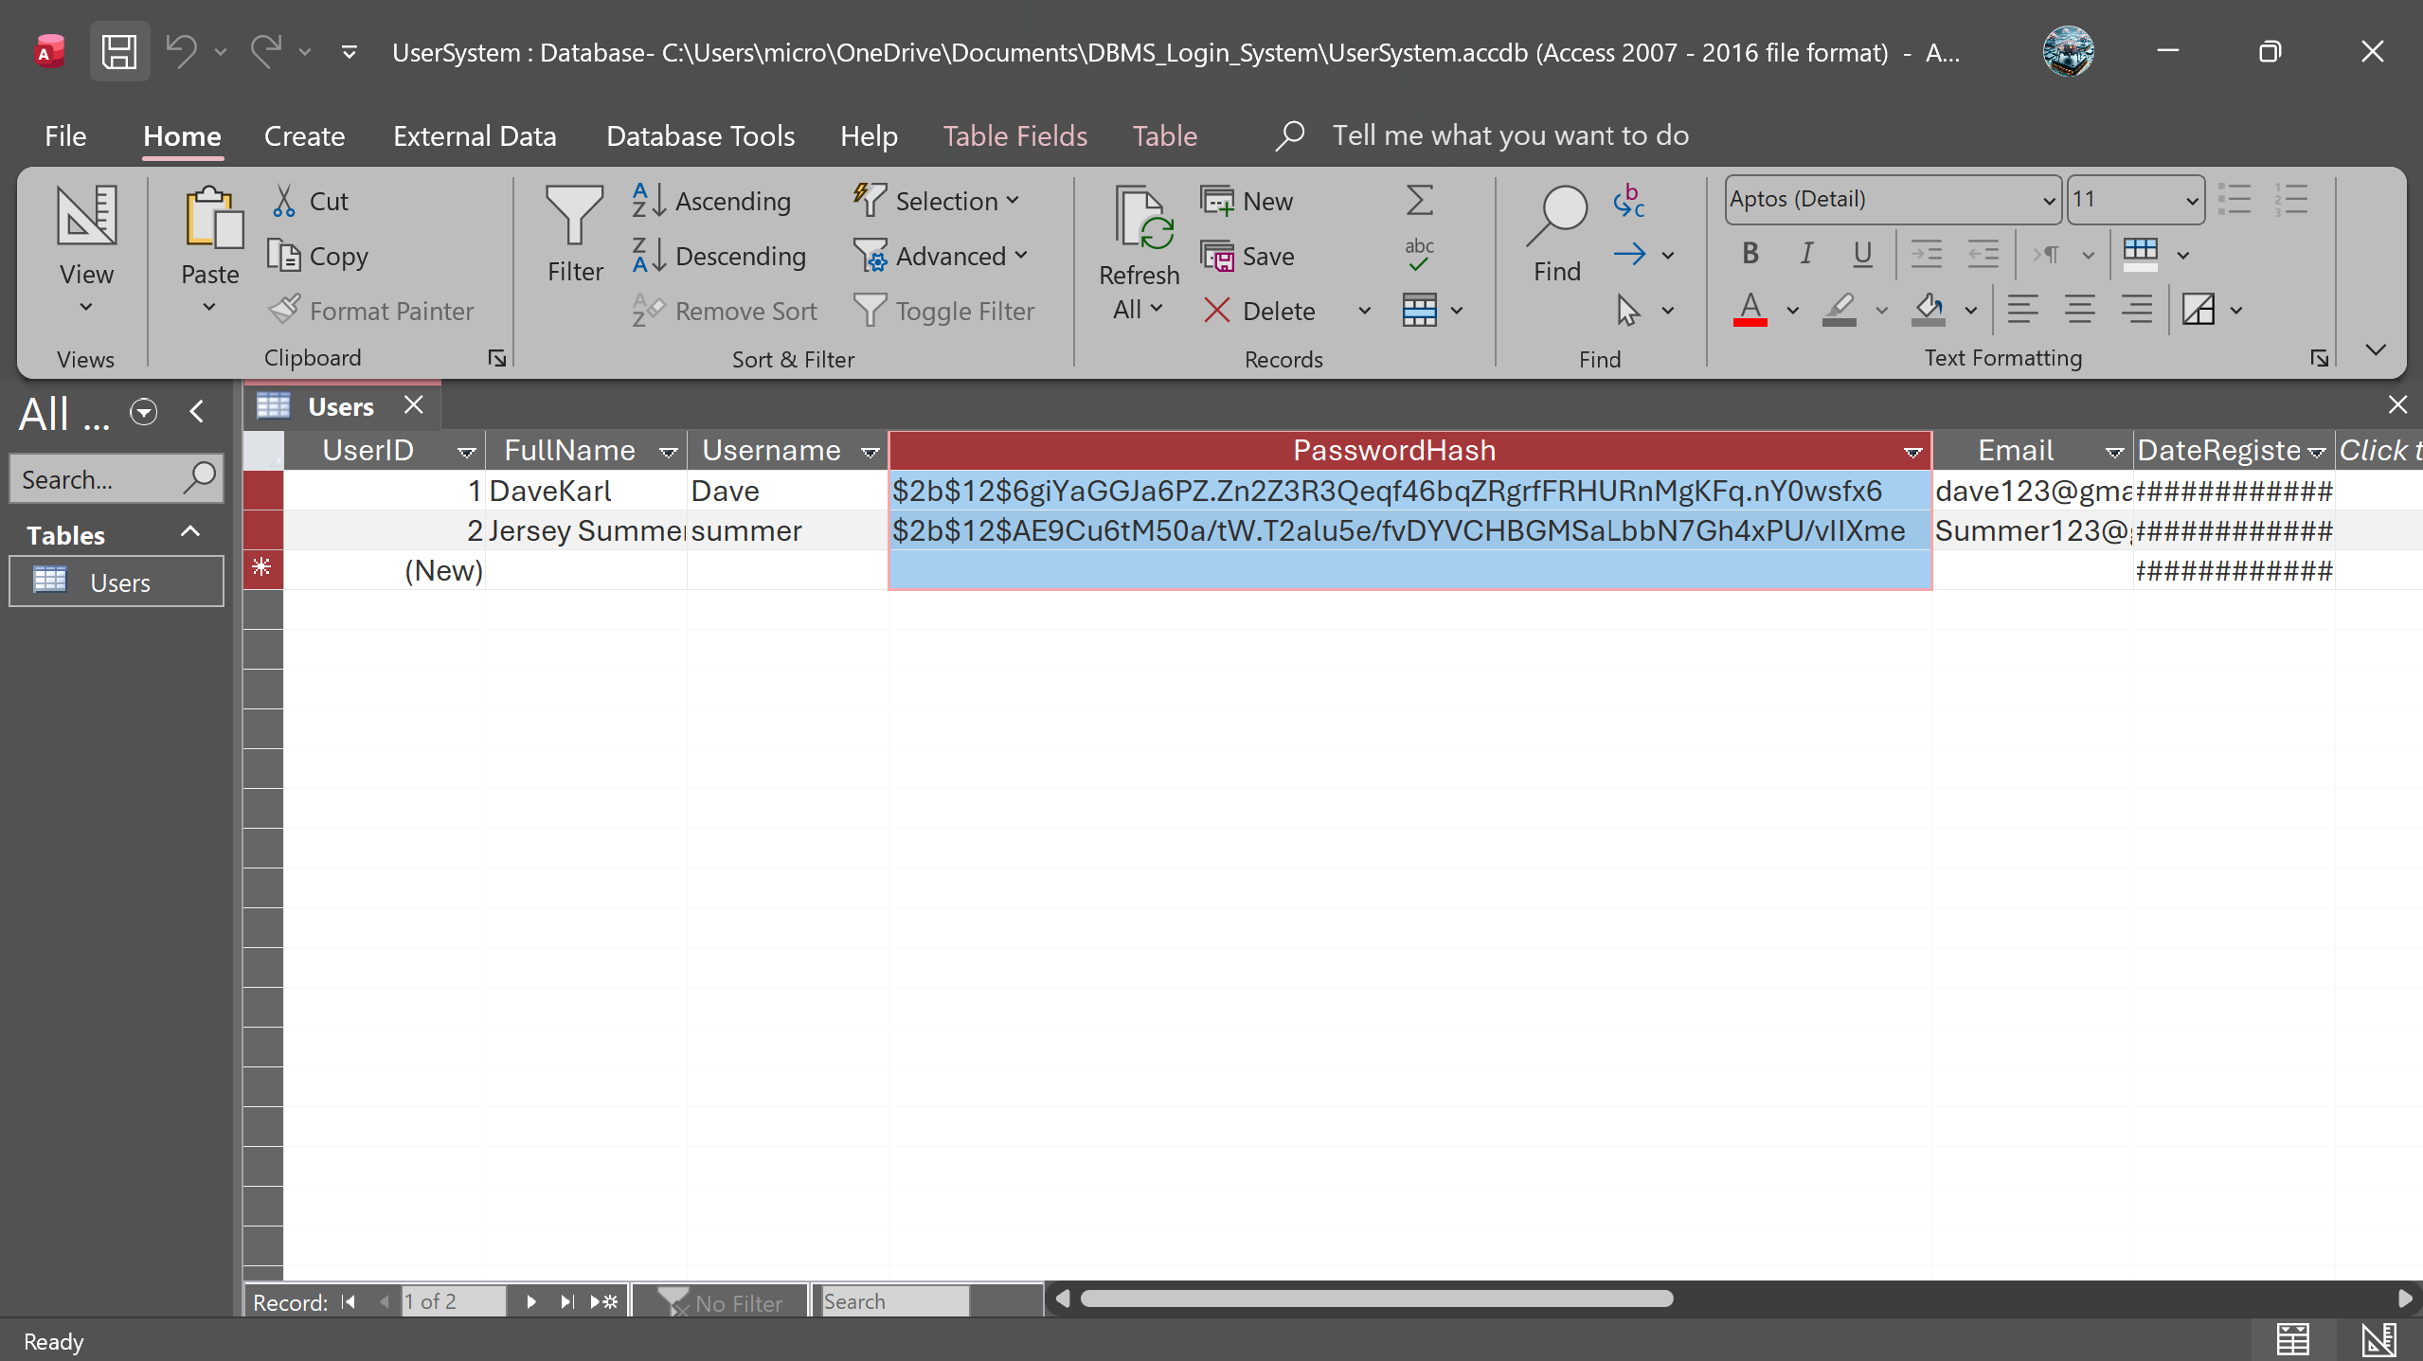
- Screenshot 6 – Microsoft Access Datasheet – Registered User + bcrypt Hash

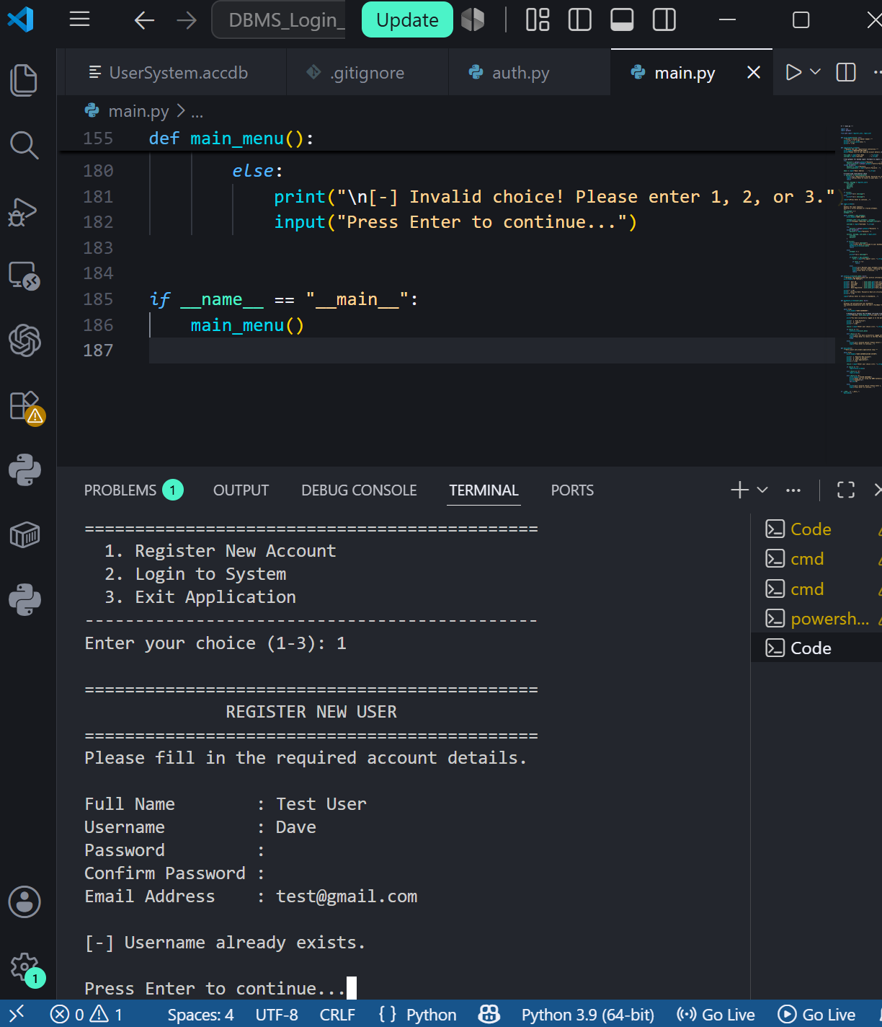
- Screenshot 7 – Failed Registration

- Screenshot 8 – Login Screen – Username Entered

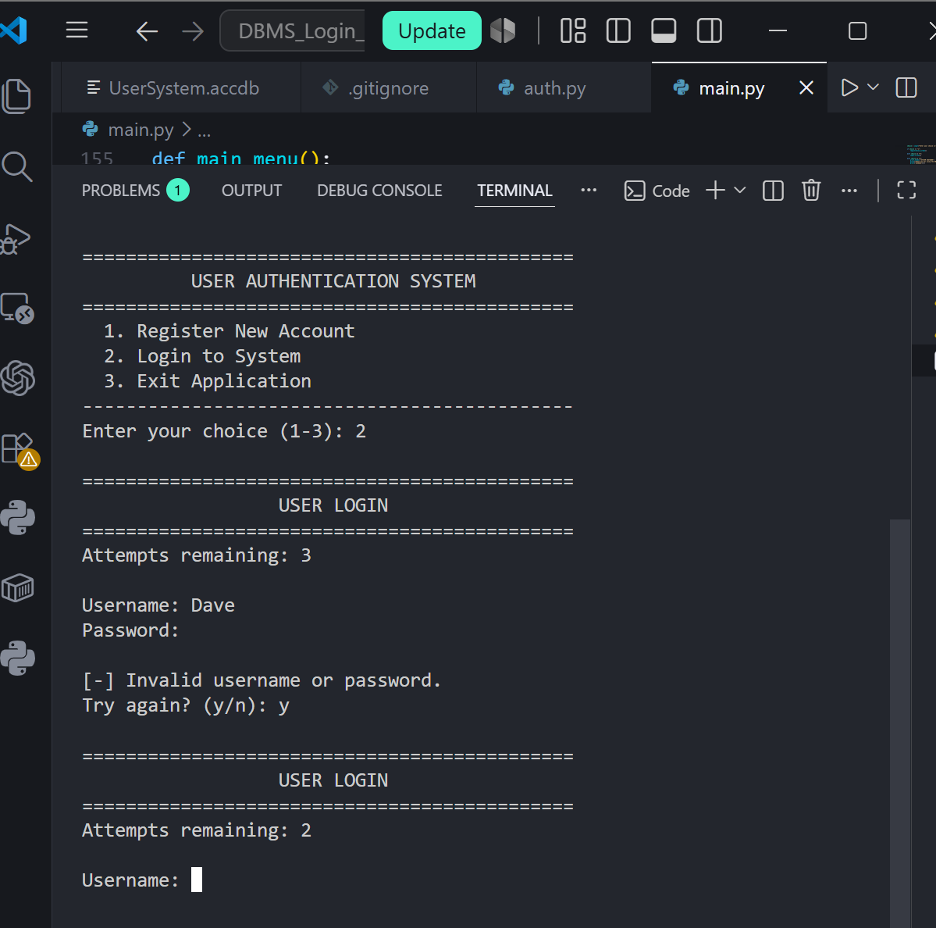
- Screenshot 9 – Failed Login – Invalid Username or Password + Attempt Counter

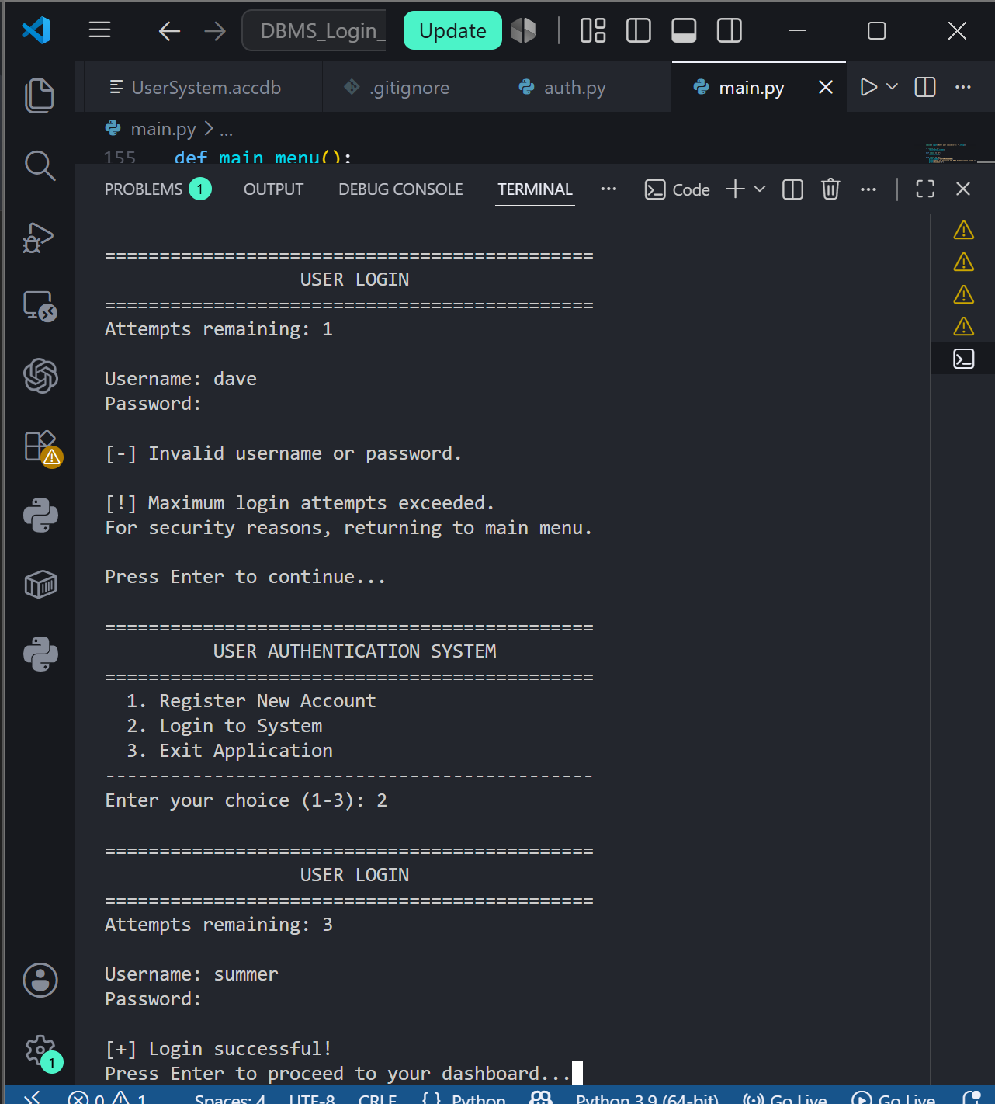

- Screenshot 10 – Successful Login

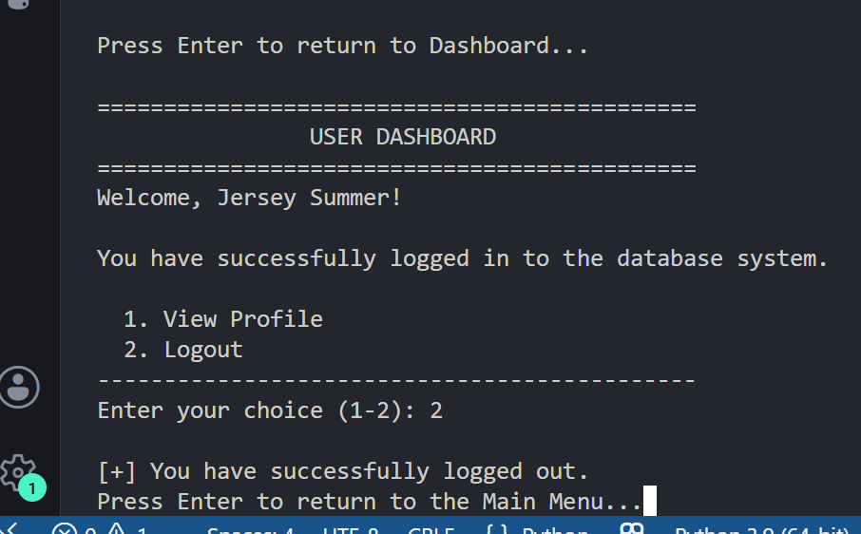
- Screenshot 11 – Personalized Dashboard

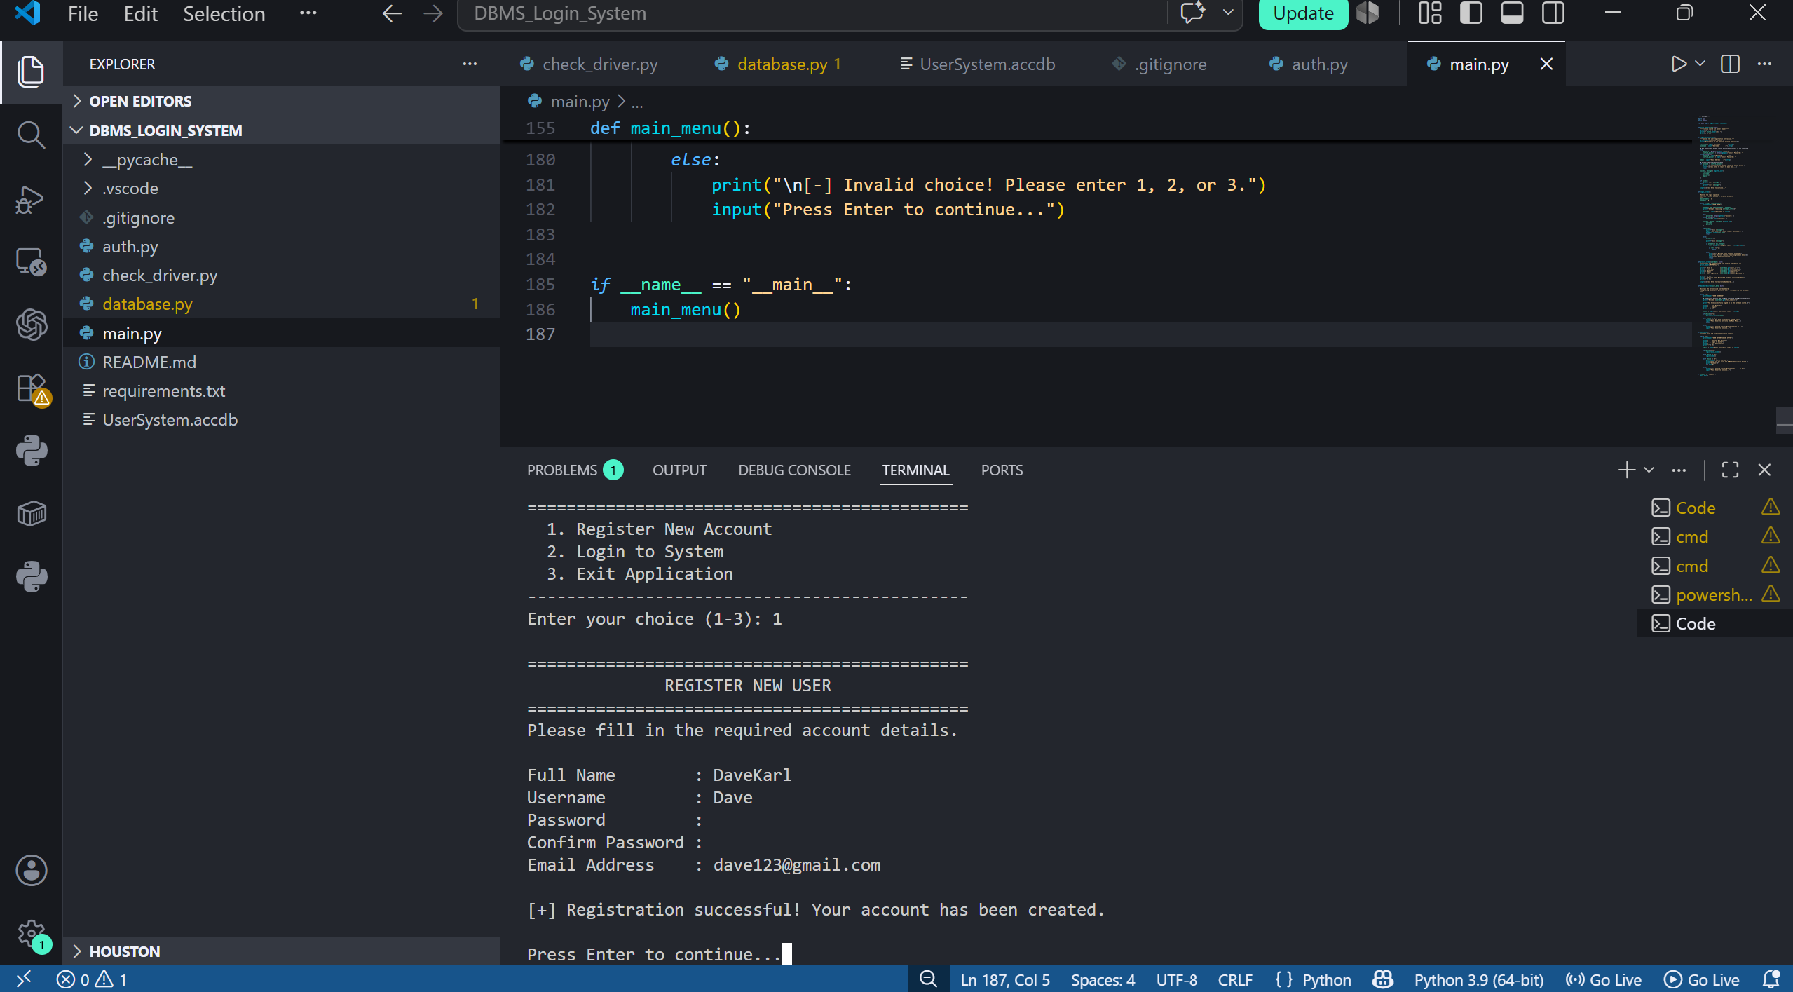
- Screenshot 12 – View Profile – Account Details Without Password/Hash

- Screenshot 13 – Logout Confirmation + Main Menu

