INDIAN INSTITUTE OF MANAGEMENT RANCHI
Executive MBA 2025-27 | Term V | Logistics and Warehousing Management
Working with AI (WAI) Project Report
ReLoop: Move the Decision, Not the Asset
An AI-enabled reverse-logistics network for corporate IT-asset and
e-waste recovery in India
Submitted to
Prof. Krishna Kumar Dadsena
Submitted by
Himanshu Rai
Roll No. XW013-25 | himanshu.raixw25@iimranchi.ac.in
Submission date: 20 October 2026
AI-use declaration. In line with the WAI guidelines, generative AI (Claude, Anthropic) was used for problem scoping, literature mapping, code drafting and critique, synthetic-data design and a simulated expert panel that was later used only as a benchmark against real practitioner ratings. Every number in this report is produced by the author's reproducible Python code (run_all.py) or a cited public source; every AI output was checked before use. The full Prompt Logbook, code, data and dashboard are submitted alongside this report.

Executive Summary
India generated 13.98 lakh tonnes of e-waste in FY 2024-25 and formally processed 9.88 lakh tonnes. Built entirely on public records (the CPCB recycler registry of 411 authorised units, Parliament replies, PIB releases and TRAI data), this project finds that the binding constraint is not recycling capacity. Authorised capacity has grown 5.4 times since 2020 to 42.31 lakh tonnes, yet only 23.4% of it was used in FY25. The problem is where the flow goes: Uttar Pradesh, Uttarakhand and Haryana process 65.9% of all formal e-waste, while the southern and western states that host most BFSI and GCC technology estates generate an estimated 45.9% of it, process 29.5%, and leave 16 lakh tonnes of their own authorised capacity 82% idle.
For corporate IT assets this means un-wiped, data-bearing laptops and servers travel 1,400 to 2,300 km past idle local recyclers before anyone decides whether they should be redeployed, resold, harvested or shredded. The project asks how a corporate IT-asset-disposition (ITAD) network should be redesigned, and which AI capabilities it needs, to recover more value with less freight, carbon and data risk. It combines (i) real-data diagnostics and a K-means typology of 16 regional e-waste systems, (ii) a two-model volume forecast, (iii) a Random Forest grading engine, (iv) mixed-integer facility location over the real CPCB recycler network and vehicle-routing milk-runs (Google OR-Tools), and (v) fuzzy FMEA and NPV analysis.
Findings. For a 2,400 tonne-per-year portfolio (about 5,16,000 assets), three regional hubs at Bengaluru, Pune and Gurugram, each feeding registered recyclers in its own region, cut annual logistics cost by 40.7% (Rs 7.41 Cr to Rs 4.39 Cr), transport CO2e by 80.1% and data-bearing tonne-km by 80.8%; the design holds under plus or minus 30% cost shocks. AI grading lifts value recovered per asset by Rs 839 (+15.2%) over the common rule of sending everything past refresh age to the recycler. Network redesign alone barely pays (NPV Rs 1.54 Cr), but with only half the modelled grading uplift the programme returns a five-year NPV of Rs 56.6 Cr on Rs 5.11 Cr of capex. A fuzzy FMEA rated by practitioners ranks leakage to informal channels, refresh-cycle return surges and in-transit data breach as the top risks.
Recommendation. Move the decision, not the asset: grade and sanitise within about 300 km of the source, contract the under-used registered recyclers already in each region, and roll out in 15 stage-gated months starting with a Pune pilot.

1. Problem Identification

1.1 Background and context
India is the world's third-largest generator of e-waste (Balde et al., 2024). CPCB estimates rose from 7.08 lakh tonnes in FY 2017-18 to 13.98 lakh tonnes in FY 2024-25. The E-Waste (Management) Rules, 2022, in force since April 2023, replaced collection targets with Extended Producer Responsibility (EPR) recycling targets of 60% (FY24-25), 70% (FY26-27) and 80% from FY28, traded through EPR certificates (MoEFCC, 2022). Formal capacity has responded strongly: the CPCB registry now lists 411 authorised recyclers with 42.31 lakh tonnes of annual capacity, up from 312 units and 7.8 lakh tonnes in 2020 (Lok Sabha, 2020).
Corporate IT is a distinct stream inside this market. Unlike household e-waste it is data-bearing (governed by NIST SP 800-88 sanitisation practice and India's Digital Personal Data Protection Act, 2023), value-bearing (enterprise laptops and servers are often reusable), and predictable, because it arrives in waves driven by three-to-five-year refresh cycles in BFSI and GCC estates clustered in Bengaluru, Hyderabad, Pune, Chennai, Mumbai and the NCR.

1.2 The core problem
The prevailing practice is a single national ITAD vendor. Client sites pack retired assets and ship them, un-graded and un-wiped, by part-load truck to the vendor's central facility, typically in the northern belt where processing capacity sits. Only there is the asset graded. This sequence creates three linked costs: (a) long-haul freight and carbon on low-density cargo; (b) data exposure on every kilometre travelled before sanitisation; and (c) value decay, because returned electronics lose value with time and conservative rules ("age four years or more goes to the recycler") destroy reusable value (Blackburn et al., 2004).

1.3 Evidence
Table 1. Evidence that the problem exists (author's analysis of public data)
Indicator (real public data) | Value | Implication
Authorised recycling capacity: 2020 / 2021 / Aug 2026 | 7.82 / 13.86 / 42.31 lakh t | Capacity grew 5.4x; 411 registered recyclers
National capacity utilisation, FY25 | 23.4% | Capacity is not the bottleneck; feedstock and routing are
Share of processing in UP + Uttarakhand + Haryana | 65.9% | They hold 53.4% of capacity but process far more than they generate
South/west states: capacity and its utilisation | 16 lakh t; 18.2% used | Licensed capacity exists close to the IT estates and sits idle
Mismatch index: Maharashtra / Karnataka / Tamil Nadu | 0.41 / 0.23 / 0.21 | Large net exporters of e-waste (index < 1)
Ten districts' share of national capacity | 47.6% | Led by Meerut, Haridwar, Bulandshahr
Sources: CPCB EPR-portal recycler registry (Aug 2026); Lok Sabha USQ 983 (2020) and 2458 (2021); PIB release 2147876 (2025); TRAI via Jharkhand Economic Survey 2025-26; Census 2011. Mismatch index = processing share / generation share.

1.4 Why AI is necessary
Spreadsheet rules cannot grade half a million heterogeneous assets a year, and single-vendor contracts ignore geography. The problem decomposes into tasks where AI and analytics add specific value: multi-attribute classification of each asset's best disposition (machine learning); unsupervised clustering of client sites into service regions; combinatorial optimisation of hub location and routing (mixed-integer programming, vehicle routing); forecasting under a regulatory regime change; risk rating under linguistic expert uncertainty (fuzzy logic); and generative AI to accelerate scoping, coding and critical review.

1.5 Stakeholders, scope and managerial significance
Stakeholders. The CIO and CISO own data-breach exposure and destruction evidence; the CFO and procurement own recovered value and vendor cost; ESG teams own Scope 3 transport emissions and BRSR disclosures; ITAD 3PLs, refurbishers and recyclers depend on feedstock volume and quality; producers need traceable recycling to earn EPR certificates under CPCB and SPCB oversight; and informal workers and communities bear the health cost of leakage to unsafe channels.
Scope. Corporate IT assets (laptops, desktops, monitors, servers, network equipment and mobiles) from BFSI and GCC clients in 12 Indian cities, FY26 to FY30. Out of scope: household e-waste, metallurgical recovery processes, solar panels and cross-border shipments. Constraint: enterprise asset registers are confidential, so asset-level data is synthetic and disclosed. Significance: the problem touches cost (freight), revenue (resale value), risk (data, compliance) and ESG (carbon, circularity) at once, which is why it belongs on a COO's agenda rather than a facilities checklist.
Problem statement. Corporate e-waste in India is moved before it is understood: un-graded, data-bearing IT assets travel up to 2,300 km to centralised processors, past idle licensed capacity near their source, inflating freight, carbon and data risk while rule-based disposal destroys reusable value. This project uses AI-based grading, network optimisation and fuzzy risk analysis to design a regional "grade-then-route" ITAD network and quantify its value.

2. Literature Review
Reverse logistics foundations. Govindan, Soleimani and Kannan (2015) review over 380 papers and find network design to be the dominant reverse-logistics theme, while calling for models that handle uncertainty and integrate decisions. Guide and Van Wassenhove (2009) argue that closed-loop chains should be designed around value recovery rather than cost minimisation, and Blackburn et al. (2004) show that for products whose value decays quickly, the disposition decision should be pre-poned and made close to the point of return in a "responsive" reverse chain. For electronics specifically, Islam and Huda (2018) find that WEEE network models are concentrated in developed economies and rarely address the informal sector that dominates emerging markets; Kilic, Cebeci and Ayhan (2015) provide the methodological precedent of a mixed-integer model locating WEEE collection and recycling facilities under alternative collection rates.
Green logistics and performance. Lai and Wong (2012) show that green logistics practices improve both environmental and operational performance when regulatory pressure is high, which is the condition EPR now creates in India. Fugate, Mentzer and Stank (2010) frame logistics performance as efficiency, effectiveness and differentiation; ReLoop's KPI set (cost per tonne, value recovered, certified destruction) maps onto these three.
Digitalisation and AI. Cichosz, Wallenburg and Knemeyer (2020) identify legacy systems and data fragmentation as the main barriers to logistics service providers' digital transformation and customer co-creation as a success factor. Dadsena et al. (2024) map strategies to overcome supply-chain digitisation barriers against the Sustainable Development Goals. Random Forests (Breiman, 2001) remain a robust, interpretable choice for tabular classification of this kind.
Risk and circularity. Dadsena, Sarmah and Naikan (2019) evaluate risks in sustainable road freight with an FMEA-based approach for the Indian trucking industry. Liu, Liu and Liu (2013) document the weaknesses of crisp risk priority numbers, and Wang et al. (2009) propose fuzzy aggregation of expert judgements. Dadsena et al. (2026) find that circular-economy practices built on industrial symbiosis enhance firm performance, which supports regional recycler partnerships rather than one distant contract.
Table 3. Literature gaps and the project's contribution
Gap in existing work | How ReLoop addresses it
Studies centre on household WEEE; the B2B ITAD stream, where data security is a design constraint, is under-studied | Data-bearing tonne-km is modelled as an explicit outcome and a top-ranked risk
Disposition ("what") and network design ("where") are optimised separately | ML-predicted disposition mix sets the onward flows in the network model
Indian analyses rarely use post-2023 state-level CPCB data | FY24-FY25 PIB state data drives the mismatch diagnosis and forecast
Risk analysis is seldom linked to network choices | Fuzzy FMEA results shape hub siting, transport security and roadmap gates

2.1 Concept map: how LWM sessions are applied
Table 4. Mapping of course concepts to the project
LWM session(s) | Concept from class | Where applied in ReLoop
1 | Logistics scope, cost-service trade-off | Problem framing; three linked costs
2 (CUHK case) | 3PL vs 4PL, outsourcing criteria and contracts | Shift from one national vendor to a 4PL-orchestrated regional network
3-4 (CMA CGM, XDel) | IT, tracking, route optimisation | QR/RFID chain of custody; CVRP milk-runs; control tower
5-6 (Snapdeal) | E-commerce returns, reverse-logistics gatekeeping | Disposition hierarchy; AI grading at the gate
7-8 (MIT SMR) | Green logistics drivers and metrics | CO2e per tonne-km; consolidation
9 (Plaza Zaragoza) | Freight cost drivers, hub consolidation | Low-density "cube-out" pricing; LTL vs FTL; hub-and-spoke
10-11 | Resilience, transport risk | Fuzzy FMEA; sensitivity analysis
12-14 (Raymond) | Warehouse site, layout, material handling | Hub zoning: quarantine, wipe, grade, dispatch
15 | Logistical and reusable packaging | Reusable secure totes; Li-ion battery packaging
16-17 (KYY) | Warehouse automation, human partners | Automated wipe stations with human override
18-19 | Performance management; sustainable warehousing | KPI dashboard; ISO 14001-ready hubs
20 (Zhiyuanhui) | Technology-first vs scenario-first digitisation | Scenario-first, stage-gated rollout

3. AI Tools and Methodology
Table 5. AI and analytics tools
Tool | Role in project | Rationale
Claude (Anthropic) | Scoping, literature mapping, code drafting and review, red-team critique, synthetic-data design, simulated expert panel | Long-context reasoning over course material; strong code generation; used under human verification
Python: pandas, NumPy, SciPy | Data preparation; logistic S-curve fit | Transparent and reproducible
scikit-learn | Random Forest classifier; K-means; silhouette | Robust on tabular data; feature importance aids explanation
Google OR-Tools (SCIP, routing) | Facility-location MILP; capacitated vehicle routing | Industrial-grade open-source solvers
Chart.js HTML dashboard | Control tower with live what-if NPV | Runs offline in any browser; no licence needed

Prompt design. Prompts followed a Role-Context-Constraint-Output pattern (for example, "act as a logistics OR modeller; here is the data schema; use only OR-Tools; return commented code"). Separate critic prompts asked the model to attack each result, and verification prompts checked every citation against its DOI. A non-negotiable rule was that no number enters the report unless it comes from code output or a cited source. Two AI suggestions were rejected after critique: Prophet for forecasting (seven annual points and a methodology break make it over-fit), and the first network model, whose freight rates under-priced low-density IT cargo and made the status quo look cheaper (Prompt Logbook entries 7 and 9).
Coding workflow. Nine modular scripts (a01 to a09) share one configuration file, use a fixed random seed and write every headline number to a single results file, so the report, deck and dashboard cannot drift apart. One command (run_all.py) reproduces everything in about a minute. Analytical approach: diagnose, predict, optimise, then evaluate risk and value (Figure M).
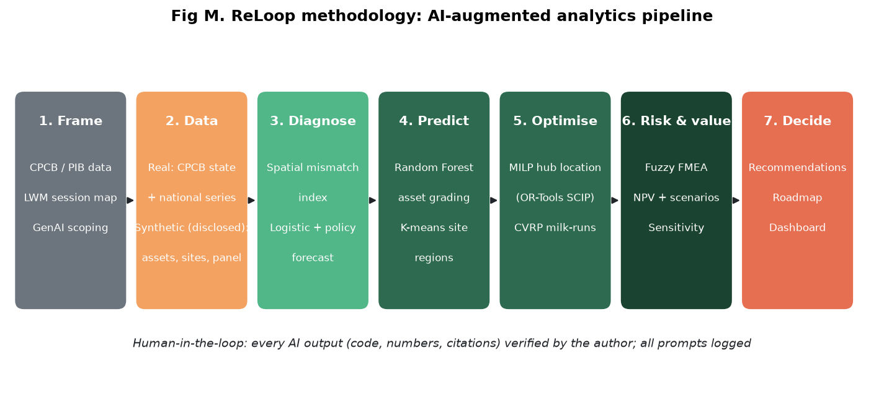
Figure M. Methodology flowchart: AI-augmented analytics pipeline

4. Data Collection and Preparation
The project was rebuilt so that every diagnostic and the recycler side of the network rest on real public records. Synthetic data is used only where the information is inherently confidential (enterprise asset registers and client volumes).
Table 6. Data inventory
Dataset | Type | Source | Size | Used in
Recycler registry: company, district, state, authorised (CTO) capacity | Real | CPCB EPR portal, downloaded 23 Aug 2026 | 413 rows | Capacity atlas, typology, MILP
Recyclers, capacity, collection centres, processing FY20-FY21 | Real | Lok Sabha USQ 983 (2020), USQ 2458 (2021) | 18-35 states | Capacity trend, panel
National generation and formal processing FY18-FY25; state processing FY24-FY25 | Real | CPCB via PIB (2023, 2025) | 7 yrs; 19 states | Mismatch, forecast
Tele-density and internet density by state, Sep 2024 | Real | TRAI, via Jharkhand Economic Survey 2025-26, Table 9.8 | 16 areas | Generation proxy
Population 2011; GSDP FY24 (approximate) | Real / proxy | Census of India 2011; RBI Handbook (robustness only) | 18-21 states | Proxy, robustness
IT-asset return records | Synthetic | Generated (seed 42) from documented grading logic | 12,000 | AI grading
Client sites and volumes, 12 cities; Pune tickets | Synthetic / assumption | Real locations, generated volumes | 424; 20 | Clustering, MILP, CVRP
FMEA ratings | Real (survey) | Anonymous practitioner survey, Google Forms, 4-5 Oct 2026 | 4 responses; 3 used | Fuzzy FMEA

Cleaning. The registry contained two dummy entries ("Recycler Test", "Recycler Test 2") that were removed, leaving 411 recyclers across 107 districts in 19 states; no exact duplicates were found. Districts were geocoded to approximate headquarters coordinates. In the 2021 Lok Sabha annexure, entries marked "Not received" or "-" were treated as missing, not zero, and an implausible value for Jammu and Kashmir ("150,559" against 87 t a year earlier) was excluded. Because TRAI reports by licensed service area, Telangana is grouped with Andhra Pradesh and Uttarakhand with Uttar Pradesh in the mismatch analysis. FY 2022-23 national processing is not published consistently and was left missing. In the FMEA survey, one of four responses gave the same rating (Medium) to all 30 items; such straight-lined responses carry no information about relative risk and were excluded from the main analysis, with results including it reported as a robustness check.
Normalisation and proxies. CPCB does not publish state-wise generation. The primary proxy is internet subscribers (TRAI internet density x Census population), a direct measure of the installed device base; GSDP share is used only as a robustness check. The two proxies rank regions almost identically (Spearman rho = 0.99), so the findings do not depend on the proxy choice. All volumes are expressed as national shares; the capacity index and mismatch index are ratios of shares.
Limitations. (1) Census 2011 population understates 2024 levels but shares change slowly. (2) The registry (411 units, Aug 2026) and PIB's FY25 count (446) differ by date and definition. (3) Asset-level grading data, client volumes and cost parameters are synthetic or assumed (Annex C) and tested through sensitivity analysis. (4) The FMEA panel is small (three usable practitioners) and should be re-run with hub staff after the pilot.

5. Analysis and Insights

5.1 Diagnosis: idle capacity, inverted flows
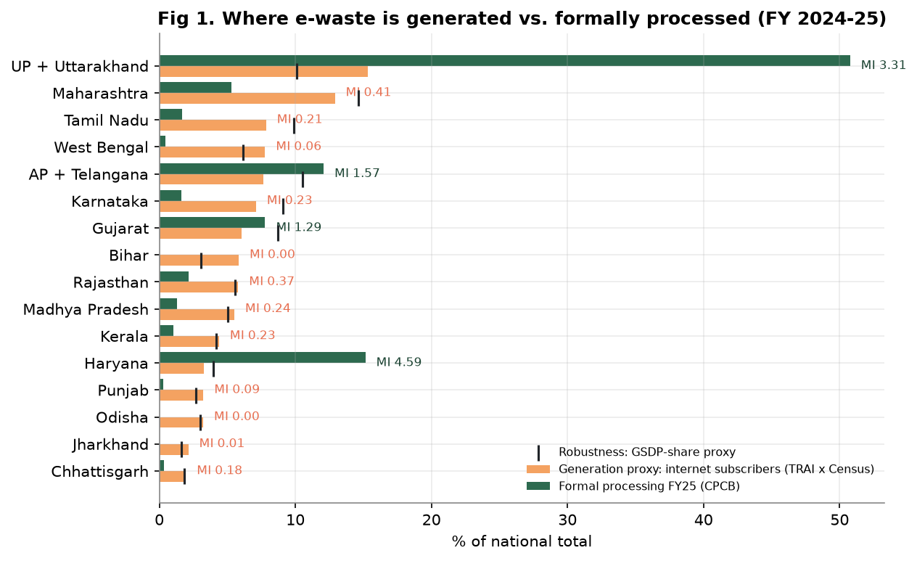
Figure 1. Generation proxy vs. formal processing by TRAI service area, FY 2024-25 (MI = mismatch index; ticks = GSDP robustness proxy)
UP plus Uttarakhand (MI 3.31) and Haryana (4.59) process three to four-and-a-half times their share of generation, while Maharashtra (0.41), Karnataka (0.23) and Tamil Nadu (0.21) export most of theirs. Figure 1b-c shows why this is a logistics problem and not a capacity problem.
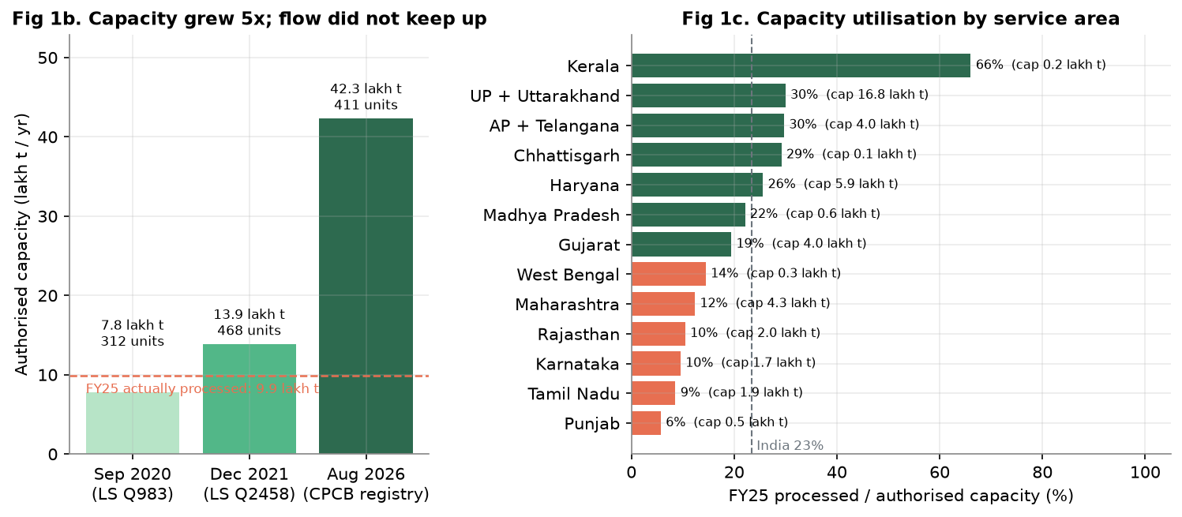
Figure 1b-c. Authorised capacity over time, and FY25 utilisation by service area (CPCB registry, Lok Sabha, PIB)
Capacity has outgrown flow five-fold, and utilisation is lowest exactly where corporate IT waste originates: Karnataka 10%, Tamil Nadu 9%, Maharashtra 12%. A K-means model on three size-neutral ratios (mismatch index, capacity index, utilisation) separates the 16 regions into four types (silhouette 0.5): processing hubs (UP + Uttarakhand, AP + Telangana, Gujarat, Haryana); under-fed capacity (Maharashtra, Tamil Nadu, West Bengal, Karnataka, Rajasthan, Madhya Pradesh, Punjab, Chhattisgarh); processing deserts (Bihar, Odisha, Jharkhand); and one small saturated system (Kerala). Insight: a 3PL serving IT estates in under-fed regions can contract licensed recyclers locally instead of trucking north; the economic barrier is consolidation, not capacity.
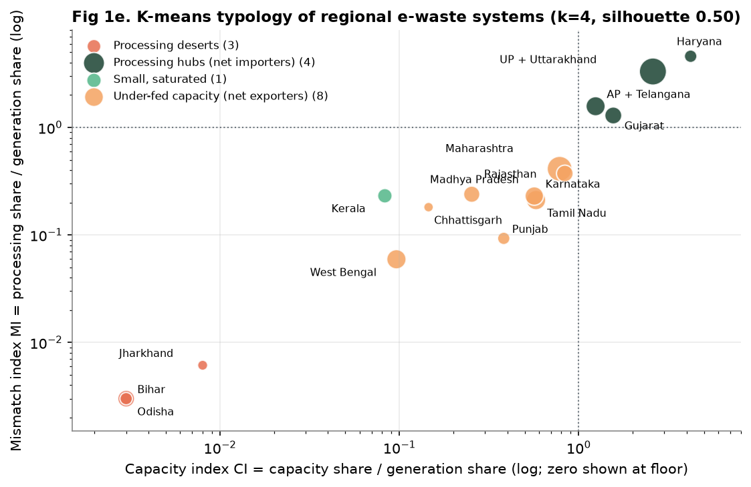
Figure 1e. Data-driven typology of regional e-waste systems (bubble size = generation share)

5.2 Volume outlook: plan for a band, not a plant
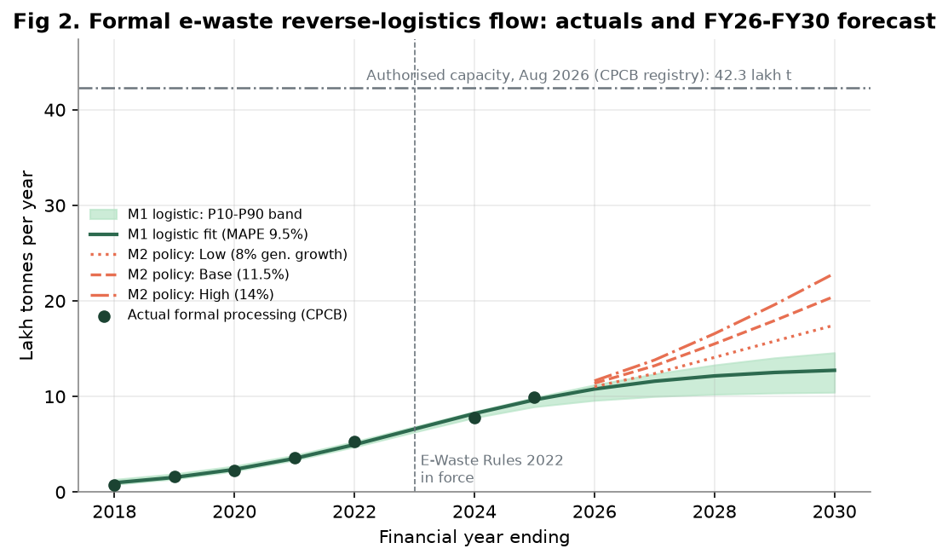
Figure 2. Formal reverse-logistics flow: actuals FY18-FY25, two forecast models to FY30, and authorised capacity
The data-only logistic curve fits history well (MAPE 9.5%) and saturates near 12.74 lakh tonnes by FY30; the EPR policy model gives 17.46 to 22.88 lakh tonnes (base 20.48). A data-only model cannot see a regulatory step-change, so planning should use the band. Even the high scenario would use only 54.1% of today's authorised capacity. Insight: India does not need more recycling plants this decade; it needs collection, consolidation and routing that bring flow to the plants it already has.

5.3 AI grading engine: deciding at the gate
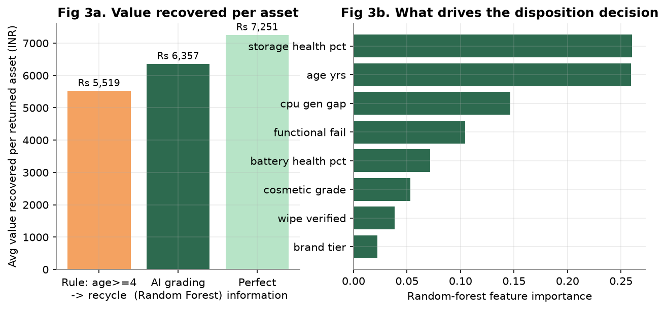
Figure 3. (a) Average value recovered per asset under three policies; (b) drivers of the disposition decision
On a 3,000-asset hold-out set the Random Forest reaches 76.5% accuracy and macro-F1 of 0.766 (five-fold CV 0.766 plus or minus 0.006), against 48.5% for the age rule. Accuracy is the wrong yardstick, however; value is the right one. Scoring every decision at its realised rupee value (with a Rs 1,200 rework penalty for over-optimistic routing), AI grading recovers Rs 6,357 per asset versus Rs 5,519 under the rule, closing 48.4% of the gap to perfect information. The rule sends 59% of assets to the recycler; the model shows only about 23% truly belong there. Storage health, age and processor-generation gap drive the decision, which tells operations exactly which three readings a grader must capture at intake.

5.4 Network design over the real recycler network
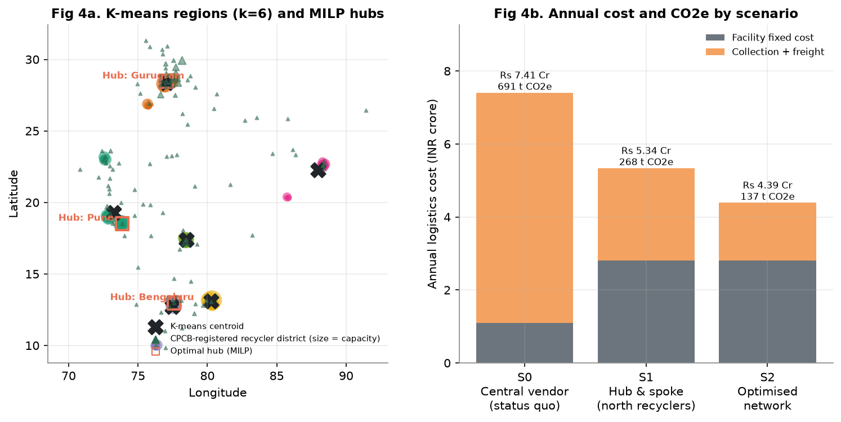
Figure 4. (a) K-means service regions, real recycler districts and MILP-selected hubs; (b) annual cost and CO2e by scenario
Table 7. Network scenarios for a 2,400 t/yr portfolio (recyclers = real CPCB registry)
Metric (per year) | S0 Central vendor | S1 Hubs + north recyclers | S2 Optimised
Total logistics cost (Rs crore) | 7.41 | 5.34 | 4.39
Tonne-km (million) | 3.46 | 1.89 | 0.71
Data-bearing tonne-km (million) | 3.46 | 0.67 | 0.66
Transport CO2e (tonnes) | 691 | 268 | 137
Average onward haul to recycler (km) | 1,440 | 1,135 | 41
S0 vendor located in Gautam Buddha Nagar (a real recycler cluster). S2 hubs: Bengaluru, Pune, Gurugram. Assumptions in Annex C; sensitivity in Annex D.
The recycler side of the model is the real CPCB network: 107 districts with registered capacity, of which a conservative 2% is assumed contestable by this portfolio. K-means on client sites (k = 6, silhouette 0.872) recovers six service regions centred near Pune, Gurugram, Bengaluru, Kolkata, Hyderabad and Chennai, validating the candidate hubs. The MILP opens three hubs and routes sanitised material to registered recyclers in Bangalore Urban and Rural, Pune and Faridabad, cutting the average onward haul from 1,440 km to about 41 km. Consolidating and sanitising near source (S0 to S1) saves Rs 2.07 Cr; using regional registered recyclers (S1 to S2) saves a further Rs 0.95 Cr and halves emissions again. The same three hubs win when freight or fixed costs move 30% either way (savings 28.3% to 49.8%); only in the adverse combined case does the optimiser switch to Pune and Chennai, still saving 23.2%.

5.5 First-mile milk-runs
As Figure D3 (Annex D) shows, today each pickup ticket triggers a dedicated round trip, with vans 24.7% full on average. Batching a week's 20 tickets into 6 capacitated routes cuts vehicle-km by 65% (1,364 to 478 km) and lifts utilisation to 82.5%, saving about Rs 12.41 lakh and 12 t CO2e a year in Pune alone. The trade-off is service time, which is managed by a weekly pickup SLA.

5.6 Risk prioritisation
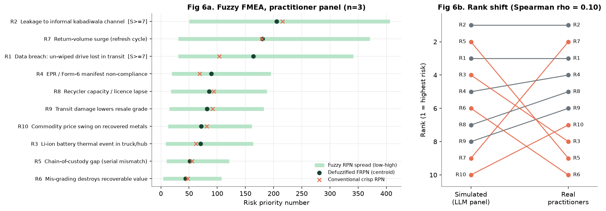
Figure 6. (a) Fuzzy FMEA from practitioner ratings; (b) rank shift from the AI-simulated panel to real practitioners
Ten failure modes were rated by an anonymous practitioner panel (4 responses; 3 used after removing one straight-lined response; weights by experience: two experts with 15+ years, one with under 5). The top three risks are leakage to informal scrap channels (R2), return-volume surges during refresh cycles (R7) and in-transit data breach (R1). The ranking is robust to method (fuzzy vs crisp rank correlation 0.93) and to including the excluded response (rho 0.99). Two failure modes, R2 and R1, carry severity of 7 or more; under a severity override they are treated as critical regardless of RPN, since RPN under-weights rare but catastrophic events (Liu et al., 2013).
The comparison with the earlier AI-simulated panel is itself a finding (Figure 6b): the rank correlation is only 0.1. The simulated experts agreed on the dramatic risks (breach, leakage) but placed refresh-cycle surges ninth, where practitioners place them second, and over-rated chain-of-custody gaps, which practitioners consider well controlled by existing serial tracking. Practitioners also rated mis-grading (R6) as the lowest risk, which helps explain why value leakage persists: what is not seen as a risk is not managed. Implications: the S2 design already addresses R1 and R2 by wiping and serial-verifying within one short leg; R7 calls for refresh-calendar agreements with clients and modular, leased hub capacity (Section 5.2); and R6 makes the case for measuring recovered value explicitly on the control-tower dashboard.

6. Managerial Recommendations

6.1 Strategic insights
- Move the decision, not the asset. Grade and sanitise at three regional hubs within roughly 300 km of client sites, and feed the idle registered recyclers already in each region. This single design choice lowers freight, carbon and data exposure together, so it needs no trade-off between the CFO, the CISO and the ESG head.
- Value, not freight, is the prize. Logistics redesign is the enabler that pays for itself; AI grading is what makes the programme a business. Investment and management attention should follow that ratio.
- Turn compliance into a product. Serial-level chain of custody, certified destruction and EPR-certificate traceability can be sold to clients as an assured service, differentiating the 3PL in Fugate et al.'s (2010) sense rather than competing on price per tonne.

6.2 Cost-benefit analysis
Table 8. Investment and benefits (benefits ramp 40%, 70%, then 85% from year 3)
Item | Rs crore
3 regional ITAD hubs (secure cage, racking, wipe stations, shredder) | 3.30
AI grading + asset-tracking platform (QR/RFID, control tower) | 0.90
GPS e-locks and IoT trackers for secure vans | 0.25
Training, SOPs, R2/ISO 27001 certification readiness | 0.20
Contingency (10%) | 0.46
Total one-time investment | 5.11
Additional annual running cost (platform, 2 analytics FTE) | 0.75 per year
Annual network saving (S2 vs S0) + milk-run saving | 3.01 + 0.67
Annual value-recovery uplift, full model / counted in base case (50%) | 43.3 / 21.65

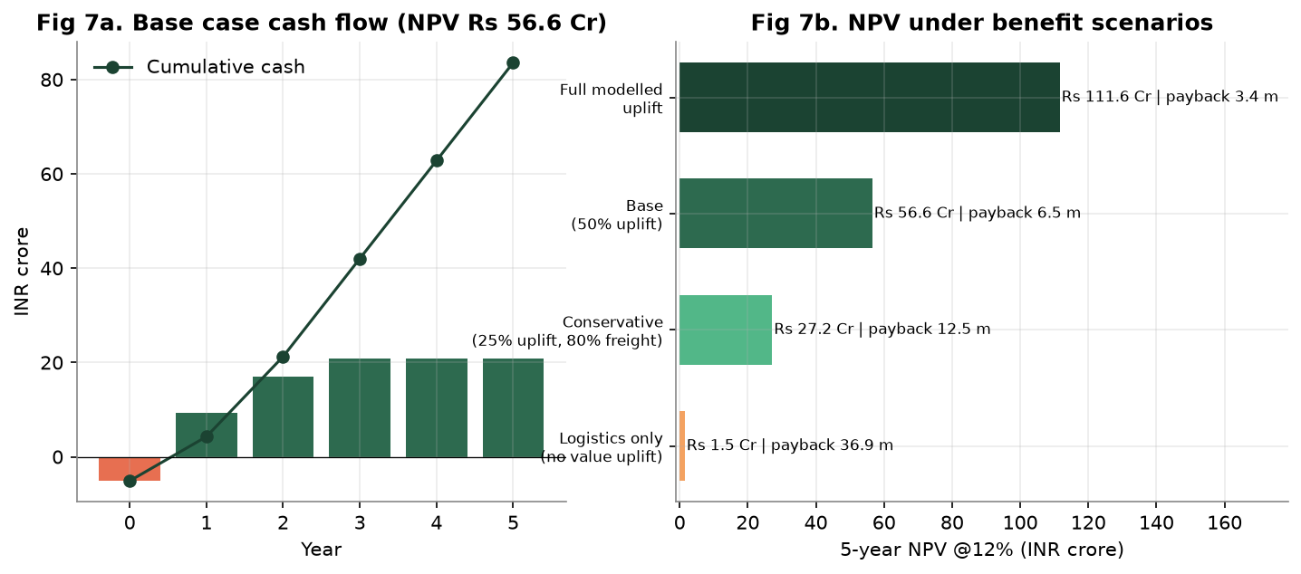
Figure 7. (a) Base-case cash flow; (b) five-year NPV at 12% under benefit scenarios
Even the conservative case (25% of the modelled uplift and 80% of freight savings) returns NPV of Rs 27.19 Cr with a 12.5-month payback. The decision rule for leadership is simple: approve if the pilot shows that AI grading captures at least a quarter of its modelled uplift on real assets.

6.3 Short-term and long-term actions
Horizon | Actions
0-6 months | Pune pilot hub and milk-runs; AI grading in shadow mode on the real asset register; secure vans with GPS e-locks; chain-of-custody SOP; refresh-calendar agreements with clients to smooth return surges (R7)
6-15 months | Bengaluru and Gurugram hubs; volume contracts with under-used registered recyclers (two per region); grading live with human override; EPR auto-reporting; R2v3 and ISO 27001 certification
15+ months | Offer certified-ITAD-as-a-service to new clients; retrain models quarterly; formalise informal collectors as accredited partners; evaluate a fourth hub if the FY30 band materialises

6.4 Change management
The largest change is contractual, not technical: procurement moves from one national vendor to a 4PL-orchestrated network, so the CISO must co-own vendor selection. Graders need upskilling to read model outputs and override them with a reason code; the override log becomes training data. Following the scenario-first lesson of the Zhiyuanhui case (Session 20), every phase is justified by an operating scenario and a KPI gate, not by the technology itself.

7. Implementation Roadmap
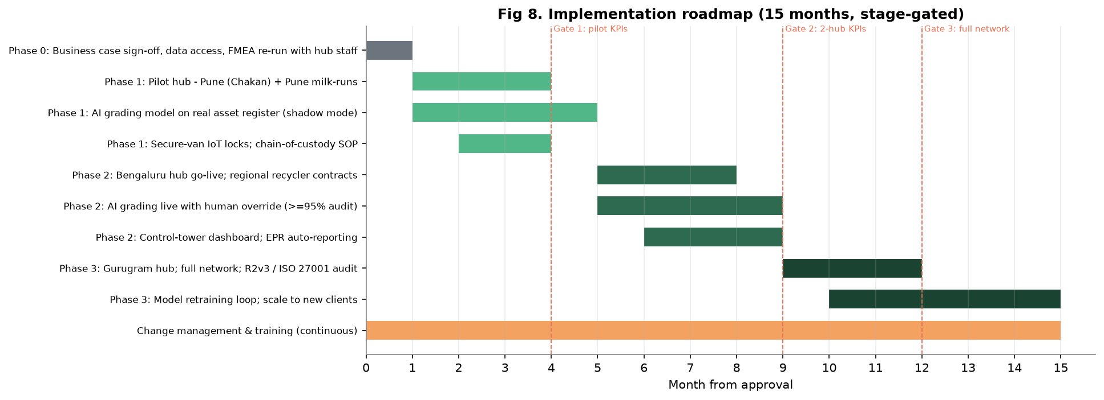
Figure 8. Fifteen-month stage-gated implementation plan
Resources. People: a programme lead, three hub managers, two data scientists, 20 to 30 graders and technicians per hub, and a security and compliance officer. Technology: QR/RFID asset tracking, the grading-model service, an OR-Tools planning engine, the control-tower dashboard and GPS e-locks. Capital: Rs 5.11 Cr one-time, with hubs leased rather than owned to preserve flexibility against the forecast band. Training: NIST 800-88 sanitisation, Li-ion handling (UN3480), the model-override protocol and DPDP Act obligations. Implementation risks and mitigations are listed in Annex D (Table D3); the most important gate is that the model goes live only if it captures at least 25% of its modelled value in shadow mode.

8. Ethical, Legal and Bias Considerations
- Responsible AI. The grading model recommends; a trained grader decides. Every override is logged with a reason code, keeping accountability with a person and building an audit trail.
- Bias. The synthetic data encodes my own assumptions about how assets should be graded, so the model can only be as good as that logic until retrained on real outcomes. The brand-tier feature could systematically down-grade lower-cost brands; its effect will be monitored, and it will be dropped if it does not add predictive value on real data.
- Hallucination risk. Generative AI was not allowed to originate numbers or references. Every figure is produced by code; every citation was checked against its source. The AI-simulated expert panel was replaced by real practitioner ratings; the low agreement between the two (rho 0.1) is reported as evidence that AI judgement cannot substitute for field knowledge.
- Data privacy and law. Asset records can link to employee identities, so the model uses pseudonymised asset IDs only, consistent with the DPDP Act, 2023. Sanitisation follows NIST SP 800-88, and transport follows the manifest requirements of the E-Waste Rules, 2022.
- Social impact. Diverting flow from informal recyclers affects livelihoods. The roadmap therefore proposes accrediting informal collectors as formal partners rather than excluding them.

9. Conclusion
Public data show that India's e-waste system has enough licensed capacity but uses less than a quarter of it, because flows are routed by contract rather than by geography. For corporate IT, deciding at the gate and routing regionally lowers cost by about two-fifths, carbon by about four-fifths and data exposure by about four-fifths, while AI grading converts compliance spending into recovered value. The main limitations are the synthetic asset-level data, the population-based generation proxy and assumed cost parameters; the pilot is designed to replace each with real evidence. Future work should test stochastic network models over the forecast band and estimate the value-decay curve of returned IT assets in India.

References
Balde, C. P., Kuehr, R., Yamamoto, T., McDonald, R., D'Angelo, E., Althaf, S., Bel, G., Deubzer, O., Fernandez-Cubillo, E., Forti, V., Gray, V., Herat, S., Honda, S., Iattoni, G., Khetriwal, D. S., Luda di Cortemiglia, V., Lobuntsova, Y., Nnorom, I., Pralat, N., & Wagner, M. (2024). The global e-waste monitor 2024. International Telecommunication Union and United Nations Institute for Training and Research.
Blackburn, J. D., Guide, V. D. R., Jr., Souza, G. C., & Van Wassenhove, L. N. (2004). Reverse supply chains for commercial returns. California Management Review, 46(2), 6-22.
Breiman, L. (2001). Random forests. Machine Learning, 45(1), 5-32.
Central Pollution Control Board. (2026). Recycler registration granted list [Data set]. EPR portal for e-waste management. Retrieved August 23, 2026.
Cichosz, M., Wallenburg, C. M., & Knemeyer, A. M. (2020). Digital transformation at logistics service providers: Barriers, success factors and leading practices. The International Journal of Logistics Management, 31(2), 209-238. https://doi.org/10.1108/IJLM-08-2019-0229
Dadsena, K. K., Pant, P., Paul, S. K., & Pratap, S. (2024). Overcoming strategies for supply chain digitization barriers: Implications for sustainable development goals. Business Strategy and the Environment. Advance online publication.
Dadsena, K. K., Rathore, P. K., Kaliyan, M., Jayaraman, R., & Saha, E. (2026). Adoption of circular economy practices in supply chains to enhance firm performance: Industrial symbiosis and ecological modernization theory perspective. The International Journal of Logistics Management. Advance online publication.
Dadsena, K. K., Sarmah, S. P., & Naikan, V. N. A. (2019). Risk evaluation and mitigation of sustainable road freight transport operation: A case of trucking industry. International Journal of Production Research, 57(19), 6223-6245.
Department of Planning and Development, Government of Jharkhand. (2026). Jharkhand economic survey 2025-26 (Table 9.8, citing Telecom Regulatory Authority of India data, September 2024).
Fugate, B. S., Mentzer, J. T., & Stank, T. P. (2010). Logistics performance: Efficiency, effectiveness, and differentiation. Journal of Business Logistics, 31(1), 43-62.
Govindan, K., Soleimani, H., & Kannan, D. (2015). Reverse logistics and closed-loop supply chain: A comprehensive review to explore the future. European Journal of Operational Research, 240(3), 603-626. https://doi.org/10.1016/j.ejor.2014.07.012
Guide, V. D. R., Jr., & Van Wassenhove, L. N. (2009). The evolution of closed-loop supply chain research. Operations Research, 57(1), 10-18.
Islam, M. T., & Huda, N. (2018). Reverse logistics and closed-loop supply chain of waste electrical and electronic equipment (WEEE)/e-waste: A comprehensive literature review. Resources, Conservation and Recycling, 137, 48-75.
Kilic, H. S., Cebeci, U., & Ayhan, M. B. (2015). Reverse logistic system design for the waste of electrical and electronic equipment (WEEE) in Turkey. Resources, Conservation and Recycling, 95, 120-132.
Kissel, R., Regenscheid, A., Scholl, M., & Stine, K. (2014). Guidelines for media sanitization (NIST Special Publication 800-88 Rev. 1). National Institute of Standards and Technology.
Lai, K.-H., & Wong, C. W. Y. (2012). Green logistics management and performance: Some empirical evidence from Chinese manufacturing exporters. Omega, 40(3), 267-282. https://doi.org/10.1016/j.omega.2011.07.002
Liu, H.-C., Liu, L., & Liu, N. (2013). Risk evaluation approaches in failure mode and effects analysis: A literature review. Expert Systems with Applications, 40(2), 828-838.
Lok Sabha. (2020, September 18). E-waste (Unstarred Question No. 983). Ministry of Environment, Forest and Climate Change.
Lok Sabha. (2021, December 13). E-waste management (Unstarred Question No. 2458). Ministry of Environment, Forest and Climate Change.
Ministry of Environment, Forest and Climate Change. (2022). E-Waste (Management) Rules, 2022 (G.S.R. 801(E)). Government of India.
Office of the Registrar General and Census Commissioner. (2011). Census of India 2011: Primary census abstract. Government of India.
Press Information Bureau. (2023, July 27). Generation of e-waste [Press release, ID 1943201]. Government of India.
Press Information Bureau. (2025, July 24). E-waste processing management [Press release, ID 2147876]. Government of India.
Sople, V. V. (2012). Logistics management (3rd ed.). Pearson Education India.
Wang, Y.-M., Chin, K.-S., Poon, G. K. K., & Yang, J.-B. (2009). Risk evaluation in failure mode and effects analysis using fuzzy weighted geometric mean. Expert Systems with Applications, 36(2), 1195-1207.

Annexures

Annex A. Prompt Logbook (summary)
The complete logbook (prompt text, tool, output summary, usage and reflection for each entry) is submitted as a separate file. Selected entries:
# | Purpose of prompt | Outcome and reflection
1 | Choose a topic unique within the batch and aligned to faculty research | Batch profile showed ~16 of 35 peers from metals; e-waste ITAD chosen
3 | Locate official CPCB state and national data | PIB releases located; AI-quoted figures cross-checked against originals
5 | Design synthetic asset data with documented grading logic | Accepted with changes: added wipe-verification constraint
7 | Recommend a forecasting method | Prophet suggested, rejected after critique; dual-model approach adopted
9 | Critique the first network result | Freight under-priced low-density cargo; rates corrected; result reversed
11 | Simulate a 3-expert FMEA panel | Used only as a benchmark once real ratings arrived
18 | Analyse the practitioner survey; screen data quality | One straight-lined response excluded; real vs simulated rank rho = 0.10
14-16 | Rebuild on real public data; clean registry; test proxy sensitivity | Registry cleaned (2 test records); proxies agree (rho 0.99); real recyclers in MILP

Annex B. Code repository
Repository: ReLoop_WAI (submitted as a zip in the course Drive folder; GitHub link to be added). Scripts a01_spatial_mismatch.py through a09_build_dashboard.py; run_all.py reproduces every output. Core of the MILP objective (a04_network_design.py):
minimise SUM(hub fixed cost x open[h]) + SUM(demand[c] x (first-mile + LTL rate x km[c,h]) x assign[c,h]) + SUM(FTL rate x km[h,r] x flow[h,r])
subject to: each city assigned to exactly one open hub; hub load <= capacity x open[h]; onward flow = ML-predicted recycle share x hub load; recycler intake <= available capacity.

Annex C. Assumptions register
Parameter | Value | Basis
Part-load (LTL) rate, data-bearing leg | Rs 17 per t-km | Volumetric rate for low-density IT cargo plus security premium
Full-truck (FTL) rate, sanitised leg | Rs 8 per t-km | Truck cubes out at ~6-7 t of IT assets
Hub fixed cost | Rs 0.70-0.95 Cr per year | Lease of ~15,000 sq ft, secure cage, certification, supervisors
Emission factors (LTL / FTL) | 0.20 / 0.11 kg CO2e per t-km | GLEC-style factors adjusted for low load factor
Value per asset by disposition | e.g. laptop Rs 22,000 / 11,000 / 2,500 / 350 | Redeploy (avoided purchase) / resale / parts / material
Road circuity | 1.30 inter-city; 1.45 urban | Ratio of road to great-circle distance
Discount rate; horizon | 12%; 5 years | Typical corporate hurdle rate

Annex D. Additional model outputs
Table D1. Robustness of the network decision
Sensitivity case | Hubs opened | S0 (Cr) | S2 (Cr) | Saving
Freight -30% | Bengaluru, Pune, Gurugram | 5.65 | 4.05 | 28.3%
Freight +30% | Bengaluru, Pune, Gurugram | 9.17 | 4.74 | 48.3%
Hub fixed cost +30% | Bengaluru, Pune, Gurugram | 7.74 | 5.23 | 32.4%
Hub fixed cost -30% | Bengaluru, Pune, Gurugram | 7.08 | 3.55 | 49.8%
Worst case: freight -30%, fixed +30% | Pune, Chennai | 5.98 | 4.59 | 23.2%

Table D2. Fuzzy FMEA results (practitioner panel, n = 3)
ID | Failure mode | S | O | D | Fuzzy RPN | Crisp RPN
R2 | Leakage to informal kabadiwala channel | 7.74 | 2.85 | 7.74 | 205.2 | 215.5
R7 | Return-volume surge (refresh cycle) | 6.11 | 4.33 | 5.22 | 180.1 | 179.4
R1 | Data breach: un-wiped drive lost in transit | 7.52 | 2.41 | 7.3 | 164.2 | 103.4
R4 | EPR / Form-6 manifest non-compliance | 4.41 | 3.52 | 4.41 | 89.5 | 68.9
R8 | Recycler capacity / licence lapse | 4.63 | 3.74 | 3.74 | 85.6 | 93.9
R9 | Transit damage lowers resale grade | 4.63 | 2.85 | 4.63 | 81.9 | 91.7
R10 | Commodity price swing on recovered metals | 3.74 | 3.74 | 3.74 | 71.7 | 81.4
R3 | Li-ion battery thermal event in truck/hub | 3.52 | 2.63 | 5.22 | 70.3 | 62.3
R5 | Chain-of-custody gap (serial mismatch) | 4.63 | 2.26 | 3.52 | 51.5 | 55
R6 | Mis-grading destroys recoverable value | 3.74 | 2.63 | 2.85 | 44 | 47.7

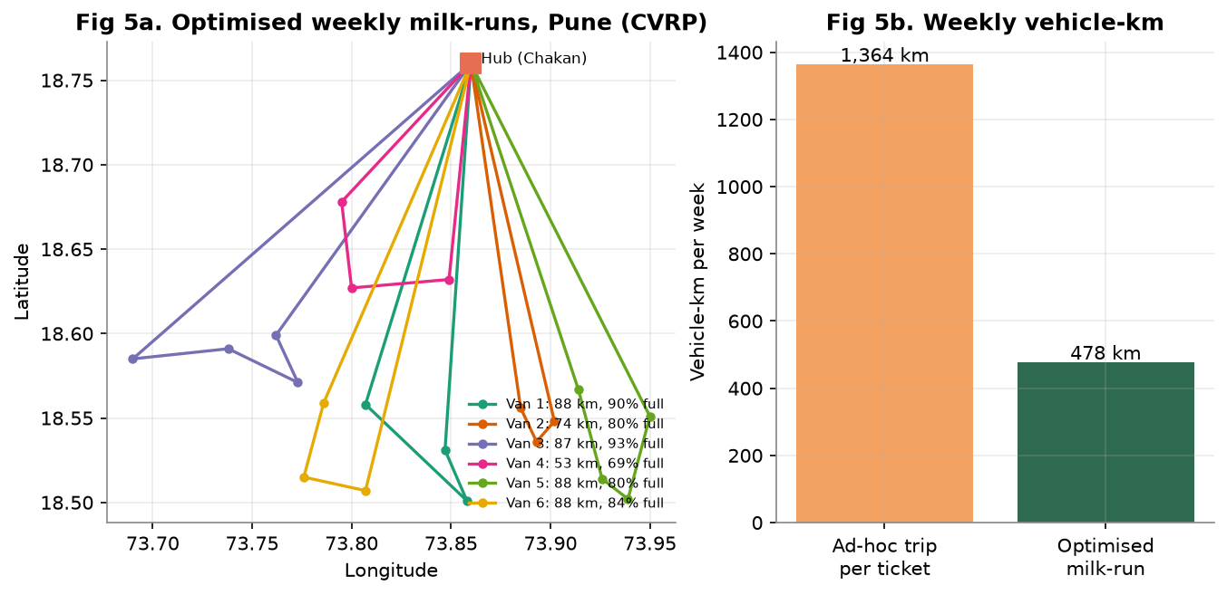
Figure D3. Optimised weekly milk-runs from the Pune hub and weekly vehicle-km
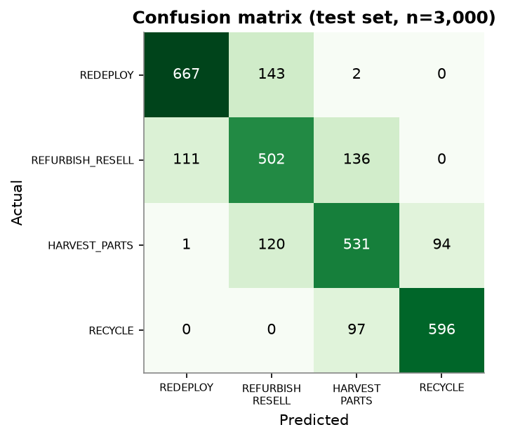
Figure D1. Confusion matrix of the grading model (hold-out set)
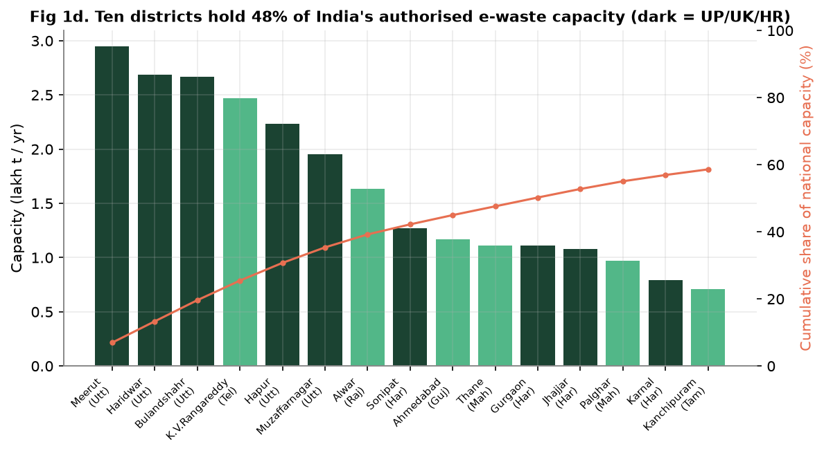
Figure D2. Top 15 districts by authorised e-waste capacity (CPCB registry, Aug 2026)
Table D3. Implementation risks and mitigations
Implementation risk | Mitigation
Model under-performs on real assets | Shadow mode for four months; go-live only if uplift is at least 25% of modelled value (Gate 1)
Regional recycler capacity or licence lapse | Two recyclers per region; quarterly licence checks on the CPCB EPR portal
Client reluctance to leave the national vendor | Start with one anchor client; publish certified-destruction and carbon reports
Data access for model retraining | Pseudonymised asset feed agreed in contract; no employee data in the model

Annex E. Dashboard
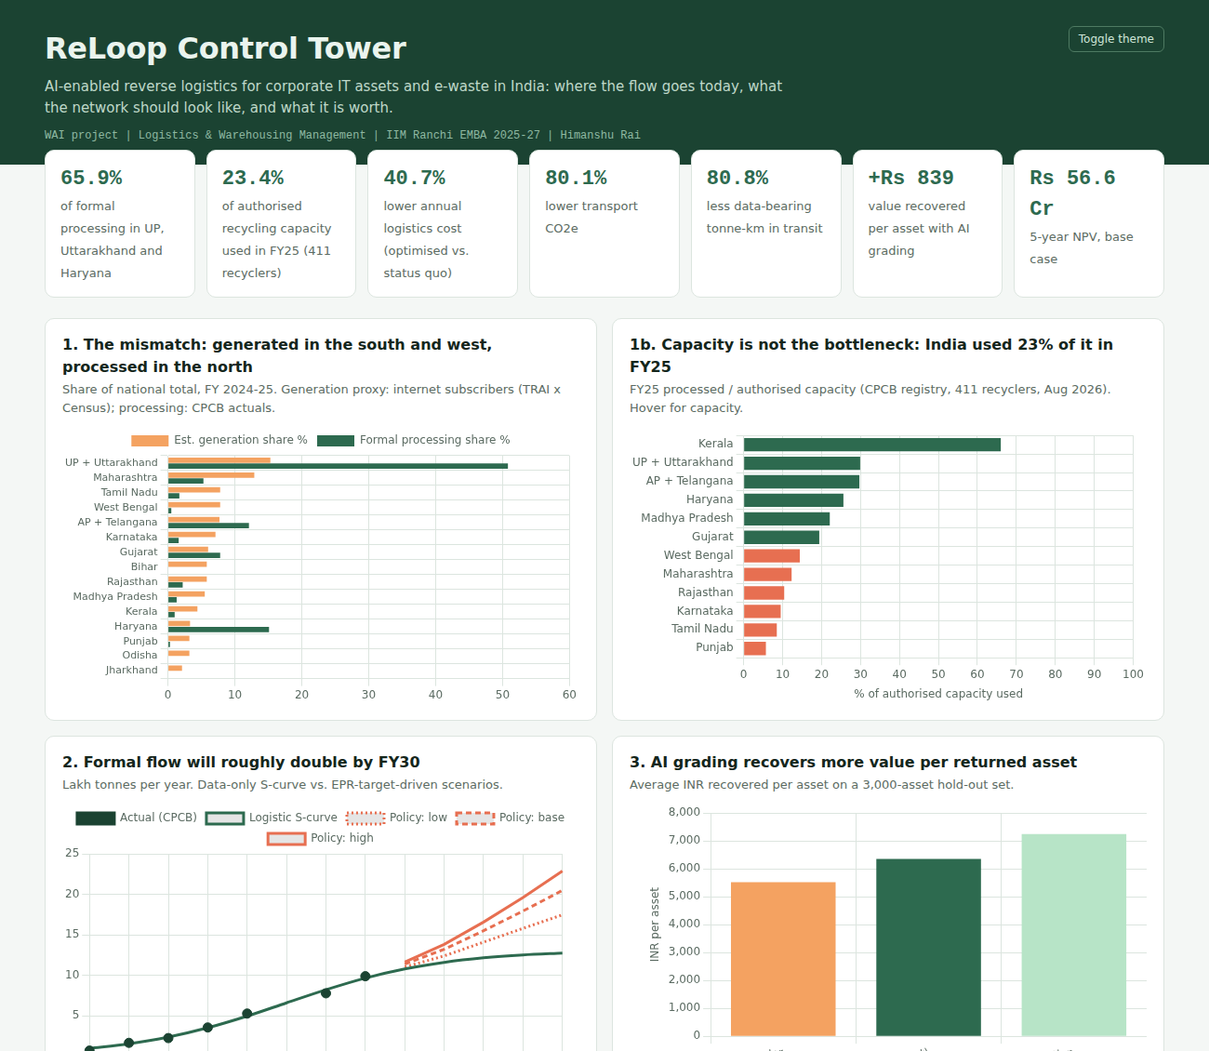
Figure E1. ReLoop Control Tower dashboard (offline HTML; includes a live what-if NPV panel)

Annex F. Data dictionary: synthetic IT-asset return file
Field | Description
asset_type, city | Laptop, desktop, monitor, server, network, mobile; client city
age_yrs, cpu_gen_gap | Age in years; processor generations behind current
storage_health_pct, battery_health_pct | Drive health; battery health (blank where not applicable)
cosmetic_grade, functional_fail, brand_tier | A-D grade (4-1); failed diagnostics flag; enterprise / mid / consumer
wipe_verified | NIST 800-88 wipe passed (if not, asset cannot leave as a device)
best_disposition | Target: REDEPLOY, REFURBISH_RESELL, HARVEST_PARTS, RECYCLE

