Acadedge System Requirements

# Online Exams

1. The student should be able to give exams from the app and website
2. There will be more than 1 exam available at any given time
3. Each exam will have few fields:
   1. Exam title
   2. List of Questions
   3. Start date and time
   4. Duration
   5. Total marks
   6. Negative mark per question
   7. Status: Active, not active
   8. Background image url
   9. Course id
4. Exams will have multiple questions in them
5. A question will have few fields:
   1. Question description
   2. Mark
   3. image url
   4. can have multiple correct answers
   5. 4 answer options
   6. Correct answer option
6. Each question has few answer options in it and 1 or more of them is the correct answer
7. Each answer has few fields:
   1. Answer description
   2. Image url
8. The user while giving the exam, can choose to skip 1 or more questions.
9. On exam complete, the result for each user will be sent to the server. The server then evaluates the results and stores them per user
10. The result will contain few fields:
    1. Per question answer
    2. Per question time taken
11. There will be provision to
    1. get all the exams
    2. get exam details for an exam id
    3. save exam results per user
    4. get exam results per user
    5. get all results for all users per exam

# Control Flow

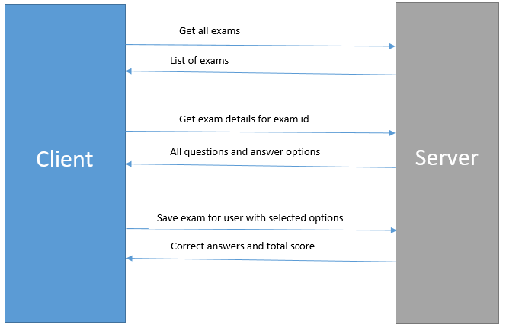

# Courses

1. Each course will have few subjects attached to them
2. Subject has following things:
   1. Subject Name
   2. Course Id
   3. Teams meeting link

# Class Videos

1. Every subject has a list of videos
2. The videos are uploaded in youtube
3. The youtube links are stored on our server
4. Video has following things:
   1. Video name
   2. Video description
   3. Video duration
   4. Video image
   5. Video YouTube link

# Assignments

1. Each subject will have a list of assignments
2. Each assignment contains a long text
3. Student can fetch all the assignments
4. Students can upload image for each assignment
5. Student can submit assignment only once
6. All the subsequent times can only see the submitted answer
7. Students, teachers and Parents can fetch the assignment results