Name: Le Hoang Phat

StudentID: 523V0013

Introduction: Creating a School Management Web App using ASP.NET Core

Exercise 1: Develop a School Management Web App with ASP.NET Core Web Application using Razor Pages

Screenshots:

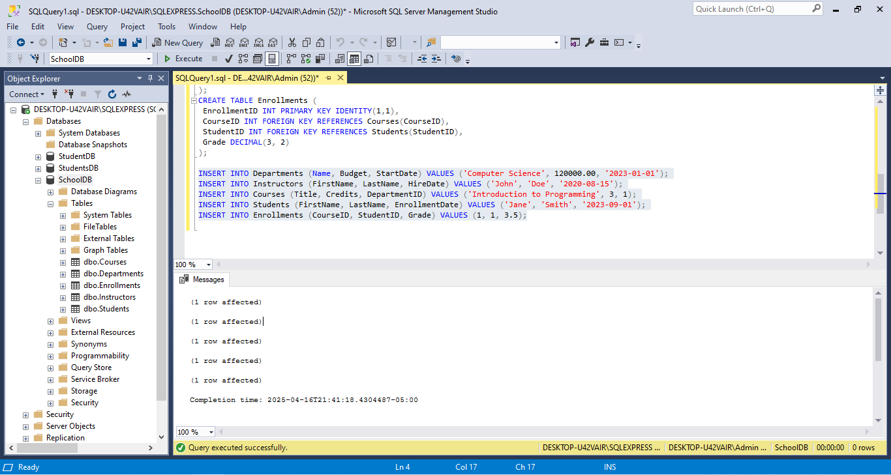

Figure 1 Setting up Database

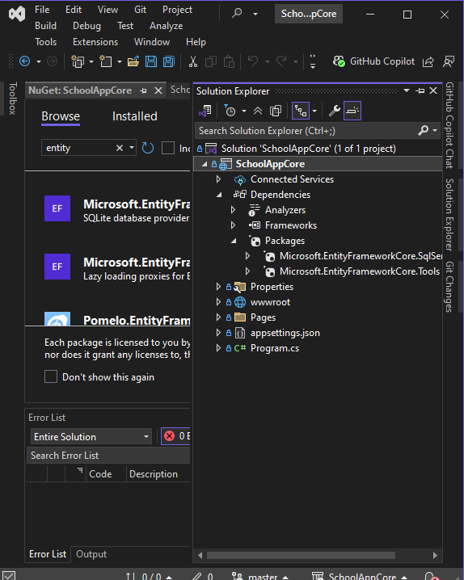

Figure 2 Creating the ASP.NET Core Web Application

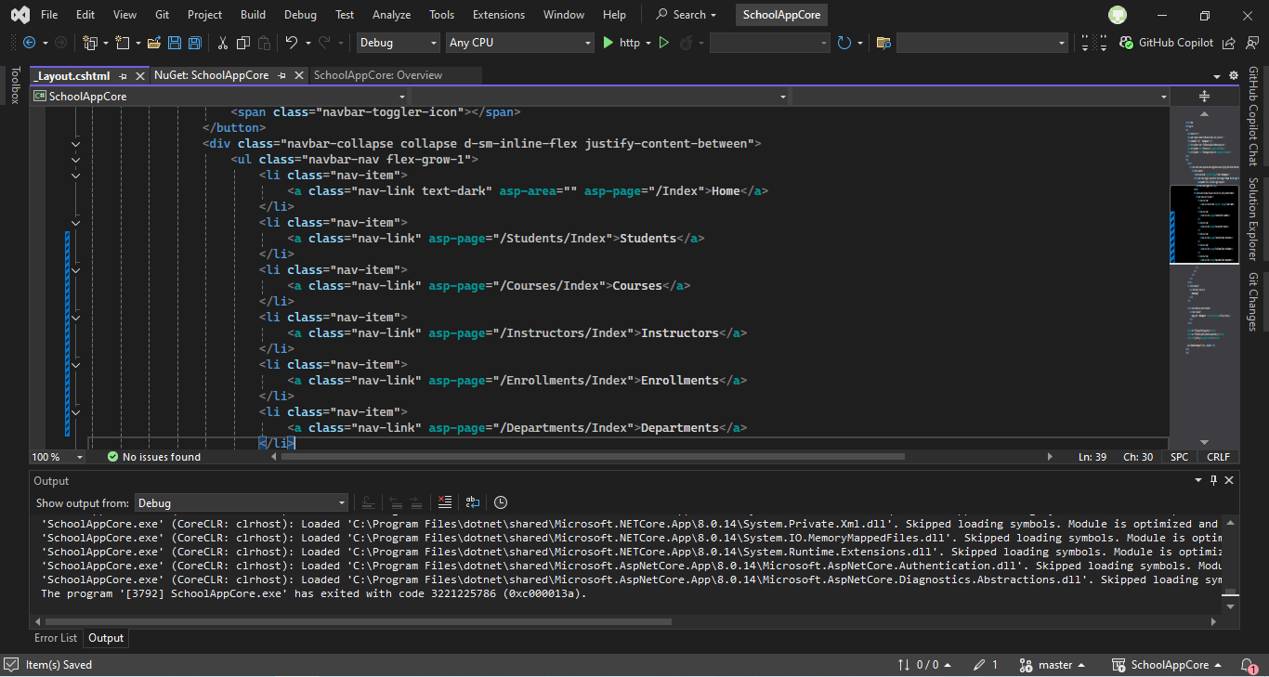

Figure 3 Modify the Menu in _Layout.cshtml

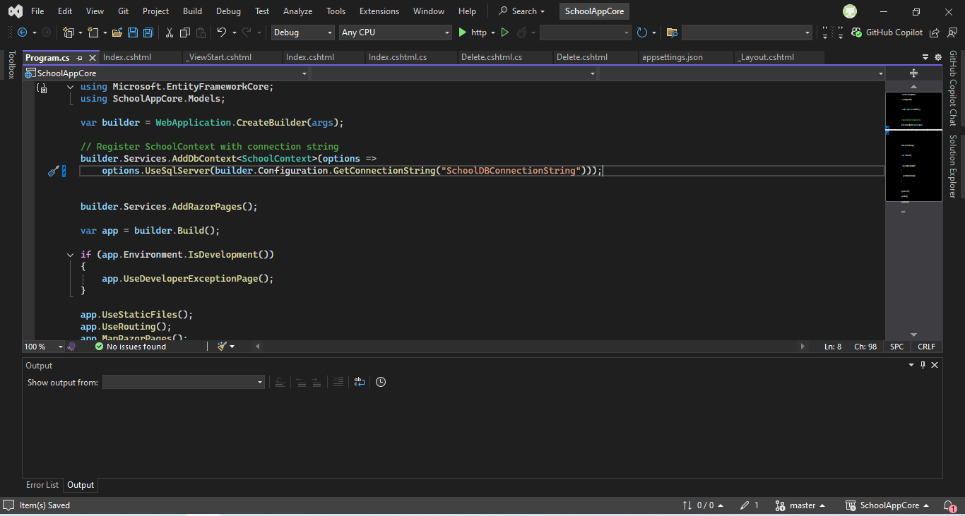

Figure 4 Setting Up the Database Connection

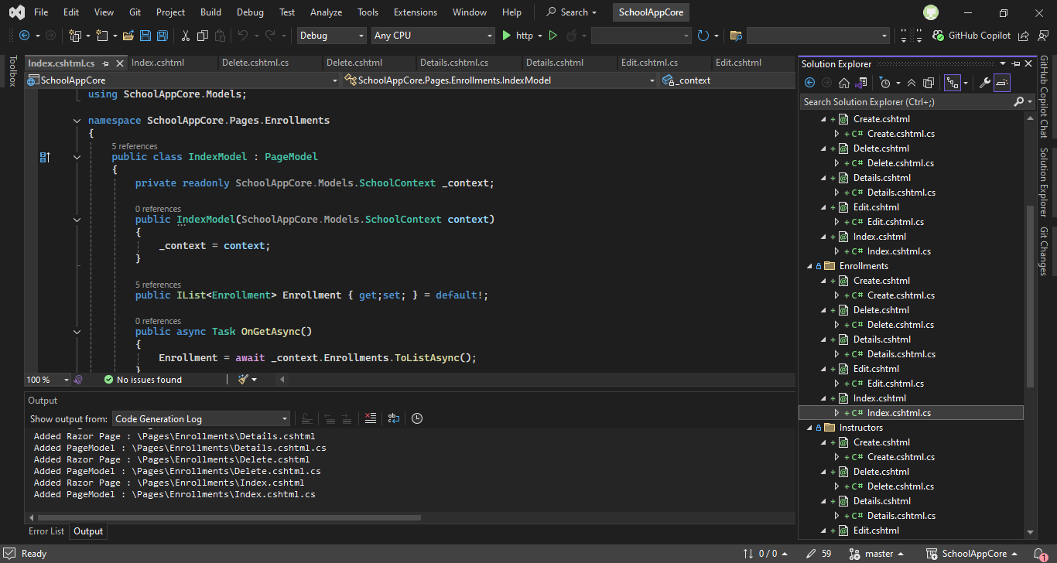

Figure 5 Creating Razor Pages

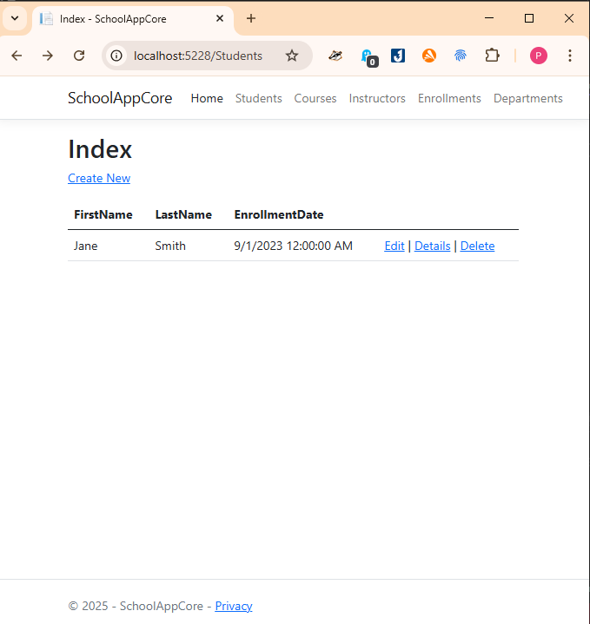

Figure 6 Testing the Application

Exercise 2: Develop a School Management Web App with ASP.NET Core Web App (MVC)

Screenshots:

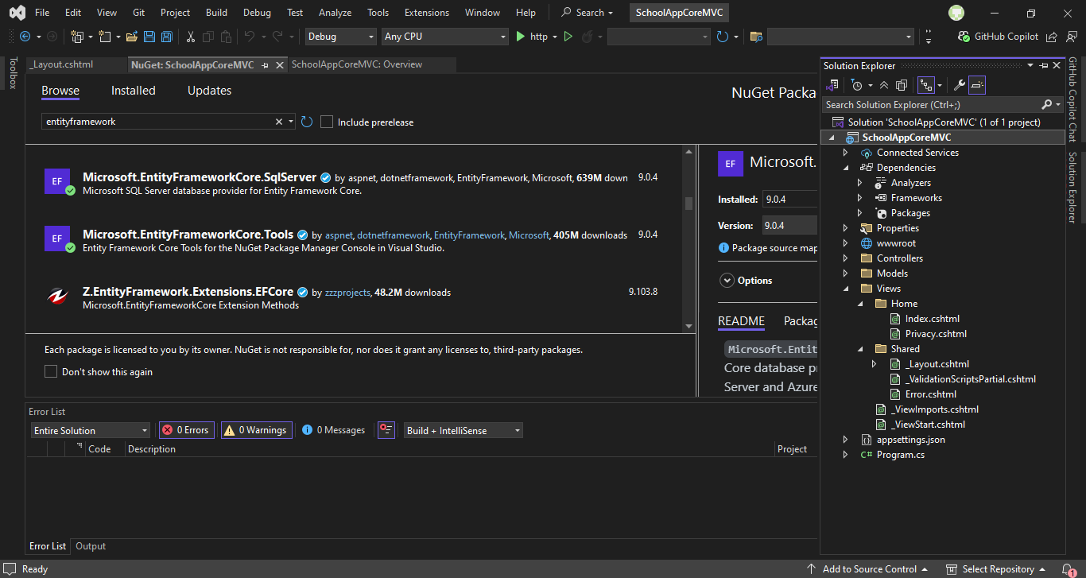

Figure 7 Setting up an environment

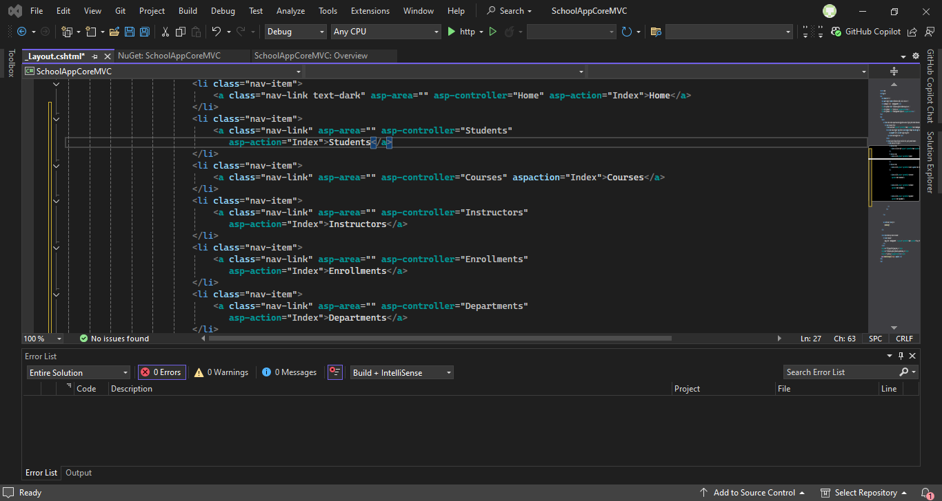

Figure 8 Modify the Menu in _Layout.cshtml

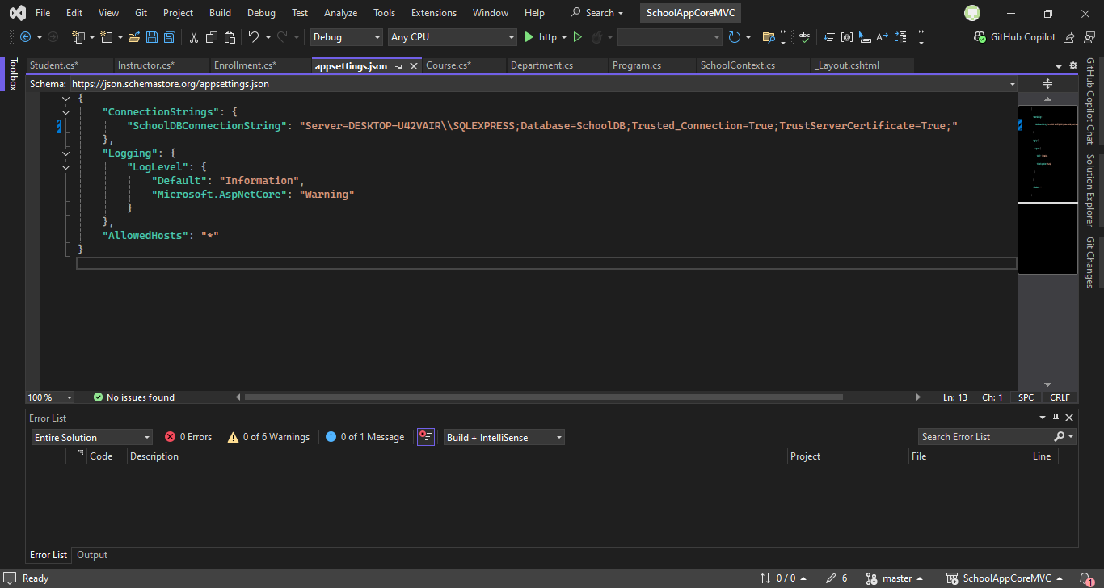

Figure 9 Setting Up the Database Connection

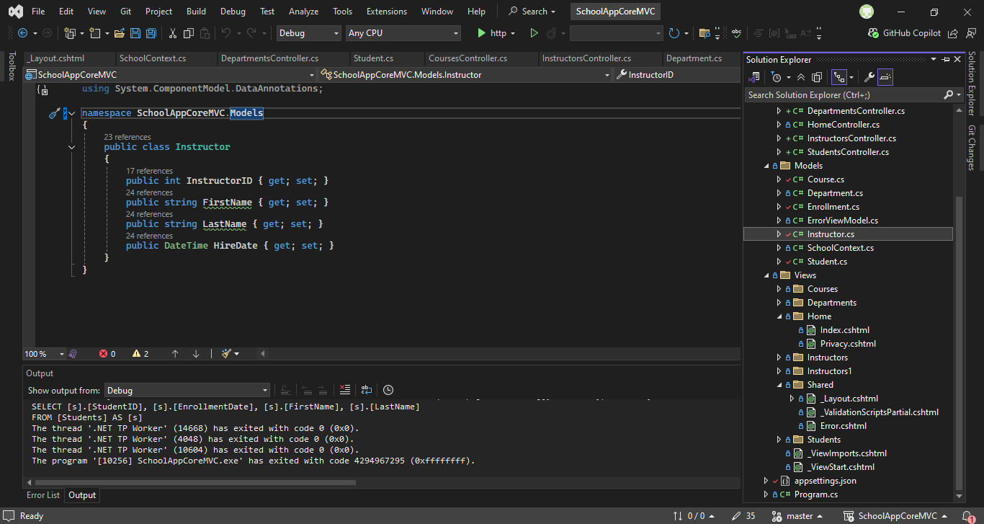

Figure 10 Creating Controllers and Views

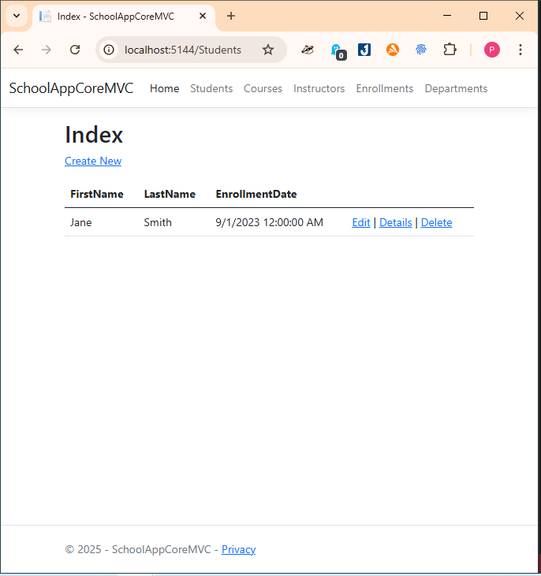

Figure 11 Testing the Application

Conclusion: Relatively easy to use and understand, the tutorial was concise and I learnt how to create an application using ASP.Net core. Still couldn’t create a report.