1. Project Overview
A two-player Tic Tac Toe game built with Angular for the frontend and .NET Core REST API for the backend. The backend handles game logic, state management, and persistence, while the frontend provides an interactive UI for players.

2. Tech Stack
- Frontend: Angular 21
- Backend: .NET 8 Web API
- Database: InMemory (default) or SQLite (optional persistence)
  - (EntityFrameworkCore 8.0.31)
- Tools: EF Core, Swagger for API documentation

3. Features Implemented
- Start a new game
- Make moves (X / O)
- Validate moves (no overwriting cells)
- Detect winner or draw
- Reset game
- REST API endpoints for game lifecycle
- Angular UI with interactive 3x3 grid

4. How to Run the Backend Locally

# Navigate to API project
cd TicTacToe.Api

# Restore dependencies
dotnet restore

# Run the API
dotnet run

# API will be available at:
https://localhost:5001/swagger
5. How to Run the Frontend Locally

# Navigate to Angular project
cd tic-tac-toe-ui

# Install dependencies
npm install

# Run Angular app
ng serve

# UI will be available at:
http://localhost:4200

6. API Endpoint Summary
Endpoint | Method | Description
/api/games | POST | Start new game
/api/games/{id} | Get | Get the game
/api/games/{id}/moves | POST | Make a move
/api/games/{id}/undo | POST | Undo current game last move
/api/games/{id}/reset | POST | Reset game
/api/scoreboard | Get | Get scoreboard
Api/scoreboard/reset | Post | Reset scoreboard

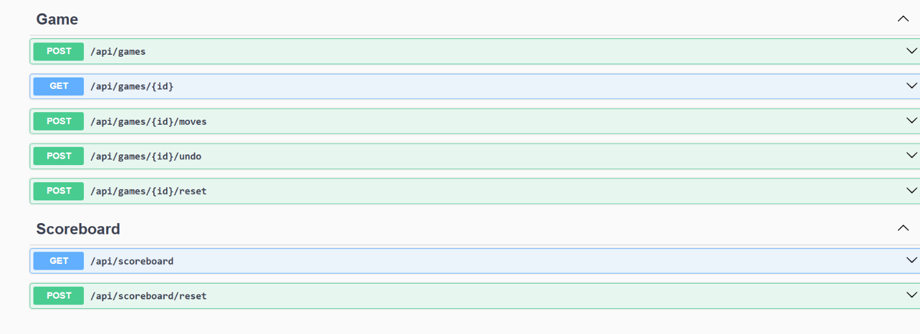

7. How to Run Tests
- Backend
cd TicTacToe.Api.Tests
dotnet test

- Frontend

cd tic-tac-toe-ui
ng test

8. AI Tools and Prompt Summary

- Used Microsoft Copilot to generate:
  - Backend API scaffolding (controllers, services, models).
  - Angular component/service code.

9. Design Decisions

- Separation of concerns: API and UI in separate solutions.
- Database choice: In Memory for simplicity, SQLite for persistence.
- REST API: Chosen for simplicity and stateless communication.
- Angular: Provides reactive UI and modular component design.
10. Clarifications and Assumptions

- Game is two-player only (no AI opponent).
- Moves are made sequentially (X always starts).
- Persistence optional (SQLite used only if needed).
- No authentication or user management implemented.

11. Known Limitations

- No multiplayer over network (only local play).
- No AI opponent mode.
- Limited error handling (e.g., invalid game IDs).
- Basic UI styling (no animations or advanced UX).

12. Future Improvements

- Add multiplayer support using SignalR for real-time play.
- Add AI opponent mode (minimax algorithm).
- Enhance UI with animations and responsive design.
- Add leaderboard and game history.
- Implement user authentication for personalized sessions.
- Deploy to Azure with CI/CD pipeline.
- Adding Dockerfile (image creation and enable containerization)

