# Kubernetes与Zun调度编排融合研发环境汇总

## Kubernetes环境部署文档

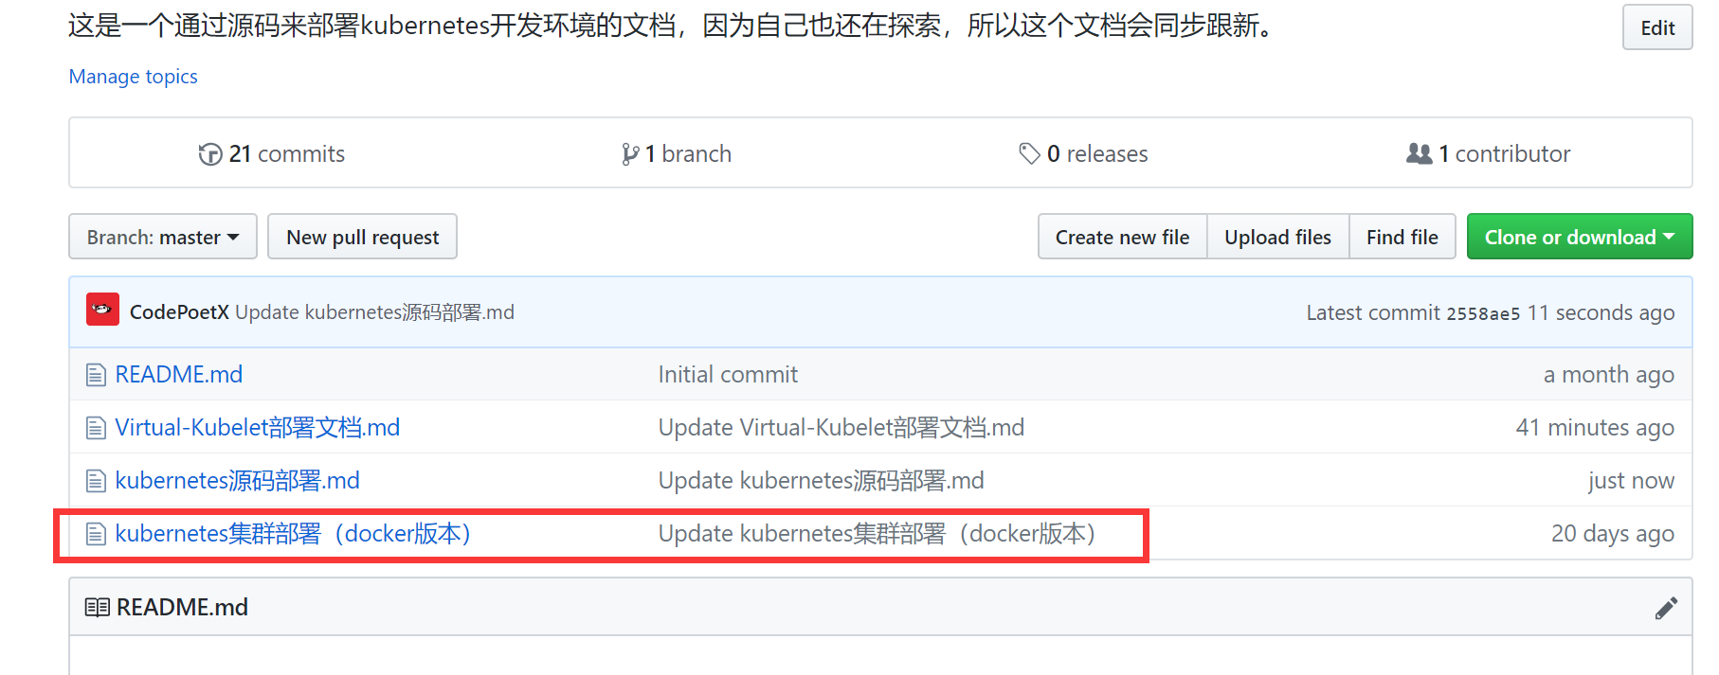

<https://github.com/CodePoetX/Kubernetes_Doc/blob/master/kubernetes%E9%9B%86%E7%BE%A4%E9%83%A8%E7%BD%B2%EF%BC%88docker%E7%89%88%E6%9C%AC%EF%BC%89>

## OpenStack Rocky版本环境部署文档

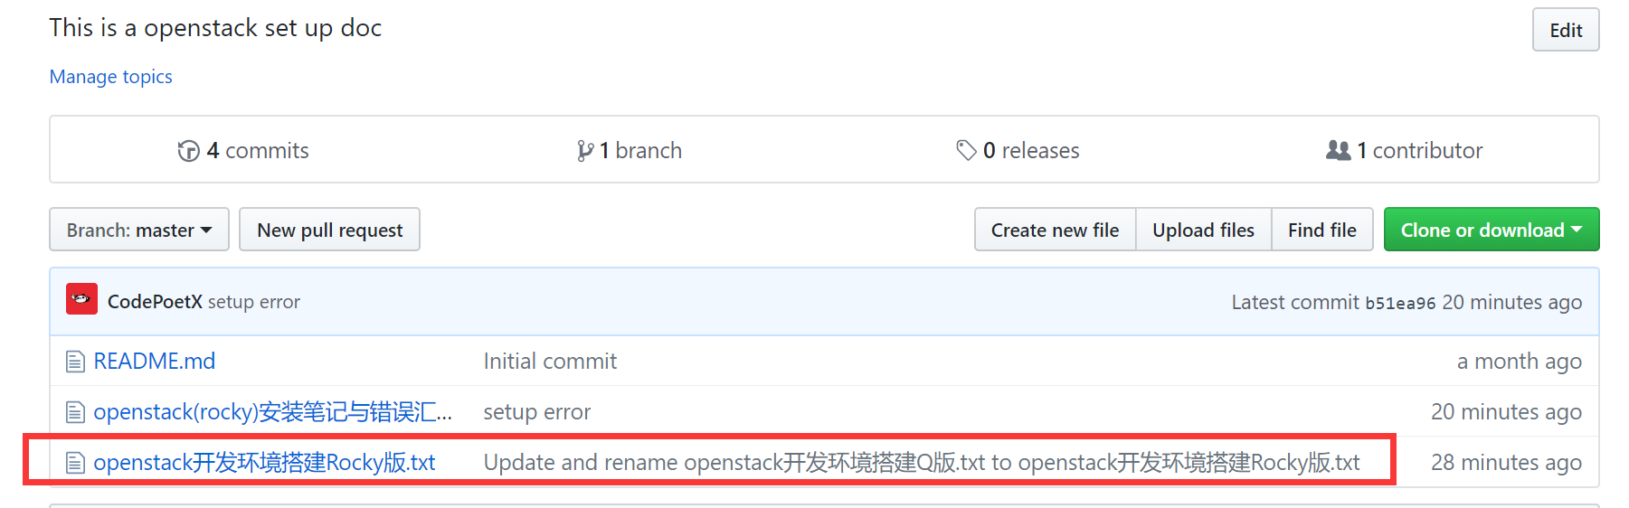

<https://github.com/CodePoetX/openstack_doc/blob/master/openstack%E5%BC%80%E5%8F%91%E7%8E%AF%E5%A2%83%E6%90%AD%E5%BB%BARocky%E7%89%88.txt>

## golang语言环境部署

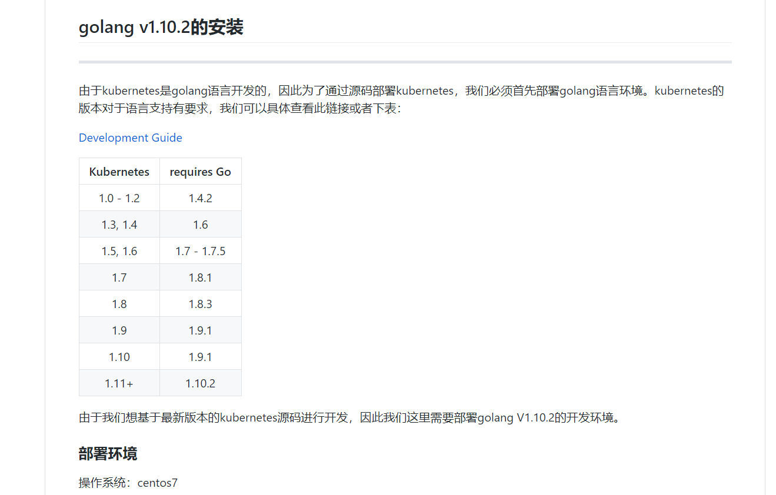

<https://github.com/CodePoetX/Kubernetes_Doc/blob/master/kubernetes%E6%BA%90%E7%A0%81%E9%83%A8%E7%BD%B2.md>

## Virtual Kubelet环境部署文档

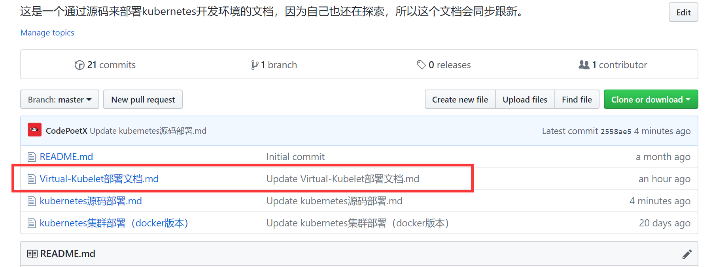

<https://github.com/CodePoetX/Kubernetes_Doc/blob/master/Virtual-Kubelet%E9%83%A8%E7%BD%B2%E6%96%87%E6%A1%A3.md>

## Virtual Kubelet源码clone地址

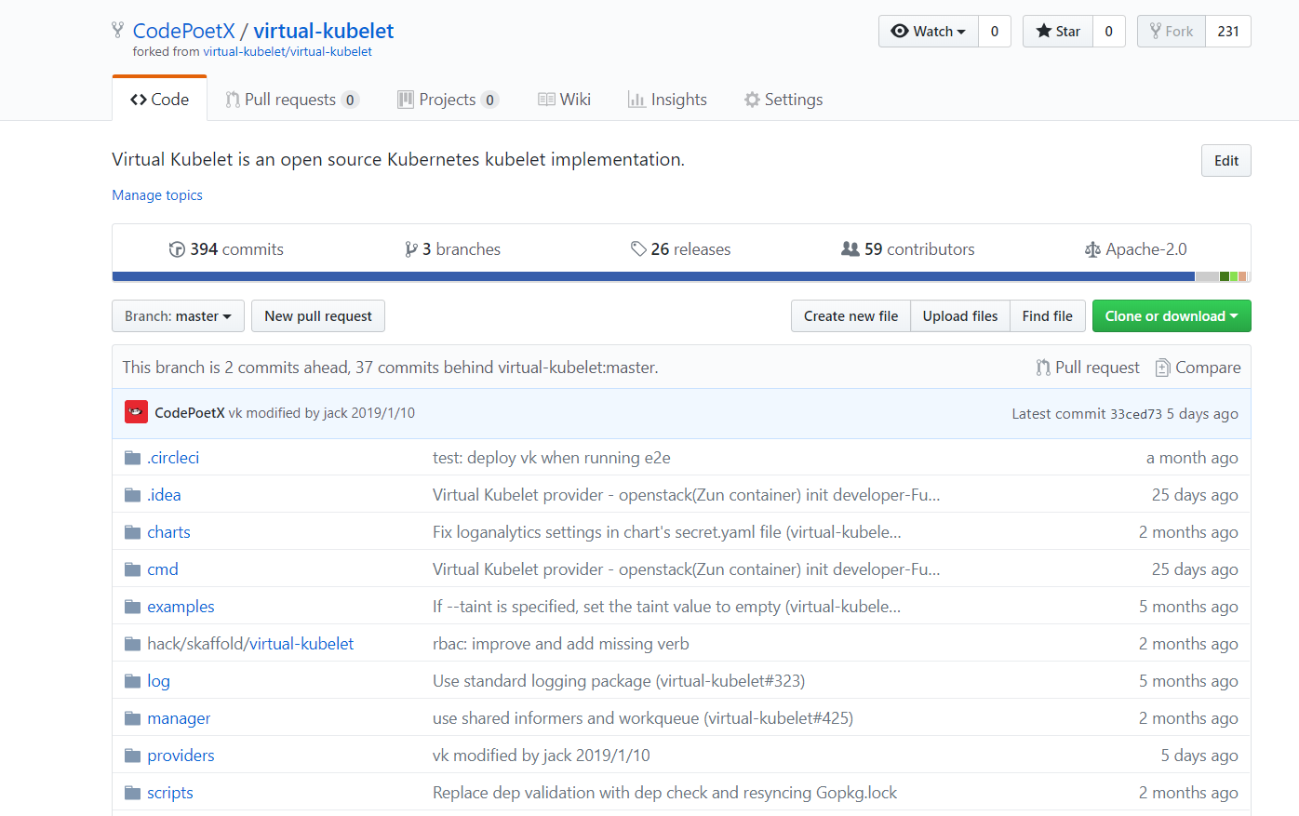

<https://github.com/CodePoetX/virtual-kubelet.git>

## Virtual Kubelet依赖的gophercloud项目clone地址

https://github.com/CodePoetX/gophercloud.git