**Requirements: (30 Points)**

1. Measure the ambient temperature using TMP 36 temperature sensor

2. Convert the analog voltage from the TMP 36 temperature sensor to a digital value using an MCP3008 ADC

3. Interface the ADC with the ESP8266 NodeMcu using the SPI bus

4. Calibrate the temperature sensor to read the right temperature

5. Interface an 128x64 OLED display with ESP8266 NodeMcu using the I2C bus

6. Display the ambient temperature in Celsius and Fahrenheit on the OLED display.

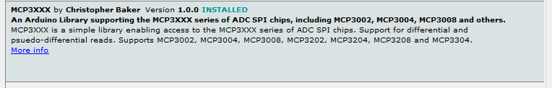

Interface the 128x64 OLED display with the ESP 8266 NodeMcu using the video https://www.youtube.com/watch?v=RpK7-Ljnpho

Ssd1306 not done

Tmp36 with mcp3008

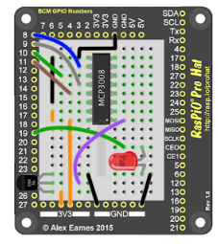

Oled with esp8266

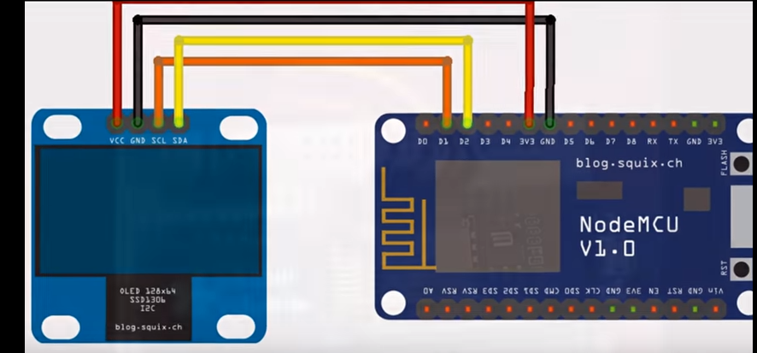

<https://www.youtube.com/watch?v=NGNNDz_ylzs>

<https://randomnerdtutorials.com/esp8266-0-96-inch-oled-display-with-arduino-ide/>

https://www.instructables.com/id/OLED-Interfaced-to-NodeMCU/