**CSCE 5550 Applications of Cryptography**

**Programming Project: “Password Manager”**

**Submitted by Kuntal Patel**

**Project Task:** Write a password manager program.

Short description and screenshots

How to run program

* Delete “passwords” file from the directory if present.
* On the command prompt run program from the same directory where the program is saved.
* Command: python filename websitename



* If program has no errors, you will see PASSMAN text symbol

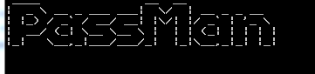

* Since we are first time running the program it will ask for master password, if we want to choose our own password type y. If we want randomly generated master password type n and program will generate random master password. After generation of master password next time program will directly ask for the master password.

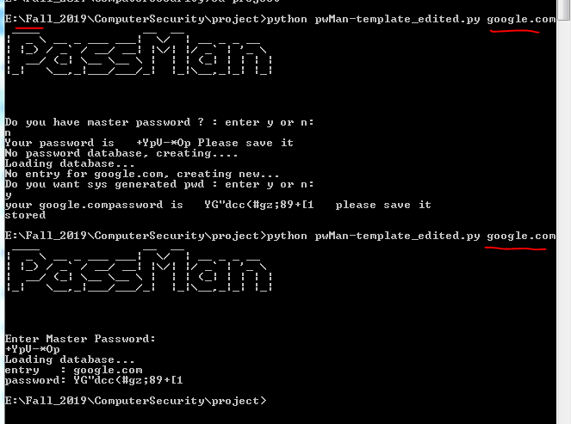

* For new entry, system will suggest random password or we can enter our own password and program will store it and retrieve as required in future.

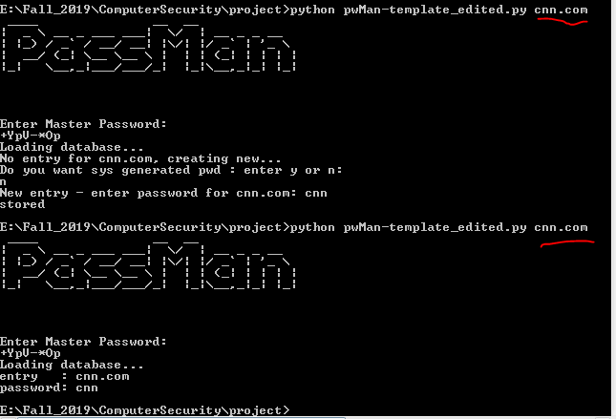

* Error handling when entering few arguments

