NPP波段信息

|  |  |  |  |  |
| --- | --- | --- | --- | --- |
| 用途 | 波段 | 中心波长  （μm） | 波段宽度  （μm） | 分辨率  （m） |
| Ocean Color Aerosol | M1 | 0.415 | 0.02 | 750 |
| M2 | 0.445 | 0.02 | 750 |
| M3 | 0.49 | 0.02 | 750 |
| M4 | 0.555 | 0.02 | 750 |
| Imagery band | I1 | 0.64 | 0.075 | 370 |
| Ocean Color Aerosol | M5 | 0.673 | 0.021 | 750 |
| Day/Night Band | DNB | 0.7 | 0.4 | 750 |
| Atmospheric Correction | M6 | 0.746 | 0.021 | 750 |
| NDVI | I2 | 0.865 | 0.039 | 370 |
| Ocean Color Aerosol | M7 | 0.865 | 0.039 | 750 |
| Cloud Particle Size | M8 | 1.24 | 0.02 | 750 |
| Cirrus Cloud Cover | M9 | 1.378 | 0.02 | 750 |
| Binary Snow Map | I3 | 1.61 | 0.06 | 370 |
| Snow Fraction | M10 | 1.61 | 0.06 | 750 |
| Clouds | M11 | 2.25 | 0.05 | 750 |
| Imagery band Clouds | I4 | 3.74 | 0.38 | 370 |
| Sea Surface Temperature | M12 | 3.7 | 0.18 | 750 |
| Sea Surface Temperature/Fires | M13 | 4.05 | 0.155 | 750 |
| Cloud Top Properties | M14 | 8.55 | 0.3 | 750 |
| Sea Surface Temperature | M15 | 10.763 | 1 | 750 |
| Imagery band Clouds | I5 | 11.45 | 1.9 | 370 |
| Sea Surface Temperature | M16 | 12.013 | 0.95 | 750 |

星地通文件解析

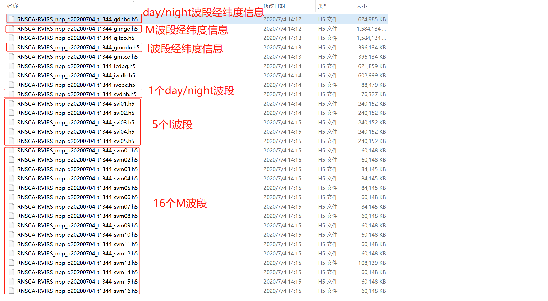

| **Primary Earth Data Records** | **Band Name** | **Center (microns)** | **Width (FWHM)** |
| --- | --- | --- | --- |
| Ocean Color Aerosol | M1 | 0.415 | 0.02 |
| M2 | 0.445 | 0.02 |
| M3 | 0.49 | 0.02 |
| M4 | 0.555 | 0.02 |
| Imagery band | I1 | 0.64 | 0.075 |
| Ocean Color Aerosol | M5 | 0.673 | 0.021 |
| Day/Night Band | DNB | 0.7 | 0.4 |
| Atmospheric Correction | M6 | 0.746 | 0.021 |
| NDVI | I2 | 0.865 | 0.039 |
| Ocean Color Aerosol | M7 | 0.865 | 0.039 |
| Cloud Particle Size | M8 | 1.24 | 0.02 |
| Cirrus Cloud Cover | M9 | 1.378 | 0.02 |
| Binary Snow Map | I3 | 1.61 | 0.06 |
| Snow Fraction | M10 | 1.61 | 0.06 |
| Clouds | M11 | 2.25 | 0.05 |
| Imagery band Clouds | I4 | 3.74 | 0.38 |
| Sea Surface Temperature | M12 | 3.7 | 0.18 |
| Sea Surface Temperature/Fires | M13 | 4.05 | 0.155 |
| Cloud Top Properties | M14 | 8.55 | 0.3 |
| Sea Surface Temperature | M15 | 10.763 | 1 |
| Imagery band Clouds | I5 | 11.45 | 1.9 |
| Sea Surface Temperature | M16 | 12.013 | 0.95 |