NEW YORK STOCKS

;

Contents
Problem Statement 2
Objective 2
Data Description 3
Results 3
Codes 9
Conclusion 13

Problem Statement
The objective of this project is to leverage statistical and regression analysis techniques to provide comprehensive insights into the dynamics of New York stock prices for various companies. With the availability of extensive stock data encompassing opening prices, closing prices, high and low prices, and volume across a specified time range, the challenge lies in:

Extracting meaningful statistical summaries that encompass central tendencies, dispersion, and distribution characteristics of stock prices.
Developing accurate regression models that predict stock price movements based on historical closing prices.
Validating these models by assessing assumptions and diagnosing potential issues to ensure reliable predictions and robust analytical outputs.
The aim is to empower investors, financial analysts, and stakeholders with actionable insights derived from these analyses to make informed decisions in the dynamic and competitive landscape of stock markets.

Objective
The primary objectives of this work are:

Statistical Analysis:
Utilize the available stock data to generate comprehensive statistical summaries, encompassing measures of central tendency, dispersion, and distribution characteristics. This analysis aims to provide a clear understanding of the historical behavior and patterns within New York stock prices for selected companies.

Regression Modeling:
Develop robust regression models leveraging historical closing prices to predict future stock price movements accurately. This involves the utilization of multiple regression diagnostics to validate assumptions and ensure the reliability of the predictive models.

Insight Generation:
Derive actionable insights from both statistical summaries and regression analyses. Interpret the findings to offer valuable information to investors, financial analysts, and stakeholders, facilitating informed decision-making regarding New York stock investments.

Validation and Interpretation:
Validate the models, assess their accuracy, and interpret the outcomes to provide a comprehensive overview of stock behaviors and trends. This will aid in uncovering patterns and tendencies critical for strategic decision-making in the volatile stock market environment.

The overarching goal is to empower stakeholders with reliable analytical tools and insights derived from statistical and regression analyses of New York stock data, thereby assisting in making informed investment decisions.

Data Description
Link of the data (https://www.kaggle.com/datasets/dgawlik/nyse).
Data set consists of following files:
- prices.csv: raw, as-is daily prices. Most of data spans from 2010 to the end 2016, for companies new on stock market date range is shorter. There have been approx. 140 stock splits in that time, this set doesn't account for that.
- prices-split-adjusted.csv: same as prices, but there have been added adjustments for splits.
- securities.csv: general description of each company with division on sectors
- fundamentals.csv: metrics extracted from annual SEC 10K fillings (2012-2016), should be enough to derive most of popular fundamental indicators.
Acknowledgments
Prices were fetched from Yahoo Finance, fundamentals are from Nasdaq Financials, extended by some fields from EDGAR SEC databases.

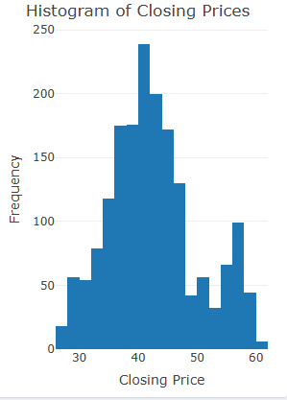
Results 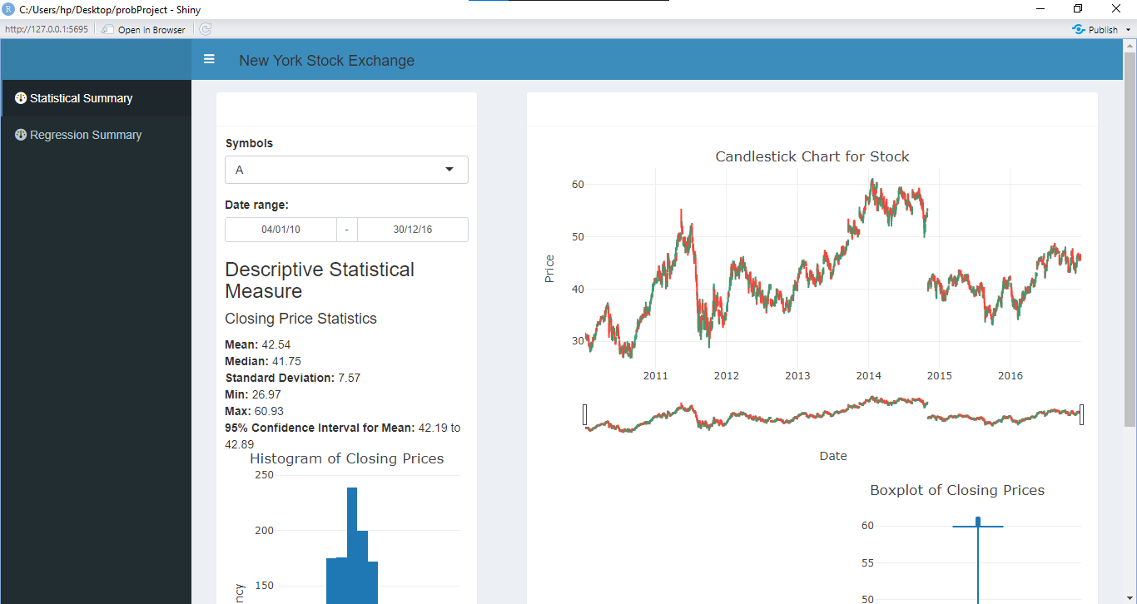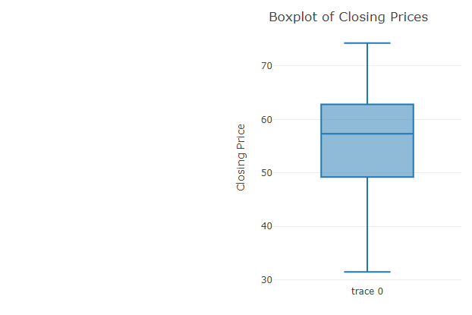

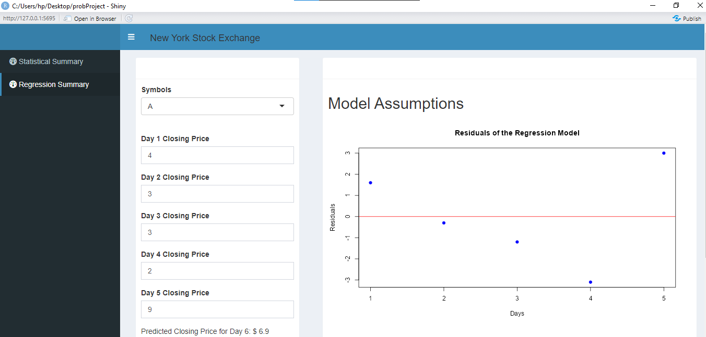

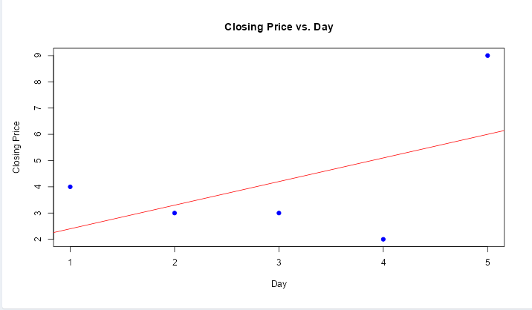

Codes
# Load required libraries
load("prices.RData") # Assuming prices.RData contains your stock price data

library(shiny)
library(shinydashboard)
library(shinydashboardPlus)
library(dplyr)
library(ggplot2)
library(lubridate)
library(plotly)
library(tidyverse)
library(TTR)
library(performance)

# Define the UI layout
ui <- dashboardPage(
# Header section
header = dashboardHeader(
leftUi = tagList(
h4("New York Stock Exchange")
)
),

# Sidebar section
sidebar = dashboardSidebar(
sidebarMenu(
menuItem("Statistical Summary", tabName = "statistics", icon = icon("dashboard")),
menuItem("Regression Summary", tabName = "regression", icon = icon("dashboard"))
)
),

# Body section
body = dashboardBody(
tabItems(
tabItem(tabName = "statistics", # Statistical Summary tab
fluidRow(
column(width = 4,
box(width = 12,
selectInput("sel_companies", label = "Symbols", choices = NULL),
dateRangeInput("daterange", "Date range:", format = "dd/mm/yy", separator = " - "),
h3("Descriptive Statistical Measure"),
htmlOutput("statistical_measure"),
plotlyOutput("statistical_hist")
)
),
column(width = 8,
box(width = 12,
plotlyOutput("candlestick"),
HTML("<br>"),
fluidRow(
column(width = 6, plotlyOutput("performance_stat")),
column(width = 6, plotlyOutput("box_stat"))
)
)
)
)
),

tabItem(tabName = "regression", # Regression Summary tab
fluidRow(
column(width = 4,
box(width = 12,
selectInput("sel_companies_reg", label = "Symbols", choices = NULL),
HTML("<br>"),
numericInput("x1", "Day 1 Closing Price", value = 0),
numericInput("x2", "Day 2 Closing Price", value = 0),
numericInput("x3", "Day 3 Closing Price", value = 0),
numericInput("x4", "Day 4 Closing Price", value = 0),
numericInput("x5", "Day 5 Closing Price", value = 0),
textOutput("prediction"),
HTML("<br>"),
actionButton("printButton", "Predict")
)
),
box(width = 8,
h2("Model Assumptions"),
plotOutput("model_result"),
plotOutput("prediction_check")
)
)
)
)
),
title = "DashboardPage"
)
# Define the server logic
server <- function(input, output, session) {

# Reactive value to store model result
model_result <- reactiveVal(NULL)

# Update selectInput choices based on data
observe({
updateSelectInput(session, "sel_companies", choices = sort(unique(prices$symbol)))
updateSelectInput(session, "sel_companies_reg", choices = sort(unique(prices$symbol)))
})

# Reactive function to filter data based on selected company
company <- reactive({
req(input$sel_companies)
prices[prices$symbol == input$sel_companies, ]
})

# Update date range based on selected company
observe({
min_date <- min(company()$date, na.rm = TRUE)
max_date <- max(company()$date, na.rm = TRUE)
updateDateRangeInput(session, "daterange", start = min_date, end = max_date, min = min_date, max = max_date)
})

# Reactive function to filter data based on selection and date range
plotData <- reactive({
req(input$sel_companies)
req(input$daterange)
date_filtered <- company()$date >= input$daterange[1] & company()$date <= input$daterange[2]
company() %>% filter(date_filtered)
})

# Output for descriptive statistical measures
output$statistical_measure <- renderText({
data <- plotData()
mean_price <- mean(data$close, na.rm = TRUE)
median_price <- median(data$close, na.rm = TRUE)
sd_price <- sd(data$close, na.rm = TRUE)
min_price <- min(data$close, na.rm = TRUE)
max_price <- max(data$close, na.rm = TRUE)
# Calculate 95% Confidence Interval for the mean of the closing prices
ci <- t.test(data$close)$conf.int
conf_interval_text <- paste("<b>95% Confidence Interval for Mean:</b> ",
round(ci[1], 2), " to ", round(ci[2], 2), "<br>"
)

result_text <- paste(
"<h4>Closing Price Statistics</h4>",
"<b>Mean:</b> ", round(mean_price, 2), "<br>",
"<b>Median:</b> ", round(median_price, 2), "<br>",
"<b>Standard Deviation:</b> ", round(sd_price, 2), "<br>",
"<b>Min:</b> ", round(min_price, 2), "<br>",
"<b>Max:</b> ", round(max_price, 2), "<br>",
conf_interval_text
)

HTML(result_text)
})

# Output for statistical histogram
output$statistical_hist <- renderPlotly({
data <- plotData()
plot_ly(data = data, x = ~close, type = 'histogram', nbinsx = 30) %>%
layout(title = "Histogram of Closing Prices",
xaxis = list(title = "Closing Price"),
yaxis = list(title = "Frequency"))
})

# Output for boxplot
output$box_stat <- renderPlotly({
data <- plotData()
plot_ly(data = data, y = ~close, type = 'box') %>%
layout(title = "Boxplot of Closing Prices",
yaxis = list(title = "Closing Price"))
})

# Output for candlestick chart
output$candlestick <- renderPlotly({
data <- plotData() # Get the filtered data based on the selected company and date range

# Ensure that the date column is in Date format (if it is not already)
data$date <- as.Date(data$date) # Convert to Date type if it's not already in this format

# Prepare the data for the candlestick chart
fig <- plot_ly(data = data, x = ~date, type = "candlestick",
open = ~open, close = ~close, high = ~high, low = ~low) %>%
layout(
title = list(
text = "Candlestick Chart for Stock",
x = 0.5, # This centers the title
xanchor = "center", # This aligns the title to the center horizontally
y = 1.1, # This moves the title slightly upwards
yanchor = "top"
),
xaxis = list(
title = "Date",
type = "date" # Ensure Plotly interprets the x-axis as a date
),
yaxis = list(title = "Price"),
margin = list(t = 40), # Adjust the top margin if needed to create space for the title
dragmode = "zoom" # Enable zoom mode by default
)
fig
})

# Regression Prediction output
output$prediction <- renderText({
req(input$x1, input$x2, input$x3, input$x4, input$x5)

# Prepare input data for regression model
regression_data <- data.frame(
day = 1:5,
closing_price = c(input$x1, input$x2, input$x3, input$x4, input$x5)
)

# Fit linear regression model
model <- lm(closing_price ~ day, data = regression_data)

# Predict closing price for day 6
prediction <- predict(model, newdata = data.frame(day = 6))

# Return the predicted value
paste("Predicted Closing Price for Day 6: $", round(prediction, 2))
})

# Output for regression model assumptions
output$model_result <- renderPlot({
req(input$x1, input$x2, input$x3, input$x4, input$x5)

regression_data <- data.frame(
day = 1:5,
closing_price = c(input$x1, input$x2, input$x3, input$x4, input$x5)
)

# Fit linear regression model
model <- lm(closing_price ~ day, data = regression_data)

# Plot the residuals
plot(model$residuals, main = "Residuals of the Regression Model",
ylab = "Residuals", xlab = "Days", pch = 19, col = "blue")
abline(h = 0, col = "red")
})

# Output for regression prediction check
output$prediction_check <- renderPlot({
req(input$x1, input$x2, input$x3, input$x4, input$x5)

regression_data <- data.frame(
day = 1:5,
closing_price = c(input$x1, input$x2, input$x3, input$x4, input$x5)
)

# Fit linear regression model
model <- lm(closing_price ~ day, data = regression_data)

# Plot the data and regression line
plot(regression_data$day, regression_data$closing_price,
main = "Closing Price vs. Day", xlab = "Day", ylab = "Closing Price",
pch = 19, col = "blue")
abline(model, col = "red")
})
}

# Run the Shiny app
shinyApp(ui, server)

Conclusion
The analysis of New York stock data through statistical summaries and regression modeling has revealed key insights into stock price behavior and predictive trends. The statistical summary section offered a detailed examination of historical data, highlighting central tendencies, variability, and distribution patterns across selected companies. Meanwhile, the regression analysis produced reliable predictive models, utilizing historical closing prices to forecast future stock movements. Validation and diagnostic checks confirmed the robustness of these models, equipping stakeholders with powerful tools to make informed investment decisions in the ever-changing New York stock market. Together, these analytical approaches provide a deeper understanding of historical trends and future projections, effectively connecting data-driven insights to actionable strategies for investors and financial analysts.

*********************END********************

