Answer all the following questions in “one word document named properly to reflect your name + course code with section + week of the course + file contents”.

🡺 Please keep only these portions of the document with your answers.  
 **Kindly delete the instructions and notes.   
 −20% cost if you make me wade through all the stuff you were asked to delete.**

**Part 1: Compression (40 points)**

* Explore file compression using the [ substitution token 🡪 original character string ] dictionary ideas in the lecture notes. The total text of this nursery rhyme is 187 characters including a trailing space after each word:

**the itsy bitsy spider crawled up the water spout**

**down came the rain and washed the spider out**

**out came the sun and dried up all the rain**

**and the itsy bitsy spider went up the spout again**

Copy the four lines of the above rhyme to a new MS-Word document (Ctrl-N).  
In the bottom left of the Word display, click “38 words”.  
It should have 187 characters with spaces.



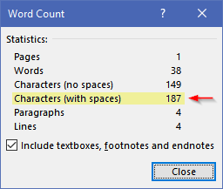

This may help with your substitution analysis:

* copy the rhyme to another new document (Ctrl-N) used only for investigation
* Find and Replace a **space** with a **space** **+ paragraph marker** **^p** (Ctrl+H)  
  Find what: □ Replace with: □^p   
  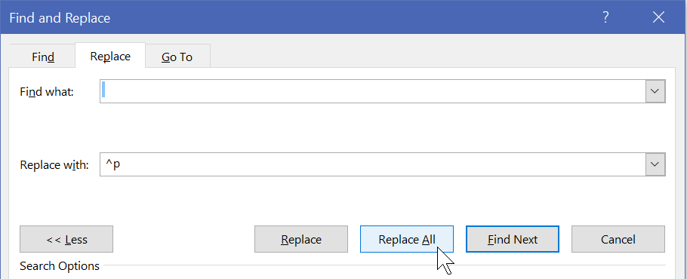
* Then sort the lines to see repeating words. (Alt H S O)  
  

Sort by Paragraphs resulting in the rhyme's words, one per line, in alphabetical order;   
this makes it easy to see repeating words: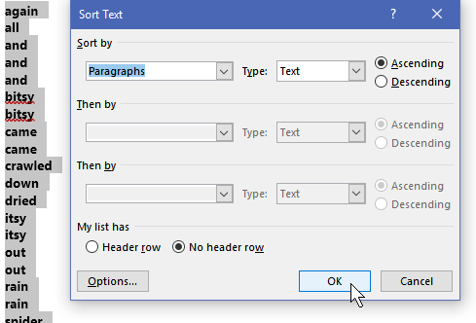

Anything occurring only once is not worth substituting with a token and including in the dictionary; you will just be adding two characters (the tokens) to the file. Any string with a length of 2 or 3 and occurring only twice is similarly not worth it.

Here is an example of saving many characters with two repeating words including their trailing spaces ("the ", "and ") replaced by tokens (!,@) along with the dictionary entries:

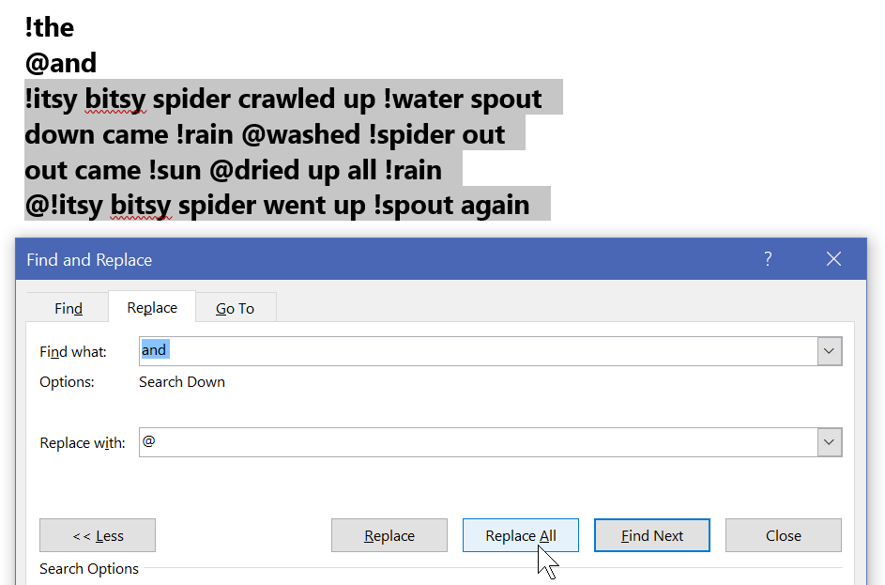

**FYI, this is the formula for characters saved:**  
For the ***length*** of any string occurring ***n*** times and replaced by a single character token:

Saving ***n*** occurrences * ***length*** costs the dictionary entry (token char + string ***length***) plus the ***n*** token placeholders in the data stream.

e.g. "the " occurs 8 times with a length of 4 including the trailing space (32 characters)  
less the compression overhead of a 5 char dictionary entry + 8 tokens (13 characters)  
is 32 original less 13 overhead = 19 characters saved.

**How much more can you compress the text?**

* Use digits and the special characters on the shifted top row for tokens: **1234567890!@#$%&*()_+** Note: do not use **^**, it is a Microsoft escape char.
* Do not type a 🡪 separator in the *token🡪string* dictionary entries because it will inflate your character count. Software would read the first column as the substitution token, and the original character string starting in column 2 to end-of-line. Do this: **\*the**
* Copy & Paste into this document:  
  🡺 your dictionary of token🡪string characters, one entry per line.  
  🡺 rhyme with the token substitutions, i.e. the compressed text  
  🡺 how many characters are in the dictionary + compressed text and   
  what is it as percentage of the original’s 187?   
  🡺 Now test your compression algorithm by decompressing and pasting the decompressed version below. All algorithms must be tested. How did that work out?

**Part 2:** For this part of the activity, complete the following:

* If it is not already there, extract / decompress the files in this week’s activity .zip archive to your Desktop.
  + Remember that compressed files must be decompressed before they can be used. Windows does this automatically into the %temp% folder if you open a file directly from a .zip archive.
* Download this week’s PowerPoint slides and save to your Desktop folder
  + open it, File menu, Save As, PDF (*.pdf)
  + File menu, Save As, PowerPoint 97-2003 Presentation (*.ppt)  
    *If you see the Microsoft PowerPoint Compatibility Checker, click Continue.*

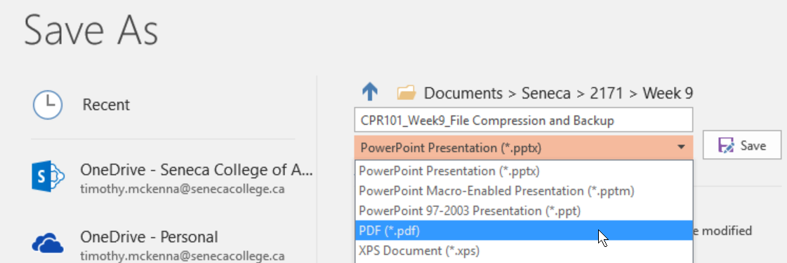

Compress all files from your Desktop folder into a zip archive:

* select the files then right click and use the   
  S*end to* > *Compressed (zipped) folder* option or use 7zip.

Open the .zip archive with Windows Explorer.   
Use the Snipping Tool ( + “snip”) to copy only the information seen below.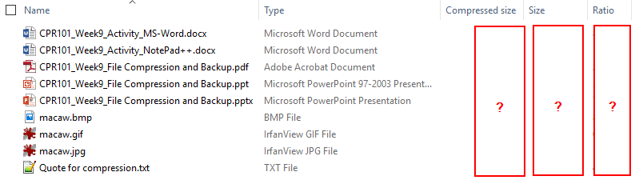

The compression ratio is (1 – compressed / original size) showing the space saved by the zipping, i.e. compressing, the original files into the archive.

FYI: opening the .zip archive with 7zip will show exact bytes for original Size and Packed (compressed) size. 7zip does not show the compression ratio.

Paste the image of the Windows Explorer .zip archive information here…

Use the Snipping Tool ( + “snip”) to copy only the information seen above.

**🡺**

What do the compression ratio percentages tell you about the contents of the different kinds of files? Were some of the files already compressed in their original format before zipping tried to compress them further? Which files do you think were already compressed? **(10 points)  
🡺**

The files with high Ratios were compressed the most. Which files were they? Why were they compressed the most? **(10 points)**See <https://www.noupe.com/design/everything-you-need-to-know-about-image-compression.html>   
🡺

**Part 3: Backup**

* In order to preserve important information from accidental deletion, make a copy in a geographically separate location on an independent platform. One option would be to store your data, somewhere on the college’s network such as the matrix server or Office 365's OneDrive. Because you are likely already signed on to Blackboard, try out the content area of Blackboard.
  1. Login to Blackboard in case you are not.
  2. Click on the Content System tab near the top right
     1. You may need to click on Users and click on your name
  3. From the menu under “My Content”, click on Create Folder
  4. Name the folder CPR101_Activities and click Submit
  5. Click on the new folder to open it up
  6. Select Upload, then select Upload Files from the menu  
     

You can upload one file at a time or all the files contained in a Zip file.  
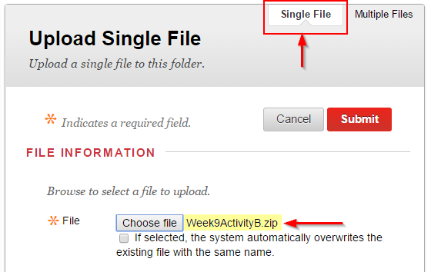

* 1. Browse your CPR101 files and upload something to the folder, e.g. the zip archive you created in Section B…being compressed and a single file upload, it would take the minimum amount of time.   
       
     Congratulations. You just backed up something to the “cloud”.

🡺 paste a screen shot of your backup results. (Alt-PrtScn or use the Snipping Tool) **(10 points)**

**Imagine your laptop just stopped working and could not be restarted** after you completed a great many hours of work today and yesterday. What is (or what should have been) your backup & restore strategy? How does your strategy address the 3 characteristics of a real backup? How does your strategy fulfill the 3-2-1 backup check? Replacing a machine is more than just restoring your lost data files. What about the Operating System and the applications which process those files? How long would this all take…and what if you a had a big assignment due tomorrow? **(30 points)**🡺