* **TL;DR**   
  ICT is a discipline which often needs much explanation (ICT = Information and Communications Technology, TL;DR = Too Long; Didn't Read) and always requires attention to detail such as reading all the documentation *carefully*. **If ICT was simple, easy, and quick, no one would pay us to do it.** CPR101 is no exception and you are being paid to do it, paid in marks, but paid nonetheless.
* The School of ICT tries to be operating system agnostic. We believe in the existence of one true and [eternal](https://en.wikipedia.org/wiki/Halting_problem) [Turing Machine](https://en.wikipedia.org/wiki/Turing_machine). When it comes to implementation, faith and beliefs may vary but all are respected.
* There are times when affiliation with a particular operating system is necessary and when it is, CPR101 uses Microsoft Windows. Hello, Apple macOS people, welcome…we mean you no harm. That goes for you Linux gurus, too. We admire Apple users for their good taste in hardware and Linux geeks for their virtue of nerdiness. Windows runs 82.45% to 88% of the desktop/laptop market worldwide and macOS is 9% to 12.64%. However Microsoft PCs dominate in the business world.
* You do not need a personal Windows machine to be successful at Seneca. Our programs cover all major Operating Systems (IBM, *nix, Windows, with some Apple specific courses); Seneca labs give you access to all OS flavours. There will be times when it is necessary to work on the native OS platform or at least within a virtual Windows machine.
* There are many steps in the first two weeks of CPR101 activities all of which are specific to Windows and can be completed on Seneca lab PCs.
* For weekly CPR101 activities, copy the 🡺 *questions* into a Word document and answer them as best you can.   
  Remove the instructions not part of the 🡺 question…such as the notes on this on this page.
* The suggested format of your document’s filename is  
  *your-SenecaID*_course code_W*nn*_*content*.docx   
  where W*nn* is the week number and *content* describes what is in the file, e.g.  
   *tmckenna*_CPR101_W*01_FileSystems-VisualStudio*.docx  
  It's a good file name if, six months from now, you don't have to open it to know what's in it.
* Submit an MS Word (or PDF) document to Blackboard Assignments via the weekly topic link. Activities are due by the end of your class's calendar day at 23:59. Keep only the 🡺questions and your answers. Delete all the explanatory steps (such as this).
* Please submit either a Word .docx file or a PDF file; your instructor will charge you 20% for the effort of dealing with anything else. No need to enter any "Submission Text" comments...they just slow down both our processes.
* **Note for any course**: answers copied and pasted from Internet sites without proper citation and referencing or copied from another student will result in zero marks **FOR THE ENTIRE SUBMITTED WORK** and may be subject to Academic Honesty review. Please DO discuss details of the activity with your colleagues and instructor but create the answer in your own words according to your own understanding.   
  The rule is: you can talk all you want but don’t copy/paste anything without attribution.
* Ensure you are working with the unzipped files from the downloaded Blackboard zip file. Extract the files from the zip archive to a Desktop or Download folder and then delete the .zip file to avoid confusion. (Yes, you can double click to open a file within the zip archive—the OS automatically decompresses it to a deeply buried temporary work folder—but you cannot easily do the following activity with those temp files.)
* Submit the Word document with your answers through my.senecacollege.ca (Blackboard) — click on this week’s topic link and submit the assignment.  
  Week 1 File Systems and Visual Studio  
  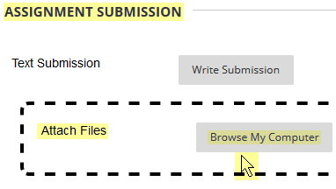

**Part 1: Visual Studio Community introduction**

Complete the Visual Studio project creation and Hello World program using the Visual Studio 2017 IDE (Integrated Development Environment)  
See the CPR101_Week1_VS_2017 demo.docx.

*The Visual Studio Community IDE used and needed for IPC144 runs only in a Windows operating system. There is a "Visual Studio for macOS" and "Visual Studio Code" for all OSs but those products are more similar in name than in substance. (Microsoft would not maintain three different products if they were all the same.) By a wide margin, Visual Studio is the IDE most used by professional developers; VS supports many target environments, not just Microsoft Windows platforms.*

Remove the instructions before you submit. Keep only the 🡺questions and your answers. (**Delete this line and all that came before it.)**

🡺 Where is the helloWorld.c source file? Copy its full path and paste here. (20 marks)

*(Hints at using File Explorer to find it are in the VS demo document.)*

🡺 What is the content of your helloWorld.c source file? Your source code, of course.  
Copy & Paste the text from your Visual Studio editor into your answers document. (20 marks)

**Part 2: Proper naming convention and having correct file extensions**

**In this activity, four files can be found in the “CPR101_Week1_Activity_WorkFiles” subfolder. Those files all have the wrong file extension. Your task is to add the correct extension to those file names so the system can properly process those files.**

* + **IF** the filename extensions are **not** being displayed in File Explorer:

1. Press Alt-V to activate the View menu: 
2. 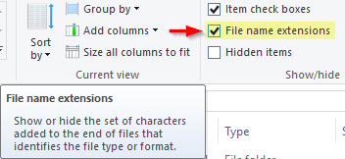Click to turn on the display of  
   "File name extensions"

Normally, when you right-click a file, a number of options are available to process that file. E.g. Preview, Open, Open with > [optional applications]. These options are based on the file’s extension which the system relates to an application. Double clicking a file name opens it using the default application.

File**.txt ⇨** Notepad File**.html ⇨** Web Browser  
File**.bmp ⇨** Paint graphics File**.jpg ⇨** Windows Picture Viewer

**IF,** when you open or double click a file and you see the error message "This app can't be activated when UAC is disabled", **then** Windows security is preventing automatic execution of the associated application. **In this case,** click and drag the file from File Explorer and drop it into a Firefox browser tab; any browser can render any of these file types but only if the file’s content matches its file extension. Firefox gives the best feedback when there is a problem.If nothing happens when you click and drag, you are probably dragging a compressed file from the .zip. Software works only with uncompressed files.

🡺 What happens when you drop the file into Firefox? It will not be as you might expect from the file extension. (10 marks)

* + lunamoth.bmp **🡪**
  + lunamoth.html **🡪**
  + lunamoth.jpg **🡪**
  + lunamoth.txt **🡪**

**Open these files with Notepad or Notepad++ to inspect their content:**   
Start Notepad ( + “Notepad”), then click and drag the file from File Explorer into Notepad. This will give a clue to the file’s contents.

* + The first 3 bytes of a **JPEG** (.jpg) photo file begin with “**ÿØÿ**”
  + The first 2 bytes of a **bitmap** (.bmp) graphics file begin with “**BM**”
  + Web pages are text files with **HyperText Markup Language** (.html, .htm). They begin with “**<!DOCTYPE html>**” and/or “**<html … >**”.
  + Text files (.txt) can contain any characters but usually contain human readable information.
    - Reference https://en.wikipedia.org/wiki/List_of_file_signatures

Now, rename each file **adding** the proper extension until all four files open correctly. You should be able to see text and photos. e.g. rename **lunamoth.bmp** to **lunamoth.bmp.???** in order to keep track of which extension was renamed to another extension. Only the last extension on a file’s name is used by the operating system.

🡺 What are the new names of the files? **(10 points)**

* + lunamoth.bmp.***???***
  + lunamoth.html.***???***
  + lunamoth.jpg.***???***
  + lunamoth.txt.***???***

🡺 What does this experience tell you about the importance of file names and their extensions? **(10 points)**

**Part 3: Working with a removable USB drive and a local drive while doing common file/directory operations**  **(10 marks)**

* + Open Filer Explorer and navigate to your folder containing the above Week 1 files.

In the left hand pane within the folder tree and using right-click…

* + Create a new folder somewhere on the C: drive, e.g. under Desktop or Downloads.
  + Create a new folder on your USB drive—or the T: drive on a lab PC if you don't have a USB drive (*get one soon*)

🡺 What happens when you select the lunamoth files in your original folder, then drag them to the new folder on your USB drive or the T: drive, i.e. when the target drive is different from the source drive?

🡺 What happens when you select the lunamoth files in your original folder, then drag them to the new folder on the C: drive, i.e. when dragging to a different folder within the same drive?

🡺 Does the file still open properly after you change the filename of a file on the USB or T: drive, then click, drag, and drop into a Firefox tab?

🡺 After deleting a file, can you restore it? How?

🡺 Did any of these operations have an effect on the original files?

**Part 4: Backing up your files**

A backup is two copies in separate geographic locations on independent systems.

Use the browser to open the **Content System** in Blackboard   


It is a simple repository where you can store folders and files.

Storage is also available by going to **mySeneca.ca** and opening OneDrive.   
Click on the grid in the top left to open the menu and click on OneDrive.  
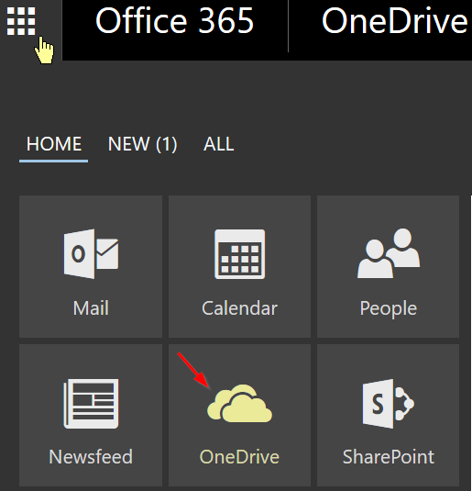

For the next question, if you do not have a USB drive with you, just work with OneDrive in Office 365 and the Blackboard Content System.

🡺 (20 marks in total for the following)

* + Can you work with files (e.g. edit a text.txt or source.c file ) …
    - directly on your USB drive?
    - directly in the Content System?
    - directly on OneDrive?
  + Is it worth the effort to copy the files and directories from the USB drive (or Content System or OneDrive) to the local drive, work with and save them locally, and then transfer local files back? What are the benefits and risks in having the same file on your local system and on a removeable drive or remote system?
  + What about backup…do you have two copies of your files in geographically separate locations on independent systems? Where?
  + Make sure you have a proper backup before doing this:  
    What happens when the lab PC is restarted (not just logged off)?
  + After the lab PC has been restarted (or if using your own PC), do you now have **two copies** of today's files in **separate geographic locations** on **independent** systems?   
    *If not, do what you need to do so that you can honestly answer "yes".*  
    N.B. *two* way synchronization of your PC's files with a cloud data service makes your system *interdependent* with the cloud; although separated by geography, you have one file in two places and that's not a copy.

**USB flash drives are wonderfully portable which makes them easily losable.** If you do lose your drive, usually by forgetting it in the lab PC, how will it ever get back to you?

*Little Bo-Bleep  
has lost her USB-flash-drive-with-files-on-each-of-her sheep,  
And doesn't know where to find it;  
Without her name,  
Home ne'er it came,  
But would have if she had signed it.*

(Sadly, she didn't have a backup.)

* Rename your USB drive's volume label to your name.
* Put a !!_PLEASE_RETURN_TO_!!.txt file in the root with your email address, contact information, and a nice message promising a reward coffee.
* And it just might come home wagging its data behind it.