**Case Study: Seneca Insurance Company**

The Seneca Insurance Company is a small business, with 61 employees, located in the greater Toronto area.  The company is well established with many long-time customers who like the personal service Seneca provides. The customer base has steadily grown. The business is run using Windows 7 desktops connected in a workgroup (Microsoft’s peer-to-peer local area network) using MS-Office products (Word, Excel, and Access) for record keeping. These are no longer adequate tools with which to run the business.

Customers call the office when they need to make a claim on their insurance policy. Claims representatives take calls as they come in, search for customer records and files within the workgroup, and initiate a claim. When not taking calls, claims representatives are reviewing customer records, following up on claims files in process, and sending out policy renewal notices to customers.

The Microsoft workgroup had acceptable performance when the company had only 12 employees. Searches for customer records and files were completed within seconds. With five times as many desktops, searches can now take minutes. The existing network infrastructure was upgraded within the last year as was new employee cubicle furniture but it did not sufficiently improve performance, effectiveness, or efficiency. In addition, the data management and backup across 61 machines is now a time consuming chore.

Management has invested in a new insurance business software package to manage their customers' policies and claims. This client-server software package includes APIs to support a web site where customers submit and inquire into their accident claims over the Internet. Note that customers will still talk to representatives to sort out details of claims in process and their insurance needs. A contract, under its own budget, has been signed with IBM who will create the web site and provide web hosting services (Platform-as-a-Service), cloud storage (Infrastructure-as-a-Service) as needed, and act as ISP (Internet Service Provider). Internet bandwidth is 100Mb download, 25Mb upload).

A hardware budget of $110,000 for the purchase of a local server and, for all employees, new Windows 10 desktops with large screens and miscellaneous software/hardware has been approved by management.

There is a services budget for your team of up to $25,000 for installation and deployment of the new machines. Your billing rate is $100 per person per hour for tasks that involve software, configuration, or data migration; you can hire Seneca coop students at $25/hour for simple manual labour tasks that require little or no IT skills such as unboxing and plugging in equipment.

The local tower-type Windows Server will host the new client-server insurance business software package and be a central repository for all shared company records and files. The server and software package must be installed and tested to support the API called by IBM’s web hosting service over a VPN. The server must be reliable, e.g. resistant to internal storage failures (RAID) and intermittent power failures (UPS with capacity in the order of minutes to allow an orderly shutdown, not hours of normal operation).

Client-side software for the insurance business package must be installed on new employee desktops.

All shared data from the Win7 employee computers (customer records and files) must be moved to the local server and reconciled from the 61 computers’ peer-to-peer workgroup to eliminate duplicate files. An employee's personal data files not previously shared on the old peer-to-peer workgroup must be transferred from the employee’s Win7 to their new Win10 computers. Old Win7 desktops must be securely wiped of data and disposed of responsibly.

The server will store all MS-Office files previously residing on employees' old Win7 desktops and provide file serving to employees. Users must have access to current Office apps in order to edit MS-Office files stored on the server. No MS-Office files will be stored on employee desktops.

The server's file system must have version control or a file history system to preserve document version changes. All corporate data, both on the server and employee computers, must be backed up daily, securely, and off-site with an automatic process.

Note that PowerShell can help with various tasks in the deployment process and possibly daily backup.

# Project Structure

|  |  |
| --- | --- |
| **Project Milestones** | **Due** |
| Initiation Week 11 Project Management lecture. Activity 11: individual work on project management. Share this with teammates.  Team agrees on a unified version of project management processes for the group. | 1 day after week 11 class |
| Planning Deliverable #1: form Project Team. Agree on project management plan and members' individual responsibilities. Create Portfolio page to document same. | 3 days after week 11 class Share a Portfolio snapshot with your team and instructor. |
| Executing, Monitoring and Control Deliverable #2: create Project Proposal, WBS, Budget.  Update Deliverable #1 project plan with actual accomplishments by each team member. This can be as simple as marking tasks (DONE).  Deliverable #3 for 3 person teams only: create two minute instructional video on any course topic you feel would benefit your client's users. | 1 day after week 12 class Share a Portfolio snapshot with your team and instructor. |
| Closing Team reviews portfolio and signs off on all deliverables. Corrections are made as needed; a Sign Off section identifying all team members is added to the Deliverable #1 page in the portfolio. Submit one Portfolio for the Final Project (assignment link above) on behalf of the team. | 1 day after last deliverable milestone. Share a final Portfolio snapshot with your team and instructor. |

Based on the above case study, create a Project Management Presentation. The presentation will be delivered online using MySeneca, My Portfolio tool (notes are below). This tool will create a small web site containing the project deliverables for the Seneca Insurance Company. **Students can work solo or in groups of 2 or 3 (but not 4).** All students will get the same project mark.

Groups can have problems, you are working with other people after all. Many problems proceed from splitting up the work into individual assignments (siloed tasks with last minute mashup). Many problems are avoided by sharing the work as follows.

Everyone completes a rough/high level draft of all parts of the assignment. Circulate the drafts for review. The team meets to combine the drafts into an outline and set the project's scope. Set S.M.A.R.T. goals in assigning tasks to deliver the scope. If everyone cooperates for the sake of the project, not individual benefit, then everyone will benefit: the whole will become more than the sum of the parts.

It is expected that each group will attempt to solve their own problems before asking the instructor for assistance / mediation. A Problem Report can be filed for unresolved group issues (marks may be allocated based on individual contribution to the project).

Although class time is allocated to work on the Assignment, it is expected that the group will meet outside class time to complete the Assignment tasks.

# Project Deliverables and Specifications:

Team members create the content for their project using MS Word and Excel; make sure all members of the group have access to current versions of those files; Office 365 has functions to share and collaborate. Every team member must have a copy of or access to all assignment files and see snapshots of the Blackboard Portfolio. Although **only one member will create the portfolio**, all members must be able to recreate it from source documents.

**Deliverable #1 – the project plan – post the following to the portfolio.**

The Portfolio’s first page is “Project Team”: the group’s team name, its members, and how the work is shared and assigned. That is, present your project plan to upgrade the Seneca Insurance Company's systems.

This is the initial plan of who does what based on your best guess of the work to be done to achieve the deliverables. This will be revised and edited as the project progresses. By the final deliverable, this page will show details of who did what, both planned and actual.

Share a Snapshot of your portfolio with your instructor and your teammates. **Do not password protect your portfolio (it is already secure under your mySeneca account).**

**Deliverable #2 (three components: Proposal, WBS, Budget)**

1. Your group’s Project Proposal to the Seneca Insurance Company (your client) announces the project to the company and *sets expectations for the project*. The proposal must address the client's point of view. **A proposal template document is posted on Bb with these assignment specs.**

The Proposal is a summary of the project with your estimate of the work to be done, costs, and phases or sub-projects.

The proposal’s Background section assures the client that you understand their business problem. You do that by reflecting it back to them. It usually opens with relevant business history and a problem statement. What circumstances caused the business to request this proposal from you? 🡺 summarize the client’s problems found in the case study.

The Objectives section lists the client’s anticipated business benefits and project success criteria. 🡺 *After* the Scope of your work is done, what benefits will accrue to the Insurance company? What will the client gain by the end of the project? How will their business operations be better?

The Statement of Scope (SoS) is a summary of the products and/or services your team will deliver to satisfy the business objectives. It includes a high-level list of the features and functions the client's business will gain as a result. 🡺 The scope is what you will do: what is included and how your work will be implemented and deployed. The SoS defines and controls what work is *and is not* included in this proposal for the project. Items essential to the success of the project but not within the SoS are stated as necessary conditions, e.g. pre-existing infrastructure such as LAN/WAN or client supplied/contracted IT services such as IBM’s web hosting and the insurance application.

1. Prepare a [Work Breakdown Structure](http://www.brighthubpm.com/templates-forms/2645-what-is-a-work-breakdown-structure/) (WBS) of the client’s project. It provides the detail to support the Statement of Scope in the proposal. Using the WBS as an outline, prepare a chart showing the WBS tasks, the estimated hours to complete, if the task is dependent upon another task being finished before this task can be started, and the person(s) responsible for completing each task. Finally, use this data to calculate calendar start/end dates. Review the Project Management PowerPoint lecture presentation for more information.
2. Prepare a detailed cost estimate of the project to support the Project Proposal’s summary of costs and budgets. Do some research and use real costs, e.g. Dell.ca offers information on Advanced Tower Servers which must have a RAID 5 storage configuration (4 identical drives: 3 drives for approx. 2TB of data storage + 1 drive for the RAID 5 parity) and desktops for users with large screens, keyboards, and mice.

**Deliverable #3 –** **instructional video for end users**

**For 3 person teams only: create two minute instructional video on any course topic you feel would benefit your client's users.**

Create a **2 minute instructional video for end users** in H.264 MPEG-4 .MP4 file format; suggested topics are listed below. The video can be posted as an artifact on a page of the portfolio. If it is also posted on YouTube, a clickable link must be provided (not just the URL). You can also embed the video content into the web page from an uploaded artifact and/or link to it.

Please, or in other words *you must*, use the H.264 MP4 file format. It can be streamed and rendered by all browsers. Other formats require download (which sometimes takes minutes) then must be run by an associated application (which may or may not be available on your instructor’s system).

The IT industry regularly uses this type of just-in-time user education resource. For example, the client’s new insurance business application would come with numerous short videos and screen capture tutorials on all aspects of using the application.

The video’s audience will be the client’s end users (Seneca Insurance employees). The portfolio page containing the video can contain comments to help the user get the most from the video. E.g. Why would users invest their time to watch it? Are there notes that would help them learn and remember the content?

The video must be an original work (you cannot use a completed YouTube, or other video as part of your presentation). The video requires voice over by one or more group members. The video does **not** require music; in this type of instructional presentation, music is almost always a distraction from the voice-over (no need for a soundtrack to cue emotion) and/or an annoyance (not everyone likes the music you like). You can use PowerPoint’s export feature to create a video format or any video making tool, such as [MovieMaker](http://www.techradar.com/news/the-best-free-windows-movie-maker-alternative). The video can use slides, [animation](https://www.google.ca/search?q=video+animation+maker), [screen](https://www.google.ca/search?q=screen+capture) [shots](https://www.take-a-screenshot.org/), [screen recording](https://www.google.ca/search?q=screen+recording), and/or live action. Avoid displaying a screen with large amounts of text — a text crawl is allowed only when starting a Star Wars movie. Summary bullet points are fine to support voice over. Extensive notes belong on the portfolio page as text near the link to the video.

**At milestone points, share a Snapshot of your portfolio (instructions below) with your instructor and your teammates. Teammates should also share source documents. Every team member must have a copy of all assignment files and snapshot access to the portfolio.**

Sources must be cited and referenced for any concepts, text, or images used in the project.

The final project submission includes updates to Deliverable #1 to document the tasks everyone did to complete the project, all other Deliverables, and the Sign Off document found below. **The portfolio containing all deliverables is submitted as a Bb Assignment at this time**.

# Portfolio Creation

One member of your team will create a Blackboard portfolio; Blackboard does not support multiple users editing a single portfolio.

Build your web site using the Blackboard Portfolio tool as you and your team complete the components. Use the header, footer, and other tools to make your presentation look professional. Organize and display the content on a separate page or section for each component for easy navigation. The goal is a clear, easy to understand, and easy to access web presentation.

Simply uploading a series of Artifacts (the Word/Excel source files) does not make much of a presentation. *(The data's context within the project is two steps removed. It forces the user to download and open documents separately and assumes the user's platform has the necessary software to open the files. The page's accessibility is diminished. The user becomes annoyed at the needlessly extra steps, time, and effort it takes to see the data. As a professional project proposal, it would be rejected because it indicates laziness on the part of the author and is inconsiderate of the user. Nobody wants that team working for them.)* Display all text and charts directly on a portfolio page. Copy & paste from a Word or Excel *local app* into text boxes within the portfolio editing page; do not copy from the Office/365 web interface—Word or Excel Online—into the portfolio web editor (transferring from one complex web editor, Office 365, to another complex web editor, Blackboard, is not reliable). Where absolutely necessary and unavoidable, convert items to PDF format before attaching as an artifact.  
See <http://www.niu.edu/blackboard/_pdf/guides/Portfolios-Student.pdf>   
<http://www.niu.edu/blackboard/students/portfolios/share.shtml>   
🡺 only use "share with external users via email"

## The Portfolio tool is under your account name, Tools, Portfolios Homepage **or** and

## **To view a sample Portfolio:** At the left, click the big "Shared with Me" button, then at the upper right, click Discover Portfolios, then on the left, click the most recent Final Project Sample Even though it was already shared with the members of course, you might not be able to view what is shared with you until making the system discover a portfolio that it already knows was shared with you.

## **To create a Portfolio…**

Try Layout 4 to give you most horizontal room on the page.   
when Editing, select Preview and Customize in upper right  
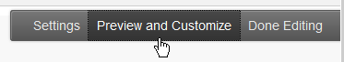 ,  
use Customize Style button in upper left when Viewing cid:image002.png@01D3D8B6.F5A67250

**When sharing assignment milestones,** click on the Portfolio’s **More** link and select **Share**. (See screen images below) This is used to send a “snapshot” of your web site to others for review and comments. Each time you change the portfolio, you must Share again to send the latest snapshot; this is typically done at milestone review points.

🡺 Tools, Portfolios. Click “More” under your portfolio’s name, click Share, then Share a Snapshot with **External Users**, and enter your teammate’s @mySeneca.ca email and your professor’s email @SenecaCollege.ca.  
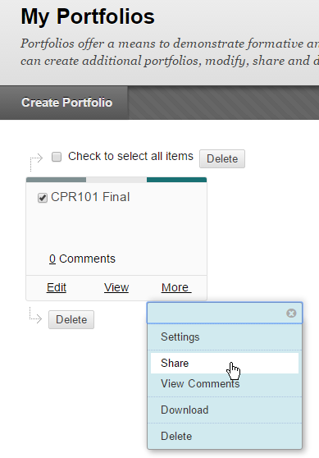  
🡺 only use "share with external users via email"  
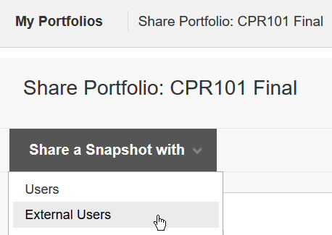  
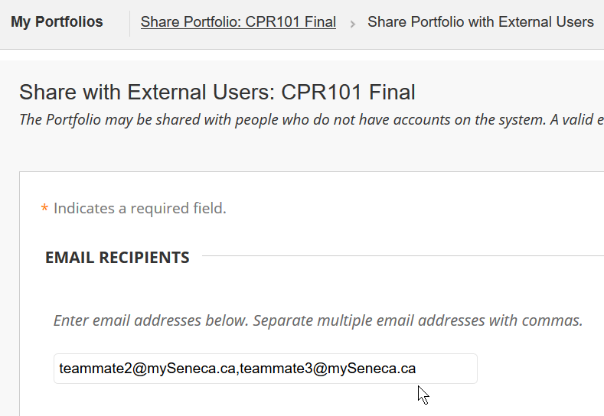  
**Portfolio Sample**  
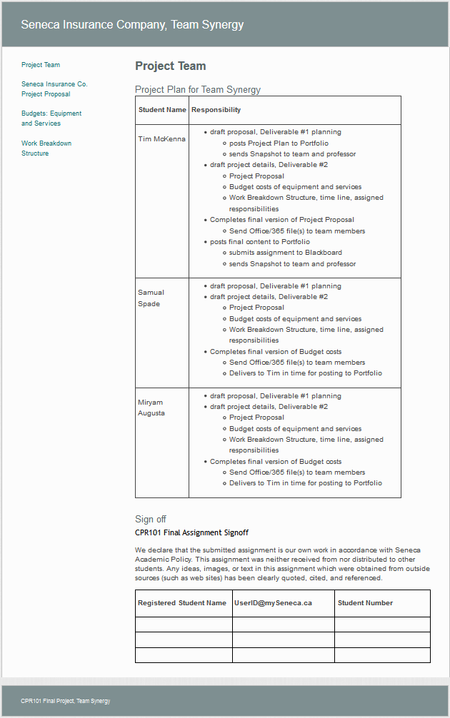

# CPR101 Final Assignment Signoff

We declare that the submitted assignment is our own work in accordance with Seneca Academic Policy. This assignment was neither received from nor distributed to other students. Any ideas, images, or text in this assignment which were obtained from outside sources (such as web sites) has been clearly quoted, cited, and referenced.

|  |  |  |
| --- | --- | --- |
| **Registered Student Name** | **UserID@mySeneca.ca** | **Student Number** |
|  |  |  |
|  |  |  |
|  |  |  |

Notes

**All group members must “sign off”** on the Assignment, just like a real-world project. **Display the above as a section within the Project Team page.** This is part of the final deliverable to be included with the portfolio.

**Submit the portfolio with all completed deliverables as a Blackboard assignment. Only one member of the group needs to do this.** Share a Snapshot of your submitted portfolio with your teammates *and* your instructor: it confirms who made the submission and who is in the group. **Teammates should also share source documents. Every team member must have a copy of all assignment files and snapshot access to the portfolio.**

The final version of your assignment is presented to your instructor for marking by **submitting** the portfolio as an **Assignment** on Blackboard (it is configured to accept a portfolio).

All members of the assignment group will receive the same mark unless a Group Problem Report is filed with the portfolio (as a section on the Team page) and by email to your instructor.

# Group Problem Report: CPR101

|  |  |  |  |  |  |  |  |  |  |  |  |  |  |  |  |
| --- | --- | --- | --- | --- | --- | --- | --- | --- | --- | --- | --- | --- | --- | --- | --- |
| I/We the undersigned:  |  |  | | --- | --- | | Student Name | Student Signature | |  |  | |  |  | |  |  |   agree that ____________________________________________________                             **Name of Problem Group Member**  **Nature of the problem:**   |  | | --- | |  |   **Attempts to correct the situation:**   |  |  | | --- | --- | | **Date** | **What did you  do to correct the problem?** | |  |  | |  |  | |

See <http://www.dummies.com/careers/project-management/acknowledging-resolving-conflicts-product-management/>