**Lista de componentes**

Tarjeta: CKTO_ADC

Fecha: 12/12/2019

|  |  |  |  |
| --- | --- | --- | --- |
| **Item** | **Cant.** | **Referencia** | **Descripción** |
| **1** | 10 | C1, C3, C6, C10, C11, C13, C15, C17, C24, C26 | Capacitor de cerámico de 0.1uF SMD 0402 |
| **2** | 12 | C2, C4, C5, C8, C9, C12, C14, C16, C25, C27, C37, C39 | Capacitor de cerámico de 1uF SMD 0402 |
| **3** | 2 | C18, C19 | Capacitor de cerámico de 20pF SMD 0603 |
| **4** | 4 | C20, C21, C22, C23 | Capacitor de cerámico de 330pF SMD 0805 |
| **5** | 12 | C28, C29, C30, C31, C32, C33, C34, C35, C36, C38, C40, C41 | Capacitor de cerámico de 0.1uF SMD 0603 |
| **6** | 2 | D2, D3 | Diodo axial 1N4148 |
| **7** | 5 | F1, F2, F3, F4, F5 | CI Filtro pasa bajos NFE61PT |
| **8** | 1 | IC1 | CI Conversor A/D AD7177-2 SMD TSSOP24 |
| **9** | 1 | IC2 | CI Voltaje de referencia ADR4525 SMD SOIC8 |
| **10** | 1 | IC3 | CI Multiplexor ADG1408 SMD TSSOP16 |
| **11** | 1 | IC4 | CI Aislador magnético ADUM1400 SMD SO-16W |
| **12** | 1 | IC5 | CI Aislador magnético ADUM1401 SMD SO-16W |
| **13** | 3 | R1, R2, R3 | Resistencia de 10 Ohm SMD 0603 |
| **14** | 8 | R4, R5, R6, R7, R9, R10, R11, R12 | Resistencia de 200 Ohm SMD 0603 |
| **15** | 8 | R13, R15, R17, R19, R21, R23, R25, R27 | Resistencia de 10K Ohm SMD 0603 |
| **16** | 8 | R14, R16, R18, R20, R22, R24, R26, R28 | Resistencia de 1M Ohm SMD 0603 |
| **17** | 1 | XTAL1 | Cristal de cuarzo de 16MHZ pasante |
| **18** | 2 | VIN_3.3, +/-5VAN | Bornera de 2 pines |
| **19** | 1 | +/-2.5VAN | Bornera de 3 pines |
| **20** | 2 | SPI_BUS, ADD_BUS | Espadin macho 6 pines recto |
| **21** | 1 | ANALOG_INPUT | Conector DB25 hembra para PCB |

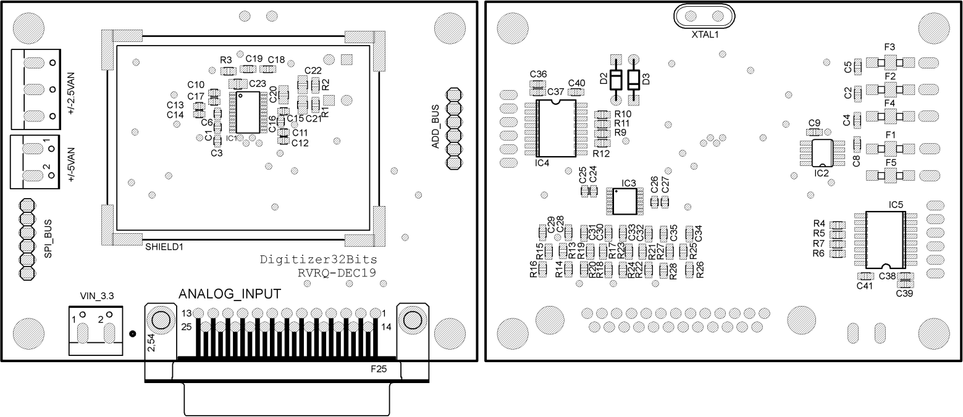

Componentes capa TOP. Componentes capa BOTTOM