**Lista de componentes**

Tarjeta: CKTO_CONTROL

Fecha: 12/12/2019

|  |  |  |  |
| --- | --- | --- | --- |
| **Item** | **Cant.** | **Referencia** | **Descripción** |
| **1** | 9 | C1,C2,C6,C7,C8,C9,C10,C14,C15 | Capacitor de cerámico de 0.1uF SMD 0603 |
| **2** | 2 | C4,C5 | Capacitor de cerámico de 20pF SMD 0603 |
| **3** | 1 | C3 | Capacitor de tantalio de 10uF SMD 1206 |
| **4** | 2 | C11,C12 | Capacitor electrolítico de aluminio de 47uF SMD |
| **5** | 1 | C13 | Capacitor electrolítico de aluminio de 100uF SMD |
| **6** | 1 | R3 | Resistencia de 100 Ohm SMD 0603 |
| **7** | 1 | R4 | Resistencia de 10K Ohm SMD 0603 |
| **8** | 1 | R17 | Resistencia de 1K Ohm SMD 0603 |
| **9** | 1 | R18 | Resistencia de 30 Ohm SMD 0603 |
| **10** | 12 | R5, R6, R7, R8, R9, R10, R11, R12, R13, R14, R15, R16 | Resistencia de 200 Ohm SMD 0603 |
| **11** | 1 | XTAL1 | Cristal de Cuarzo de 20 MHZ pasante |
| **12** | 1 | IC1 | CI PIC16LF876A SMD SO28 |
| **13** | 1 | IC2 | CI NC7SZ32 compuerta lógica OR SMD SOT-23-5 |
| **14** | 1 | IC3 | CI MAX3232 driver level RS232 SMD SOIC16 |
| **15** | 1 | IC4 | CI LT1121-3.3 regulador de coltaje SO08 |
| **16** | 2 | COM, COM_GPS | Espadin macho 3 pines 90° |
| **17** | 2 | LOG, RESET | Espadin macho 2 pines 90° |
| **18** | 1 | RB0 | Espadin macho 2 pines recto |
| **19** | 1 | PROGRAM | Espadin macho 6 pines 90° |
| **20** | 2 | SPI_BUS, ADD_BUS | Header hembra 6 pines recto. |
| **21** | 1 | VIN | Bornera de 2 pines |

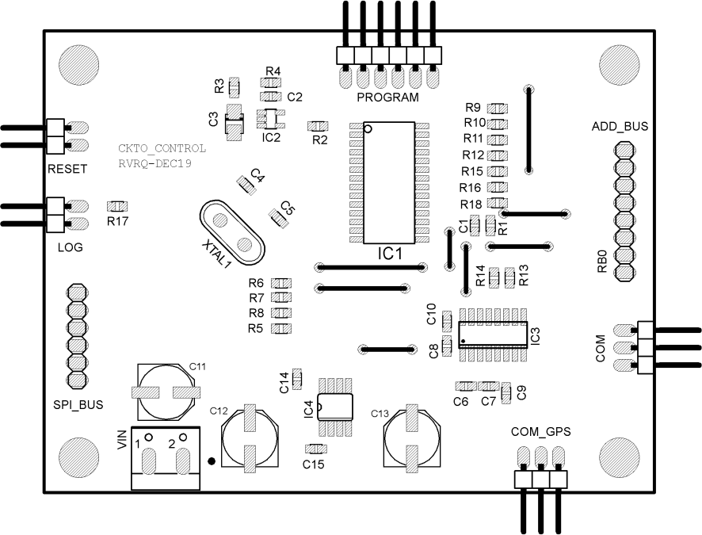

Componentes capa TOP.