**Lista de componentes**

Tarjeta: Digi32MCU

Fecha: 02/08/2022

|  |  |  |  |
| --- | --- | --- | --- |
| **Item** | **Cant.** | **Referencia** | **Descripción** |
| 1 | 2 | C1, C2 | Capacitor cerámico 22pF SMD 0603. |
| 2 | 1 | C3 | Capacitor cerámico 0.1uF SMD 0603. |
| 3 | 1 | R1 | Resistencia 100 Ohm SMD 0603. |
| 4 | 1 | R2 | Resistencia 10K Ohm SMD 0603. |
| 5 | 1 | C4 | Capacitor aluminio 100uF SMD. |
| 6 | 1 | IC1 | Microcontrolador PIC18F258 SOIC28. |
| 7 | 1 | Q1 | Cristal 9.8304 SMD. |
| 8 | 1 | F1 | Filtro LC NFE61PT102 SMD. |
| 9 | 1 | PROG | DIP Switch 4 pines. |
| 10 | 1 | 5VDC_IN | Bornera de 2 pines. |
| 11 | 1 | CON1 | Conector espadín hembra de 40 pines. |
| 12 | 2 | RST, TO_PROGRAM | Espadines machos. |

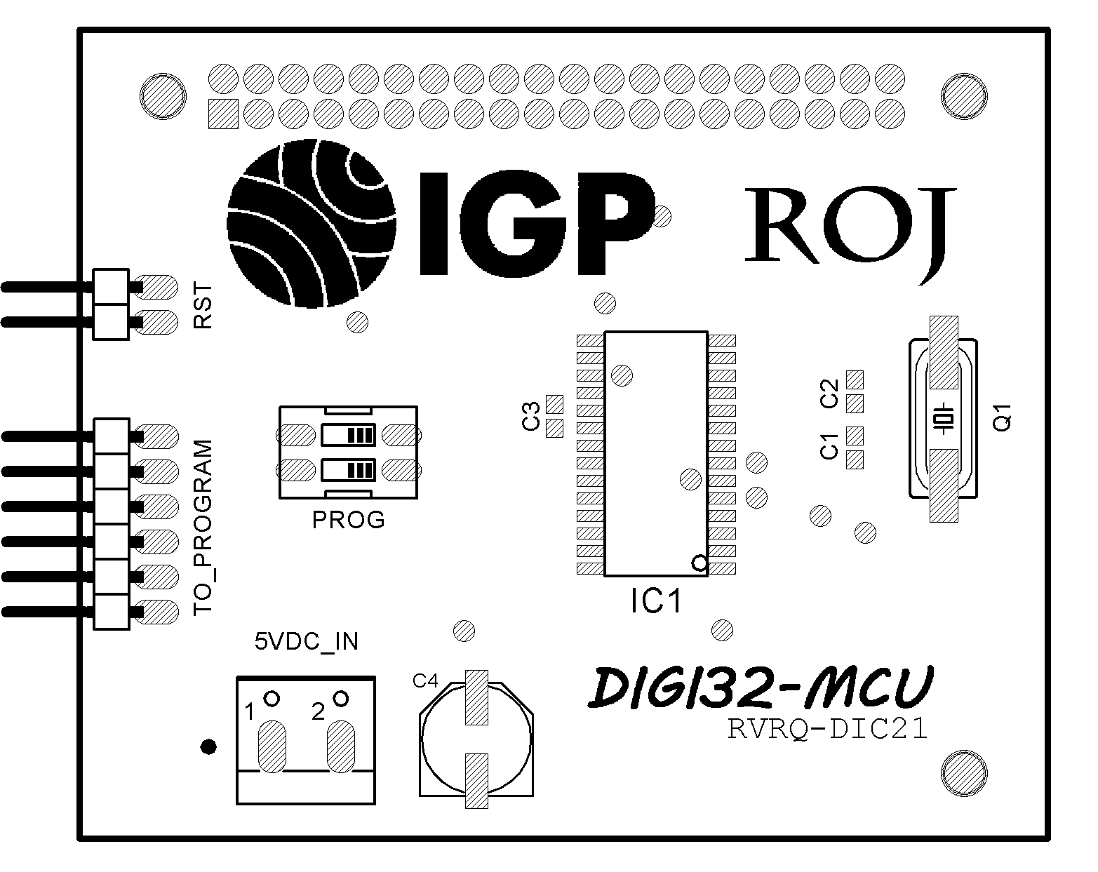

Fig. 01. Componentes capa TOP.

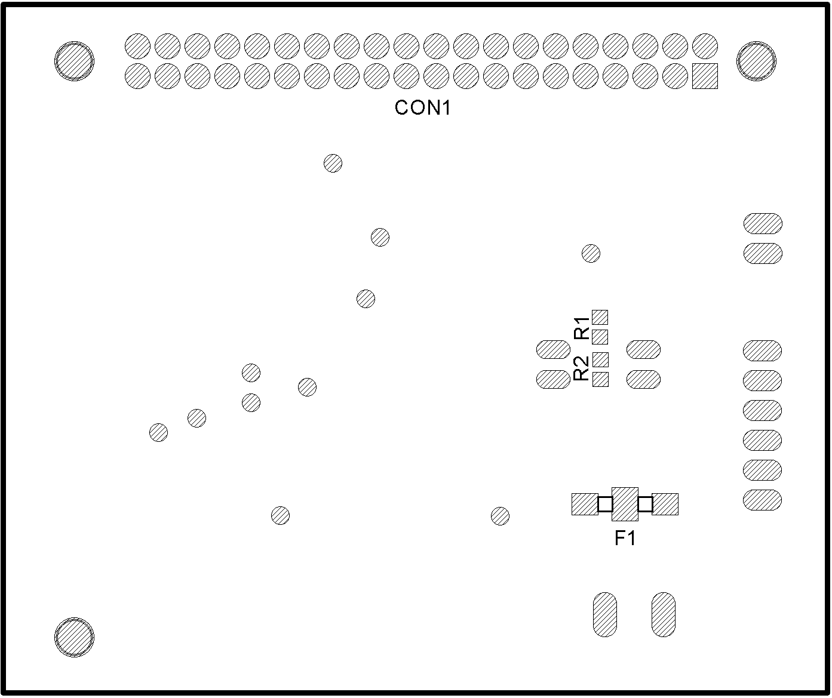

Fig. 02. Componentes capa BOTTOM.