**Lista de componentes**

Tarjeta: Digitizer10V

Fecha: 04/07/2023

|  |  |  |  |
| --- | --- | --- | --- |
| **Item** | **Cant.** | **Referencia** | **Descripción** |
| 1 | 5 | R29, R31, R32, R46, R47 | Resistencia 10 Ohm SMD 0805 |
| 2 | 1 | R30 | Resistencia 30 Ohm SMD 0603 |
| 3 | 22 | R17, R18, R19, R20, R21, R22, R24, R25, R27, R34, R35, R36, R37, R38, R39, R40, R42, R43, R44, R45 R49, R51 | Resistencia 200 Ohm SMD 0603 |
| 4 | 3 | R23, R26, R33 | Resistencia 1K Ohm SMD 0603 |
| 5 | 9 | R1, R3, R5, R7, R9, R11, R13, R15, R28 | Resistencia 10K Ohm SMD 0603 |
| 6 | 8 | R2, R4, R6, R8, R10, R12, R14, R16 | Resistencia 1M Ohm SMD 0603 |
| 7 | 2 | C42, C45 | Capacitor de cerámico 20pF SMD 0603 |
| 8 | 1 | C60 | Capacitor de cerámico 22nF SMD 0603 |
| 9 | 30 | C1, C2, C3, C4, C5, C6, C7, C8, C9, C10, C12, C14, C16,  C20, C21, C30, C31, C38, C39, C40, C41, C44, C46, C47, C48, C49, C50, C51, C56, C57 | Capacitor de cerámico 0.1uF SMD 0603 |
| 10 | 1 | 24 | Capacitor de aluminio 1uF electrolítico SMD-CAN 4.30mm x 4.30mm |
| 11 | 8 | C11, C13, C15, C33, C35, C43, C58, C59 | Capacitor de tantalio 10uF polarizado SMD 1206 |
| 12 | 6 | C17, C19, C22, C24, C27, C29 | Capacitor de aluminio 47uF electrolítico SMD-CAN 6.60mm x 6.60mm |
| 13 | 3 | C18, C23, C28 | Capacitor de aluminio 100uF electrolítico SMD-CAN 6.60mm x 6.60mm |
| 14 | 2 | C32, C34 | Capacitor de tantalio 0.1uF polarizado SMD 1206 |
| 15 | 2 | C36, C37 | Capacitor de tantalio 2.2uF polarizado SMD 1206 |
| 16 | 2 | D3, D4 | Diodo TVS bidireccional SMBJ15CA-TR 15V 600W |
| 17 | 2 | D1, D2 | Diodo TVS unidireccional SMLVT3V3 3.3V 600W |
| 18 | 1 | D5 | Diodo Stky DB2X20700L 20V/1A SMD SOD-123F |
| 19 | 3 | F1, F2, F3 | Filtro LC NFE61PT102E1H9L 1000pF SMD 3-PC |
| 20 | 1 | IC1 | CI Multiplexor 8 x 1 MAX337EAI+ SMD 28SSOP |
| 21 | 1 | IC6 | CI ADC 16bits ADS7825 SOIC-28 |
| 22 | 1 | IC2 | CI Regulador DC/DC 1W NMA0515DC |
| 23 | 1 | IC3 | CI Regulador +5.0V LT1121-5 SOIC8 |
| 24 | 1 | IC5 | CI Regulador +3.3V LT1121CS8-3.3#PBF SOIC8 |
| 25 | 1 | IC9 | CI Microcontrolador PIC18LF258 SOIC28 |
| 26 | 2 | IC10, IC13 | Puerta lógica OR NC7SZ32M5X |
| 27 | 1 | IC11 | IC interface RS232 3-5V MAX3232IDR SOIC16-N |
| 28 | 2 | IC7, IC8 | IC interface digital ADUM1401BRWZ-RL SOIC16-W |
| 29 | 1 | IC14 | IC XOR M74VHC1GT86DFT1G SMD SOT-353 |
| 30 | 1 | IC15 | IC OPAM OP07CR SMD SO08 |
| 31 | 1 | GPS | Conector SMD 08FMN-SMT-A-TF(LF)(SN) |
| 32 | 1 | SERIAL | Conector IDC 2x5 pines macho. |
| 33 | 4 | GAP1, GAP2, GAP3, GAP4 | Supresor de plasma de gas ST CG75L |
| 34 | 1 | LED_GPS | Espadín macho. |
| 35 | 1 | VINPUT | Bornera de 2 pines |
| 36 | 1 | CHANNEL_INPUT | Conector DB25 Hembra para PCB |
| 37 | 1 | XTAL | Cristal 9.8304MHz 18pF SMD |

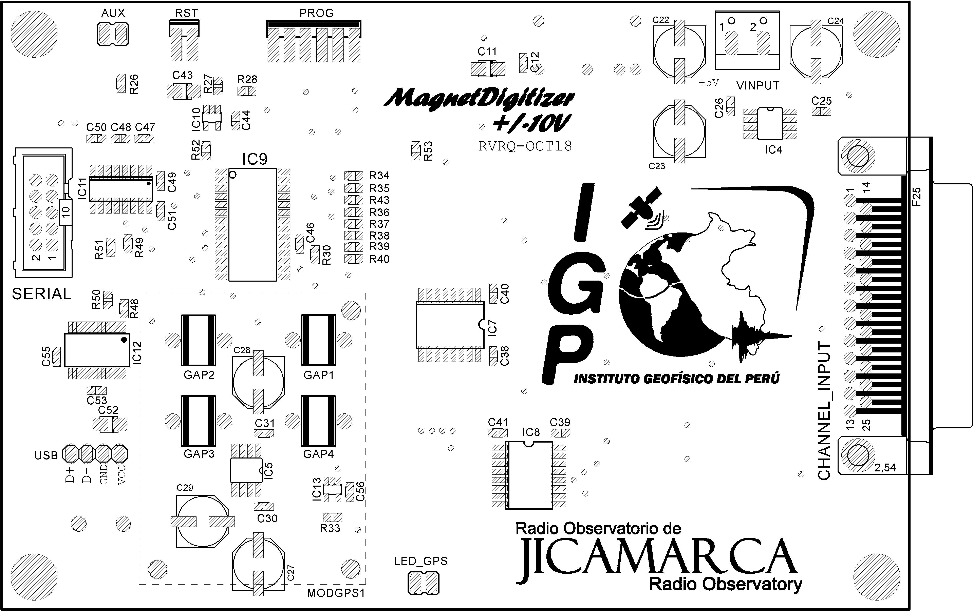

Distribución de componentes capa TOP.

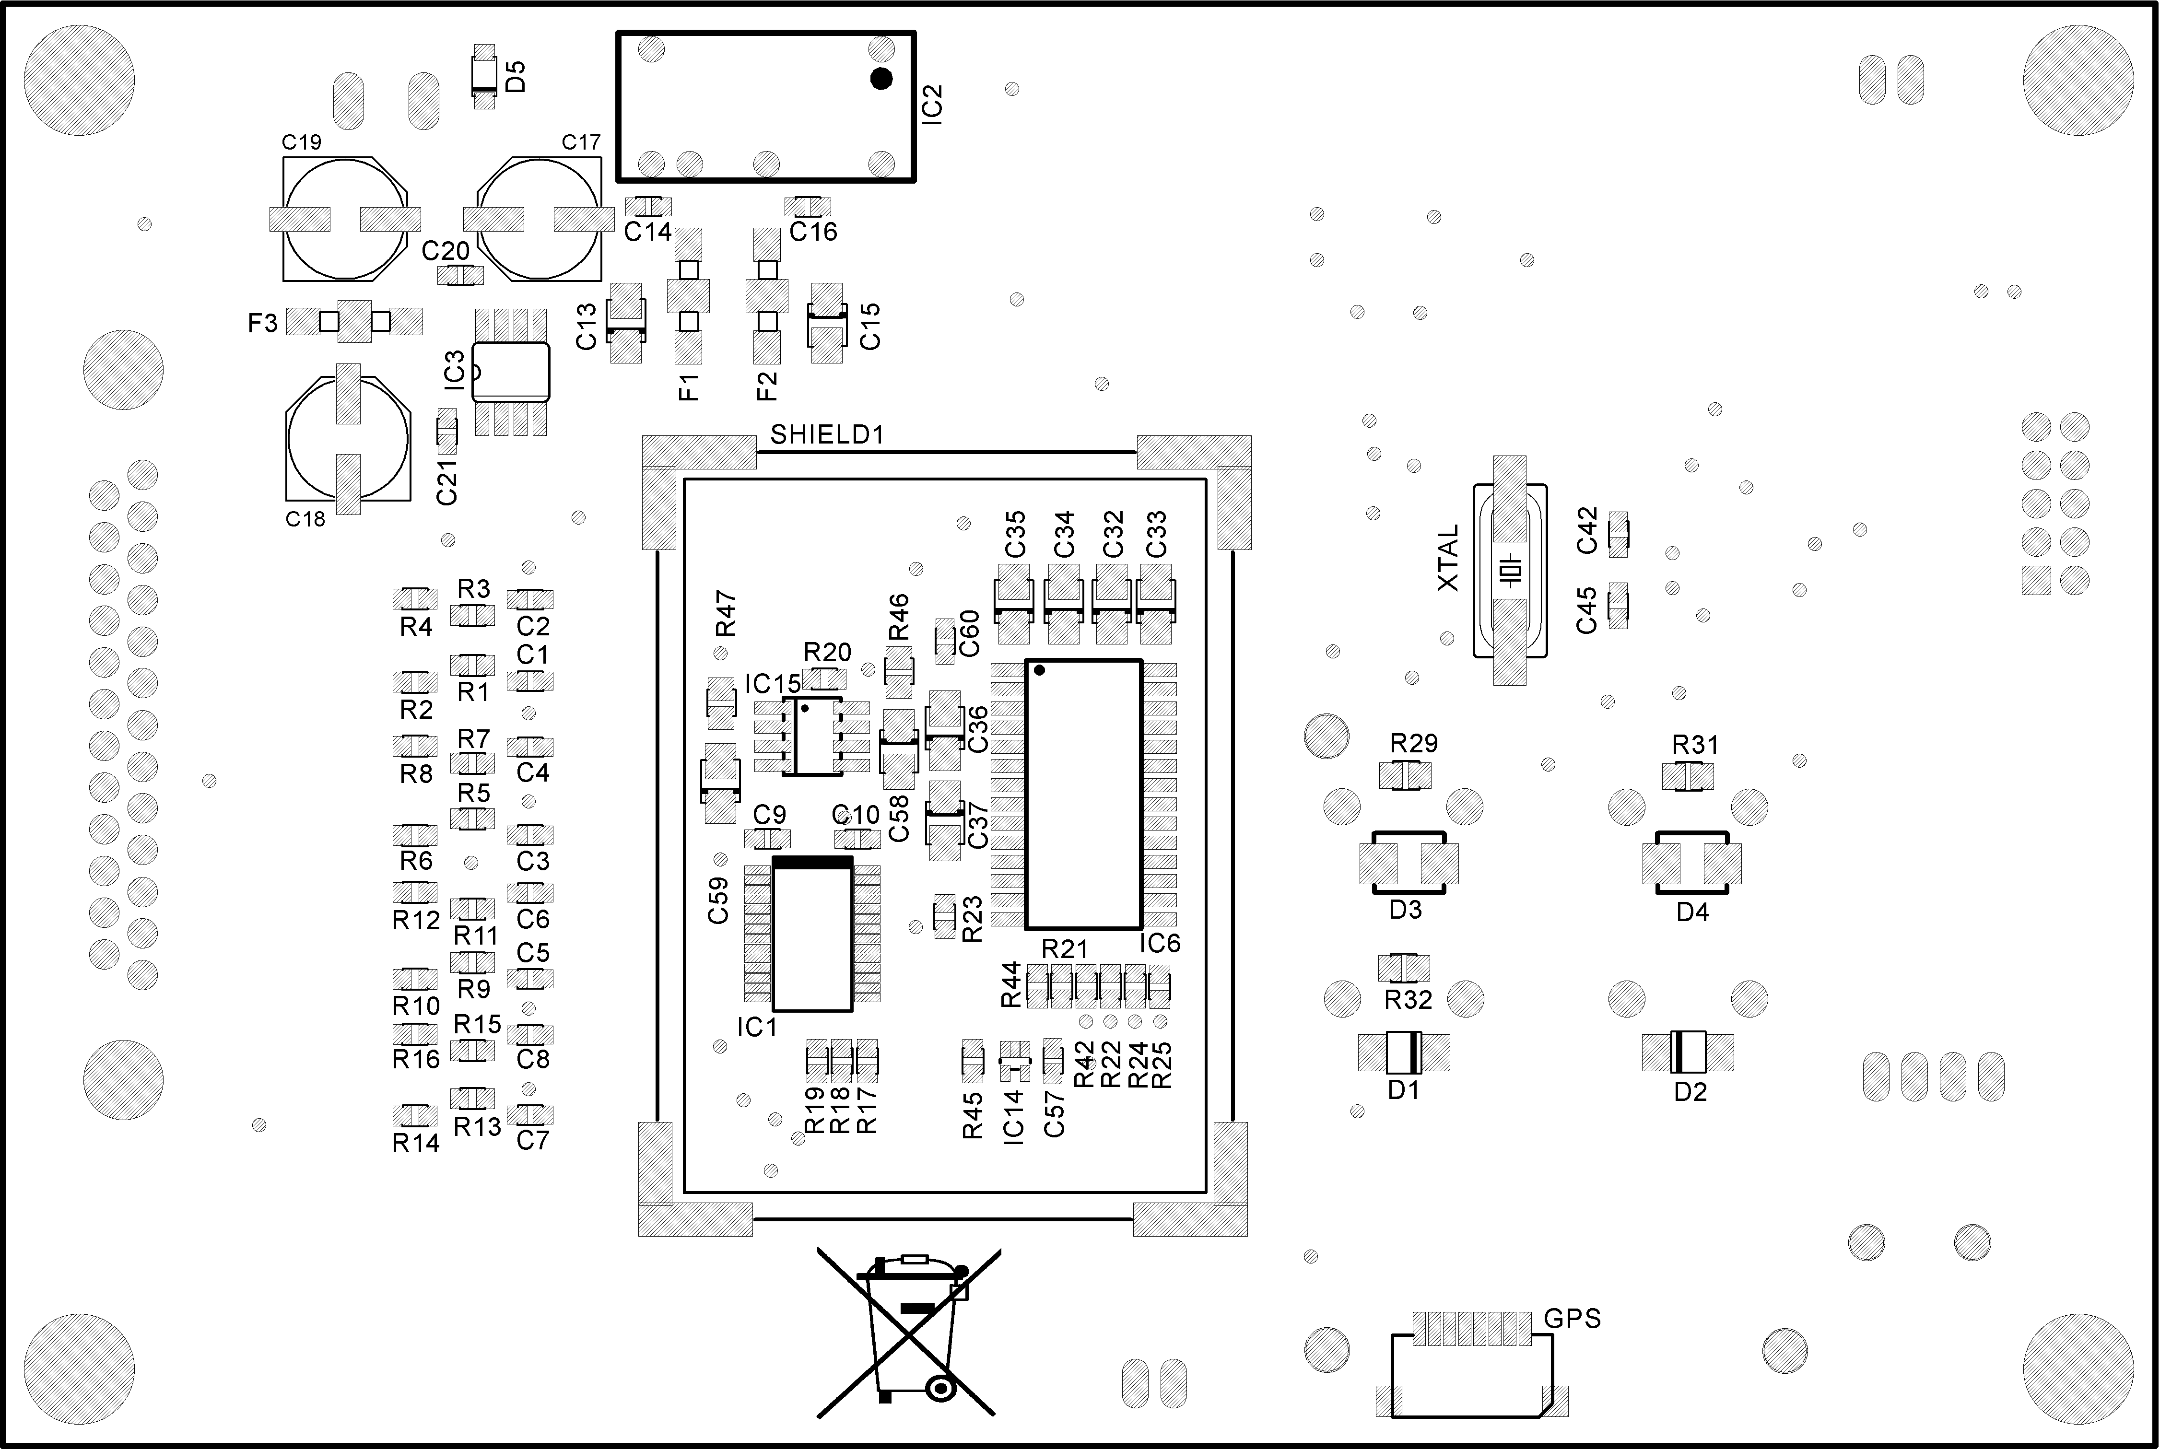

Distribución de componentes capa BOTTOM.