Kieyn Parks

SNHU

CS-499

Narrative 5-2

In database management system (DBMS)is used to manage the database. All CRUD functionality is handled by the DBMS. The functions are:

1. Insert documents.
2. Find a document.
3. Delete a document.
4. Update a document.

The DBMS was created from scratch from project inception. It

I chose Mongodb as my database because it is easy to sort JSON file formats in python as JSON follows the map structure of python dictionaries (associative array). The DBMS artifact is a demonstration of my back-end skills in NoSQL database (mongodb) to perspective employers.

The following modification were made to the database management system:

1. Delete a record

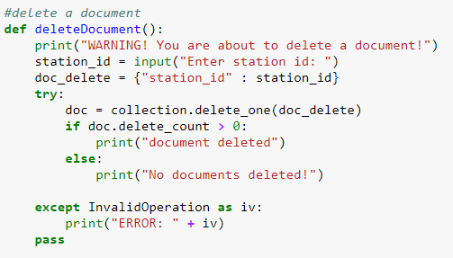

1. Search a record

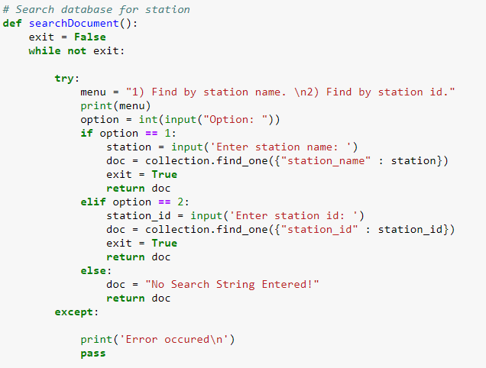

1. Clean up the main function by creating a separate function to handle data collection.

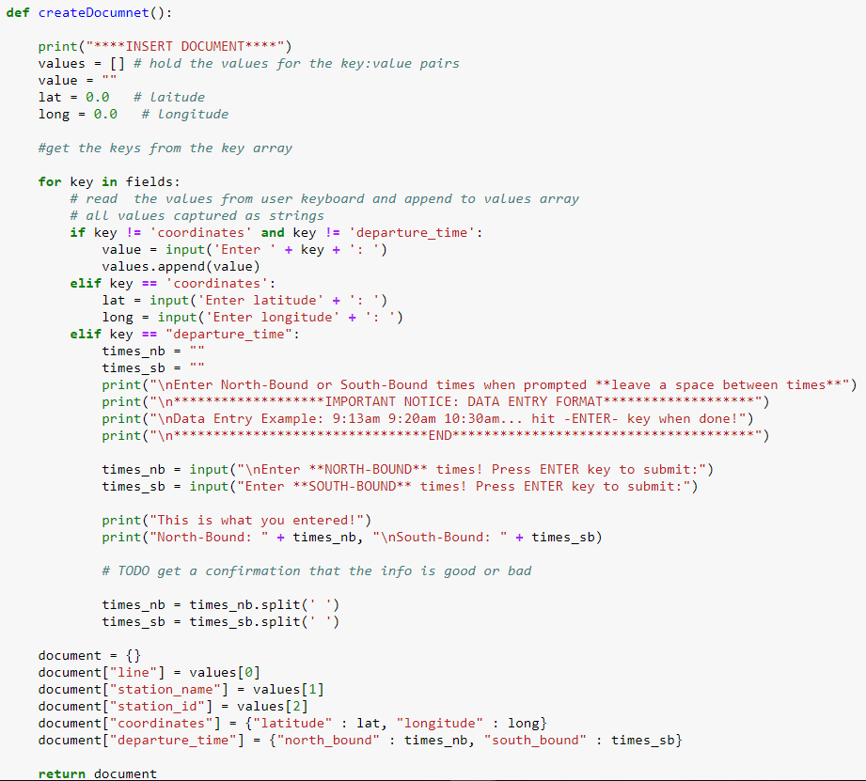

1. Add a new train line to the database.

Previously there existed one trainline in the database “Jersey coast line” now I have added a second line to the database “Pascack valley line”.

See exported excel spread sheet for details.

So far, I have the insert, delete, and find functionality working for the database management system the only function to add is the update function.

Reflection:

During this update there were no major challenges implementing the delete and search functionality. In the search function the json file format was a bit messy to read so I had to learn of to format the json file to make it readable to the user.

The delete function returned an object that must be further inspected to find out if the delete was successfully executed or if nothing was deleted (no file found matching the search string). First a results object is created which holds the return object of the delete_one() function.

