**Project Report Documentation**

**1. Project Summary Report**

**Overview**

This report provides a detailed summary of a selected project, including milestones, tasks, and participant contributions.

**Filter Options**

1. **Branch-wise Project Filter** – Select a branch to view all associated projects.
2. **Project Selection** – Choose a specific project to view its summary.
3. **Date Range Filter** – Filter data by selecting a **Start Date** and **End Date**.

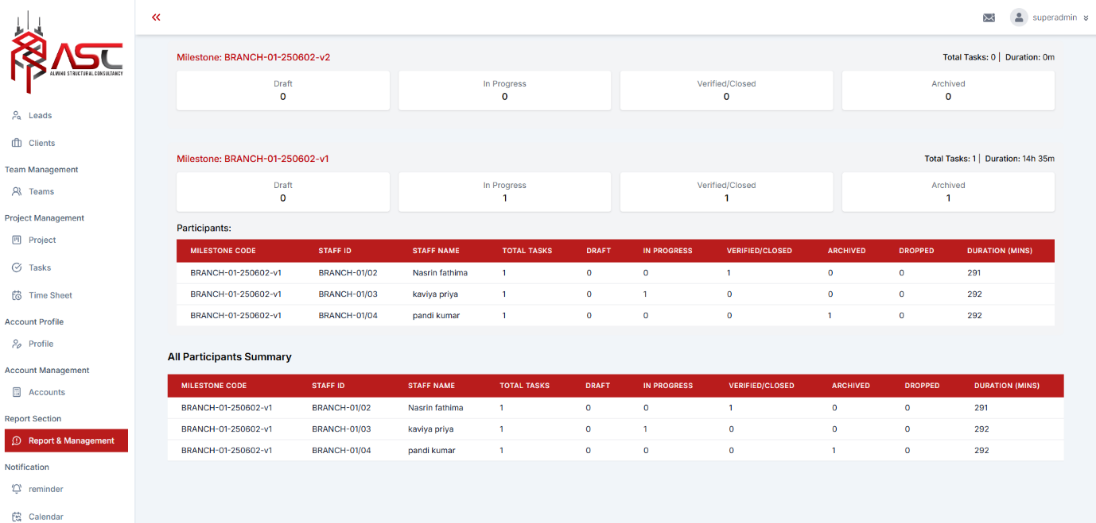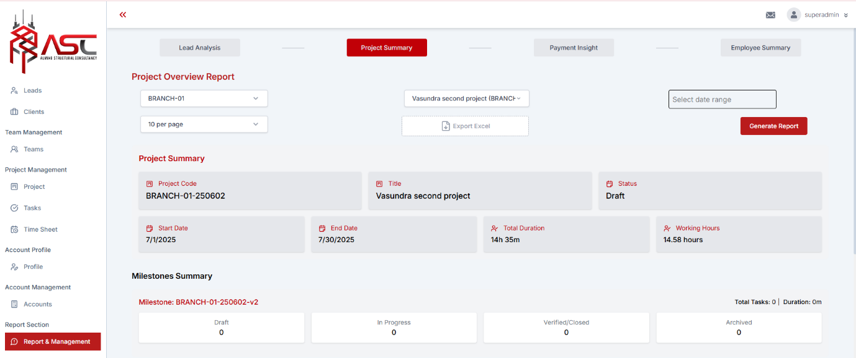

**Data Displayed**

* **Project Details:**
  + Project Code, Title, Status
  + Start Date, End Date, Total Duration, Working Hours
* **Milestones Summary:**
  + Milestone codes, total tasks, duration
  + Breakdown of task statuses (Draft, In Progress, Verified/Closed, Archived)
* **Participants Summary:**
  + Staff ID, Staff Name, Task Distribution
  + Task status (Draft, In Progress, Verified/Closed, Archived, Dropped)
  + Duration spent by each participant

**2. Employee Summary Report**

**Overview**

This report provides a detailed summary of an employee’s work, including projects, tasks, and time spent.

**Filter Options**

1. **Branch Code Filter** – Select a branch to view its employees.
2. **Staff ID Filter** – Choose a specific employee to view their summary.
3. **Date Range Filter** – Filter data by selecting a **Start Date** and **End Date**.

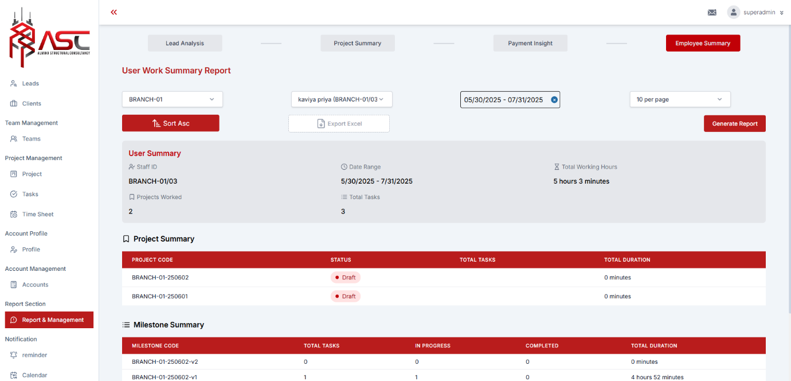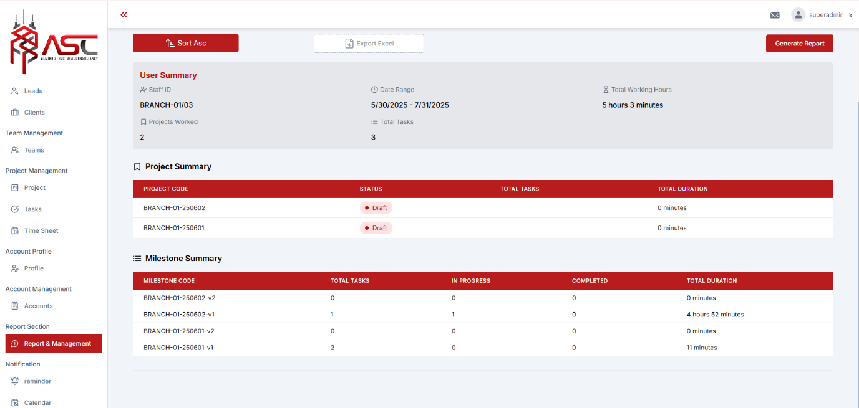

**Data Displayed**

* **User Summary:**
  + Staff ID, Date Range, Total Working Hours
  + Total Projects Worked, Total Tasks
* **Project Summary:**
  + Project Code, Status, Total Tasks, Total Duration
* **Milestone Summary:**
  + Milestone Code, Task Count (In Progress, Completed)
  + Total Duration per milestone

**3. Timesheet Summary Report**

**Overview**

This report displays employee check-in/check-out logs with task-wise time tracking.

**Filter Options**

1. **Branch-wise Staff Filter** – Select a branch and then a specific employee.
2. **Task ID Filter** (Optional) – Enter a Task ID to view specific task logs.
3. **Date Range Filter** – Filter entries by selecting a **Start Date** and **End Date**

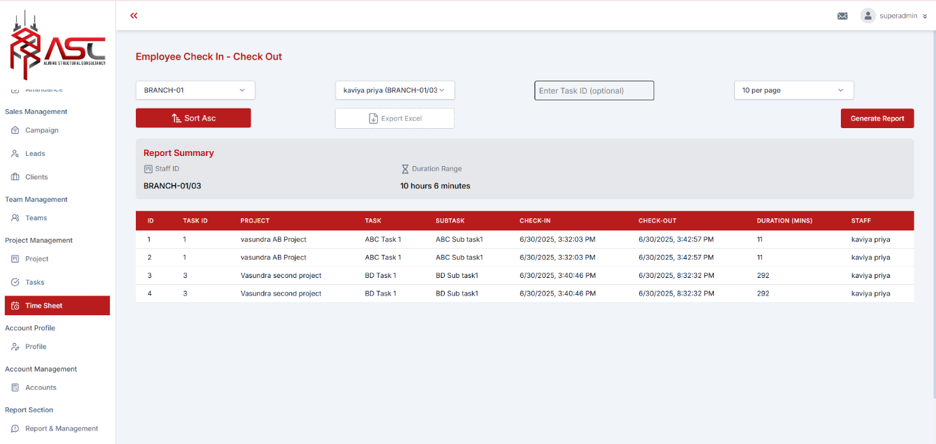

**Data Displayed**

* **Report Summary:**
  + Staff ID, Total Duration Range
* **Check-in/Check-out Logs:**
  + Task ID, Project, Task, Subtask
  + Check-in & Check-out Timestamps
  + Duration (in minutes)
  + Staff Name

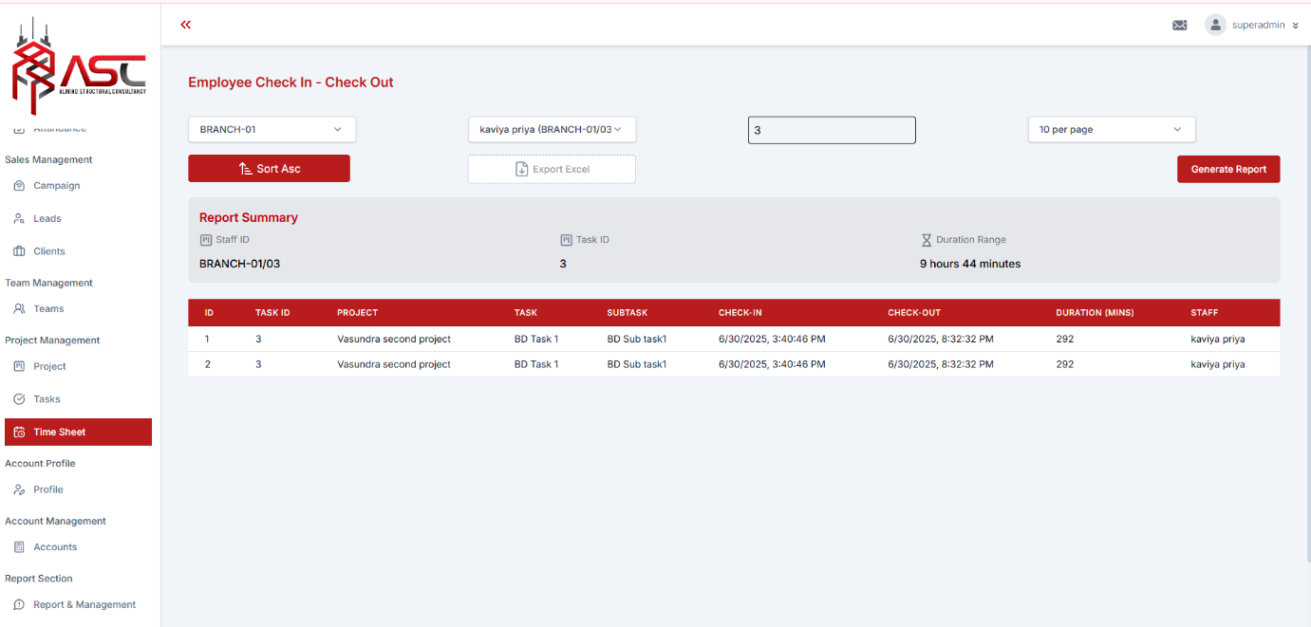

**Conclusion**

These reports provide comprehensive insights into project progress, employee contributions, and time tracking. Users can filter data by branch, staff, date range, and task ID for customized analysis.